6.1

9.

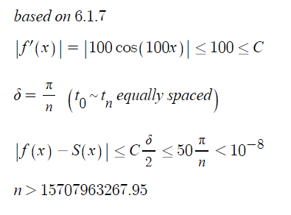

11.

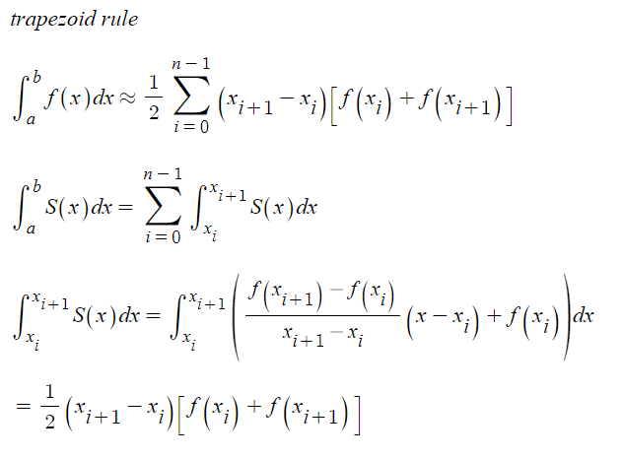

17.

The following code gives the answer.

This is based on the Formulas (5) and (6).

t=[-1,0,1/2,1,2,5/2]

y=[2,1,0,1,2,3]

z=[0]

for i in range(len(t)-1):

z.append(-z[-1]+2\*(y[i+1]-y[i])/(t[i+1]-t[i]))

print(z)

Q=[]

for i in range(len(z)-1):

a=(z[i+1]-z[i])/2/(t[i+1]-t[i])

Q.append(a)

for i in range(len(Q)):

xmt="(x-"+str(t[i])+")"

print("Q",i,"(x)=",Q[i],xmt,"^2+",z[i],xmt,"+",y[i],sep='')

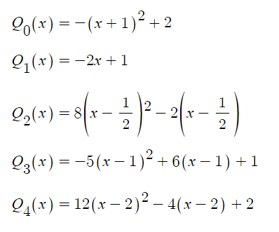

21.

Yes.

The domain is R.

|x| is continuous on R.

There is a partitioning of the interval such that S is a linear polynomial on each subinterval.

If a specific interval contains 0, then let 0 one of the ts so that each subinterval is linear.

26.

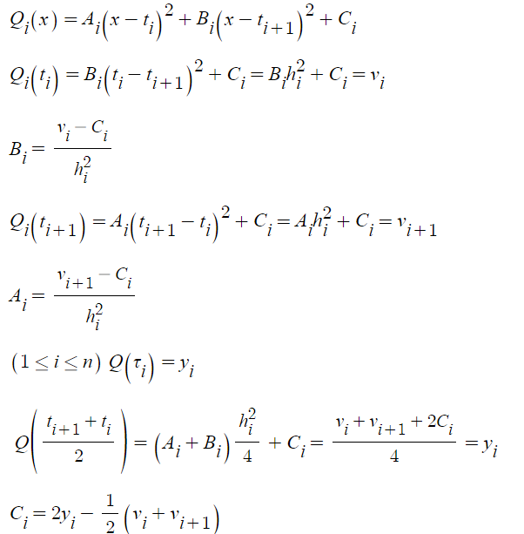

27.

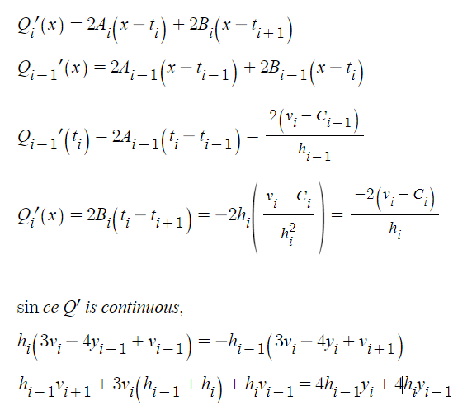

Com

4.

refer to 6.1.4.py

(x-1)\*(x-3)\*(x-5) as f

[0,6] as [a,b]

e as 0.1 gives

28 knots

values of knots

[0, 0.1875, 0.369140625, 0.54510498046875, 0.7155704498291016, 0.8807088732719421, 1.040686720982194, 1.1956652609515004, 1.345800721546766, 1.6366881764500931, 1.9093951654219623, 2.1650579675830897, 2.4047418446091466, 2.854149114033003, 3.2473804747788777, 3.5914579154315183, 3.892525676002579, 4.155959966502256, 4.386464970689474, 4.58815684935329, 4.764637243184128, 4.919057587786112, 5.054175389312848, 5.290631541984636, 5.467973656488477, 5.600980242366358, 5.800490121183179, 6]

function values

[-15, -10.997314453125, -7.685847960412502, -4.974868218313759, -2.7838478141100884, -1.0414088085396762, 0.3156286654467014, 1.343103745394857, 2.0902871449956626, 2.9193698612063224, 3.0652333299570733, 2.7577064955947925, 2.1701134471995607, 0.5803009336765579, -0.9743829316351357, -2.158926395376306, -2.85911489197915, -3.0791959390637147, -2.880678907203369, -2.3469112064600215, -1.5635663583070936, -0.6087595614463764, 0.451171954640425, 2.8564011803452964, 5.160271234301509, 7.191965841491953, 10.761569183451094, 15]

6.2

4.

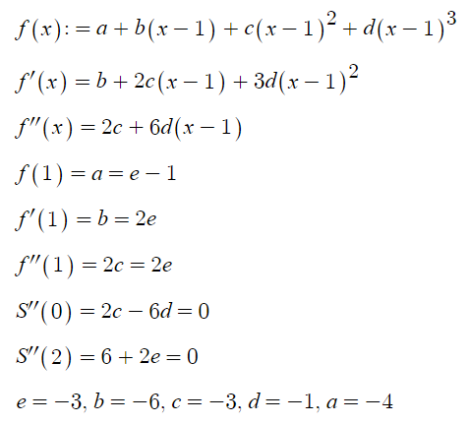

8.

a.

There are n intervals with n different functions. Each of the functions needs m+1 conditions to be unique. so total n(m+1) conditions are needed for uniqueness.

b.

there are n subintervals and endpoints of them should be interpolated so total 2n.

c.

There are total n-1 points except endpoints. since the 1~(m-1) derivatives should be continous, there are m-1 conditions are each so total (n-1)(m-1).

d.

n(m+1)-(n-1)(m-1)-2n=m-1

17.

since total 5(n-1) are needed and by the continuity of the function itself and the 1~3 derivatives at n-2 points, 4(n-2) conditions are already given. 5(n-1)-4(n-2) gives n+3.

23.

there needs to be 4n conditions for the spline to be unique.

since the 1, 2 derivatives should be continuous including endpoints,

there are 2n conditions for this.

since there are n subintervals(or functions) and two interpolations for each,

2n conditions are given.

so there are enough conditions for a periodic cubic spline to be unique.

27.

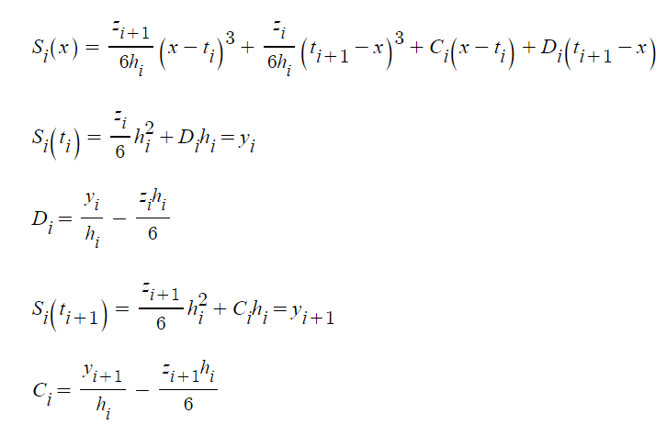

37.

if S is a spline of degree k on [a,b],

S’ should be continuous function on [a,b] which means its domain can also be [a,b].

since S and 1~k-1 drivatives are continuous on [a,b],

S’ and 1~k-2 derivatives are continuous on [a,b].

since there exist points that divides the interval such that S is a polynoimial of degree at most k on each subinterval,

the same points divides the interval such that S’ is a polynomial of degree at most k-1 on each subinterval.

so S’ is a spline of degree k-1 on [a,b]

41.

(0,1) (1,2) (2,3) (3,4) (4,5)

h0=h1=h2=h3=1

u1=u2=u3=4

b0=b1=b2=b3=1

v1=v2=v3=0

4z1+z2=0

z1+4z2+z3=0

z2+4z3=0

so z0=z1=z2=z3=z4=0

Si(x)=x+1 (0≤i≤3)

Com

4.

refer to 6.2.4.py

the result is as follows.

0.0

-0.000103422330433256

-0.00024351482686513215

-0.00027069094267428984

-0.00016250732198119788

0.0

9.925184766546025e-05

0.00012618021035304405

9.551014035469318e-05

3.371592030365633e-05

0.0

5.2855971444887295e-05

0.00011363185074109161

0.0001170393960795435

6.0210219310574686e-05

0.0

7.112514036955453e-06

3.681861579585277e-05

4.568216926958968e-05

2.6086264846236773e-05

0.0

-2.320507124065063e-06

5.802221307416033e-06

9.95983682156032e-06

6.602750115658473e-06

0.0

-2.9702926980790245e-06

-3.0026433119334506e-06

-1.7397366103288903e-06

-2.5901044159448716e-07

5.551115123125783e-17

-2.1342812731028893e-06

-4.103555784673585e-06

-3.928568319766512e-06

-1.7573696725059484e-06

2.7755575615628914e-17

-1.4395809005973703e-06

-3.3851280403507378e-06

-3.4970816930324222e-06

-1.6795395512969602e-06

2.7755575615628914e-17

-9.548946865445274e-07

-2.445510776494242e-06

-2.5931486738461906e-06

-1.2716329402251425e-06

0.0

-6.39000990676486e-07

-1.6939743136823449e-06

-1.8134614633014134e-06

-8.954375433911643e-07

0.0

-4.3210401012849786e-07

-1.1592376439328866e-06

-1.244691061219605e-06

-6.155062646923115e-07

-1.3877787807814457e-17

-2.958165156163872e-07

-7.943575981578244e-07

-8.526152195931225e-07

-4.208815635453611e-07

1.3877787807814457e-17

-2.06726461324247e-07

-5.518710070595567e-07

-5.918151925327075e-07

-2.923867344073461e-07

0.0

-1.412833359609733e-07

-3.7732483068597666e-07

-4.01979159250776e-07

-1.9449093349721558e-07

0.0

-1.1749259858084837e-07

-3.010719753226976e-07

-3.2653669557181075e-07

-1.710753765316042e-07

1.3877787807814457e-17

-2.334467490150427e-08

-9.115161822559337e-08

-7.619454499285805e-08

4.744331608130814e-09

0.0

-2.481831250025768e-07

-5.348305355395988e-07

-6.458412436100014e-07

-4.7147544428999266e-07

0.0

6.796122548682892e-07

1.3573428329499704e-06

1.7331304811227244e-06

1.430291215277768e-06

0.0

-2.7199880986636393e-06

-5.537820424665607e-06

-6.967495795803802e-06

-5.5799791141425414e-06

0.0

1.0012784663955554e-05

2.0314118535341708e-05

2.5630258070973022e-05

2.0644600650820966e-05

1.3877787807814457e-17

11.

refer to 6.2.11.py

the result is as follows.

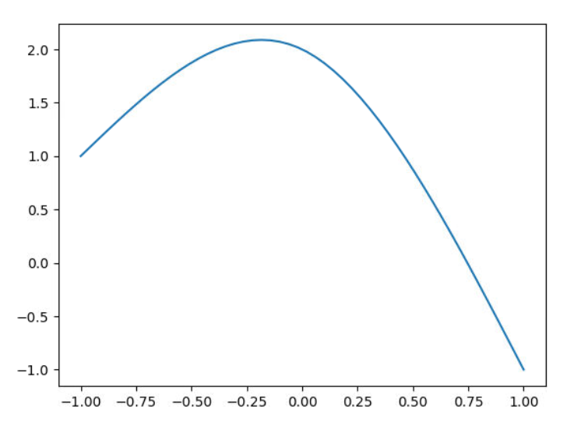

6.3

3.

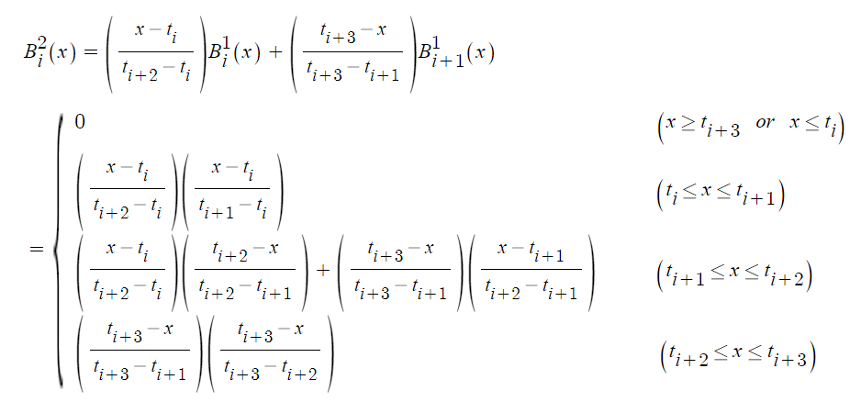

it’s piecewise quadratic and zero at every knot except ti+1 and ti+2.

7.

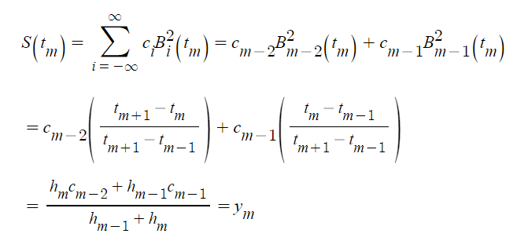

18.

If all coefficients are zero, then the sum would be zero.

If not, the spline has x^n terms where n is less than or equal to k, which is not always 0.

21.

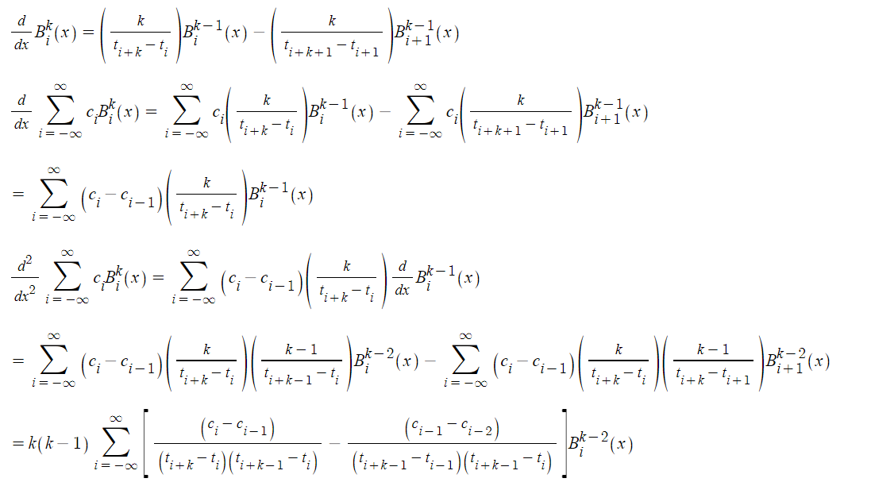

24.

this is trivial result from the exercise 6.3.3.

26.

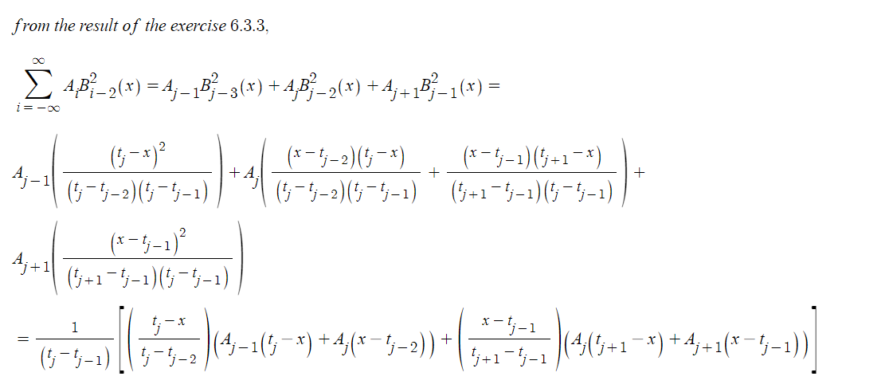

29.

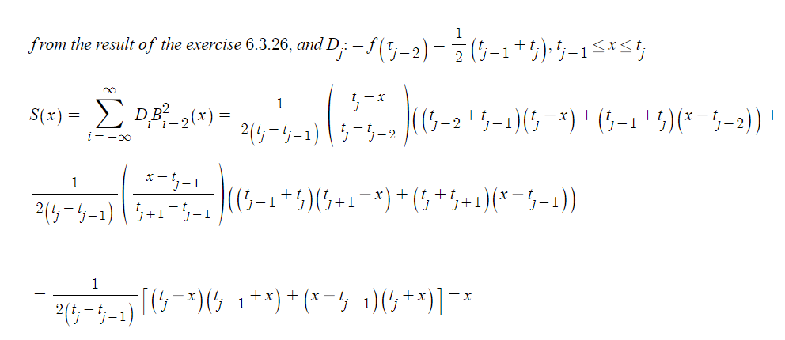

34.

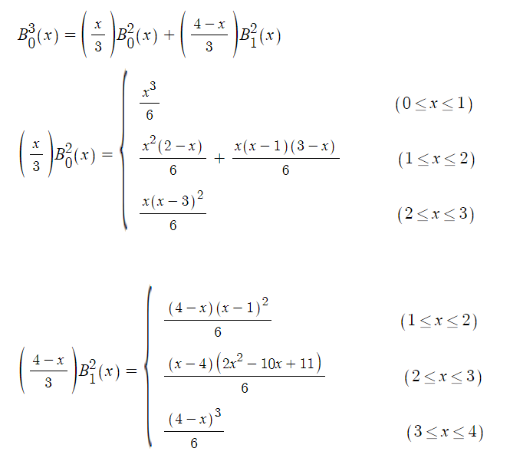

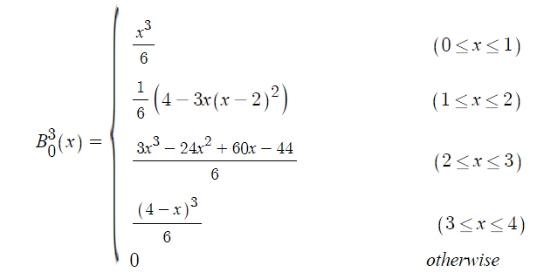

37.

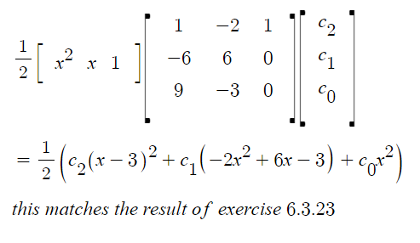

38.

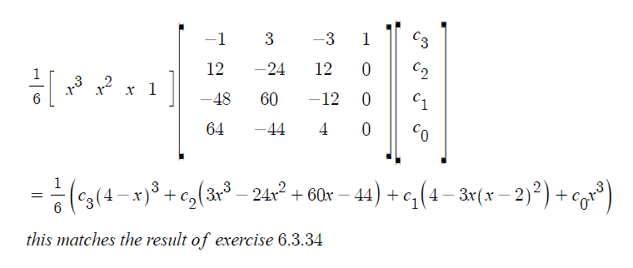

Com

7.

refer to 6.3.7.py

187687.58590639057

19.

refer to 6.3.19.py

