CS 2005: Database Systems | Spring 2026
⚡ EXPIRY RUSH
Beat the Clock. Save More.

Project Report

Group Member | Student ID
Rameen Ramzan | 24K-0557
Amna Sami | 24K-0561
Umama Zubair | 24K-0621

Group Leader: Umama Zubair | Submitted: 27 April 2026
Department of Computer Science | FAST-NUCES

A Dynamic Discount Marketplace for Near-Expiry Products

1. Introduction (Aim & Motivation)

1.1 Overview
Expiry Rush is a web-based marketplace that connects grocery stores and food sellers with consumers by offering near-expiry food products at dynamically discounted prices. The core idea is simple yet powerful: as a product's expiration date approaches, its discount automatically increases — reaching up to 90% off — creating an urgency-driven shopping experience that benefits all parties.

1.2 Motivation
The motivation behind Expiry Rush stems from two interconnected global challenges:
- Food Waste: According to the UN Food and Agriculture Organization, approximately one-third of all food produced globally is wasted. In Pakistan alone, millions of rupees worth of food is discarded by retail stores every week simply because products approach their best-before date.
- Consumer Affordability: Rising inflation has significantly reduced the purchasing power of middle- and lower-income households. Discount food markets exist but lack the technology to dynamically price products in real time.

Expiry Rush directly addresses both problems simultaneously:
- For sellers — it converts impending losses into revenue, clearing perishable inventory before it becomes waste.
- For consumers — it provides access to fresh, quality food at dramatically reduced prices.
- For society — it reduces food waste and contributes to more sustainable consumption patterns.

1.3 Aim
The primary aim of this project is to design, develop, and deploy a fully functional database-backed web application that:
- Implements a real-time dynamic pricing engine in SQL, where price discounts are calculated live based on time remaining until product expiry.
- Provides role-based access for three user types: Admin, Seller, and Customer.
- Uses advanced database concepts including views, stored procedures, transactions, and foreign key constraints.
- Delivers a complete e-commerce workflow: product listing → browsing → cart (with price locking) → checkout → order history.

2. Background (Research & Project Selection)

2.1 Research Context
Before selecting the project topic, the team surveyed existing solutions in the food-tech and e-commerce space. Key observations included:
- Apps like Too Good To Go (Europe) and Food for All (USA) have demonstrated that near-expiry discount platforms are commercially viable and socially impactful.
- No comparable, locally-built platform exists for the Pakistani market, which represents a significant gap.
- Traditional retail systems do not support real-time pricing — discounts are applied manually, leading to missed windows and unnecessary waste.

2.2 Why This Project?
The project was selected for the following academic and practical reasons:
- Database Richness: The problem domain naturally maps to complex database requirements — multiple entities, relationships, real-time computed fields, transactions, and reporting.
- SQL Complexity: Implementing time-based dynamic pricing purely in SQL (using TIMESTAMPDIFF and computed views) demonstrates advanced query writing skills that go beyond CRUD operations.
- Stored Procedures & Transactions: Atomic order placement with cart-locking, stock deduction, and payment recording demonstrates real-world transactional database design.
- Role-Based Architecture: The three-tier user model (Admin / Seller / Customer) mirrors enterprise database design patterns.

2.3 Technologies Chosen
Component | Technology | Justification
Database | MySQL 8.0 | Industry-standard RDBMS; supports views, stored procedures, transactions, events
Backend | PHP 8.x | Native MySQL integration; simple deployment with XAMPP
Frontend | HTML5 + Bootstrap 5 | Responsive UI; rapid prototyping without a JS framework
Live Updates | JavaScript (Fetch API) | Real-time countdown timers and price refresh without page reload
Dev Environment | XAMPP (Apache + MySQL) | Cross-platform; standard for academic PHP/MySQL projects

3. Project Specification

3.1 Functional Requirements

Customer
- Register and log in with email and password (bcrypt hashed)
- Browse active products with real-time countdown timers and live prices
- Filter products by category; sort by price, discount, or time remaining
- Add items to cart with a 10-minute price lock
- Place orders through a single atomic checkout (stored procedure)
- View full order history and individual order details
- Set Rush Alerts to be notified when a product hits a target discount

Seller
- Register as a seller; manage product listings
- Add and update products (name, category, base price, stock, expiry date/time)
- View incoming orders for their listed products
- Monitor real-time stock levels and product performance on a dashboard

Admin
- Manage all users (activate/deactivate accounts)
- Manage product categories
- Access platform-wide revenue reports (daily breakdown via stored procedure)
- Monitor all orders and system activity

3.2 Non-Functional Requirements
Requirement | Specification
Performance | Product prices and countdowns refresh every 30 seconds via AJAX API call
Data Integrity | All order placements are wrapped in database transactions (ACID-compliant)
Security | Passwords stored as bcrypt hashes; role-based session access control
Scalability | Relational schema normalized to 3NF; indexed on key lookup fields
Usability | Fully responsive Bootstrap 5 UI; mobile-friendly
Availability | Runs on standard XAMPP stack; no cloud dependency required

3.3 ERD — Entity Relationship Diagram

3.3a Hand-Drawn ERD
A hand-drawn ERD was prepared to sketch the initial data model before implementation. It identifies all entities, their primary keys, and the relationships between them.
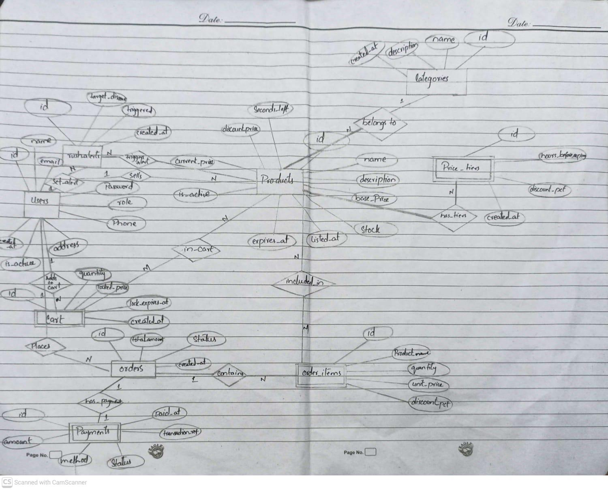

3.3b Software ERD (MySQL draw.io)
The software-generated ERD was produced using draw.io after the schema was finalized. It reflects the exact table structure, foreign keys, and data types implemented in database.sql.
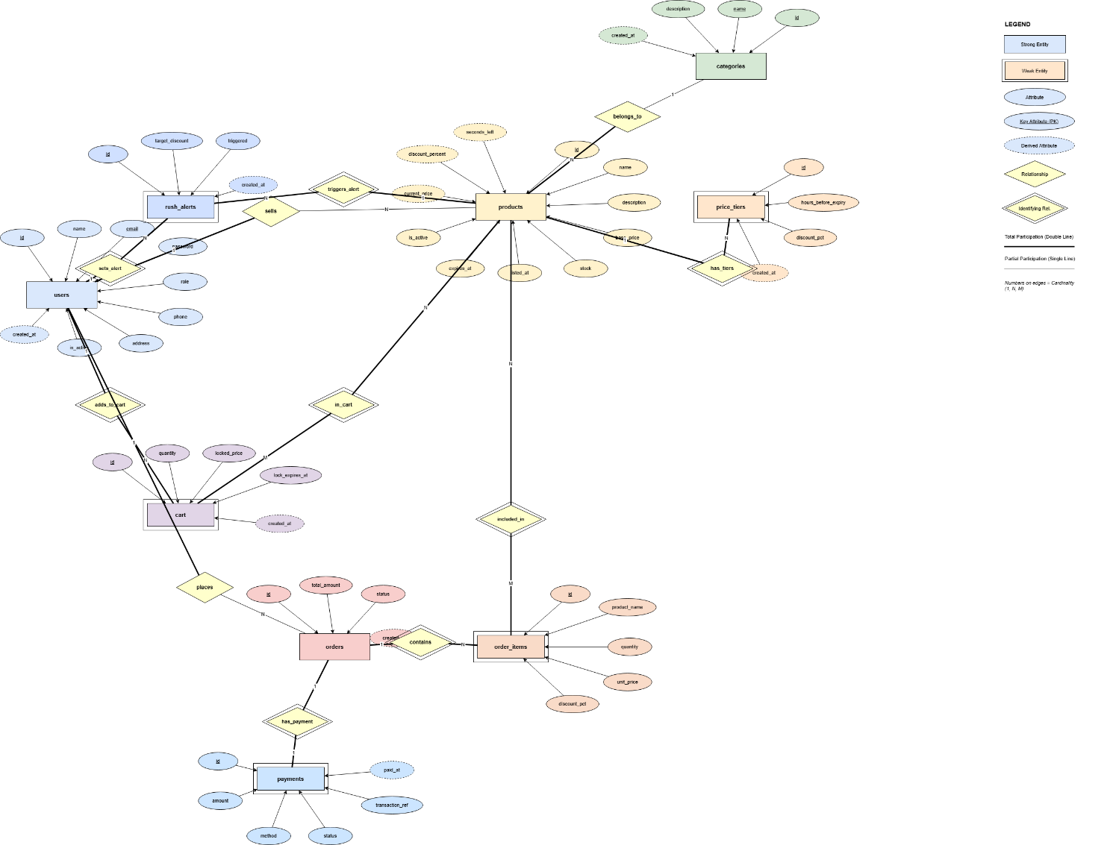

4. Problem Analysis

4.1 Core Problem Statement
Food retailers in Pakistan face a recurring dilemma: as perishable products approach their expiry date, their commercial value drops to zero — yet the physical product remains safe and nutritious for consumption. Without a systematic mechanism to dynamically reduce prices and notify interested buyers, retailers are left with two options: donate the stock (at a logistical cost) or dispose of it as waste.
Simultaneously, cost-sensitive consumers have no reliable platform to discover and purchase near-expiry goods in real time. Manually browsed discount sections in supermarkets are inconsistent and not time-aware.

4.2 Problem Decomposition
Problem | Impact | Database Solution
No real-time pricing | Products expire unsold | Computed view (active_products) with TIMESTAMPDIFF formula
No inventory awareness | Overselling / stock mismatch | FOR UPDATE lock + stock check in place_order procedure
Price changes between add-to-cart and checkout | Buyer pays wrong price | locked_price + lock_expires_at in cart table
No alert system | Buyers miss target discounts | rush_alerts table with is_triggered flag
No revenue visibility for admin | Cannot measure platform success | get_revenue_report stored procedure with GROUP BY date

4.3 Data Flow Analysis
The system can be described through three primary data flows:
- Product Listing Flow: Seller adds product → stored in products table → active_products view computes live price using listing time and expiry time → API endpoint serves JSON to frontend.
- Purchase Flow: Customer adds to cart → price locked in cart.locked_price → place_order procedure validates locks, checks stock, deducts inventory, records order and payment atomically → cart cleared on success.
- Alert Flow: Customer sets target discount threshold → rush_alerts row created → background check (or page load) compares live discount_percent → alert triggered when threshold met.

4.4 normalization
Normalization Process Documentation (UNF → BCNF)

Starting Point: Unnormalized Form (UNF)
Initial structure combining all data into flat tables:
FLAT_ORDER:
FLAT_ORDER(
order_id, customer_name, customer_email, customer_phone, customer_address,
product_id, product_name, category_name, seller_name, base_price,
unit_price, discount_pct, quantity,
tier_1_hours, tier_1_disc, tier_2_hours, tier_2_disc, tier_3_hours, tier_3_disc,
payment_method, payment_status, payment_ref, order_status, order_date
)
FLAT_USER:
FLAT_USER(
user_id, user_name, user_email, password, role, phone, address,
alert_product_1, alert_disc_1, alert_triggered_1,
alert_product_2, alert_disc_2, alert_triggered_2
)
Issues observed: repeating groups (price tiers and alerts), redundant customer data, and lack of a proper primary key for orders.

Step 1 — First Normal Form (1NF)
Fixing repeating groups and ensuring atomic attributes.
Transformations:
1. Extract price tiers:
PRICE_TIERS(id, product_id, hours_before_expiry, discount_pct)
2. Extract alert subscriptions:
RUSH_ALERTS(id, user_id, product_id, target_discount, triggered)
3. Separate order data:
ORDER_ITEMS(id, order_id, product_id, product_name, category_name, seller_name, quantity, unit_price, discount_pct)
ORDERS(id, customer_id, customer_name, customer_email, customer_phone, total_amount, status, created_at)
PAYMENTS(id, order_id, amount, method, status, transaction_ref, paid_at)

Step 2 — Second Normal Form (2NF)
Removing partial dependencies from composite keys.
Issue: product-related attributes depended only on product_id.
Fix: move product details to PRODUCTS table:
PRODUCTS(id, name, category_id, seller_id, base_price, stock, listed_at, expires_at, is_active)
ORDER_ITEMS(id, order_id, product_id, quantity, unit_price, discount_pct)

Step 3 — Third Normal Form (3NF)
Removing transitive dependencies.
Fixing ORDERS (customer details moved to USERS):
ORDERS(id, customer_id, total_amount, status, created_at)
USERS(id, name, email, phone, address, role, password)
Fixing PRODUCTS (category and seller separation):
CATEGORIES(id, name, description, created_at)
PRODUCTS(id, seller_id, category_id, name, description, base_price, stock, listed_at, expires_at, is_active)

Step 4 — BCNF
All tables were checked to ensure that every functional dependency has a superkey as determinant. No structural changes were required beyond 3NF.

Intentional Denormalization
The ORDER_ITEMS table includes product_name as a snapshot to preserve historical accuracy of orders. Although this introduces a dependency (product_id → product_name), it is acceptable because the table is insert-only.

Final Schema
USERS(id, name, email, password, role, phone, address, is_active, created_at)
CATEGORIES(id, name, description, created_at)
PRODUCTS(id, seller_id, category_id, name, description, base_price, stock, listed_at, expires_at, is_active)
PRICE_TIERS(id, product_id, hours_before_expiry, discount_pct, created_at)
CART(id, customer_id, product_id, quantity, locked_price, lock_expires_at, created_at)
ORDERS(id, customer_id, total_amount, status, created_at)
ORDER_ITEMS(id, order_id, product_id, product_name, quantity, unit_price, discount_pct)
PAYMENTS(id, order_id, amount, method, status, transaction_ref, paid_at)
RUSH_ALERTS(id, user_id, product_id, target_discount, triggered, created_at)

5. Solution Design

5.1 Architecture Overview
Expiry Rush follows a classic three-tier architecture:
- Presentation Tier: HTML/PHP templates styled with Bootstrap 5; JavaScript handles countdowns and AJAX price refreshes.
- Application Tier: PHP scripts handle session management, role-based routing, form processing, and call stored procedures.
- Data Tier: MySQL database with 9 tables, 3 views, 3 stored procedures, and a dynamic pricing engine in SQL.

5.2 Database Schema

Tables
Table | Rows (Seeded) | Purpose
users | 3 demo + registrations | Stores all user accounts with role (customer/seller/admin)
categories | 8 | Product categories (Dairy, Bakery, Fruits, etc.)
products | 10 demo | Product listings with base price, stock, and expiry datetime
price_tiers | Optional | Custom discount schedules (override formula per product)
cart | Dynamic | Active cart items with locked price and 10-min lock expiry
orders | Dynamic | Order header with customer, total, and status
order_items | Dynamic | Line items per order with unit price and discount applied
payments | Dynamic | Payment record per order (method, status, transaction ref)
rush_alerts | Dynamic | Customer-defined discount threshold alerts per product

Views
View | Description
active_products | All in-stock, non-expired products with live discount_percent and current_price computed via TIMESTAMPDIFF formula
expiring_soon | Subset of active_products expiring within the next 120 minutes, ordered by urgency
order_summaries | Joined view of orders, users, payments, and order item count for admin/seller dashboards

Stored Procedures
Procedure | Called By | Key Logic
place_order(customer_id, method) | Customer checkout | BEGIN TRANSACTION → validate cart locks → check stock (FOR UPDATE) → insert order + items → deduct stock → insert payment → COMMIT or ROLLBACK
upsert_product(id, seller_id, ...) | Seller product form | INSERT if id=0 (new product), UPDATE if id>0 (edit) — enforces seller_id ownership
get_revenue_report(days) | Admin reports | Aggregates completed orders by date for last N days — returns daily revenue, order count, item count, avg order value

5.3 Dynamic Pricing Formula
The pricing engine is implemented entirely in SQL within the active_products view:
discount_percent = GREATEST(0, LEAST(90,
ROUND((1 - (seconds_remaining / total_product_lifespan_seconds)) * 90)
))
current_price = base_price × (1 - discount_percent / 100)
This formula ensures: (a) 0% discount when first listed, (b) a smooth linear progression to 90% as expiry approaches, (c) hard limits via GREATEST/LEAST to prevent negative or over-100% values.

5.4 Cart Price Locking
When a customer adds a product to their cart, the current price is captured in cart.locked_price and a cart.lock_expires_at timestamp is set 10 minutes in the future. During the place_order procedure, if any cart lock has expired, the transaction is rolled back and the customer is prompted to refresh their cart — preventing them from purchasing at a stale (too-low) price.

5.5 Project File Structure
Directory / File | Purpose
index.php | Login and registration page (public entry point)
config/db.php | Database connection, app constants (DB credentials, CART_LOCK_MINUTES)
includes/auth.php | Session management, role checks, price calculation helpers
includes/header.php / footer.php | Shared navigation and page chrome
customer/browse.php | Product browsing with live timers, filters, sort
customer/cart.php + cart_action.php | Cart view and add/remove/clear cart actions
customer/checkout.php | Calls place_order stored procedure; displays result
customer/orders.php + order_detail.php | Order history and individual order view
customer/alerts.php | Rush Alerts management
seller/dashboard.php + products.php | Seller stats overview and product listing
seller/product_save.php | Calls upsert_product stored procedure
seller/orders.php | Orders containing seller's products
admin/dashboard.php + reports.php | Platform-wide dashboard and revenue reports
admin/users.php + categories.php | User and category management
api/price.php | JSON endpoint for JavaScript live price/discount updates
assets/css/style.css | Custom stylesheet (dark theme, card layouts)
assets/js/app.js | Countdown timers, Fetch-based live price refresh

6. Implementation & Testing Phase

6.1 Development Phases

Phase 1 — Database Design (Week 1–2)
- Drafted ERD by hand; identified all entities and relationships
- Wrote and tested database.sql: tables, foreign keys, views, stored procedures
- Populated seed data with 3 demo users, 8 categories, 10 sample products

Phase 2 — Backend Development (Week 2–3)
- Set up XAMPP environment; configured config/db.php
- Built authentication system: login, registration, session management, role-based redirect
- Implemented customer module: browse, cart, checkout, orders, alerts
- Implemented seller module: dashboard, product management, order view
- Implemented admin module: user management, category management, revenue reports

Phase 3 — Frontend & Integration (Week 3–4)
- Styled all pages with Bootstrap 5 and custom CSS (dark theme, countdown cards)
- Built JavaScript countdown timers with AJAX price refresh (api/price.php)
- Tested full purchase flow end-to-end
- Wrote README.md setup guide; created fix_passwords.sql utility

6.2 Testing

6.2a Unit Testing — Database Objects
Test Case | Input | Expected Output | Result
active_products view | Product with expires_at 4 hrs from now, listed 20 hrs ago | ~83% discount, price = base × 0.17 | PASS
expiring_soon view | Filter active products | Only products with minutes_remaining ≤ 120 | PASS
place_order — success | Valid cart, unlocked prices, sufficient stock | Order created, stock deducted, cart cleared, payment recorded | PASS
place_order — expired lock | Cart item with lock_expires_at in the past | ROLLBACK; result = 'ERROR: Cart lock expired' | PASS
place_order — insufficient stock | Quantity requested > stock available | ROLLBACK; result = 'ERROR: Insufficient stock' | PASS
upsert_product — insert | p_id = 0, valid seller_id | New product row created; p_result_id = new id | PASS
upsert_product — update | p_id = existing, matching seller_id | Row updated; p_result_id = same id | PASS
get_revenue_report | p_days = 7 | One row per day with revenue, order count, items sold | PASS

6.2b Integration Testing — User Flows
Flow | Steps | Result
Customer Registration | Visit index.php → Register tab → submit form → redirected to browse.php | PASS
Login (all 3 roles) | Submit demo credentials → redirect to correct dashboard | PASS
Add to Cart | Browse product → Add to Cart → verify locked_price and lock_expires_at in DB | PASS
Checkout | Proceed to checkout → select payment method → submit → order created, stock reduced | PASS
Seller adds product | Login as seller → Add Product form → submit → product appears in browse | PASS
Admin revenue report | Login as admin → Reports → enter days → table shows daily breakdown | PASS
Price refresh | Leave browse.php open for 30s → prices update without page reload | PASS

6.3 Screenshots — Implementation
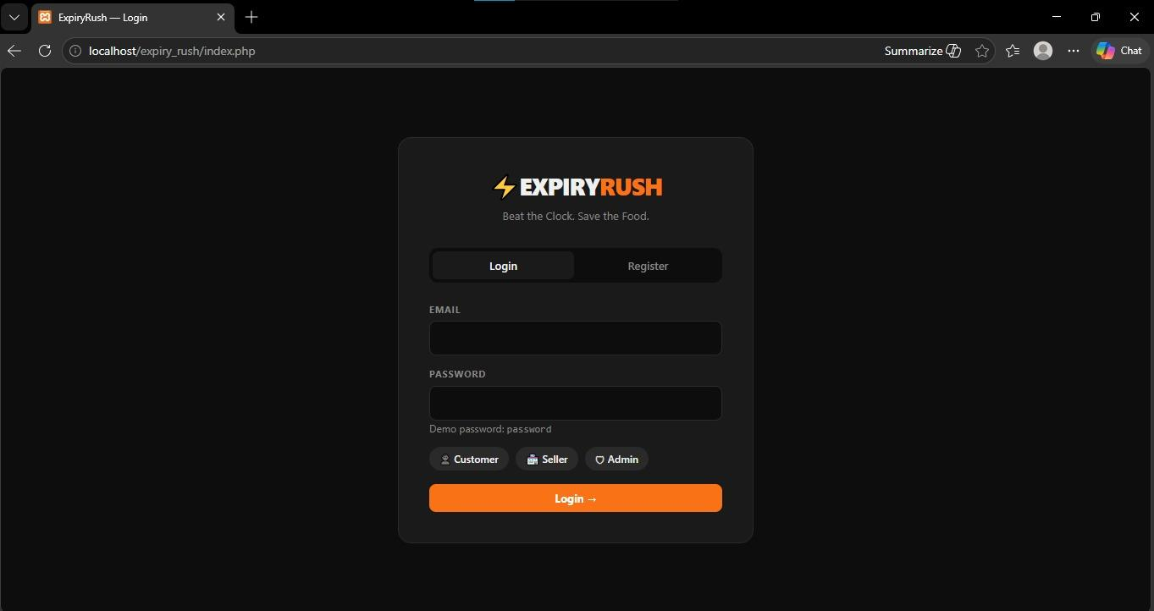

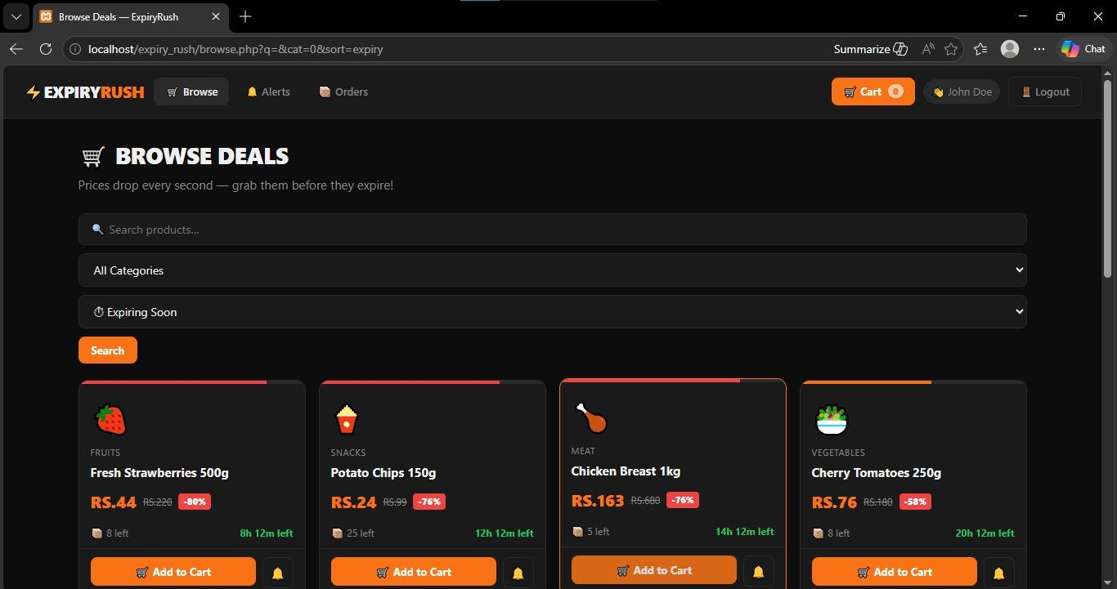

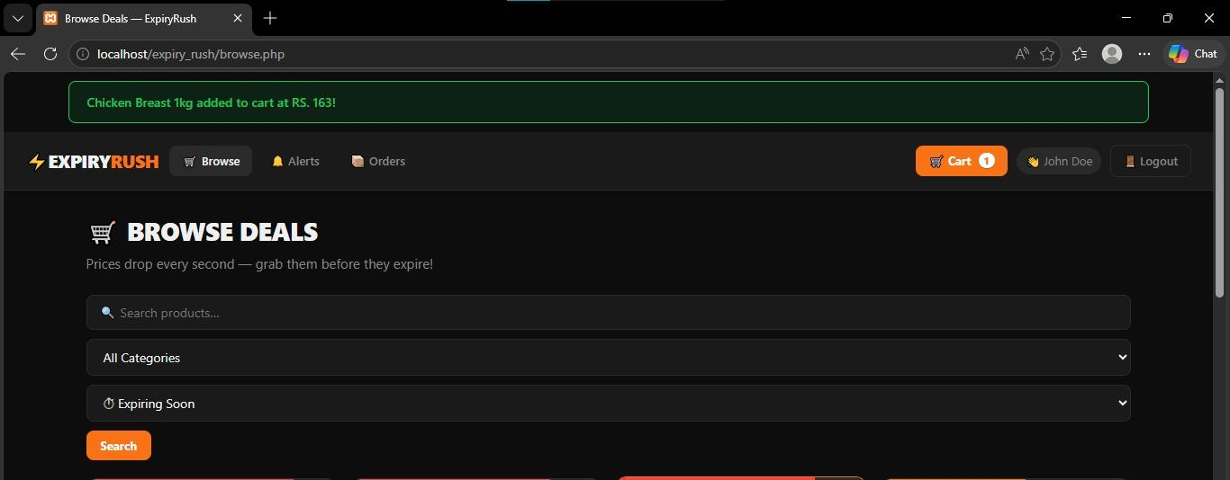

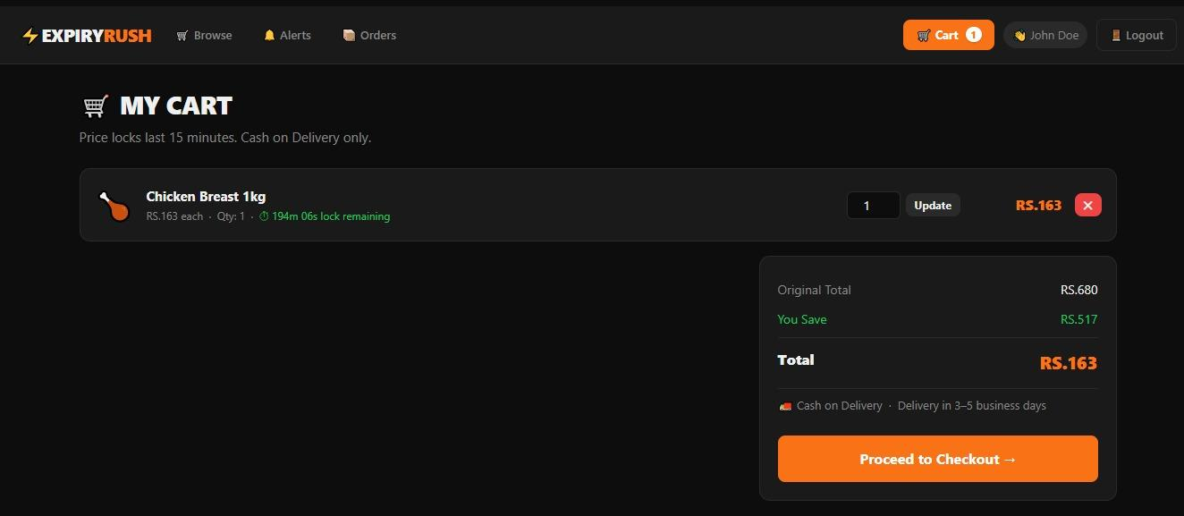

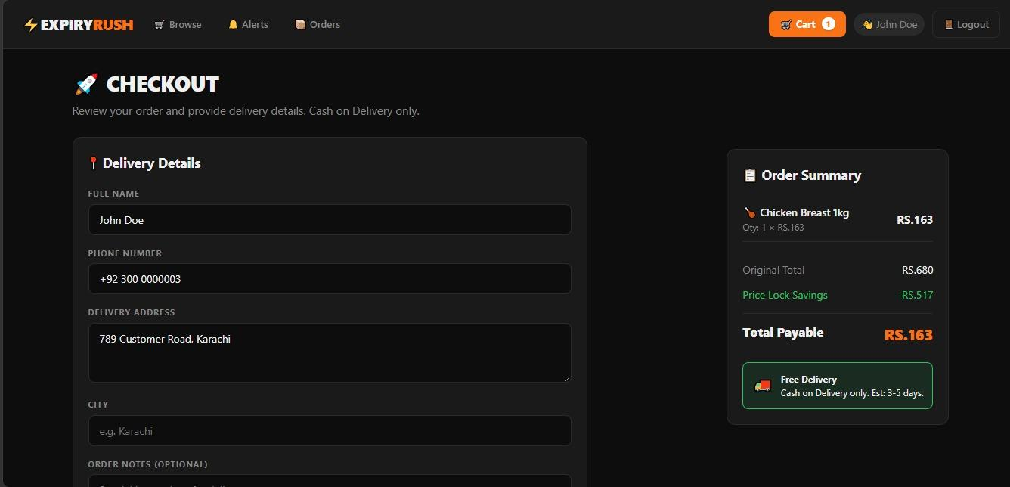

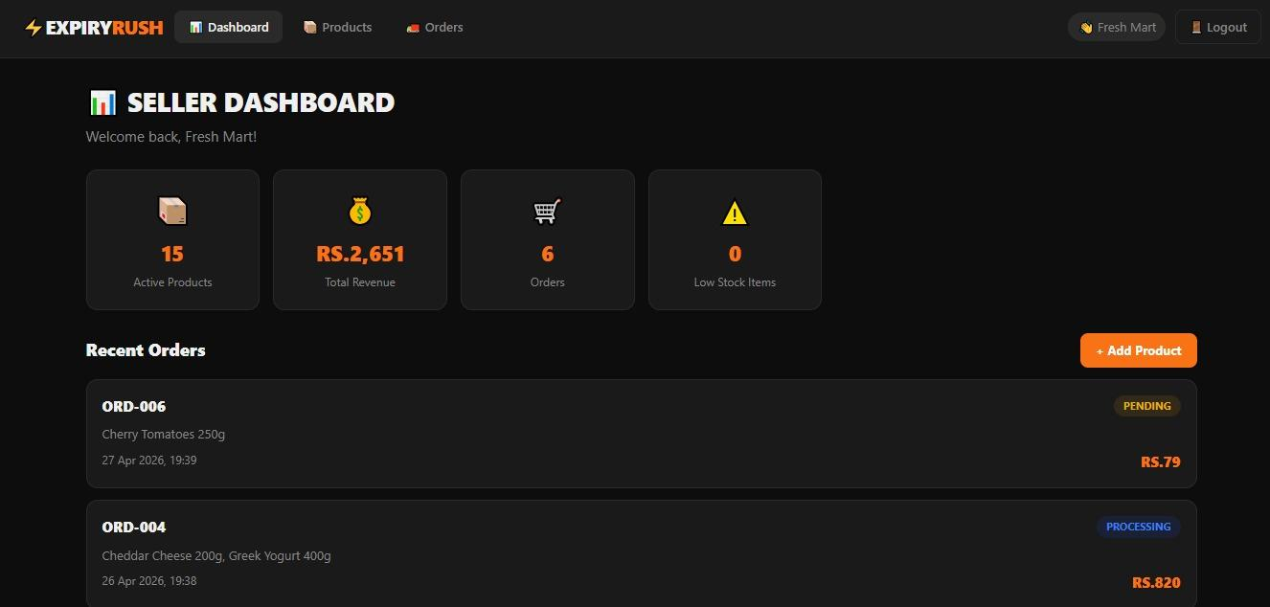

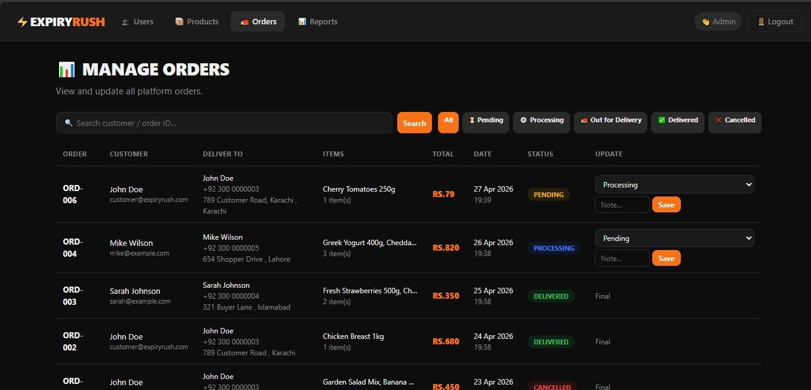

7. Project Breakdown Structure (Workload Distribution & Timeline)

7.1 Timeline
Week | Dates (Approx.) | Milestone
Week 1 | Apr 1–7 | Project brainstorming, topic selection, hand-drawn ERD, schema design
Week 2 | Apr 8–14 | database.sql implementation (tables, views, procedures), seed data, testing SQL
Week 3 | Apr 15–21 | PHP backend: auth, customer module, seller module, admin module
Week 4 | Apr 22–27 | Frontend styling, JavaScript timers, integration testing, report writing, submission

7.2 Workload Distribution
Member | Role | Responsibilities
Rameen Ramzan | Database Architect | Schema design, ERD (hand + software), database.sql, views, stored procedures, testing SQL
Amna Sami | Backend Developer | PHP: auth system, customer module (browse, cart, checkout, orders, alerts)
Umama Zubair | Backend Developer | PHP: seller module (dashboard, products, orders), admin module (users, categories, reports)
 | Frontend & Docs | Bootstrap styling, CSS, JavaScript (timers, AJAX), README.md, project report
Note: All members participated in testing, code review, and the final presentation preparation.

8. Conclusion (Summary & Discussion)

8.1 Summary
Expiry Rush successfully demonstrates the power of a well-designed relational database as the backbone of a real-world web application. The project goes beyond basic CRUD operations to implement a fully functional, dynamic-pricing marketplace with the following standout database features:
- A real-time pricing engine implemented entirely in SQL using TIMESTAMPDIFF within a computed view, calculating live discounts on every query.
- Three roles managed through a single users table with an ENUM-based role discriminator and role-specific session routing.
- An ACID-compliant order placement stored procedure that enforces cart price locks, checks stock atomically using FOR UPDATE, and performs a multi-table write within a single transaction — committing on success and rolling back on any failure.
- A cart price-locking system that prevents price manipulation between browse and checkout.
- A Rush Alerts notification system allowing consumers to set target discount thresholds.
- Three database views (active_products, expiring_soon, order_summaries) that encapsulate complex joins and calculated fields for clean, reusable data access.

8.2 Discussion
The development process revealed several important lessons in practical database systems design:
- Computed views are powerful but must be used carefully — querying active_products on a table with millions of rows would require optimization (e.g., indexed computed columns or materialized views) to remain performant.
- Transaction design is non-trivial — determining the correct scope, lock granularity, and error handling for place_order required careful thought and multiple iterations.
- Database-first design paid off — by designing the schema and SQL objects before writing PHP, the application layer stayed thin and logic remained centralized in the database.
- The 10-minute cart lock is a deliberate trade-off: too short frustrates users; too long blocks stock for other buyers. In a production system, this would be configurable and surfaced clearly in the UI.

8.3 Future Enhancements
Given additional time, the following enhancements would be valuable:
- MySQL Event Scheduler: Auto-deactivate expired products (is_active = 0) via a scheduled event instead of relying on the view's WHERE clause.
- Email Notifications: Trigger real emails when rush alerts fire, using a PHP mailer or third-party API.
- Geolocation: Allow customers to browse products from stores near them, adding a location field to the sellers table.
- Seller Ratings & Reviews: An additional table capturing customer feedback per seller.
- Analytics Dashboard: Richer charts using Chart.js on the admin dashboard, powered by the get_revenue_report procedure.
- Mobile App: A React Native or Flutter frontend consuming the existing api/price.php JSON endpoint.

8.4 Final Remarks
Expiry Rush demonstrates that thoughtful database design, normalized schemas, reusable views, transactional stored procedures, and a real-time pricing formula can power a commercially relevant application that addresses genuine social and economic problems. The project meets and exceeds the requirements of CS 2005, applying all core course concepts in a unified, working system.
We hope this project inspires further exploration into how database systems can be leveraged not just for data storage, but as intelligent, active components of modern applications.

