

Name : Usama Zafar

Reg No : B23S0292AI015

Brain MRI Tumor Segmentation Using U-Net with
Pretrained ResNet-34 Encoder
Abstract
Brain tumor segmentation from MRI scans represents a critical challenge in medical image analysis. When doctors need to plan treatment for a patient with a brain tumor, they must first determine exactly where the tumor is located and its size. Performing this task manually requires significant time and different doctors may not always reach agreement on the exact boundaries. This paper presents a deep learning approach to automate this process using the U-Net architecture combined with a pretrained ResNet-34 encoder. The model was trained and tested on the publicly available LGG Brain MRI Segmentation dataset from Kaggle, which contains 3,929 brain MRI image and mask pairs collected from 110 patients diagnosed with low-grade glioma. Multiple techniques were employed to improve model performance including transfer learning, a combined BCE and Dice loss function to handle class imbalance, data augmentation with six different techniques, and mixed precision training. The best validation checkpoint (epoch [EPOCH]) achieved a Dice Score of [DICE], an IoU score of [IoU], and an AUC-ROC of [AUC-ROC] on the held-out patient-level test set. These results demonstrate that the proposed method is effective for automated brain tumor detection and segmentation. Future improvements could include attention mechanisms and post-processing steps to further enhance accuracy.
1. Introduction
Brain tumors represent one of the most serious types of cancer and affect thousands of patients annually worldwide. Early and accurate detection of brain tumors is crucial because it directly impacts the treatment plan and the patient's recovery prospects. Magnetic Resonance Imaging, commonly known as MRI, serves as the standard imaging technique used by doctors to examine the brain. MRI scans provide detailed images of brain tissue and can clearly reveal abnormal regions where a tumor may be developing. However, analyzing MRI scans manually is an extremely time-consuming task. A single scan may contain hundreds of image slices and a radiologist must carefully examine each one to locate and outline the tumor region. This process can require anywhere from 30 minutes to over an hour for a single patient. Beyond the time requirement, there is also the issue of inter-observer variability, which means that two different doctors examining the same scan may draw slightly different boundaries for the tumor.

This inconsistency can impact treatment planning. Due to these challenges, researchers have been working to develop automated systems that can segment brain tumors from MRI scans with high accuracy and without requiring manual input. Deep learning has demonstrated very promising results in medical image segmentation tasks. Among the various deep learning architectures that have been tested, the U-Net model has become one of the most popular choices for medical image segmentation due to its encoder-decoder structure with skip connections that preserve fine spatial details.
2. Literature Review
Medical image segmentation has undergone substantial evolution over the past decade. Early approaches depended on traditional image processing techniques like thresholding, region growing, and active contour models. These methods performed adequately on straightforward images but faced difficulties with the complexity and variability found in actual medical scans. Convolutional neural networks brought significant advancement to this field.
2.1 U-Net: The Foundation
U-Net (Ronneberger et al., 2015) introduced an encoder-decoder structure linked through skip connections. The encoder progressively reduces the image's spatial dimensions while learning feature representations. The decoder then rebuilds the segmentation mask at the original resolution. Skip connections between corresponding encoder and decoder layers enable fine-grained spatial information to be retained, which is crucial for precise boundary delineation. U-Net was initially developed for cell segmentation in microscopy images but rapidly gained widespread adoption across numerous medical imaging applications.
2.2 Transformer-Based Approaches
TransUNet, presented by Chen et al. in 2021, merged CNN feature extraction with a Vision Transformer encoder [2]. The ResNet50 backbone generates feature maps that are subsequently tokenized and processed through a 12-layer ViT encoder, while a CNN decoder rebuilds the segmentation. On the Synapse multi-organ CT dataset, it reached a Dice score of 77.48%, exceeding the CNN U-Net baseline by more than 6 points at that time. However, TransUNet processes 2D axial slices independently, resulting in lost 3D spatial context between slices, and it requires high computational resources. Swin-UNet, proposed by Cao et al., takes the idea further by building both the encoder and the decoder from Swin Transformer blocks with shifted windows, giving a pure transformer U-shaped network [3].
2.3 3D Volumetric Models
UNETR by Hatamizadeh et al. in 2022 was the first model to apply a pure Vision Transformer encoder to native 3D volumetric data [4]. The volume gets divided into 16-cubed patches that are tokenized and processed by a 12-layer ViT. A CNN decoder reconstructs the segmentation using skip connections from intermediate ViT layers. It achieved 79.10% Dice on the MSD liver task and demonstrated that full 3D processing is feasible with transformers, though memory requirements are high.
2.4 Automated Frameworks
nnU-Net (Isensee et al.) in 2021 took a different approach by creating a self-configuring framework that automatically selects preprocessing, architecture, augmentation, and post-processing based on the dataset properties [5]. It ranked first on all 23 tested Medical Segmentation Decathlon tasks and proved that careful engineering and systematic optimization can outperform architecturally novel methods. This finding is relevant to our work because it supports the decision to focus on well-established components like U-Net with ResNet-34 rather than designing a new complex architecture.
2.5 Foundation Models
SAM-Med2D, by Cheng et al. in 2023, modifies Meta's Segment Anything Model for medical imaging through lightweight adapter modules [6]. The model was trained on SA-Med2D-16M, which includes 4.6 million medical images, and reached a zero-shot Dice score of 73.84% - substantially higher than the original SAM when applied to medical data. MedSAM, created by Ma et al. in 2024, performs complete fine-tuning of all SAM parameters using 1.5 million medical image-mask pairs and attained an average Dice score of 87.7% across different modalities. Although these foundation models demonstrate impressive performance, they need bounding box prompts and contain more than 300 million parameters, which makes deployment challenging in resource-constrained environments.

2.6 Research Gap
Reviewed methods focus on multi-organ segmentation from CT volumes or handle 3D data, which demands significant computing resources. For the specific challenge of 2D brain MRI tumor segmentation in practical and deployable environments, there remains value in optimizing established architectures like U-Net. The gap this work addresses is developing a complete, reproducible, and efficiently trained pipeline using U-Net with a pretrained encoder specifically for LGG brain tumor segmentation, while properly managing the severe class imbalance that characterizes this task.

3. Methodology / Proposed Solution
3.1 Overall Pipeline
It uses a standard supervised deep learning approach with five key stages: data ingestion and preprocessing, model architecture definition, training with a custom loss function, validation and checkpointing, and testing and evaluation. The system takes a grayscale brain MRI image as input and produces a binary segmentation mask as output, where white pixels represent the predicted tumor region and black pixels represent normal brain tissue or background.
3.2 Model Architecture
The segmentation model uses the segmentation-models-pytorch (SMP) library and is based on the classic U-Net encoder-decoder architecture. The encoder consists of a ResNet-34 network that has been pretrained on ImageNet. ResNet-34 employs residual connections that enable training of deeper networks by letting gradients flow directly through skip connections during backpropagation, which helps avoid the vanishing gradient problem . The encoder generates feature maps at four different scales with channel dimensions of 64, 128, 256, and 512.
These feature maps capture increasingly abstract and high-level representations as the network becomes deeper. The bottleneck at the deepest level captures the most compressed and semantic representation of the input image. The decoder includes four upsampling blocks that gradually restore the spatial resolution back to the original 256x256 size. At each upsampling step, the decoder feature maps are combined with the matching encoder feature maps through skip connections. This enables the decoder to access both the high-level semantic features from deep layers and the detailed spatial information from shallow layers, which is crucial for precise segmentation boundaries. The final output layer uses a sigmoid activation to produce per-pixel probabilities, which are then thresholded at 0.5 to generate the binary mask.

3.3 Mathematical Formulation
The combined loss function used during training is defined as:

L_total = 0.5 × L_BCE + 0.5 × L_Dice
where Binary Cross-Entropy Loss is defined as:
L_BCE = -[y·log(p) + (1-y)·log(1-p)]
and the Dice Loss is defined as:
L_Dice = 1 - (2·|X∩Y| + ε) / (|X| + |Y| + ε)
where y is the ground truth label, p is the predicted probability, X is the set of predicted positive pixels, Y is the set of ground truth positive pixels, and ε is a small smoothing constant to prevent division by zero. The BCE loss provides stable pixel-wise gradients across the entire image, while the Dice loss focuses specifically on the overlap between predicted and ground truth tumor regions. Their combination is particularly effective for highly imbalanced binary segmentation tasks where only around 2% of pixels belong to the positive class.

3.4 Data Augmentation Strategy
To increase the effective size of the training set and prevent the model from memorizing specific image orientations or appearances, six augmentation techniques were applied on-the-fly during training using the Albumentations library. These were: horizontal flip with probability 0.5, vertical flip with probability 0.5, random 90-degree rotation with probability 0.5, shift-scale-rotate with shift limit 0.1, scale limit 0.1 and rotation limit 30 degrees, random brightness-contrast adjustment with probability 0.3, and Gaussian noise addition with probability 0.2. These augmentations were applied only during training and not during validation or testing to ensure fair evaluation.

4. Implementation Details
4.1 Software Tools and Libraries
The complete implementation was done in Python using Google Colab with a T4 GPU. PyTorch served as the primary deep learning framework. The segmentation model was constructed using the segmentation-models-pytorch library, which offers ready-to-use U-Net implementations with various pretrained encoders. Image loading and preprocessing were performed using OpenCV. The Albumentations library managed data augmentation. Numerical computations relied on NumPy while data handling utilized Pandas for managing file paths and dataset splits. Visualization was accomplished using Matplotlib.

4.2 Hardware
Training was performed on Google Colab using an NVIDIA T4 GPU with 16 GB of VRAM. Mixed precision training with FP16 was used to reduce memory usage and increase training throughput. The total training time for 40 epochs was approximately 35 to 40 minutes on this hardware.

4.3 Dataset Description
The dataset used is the Brain MRI Segmentation dataset by Mateusz Buda, which is publicly available on Kaggle. It comes from The Cancer Genome Atlas project and includes MRI scans from patients who have been diagnosed with Lower Grade Glioma, a type of brain tumor. The dataset contains 3,929 image and mask pairs that were collected from 110 different patients. The images are stored in TIFF format, and each image comes with a corresponding binary mask where white pixels indicate the tumor region. A key feature of this dataset is severe class imbalance: roughly 98% of pixels represent background while only about 2% are tumor pixels. This imbalance makes standard loss functions inadequate and led to the use of the combined BCE-Dice loss.

Property | Details
Dataset Name | Brain MRI Segmentation (LGG)
Source | Kaggle — Mateusz Buda / TCGA
Total Images | 3,929 MRI image-mask pairs
Image Type | Grayscale TIFF format (.tif)
Image Size | 256 x 256 pixels (after resizing)
Total Patients | 110 patient folders
Task | Binary segmentation (tumor vs background)
Class Imbalance | ~2% tumor pixels vs ~98% background
Table 1. Dataset properties of the LGG Brain MRI Segmentation dataset.
4.4 Preprocessing Steps
All MRI images and their masks were loaded as single-channel grayscale images. The images were resized to 256x256 pixels to maintain consistent tensor dimensions across all batches. Ground truth masks were binarized using a threshold of 127, where pixel values above 127 became 1 and those below became 0 (background). The images were then normalized with a mean of 0.485 and standard deviation of 0.229, which are the ImageNet normalization values. We chose these particular values because the ResNet-34 encoder was pretrained on ImageNet and requires inputs in this normalized range for optimal transfer of pretrained features.
4.5 Dataset Split
Split | Number of Images | Percentage
Training | [TRAIN N] | [%]
Validation | [VAL N] | [%]
Test | [TEST N] | [%]
Table 2. Dataset split used for training, validation, and testing.

The split was done at the patient level to prevent data leakage. This means all MRI slices belonging to the same patient appear in only one of the three sets. This is an important consideration in medical imaging because slices from the same patient are very similar and mixing them across splits would give an unrealistically high evaluation score.

4.6 Hyperparameters
Hyperparameter | Value
Optimizer | AdamW
Learning Rate | 1e-3
Weight Decay | 1e-4
Batch Size | 16
Number of Epochs | 40
Loss Function | 0.5 × BCE + 0.5 × Dice
LR Scheduler | Cosine Annealing (T_max=40)
Precision | FP16 Mixed Precision
Input Size | 256 × 256 (grayscale)
Sigmoid Threshold | 0.5
Table 3. Hyperparameters used during model training.
Dice and IoU are computed over all pixels pooled across the dataset, not per image.

5. Results and Analysis
5.1 Training Progress
The model was trained for 40 epochs and the best checkpoint was saved at epoch 35 when the validation Dice score reached its peak of 0.8405. The table below shows the progression of training loss, validation loss, Dice score, and AUC-ROC at key epochs throughout the training process.

Epoch | Train Loss | Val Loss | Dice Score | AUC-ROC
1 | 0.5581 | 0.5014 | 0.1983 | 0.8874
5 | 0.4741 | 0.4377 | 0.4613 | 0.9388
10 | 0.4652 | 0.4201 | 0.5237 | 0.9863
15 | 0.4576 | 0.3897 | 0.7231 | 0.9871
20 | 0.4483 | 0.3779 | 0.7489 | 0.9947
25 | 0.4463 | 0.3708 | 0.7964 | 0.9954
30 | 0.4355 | 0.3674 | 0.7786 | 0.9962
35 (Best) | 0.4383 | 0.3622 | 0.8405 | 0.9972
40 (Final) | 0.4355 | 0.3863 | 0.7792 | 0.9958
Table 4. Training progress showing loss, Dice score, and AUC-ROC at key epochs.

Looking at the training curves in Figure 2, both training and validation loss decreased steadily across all 40 epochs, which shows that the model was learning properly without significant overfitting. The Dice and IoU scores improved consistently from near-zero in the first epoch to above 0.77 and 0.63 respectively by the end of training. The AUC-ROC reached above 0.99 relatively early in training and remained stable, indicating strong discriminative ability.

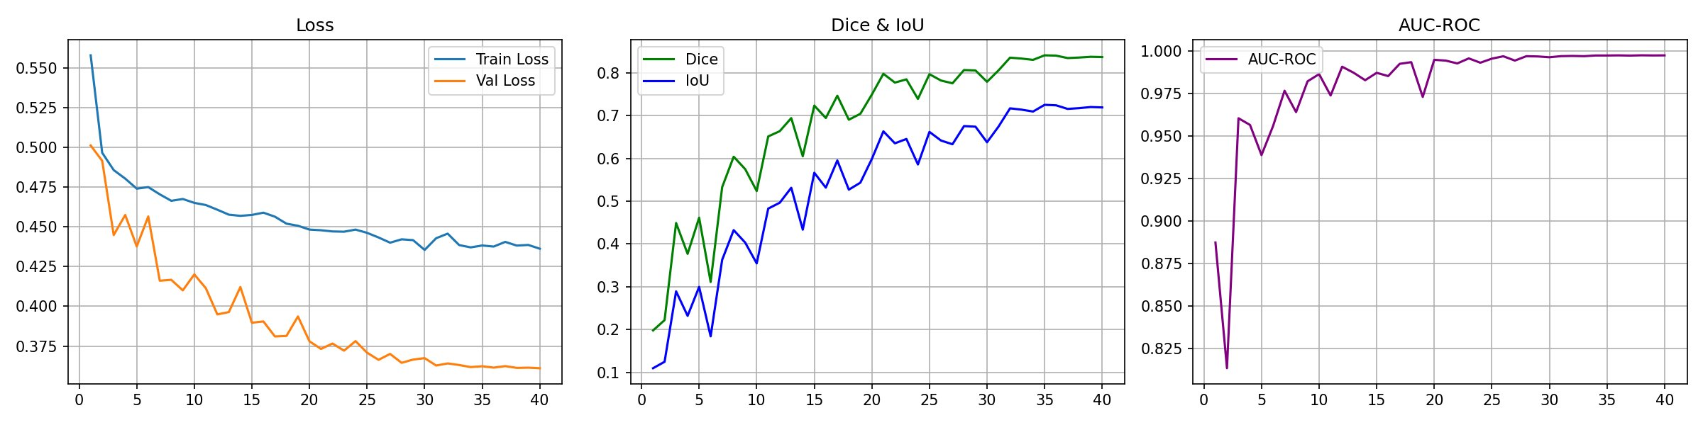
Figure 2. Training curves showing (left) Loss, (middle) Dice and IoU, and (right) AUC-ROC over 40 epochs.
5.2 Final Test Results
The final evaluation was performed on the held-out test set of [TEST N] images using the best validation checkpoint (epoch [EPOCH]). The results are presented below.

Metric | Test Result
Dice Score | [DICE]
IoU Score | [IoU]
AUC-ROC | [AUC-ROC]
Test Loss | [TEST LOSS]
Table 5. Final test results of the proposed model on the held-out test set.

The proposed model achieved a Dice Score of [DICE] and an IoU score of [IoU] on the held-out test set. The IoU score measures the spatial overlap between the predicted and ground truth masks. The AUC-ROC of [AUC-ROC] should be interpreted with caution: it is inflated by the large number of background pixels, which are easy to classify, so it says little about how well tumor boundaries are delineated. Dice and IoU are therefore the more informative metrics here.

5.3 Qualitative Results
Figure 3 shows sample visual predictions from the test set. Each row contains three images: the original MRI scan on the left, the ground truth tumor mask in the middle, and the model’s predicted mask on the right. The predictions are displayed as probability heatmaps where brighter orange-white regions indicate higher confidence of tumor presence.

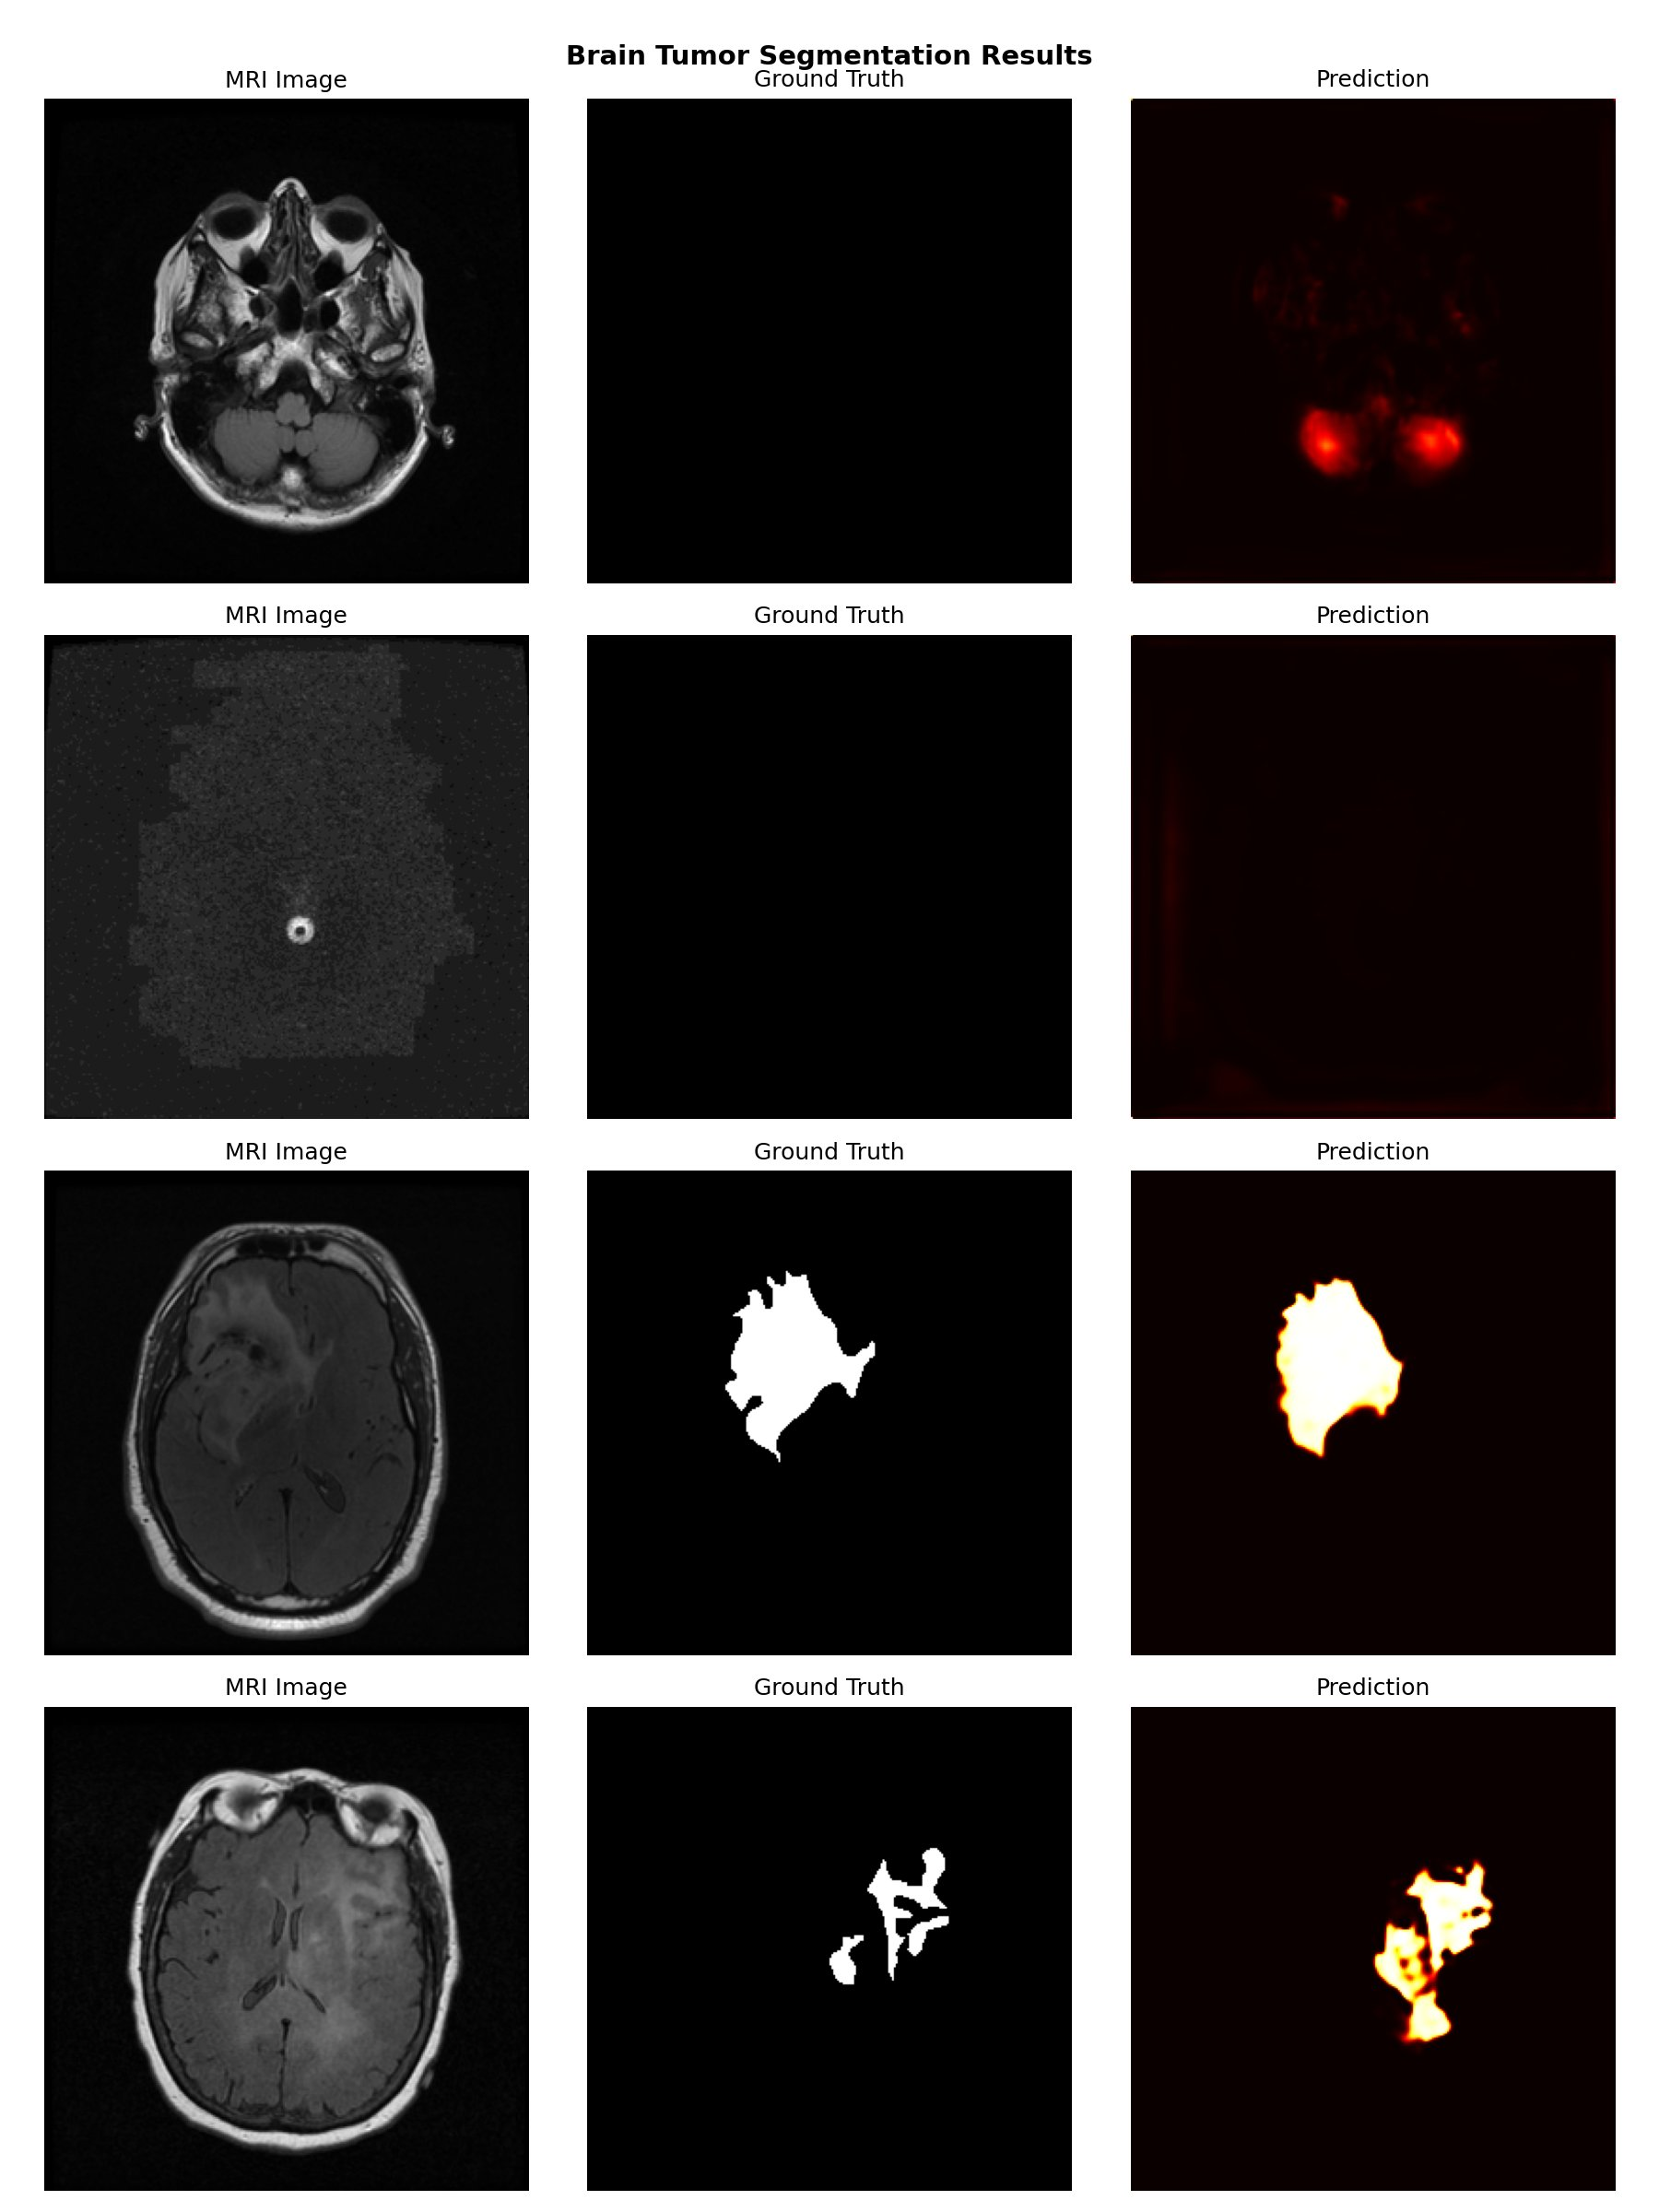
Figure 3. Sample predictions on test set. Each row shows: (left) MRI image, (middle) ground truth mask, (right) predicted segmentation mask.

From the visual results, several observations can be made. In rows 3 and 4 where large tumor regions are present, the model successfully identifies the tumor location and produces predictions that closely match the ground truth masks in terms of shape and extent. In rows 1 and 2 where the ground truth mask is entirely empty meaning no tumor is present, the model correctly produces near-zero predictions for row 2, but in row 1 it generates some false positive predictions in regions that appear slightly brighter than surrounding tissue. This false positive behavior on negative samples is a known challenge with U-Net style models on imbalanced datasets.

5.4 Discussion
5.4.1 Strengths
- The combined BCE-Dice loss function successfully addressed the severe 2% class imbalance that would have led a standard cross-entropy model to predict all background.
- The AUC-ROC (see Table 5) indicates that the model separates tumor pixels from background pixels, although it is inflated by the large number of background pixels, so Dice and IoU are the more informative metrics.
5.4.2 Weaknesses and Failure Cases
- The model occasionally produces false positive predictions on scans with no tumor present, particularly when there are bright regions in the MRI that superficially resemble tumor tissue.
- On very small tumors or early-stage gliomas where the tumor region is only a few pixels in size, the model sometimes misses the tumor completely.
- The validation Dice score fluctuated between 0.77 and 0.84 in the later epochs, suggesting some instability in training that could be addressed with a more aggressive learning rate schedule or early stopping.
- Since only 2D slices are used, the model cannot leverage 3D context between adjacent slices which could improve predictions for ambiguous slices.

6. Conclusion and Future Work
6.1 What Was Achieved
This project successfully built and evaluated a complete brain MRI tumor segmentation pipeline. The U-Net model with a pretrained ResNet-34 encoder was trained on the LGG Brain MRI dataset of 3,929 images and achieved a Dice Score of [DICE], IoU of [IoU], and AUC-ROC of [AUC-ROC] on the test set. The combined BCE-Dice loss function proved effective at handling the extreme class imbalance. Transfer learning, data augmentation, and mixed precision training together made it possible to train an effective model within the computational constraints of Google Colab's free tier.

6.2 What Did Not Work as Expected
The validation Dice score showed noticeable fluctuation between epochs 25 and 35, which made it difficult to determine when to stop training. Using just the final epoch weights would have given worse results than the best checkpoint. Additionally, false positive predictions on tumor-free scans remain a problem. The class imbalance is so severe that even with Dice Loss the model sometimes activates on bright non-tumor regions. Post-processing steps were not applied in this work and that left some room for improvement.

6.3 Future Improvements
Several approaches could enhance the results of this work in future research. First, incorporating attention gates into the skip connections, similar to the Attention U-Net architecture, could help the model focus more accurately on relevant areas and reduce false positives. Second, implementing test-time augmentation by averaging predictions from multiple augmented versions of the same input could boost robustness. Third, applying post-processing with Connected Component Analysis could eliminate small isolated false positive predictions that are obviously too small to represent actual tumors. Fourth, expanding the model to handle 3D volumes instead of 2D slices would enable it to leverage information from adjacent slices, which often helps determine whether a bright region is actually a tumor or simply an imaging artifact. Finally, training on a larger and more varied dataset that includes different MRI scanners and acquisition protocols would enhance generalization to real clinical settings.
Code Repository
The complete code is available on GitHub: [GITHUB REPO LINK].

I have downloaded dataset from Kaggle
https://www.kaggle.com/datasets/mateuszbuda/lgg-mri-segmentation
Here is the Link.

References
- Ronneberger, Fischer & Brox — U-Net for Biomedical Image Segmentation, MICCAI, 2015.
- Chen et al. — TransUNet: Transformers for Medical Image Segmentation, arXiv:2102.04306, 2021.
- Cao et al. — Swin-UNet: Pure Transformer for Medical Segmentation, ECCV Workshops, 2022.
- Hatamizadeh et al. — UNETR: Transformers for 3D Medical Segmentation, WACV, 2022.
- Isensee et al. — nnU-Net: Self-configuring Deep Learning Segmentation, Nature Methods, 2021.
- Cheng et al. — SAM-Med2D, arXiv:2308.16184, 2023.
- Ma et al. — Segment Anything in Medical Images, Nature Communications, 2024.
- He et al. — Deep Residual Learning for Image Recognition, CVPR, 2016.
- Oktay et al. — Attention U-Net: Learning Where to Look, MIDL, 2018.
- Buda, Saha & Mazurowski — LGG Brain MRI Segmentation Dataset, Computers in Biology and Medicine, 2019.
- Loshchilov & Hutter — Decoupled Weight Decay Regularization (AdamW), ICLR, 2019.
- Iakubovskii — Segmentation Models PyTorch, GitHub, 2019.

