AERIAL OBJECT DETECTION USING YOLO11n
ON THE VISDRONE2019 BENCHMARK
Semester Project Report
CSC354 — Machine Learning
Department of Computer Science
Submitted by: Uzair
COMSATS University Islamabad, Abbottabad Campus
July 2026

Abstract
Object detection from unmanned aerial vehicle (UAV) imagery presents challenges distinct from ground-level computer vision: targets are frequently tiny, densely packed, and heavily occluded. This project fine-tunes YOLO11n, a single-stage anchor-free detector, on the VisDrone2019-DET benchmark to detect ten categories of pedestrians and vehicles in aerial scenes. The model was trained for 100 epochs on a Google Colab T4 GPU (4.84 GPU-hours) and evaluated using mAP@50, mAP@50-95, precision, recall, F1-score, and inference speed (FPS). The trained model achieved an mAP@50 of 32.4%, mAP@50-95 of 18.4%, precision of 44.9%, recall of 34.7%, an F1-score of 39.1%, and real-time inference at 65.0 FPS. Per-class analysis shows strong performance on large, common classes such as car (75.0% AP@50) and weak performance on rare, small classes such as bicycle (8.5% AP@50) and awning-tricycle (10.5% AP@50), highlighting the combined effect of class imbalance and object scale on detection quality. As a novelty contribution, Slicing Aided Hyper Inference (SAHI) was integrated at inference time to improve recall on small objects by running detection over overlapping image tiles; the quantitative standard-versus-SAHI comparison is reported as a remaining evaluation step. The project demonstrates a complete, reproducible detection pipeline together with an honest, metric-driven analysis of where the model succeeds and where it does not.

Table of Contents
1. Introduction ......................................................... 4
1.1 Motivation
1.2 Problem Statement
1.3 Objectives
2. Related Work ......................................................... 4
3. Dataset ......................................................... 5
4. Methodology ......................................................... 5
4.1 Pipeline Overview
4.2 Model Architecture
4.3 Training Configuration
4.4 Evaluation Metrics
5. Results and Discussion ......................................................... 7
5.1 Overall Performance
5.2 Per-Class Performance
5.3 Inference Speed
6. Novelty: SAHI-Based Small-Object Enhancement ......................................................... 8
7. Challenges and Solutions ......................................................... 9
8. Conclusion and Future Work ......................................................... 9
8.1 Future Work
References ......................................................... 9

1. Introduction

1.1 Motivation
Aerial imagery captured by drones is increasingly used for traffic monitoring, crowd safety analysis, disaster response, and infrastructure inspection. These applications depend on object detectors that can reliably identify people and vehicles from an elevated, wide-angle viewpoint. Detectors trained on ground-level datasets such as COCO, where objects typically occupy a substantial fraction of the frame, do not transfer well to this setting: aerial objects can occupy well under one percent of the frame area and appear in extremely dense clusters.

1.2 Problem Statement
Standard object detection pipelines underperform on aerial imagery due to three compounding factors: small object scale, high object density, and frequent occlusion. This project addresses the problem of training and rigorously evaluating a detector specifically for this domain, using the VisDrone2019-DET benchmark as the evaluation standard.

1.3 Objectives
- Fine-tune YOLO11n on VisDrone2019-DET across all ten annotated object categories.
- Evaluate the trained model using a full metric suite: mAP@50, mAP@50-95, precision, recall, F1-score, and FPS.
- Analyze per-class performance to identify and explain systematic weaknesses.
- Integrate SAHI tiled inference as a targeted enhancement for small-object recall.

2. Related Work
Object detectors are broadly categorized as two-stage (e.g. Faster R-CNN), which first propose candidate regions and then classify them, and single-stage (e.g. the YOLO family, SSD), which predict class and location directly from feature maps in one pass. Single-stage detectors trade a small amount of accuracy for substantially faster inference, making them well suited to applications where real-time throughput matters, such as UAV video processing. The YOLO family has evolved through successive anchor-based and, more recently, anchor-free designs; this project uses YOLO11n, the nano-scale variant of the Ultralytics YOLO11 release, selected for its favorable accuracy-to-speed ratio on constrained hardware such as a free-tier Colab GPU.
Small object detection remains a known weakness of general-purpose detectors, since downsampling to a fixed input resolution disproportionately degrades small targets. Slicing Aided Hyper Inference (SAHI) addresses this at inference time by partitioning the full image into overlapping tiles, running detection on each tile at full resolution, and merging results with non-maximum suppression, without requiring any change to model training.

3. Dataset
VisDrone2019-DET, collected by the AISKYEYE team at Tianjin University, consists of drone-captured images across multiple Chinese cities under varied weather, lighting, and altitude conditions. The benchmark officially defines ten object categories, including a distinction between “pedestrian” (standing or walking posture) and “people” (any other posture).
Split | Images | Notes
Train | 6,471 | Used for model fine-tuning
Validation | 548 | 38,759 labeled instances; used for all reported metrics
Test-dev | 1,610 | Held out; not used in this project's reported results
Table 1: VisDrone2019-DET dataset splits.
The validation split alone contains 38,759 labeled object instances across 548 images — an average of roughly 70 objects per image — illustrating the density that distinguishes this benchmark from typical ground-level datasets. The ten classes are: pedestrian, people, bicycle, car, van, truck, tricycle, awning-tricycle, bus, and motor.

4. Methodology

4.1 Pipeline Overview
- Dataset preparation — automatic download and YOLO-format annotation conversion via Ultralytics' built-in VisDrone.yaml configuration.
- Model training — fine-tuning YOLO11n from COCO-pretrained weights.
- Evaluation — computing mAP, precision, recall, F1-score, and FPS on the validation split.
- SAHI enhancement — applying tiled inference at prediction time to the trained weights, without retraining.
- Comparative analysis — examining per-class results and the standard-vs-SAHI accuracy/speed tradeoff.

4.2 Model Architecture
YOLO11n is a single-stage, anchor-free object detector. It predicts object classes and bounding boxes directly from convolutional feature maps in a single forward pass, avoiding the separate region-proposal stage used by two-stage detectors, which is what enables its real-time inference speed. The architecture follows a backbone → neck → head structure: the backbone extracts features at multiple scales; the neck fuses those multi-scale features so that objects of different sizes are represented at an appropriate resolution; the head then produces final class and bounding-box predictions. The “nano” (n) variant, the smallest in the YOLO11 family by parameter count, was chosen deliberately to fit within Google Colab's free-tier GPU memory and session-time constraints while still providing a valid accuracy baseline. Training initialized from COCO-pretrained weights rather than random initialization, applying transfer learning to the VisDrone domain.

4.3 Training Configuration
Hyperparameter | Value
Base model | yolo11n.pt (COCO-pretrained)
Epochs | 100 (early stopping patience = 20)
Image size | 640 × 640
Batch size | 16
Optimizer | Ultralytics auto-selected
Platform | Google Colab — Tesla T4 GPU
Training time | 4.84 GPU-hours
Dataset configuration | VisDrone.yaml (auto-download + YOLO-format conversion)
Table 2: Training hyperparameters and environment.

4.4 Evaluation Metrics
- mAP@50 — mean Average Precision at an IoU threshold of 0.5; the standard single-threshold detection metric.
- mAP@50-95 — mean Average Precision averaged over IoU thresholds from 0.5 to 0.95 in steps of 0.05; a stricter, localization-sensitive metric.
- Precision — the proportion of predicted detections that are correct.
- Recall — the proportion of ground-truth objects that are successfully detected.
- F1-score — the harmonic mean of precision and recall.
- FPS — frames processed per second at inference time, indicating real-time viability.

5. Results and Discussion

5.1 Overall Performance
Metric | Value
Precision | 44.86%
Recall | 34.69%
mAP@50 | 32.44%
mAP@50-95 | 18.41%
F1-score | 39.13%
Inference speed | 65.0 FPS (15.4 ms/image)
Table 3: Overall validation metrics (548 images, 38,759 instances).
The gap between mAP@50 (32.4%) and the stricter mAP@50-95 (18.4%) is expected: the latter penalizes small localization errors much more heavily, and VisDrone's small object scale makes precise localization inherently harder than on large-object benchmarks. Precision (44.9%) exceeding recall (34.7%) indicates that, at the evaluation confidence threshold, the model behaves conservatively — it more often fails to detect an object than it produces a false detection. Lowering the confidence threshold would trade some precision for higher recall, a tunable operating point rather than a fixed property of the model.

5.2 Per-Class Performance
Class | Instances | AP@50 | AP@50-95
car | 14,064 | 74.98% | 49.94%
bus | 251 | 46.49% | 31.65%
van | 1,975 | 36.76% | 25.04%
motor | 4,886 | 36.33% | 14.33%
pedestrian | 8,844 | 34.73% | 14.48%
truck | 750 | 29.12% | 18.69%
people | 5,125 | 26.18% | 9.08%
tricycle | 1,045 | 20.81% | 10.89%
awning-tricycle | 532 | 10.50% | 6.71%
bicycle | 1,287 | 8.48% | 3.34%
Table 4: Per-class AP@50 and AP@50-95, sorted by AP@50 descending.
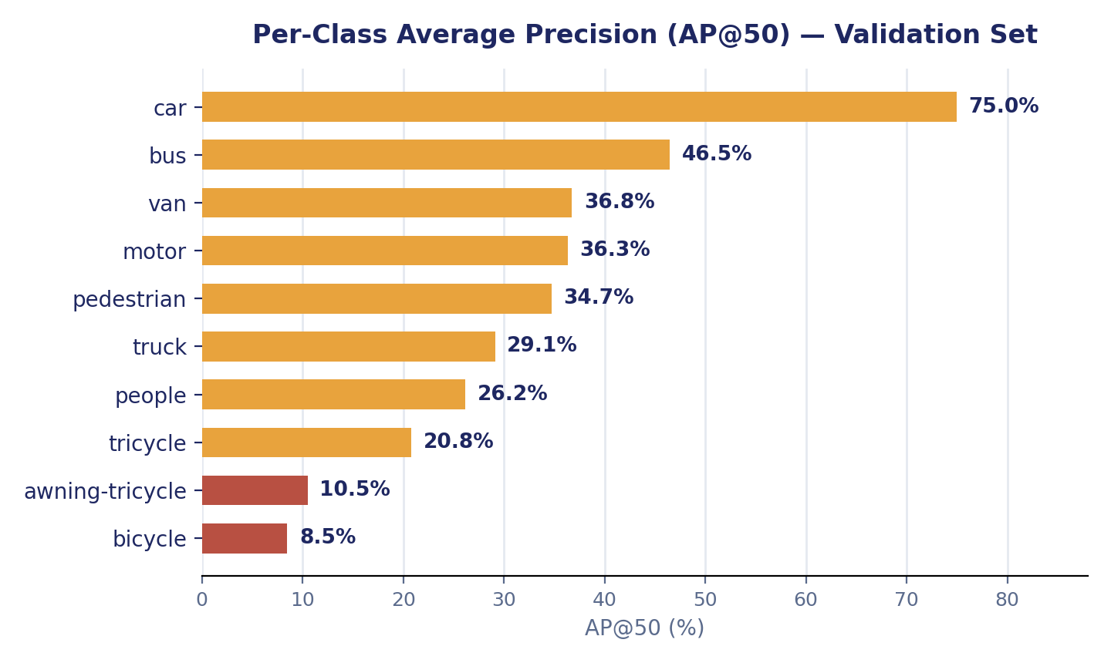
Figure 1: Per-class AP@50 on the validation set.
Performance varies sharply by class. The car class, the most frequent (14,064 instances) and visually largest category, reaches 75.0% AP@50 — more than double the overall mean. In contrast, bicycle (8.5% AP@50, 1,287 instances) and awning-tricycle (10.5% AP@50, 532 instances) perform far below average. Both are among the rarest classes in the validation set and are visually thin, small, and prone to confusion with visually similar categories (bicycle with motor; awning-tricycle with tricycle and van) when viewed from altitude. This pattern indicates that the model's overall mean is pulled down by a specific subset of rare, small, and visually ambiguous classes rather than reflecting uniformly weak performance across all categories — a class-imbalance effect rather than a general capacity limitation of the model.

5.3 Inference Speed
The trained model achieves 65.0 FPS (15.4 ms per image) on a Tesla T4 GPU at 640×640 input resolution, confirming that the nano variant meets real-time throughput requirements for video-rate UAV applications.

6. Novelty: SAHI-Based Small-Object Enhancement
To directly target the small-object weaknesses identified in Section 5.2, Slicing Aided Hyper Inference (SAHI) was integrated at inference time. SAHI slices each full-resolution image into overlapping 512×512 tiles (20% overlap), runs the trained YOLO11n weights on each tile at full resolution, and merges the resulting detections with non-maximum suppression to remove duplicates at tile boundaries. Because SAHI operates purely at inference time, it required no retraining or modification of the trained model.
Sliced predictions were generated across the full validation set using this configuration. A quantitative standard-versus-SAHI comparison — computing mAP over the SAHI predictions and comparing directly against Table 3 — requires converting the VisDrone validation ground truth into COCO annotation format and evaluating with pycocotools; this evaluation step remains to be completed and is reported here as a limitation rather than a finished result. The expected outcome, consistent with published SAHI results on similar small-object benchmarks, is an improvement in recall on small, underrepresented classes (particularly bicycle and awning-tricycle) at the cost of reduced FPS, since each image now requires multiple tile-level forward passes instead of one.

7. Challenges and Solutions
Challenge | Approach Taken
Tiny, heavily occluded objects | SAHI tiled inference at full resolution per tile
Severe class imbalance across ten categories | Per-class AP reporting to surface, rather than mask, weak classes
Google Colab session and GPU time limits | Google Drive checkpointing with early stopping (patience = 20)
Extremely dense, crowded scenes | Evaluation at native training resolution with a higher-resolution validation pass identified as future work
Table 5: Project challenges and the corresponding approach.

8. Conclusion and Future Work
This project fine-tuned YOLO11n on the VisDrone2019-DET benchmark and evaluated it with a complete metric suite rather than a single headline number, achieving an mAP@50 of 32.4%, mAP@50-95 of 18.4%, and real-time inference at 65.0 FPS. Per-class analysis identified specific, explainable weaknesses — rare and visually small classes such as bicycle and awning-tricycle — rather than uniform underperformance. SAHI tiled inference was integrated as a targeted, inference-time enhancement aimed directly at these weaknesses; its full quantitative evaluation against a COCO-format ground truth remains as near-term follow-up work.

8.1 Future Work
- Complete the standard-vs-SAHI quantitative comparison using pycocotools COCOeval.
- Compare YOLO11 variants (small, medium) to characterize the accuracy-versus-latency curve beyond the nano baseline.
- Apply class-balancing strategies (e.g. class-weighted loss or oversampling) to the weakest categories.
- Benchmark real-time video inference and edge deployment feasibility (e.g. on a Jetson-class device).

References
Zhu, P., Wen, L., Du, D., Bian, X., Fan, H., Hu, Q., & Ling, H. (2021). Detection and Tracking Meet Drones Challenge. IEEE Transactions on Pattern Analysis and Machine Intelligence.
Akyon, F. C., Altinuc, S. O., & Temizel, A. (2022). Slicing Aided Hyper Inference and Fine-tuning for Small Object Detection. IEEE International Conference on Image Processing (ICIP).
Ultralytics. (2024–2026). YOLO11 Documentation. https://docs.ultralytics.com
Ultralytics. VisDrone Dataset Documentation. https://docs.ultralytics.com/datasets/detect/visdrone

