NATIONAL UNIVERSITY OF COMPUTER & EMERGING

SCIENCE

Computer Network Lab (CL-307)

Lab Session 02
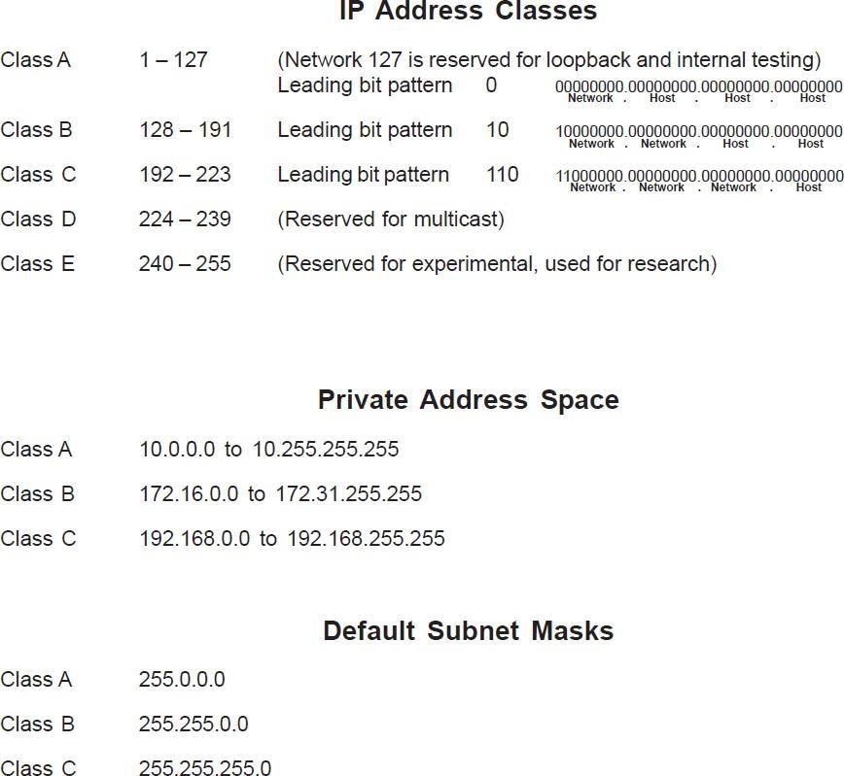
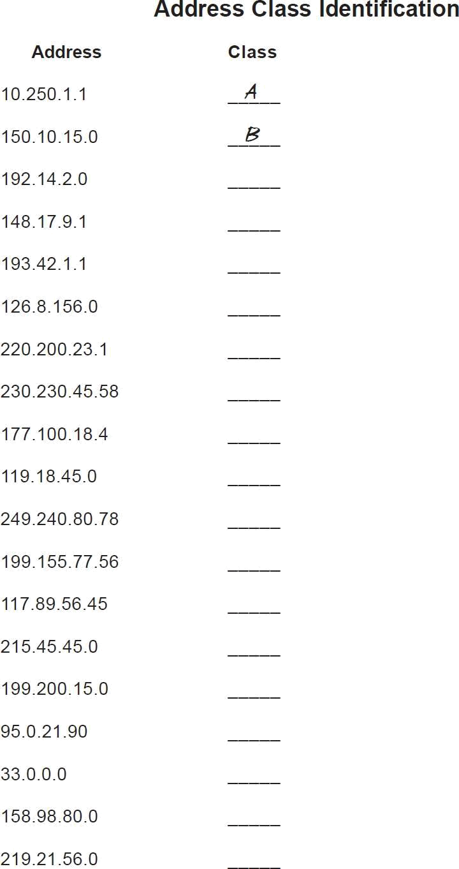
C
B
C
A
C
D

B
A
E
C
A
C
C
A
A

B
C

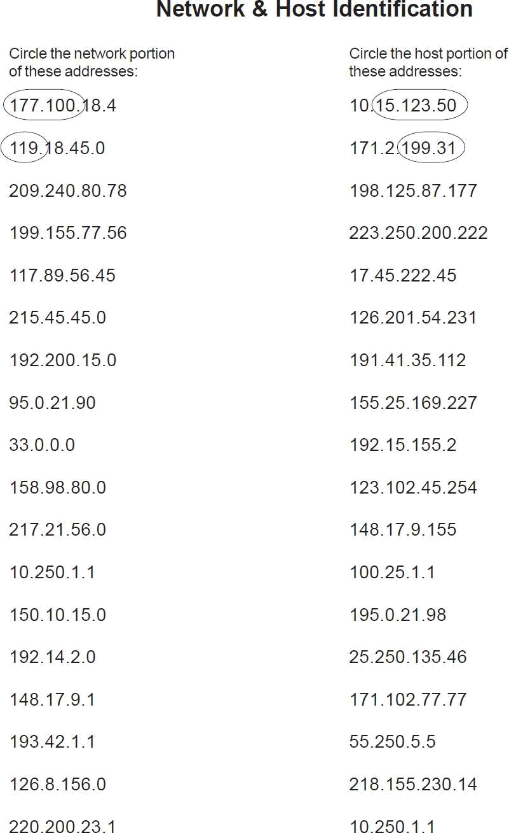
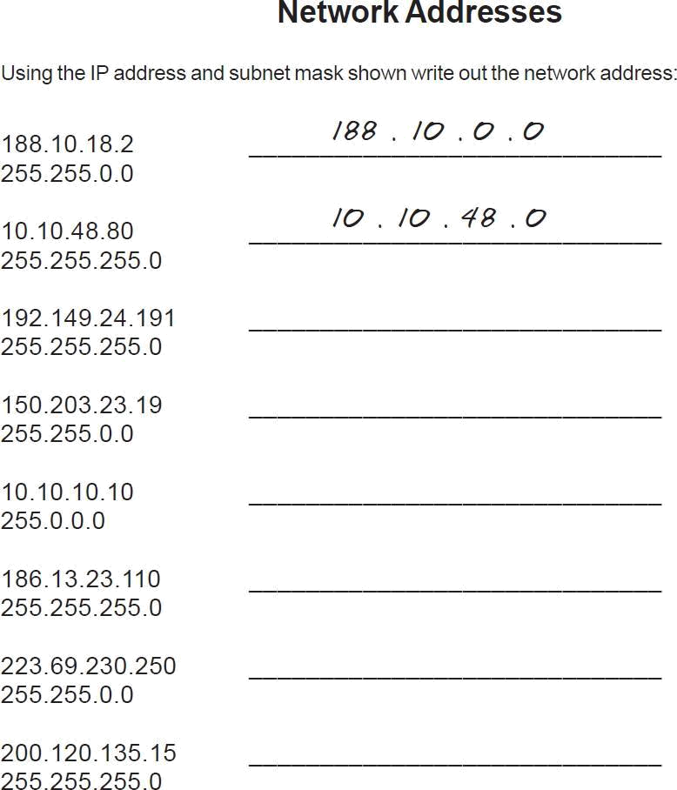
192.149.24.0

150.203.0.0

10.0.0.0

186.13.23.0

223.69.0.0

200.120.135.0
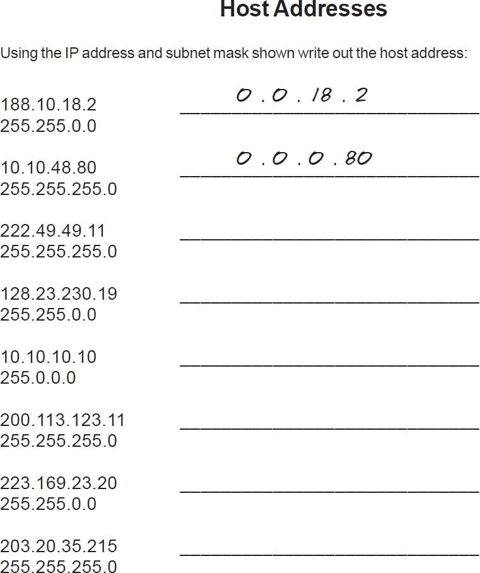
0.0.0.11

0.0.230.19

0.10.10.10

0.0.0.11

0.0.23.20

0.0.0.215
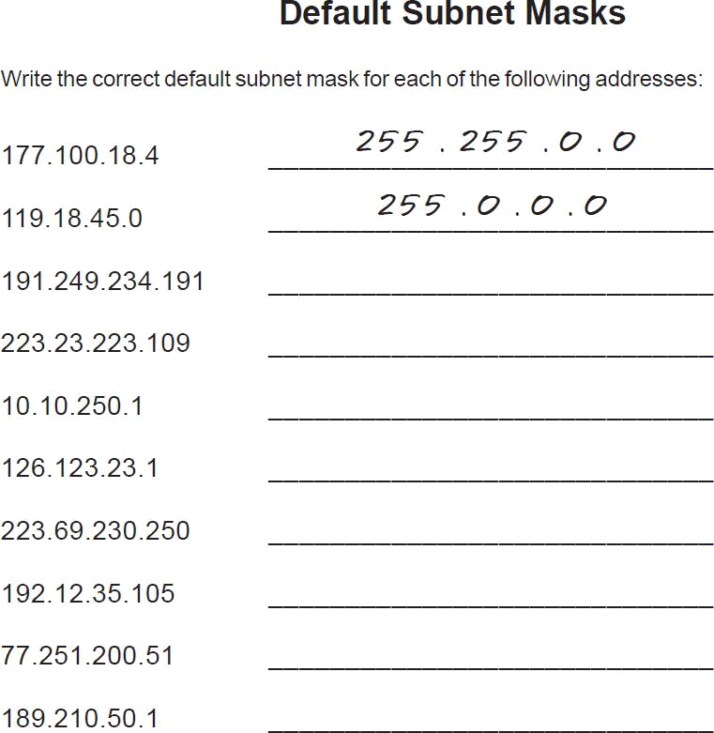

255.255.255.0
255.255.255.0
255.0.0.0
255.0.0.0
255.255.255.0
255.255.255.0
255.0.0.0
255.255.255.0

