https://mrcloudbook.com/devsecops-ci-cd-deploying-a-secure-hotstar-clone-even-if-youre-not-a-pro/

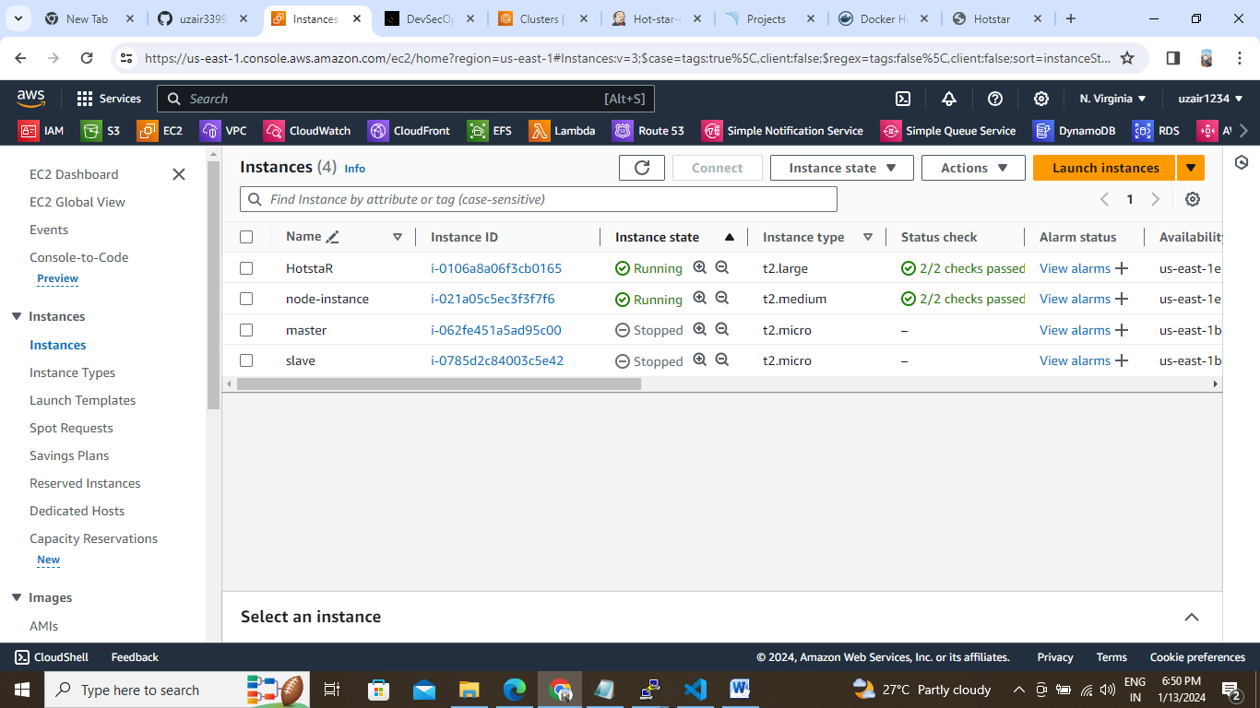

Hotstar instance

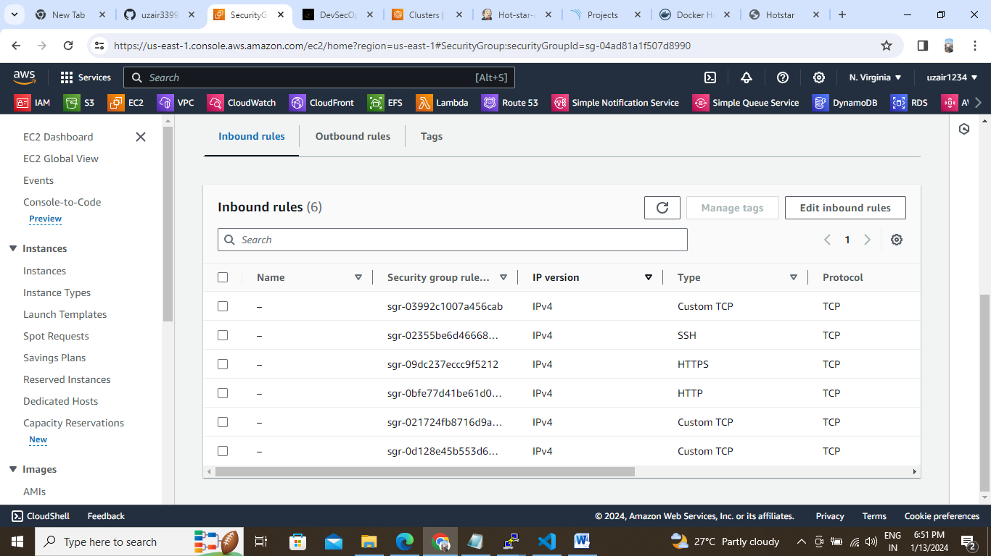

Pipelines:

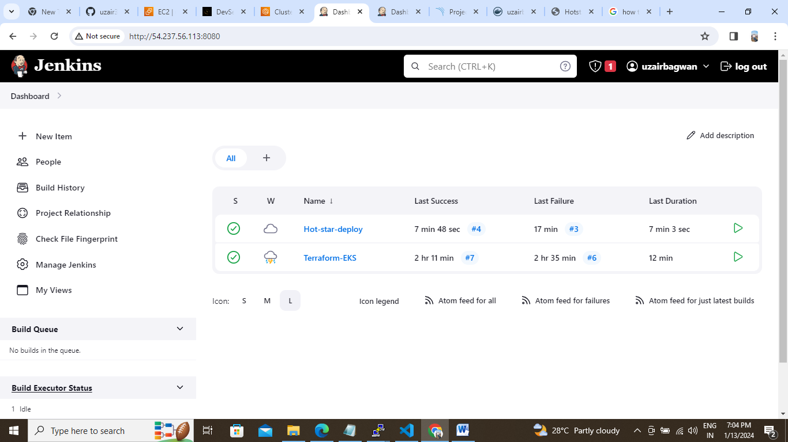

Terraform-EKS Pipeline:

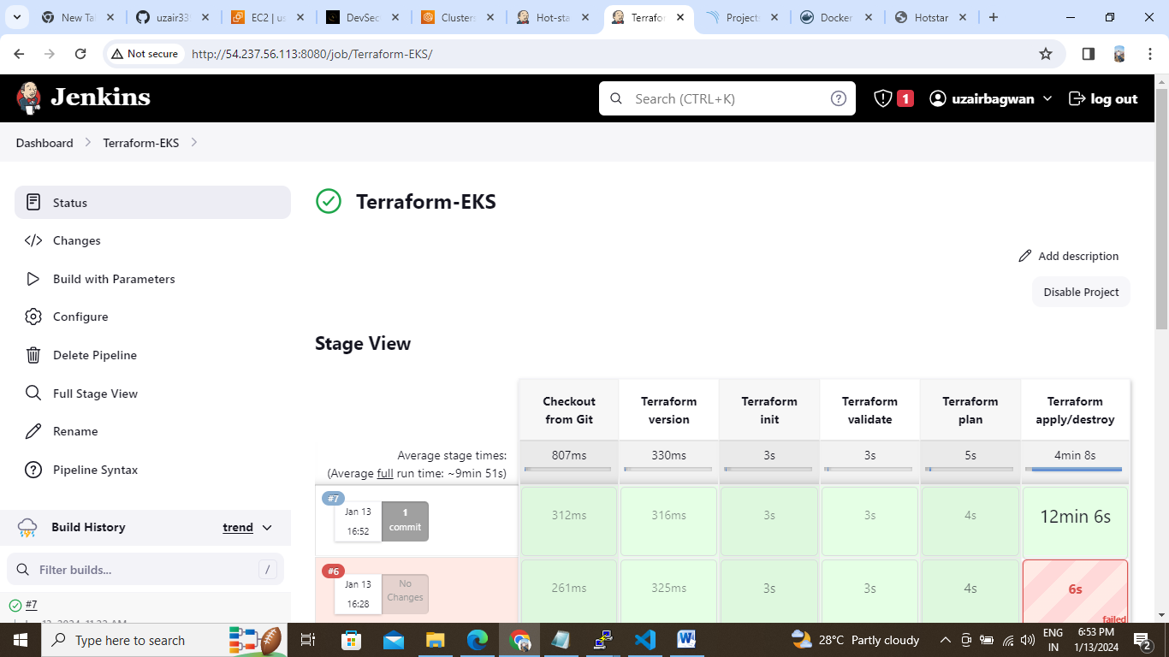

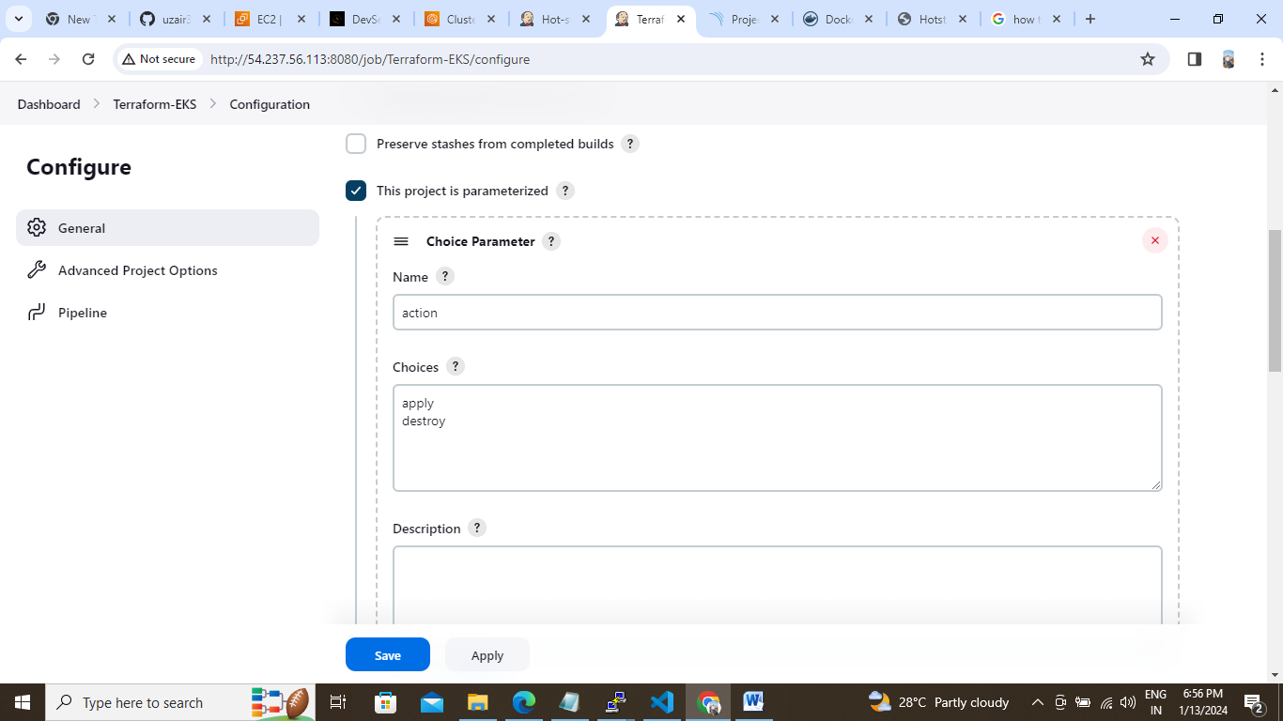

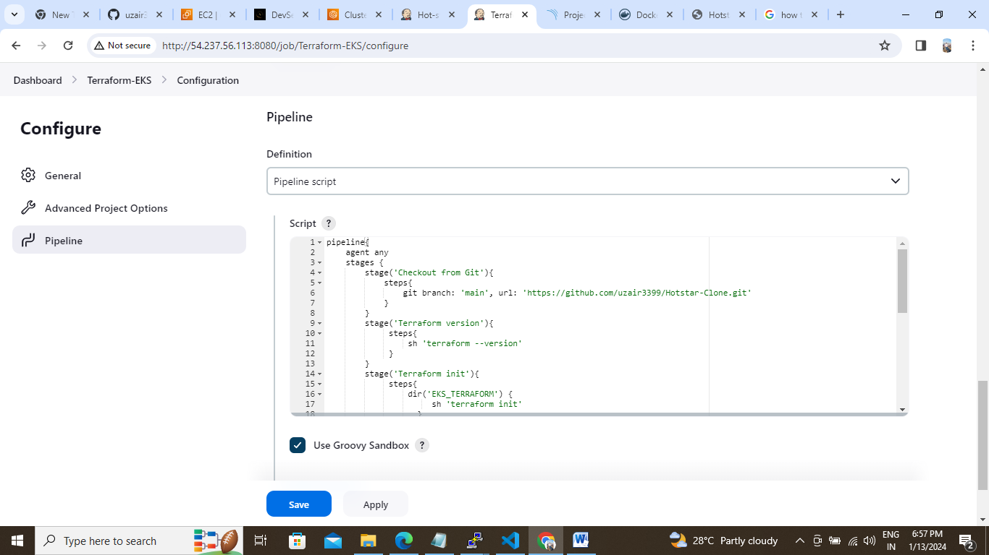

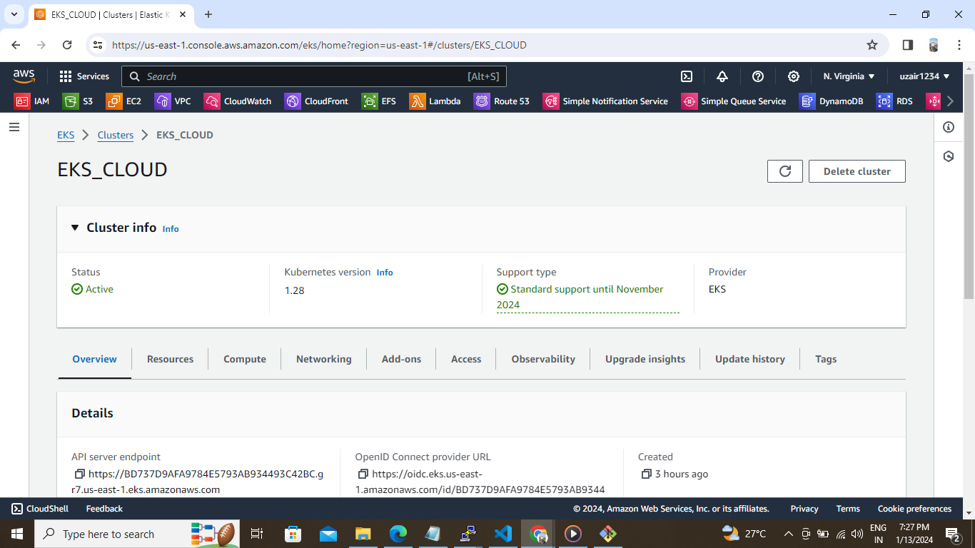

**Pipeline**:

**pipeline{**

**agent any**

**stages {**

**stage('Checkout from Git'){**

**steps{**

**git branch: 'main', url: 'https://github.com/uzair3399/Hotstar-Clone.git'**

**}**

**}**

**stage('Terraform version'){**

**steps{**

**sh 'terraform --version'**

**}**

**}**

**stage('Terraform init'){**

**steps{**

**dir('EKS_TERRAFORM') {**

**sh 'terraform init'**

**}**

**}**

**}**

**stage('Terraform validate'){**

**steps{**

**dir('EKS_TERRAFORM') {**

**sh 'terraform validate'**

**}**

**}**

**}**

**stage('Terraform plan'){**

**steps{**

**dir('EKS_TERRAFORM') {**

**sh 'terraform plan'**

**}**

**}**

**}**

**stage('Terraform apply/destroy'){**

**steps{**

**dir('EKS_TERRAFORM') {**

**sh 'terraform ${action} --auto-approve'**

**}**

**}**

**}**

**}**

**}**

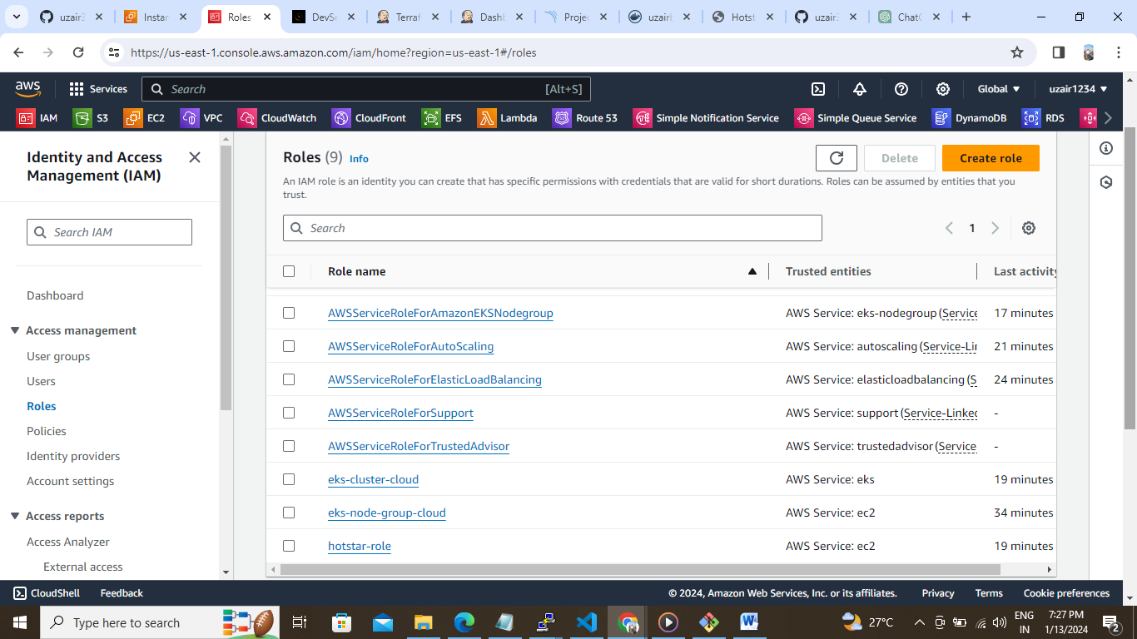

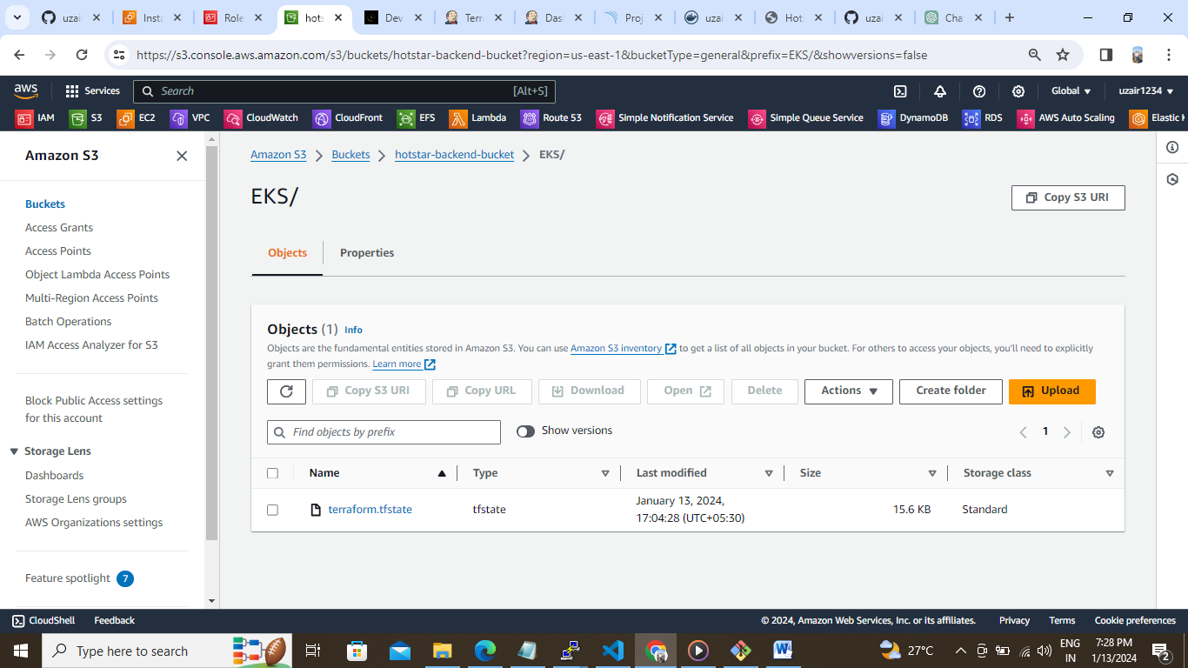

**Host-star-deploy pipeline:**

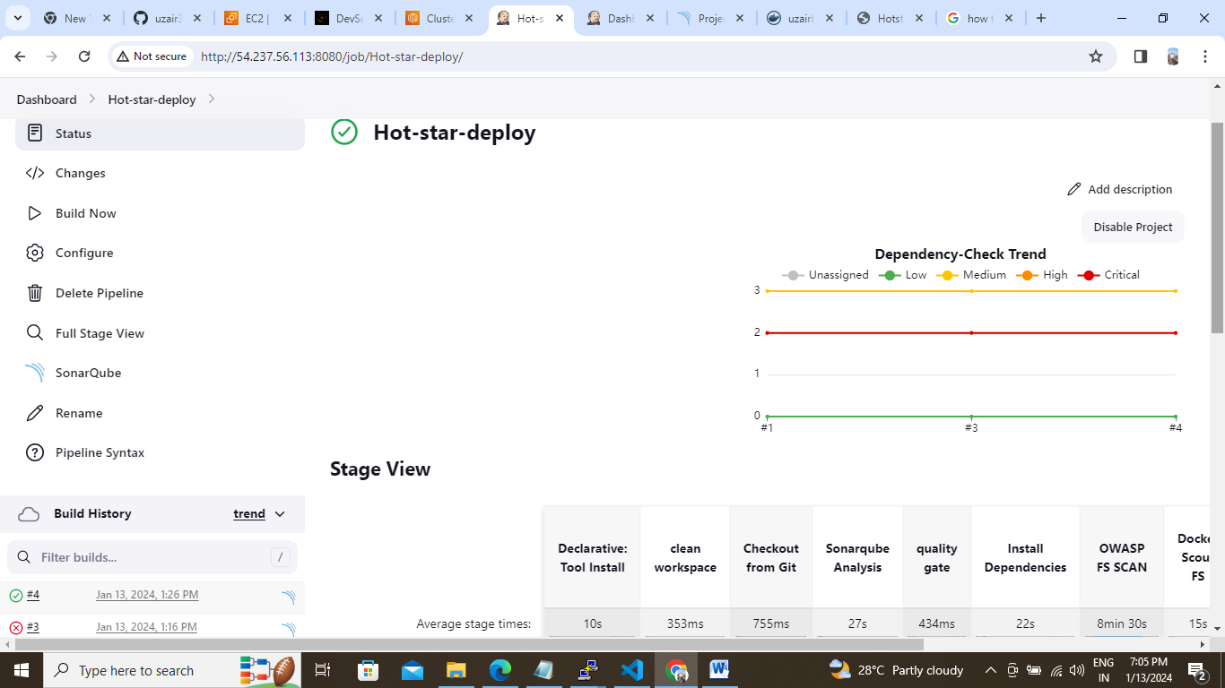

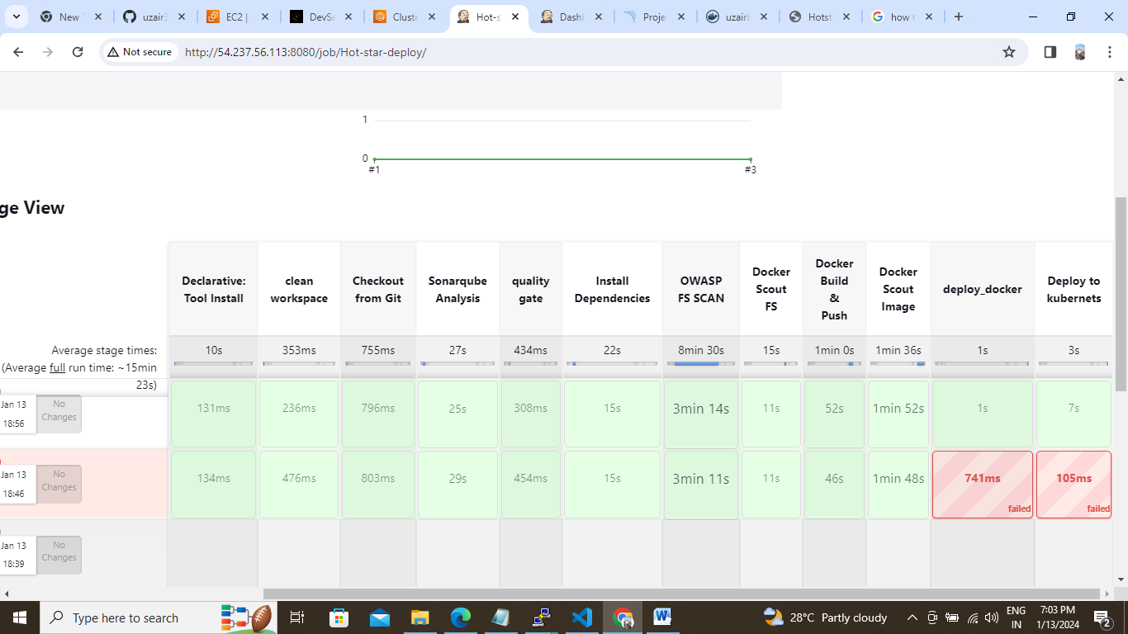

**Pipeline Code:**

**pipeline{**

**agent any**

**tools{**

**jdk 'jdk17'**

**nodejs 'node16'**

**}**

**environment {**

**SCANNER_HOME=tool 'sonar-scanner'**

**}**

**stages {**

**stage('clean workspace'){**

**steps{**

**cleanWs()**

**}**

**}**

**stage('Checkout from Git'){**

**steps{**

**git branch: 'main', url: 'https://github.com/uzair3399/Hotstar-Clone.git'**

**}**

**}**

**stage("Sonarqube Analysis "){**

**steps{**

**withSonarQubeEnv('sonar-server') {**

**sh ''' $SCANNER_HOME/bin/sonar-scanner -Dsonar.projectName=Hotstar \**

**-Dsonar.projectKey=Hotstar'''**

**}**

**}**

**}**

**stage("quality gate"){**

**steps {**

**script {**

**waitForQualityGate abortPipeline: false, credentialsId: 'Sonar-token'**

**}**

**}**

**}**

**stage('Install Dependencies') {**

**steps {**

**sh "npm install"**

**}**

**}**

**stage('OWASP FS SCAN') {**

**steps {**

**dependencyCheck additionalArguments: '--scan ./ --disableYarnAudit --disableNodeAudit', odcInstallation: 'DP-Check'**

**dependencyCheckPublisher pattern: '**/dependency-check-report.xml'**

**}**

**}**

**stage('Docker Scout FS') {**

**steps {**

**script{**

**withDockerRegistry(credentialsId: 'docker', toolName: 'docker'){**

**sh 'docker-scout quickview fs://.'**

**sh 'docker-scout cves fs://.'**

**}**

**}**

**}**

**}**

**stage("Docker Build & Push"){**

**steps{**

**script{**

**withDockerRegistry(credentialsId: 'docker', toolName: 'docker'){**

**sh "docker build -t hotstar ."**

**sh "docker tag hotstar uzairbagwan/hotstar:latest "**

**sh "docker push uzairbagwan/hotstar:latest"**

**}**

**}**

**}**

**}**

**stage('Docker Scout Image') {**

**steps {**

**script{**

**withDockerRegistry(credentialsId: 'docker', toolName: 'docker'){**

**sh 'docker-scout quickview uzairbagwan/hotstar:latest'**

**sh 'docker-scout cves uzairbagwan/hotstar:latest'**

**sh 'docker-scout recommendations uzairbagwan/hotstar:latest'**

**}**

**}**

**}**

**}**

**stage("deploy_docker"){**

**steps{**

**sh "docker run -d --name hotstar -p 3000:3000 uzairbagwan/hotstar:latest"**

**}**

**}**

**stage('Deploy to kubernets'){**

**steps{**

**script{**

**dir('K8S') {**

**withKubeConfig(caCertificate: '', clusterName: '', contextName: '', credentialsId: 'k8s', namespace: '', restrictKubeConfigAccess: false, serverUrl: '') {**

**sh 'kubectl apply -f deployment.yml'**

**sh 'kubectl apply -f service.yml'**

**}**

**}**

**}**

**}**

**}**

**}**

**}**

**SonarQube:**

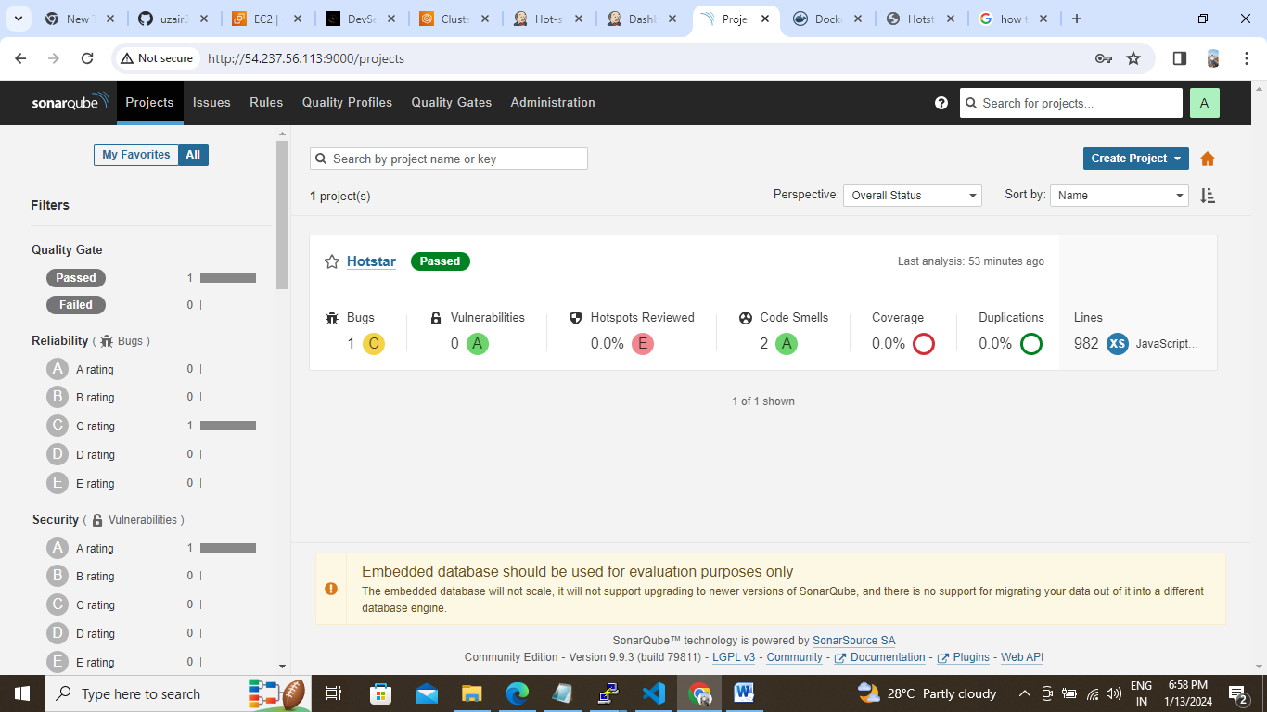

**DockerHub:**

