Step 1: Importing Libraries

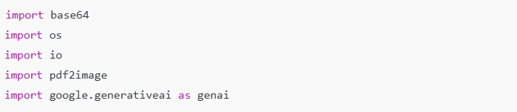

Explanation:

* We’re bringing in some tools (called libraries) to help us do different tasks.
* base64 helps us turn files into code that can be sent over the internet.
* os lets us work with the computer’s environment, like setting secret keys.
* io and pdf2image help us change PDF files into images, so we can read them more easily.
* google.generativeai is the Google Generative AI tool we’re using to analyze the resume and job description.

Step 2: Setting Up the API Key

Explanation:

* Here, we’re adding our Google API key to tell the computer that we have permission to use Google’s AI tools. It’s like giving the AI robot a password so it can start working.
* This key is stored as an environment variable using os.environ, which is a secure way to handle the API key. Then we tell Google’s AI library (genai) to use this key.

Step 3: Defining the Function to Get AI’s Response

Explanation:

* This is a function called get_gemini_response, which asks the AI to read and respond to a job description and resume.
* input is the job description text.
* pdf_content is the resume (which we’ll convert to an image in the next step).
* prompt is an extra set of instructions we give the AI to help it know exactly what we want.
* We use genai.GenerativeModel('gemini-1.5-flash') to select a specific AI model called "gemini-1.5-flash" that is good at understanding language. Then we ask this model to create a response based on the job description, resume, and prompt.
* The function then sends back (returns) the AI’s response as text.

Step 4: Setting Up the PDF Input

Explanation:

* This function, input_pdf_setup, takes a PDF file (the uploaded resume) and prepares it so the AI can read it.
* It converts the first page of the PDF into an image, so we can send it to the AI.
* The image is then converted into a special code using base64, which allows it to be sent securely.
* We put this code in pdf_parts so it can be used by the AI model.
* If there is no file uploaded, it will show an error message.

How It Works Together:

1. Uploading the Resume:
   * The user uploads a resume in PDF format.
2. Preparing the Resume for AI:
   * The input_pdf_setup function changes the PDF into an image so it can be read by the AI.
3. Generating the Response:
   * The get_gemini_response function sends the job description, prepared resume, and prompt to the AI, which then returns a customized response.
4. What the AI Does:
   * The AI compares the resume to the job description and checks for keywords, important skills, and experiences.
   * It then gives feedback on how well the resume matches the job and highlights missing keywords or areas for improvement.

In Summary:

This code helps analyze a resume to see how well it matches a job description using Google’s Generative AI model. It:

* Converts the PDF resume to an image so it can be read.
* Sends the resume and job description to the AI, along with instructions.
* The AI then reviews the resume and provides a match percentage, missing keywords, and final feedback.