Problem 1:
int main()
{
int n;
cout << "Enter the number of rows: ";
cin >> n;
for (int i = 1; i <= n; i++)
{
for (int j = n; j > i; j--)
{
cout << " ";
}
for (int k = 1; k <= (2 * i - 1); k++)
{
cout << "*";
}
cout << "\n";
}
for (int i = n - 1; i >= 1; i--)
{
for (int j = n; j > i; j--)
{
cout << " ";
}
for (int k = 1; k <= (2 * i - 1); k++)
{
cout << "*";
}
cout << "\n";
}
}

Output:
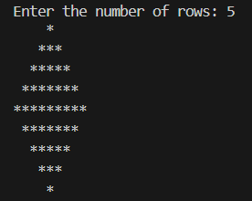

PROBLEM 2:
int main()
{
int n;
cout << "Enter the number of rows: ";
cin >> n;
for (int i = n; i >= 1; i--)
{
for (int j = n; j > i; j--)
{
cout << " ";
}
for (int k = 1; k <= (2 * i - 1); k++)
{
cout << "*";
}
cout << "\n";
}
for (int i = 2; i <= n; i++)
{
for (int j = n; j > i; j--)
{
cout << " ";
}
for (int k = 1; k <= (2 * i - 1); k++)
{
cout << "*";
}
cout << "\n";
}
}
Output:
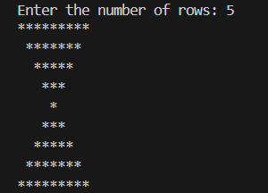

Problem 3
10. Hollow Diamond
int main (){
for (int i = 1; i <= 5; i++){
for (int j = 6; j > i; j--){
cout << " ";
}
for (int k = 1; k <= i; k++){
if (k == 1 || k == i){
cout << "* ";
}
else{
cout << " ";
}
}
cout << endl;
}

for (int i = 6; i >= 1; i--){
for (int j = 6; j > i; j--){
cout << " ";
}
for (int k = 1; k <= i; k++){
if (k == 1 || k == i){
cout << "* ";
}
else{
cout << " ";
}
}
cout << endl;
}
return0;
}
