Data Structure and algorithms (LAB)

Lab Task

Name: UzairAlam

Problem 1
#include <iostream>
using namespace std;

struct Node
{
string id;
Node *next;
Node *pre;

Node() : id(""), next(nullptr), pre(nullptr) {}
Node(const string &id) : id(id), next(nullptr), pre(nullptr) {}
};

class doubleLinkList
{
Node *head, *tail;

public:
doubleLinkList() : head(nullptr), tail(nullptr) {}

void insertAtBegin(const string &id)
{
Node *newNode = new Node(id);
if (head == nullptr)
{
head = newNode;
tail = newNode;
return;
}
newNode->next = head;
head->pre = newNode;
head = newNode;
}

void traversal() const
{
Node *current = head;
while (current != nullptr)
{
cout << current->id << " ";
current = current->next;
}
cout << endl;
}
void traversalBackward() const
{
Node *current = tail;
while (current != nullptr)
{
cout << current->id << " ";
current = current->pre;
}
cout << endl;
}
};

int main()
{
doubleLinkList list;
list.insertAtBegin("104");
list.insertAtBegin("103");
list.insertAtBegin("102");
list.insertAtBegin("101");

list.traversal();
list.traversalBackward();
}
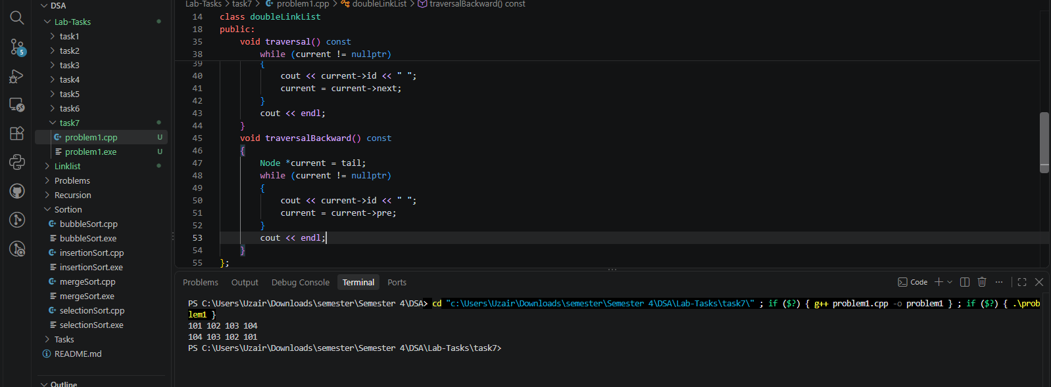

Problem 2
#include <iostream>
using namespace std;

struct Node
{
string id;
Node *next;
Node *pre;

Node() : id(""), next(nullptr), pre(nullptr) {}
Node(const string &id) : id(id), next(nullptr), pre(nullptr) {}
};

class doubleLinkList
{
Node *head, *tail;

public:
doubleLinkList() : head(nullptr), tail(nullptr) {}

void insertAtBegin(const string &id)
{
Node *newNode = new Node(id);
if (head == nullptr)
{
head = newNode;
tail = newNode;
return;
}
newNode->next = head;
head->pre = newNode;
head = newNode;
}

void insertionAtEnd(const string &id)
{
Node *newNode = new Node(id);
if (head == nullptr)
{
head = newNode;
tail = newNode;
return;
}

tail->next = newNode;
newNode->pre = tail;
tail = newNode;
}

void traversal() const
{
Node *current = head;
while (current != nullptr)
{
cout << current->id << " ";
current = current->next;
}
cout << endl;
}
void traversalBackward() const
{
Node *current = tail;
while (current != nullptr)
{
cout << current->id << " ";
current = current->pre;
}
cout << endl;
}
};

int main()
{
doubleLinkList list;
list.insertAtBegin("504");
list.insertAtBegin("503");
list.insertAtBegin("502");
list.insertAtBegin("501");
list.insertionAtEnd("505");
list.traversal();
list.traversalBackward();
}
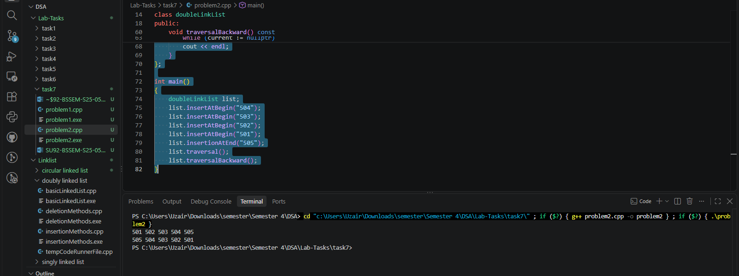

Problem 3
#include <iostream>
using namespace std;

struct Node
{
string id;
Node *next;
Node *pre;

Node() : id(""), next(nullptr), pre(nullptr) {}
Node(const string &id) : id(id), next(nullptr), pre(nullptr) {}
};

class doubleLinkList
{
Node *head, *tail;

public:
doubleLinkList() : head(nullptr), tail(nullptr) {}

void insertAtBegin(const string &id)
{
Node *newNode = new Node(id);
if (head == nullptr)
{
head = newNode;
tail = newNode;
return;
}
newNode->next = head;
head->pre = newNode;
head = newNode;
}

void insertAfterTarget(const string &target, const string &id)
{
Node *current = head;

while (current != nullptr && current->id != target)
current = current->next;

if (current == nullptr)
{
cout << "Target Doesn't Exist\n";
return;
}

Node *newNode = new Node(id);

newNode->next = current->next;
newNode->pre = current;

if (current->next != nullptr)
current->next->pre = newNode;

current->next = newNode;

if (current == tail)
tail = newNode;
}

void traversal() const
{
Node *current = head;
while (current != nullptr)
{
cout << current->id << " ";
current = current->next;
}
cout << endl;
}
void traversalBackward() const
{
Node *current = tail;
while (current != nullptr)
{
cout << current->id << " ";
current = current->pre;
}
cout << endl;
}
};

int main()
{
doubleLinkList list;
list.insertAtBegin("10");
list.insertAtBegin("20");
list.insertAtBegin("40");
list.insertAtBegin("50");
list.insertAfterTarget("40", "30");
list.traversal();
list.traversalBackward();
}
