Problem 1
#include <iostream>
using namespace std;

int main()
{
int arr[8] = {10, 20, 30, 40, 50, 60, 70, 80};

cout << "Elements in ARRAY: ";
for (int i = 0; i < 8; i++)
{
cout << arr[i] << " ";
}
cout << endl;

return 0;
}
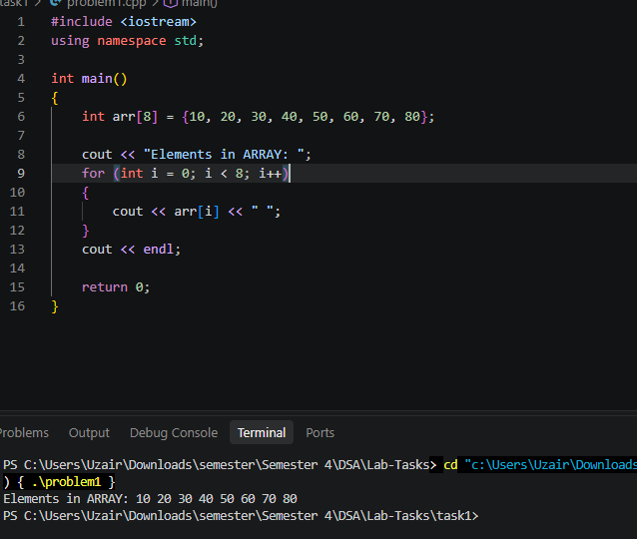

Problem 2
#include <iostream>
using namespace std;

int main()
{
int size = 8;
int arr[size] = {10, 20, 30, 40, 50, 60, 70, 80};

int pos = 0;

for (int i = size; i > pos; i--)
{
arr[i] = arr[i - 1];
}
arr[pos] = 5;
size++;

cout << "After Insertion in ARRAY: ";
for (int i = 0; i < size; i++)
{
cout << arr[i] << " ";
}

cout << endl;

return 0;
}
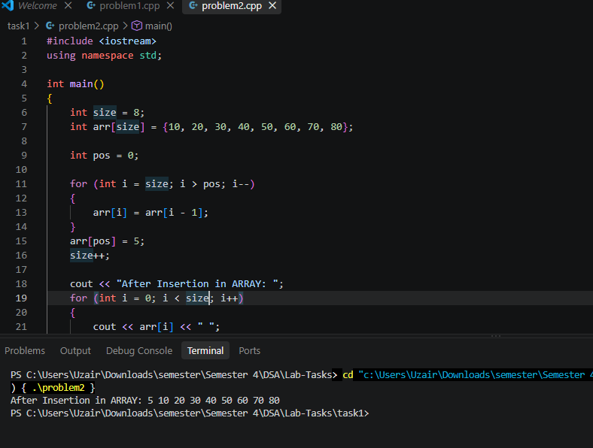

Problem 3
#include <iostream>
using namespace std;

int main()
{
int size = 8;
int arr[size] = {10, 20, 30, 40, 50, 60, 70, 80};

size--;
for (int i = 0; i < size; i++)
{
cout << arr[i] << " ";
}

cout << endl;

return 0;
}

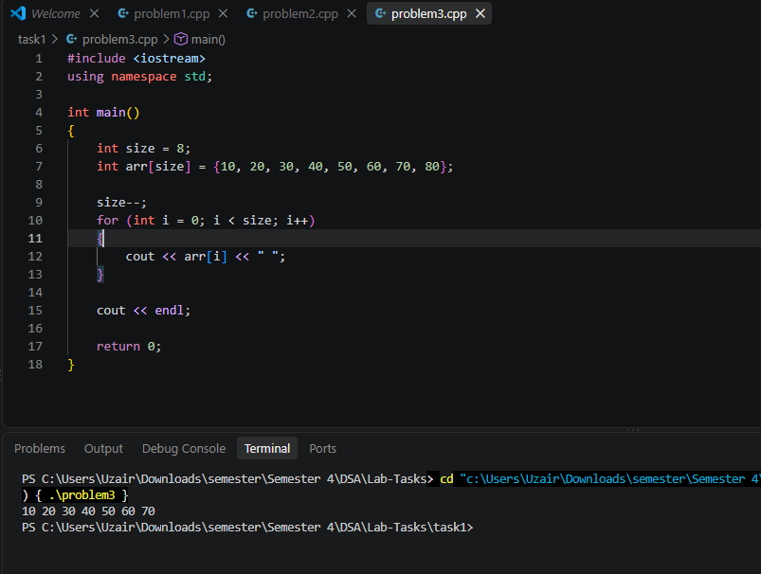

Problem 4

#include <iostream>
using namespace std;

int main()
{
int size = 8;
int arr[size] = {10, 20, 30, 40, 50, 60, 70, 80};

int pos = 0;

cout << "Elements in ARRAY: ";
for (int i = 0; i < size; i++)
{
cout << arr[i] << " ";
}

cout << endl;

for (int i = size; i > pos; i--)
{
arr[i] = arr[i - 1];
}
arr[pos] = 5;
size++;

cout << "After Insertion in ARRAY: ";
for (int i = 0; i < size; i++)
{
cout << arr[i] << " ";
}

cout << endl;

for (int i = pos; i < size; i++)
{
arr[i] = arr[i + 1];
}
size--;

cout << "After Deletion in ARRAY: ";
for (int i = 0; i < size; i++)
{
cout << arr[i] << " ";
}

cout << endl;

return 0;
}

