Problem 1
// Task 1 : Create a structure named Student with two members : name and age.Create one variable of the structure and display its values.

#include <iostream>
using namespace std;

struct General
{
string name{};
int age{};
} myStruct;

int main()
{
myStruct.age = 12;
myStruct.name = "ALI";

cout << "Name: " << myStruct.age
<< "\nAge: " << myStruct.name << endl;

return 0;
}

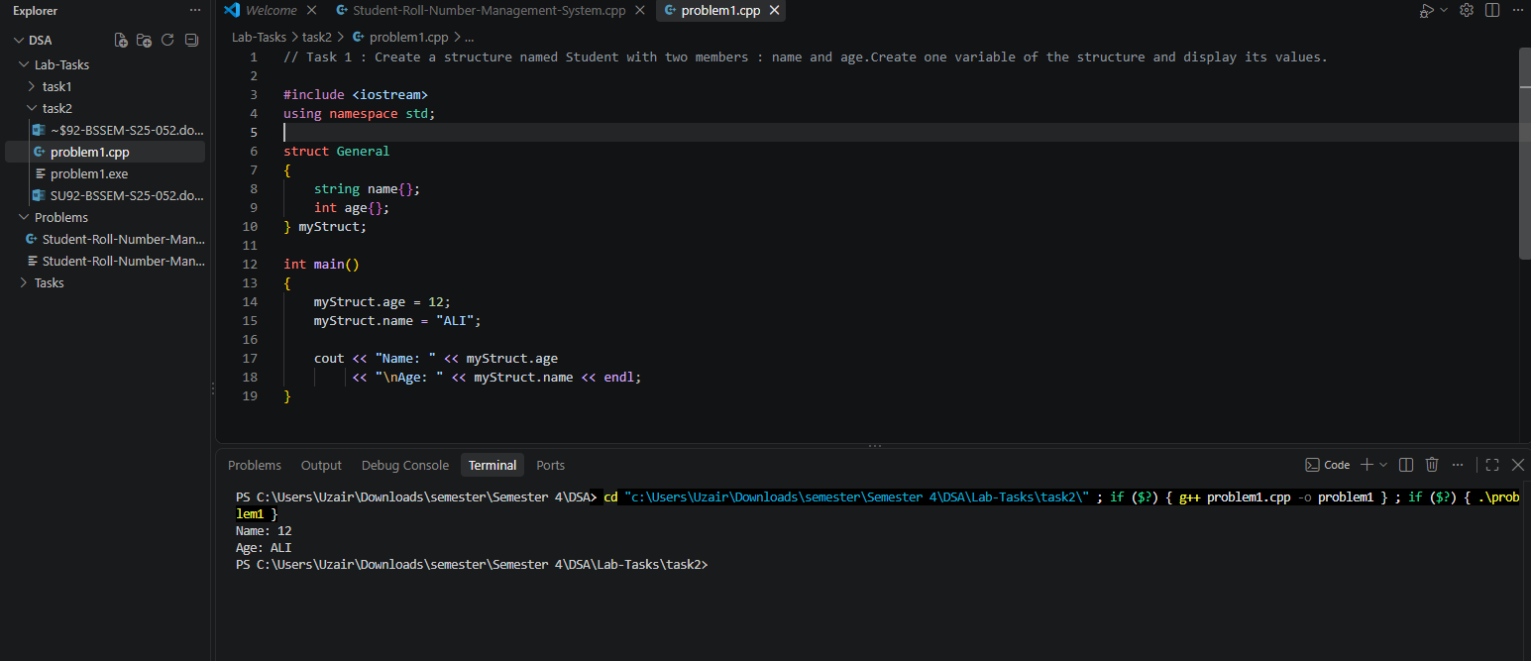

Problem 2
// Task 2 : Create one node dynamically, store a value in data, and set its next pointer to NULL.

#include <iostream>
using namespace std;

struct Node
{
int data{};
Node *next;
};

int main()
{
Node *firstNode = new Node;
firstNode->data = 100;
firstNode->next = NULL;

cout << "FIrst Node DATA: " << firstNode->data << endl;

delete firstNode;
return 0;

}

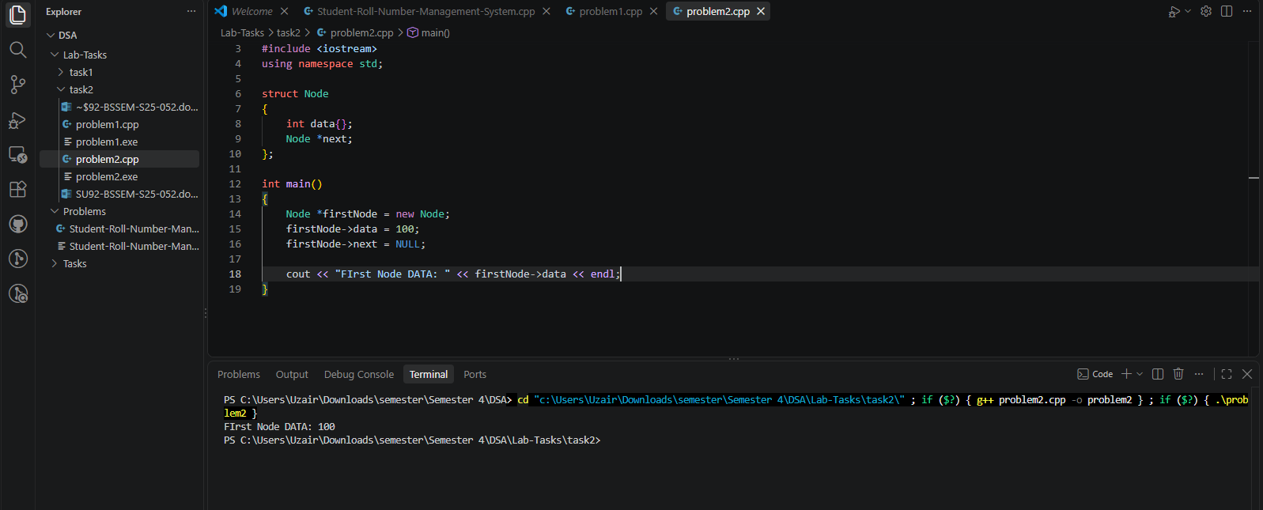

Problem 3
// Task 3 : Create three nodes containing 10, 20, and 30. Connect them in sequence and make the last node point to NULL.
#include <iostream>
using namespace std;

struct Node
{
int data{};
Node *next;
};

int main()
{
Node *firstNode = new Node;
Node *secondNode = new Node;
Node *thirdNode = new Node;

firstNode->data = 10;
secondNode->data = 20;
thirdNode->data = 30;

firstNode->next = secondNode;
secondNode->next = thirdNode;
thirdNode->next = NULL;

cout << "FIrst Node DATA: " << firstNode->data << endl;
cout << "Second Node DATA: " << secondNode->data << endl;
cout << "Third Node DATA: " << thirdNode->data << endl;

delete firstNode;
delete secondNode;
delete thirdNode;

return 0;
}

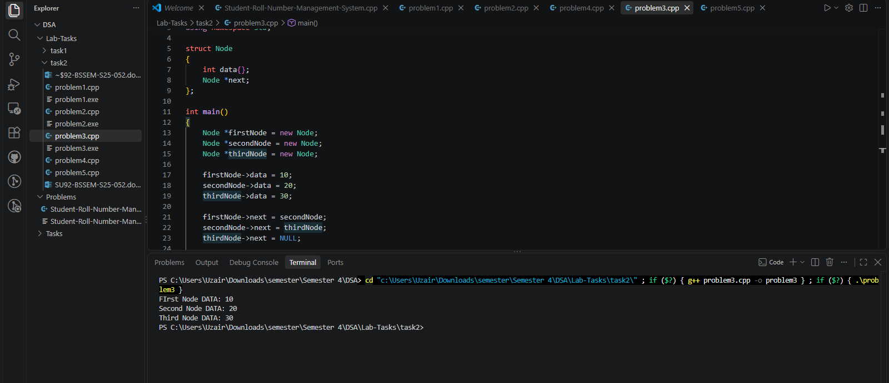

Problem 4
// Task 4 : Create three connected nodes and use a head pointer to point to the first node.Display the value stored in the first node.
#include <iostream>
using namespace std;

struct Node
{
int data{};
Node *next;
};

int main()
{

Node *firstNode = new Node;
Node *secondNode = new Node;
Node *thirdNode = new Node;
Node *Head = firstNode;

firstNode->data = 10;
secondNode->data = 20;
thirdNode->data = 30;

firstNode->next = secondNode;
secondNode->next = thirdNode;
thirdNode->next = NULL;

cout << "FIrst Node DATA: " << Head->data << endl;

delete firstNode;
delete secondNode;
delete thirdNode;

return 0;
}

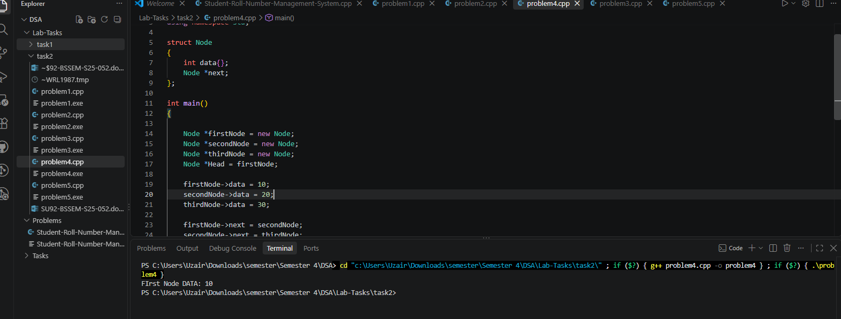

Problem 5
// Task 5 : Create two nodes representing customers 101 and 102. Connect the first customer to the second using the next pointer.
#include <iostream>
using namespace std;

struct Node
{
int data{};
Node *next;
};

int main()
{
Node *customer101 = new Node;
Node *customer102 = new Node;
customer101->data = 101;
customer102->data = 102;

customer101->next = customer102;
customer102->next = NULL;

cout << "Customer: " << customer101->data << endl;
cout << "Customer: " << customer102->data << endl;

delete customer101;
delete customer102;
return 0;
}

