Data Structure and algorithms (LAB)
Lab Task
Name: UzairAlam

Problem 1
#include <iostream>
using namespace std;

struct Node
{
int data;
Node *next;
};
Node *head = NULL;

int main()
{
Node *currentNode = NULL;

for (int i = 1; i <= 10; i += 2)
{
Node *newNode = new Node;
newNode->data = i * 10;
newNode->next = NULL;
if (head == NULL)
{
head = newNode;
currentNode = newNode;
}
else
{
currentNode->next = newNode;
currentNode = newNode;
}
}

int i = 1;
currentNode = head;
while (currentNode != NULL)
{
cout << "Node " << i << "\nData: " << currentNode->data << "\nAddress: " << currentNode->next << "\n"
<< endl;
currentNode = currentNode->next;
i++;
}

return 0;
}
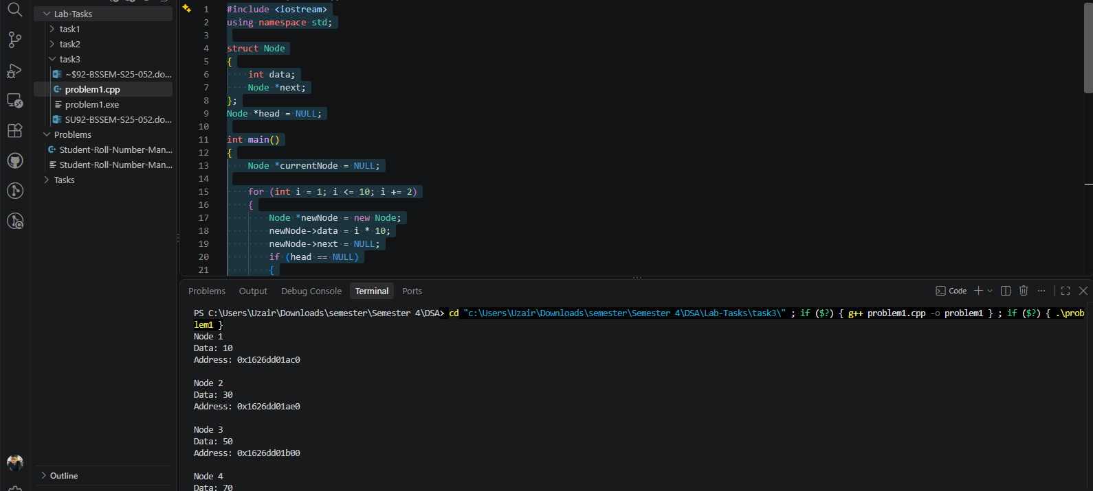

Problem 2
#include <iostream>
using namespace std;

struct Node
{
int data;
Node *next;
};
Node *head = NULL;

int main()
{
Node *currentNode = NULL;

for (int i = 2; i <= 10; i += 2)
{
Node *newNode = new Node;
newNode->data = i * 10;
newNode->next = NULL;
if (head == NULL)
{
head = newNode;
currentNode = newNode;
}
else
{
currentNode->next = newNode;
currentNode = newNode;
}
}

currentNode = head;

while (currentNode != NULL)
{
cout << currentNode->data << " --> ";
currentNode = currentNode->next;
}
cout << "NULL" << endl;

Node *newNode = new Node;
newNode->data = 10;
newNode->next = head;

head = newNode;
currentNode = head;

while (currentNode != NULL)
{
cout << currentNode->data << " --> ";
currentNode = currentNode->next;
}
cout << "NULL" << endl;
return 0;
}

