Data Structure and algorithms (LAB)

Lab Task

Name: UzairAlam

Problem 1
#include <iostream>
#include <string>
using namespace std;

struct Node
{
string productID;
Node *next;

Node(const string &id) : productID(id), next(nullptr) {}
};

Node *head = nullptr;
Node *current = nullptr;

int main()
{
Node *firstNode = new Node("p101");
Node *secondNode = new Node("p102");
Node *thirdNode = new Node("p103");
Node *fourthNode = new Node("p104");

firstNode->next = secondNode;
secondNode->next = thirdNode;
thirdNode->next = fourthNode;
fourthNode->next = nullptr;

head = firstNode;
current = head;
while (current->next != nullptr)
{
cout << current->productID << " -> ";
current = current->next;
}
cout << current->productID << " -> ";
cout << "nullptr" << endl;

Node *fifthNode = new Node("p105");
fifthNode->next = nullptr;
current->next = fifthNode;

current = head;
while (current->next != nullptr)
{
cout << current->productID << " -> ";
current = current->next;
}
cout << current->productID << " -> ";
cout << "nullptr" << endl;
}
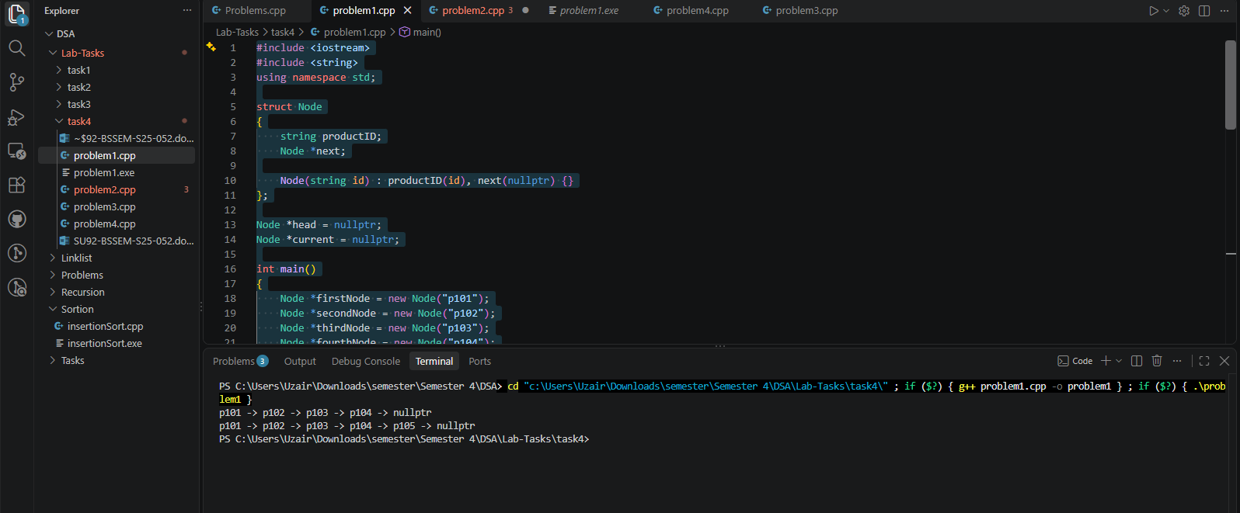

Problem 2
#include <iostream>
#include <string>
using namespace std;

struct Node
{
string data;
Node *next;

Node(const string &station) : data(station), next(nullptr) {}
};

Node *head = nullptr;
Node *current = nullptr;

int main()
{
Node *firstNode = new Node("Lahore");
Node *secondNode = new Node("Gujranwala");
Node *thirdNode = new Node("Rawalpindi");
Node *fourthNode = new Node("Islamabad ");

firstNode->next = secondNode;
secondNode->next = thirdNode;
thirdNode->next = fourthNode;
fourthNode->next = nullptr;

head = firstNode;
current = head;
while (current->data != "Gujranwala")
{
current = current->next;
}

Node *fifthNode = new Node("Gujrat");
fifthNode->next = current->next;
current->next = fifthNode;

current = head;
while (current->next != nullptr)
{
cout << current->data << " -> ";
current = current->next;
}
cout << current->data;
}
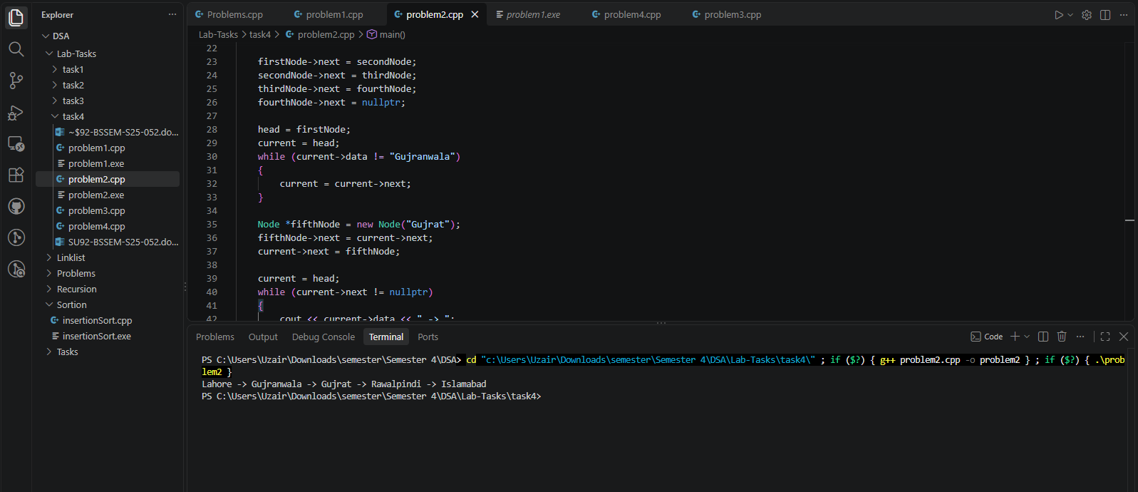

Problem 3
#include <iostream>
#include <string>
using namespace std;

struct Node
{
string productID;
Node *next;

Node(const string &id) : productID(id), next(nullptr) {}
};

Node *head = nullptr;
Node *current = nullptr;

int main()
{
Node *firstNode = new Node("O101");
Node *secondNode = new Node("O102");
Node *thirdNode = new Node("O103");
Node *fourthNode = new Node("O104");

firstNode->next = secondNode;
secondNode->next = thirdNode;
thirdNode->next = fourthNode;
fourthNode->next = nullptr;

head = firstNode;
current = head;
while (current->next != nullptr)
{
cout << current->productID << " -> ";
current = current->next;
}
cout << current->productID << " -> ";
cout << "nullptr" << endl;

// Inserting new Node at the end
Node *fifthNode = new Node("O105");
fifthNode->next = nullptr;
current->next = fifthNode;

// Inserting new Node after O102
current = head;
while (current->productID != "O102")
{
current = current->next;
}

Node *sixthNode = new Node("O1025");
sixthNode->next = current->next;
current->next = sixthNode;

current = head;
while (current->next != nullptr)
{
cout << current->productID << " -> ";
current = current->next;
}
cout << current->productID << " -> ";
cout << "nullptr" << endl;
}
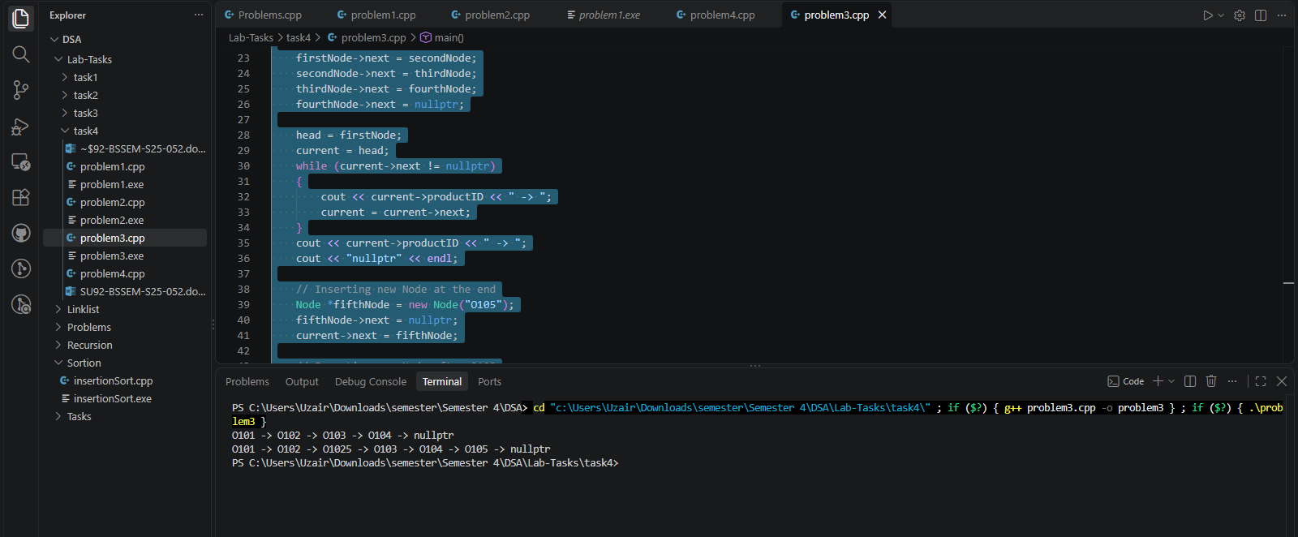

Problem 4
#include <iostream>
#include <string>
using namespace std;

struct Node
{
string productID;
Node *next;

Node(const string &id) : productID(id), next(nullptr) {}
};

Node *head = nullptr;
Node *current = nullptr;

int main()
{
Node *firstNode = new Node("E101");
Node *secondNode = new Node("E102");
Node *thirdNode = new Node("E103");
Node *fourthNode = new Node("E104");

firstNode->next = secondNode;
secondNode->next = thirdNode;
thirdNode->next = fourthNode;
fourthNode->next = nullptr;

// Inserting new Node after E102
head = firstNode;
current = head;
while (current->productID != "E102")
{
current = current->next;
}

Node *fifthNode = new Node("E1025");
fifthNode->next = current->next;
current->next = fifthNode;

// Inserting new Node after E103
current = head;
while (current->productID != "E103")
{
current = current->next;
}

Node *sixthNode = new Node("E1035");
sixthNode->next = current->next;
current->next = sixthNode;

current = head;
while (current->next != nullptr)
{
cout << current->productID << " -> ";
current = current->next;
}
cout << current->productID << " -> ";
cout << "nullptr" << endl;
}
