Data Structure and algorithms (LAB)

Lab Task

Name: UzairAlam

Problem 1
#include <iostream>
using namespace std;
void bubbleSort(int arr[], int size, char order = 'A')
{
for (int i = 0; i < size - 1; i++)
{
for (int j = 0; j < size - 1 - i; j++)
{
if ((arr[j] > arr[j + 1] && order == 'A') || (arr[j] < arr[j + 1] && order == 'D'))
{
int temp = arr[j];
arr[j] = arr[j + 1];
arr[j + 1] = temp;
}
}
}
}

void printArr(int arr[], int size)
{
for (int i = 0; i < size; i++)
cout << arr[i] << " ";
cout << endl;
}

int main()
{
int size = 5;
int arr[size] = {65, 42, 89, 55, 30};
bubbleSort(arr, size);

printArr(arr, size);

return 0;
}
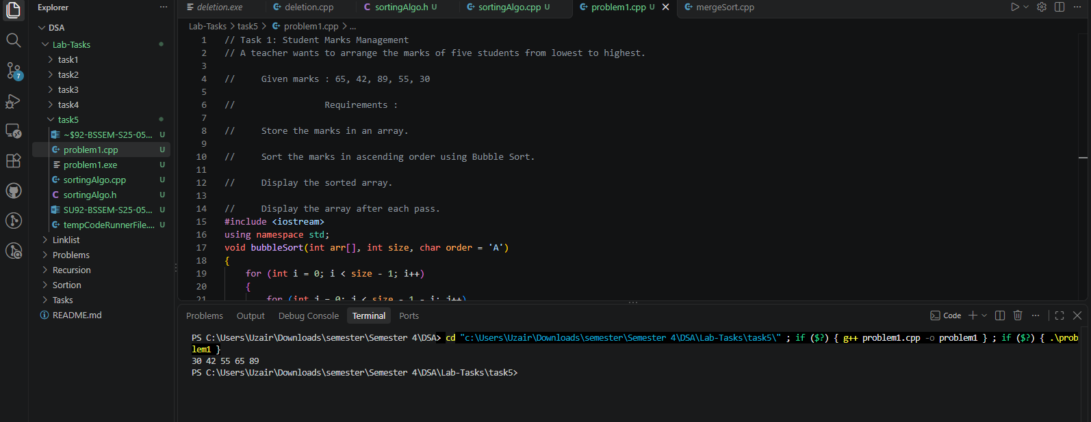

Problem 2
#include <iostream>
using namespace std;
void selectionSort(int arr[], int size, char order = 'A')
{
order = toupper(order);
for (int i = 0; i < size - 1; i++)
{
int index = i;
for (int j = i + 1; j < size; j++)
{

if ((arr[j] < arr[index] && order == 'A') || (arr[j] > arr[index] && order == 'D'))
{
index = j;
}
}
int temp = arr[i];
arr[i] = arr[index];
arr[index] = temp;
}
}

void printArr(int arr[], int size)
{
for (int i = 0; i < size; i++)
cout << arr[i] << " ";
cout << endl;
}

int main()
{
int size = 5;
int arr[size] = {450, 120, 300, 80, 250};
selectionSort(arr, size, 'D');

printArr(arr, size);

return 0;
}
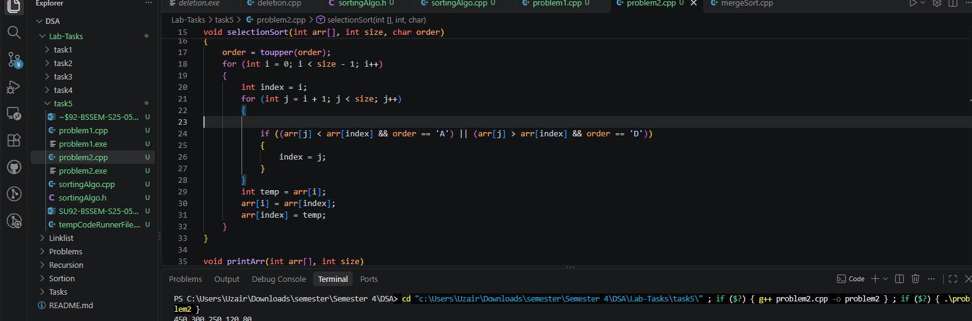

Problem 3
#include <iostream>
using namespace std;
void selectionSort(int arr[], int size, char order = 'A')
{
order = toupper(order);
for (int i = 0; i < size - 1; i++)
{
int index = i;
for (int j = i + 1; j < size; j++)
{

if ((arr[j] < arr[index] && order == 'A') || (arr[j] > arr[index] && order == 'D'))
{
index = j;
}
}
int temp = arr[i];
arr[i] = arr[index];
arr[index] = temp;
}
}

void printArr(int arr[], int size)
{
for (int i = 0; i < size; i++)
cout << arr[i] << " ";
cout << endl;
}

int main()
{
int size = 5;
int arr[size] = {12, 5, 18, 3, 9};
selectionSort(arr, size);

printArr(arr, size);

return 0;
}

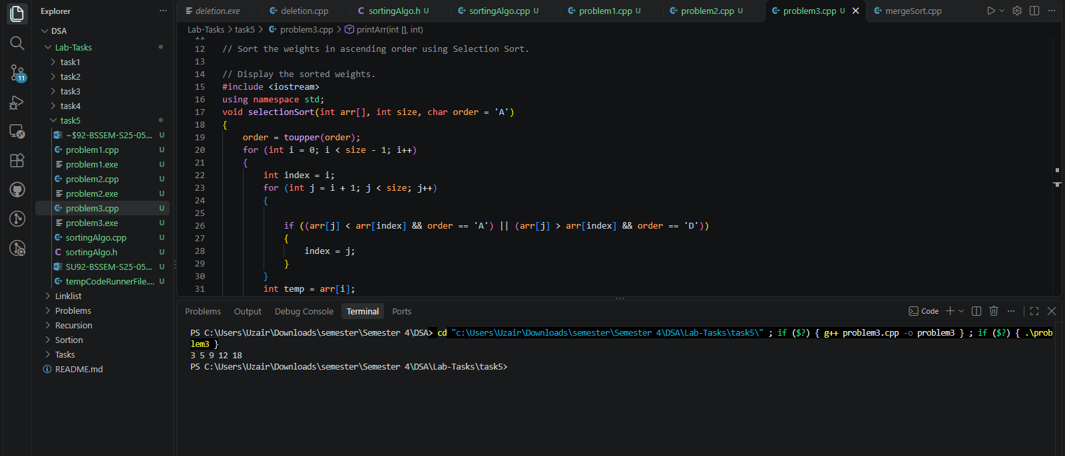

Problem 4
#include <iostream>
using namespace std;
void selectionSort(int arr[], int size, char order = 'A')
{
order = toupper(order);
for (int i = 0; i < size - 1; i++)
{
int index = i;
for (int j = i + 1; j < size; j++)
{

if ((arr[j] < arr[index] && order == 'A') || (arr[j] > arr[index] && order == 'D'))
{
index = j;
}
}
int temp = arr[i];
arr[i] = arr[index];
arr[index] = temp;
}
}
void bubbleSort(int arr[], int size, char order = 'A')
{
order = toupper(order);
for (int i = 0; i < size - 1; i++)
{
for (int j = 0; j < size - 1 - i; j++)
{
if ((arr[j] > arr[j + 1] && order == 'A') || (arr[j] < arr[j + 1] && order == 'D'))
{
int temp = arr[j];
arr[j] = arr[j + 1];
arr[j + 1] = temp;
}
}
}
}

void printArr(int arr[], int size)
{
for (int i = 0; i < size; i++)
cout << arr[i] << " ";
cout << endl;
}

int main()
{
int size = 5;
int arr[size] = {72, 45, 90, 60, 35};
cout << "Using Selection Sort!\n";
selectionSort(arr, size, 'D');
printArr(arr, size);

cout << "Using Bubble Sort!\n";
bubbleSort(arr, size, 'D');
printArr(arr, size);

return 0;
}

