SoC-Based Out-of-Band Encryption Module with Key Management System

A Final Year / CE515 Project Report
This report presents a complete System-on-Chip (SoC) based hardware security solution implementing AES-256 encryption with an OS-independent Key Management System (KMS). The system is implemented on Zynq Zybo Z7-10 using PS–PL co-design methodology.

Abstract
Security of digital data has become a major concern in modern communication systems. Software-based encryption mechanisms rely heavily on operating systems, which may contain vulnerabilities. This project proposes a SoC-based out-of-band encryption module using AES-256 implemented in FPGA hardware. A dedicated Key Management System (KMS) is implemented in the Processing System (PS), while encryption and decryption are accelerated in Programmable Logic (PL). The design is validated through simulation, timing analysis, and functional verification.

1. Introduction
With the exponential growth of connected devices, secure data transmission has become critical. Traditional cryptographic solutions implemented in software are vulnerable to malware, OS backdoors, and side-channel attacks. Hardware-based cryptography using SoC platforms provides a more secure alternative by isolating sensitive operations.

2. Motivation and Problem Statement
Modern operating systems are complex and may expose cryptographic keys through software vulnerabilities. The motivation of this project is to eliminate dependency on the host OS by implementing encryption and key handling directly in hardware.

3. Project Objectives
- Design a secure SoC-based encryption architecture
- Implement AES-256 encryption/decryption in FPGA hardware
- Develop an OS-independent Key Management System
- Validate functionality using real hardware and simulation

4. SoC System Architecture
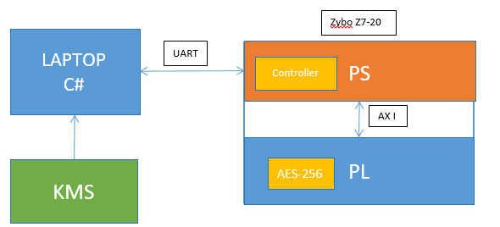
Figure 1: Proposed SoC out-of-band architecture (C# PC ↔ UART ↔ PS/PL with KMS and AES-256).

The proposed system follows a PS–PL co-design approach. The Processing System (ARM Cortex-A9) handles control, communication, and key management, while the Programmable Logic implements the AES-256 cryptographic accelerator.
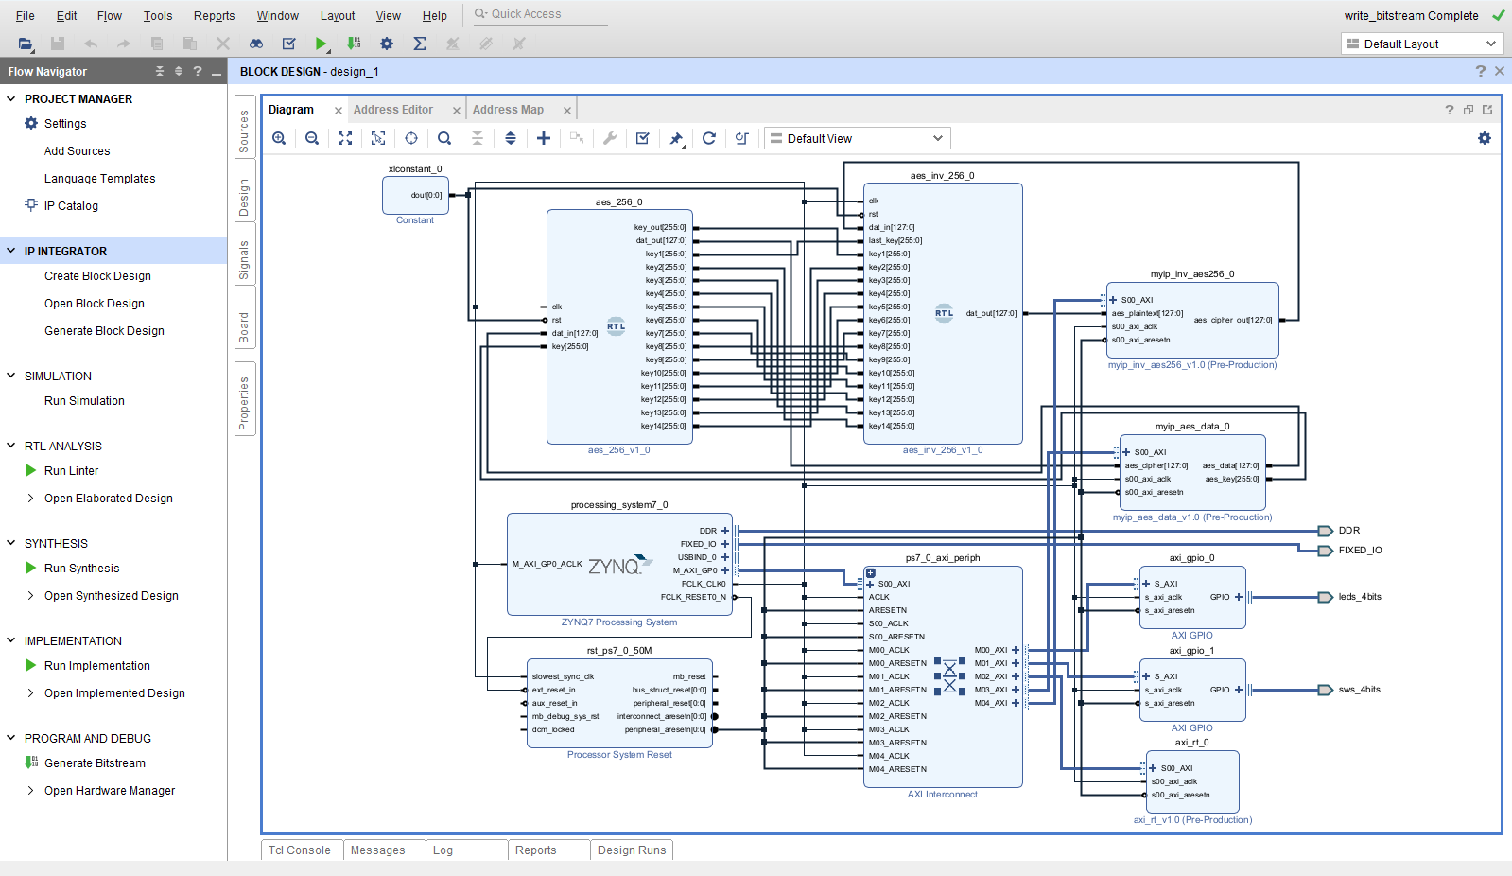

5. Hardware Platform: Zynq Zybo Z7-10
The Zynq Zybo Z7-10 board integrates a dual-core ARM processor with FPGA fabric on a single chip. AXI interconnects provide high-speed communication between PS and PL, making it ideal for secure SoC designs.

6. AES-256 Algorithm Overview
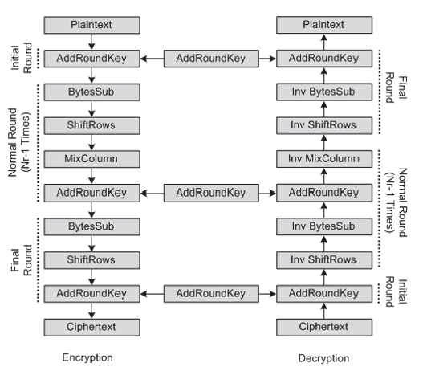
Figure 2: AES encryption and decryption round structure (high-level flow).

AES-256 is a symmetric block cipher standardized by NIST. It operates on 128-bit data blocks using a 256-bit key and performs 14 rounds of encryption. Each round consists of SubBytes, ShiftRows, MixColumns, and AddRoundKey operations.
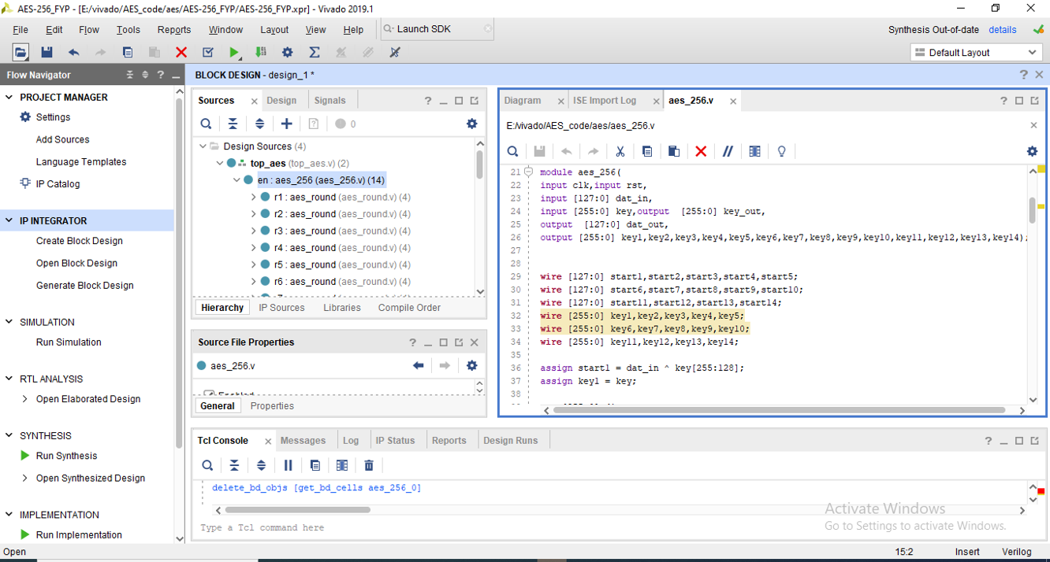

7. AES-256 Hardware Implementation in PL
The AES-256 core is implemented in Verilog HDL and synthesized using Vivado 2019.1. Round transformations and key expansion logic are implemented as modular RTL blocks.


8. Key Management System (KMS)
The Key Management System is implemented in the Processing System. It securely stores and transfers cryptographic keys to the AES core using AXI interfaces. Keys are never exposed to the host operating system.

9. Out-of-Band Communication (UART)
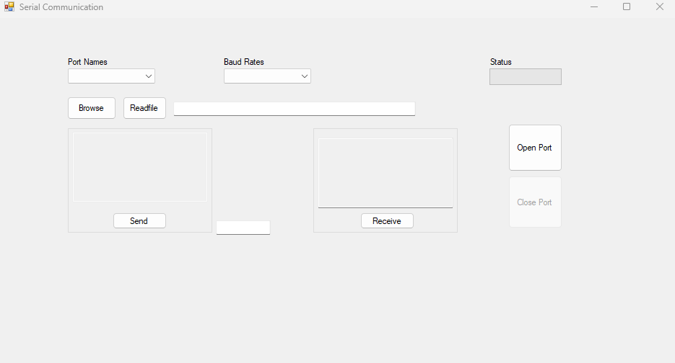
Figure 3: PC-side C# serial communication GUI used for UART data exchange.

UART is used as an out-of-band communication interface between the PC application and the SoC. Control commands and encrypted data are transmitted securely.

10. Functional Simulation and Verification
Functional verification is carried out using Vivado simulation tools. Known AES test vectors are used to verify correctness of encryption and decryption.
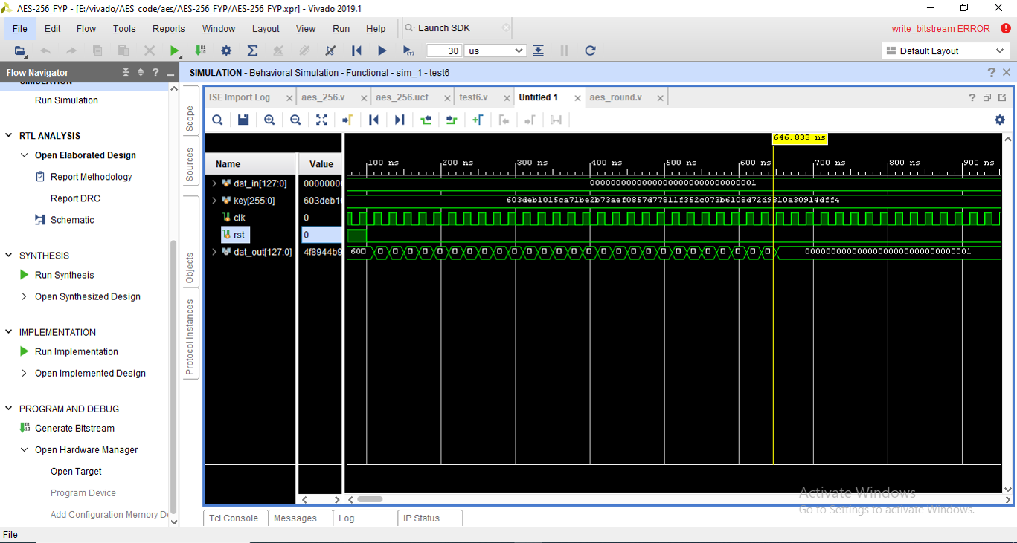

11. Synthesis and Timing Analysis
The design is synthesized and implemented using Vivado. Timing analysis confirms that all constraints are met with positive slack, ensuring reliable operation.
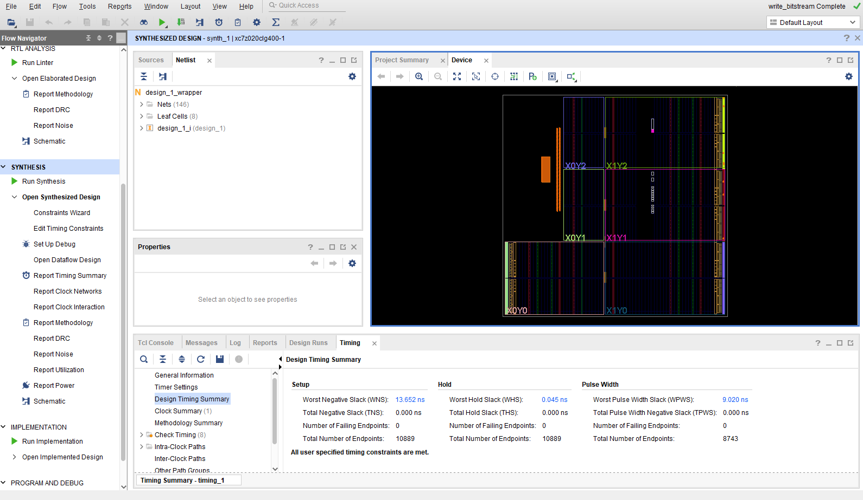

12. Results and Discussion
The implemented system successfully performs AES-256 encryption and decryption in hardware. Hardware acceleration significantly improves performance and security compared to software-only solutions.

13. Conclusion
This project demonstrates a complete SoC-based out-of-band encryption system with hardware-accelerated AES-256 and secure key management. The design validates the effectiveness of PS–PL co-design for hardware security applications.

14. Future Work
Future work includes integration of RSA/ECC for secure key exchange, secure boot support, and performance optimization through deeper pipelining.

10. Vitis (PS) Software Implementation
The Processing System (PS) software is developed using Xilinx Vitis Unified IDE. Its primary responsibility is to receive plaintext and cryptographic keys from the PC-side C# application via UART, configure the AES-256 hardware accelerator in the Programmable Logic (PL) through AXI-Lite registers, and return the encrypted or decrypted data back to the PC. This section describes the software architecture and data flow.

10.1 Role of PS Software
The Vitis application acts as a secure bridge between the external world and the FPGA logic. It performs UART communication, data formatting, register-level access to the AES core, and synchronization using control and status registers. All cryptographic computation is performed in hardware, ensuring OS-independent security.

10.2 Data Flow Between C#, PS, and PL
The PC application sends a 128-bit plaintext and a 256-bit AES key over UART. The PS receives this data, stores it in local buffers, and writes it to the AES IP registers in the PL using AXI-Lite. After triggering encryption or decryption, the PS polls the status register and reads back the 128-bit result, which is then transmitted back to the PC.
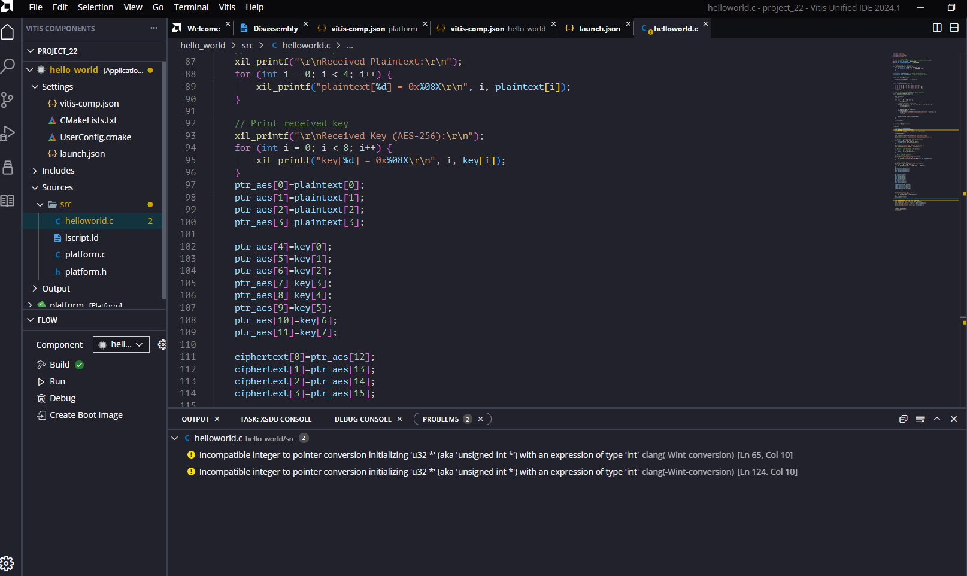
Figure: Vitis Unified IDE showing the PS application for UART communication and AXI access.

10.3 AXI-Lite Register Interface
The AES-256 hardware accelerator exposes a memory-mapped AXI-Lite interface. Plaintext is written as four 32-bit words, and the 256-bit key is written as eight 32-bit words. Control and status registers are used to start the operation and detect completion.

10.4 Vitis Software Implementation (Code Snippet)
The following code snippet illustrates the core functionality of the PS software, including UART reception, AXI register access, and result transmission. The use of Xil_In32 and Xil_Out32 ensures correct and safe access to hardware registers.
// Write plaintext to AES core
Xil_Out32(AES_BASEADDR + AES_PT0, plaintext[0]);
Xil_Out32(AES_BASEADDR + AES_PT1, plaintext[1]);
Xil_Out32(AES_BASEADDR + AES_PT2, plaintext[2]);
Xil_Out32(AES_BASEADDR + AES_PT3, plaintext[3]);
// Write 256-bit key
for (int i = 0; i < 8; i++) {
Xil_Out32(AES_BASEADDR + AES_K0 + (i * 4), key[i]);
}
// Start encryption
Xil_Out32(AES_BASEADDR + AES_CTRL, CTRL_START);
// Wait for completion
while ((Xil_In32(AES_BASEADDR + AES_STATUS) & ST_DONE) == 0);
// Read ciphertext
ciphertext[0] = Xil_In32(AES_BASEADDR + AES_OUT0);
ciphertext[1] = Xil_In32(AES_BASEADDR + AES_OUT0 + 4);
ciphertext[2] = Xil_In32(AES_BASEADDR + AES_OUT0 + 8);
ciphertext[3] = Xil_In32(AES_BASEADDR + AES_OUT0 + 12);
This software-hardware interaction completes the secure out-of-band encryption and decryption loop, demonstrating a full SoC-based cryptographic system.

11. ARM NEON Optimization Lab (Standalone – PS Side)
In addition to the FPGA-based AES acceleration, ARM NEON SIMD extensions available on the Cortex-A9 Processing System were explored to accelerate data-parallel algorithms. This lab focuses on evaluating the performance benefits of NEON intrinsics compared to classical C implementations in a bare-metal environment on the Zybo Z7 platform. Only algorithmic implementation tasks are described in this section; performance results and measurements are intentionally omitted and will be added separately.
Results:

11.1 Task 1: Sum of an Array Using NEON
The objective of this task is to compute the sum of a large array using both scalar C code and ARM NEON SIMD instructions. An array of 2048 elements is allocated in memory, where each element is a 16-bit signed integer.
First, a reference implementation sum_c() is developed using a classical loop running on the ARM core. The execution time is measured using the Cortex-A9 global timer through the XTime_GetTime() function.
Next, a NEON-optimized version sum_ni() is implemented using NEON intrinsics. Multiple array elements are loaded into NEON registers and accumulated in parallel, thereby increasing computational throughput. This implementation demonstrates how SIMD processing improves efficiency when handling data smaller than the processor register size.
Results:

11.2 Task 2: Matrix Multiplication Using NEON
This task focuses on accelerating matrix multiplication using the NEON engine. Two 4×4 matrices A and B containing 32-bit floating-point values are defined, and their product is stored in matrix C.
A baseline implementation mat_product_c() computes the matrix product using nested loops. This implementation serves as a functional reference.
A NEON-based implementation mat_product_ni() is then developed using NEON intrinsics. Vector registers are used to load matrix rows and columns, allowing multiple multiply-accumulate operations to be performed simultaneously. This approach significantly reduces the number of instructions required compared to the scalar version.

11.3 Task 3: Edge Detection Using NEON
The goal of this task is to implement an edge detection algorithm on a two-dimensional array using both scalar and NEON-optimized approaches. The input array is a 1024×1024 image, where each element is an 8-bit unsigned integer.
For each pixel C, the gradient magnitude |G| is approximated using neighboring pixels according to the following expression:
|G| = |E − W| + |N − S|
A reference C implementation edge_c() computes the gradient and compares it against a threshold to determine whether an edge is present. The result is stored in a binary output array.
The NEON-optimized version edge_ni() processes multiple pixels simultaneously using vectorized absolute difference and addition operations. This task demonstrates the suitability of NEON SIMD instructions for image processing and data-parallel workloads.
The edge detection task highlights how NEON acceleration can significantly improve performance for large-scale signal and image processing applications on ARM-based SoCs.
Results:

