RIPHAH INTERNATIONAL UNIVERSITY
Riphah School of Computing & Innovation
Lahore Campus

SOFTWARE PROJECT MANAGEMENT
Project Documentation Template

Based on IEEE Standard 1058-1998

Project Title: | VoicePilot
1st Student Name: | Daniyal Wajid
Roll Number: | 48528
2nd Student Name: | Uzair Hassan
Roll Number: | 48525
Instructor: | Adnan Ahmad
Semester: | Fall 2025
Submission Date: | 14/01/26

Table of Contents
Table of Contents 2
PHASE 1: Project Proposal & Feasibility Study (5 Marks) 7
1.1 Executive Summary 7
1.2 Project Overview 7
1.2.1 Project Purpose, Scope, and Objectives 7
1.2.2 Assumptions and Constraints 9
1.2.3 Project Deliverables 9
1.3 Feasibility Analysis 10
1.3.1 Technical Feasibility 10
1.3.2 Economic Feasibility 11
1.3.3 Operational Feasibility 11
1.3.4 Schedule Feasibility 12
1.4 Requirements Specification 12
1.4.1 Functional Requirements 12
1.4.2 Non-Functional Requirements 13
PHASE 2: Work Breakdown Structure & Estimation (5 Marks) 15
2.1 Work Breakdown Structure (WBS) 15
2.1.1 WBS Hierarchy 15
2.1.2 WBS Dictionary 16
2.2 Effort Estimation 18
2.2.1 Selected Estimation Technique 18
Technique Used: COCOMO I – Basic Model Tool Used: Manual COCOMO Calculation 18
2.2.2 COCOMO Estimation (If Selected) 18
2.3 Cost Estimation 19
PHASE 3: Project Scheduling (5 Marks) 20
3.1 Activity List 20
3.2 Gantt Chart 21
3.3 Critical Path Method (CPM) Analysis 22
3.3.1 Network Diagram 22
3.3.2 Forward Pass Calculation 22
3.3.3 Backward Pass Calculation 23
3.3.4 Slack Time Calculation 24
3.3.5 Critical Path 24
3.4 Project Calendar/Timeline 25
PHASE 4: Project Management Plans (5 Marks) 26
4.1 Communication Plan 26
4.1.1 Stakeholder Communication Matrix 26
4.1.2 RACI Matrix 27
4.2 Staffing Plan 27
4.2.1 Team Structure 27
4.2.2 Resource Allocation 27
4.3 Risk Management Plan 28
4.3.1 Risk Register 28
4.3.2 Risk Matrix 29
Risk Priority Interpretation 29
4.4 Quality Plan 29
4.4.1 Quality Objectives 29
4.4.2 Quality Assurance Activities 30
4.5 Procurement Plan 30
4.5.1 Procurement Items 30
PHASE 5: Tool Usage Documentation (Required) 31
5.1 Taiga Setup & Usage 31
5.1.1 Project Setup 31
5.1.2 Backlog Management 31
5.1.3 Timeline/Gantt View 32
5.2 Git/GitHub Setup & Usage 32
5.2.1 Repository Setup 32
5.3 Additional Tools Used 33
Appendices 34
Appendix A: Glossary of Terms 34
Appendix B: References 35

Note: Update this Table of Contents after completing the document by right-clicking and selecting 'Update Field'.

PHASE 1: Project Proposal & Feasibility Study (5 Marks)

Instructions: This section follows IEEE Standard 1058-1998. Complete all applicable sections for your project context.

1.1 Executive Summary
The Voice-Controlled Browser Automation Chrome Extension is an innovative software solution designed to enhance web browsing accessibility and efficiency through natural language voice commands. This project addresses the growing need for hands-free browser interaction, particularly beneficial for users with mobility limitations, multitasking scenarios, and modern accessibility requirements.
The extension leverages the Web Speech API to provide real-time voice recognition and command execution, enabling users to control browser tabs, navigate websites, perform searches, interact with web page elements, and manage bookmarks entirely through voice input. The system incorporates intelligent intent parsing to interpret natural language commands and execute corresponding browser actions seamlessly.
This project demonstrates the practical application of modern web technologies, including Chrome Extension Manifest V3, JavaScript ES6+, and browser automation APIs. The modular architecture ensures maintainability and extensibility, while comprehensive error handling and user feedback mechanisms provide a robust user experience. The project aligns with IEEE 1058-1998 standards for software project management, ensuring systematic planning, execution, and documentation throughout the development lifecycle.

1.2 Project Overview

1.2.1 Project Purpose, Scope, and Objectives
Purpose:
The primary purpose of this project is to develop a Chrome Extension that enables voice-controlled browser automation, providing users with an intuitive and accessible method to interact with web browsers using natural language voice commands. The extension aims to improve web browsing efficiency, accessibility, and user experience through hands-free operation.
Scope:
In-Scope: - Voice recognition using Web Speech API - Tab management (open, close, switch, reload) - Website navigation and URL handling - Google and YouTube search functionality - Page scrolling (up/down) - Element interaction (clicking buttons/links) - Window management (minimize/maximize) - Text-to-speech feedback for command confirmation - Error handling and user notifications - Chrome Extension Manifest V3 implementation - Cross-platform compatibility (Windows, macOS, Linux)
Out-of-Scope: - Mobile browser support (Android/iOS) - Offline voice recognition - Multi-language support beyond English - Complex form automation (multi-step workflows) - Browser history management - Download management - Extension settings synchronization across devices - Voice command customization interface

Objectives:
- Specific: Develop a fully functional Chrome Extension with voice recognition capabilities
- Measurable: Complete implementation of all 10 core command categories
- Achievable: Utilize existing Web Speech API and Chrome Extension APIs
- Relevant: Addresses accessibility and efficiency needs
- Time-bound: Complete within 12 weeks
- Specific: Achieve 85% accuracy rate in voice command recognition
- Measurable: Test with 100 sample voice commands across different users
- Achievable: Leverage Web Speech API’s proven recognition capabilities
- Relevant: Ensures reliable user experience
- Time-bound: Validate during testing phase (Week 10-11)
- Specific: Implement modular architecture with separation of concerns
- Measurable: Minimum 5 distinct modules (voiceEngine, intentParser, commandExecutor, etc.)
- Achievable: Follow software engineering best practices
- Relevant: Ensures maintainability and extensibility
- Time-bound: Complete architecture design by Week 3

- Specific: Create comprehensive documentation and user guide
- Measurable: README with installation, usage, and troubleshooting sections
- Achievable: Document as development progresses
- Relevant: Essential for user adoption and maintenance
- Time-bound: Complete documentation by Week 11
- Specific: Ensure zero critical security vulnerabilities
- Measurable: Pass Chrome Web Store security review
- Achievable: Follow Chrome Extension security best practices
- Relevant: Critical for user trust and distribution
- Time-bound: Security audit completed by Week 11

1.2.2 Assumptions and Constraints
Assumptions:
- Users have access to a functioning microphone and internet connection
- Users are using Chrome browser version 88 or higher (Manifest V3 support)
- Users have basic understanding of voice command syntax
- Web Speech API services are available and accessible
- Target websites are accessible and not blocked by network restrictions
- Users have appropriate permissions granted to the extension
- Development team has access to Chrome Developer Tools and testing environments
- Project stakeholders are available for feedback during review phases

Constraints:
- Technical Constraints:
- Limited to Chrome/Chromium-based browsers (Edge, Opera)
- Web Speech API requires active internet connection
- Voice recognition accuracy depends on microphone quality and ambient noise
- Chrome Extension Manifest V3 limitations on background scripts
- Content Security Policy restrictions on inline scripts
- Resource Constraints:
- Single developer (student project)
- Limited budget (academic project, no external funding)
- Development time limited to one semester (12-14 weeks)
- No access to paid APIs or cloud services
- Functional Constraints:
- Voice commands must be in English (US locale)
- Cannot execute commands on Chrome internal pages (chrome://)
- Limited to publicly accessible websites
- Cannot bypass website security measures or authentication
- Regulatory Constraints:
- Must comply with Chrome Web Store policies
- Privacy requirements for microphone access
- GDPR considerations for user data handling

1.2.3 Project Deliverables
S.No | Deliverable | Description | Due Date
1 | Project Plan | Complete SPM documentation following IEEE 1058-1998 | Week 1
2 | Requirements Specification | Functional and non-functional requirements document | Week 2
3 | System Design Document | Architecture, module design, and interface specifications | Week 3
4 | Source Code | Complete Chrome Extension implementation | Week 4
5 | Unit & Integration Test | Test cases for all modules | Week 5
6 | User Documentation | README, installation guide, user manual | Week 6
7 | Deployment Package | Packaged extension ready for Chrome Web Store | Week 7
8 | Final Presentation | Project demonstration and presentation | Week 8

1.3 Feasibility Analysis

1.3.1 Technical Feasibility
Analysis: The project is technically feasible based on the following factors:
- Available Technologies:
- Web Speech API (SpeechRecognition) is well-documented and widely supported
- Chrome Extension APIs (tabs, scripting, bookmarks) are mature and stable
- JavaScript ES6+ provides necessary language features
- Chrome Developer Tools enable effective debuggin
- Technical Complexity:
Moderate complexity requiring understanding of:
    - Chrome Extension architecture (Manifest V3)
    - Web Speech API integration
    - Natural language processing basics
    - Browser automation techniques
All technologies are within student capability level
- Risk Assessment:
- Low risk: Technologies are proven and documented
- Medium risk: Voice recognition accuracy may vary
- Mitigation: Implement fallback mechanisms and clear error messages
Conclusion: Technically feasible with available technologies and student expertise level.

1.3.2 Economic Feasibility

Cost Category | Item | Estimated Cost (PKR)
Development | Student time (8 weeks @ 14 hrs/week) | 0 (Academic)
Tools | Chrome DevTools, VS Code (Free) | 0
Testing | Browser testing, user testing | 0
Hosting | Chrome Web Store (Free) | 0
Documentation | Software licenses (Free tools) | 0
Total Project Cost |  | 0 PKR
Benefits: - Enhanced browsing accessibility - Improved user productivity - Learning experience for student - Potential for future commercialization - Portfolio project for career development
Conclusion: Highly economically feasible as an academic project with zero monetary investment required.

1.3.3 Operational Feasibility
Analysis:
- User Acceptance:
- Voice-controlled interfaces are increasingly popular (Siri, Alexa, Google Assistant)
- Addresses accessibility needs
- Potential high user adoption

- Integration:
- Seamless integration with existing Chrome browser
- No additional software installation required
- Minimal learning curve for users
- Maintenance:
- Modular architecture facilitates easy maintenance
- Chrome Extension updates are straightforward
- Community support available
- Support Requirements:
- Minimal support needed (self-explanatory interface)
- Documentation provides troubleshooting guidance
- User community can provide peer support
Conclusion: Operationally feasible with high user acceptance potential and low maintenance requirements.

1.3.4 Schedule Feasibility
Timeline Analysis:
- Total Duration: 8 weeks
- Available Time: 14 hours per week
- Total Effort: 112 hours
Milestone Breakdown:
Weeks 1-2: Planning & Requirement Analysis (28 hours)
Weeks 3-4: Design & Development (28 hours)
Weeks 5-6: Testing & Documentation (28 hours)
Weeks 7-8: Deployment & Final Review (28 hours)
Critical Path: 1. Requirements → Design → Development → Testing → Deployment

1.4 Requirements Specification

1.4.1 Functional Requirements
FR-ID | Requirement | Description | Priority
FR-001 | Voice Recognition | The system shall recognize voice commands using Web Speech API with continuous listening mode | High
FR-002 | Tab Management | The system shall support opening, closing, switching, and reloading browser tabs via voice commands | High
FR-003 | Website Navigation | The system shall navigate to specified URLs or common websites using voice commands | High
FR-004 | Search Functionality | The system shall perform Google and YouTube searches based on voice input | High
FR-005 | Page Scrolling | The system shall scroll web pages up or down based on voice commands | Medium
FR-006 | Element Interaction | The system shall click buttons, links, and other interactive elements using voice commands | Medium
FR-007 | Bookmark Management | The system shall add and remove bookmarks for the current page using voice commands | Low
FR-008 | Window Management | The system shall minimize and maximize browser windows using voice commands | Low
FR-009 | Voice Feedback | The system shall provide audio confirmation of executed commands using text-to-speech | High
FR-010 | Error Handling | The system shall handle unrecognized commands and provide appropriate error messages | High
FR-011 | Start/Stop Control | The system shall provide UI controls to start and stop voice recognition | High
FR-012 | Status Indication | The system shall display current listening status (active/inactive) in the popup UI | Medium
FR-013 | Intent Parsing | The system shall parse natural language voice commands into structured intents | High

1.4.2 Non-Functional Requirements
NFR-ID | Category | Metric | Priority
NFR-001 | Performance | Voice recognition response time < 2 seconds, command execution < 1 second | High
NFR-002 | Reliability | System uptime > 99%, error rate < 5% | High
NFR-003 | Usability | User can learn basic commands within 5 minutes, intuitive UI design | High
NFR-004 | Compatibility | Support Chrome 88+, Edge 88+, Opera 74+ | High
NFR-005 | Security | Pass Chrome Web Store security review, no data collection without consent | High
NFR-006 | Maintainability | Modular code structure, comprehensive comments, documentation | Medium
NFR-007 | Scalability | Architecture supports adding new command types without major refactoring | Low
NFR-008 | Accessibility | Voice interface accessible to users with mobility limitations | Medium
NFR-009 | Portability | Code structure allows potential porting to other browsers | Low
NFR-010 | Efficiency | Minimal memory footprint (< 50MB), CPU usage < 5% during idle | Medium

PHASE 2: Work Breakdown Structure & Estimation (5 Marks)

Instructions: Create WBS with at least 3 levels of decomposition. Apply estimation techniques and use tools like Taiga, JIRA, or online COCOMO calculator.

2.1 Work Breakdown Structure (WBS)

2.1.1 WBS Hierarchy
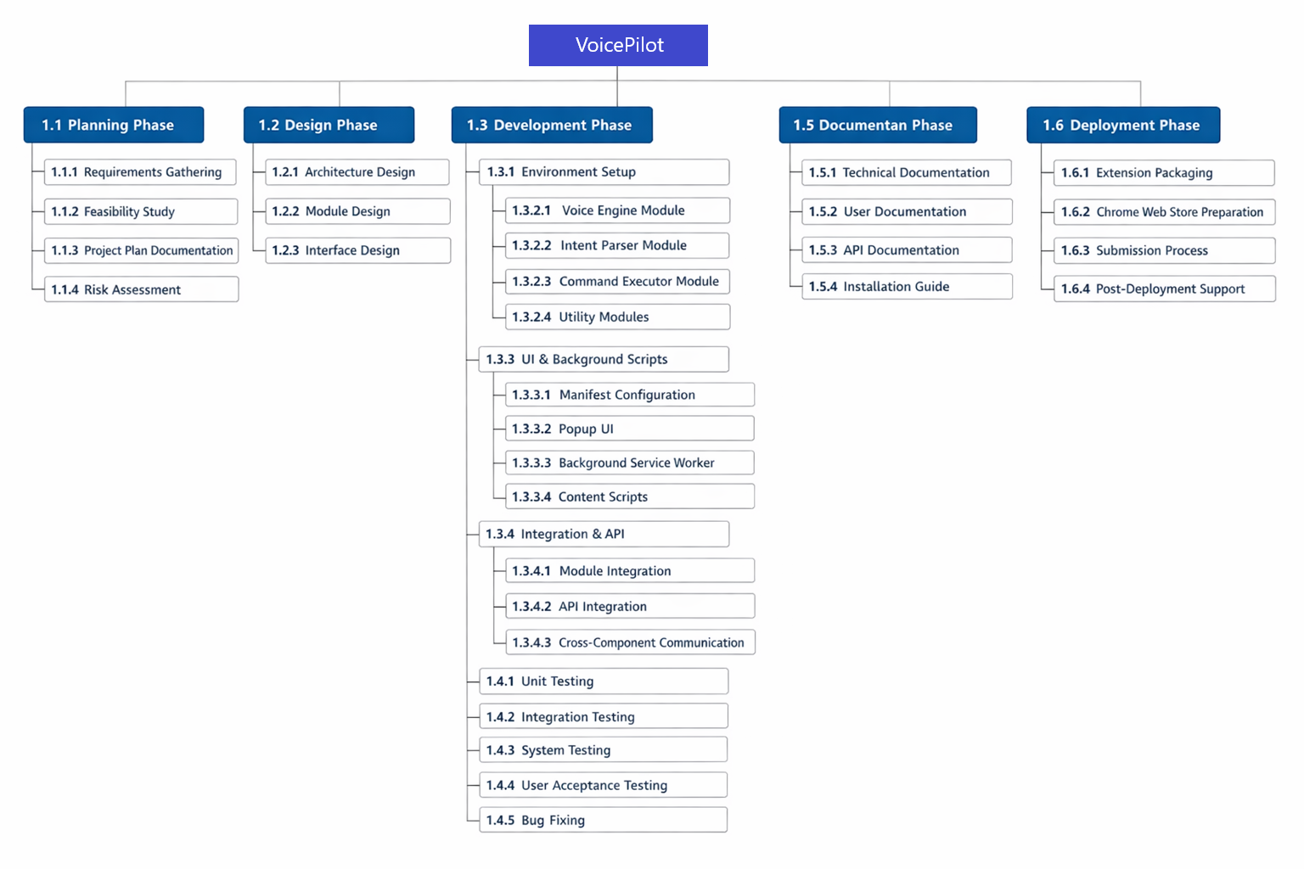

2.1.2 WBS Dictionary
WBS ID | Task Name | Description | Deliverable | Predecessor | Days | Resources
1.1.1 | Requirements Gathering | Collect and document functional and non-functional requirements | Requirements Document | - | 5 | Developer
1.1.2 | Feasibility Study | Analyze technical, economic, operational, and schedule feasibility | Feasibility Report | 1.1.1 | 3 | Developer
1.1.3 | Project Plan Documentation | Create comprehensive project plan following IEEE 1058-1998 | Project Plan Document | 1.1.2 | 7 | Developer
1.1.4 | Risk Assessment | Identify and analyze project risks | Risk Register | 1.1.2 | 2 | Developer
1.2.1 | Architecture Design | Design system architecture and component structure | Architecture Document | 1.1.3 | 5 | Developer
1.2.2 | Module Design | Design individual modules and their interfaces | Module Design Document | 1.2.1 | 4 | Developer
1.2.3 | Interface Design | Design UI/UX for popup interface | UI Mockups | 1.2.1 | 3 | Developer
1.3.1 | Environment Setup | Set up development environment and tools | Configured Environment | 1.2.2 | 2 | Developer
1.3.2.1 | Voice Engine Module | Implement voice recognition and TTS functionality | voiceEngine.js | 1.3.1 | 5 | Developer
1.3.2.2 | Intent Parser Module | Implement natural language parsing | intentParser.js | 1.3.1 | 6 | Developer
1.3.2.3 | Command Executor Module | Implement command execution logic | commandExecutor.js | 1.3.2.2 | 4 | Developer
1.3.2.4 | Utility Modules | Implement helper functions and utilities | utils/helpers.js | 1.3.1 | 2 | Developer
1.3.3.1 | Manifest Configuration | Create and configure manifest.json | manifest.json | 1.2.2 | 1 | Developer
1.3.3.2 | Popup UI | Develop popup HTML, CSS, and JavaScript | popup.html/css/js | 1.2.3 | 5 | Developer
1.3.3.3 | Background Service Worker | Implement background script for command execution | background.js | 1.3.2.3 | 6 | Developer
1.3.3.4 | Content Scripts | Implement content script for page interaction | contentScript.js | 1.3.2.1 | 4 | Developer
1.3.4.1 | Module Integration | Integrate all modules together | Integrated Codebase | 1.3.3.4 | 3 | Developer
1.3.4.2 | API Integration | Integrate Chrome Extension APIs | Working Extension | 1.3.4.1 | 2 | Developer
1.3.4.3 | Cross-component Communication | Implement message passing between components | Communication System | 1.3.4.2 | 2 | Developer
1.4.1 | Unit Testing | Write and execute unit tests for each module | Unit Test Suite | 1.3.4.3 | 5 | Developer
1.4.2 | Integration Testing | Test integrated components | Integration Test Results | 1.4.1 | 4 | Developer
1.4.3 | System Testing | End-to-end system testing | System Test Report | 1.4.2 | 5 | Developer
1.4.4 | User Acceptance Testing | Conduct UAT with sample users | UAT Report | 1.4.3 | 3 | Developer, Users
1.4.5 | Bug Fixing | Fix identified bugs and issues | Bug Fix Report | 1.4.4 | 4 | Developer
1.5.1 | Technical Documentation | Document technical architecture and code | Technical Docs | 1.4.5 | 3 | Developer
1.5.2 | User Documentation | Create user guide and README | User Manual | 1.4.5 | 3 | Developer
1.5.3 | API Documentation | Document APIs and interfaces | API Docs | 1.5.1 | 2 | Developer
1.5.4 | Installation Guide | Create installation and setup guide | Installation Guide | 1.5.2 | 1 | Developer
1.6.1 | Extension Packaging | Package extension for distribution | .crx/.zip Package | 1.5.4 | 1 | Developer
1.6.2 | Chrome Web Store Preparation | Prepare store listing and assets | Store Listing | 1.6.1 | 2 | Developer
1.6.3 | Submission Process | Submit extension to Chrome Web Store | Submitted Extension | 1.6.2 | 1 | Developer
1.6.4 | Post-Deployment Support | Monitor and address post-deployment issues | Support Log | 1.6.3 | Ongoing | Developer

2.2 Effort Estimation

2.2.1 Selected Estimation Technique

Technique Used: COCOMO I – Basic Model
Tool Used: Manual COCOMO Calculation

2.2.2 COCOMO Estimation (If Selected)

Parameter | Value
Project Type | Organic
Estimated KLOC | 3.05 KLOC
Effort (Person-Months) | 7.68
Development Time (Months) | 5.38
Team Size | 1

[Include screenshot of COCOMO calculation from the tool]

2.3 Cost Estimation
Resource/Item | Quantity | Rate | Total Cost (PKR)
Software Developer | 2 Person-Months | 80,000 / month | 160,000
QA / Testing Engineer | 2 Person-Months | 50,000 / month | 100,000
Project Management & Coordination | Included | — | 0
Testing Tools & User Evaluation | Included | — | 0
Development Tools & IDEs | — | Free / Open Source | 0
APIs & Browser Services | — | Free | 0
Infrastructure (Hardware, Internet, Power) | — | Existing | 0
Documentation & Training Material | Included | — | 0
Subtotal (Development Cost) |  |  | 260,000

PHASE 3: Project Scheduling (5 Marks)

Instructions: Create Gantt Chart showing all activities mapped on calendar. Apply CPM to identify critical path and calculate slack times. Use tools like Taiga, JIRA, MS Project, or GanttProject.

3.1 Activity List
ID | Activity Name | Duration (Days) | Predecessors | Resources | WBS Ref
A1 | Project Planning | 3 | – | Developer | 1.1.3
A2 | Requirements Gathering | 3 | A1 | Developer | 1.1.1
A3 | Feasibility Study | 2 | A2 | Developer | 1.1.2
A4 | Risk Assessment | 2 | A3 | Developer | 1.1.4
A5 | Architecture Design | 3 | A3 | Developer | 1.2.1
A6 | Module Design | 2 | A5 | Developer | 1.2.2
A7 | Interface Design | 2 | A5 | Developer | 1.2.3
A8 | Environment Setup | 2 | A6 | Developer | 1.3.1
A9 | Voice Engine Development | 3 | A8 | Developer | 1.3.2.1
A10 | Intent Parser Development | 3 | A8 | Developer | 1.3.2.2
A11 | Command Executor Development | 2 | A10 | Developer | 1.3.2.3
A12 | Utility Modules Development | 2 | A8 | Developer | 1.3.2.4
A13 | Manifest Configuration | 1 | A6 | Developer | 1.3.3.1
A14 | Popup UI Development | 3 | A7 | Developer | 1.3.3.2
A15 | Background Service Worker | 3 | A11 | Developer | 1.3.3.3
A16 | Content Scripts Development | 3 | A9 | Developer | 1.3.3.4
A17 | Module Integration | 2 | A15, A16 | Developer | 1.3.4.1
A18 | API Integration | 2 | A17 | Developer | 1.3.4.2
A19 | Cross-component Communication | 1 | A18 | Developer | 1.3.4.3
A20 | Unit Testing | 3 | A19 | Developer | 1.4.1
A21 | Integration Testing | 2 | A20 | Developer | 1.4.2
A22 | System Testing | 2 | A21 | Developer | 1.4.3
A23 | User Acceptance Testing | 2 | A22 | Developer, Users | 1.4.4
A24 | Bug Fixing | 2 | A23 | Developer | 1.4.5
A25 | Technical Documentation | 2 | A24 | Developer | 1.5.1
A26 | User Documentation | 2 | A24 | Developer | 1.5.2
A27 | API Documentation | 1 | A25 | Developer | 1.5.3
A28 | Installation Guide | 1 | A26 | Developer | 1.5.4
A29 | Extension Packaging | 1 | A28 | Developer | 1.6.1
A30 | Chrome Web Store Preparation | 2 | A29 | Developer | 1.6.2
A31 | Final Presentation & Submission | 2 | A30 | Developer | 1.6.3

3.2 Gantt Chart
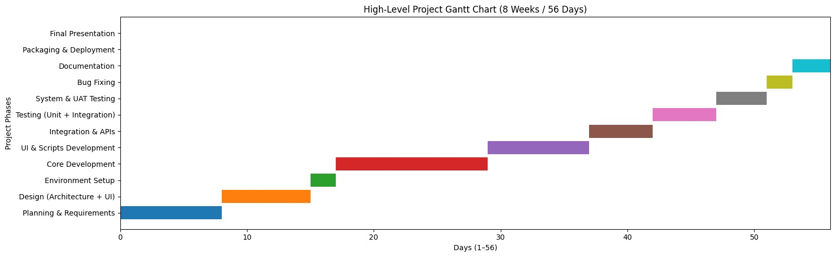

3.3 Critical Path Method (CPM) Analysis

3.3.1 Network Diagram
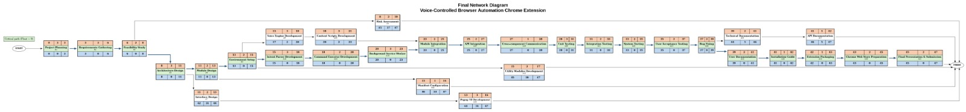

3.3.2 Forward Pass Calculation
Activity | Duration | ES (Early Start) | EF (Early Finish) | Calculation
A1 | 3 | 0 | 3 | 0 + 3
A2 | 3 | 3 | 6 | EF(A1) + 3
A3 | 2 | 6 | 8 | EF(A2) + 2
A5 | 3 | 8 | 11 | EF(A3) + 3
A6 | 2 | 11 | 13 | EF(A5) + 2
A8 | 2 | 13 | 15 | EF(A6) + 2
A10 | 3 | 15 | 18 | EF(A8) + 3
A11 | 2 | 18 | 20 | EF(A10) + 2
A15 | 3 | 20 | 23 | EF(A11) + 3
A17 | 2 | 23 | 25 | EF(A15) + 2
A18 | 2 | 25 | 27 | EF(A17) + 2
A19 | 1 | 27 | 28 | EF(A18) + 1
A20 | 3 | 28 | 31 | EF(A19) + 3
A21 | 2 | 31 | 33 | EF(A20) + 2
A22 | 2 | 33 | 35 | EF(A21) + 2
A23 | 2 | 35 | 37 | EF(A22) + 2
A24 | 2 | 37 | 39 | EF(A23) + 2
A26 | 2 | 39 | 41 | EF(A24) + 2
A28 | 1 | 41 | 42 | EF(A26) + 1
A29 | 1 | 42 | 43 | EF(A28) + 1
A30 | 2 | 43 | 45 | EF(A29) + 2
A31 | 2 | 45 | 47 | EF(A30) + 2

3.3.3 Backward Pass Calculation
Activity | Duration | LS (Late Start) | LF (Late Finish) | Calculation
A31 | 2 | 54 | 56 | 56 − 2
A30 | 2 | 52 | 54 | 54 − 2
A29 | 1 | 51 | 52 | 52 − 1
A28 | 1 | 50 | 51 | 51 − 1
A26 | 2 | 48 | 50 | 50 − 2
A24 | 2 | 46 | 48 | 48 − 2
A23 | 2 | 44 | 46 | 46 − 2
A22 | 2 | 42 | 44 | 44 − 2
A21 | 2 | 40 | 42 | 42 − 2
A20 | 3 | 37 | 40 | 40 − 3
A19 | 1 | 36 | 37 | 37 − 1
A18 | 2 | 34 | 36 | 36 − 2
A17 | 2 | 32 | 34 | 34 − 2
A15 | 3 | 29 | 32 | 32 − 3
A11 | 2 | 27 | 29 | 29 − 2
A10 | 3 | 24 | 27 | 27 − 3
A8 | 2 | 22 | 24 | 24 − 2
A6 | 2 | 20 | 22 | 22 − 2
A5 | 3 | 17 | 20 | 20 − 3
A3 | 2 | 15 | 17 | 17 − 2
A2 | 3 | 12 | 15 | 15 − 3
A1 | 3 | 9 | 12 | 12 − 3

3.3.4 Slack Time Calculation
Activity | ES | EF | LS | LF | Slack (LS-ES) | Critical?
A1 | 0 | 3 | 0 | 3 | 0 | Yes
A2 | 3 | 6 | 3 | 6 | 0 | Yes
A3 | 6 | 8 | 6 | 8 | 0 | Yes
A5 | 8 | 11 | 8 | 11 | 0 | Yes
A6 | 11 | 13 | 11 | 13 | 0 | Yes
A8 | 13 | 15 | 13 | 15 | 0 | Yes
A10 | 15 | 18 | 15 | 18 | 0 | Yes
A11 | 18 | 20 | 18 | 20 | 0 | Yes
A15 | 20 | 23 | 20 | 23 | 0 | Yes
A17 | 23 | 25 | 23 | 25 | 0 | Yes
A18 | 25 | 27 | 25 | 27 | 0 | Yes
A19 | 27 | 28 | 27 | 28 | 0 | Yes
A20 | 28 | 31 | 28 | 31 | 0 | Yes
A21 | 31 | 33 | 31 | 33 | 0 | Yes
A22 | 33 | 35 | 33 | 35 | 0 | Yes
A23 | 35 | 37 | 35 | 37 | 0 | Yes
A24 | 37 | 39 | 37 | 39 | 0 | Yes
A26 | 39 | 41 | 39 | 41 | 0 | Yes
A28 | 41 | 42 | 41 | 42 | 0 | Yes
A29 | 42 | 43 | 42 | 43 | 0 | Yes
A30 | 43 | 45 | 43 | 45 | 0 | Yes
A31 | 45 | 47 | 45 | 47 | 0 | Yes

3.3.5 Critical Path
Critical Path: A1 → A2 → A3 → A5 → A6 → A8 → A10 → A11 → A15 → A17 → A18 → A19 → A20 → A21 → A22 → A23 → A24 → A26 → A28 → A29 → A30 → A31
Total Project Duration: 56 Days

3.4 Project Calendar/Timeline
Phase/Milestone | Start Date | End Date | Duration
Phase 1: Planning & Analysis | Day 1 | Day 8 | 8 Days
Phase 2: Design | Day 9 | Day 15 | 7 Days
Phase 3: Development | Day 16 | Day 35 | 20 Days
Phase 4: Testing | Day 36 | Day 47 | 12 Days
Phase 5: Deployment & Documentation | Day 48 | Day 56 | 9 Days
Project Completion | Day 1 | Day 56 | 56 Days

PHASE 4: Project Management Plans (5 Marks)

Instructions: Develop all relevant plans including Communication, Staffing, Procurement, Risk, Quality, and Resource Plans.

4.1 Communication Plan

4.1.1 Stakeholder Communication Matrix
Stakeholder | Information Needs | Frequency | Method | Responsible
Instructor | Progress updates, guidance | Weekly | Email, Meetings | Developer
Project Supervisor | Technical review, feedback | Bi-weekly | Email, Meetings | Developer
End Users (Testing) | Feedback during UAT | During UAT | Surveys, Interviews | Developer
Development Team | Status updates, blockers | Daily (if team) | Daily Standups | Developer
University Administration | Academic compliance reports | Monthly | Formal Reports | Developer

Communication Channels:
- Email: Primary formal communication
- Meetings: Weekly progress reviews
- Documentation: Project repository (GitHub)
- Presentations: Mid-term and final presentations
Communication Protocols:
- Response time: 24–48 hours for emails
- Meeting minutes: Documented and shared
- Status reports: Weekly written updates
- Escalation: Issues reported within 24 hours

4.1.2 RACI Matrix
[R=Responsible, A=Accountable, C=Consulted, I=Informed]

Activity/Deliverable | PM | Developer | Tester | Client | Sponsor
Requirements Gathering | A | R | C | I | C
System Design | A | R | – | – | C
Development | A | R | – | – | I
Unit Testing | A | R | – | – | I
Integration Testing | A | R | – | – | C
System Testing | A | R | – | I | C
User Acceptance Testing | R | C | – | A | C
Documentation | A | R | – | – | C
Deployment | A | R | – | – | C
Bug Fixing | A | R | – | I | I

4.2 Staffing Plan

4.2.1 Team Structure
The project follows a single-developer academic team structure.
All roles including Project Manager, Developer, Tester, and Technical Writer are performed by the student developer, under the supervision of the instructor and project supervisor. External users participate only during the User Acceptance Testing phase.

4.2.2 Resource Allocation
Role | Name/ID | Allocation % | Skills Required | Duration
Project Manager | Developer (Student) | 100% | Project management, communication | Full Project
Developer | Developer (Student) | 100% | JavaScript, Chrome APIs, Web Speech API | Weeks 1–8
Tester | Developer (Student) | 30% | Testing methodologies, QA | Weeks 6–7
Technical Writer | Developer (Student) | 20% | Technical writing, documentation tools | Weeks 7–8
User Tester | External Users | 10% | Basic computer skills | UAT Phase

4.3 Risk Management Plan

4.3.1 Risk Register
ID | Risk Description | Probability | Impact | Priority | Mitigation Strategy
R1 | Web Speech API unavailable or unreliable | Medium | High | High | Test API early, implement fallback mechanisms
R2 | Voice recognition accuracy below threshold | Medium | High | High | Command confirmation and improved parsing
R3 | Chrome API changes | Low | High | Medium | Monitor release notes, use stable APIs
R4 | Insufficient development time | Medium | High | High | Prioritize core features, agile planning
R5 | Academic workload conflicts | High | Medium | Medium | Buffer time, task prioritization
R6 | Browser compatibility issues | Medium | Medium | Medium | Early multi-browser testing
R7 | Security vulnerabilities | Low | High | High | Follow security best practices
R8 | Low user adoption | Low | Low | Low | Improve UX and documentation

4.3.2 Risk Matrix
Probability / Impact | Low Impact | Medium Impact | High Impact
High Probability | R5 (Academic workload conflicts) | R4 (Insufficient development time) | R1 (Web Speech API issues)
Medium Probability | R8 (Low user adoption) | R2 (Voice recognition accuracy), R6 (Browser compatibility), R10 (Post-deployment bugs), R11 (Microphone permission issues), R12 (Performance issues) | R7 (Security vulnerabilities)
Low Probability | R8 (Low user adoption) | R3 (Chrome API changes), R9 (Extension rejection) | —

Risk Priority Interpretation
- High Risk (Red Zone):
Risks with High Impact and Medium/High Probability
Immediate monitoring and mitigation required
(R1, R2, R4, R7)
- Medium Risk (Yellow Zone):
Risks with Medium Impact or Probability
Regular monitoring
(R3, R5, R6, R9, R10, R11, R12)
- Low Risk (Green Zone):
Risks with Low Impact and Low Probability
Minimal monitoring
(R8)

4.4 Quality Plan

4.4.1 Quality Objectives
- Code coverage ≥ 80%
- Code follows JavaScript best practices (ESLint)
- All functional requirements implemented (100%)
- Voice recognition accuracy ≥ 85%
- Command execution success rate ≥ 90%
- Response time < 2 seconds
- User satisfaction ≥ 4/5

4.4.2 Quality Assurance Activities
Activity | Description | Frequency | Responsible
Requirements Review | Validate requirements completeness | Once | Developer, Instructor
Design Review | Inspect system architecture | Once | Developer, Supervisor
Code Review | Review code for standards | Each module | Developer
Unit Testing | Test individual components | Continuous | Developer
Integration Testing | Test module interactions | Weekly | Developer
System Testing | Verify system requirements | Once | Developer
User Acceptance Testing | Validate user satisfaction | Once | Developer, Users
Final Review | Ensure readiness for deployment | Once | Developer, Instructor

4.5 Procurement Plan

4.5.1 Procurement Items
Item/Service | Vendor/Source | Estimated Cost | Procurement Date
Development Tools | Visual Studio Code, Chrome DevTools | 0 (Free / Open Source) | Environment Setup Phase
Version Control System | GitHub (Free Tier) | 0 (Free) | Environment Setup Phase
Testing Tools | Chrome Browser, Built-in DevTools, Manual Testing | 0 (Free) | Testing Phase
Documentation Tools | Markdown Editors, MS Word / Google Docs | 0 (Free) | Documentation Phase
Hosting & Deployment | Chrome Web Store (Developer Console) | 0 (Free) | Deployment Phase

PHASE 5: Tool Usage Documentation (Required)

IMPORTANT: This section demonstrates your practical use of project management tools. Include screenshots with explanations for full marks (20% of rubric).

5.1 Taiga Setup & Usage

5.1.1 Project Setup
Taiga Project URL: https://tree.taiga.io/project/daniyal_94-voicepilot/timeline

5.1.2 Backlog Management

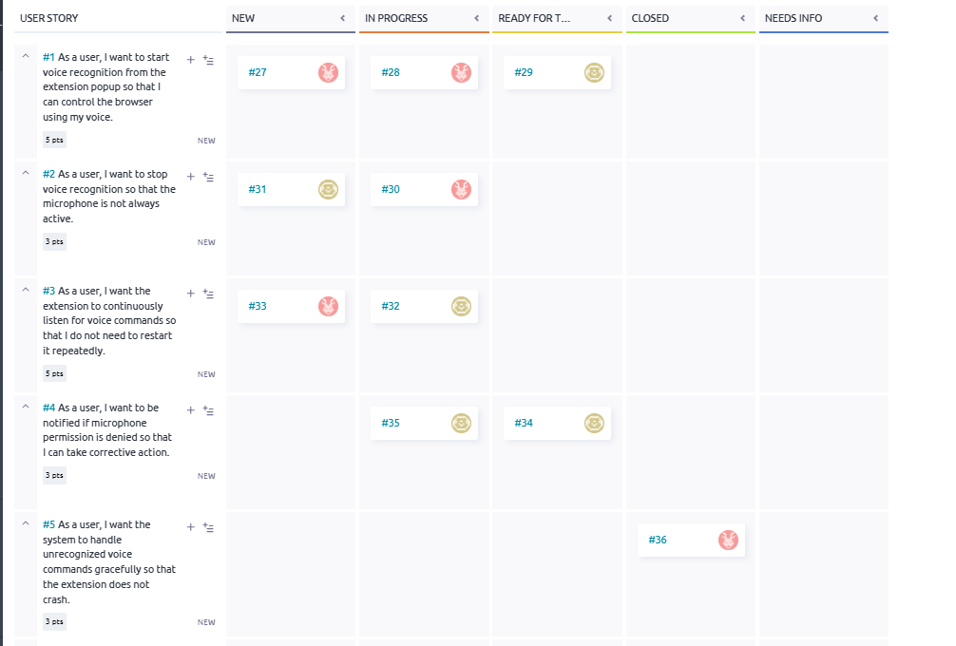

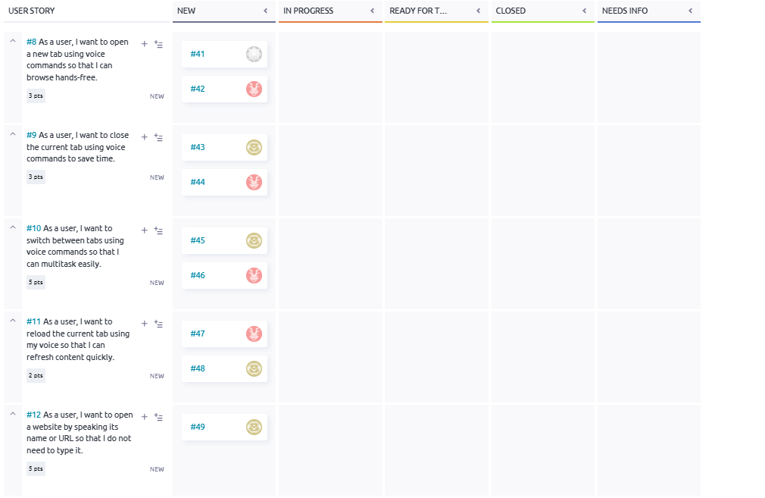

5.1.3 Timeline/Gantt View
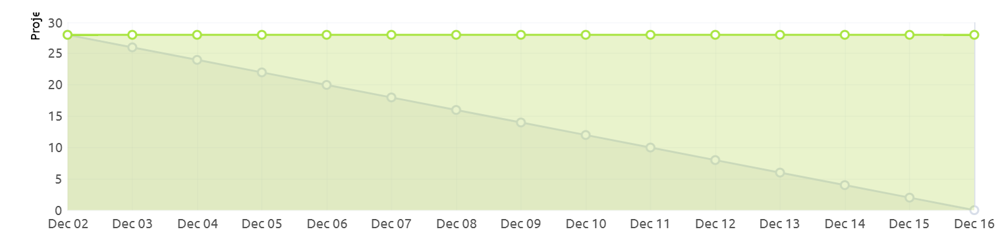

5.2 Git/GitHub Setup & Usage

5.2.1 Repository Setup
GitHub Repository URL: https://github.com/uzairhassan375/SPM-Project.git

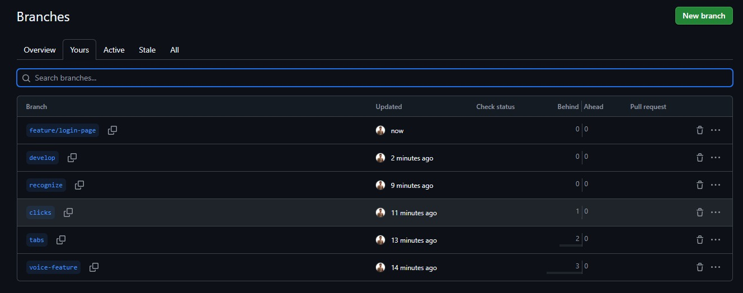

5.3 Additional Tools Used
[Document any other tools used - MS Project, JIRA, Trello, Click-up, etc.]

Tool Name | Purpose
Visual Studio Code | Code development & debugging
Git | Source code management
GitHub | Collaboration & code hosting
Taiga | Sprint & task management
Google Chrome | Development & testing
Chrome DevTools | Extension debugging
Chrome Extension Test Framework | Automated testing
Markdown | Technical & user documentation
Figma (Optional) | UI mockups
Email | Stakeholder communication
ESLint | Code linting & standards
npm (Optional) | Dependency management
Postman (Optional) | API validation

Appendices

Appendix A: Glossary of Terms
Term | Definition
Chrome Extension | A software program that extends the functionality of the Google Chrome browser
Manifest V3 | The third version of Chrome Extension manifest specification
Web Speech API | Browser API that provides speech recognition and synthesis capabilities
Service Worker | Background script that runs independently of web pages in Manifest V3
Content Script | JavaScript code that runs in the context of web pages
Intent Parsing | Process of converting natural language into structured command representations
CPM | Critical Path Method - project scheduling technique
WBS | Work Breakdown Structure - hierarchical decomposition of project work
COCOMO | Constructive Cost Model - software cost estimation model
RACI | Responsibility Assignment Matrix (Responsible, Accountable, Consulted, Informed)
UAT | User Acceptance Testing - final testing phase with end users
TTS | Text-to-Speech - conversion of text to spoken audio
STT | Speech-to-Text - conversion of speech to text
API | Application Programming Interface - set of protocols for building software
CRX | Chrome Extension package file format
CSP | Content Security Policy - security standard for preventing XSS attacks
MVP | Minimum Viable Product - version with minimum features for release
Agile | Iterative software development methodology
Scrum | Agile framework for managing product development
Kanban | Visual workflow management method
Burndown Chart | Graphical representation of work remaining over time
Velocity | Measure of work completed per sprint in agile development
Pull Request | Proposed changes to a codebase submitted for review
Commit | Snapshot of changes in version control
Branch | Parallel version of codebase for isolated development
Merge | Combining changes from different branches
Hotfix | Urgent fix applied directly to production code
Feature Branch | Branch created for developing a specific feature
IEEE 1058-1998 | IEEE standard for software project management plans

Appendix B: References
- IEEE Computer Society. (1998). IEEE Std 1058-1998 - IEEE Standard for Software Project Management Plans. New York, NY: IEEE.
- Google Developers. (2023). Chrome Extension Documentation. Retrieved from https://developer.chrome.com/docs/extensions/
- Mozilla Developer Network. (2023). Web Speech API. Retrieved from https://developer.mozilla.org/en-US/docs/Web/API/Web_Speech_API
- W3C. (2023). Web Speech API Specification. Retrieved from https://wicg.github.io/speech-api/
- Boehm, B. W. (1981). Software Engineering Economics. Englewood Cliffs, NJ: Prentice-Hall.
- Project Management Institute. (2017). A Guide to the Project Management Body of Knowledge (PMBOK Guide) (6th ed.). Newtown Square, PA: PMI.
- Chrome Web Store. (2023). Chrome Web Store Developer Dashboard. Retrieved from https://chrome.google.com/webstore/devconsole
- GitHub. (2023). Git Documentation. Retrieved from https://git-scm.com/doc
- Taiga.io. (2023). Taiga Project Management Documentation. Retrieved from https://docs.taiga.io/
- Stack Overflow. (2023). Chrome Extension Development Community. Retrieved from https://stackoverflow.com/questions/tagged/google-chrome-extension
- Chrome Developers. (2023). Manifest V3 Migration Guide. Retrieved from https://developer.chrome.com/docs/extensions/mv3/intro/
- W3Schools. (2023). JavaScript Tutorial. Retrieved from https://www.w3schools.com/js/
- MDN Web Docs. (2023). JavaScript Guide. Retrieved from https://developer.mozilla.org/en-US/docs/Web/JavaScript/Guide
- Google Developers. (2023). Chrome Extension APIs Reference. Retrieved from https://developer.chrome.com/docs/extensions/reference/
- Riphah International University. (2025). Software Project Management Course Syllabus. Lahore, Pakistan: Riphah School of Computing & Innovation.

