Governance Dynamics of the Loss and Damage Fund:Dissertation on LLM-Agent Repeated Public Goods Games
Uzair Arif
Essa Sidiqqui
2026-05-24
Institute of Business Administration
Governance Dynamics of the Loss and Damage Fund
A Dissertation on LLM-Agent Repeated Public Goods Games
Uzair Arif and Essa Sidiqqui
Final Year Project Dissertation
Supervisor: Dr. Ghamz-e-Ali Siyal
May 2026

Abstract
This dissertation examines governance dynamics of a Loss and Damage Fund using multi-agent language-model simulations. The most striking result is a 1.2% disbursal rate: across the simulation the fund accumulates 34.5 billion USD but disburses only 424 million USD, so it functions primarily as a savings vehicle rather than as full insurance. A central result is that contribution outputs rise sharply even though the baseline incentive structure is individually irrational at the MPCR used here ($β/n≈0.062$). Prompt structures incorporating repeated interaction, visible accounting, and reputational feedback are associated with substantially higher contribution outputs, while payout rules and institutional asymmetries limit the fund’s redistributive effect. Developed-group agents emerge as primary providers and developing-group agents as primary recipients under the modeled rules. The findings highlight that mobilizing resources and achieving equitable redistribution are distinct design challenges for Loss and Damage governance.

Introduction
The Loss and Damage Fund is intended to move climate finance toward vulnerable countries that face damages they did not create and cannot easily absorb. That ambition immediately raises two questions. First, can repeated interaction and transparent accounting sustain high contribution levels from richer contributors? Second, does the resulting mechanism actually redistribute enough to matter for vulnerable recipients? The simulation analyzed here speaks directly to both questions by combining a repeated public goods game, deterministic institutional assignment, and climate-shock-triggered transfers.
The key empirical finding is simple but important. Contribution outputs become very high over time even though the baseline incentive structure is individually irrational at the MPCR used here ($β/n≈0.062$), matching the standard public-goods benchmark that Nash contributions collapse when MPCR $<1$ ; this is the most striking behavioral result in the dissertation. Redistribution remains small relative to gross fund accumulation. The developed group contributes almost all LDF resources, while the developing group receives most of the payouts. That means the mechanism works as a contribution device far more effectively than as a strong equalizer. This distinction matters for interpretation: a fund can be successful at mobilizing resources without producing large net redistribution.
The design also matters. Institutional assignment is not endogenous in the sense of agents freely selecting between SI and SFI. In climate/LDF mode, developed agents are routed to the Sanctioning Institution and developing agents to the Sanction-Free Institution. That deterministic assignment reflects the asymmetries the simulation is intended to study. Because the institutional structure is fixed, the main margin of variation is not whether agents choose institutions, but how the prompt inputs and state variables change across rounds.
This dissertation is structured to answer three linked questions: what sustains cooperation in repeated LLM-agent play, how institutional design shapes that cooperation, and why contribution growth does not automatically translate into redistribution at scale.

Literature Review
This review is organized around three focused questions that motivate the simulation: (1) can repeated LLM interaction sustain cooperation; (2) does institutional design shape that cooperation; and (3) when cooperation is sustained, does it translate into redistribution?

Repeated interaction and cooperation
Recent work shows that repeated interaction, communication, and reputation mechanisms materially increase cooperation among LLM agents. Studies of sequential public-goods settings and reputation-aware protocols demonstrate that memory and messaging can move populations toward higher contributions . Classic public-goods experiments likewise show that contributions need not decay mechanically to zero and often reflect conditional cooperation rather than purely selfish free riding . Fischbacher et al. (2001) are especially relevant here because conditional cooperators raise contributions when they observe others contributing, which maps closely onto our prompt-history mechanism. These findings justify modeling repeated play with visible accounting and reputational state as core inputs to contribution outputs.

Institutional design matters
Sanctioning rules, enforcement topology, and institutional access fundamentally alter cooperation equilibria. Comparative experiments show that punishment authority and its cost structure change incentives and that institutional asymmetries can produce persistent within-group behavior differences . In public-goods experiments, costly punishment is a canonical device for sustaining cooperation . This literature motivates fixing institutional assignment in our baseline to isolate behavioral adaptation from selection effects.
Ostrom (1990) offers a complementary, micro-level perspective: communities can sustain cooperative resource management when institutions follow certain design principles (clear boundaries, rules matched to local conditions, collective-choice arrangements, monitoring, and graduated sanctions). Our simulation operationalizes several of these principles – the SI/SFI split functions as a sanctioning mechanism, reputation scores serve as monitoring, and visible accounting provides transparency – while other principles (notably endogenous collective-choice arrangements) remain outside the present design. Ostrom (2000) additionally emphasizes norms and reputational mechanisms as behavioral drivers of cooperation, which aligns with our prompt-history mechanism, where each agent’s reputation score and contribution history function as the informal monitoring and norm-signaling channels Ostrom identifies.

Cooperation versus redistribution
High contributions do not mechanically imply equitable redistribution: payout rules, participation rates, and shock timing determine coverage and net transfers. Empirical and modeling work on allocation rules and computational justice highlights that accumulated pools can yield only partial compensation unless payout formulas and participation parameters are designed for full coverage . Barrett (1994) makes a related point in a different setting: international environmental agreements can be stable as contribution devices while producing only modest net transfers, a pattern our simulation reproduces in a different institutional context. That insight motivates our focus on coverage ratios and net-transfer accounting.
Together, these strands explain why the present study emphasizes repeated play, fixed institutional architecture, and explicit accounting: they let us probe whether cooperation generated in LLM populations actually converts into meaningful redistribution under plausible payout rules.

Theoretical Framework and Model
We analyze the repository’s main 26-agent, 15-round climate scenario. Agents are partitioned into developed ($n_{D}=12$) and developing ($n_{V}=14$) groups. Each agent $i$ starts with wealth $w_{i}^{0}$, contribution capacity $κ_{i}$, vulnerability $v_{i}$, and emissions history $e_{i}$. Developed agents have higher contribution capacity, while developing agents face higher damage exposure. All results reported here derive from a single simulation run.
Round $t$ consists of contribution, institutional enforcement, and shock-transfer stages. In the contribution stage, each agent chooses $c_{i,t}∈[0,min(κ_{i},w_{i,t})]$. The public-good return is
$$R_{t}=β\sum_{j=1}^{n}{c_{j,t}}, β=1.6,$$
with equal sharing across all agents, so each agent receives $R_{t}/n$. The stage-one payoff is
$$π_{i,t}^{(1)}=w_{i,t}-c_{i,t}+\frac{1}{n}R_{t}.$$
For clarity, note that $n=26$ in our baseline. With $β=1.6$, the marginal per-capita return (MPCR) equals $β/n=1.6/26≈0.062$, which is less than one. That implies that a one-shot, unilateral contribution reduces the contributor’s private payoff (i.e., contributions are individually costly), so observed cooperation depends on repeated interaction, reputational effects, and institutional context.
In standard repeated-game logic, cooperation can still be sustained in equilibrium when agents place sufficient weight on future payoffs, as in the folk-theorem tradition of repeated games . The present simulation does not instantiate that logic in a strict game-theoretic sense, however, because the agents do not have explicit discount factors or a literal future-payoff calculus. Instead, cooperation is prompt-mediated: repeated history, reputation, and institutional context are embedded in the prompt inputs, so the observed pattern is best read as a behavioral regularity of the model-prompt system rather than as proof of strategically rational cooperation.
Institutional assignment is deterministic in climate/LDF mode. Developed agents are routed to the Sanctioning Institution (SI) and developing agents to the Sanction-Free Institution (SFI). This assignment is a normative, distributive-justice choice: developed agents are placed in SI because they bear the principal contribution obligations and are therefore the natural enforcers of contribution norms, while developing agents are placed in SFI because subjecting vulnerable recipients to punishment would contradict the fund’s compensatory purpose. Making this design choice explicit clarifies that the institutional asymmetry is intentional and interprets subsequent behavioral outcomes as arising under that normative boundary.
The LDF is activated when shocks occur. Let $1_{\{s_{t}=1\}}$ denote a shock indicator. Gross damages are Dt=i​di,t, and the realized shock distribution determines transfers through
$${\text{Payout}}_{i,t}=\frac{{\text{LDF Pool}}_{t}}{D_{t}}d_{i,t},$$
with contributions financed through a proportional rule governed by the simulation’s participation rate $γ=0.1$. The main accounting distinction used throughout this dissertation is between gross payouts and net redistribution. Gross payouts describe money leaving the fund; net redistribution requires subtracting each group’s own contributions from its payouts.
The inequality metric is the standard Gini coefficient,
$$G_{t}=\frac{1}{2n^{2}{\overset{‾}{w}}_{t}}\sum_{i=1}^{n}{\sum_{j=1}^{n}{|}}w_{i,t}-w_{j,t}|,$$
where ${\overset{‾}{w}}_{t}$ is mean wealth. Agents are Llama 3.1 8B instances run locally with deterministic decoding. The data used here come directly from the repository’s main JSON result file and the CSV tables generated from it.
The modest decline in inequality, from about 0.71 to 0.61, is also consistent with the institutional design rather than with strong redistributive convergence. Because the payout rule is proportional, the participation rate is low ($γ=0.1$), and shocks are episodic rather than continuous, transfers are too thin and too intermittent to generate the kind of fast equalization that standard redistribution theory would predict under more aggressive, need-weighted transfers.

Methodology and Implementation
This chapter summarizes the system architecture at the module level and explains how components interact to produce the simulation outputs used in the dissertation. The description focuses on responsibilities and data flow rather than source-file details.

Agent core
Each simulated agent maintains an internal state that includes current wealth, contribution capacity, recent interaction history, and a simple reputation score. In every round an agent uses its internal state and recent history to form a decision prompt, produces actions for the contribution and (where applicable) punishment stages, and records per-round diagnostics (chosen contribution, assigned punishment, payout received, and other bookkeeping fields) that are emitted into the experiment trace.

Prompt construction
Prompts are assembled from a small set of components: a rules/institution block that specifies allowable actions and constraints, a persona block that encodes the agent’s type and preferences, and a formatted history block summarizing past actions and outcomes. Numeric fields are explicitly included so that choices can be extracted deterministically from model outputs.

Response processing
Model outputs are converted into structured actions by a parsing-and-validation layer that extracts numeric choices and textual reasoning, enforces numeric bounds, records parsing anomalies for later inspection, and applies simple fallback rules when necessary to preserve simulation continuity.

Orchestration and execution loop
A central execution loop manages scenario parameters, instantiates a heterogeneous population of agents, advances rounds in sequence, and implements the contribution, enforcement, shock, and payout stages. At the end of each round the loop writes a structured record of the round (agents’ actions, institution-level events, and fund state) to the experiment trace used for downstream analysis.

Fund accounting and payout rule
The loss-and-damage fund is modeled as a pooled account that aggregates contributions each round and applies a proportional payout rule when shocks occur. The accounting pipeline records gross contributions, gross payouts, and per-agent net transfers; these fields are emitted in the per-round trace and consumed by offline aggregators.

Data extraction and analysis pipeline
Post-processing routines read the per-round traces, compute agent- and group-level aggregates (means, cumulative contributions, payouts, inequality metrics), and generate the CSV tables and figures referenced in the dissertation. This separation between runtime tracing and offline aggregation ensures that numeric claims are derived directly from the recorded simulation trace.
Overall, the system is organized around clear responsibilities – decision-making (agent state and prompt-driven actions), text-to-structure conversion (parsing and validation), experiment control (execution loop and scenario configuration), and accounting/analysis (fund ledger and aggregators). Components interact through a well-defined, machine-readable round record: the simulation emits a structured trace each round, and all downstream analysis operates on that trace to produce the results reported here.

Results
The high-level pattern is that contribution capacity is strong, redistribution is weak, and inequality falls only modestly. Table 5.1 shows selected rounds from the full 15-round history. Contribution outputs rise from 0.277 in round 1 to 384.804 in round 15, with a particularly large jump after the first major shock period. The noteworthy part is that this happens despite the individually irrational baseline of the game (MPCR $≈0.062$). The LDF pool stays small early on, then jumps dramatically by round 11 and remains large thereafter. That pattern is consistent with larger pool-balance values appearing in the prompt inputs of later rounds, after which contribution outputs increase.
Selected rounds from the main simulation. Cooperation is normalized total contribution; shocks occur in rounds 9 and 13.
Round | Cooperation | Gini | SI contrib. | SFI contrib. | Shock
1 | 0.2769 | 0.7124 | 9.67 | 2.00 | No
5 | 2.1058 | 0.6620 | 53.42 | 8.00 | No
9 | 8.1635 | 0.6238 | 650.00 | 141.43 | Yes
11 | 26.6250 | 0.6184 | 1,245.42 | 87.50 | No
13 | 216.0846 | 0.6071 | 8,244.83 | 150.00 | Yes
15 | 384.8038 | 0.6085 | 10,644.67 | 150.00 | No
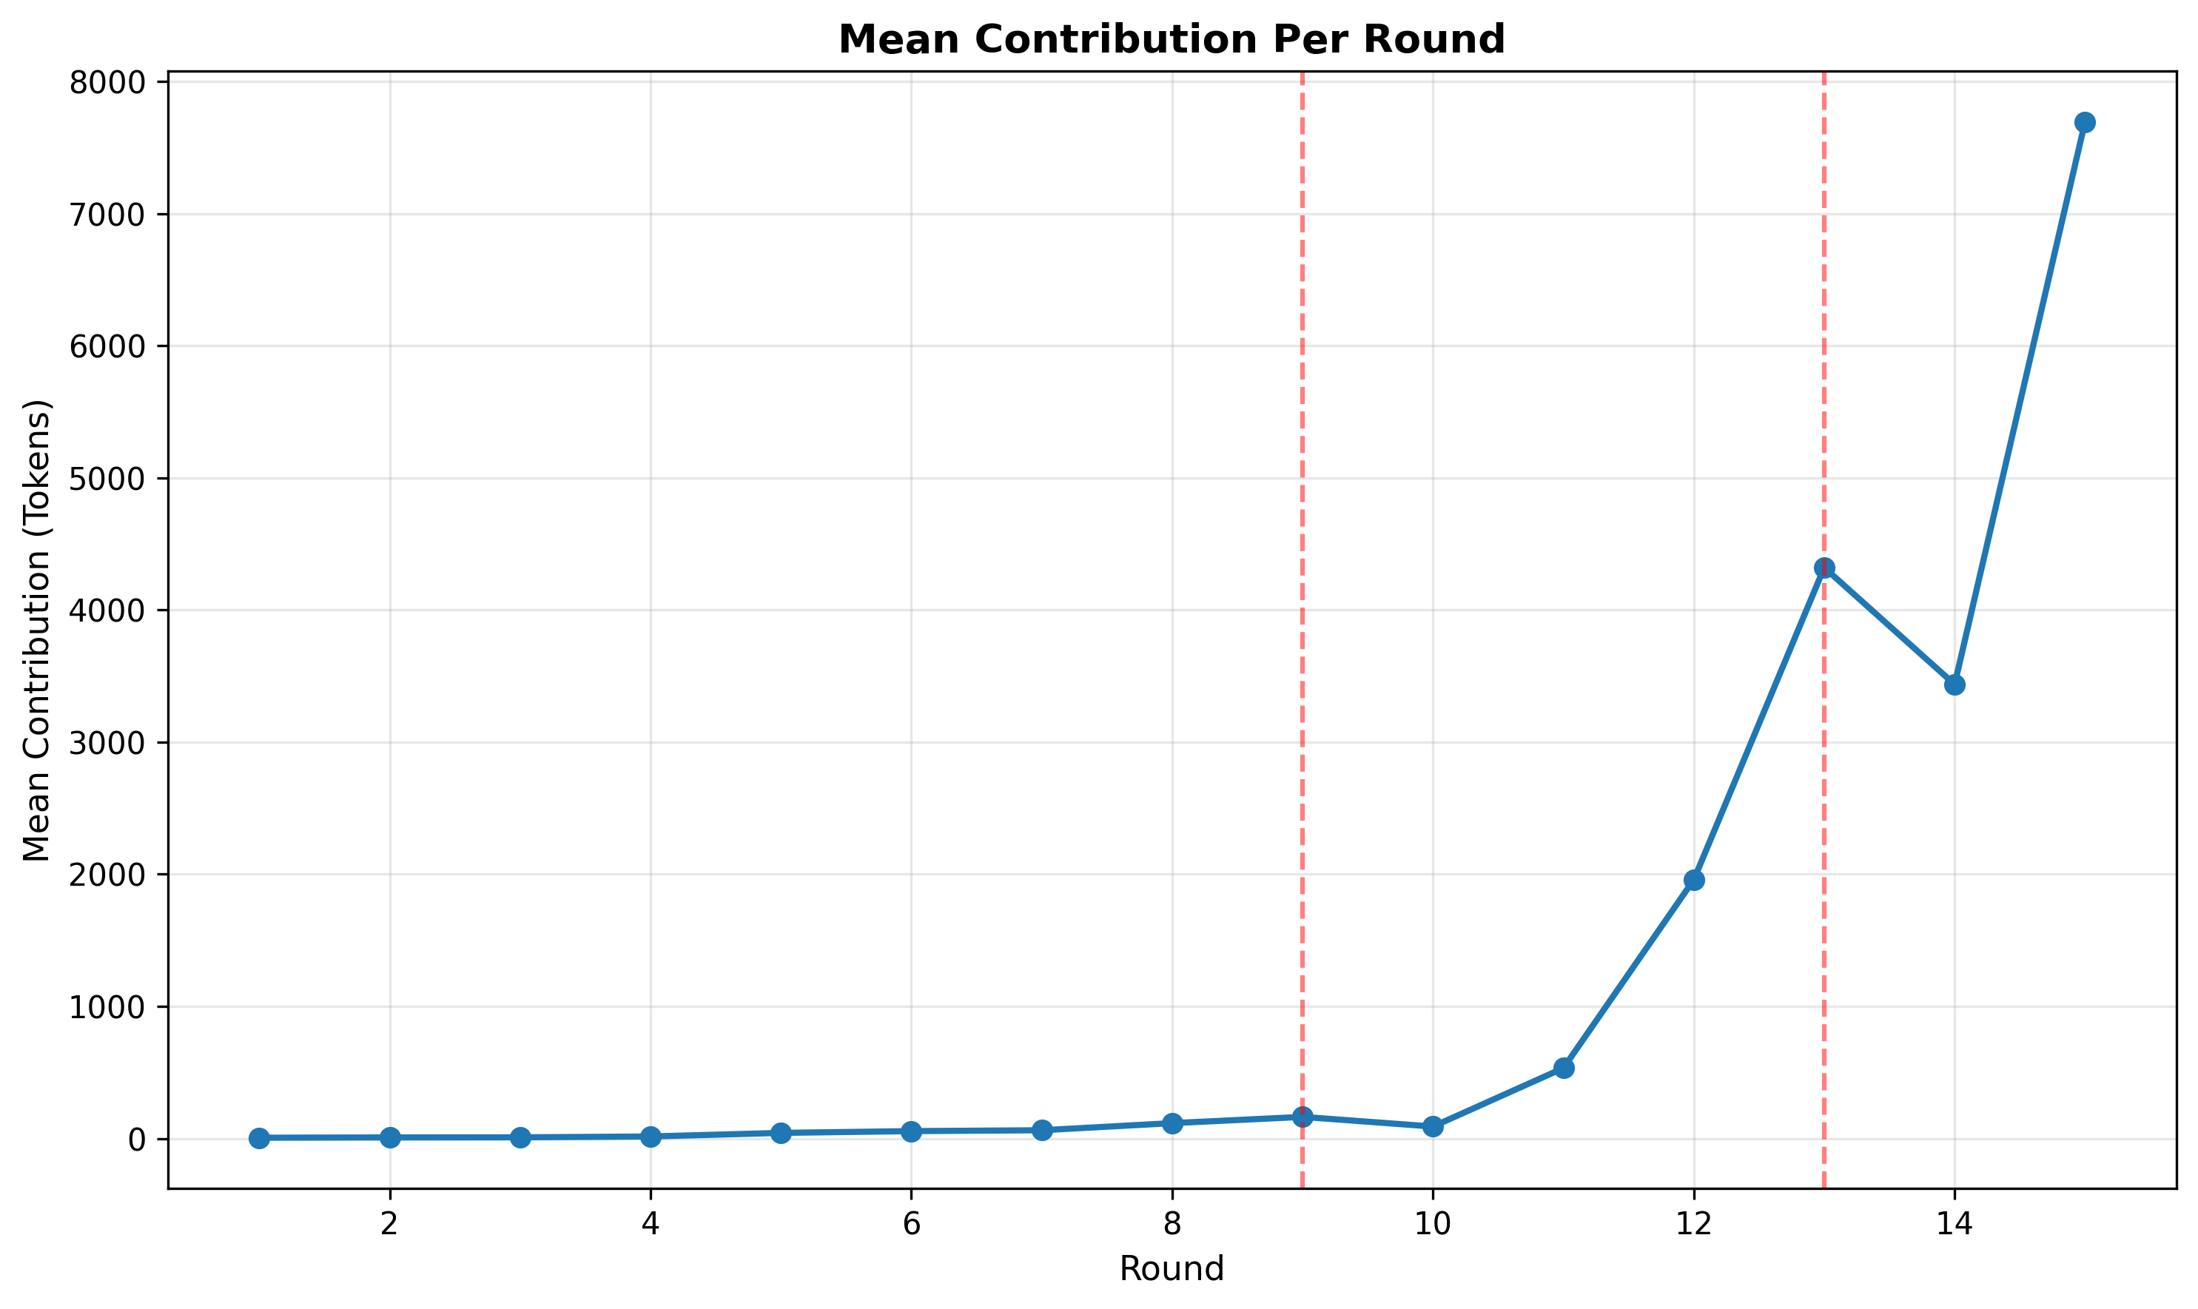
Average contribution dynamics by round (repository figure fig_mean_contribution.png). The steep late-game rise is the core cooperation result; the figure is taken directly from the repository’s generated figures.
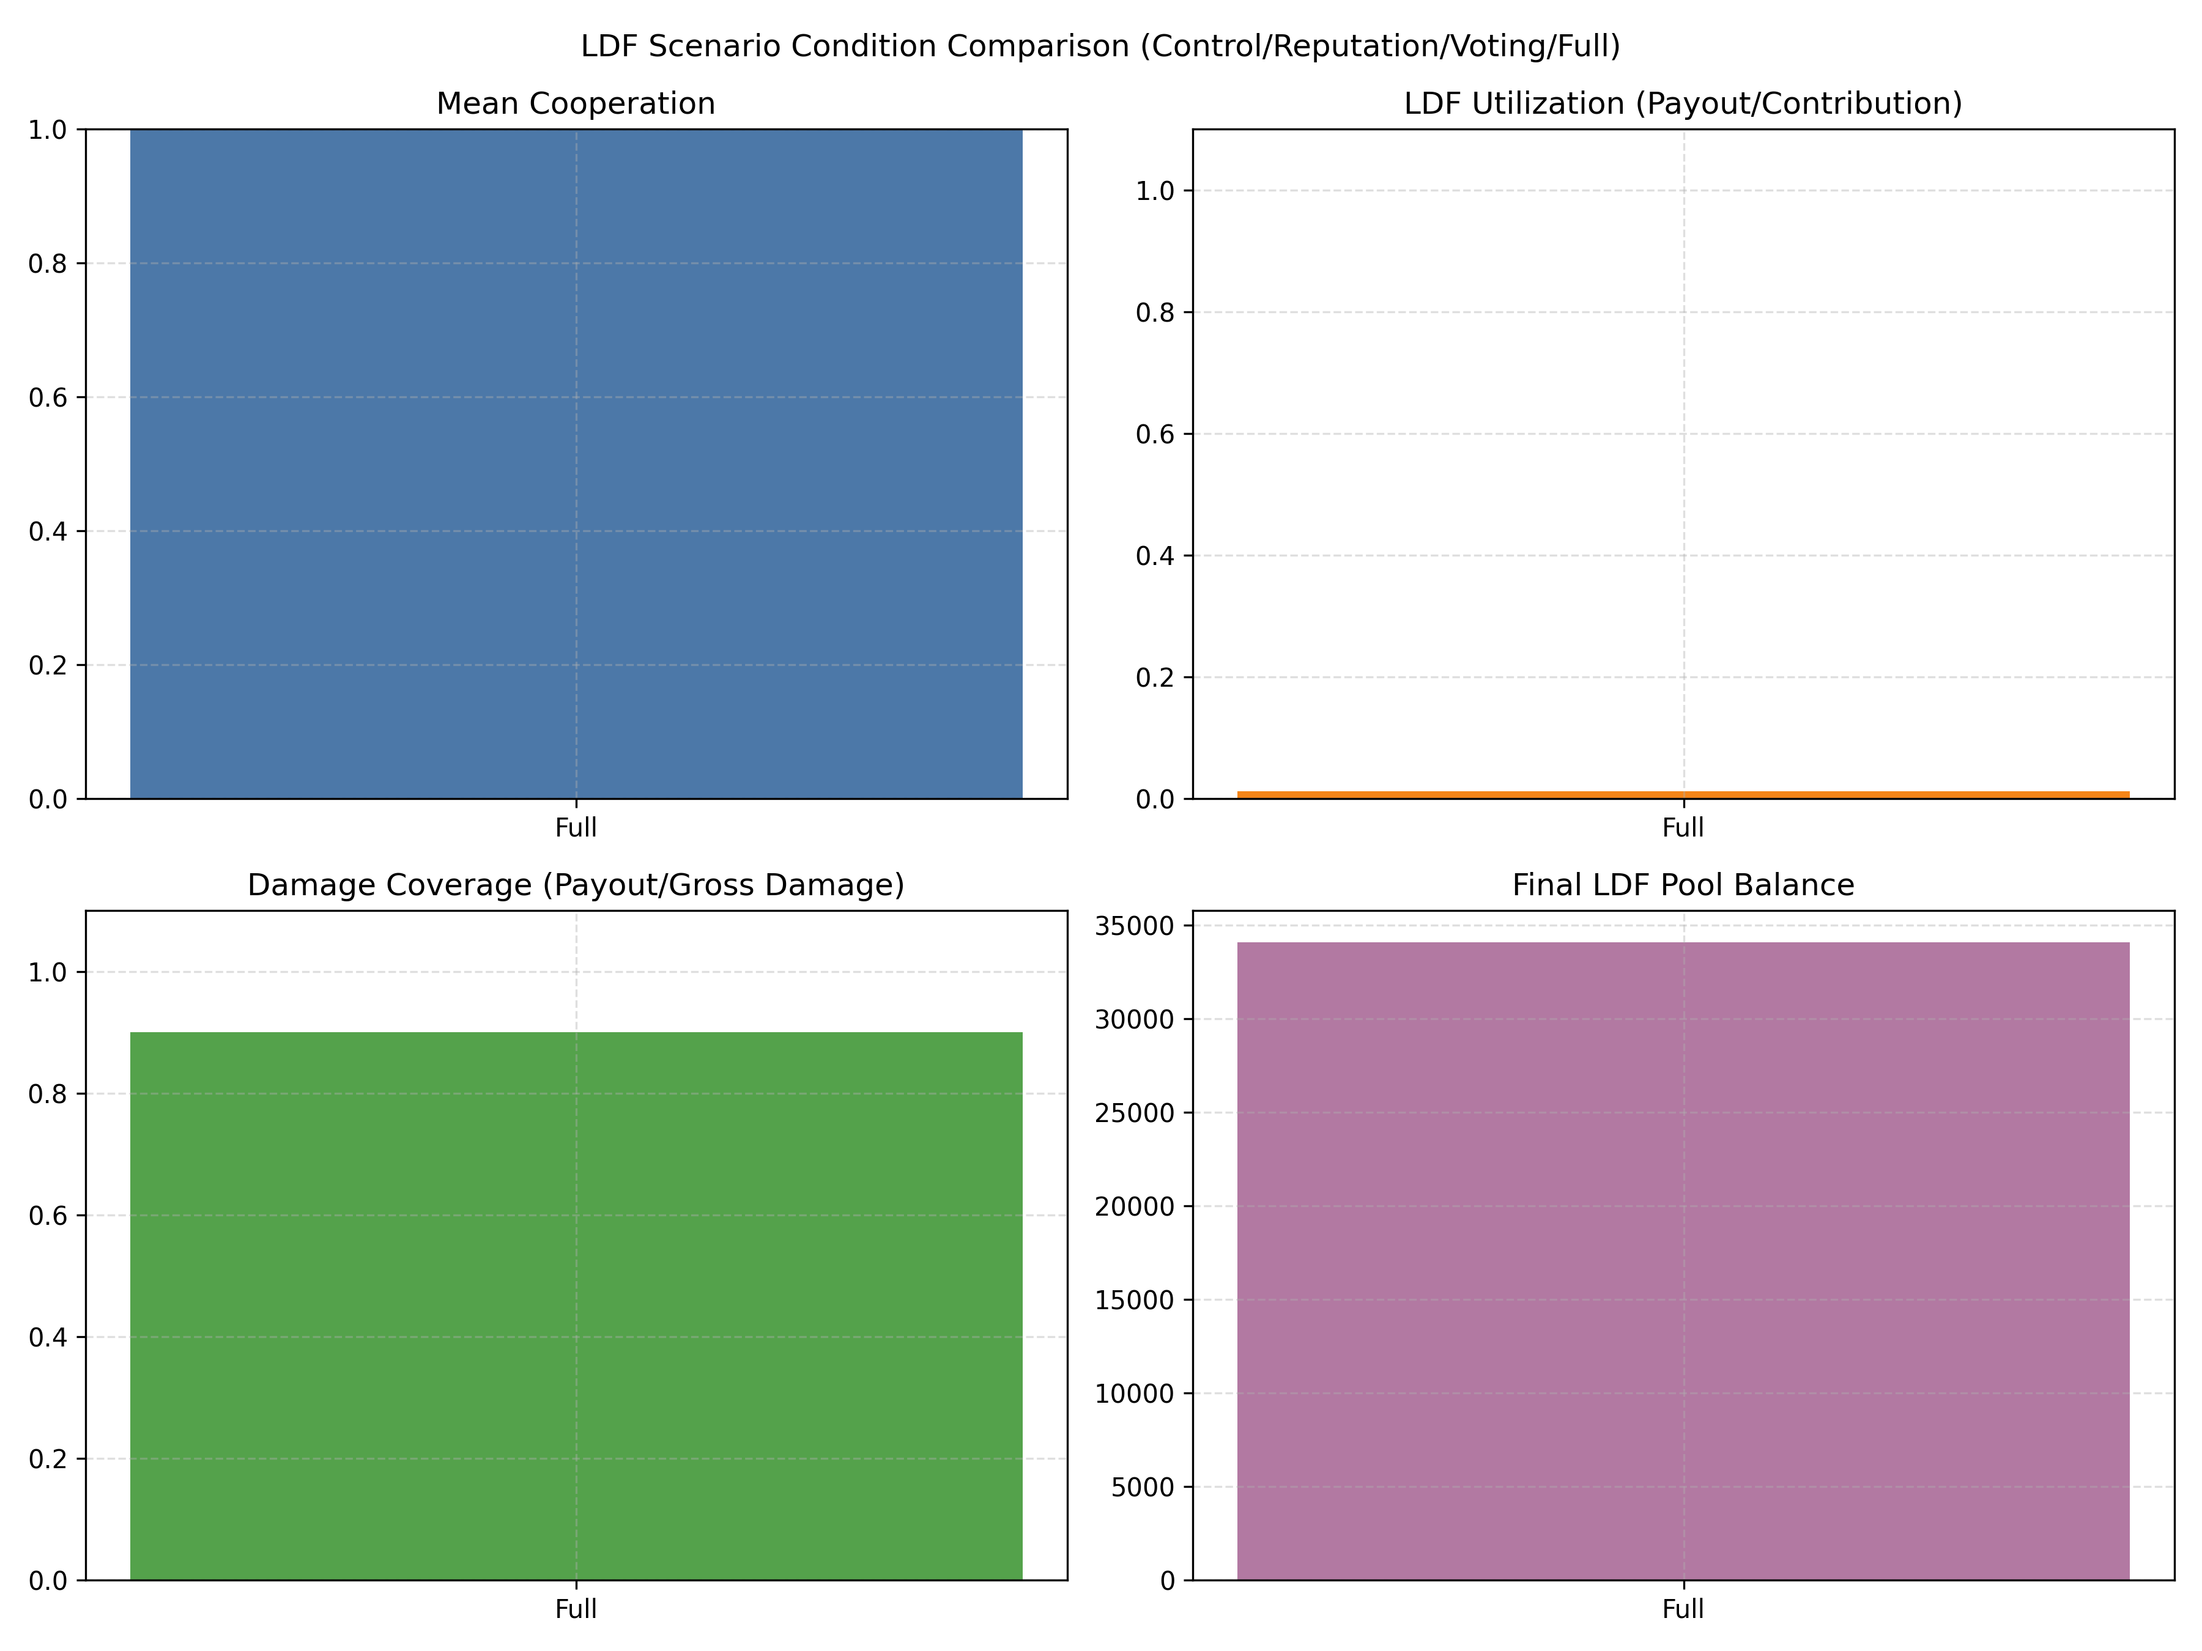
Key LDF-condition KPIs from round 13 (repository figure _13_ldf_condition_kpis.png): this figure presents contribution, payout, and coverage metrics under the round-13 shock condition and is used to discuss the fund’s redistributive performance.
Figure 5.1 (average contribution dynamics) and Figure 5.2 (round-13 KPIs) together provide the temporal and conditional context for the cooperation result. The steep rise in average contributions after round 10 coincides with the first shock period (round 9) and the large pool accumulation observed by round 13; this timing suggests a fund-visibility and reputational feedback mechanism rather than a one-off learning effect. In short, shocks both trigger payouts and create observable accounting signals that agents condition on in subsequent rounds, producing the pronounced late-game increase in contributions. Examining the KPIs in Figure 5.2, the combination of high mean cooperation, modest LDF utilization, partial damage coverage, and a growing pool balance implies that the system accumulates resources faster than it spends them – consistent with a high-contribution, low-utilization regime.
The payoff distribution is highly skewed. Table 5.2 shows that developed agents contribute more than twice as much as developing agents on average and earn roughly 5.56 times higher cumulative payoff. This is exactly the sort of result that can be missed if one looks only at total fund size: contributions are high, but the gains from cooperation are not evenly shared.
Group-level summary statistics.
Metric | Developed | Developing
$$n$$ | 12 | 14
Avg contrib. | 1,730.8556 | 808.3143
Avg payoff | 1,246,172.0294 | 224,392.4844
Avg wealth | 1,246,172.0294 | 224,392.4844
Avg rep. | 5.9016 | 5.3084
Avg punish. received | 421.5 | 0.0
LDF payout | 94.2629 | 329.9200
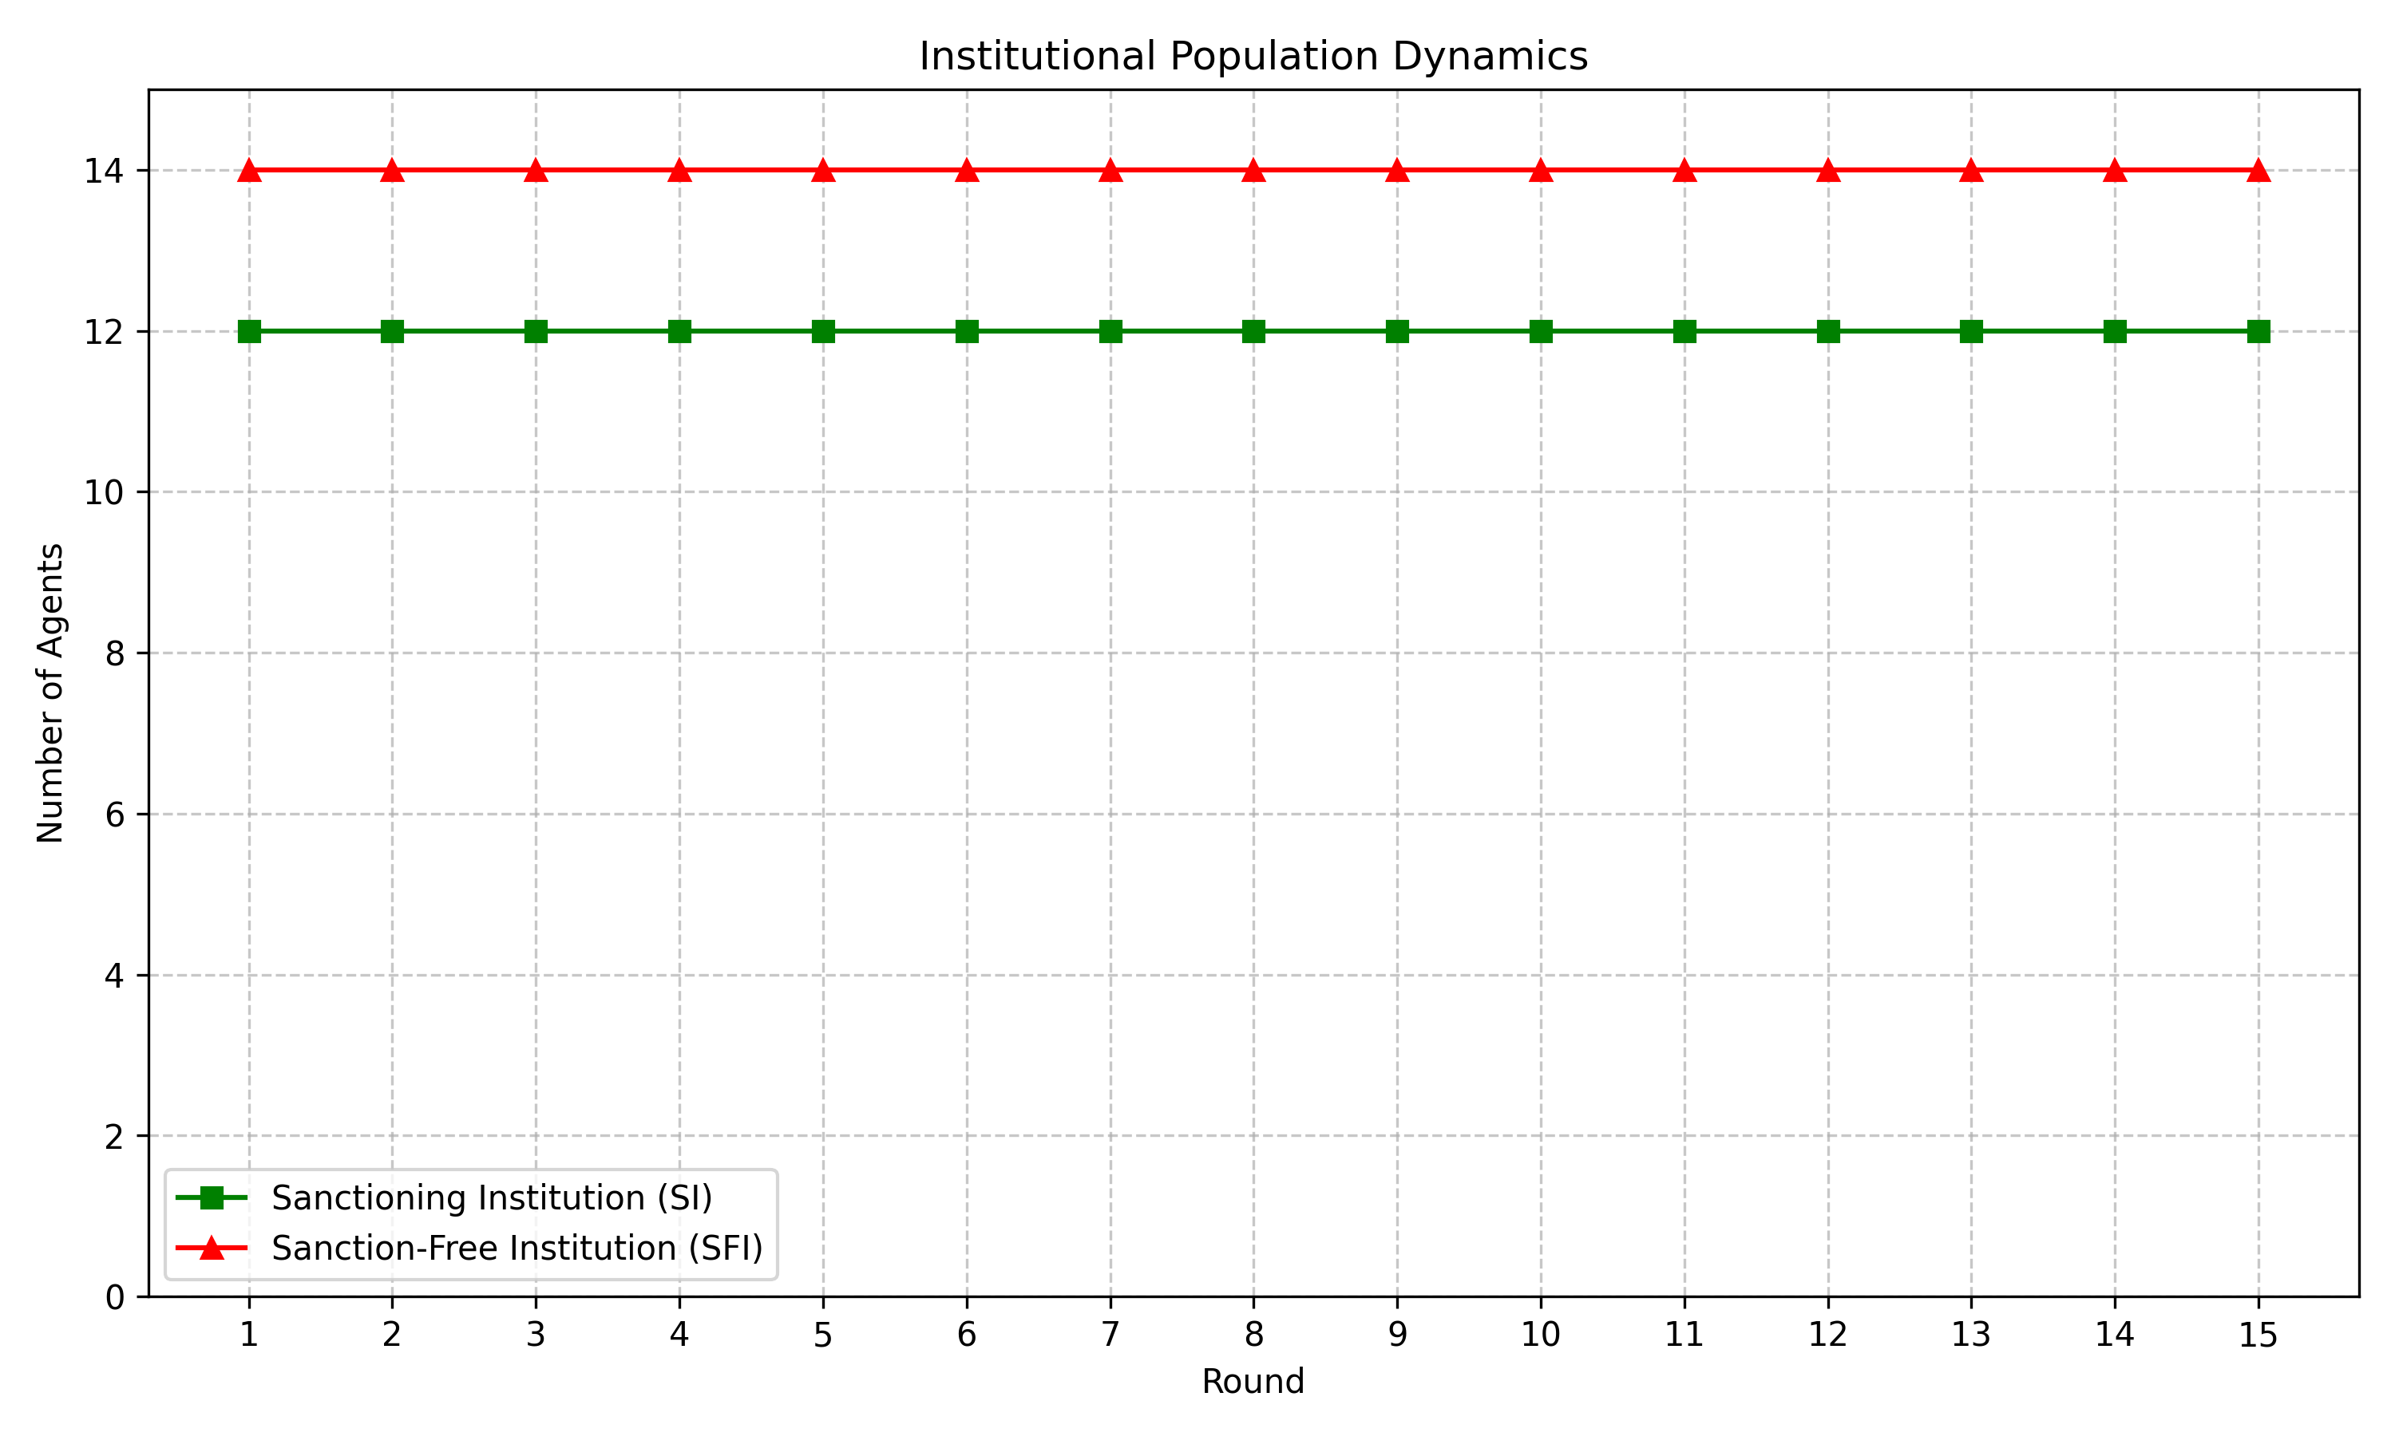
Institutional composition is fixed by design, not chosen endogenously. The figure is useful because it shows that the main action is within-group behavior, not institution switching.
The LDF is best understood as an insurance pool with weak redistributive power rather than a broad equalization device. Across the full simulation, total LDF contributions equal $34.500$ billion and total payouts equal $424.183$ million. That implies a disbursal rate of only about 1.2% (the fund therefore retains roughly 98.8% of collected contributions), so the mechanism operates more like a savings vehicle than comprehensive insurance. Developed agents contribute $34.374$ billion and receive only $94.263$ million, so they are net fund providers. Developing agents contribute $125.898$ million and receive $329.920$ million, so they are net beneficiaries. That is the right way to read the mechanism: developed countries finance the pool, developing countries draw from it when shocks hit, but the overall transfer is modest relative to total contributions.
Shock-round accounting from the main JSON file. The net damage column is the post-insurance loss after the fund payout.
Round | Gross damage | Net damage | LDF payout | Pool end
9 | 175.2679 | 17.5268 | 157.7411 | 551.4445
13 | 296.0464 | 29.6046 | 266.4417 | 34,076.1831
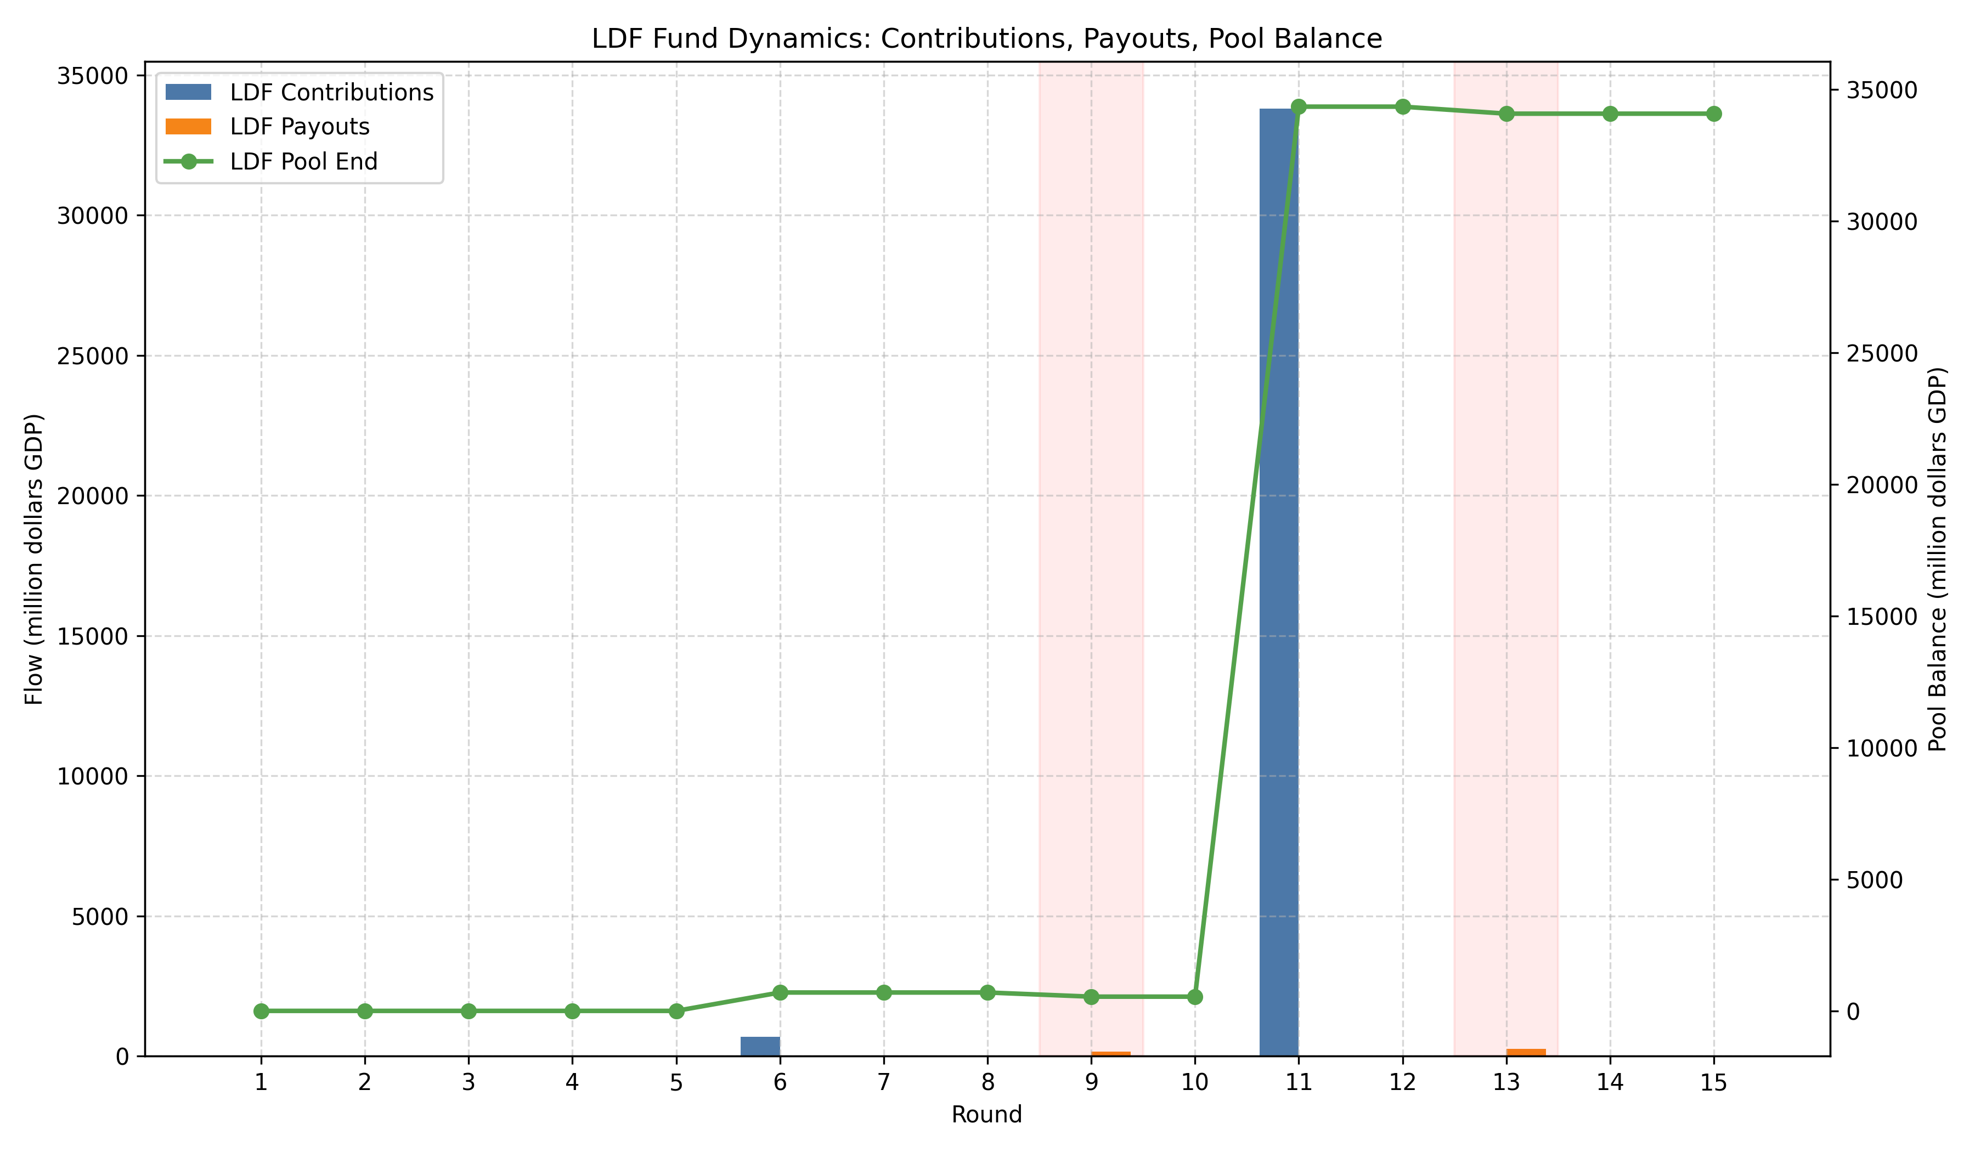
LDF pool flows. The visually important feature is the stepwise accumulation and the two payout dips in the shock rounds.
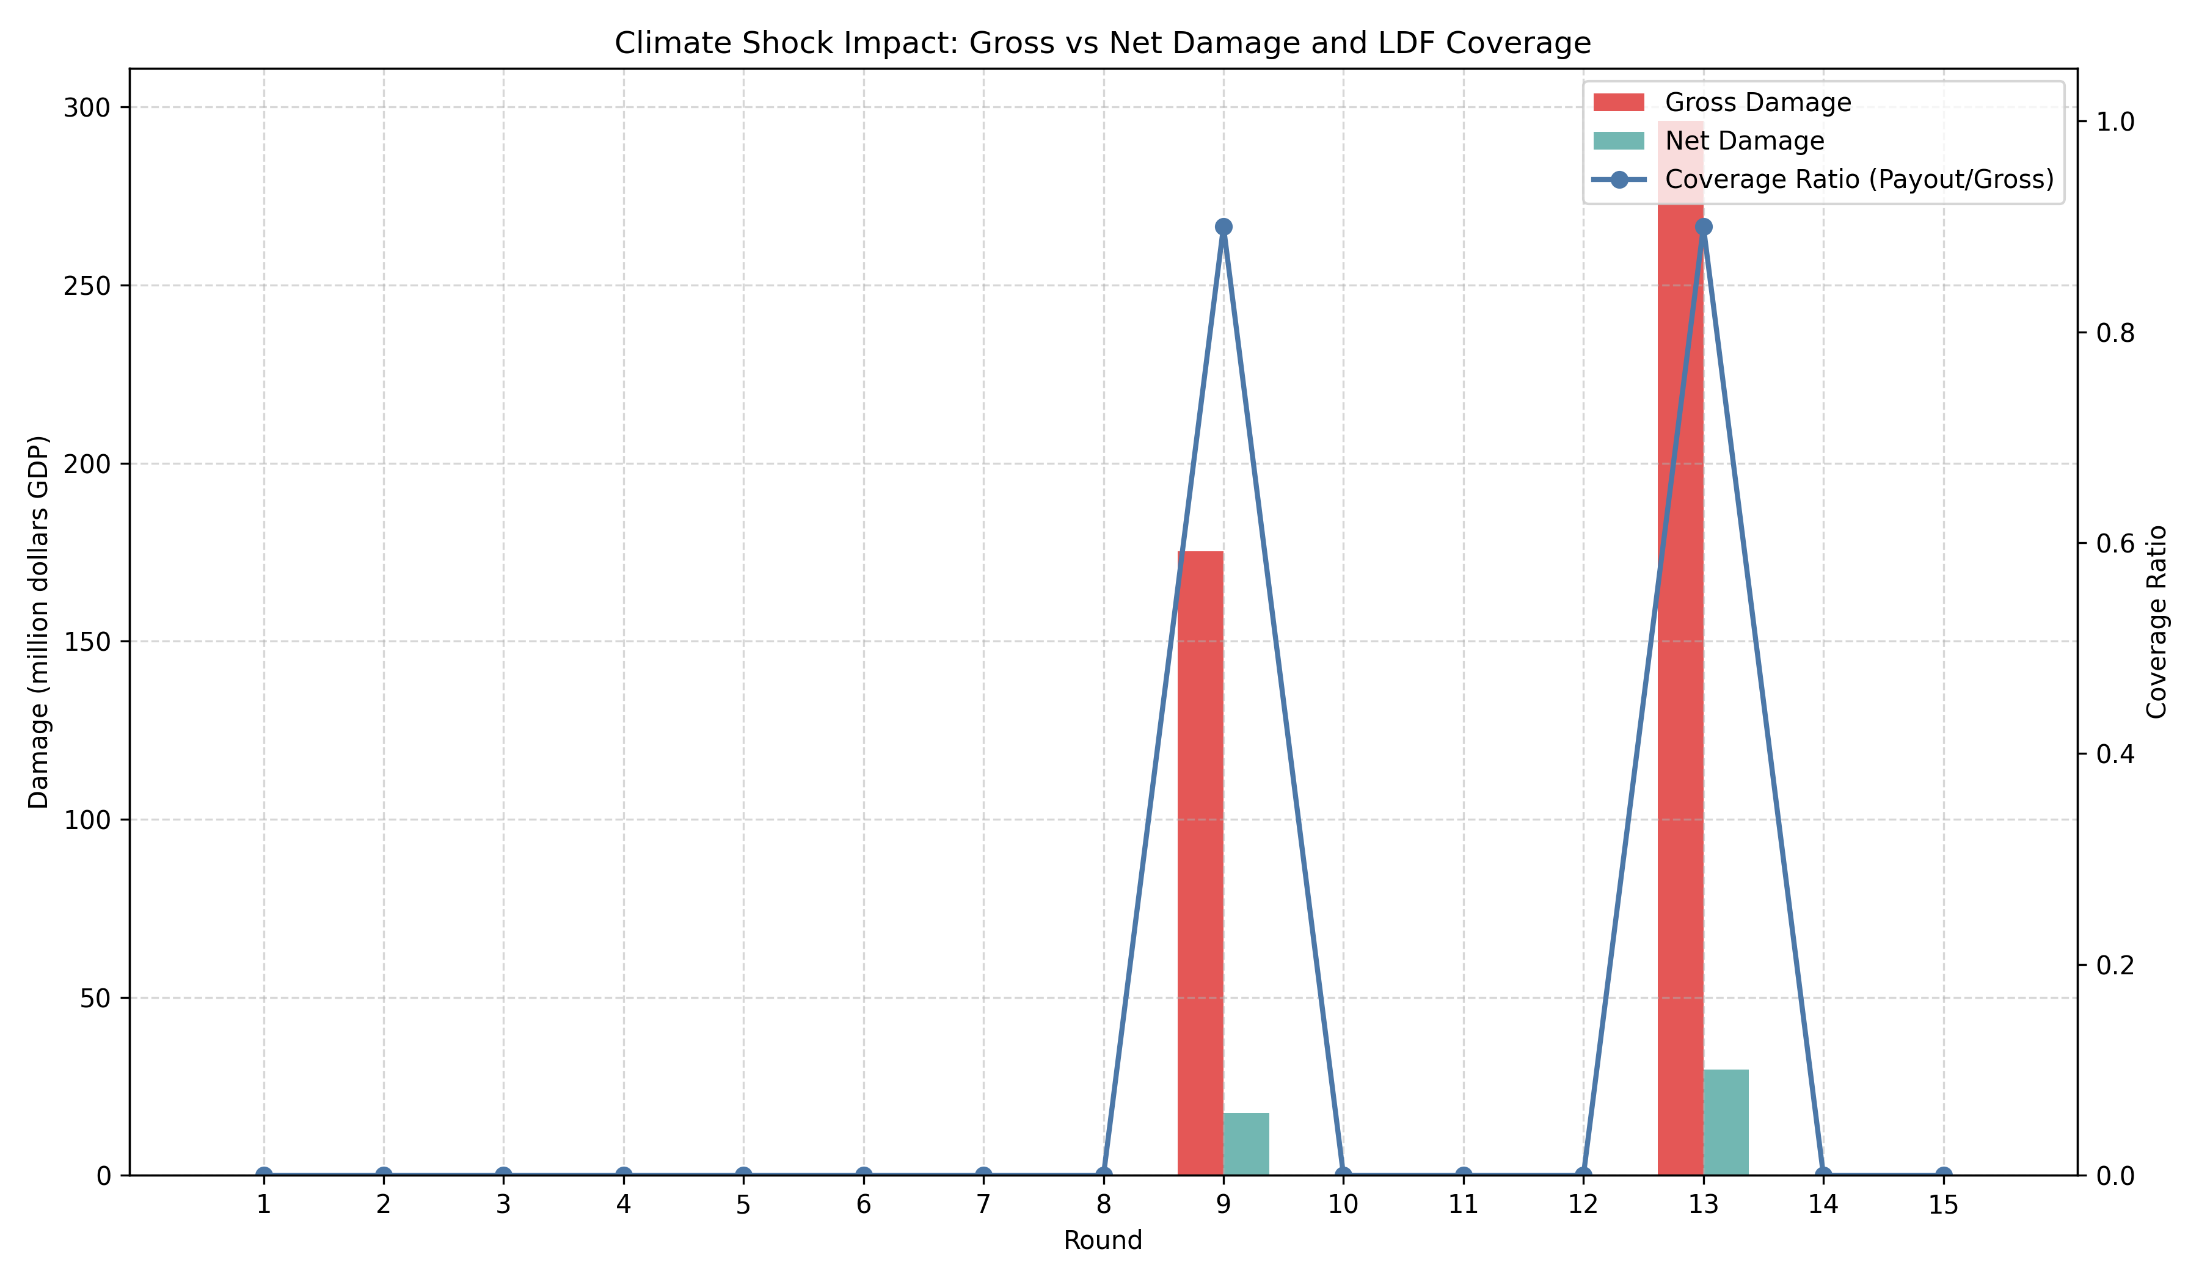
Damage coverage by the LDF. Coverage is positive but far from full insurance, which is why the mechanism should be read as partial compensation rather than redistribution at scale.
Figure 5.5 reports damage coverage, defined as LDF payout divided by gross damage (Coverage = LDF payout / Gross damage). Using the shock-round accounting in Table 5.3, coverage in round 9 is $157.7411/175.2679≈0.90$ (90%), and in round 13 is $266.4417/296.0464≈0.90$ (90%). That coverage level indicates substantial but partial compensation: even when the pool end in round 13 is numerically large (34,076.1831 million in the pool-end column), the payout rule and participation parameters produce only partial replacement of gross damages. This is direct empirical evidence for the dissertation’s weak-redistributor claim: the LDF provides meaningful compensation when shocks occur, but it does not fully insure losses under the current payout rules and participation rate.

Discussion
The main substantive result is not simply that contribution outputs rise. It is that contribution outputs rise far more strongly than redistribution does. In policy terms, the simulation supports a positive reading of contribution capacity but a cautious reading of equity. The developed group funds the system at scale, yet the developing group’s net receipt is only $204.022$ million across 15 rounds. The ratio between gross fund accumulation and net redistribution is therefore large, and the dissertation should not overstate the equalizing role of the fund.
This distinction helps explain why the contribution path and the redistribution path move differently. Contributions are visible every round, so the contribution outputs change when the prompt contains larger fund-size inputs and reputational history. Redistribution only occurs when shocks hit, so it is episodic and contingent. The result is a system that can build a large pool and coincide with higher contribution outputs, but that does not mechanically transform into a large transfer program. That is a meaningful institutional finding in its own right.
The deterministic SI/SFI assignment also sharpens the interpretation. Because developed agents are routed into SI and developing agents into SFI, the model isolates the effect of institutional asymmetry. In this environment, developed agents are both stronger contributors and the main targets of sanctioning, while developing agents are shielded from punishment authority but also excluded from sanction-based discipline. That architecture makes it easier to see that the central pattern is not institution shopping but different input-output responses under fixed structure.
The figures make the same point visually. Contribution, payoff, institution, and LDF flow graphs together show a system with strong late-stage patterning, persistent payoff asymmetry, and limited but nonzero insurance. The dissertation links each figure to the underlying experiment trace so that visual claims can be traced back to the recorded CSV/JSON outputs.
Limitations: these results are conditional on model and design choices. We used deterministic decoding of Llama 3.1 8B instances, which removes stochasticity that might appear under probabilistic decoding and may understate variability in agent behavior. The Llama 3.1 8B model class may also have systematic response tendencies to contribution and reputation prompts; as a result, we cannot fully separate whether cooperation dynamics arise from the institutional/game structure or from the way this specific model and prompt set behave. We therefore treat the findings as scenario-dependent and recommend explicit robustness checks that vary seeds, decoding schemes (stochastic vs deterministic), and LLM families. We cannot determine whether observed cooperation is sensitive to the MPCR value used; at MPCR = 0.062, contributions are individually irrational, and cooperation may reflect contribution norms embedded in the model’s training rather than genuine incentive response. Testing across MPCR values is a priority for future work. A broader limitation of LLM-agent simulations is that observed behavioral patterns may reflect statistical regularities in model training rather than strategic reasoning; we report input-output regularities in contribution behavior and do not claim that agents engage in deliberate coordination.
External validity is therefore best read as a substantive result rather than a defect to hide. The cooperative tilt in a smaller open-source model like Llama 3.1 8B may reflect exposure to climate-policy discourse during training, where loss-and-damage language is already associated with burden sharing, vulnerability, and reciprocity. If so, the model is not merely “acting cooperative” in the abstract; it is surfacing a prior learned from the climate governance vocabulary itself. That makes the behavior interesting precisely because it suggests that prompt design can activate latent normative structure in open-source models, even if the result should not be read as evidence of human-like strategic reasoning.
The literature review also matters here. The broader LLM-agent literature maps directly onto our three guiding questions. Piatti et al.’s GOVSIM shows that communication and coordinated protocols can sustain commons provision in LLM populations . Tewolde et al.’s CoOPEVaL benchmark (CoopEval) highlights how different mechanism-design choices determine which cooperation-sustaining strategies succeed in agent societies . Ren et al. demonstrate that reputational mechanisms can detect and isolate exploitative agents and thus help stabilize cooperation . Our simulation aligns with that literature on the contribution side, but it remains more cautious on redistribution: the institution can stabilize cooperation without delivering egalitarian outcomes. That is exactly the policy tension the LDF raises.

Conclusion
The simulation shows that an LDF-like mechanism can be highly effective at eliciting contributions while providing only partial redistributive coverage under the rules studied here. Policy implication: designers of loss-and-damage mechanisms should not conflate high contribution capacity with strong redistribution – institutional parameters (payout rules, participation rates, and timing of shocks) matter critically for whether resources are translated into meaningful compensation.
The single most important limitation of this study is model dependency: results are conditional on the particular LLM class (Llama 3.1 8B) and deterministic decoding used, which can influence strategic responses to prompts. Addressing this limitation is therefore the highest priority for follow-up work.
Concrete next steps: run robustness checks that (1) evaluate GPT-4-class models and other LLM families under stochastic decoding, (2) vary decoding and prompt formulations to measure sensitivity, (3) run counterfactuals allowing endogenous institution choice and alternative payout formulas (for example, full-coverage payout rules or higher participation rates), and (4) vary the MPCR to test whether contribution outputs remain high when contributions are less individually costly. The key empirical test is whether GPT-4-class models with stronger strategic reasoning close the contribution-redistribution gap or whether the gap persists as a general property of the institutional design.

Additional Tables
Top agents by cumulative payoff. The extreme concentration at the top is another reason the dissertation should be read as contribution-rich but redistribution-poor.
Agent | Group | Avg contrib. | Cum. payoff | Avg rep.
13 | Developed | 33.1333 | 8,031,192.2623 | 6.0747
23 | Developed | 893.3333 | 1,271,881.5195 | 6.2613
21 | Developed | 51.0000 | 1,255,659.9586 | 4.9013
16 | Developed | 27.4000 | 815,701.9140 | 6.8267
14 | Developed | 61.0667 | 806,807.4656 | 5.7733
6 | Developed | 117.2667 | 715,994.1684 | 5.5493
10 | Developed | 12.0000 | 502,466.0967 | 5.9040
22 | Developed | 2,030.6667 | 500,685.9952 | 6.2000
5 | Developed | 447.6667 | 391,725.7591 | 5.8960
17 | Developing | 11.8000 | 338,096.9602 | 5.7333
Accounting summary used to verify the dissertation’s redistribution claims.
Item | Value | Unit
Total LDF contributions | 34,500.36595 | million
Total LDF payouts | 424.18287 | million
Developed contributions | 34,374.4682 | million
Developed payouts | 94.2629 | million
Developing contributions | 125.8977 | million
Developing payouts | 329.9200 | million
Net transfer to developing group | 204.0223 | million
Selected rounds (appendix). Cooperation is normalized total contribution; shocks occur in rounds 9 and 13.
Round | Cooperation | Gini | SI contrib. | SFI contrib. | Shock
1 | 0.2769 | 0.7124 | 9.67 | 2.00 | No
5 | 2.1058 | 0.6620 | 53.42 | 8.00 | No
9 | 8.1635 | 0.6238 | 650.00 | 141.43 | Yes
11 | 26.6250 | 0.6184 | 1,245.42 | 87.50 | No
13 | 216.0846 | 0.6071 | 8,244.83 | 150.00 | Yes
15 | 384.8038 | 0.6085 | 10,644.67 | 150.00 | No
Condensed group breakdown (appendix) summarizing average contributions and LDF payouts by group.
Group | $$n$$ | Avg contrib. | LDF payout
Developed | 12 | 1,730.8556 | 94.2629
Developing | 14 | 808.3143 | 329.9200
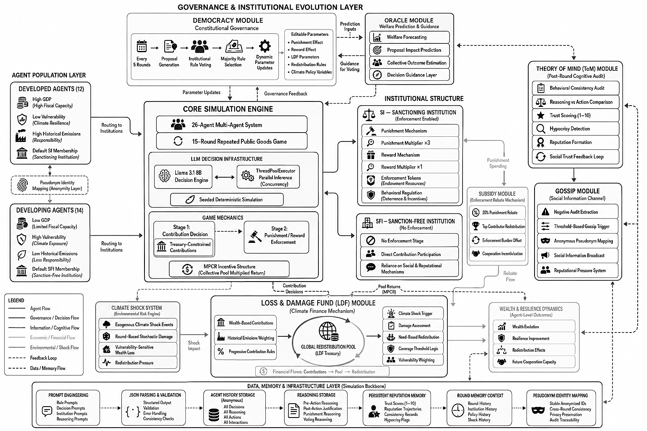
System-level pipeline diagram.
99
Ashery, A. F., Aiello, L. M., & Baronchelli, A. (2025). Emergent social conventions and collective bias in LLM populations. Science Advances, 11(20), eadu9368. https://doi.org/10.1126/sciadv.adu9368
Cross, L., Haber, N., & Yamins, D. L. K. (2025). Validating Generative Agent-Based Models of Social Norm Enforcement: From Replication to Novel Predictions. https://doi.org/10.48550/arxiv.2507.22049
De Curtö, J., De Zarzà, I., Fervier, L. S., Sanagustín-Fons, V., & Calafate, C. T. (2025). An institutional theory framework for leveraging large language models for policy analysis and intervention design. Future Internet, 17(3), 96. https://doi.org/10.3390/fi17030096
Drake, S. (2025). “Neural howlround” in large language models: a self-reinforcing bias phenomenon, and a dynamic attenuation solution. https://doi.org/10.48550/arxiv.2504.07992
Hintze, A., & Adami, C. (2026). Promoting cooperation in the public goods game using artificial intelligent agents. Npj Complexity, 3(1). https://doi.org/10.1038/s44260-025-00065-9
Hsia, Y., Yu, F., & Jiang, J. R. (2026). Neuro-Symbolic Compliance: Integrating LLMS and SMT Solvers for Automated Financial Legal Analysis. https://doi.org/10.1109/aiware69974.2025.00010
Kim, M., & Hwang, S. (2025). Dual-Scale world models for LLM agents towards Hard-Exploration problems. https://doi.org/10.48550/arxiv.2509.24116
Li, Y., & Shirado, H. (2025). Spontaneous Giving and Calculated Greed in Language Models. https://doi.org/10.18653/v1/2025.emnlp-main.267
Liang, Y., Qu, Y., Yang, J., Lin, S., & Shen, Z. M. (2025). Everyone contributes! Incentivizing strategic cooperation in Multi-LLM systems via sequential public goods games. https://doi.org/10.48550/arxiv.2508.02076
Liu, K., Hou, X., Yuan, J., & Jaques, N. (n.d.). Evaluating LLM agents as human simulators in climate social dilemmas. OpenReview. https://openreview.net/forum?id=wTgTyIgRv3
Lu, W., Dhanda, A., Chen, D. L., & Hansen, C. B. (2025). Aligning Large Language Model Agents with Rational and Moral Preferences: A Supervised Fine-Tuning Approach. https://doi.org/10.48550/arxiv.2507.20796
Madmoun, H., & Lahlou, S. (2026). Communication Enables Cooperation in LLM Agents: A Comparison with Curriculum-Based Approaches. https://doi.org/10.18653/v1/2026.eacl-short.23
Mao, S., Cai, Y., Xia, Y., Wu, W., Wang, X., Wang, F., Ge, T., & Wei, F. (2023). ALYMPICS: LLM Agents Meet Game Theory – Exploring Strategic Decision-Making with AI Agents. https://doi.org/10.48550/arxiv.2311.03220
Manik, M. M. H., & Wang, G. (2026). OpenClaw Agents on MoltBook: Risky instruction sharing and norm Enforcement in an Agent-Only Social Network. http://arxiv.org/abs/2602.02625
Moon, S. (2025). Binding large language models to virtual personas for human simulation (Publication No. 9798276022734) [Doctoral dissertation, University of California, Berkeley]. eScholarship. https://escholarship.org/uc/item/8s32x9x7
Mu, C., Zeng, Y., Zhang, Q., Shao, K., Chu, C., Guo, H., Jia, D., Wang, Z., & Hu, S. (2026). Adaptive Theory of Mind for LLM-based Multi-Agent Coordination. Proceedings of the AAAI Conference on Artificial Intelligence, 40(35), 29608–29616. https://doi.org/10.1609/aaai.v40i35.40204
Gupta, P., Zhong, Q., Yakura, H., Eisenmann, T., & Rahwan, I. (2025). The role of social learning and collective norm formation in fostering cooperation in LLM Multi-Agent Systems. https://doi.org/10.65109/czdc3237
Ospina, J. P., & Sánchez, J. F. (2025). A computational justice model for dynamic resource allocation in ad hoc networks. Complex Systems Informatics and Modeling Quarterly, 43, 53–76. https://doi.org/10.7250/csimq.2025-43.04
Piedrahita, D. G., Yang, Y., Sachan, M., Ramponi, G., Sch"olkopf, B., & Jin, Z. (2025). Corrupted by reasoning: Reasoning language models become Free-Riders in public Goods games. https://doi.org/10.48550/arxiv.2506.23276
Piatti, G., Jin, Z., Kleiman-Weiner, M., Sch"olkopf, B., Sachan, M., & Mihalcea, R. (2024). Cooperate or Collapse: Emergence of Sustainable Cooperation in a Society of LLM Agents. https://doi.org/10.48550/arxiv.2404.16698
Ren, S., Fu, W., Zou, X., Shen, C., Cai, Y., Chu, C., Wang, Z., & Hu, S. (2025). Reputation as a solution to cooperation collapse in LLM-based MASs. https://doi.org/10.48550/arxiv.2505.05029
Shi, L., Ma, C., Liang, W., Diao, X., Ma, W., & Vosoughi, S. (2025). Judging the Judges: A Systematic Study of Position Bias in LLM-as-a-Judge. In Association for Computational Linguistics (pp. 292–314). https://doi.org/10.18653/v1/2025.ijcnlp-long.18
Smit, M., & Santos, F. P. (2024). Learning Fair Cooperation in Mixed-Motive Games with Indirect Reciprocity. https://doi.org/10.48550/arxiv.2408.04549
Sumers, T. R., Yao, S., Narasimhan, K., & Griffiths, T. L. (2023). Cognitive architectures for language agents. https://doi.org/10.48550/arxiv.2309.02427
Tennant, E., Hailes, S., & Musolesi, M. (2024). Moral alignment for LLM agents. https://doi.org/10.48550/arxiv.2410.01639
Tewolde, E., Zhang, X., Piedrahita, D. G., Conitzer, V., & Jin, Z. (2026). CoOPEVaL: Benchmarking Cooperation-Sustaining Mechanisms and LLM Agents in Social Dilemmas. https://arxiv.org/abs/2604.15267
Wang, Q., & Goel, A. K. (2022). Mutual Theory of Mind for Human-AI Communication. arXiv (Cornell University). https://doi.org/10.48550/arxiv.2210.03842
Warnakulasuriya, K., Dissanayake, P., De Silva, N., Cranefield, S., Savarimuthu, B. T. R., Ranathunga, S., & De Silva, N. (2026). Evolution of Cooperation in LLM-Agent Societies: A preliminary study using different punishment strategies. In Lecture notes in computer science (pp. 115–133). https://doi.org/10.1007/978-3-032-17542-7_7
Vezhnevets, A. S., Agapiou, J. P., Aharon, A., Ziv, R., Matyas, J., Duénez-Guzmán, E. A., Cunningham, W. A., Osindero, S., Karmon, D., & Leibo, J. Z. (2023). Generative agent-based modeling with actions grounded in physical, social, or digital space using Concordia. https://doi.org/10.48550/arxiv.2312.03664
Willis, R., Zhao, J., Du, Y., & Leibo, J. Z. (2026). Evaluating collective behaviour of hundreds of LLM agents. http://arxiv.org/abs/2602.16662
Xiang, A. (2025). Diagnosing the bias iceberg in large language models: A three-level framework of explicit, evaluative, and implicit gender bias. Information Processing & Management, 63(3), 104554. https://doi.org/10.1016/j.ipm.2025.104554
Xie, Y., Gao, R., & Mei, Q. (n.d.). Distributional Alignment for Social Simulation with LLMs: A Prompt Mixture Modeling Approach. OpenReview. https://openreview.net/forum?id=6KM1siLL8a
Zhang, Y., Mei, K., Liu, M., Wang, J., Metaxas, D. N., Wang, X., Hamm, J., & Ge, Y. (2026). Agents in the Wild: Safety, Society, and the Illusion of Sociality on Moltbook. http://arxiv.org/abs/2602.13284
Zhou, Y., Zhu, W., Wen, J., Peng, W., Wu, Z., & Xue, Y. (2025). From implicit to explicit: Enhancing Self-Recognition in large language models. https://doi.org/10.48550/arxiv.2508.14408
Friedman, J. W. (1971). A non-cooperative equilibrium for supergames. Review of Economic Studies, 38(1), 1–12. https://doi.org/10.2307/2296617
Fudenberg, D., & Maskin, E. (1986). The Folk Theorem in repeated games with discounting or with incomplete information. Econometrica, 54(3), 533–554. https://doi.org/10.2307/1911307
Ledyard, J. O. (1995). 2. Public Goods: a survey of experimental research. In Princeton University Press eBooks (pp. 111–194). https://doi.org/10.1515/9780691213255-004
Isaac, R. M., & Walker, J. M. (1988). Group size effects in public goods provision: the Voluntary Contributions mechanism. The Quarterly Journal of Economics, 103(1), 179. https://doi.org/10.2307/1882648
Isaac, R., Walker, J. M., & Williams, A. W. (1994). Group size and the voluntary provision of public goods. Journal of Public Economics, 54(1), 1–36. https://doi.org/10.1016/0047-2727(94)90068-X
Fehr, E., & Gächter, S. (2000). Cooperation and punishment in public goods experiments. American Economic Review, 90(4), 980–994. https://doi.org/10.1257/aer.90.4.980
Fehr, E., & Gächter, S. (2002). Altruistic punishment in humans. Nature, 415(6868), 137–140. https://doi.org/10.1038/415137a
Andreoni, J. (1988). Why free ride? Journal of Public Economics, 37(3), 291–304. https://doi.org/10.1016/0047-2727(88)90043-6
Fischbacher, U., Gächter, S., & Fehr, E. (2001). Are people conditionally cooperative? Evidence from a public goods experiment. Economics Letters, 71(3), 397–404. https://doi.org/10.1016/S0165-1765(01)00394-9
Barrett, S. (1994). Self-Enforcing international environmental agreements. Oxford Economic Papers, 46(Supplement_1), 878–894. https://doi.org/10.1093/oep/46.supplement_1.878
Ostrom, E. (1990). Governing the Commons. In Cambridge University Press eBooks. https://doi.org/10.1017/CBO9780511807763
Ostrom, E. (2000). Collective action and the evolution of social norms. The Journal of Economic Perspectives, 14(3), 137–158. https://doi.org/10.1257/jep.14.3.137

This is a design choice, not an arbitrary tuning knob: UNFCCC assessments of developing-country climate-finance needs put the financing gap at roughly US$455–584 billion per year by 2030, which is far above current loss-and-damage mobilization capacity and makes a low participation assumption a conservative way to model realistic participation constraints rather than full coverage.

