Governance Dynamics of the Loss and Damage Fund:Evidence from LLM-Agent Repeated Public Goods

Games
Final Year Project Dissertation
Uzair Arif and Essa Sidiqqui
Supervisor: Dr. Ghamz-e-Ali Siyal
Institute of Business Administration

Abstract
This dissertation examines governance dynamics of a Loss and Damage Fund using multi-agent language-model simulations. The most striking result is a 1.2% disbursal rate: across the simulation the fund accumulates 34.5 billion USD but disburses only 424 million USD, so it functions primarily as a savings medium rather than as full insurance. A central result is that contribution outputs rise sharply even though the baseline incentive structure is individually irrational at the MPCR used here ($β/n≈0.062$). Prompt structures incorporating repeated interaction, visible accounting, and reputational feedback are associated with substantially higher contribution outputs, while payout rules and institutional asymmetries limit the fund’s redistributive effect. Developed-group agents emerge as primary providers and developing-group agents as primary recipients under the modeled rules. The results emphasize that mobilization and equitable redistribution are unique design issues of Loss and Damage governance.

Introduction
The Loss and Damage Fund is aimed at improving climate finance for vulnerable nations that endure damages that they have not caused and cannot readily absorb. This poses two questions. First, is it possible to maintain high levels of contribution by richer contributors through repeated interaction and transparent accounting? Second, does the net mechanism redistribute at a rate that is suitable to vulnerable beneficiaries? The simulation answers both questions by combining a repeated public goods game, deterministic institutional assignment and transfers due to climate-shock.
The empirical conclusion is that contribution levels are very high in the long run despite the fact that the individual incentive structure is individually irrational at the MPCR ($β/n≈0.062$) matching the standard public-goods benchmark at which Nash contributions collapse when MPCR $<1$. Redistribution is still very low in comparison to gross fund accumulation. The developing group gets most of the payouts and all the LDF resources are given by the developed group. This implies that the contribution device is much more effective as a mechanism than as a strong equalizer. This distinction shows that a fund could be efficient in raising resources without causing a substantial net redistribution.
The design also plays an important role, i.e., institutional assignment is not endogenous in the sense which agents can choose between SI and SFI. In climate/LDF mode, the developed agents are sent to the Sanctioning Institution and the developing agents to the Sanction-Free Institution. Such deterministic assignment highlights the asymmetries the simulation is studying. Since the institutional structure is fixed, the primary margin of change is not the agent choice of institutions but the variation of the prompt inputs and state variables throughout the rounds.
This dissertation is organized to address three questions, namely: what maintains cooperation in repeated LLM-agent play, how institutional design influences that cooperation, and why increasing contribution does not imply redistribution at scale.

Literature Review
This review presents three questions which drive the simulation (1) can repeated LLM interaction maintain cooperation (2) does institutional design influence that cooperation and (3) when cooperation is maintained, does it lead to redistribution?

Repeated interaction and cooperation
Recent studies demonstrate that cooperation between the LLM agents is heightened by repeated interaction, communication, and reputation mechanisms (Sumers et al., 2023; Madmoun & Lahlou, 2026; Willis et al., 2026). Studies of sequential public-goods environment and reputation-sensitive protocols reveal that memory and messaging can shift populations to increased contributions (Liang et al., 2025; Ren et al., 2025). Classic experiments on public-goods highlight that contributions do not mechanically decrease to a zero level and even reflect a conditional cooperation rather than selfish free-riding (Andreoni, 1988; Ledyard, 1995). The study by Fischbacher et al. (2001) is pertinent in this situation since conditional cooperators increase contributions when they see others contributing - which is consistent with our prompt-history mechanism. These results support the idea to model repeated play with visible accounting and reputational state as core inputs to contribution outputs (Gupta et al., 2025; Piedrahita et al., 2025).

Institutional design matters
The cooperation equilibria are changed by the rules of sanctions, the topology of their enforcement, as well as institutional access (Fehr & Gächter, 2000; Fehr & Gächter, 2002). The comparative experiments showcase that the punishment authority and its cost structure shifts incentives and that institutional asymmetries can generate enduring within-group difference in behavior (Ashery et al., 2025; Warnakulasuriya et al., 2026). Costly punishment is a canonic tool of cooperation maintenance in experiments of the public-goods. This literature elicits an interest in mending institute assignment in our baseline in order to disentangle behavioral adaptation and selection effects.
Ostrom (1990) provides a micro-level perspective that compliments this, i.e., cooperative resource management can be maintained by an institution under particular design principles (clear boundaries, rules adapted to the local conditions, arrangements of collective choice, monitoring, and graduated sanctions). A number of these principles are operationalized by our simulation. The split between SI/SFI is a sanctioning mechanism, reputation scores serve as monitoring, and visible accounting provides for transparency (De Curtö et al., 2025). The current design does not incorporate other principles such as endogenous collective-choice arrangements. Ostrom (2000) focuses on norms and reputational mechanisms as behavioral sources of cooperation that is consistent with our prompt-history mechanism in which the reputation score and history of contribution of a particular agent serve as the informal surveillance and norm-signaling tools.

Cooperation versus redistribution
Large contributions do not mean equitable redistribution - the payout rules, participation rates and timing of shocks are used to determine coverage and net transfers. Both empirical and modeling analysis of allocation rules and computational justice emphasize that accumulated pools can only provide partial compensation unless payout formula and participation parameter are tailored to full coverage (Ospina & Sánchez, 2025). Barrett (1994) also highlights a similar point within a different context. As contribution devices, international environmental agreements can be stable but generate relatively small net transfers. This motivates our focus on coverage ratios as well as net-transfer accounting (Piatti et al., 2024; Tewolde et al., 2026).
These explain why the present study focuses upon repeated play, fixed institutional architecture, and explicit accounting. They allow us to explore the question of whether cooperation induced in LLM populations can or cannot translate into significant redistribution under plausible payout rules.

Theoretical Framework and Model
We assess the 26-agent, 15-round climate scenario of the repository. Agents are partitioned into developed ($n_{D}=12$) and developing ($n_{V}=14$) groups. Each agent $i$ starts with wealth $w_{i}^{0}$, contribution capacity $κ_{i}$, vulnerability $v_{i}$, and emissions history $e_{i}$. Developed agents have higher contribution capacity while developing agents face higher damage exposure. All results reported here derive from a single simulation run.
Round $t$ consists of contribution, institutional enforcement, and shock-transfer stages. In the contribution stage, each agent chooses $c_{i,t}∈[0,min(κ_{i},w_{i,t})]$. The public-good return is
$$R_{t}=β\sum_{j=1}^{n}{c_{j,t}}, β=1.6,$$
with equal sharing across all agents, so each agent receives $R_{t}/n$. The stage-one payoff is
$$π_{i,t}^{(1)}=w_{i,t}-c_{i,t}+\frac{1}{n}R_{t}.$$
$n=26$ in our baseline (Ledyard, 1995; Isaac & Walker, 1988). With $β=1.6$, the marginal per-capita return (MPCR) equals $β/n=1.6/26≈0.062$ - which is less than one and this means that a one-shot, unilateral contribution reduces the contributor’s private payoff (i.e., contributions are individually costly), matching the standard voluntary contribution mechanism benchmarks where Nash contributions are predicted to collapse (Isaac et al., 1994). Therefore, observed cooperation depends on repeated interaction, reputational effects, and institutional context.
In standard repeated-game logic, cooperation can still be sustained in equilibrium when agents place sufficient weight on future payoffs like in the folk-theorem tradition of repeated games (Friedman, 1971; Fudenberg & Maskin, 1986). The current simulation does not represent that logic in a strong game-theoretic sense since the agents lack the explicit discount factors or a future-payoff calculus. Rather, cooperation is prompt-mediated (Sumers et al., 2023), that is, repeated history, reputation and institutional background are included in the prompt inputs such that the pattern observed is to be interpreted as a behavioral regularity of the model-prompt system and not as evidence of strategically rational cooperation (Mao et al., 2023; Lu et al., 2025).
Institutional assignment is deterministic in climate/LDF mode. The developed agents are directed to the Sanctioning Institution (SI) and the developing agents to the Sanction-Free Institution (SFI). The assignment is a distributive-justice normative choice. The reason behind the placement of developed agents in SI is that they have the greater contribution obligation and are thus the natural enforcers of contribution norms (Fehr & Gächter, 2002; Cross et al., 2025), and the reason behind the placement of vulnerable recipients in SFI is that exposing vulnerable recipients to punishment is against the compensatory nature of the fund. This elucidates that the institutional asymmetry is deliberate and perceives the subsequent behavioral consequences to be results of that normative boundary.
The LDF is activated when shocks occur. Let $1_{\{s_{t}=1\}}$ denote a shock indicator. Gross damages are Dt=i​di,t, and the realized shock distribution determines transfers through
$${\text{Payout}}_{i,t}=\frac{{\text{LDF Pool}}_{t}}{D_{t}}d_{i,t},$$
with contributions financed through a proportional rule governed by the simulation’s participation rate $γ=0.1$. The accounting difference employed in the entire dissertation is that of gross payouts and net redistribution. Gross payouts are amounts going out of the fund and net redistribution involves subtracting each group’s own contributions from its payouts.
The inequality metric is the standard Gini coefficient,
$$G_{t}=\frac{1}{2n^{2}{\overset{‾}{w}}_{t}}\sum_{i=1}^{n}{\sum_{j=1}^{n}{|}}w_{i,t}-w_{j,t}|,$$
where ${\overset{‾}{w}}_{t}$ is mean wealth. Agents are Llama 3.1 8B instances run locally with deterministic decoding. This choice eliminates variance to establish clear baseline behavioral trajectories, though it requires care to separate architectural training biases from structural game responses (Xie et al., n.d.; Shi et al., 2025; Zhou et al., 2025). The data used here come from the repository’s main JSON result file and the CSV tables generated from it.
The small reduction in the inequality, from 0.71 to 0.61, is also explained by the institutional design and not by strong redistributive convergence. The fact that the payout rule is proportional makes the participation rate low ($γ=0.1$) and shocks episodic, so transfers are too thin and intermittent to cause the kind of fast equalization one would expect with more aggressive and need-weighted transfers.

Methodology and Implementation
This chapter summarizes the system architecture, at the module level, and explains how the components interact to produce the simulation outputs used. It outlines duties and flow of data.

Agent core
The internal state of each of the simulated agent consists of current wealth, contribution capacity, recent history of interaction, and a simple reputation score. In every round an agent uses its internal state and recent history to form a decision prompt, produces actions for the contribution and (where applicable) punishment stages, and records per-round diagnostics (chosen contribution, assigned punishment, payout received, and other bookkeeping fields) that are emitted into the experiment trace.

Prompt construction
Prompts are created based on few components. A rules/institution block provides the allowed actions and restraints, a persona block provides the type of agent and preferences, and a formatted history block is provided that is an overview of past actions and outcomes. Numeric data is added to allow for choices to be deterministically derived from model outputs.

Response processing
Outputs of the model are converted into structured action performed by a parsing-and-validation layer which extracts numeric options and textual rationale, enforces numeric constraints, logs parsing anomalies to be inspected later, and implements fallback rules where needed to sustain simulation continuity.

Orchestration and execution loop
A central execution loop governs the parameters of scenario-based simulation and generates a heterogeneous population of agents, executing the rounds sequentially, and performing the contribution, enforcement, shock and payout steps. At the conclusion of each round, the loop logs a structured history of the round (actions of the agents, events at the institution level and fund state) to the experiment trace used for downstream analysis.

Fund accounting and payout rule
The loss and damage fund is set up as a pool account, and it pools the contributions round by round and is subjected to a proportional payout rule in the event of shocks. Gross contributions, gross payouts, and per-agent net transfers are recorded in the accounting pipeline. These fields are emitted and consumed by offline aggregators by the per-round trace.

Data extraction and analysis pipeline
The post-processing routines read the per-round traces, calculate the agent- and group-level (means, cumulative contributions, payouts, inequality measures) aggregates, as well as create the CSV tables and figures. This separation between runtime tracing and offline aggregation helps to make sure that numeric claims are based on the recorded simulation trace.
In general, the system is structured around explicit responsibilities - decision-making (agent state and prompt-driven actions), text-to-structure conversion (parsing and validation), experiment control (execution loop and scenario configuration), and accounting/analysis (fund ledger and aggregators). Components communicate by a properly defined machine-readable round record, i.e., the simulation produces a structured trace each round and all downstream analysis acts on that trace in order to generate the results shown here.

Results
The overarching trend is the large contribution capacity, wealth redistribution, and inequality that does not drop considerably. A selection of rounds from the entire 15 round history appears in Table 5.1. The level of contribution output increases from 0.277 in round 1 to 384.804 in round 15 with a substantial increase following the initial major shock period. The important part is that this happens even with the individually irrational baseline of the game (MPCR $≈0.062$). The LDF pool remains minimal at the beginning but upsurges and becomes very large around 11 and thereafter. This aligns with the observation of bigger pool balance in the prompt inputs of the subsequent rounds after which the contribution output grows.

Selected rounds from the main simulation. Cooperation is normalized total contribution; shocks occur in rounds 9 and 13.
Round | Cooperation | Gini | SI contrib. | SFI contrib. | Shock
1 | 0.2769 | 0.7124 | 9.67 | 2.00 | No
5 | 2.1058 | 0.6620 | 53.42 | 8.00 | No
9 | 8.1635 | 0.6238 | 650.00 | 141.43 | Yes
11 | 26.6250 | 0.6184 | 1,245.42 | 87.50 | No
13 | 216.0846 | 0.6071 | 8,244.83 | 150.00 | Yes
15 | 384.8038 | 0.6085 | 10,644.67 | 150.00 | No

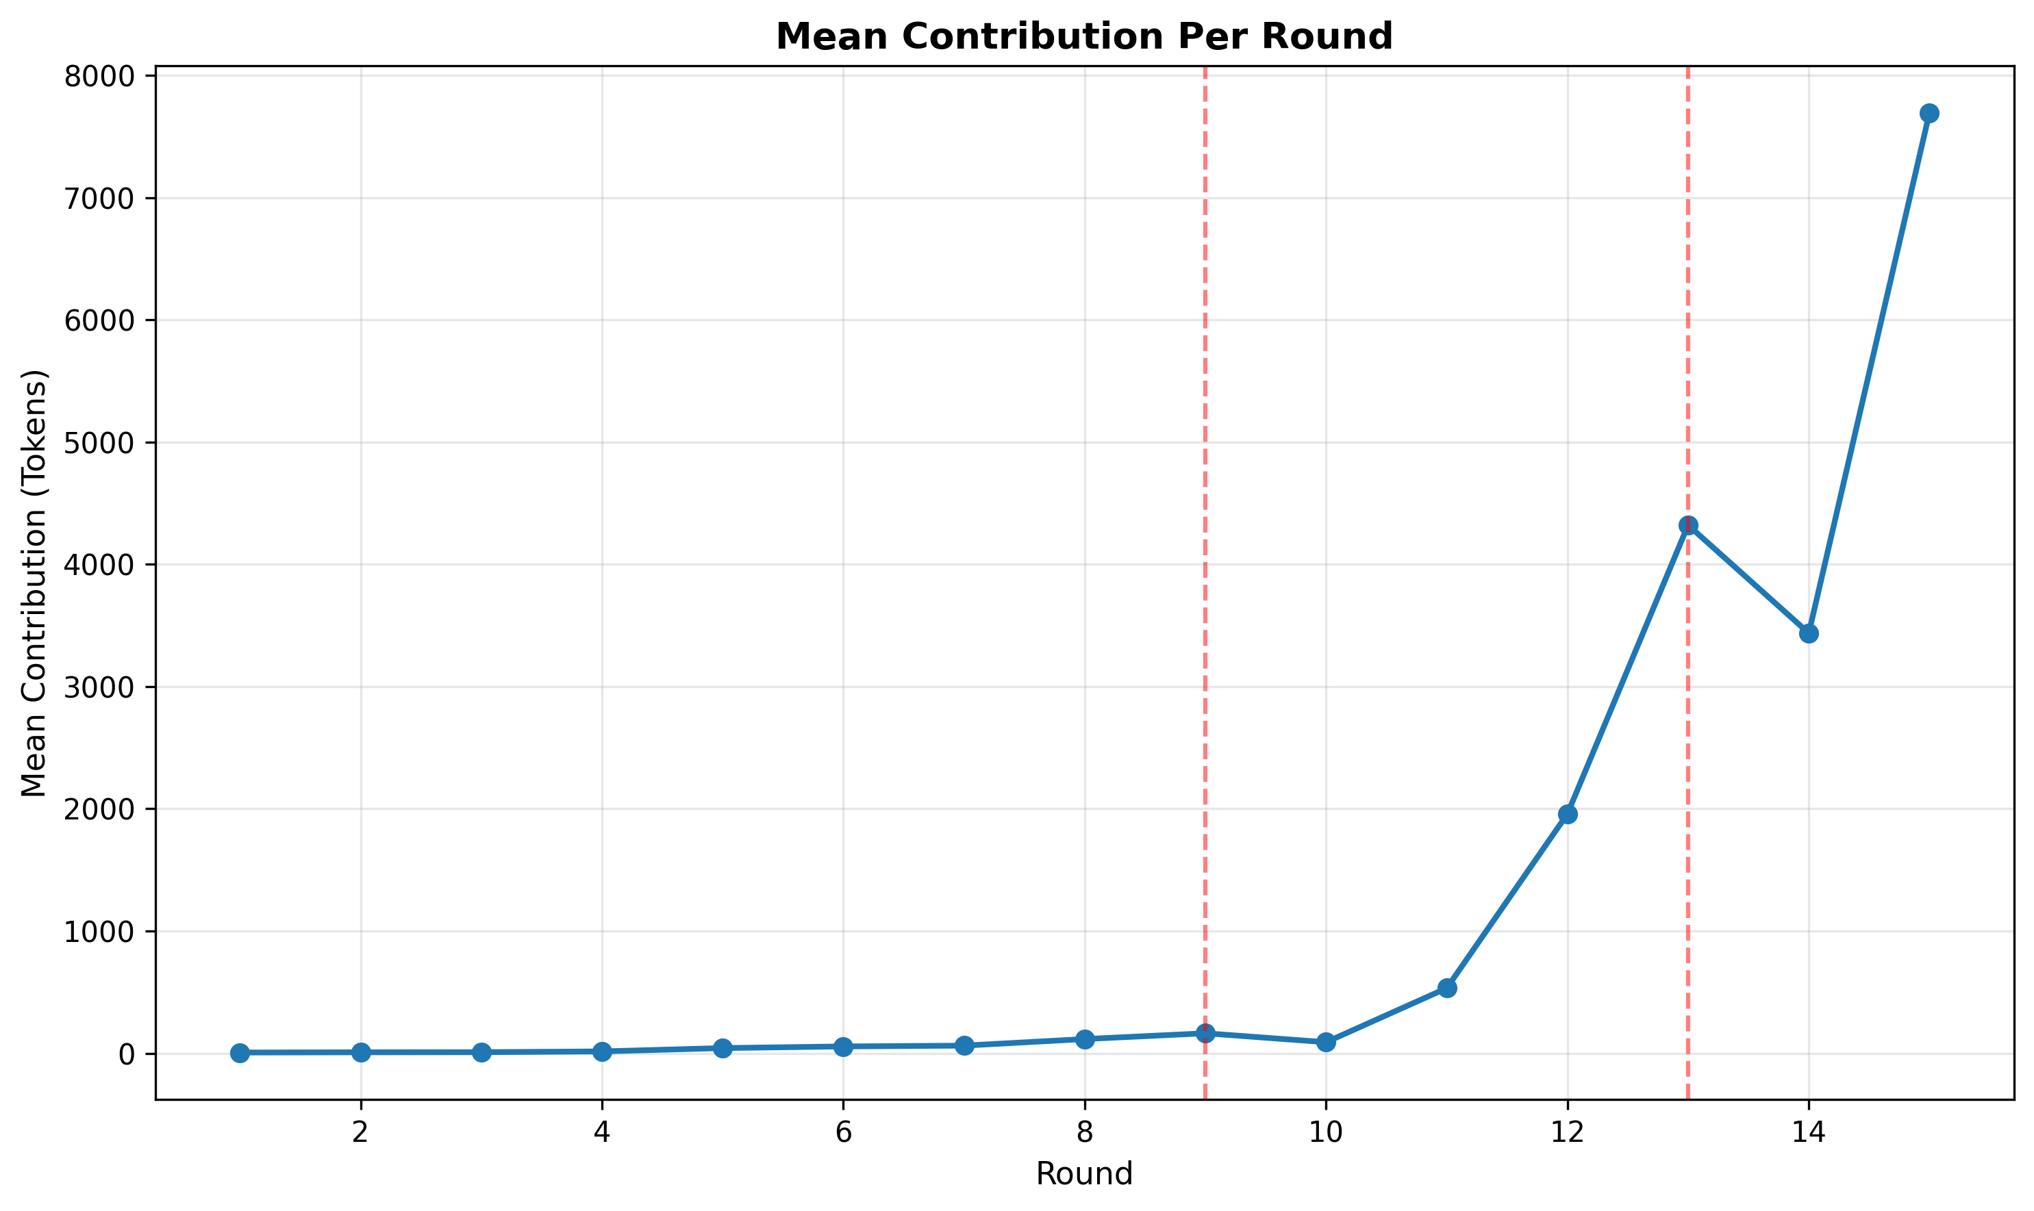
Average contribution dynamics by round. The steep late-game rise is the core cooperation result.
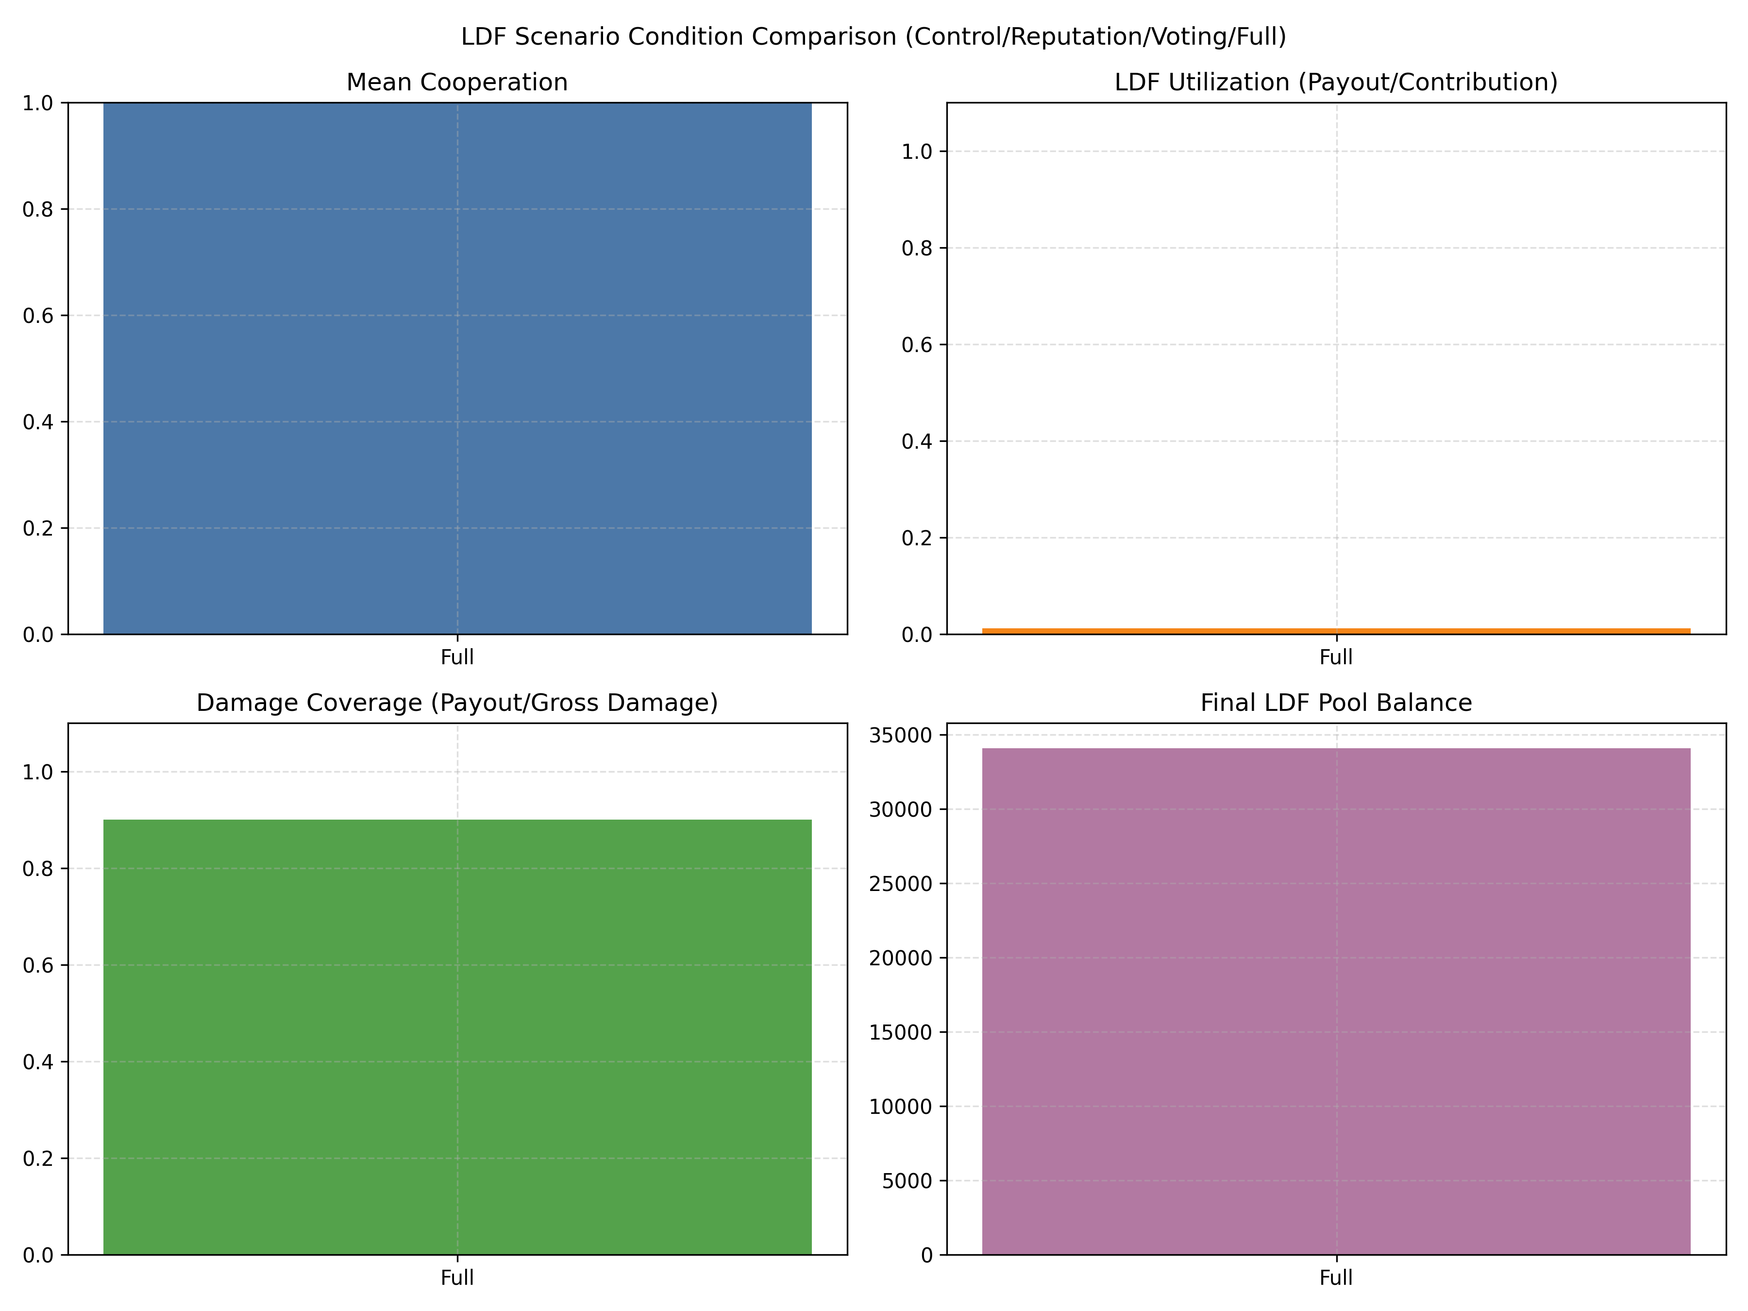
Key LDF-condition KPIs from round 13: this figure presents contribution, payout, and coverage metrics under the round-13 shock condition and is used to discuss the fund’s redistributive performance.
Figure 5.1 (average contribution dynamics) and Figure 5.2 (round-13 KPIs) offer the contextual temporal and conditional background of the cooperation result. The average contributions increase after round 10, which is during the first period (round 9) of the shock and the large pool accumulation by round 13. It implies a mechanism of fund visibility and reputational feedback instead of a one-off learning effect. Therefore, shocks cause payouts and generate measurable accounting indicators that agents condition on in subsequent rounds, which leads to the significant late-game jump in terms of contributions. Looking at the KPIs in 5.2, high mean cooperation, modest LDF utilization, partial damage coverage, and a growing pool balance highlight that the system accumulates resources faster than it spends them. This is in line with a high-contribution and low-utilization regime.
The payoff distribution is highly skewed and Table 5.2 shows that developed agents contribute more than twice as much as developing agents on average and earn 5.56 times higher cumulative payoff. This is easily overlooked when one just looks at total fund size. The level of contributions is high but the benefits of cooperation are not distributed evenly.
Group-level summary statistics.
Metric | Developed | Developing
$$n$$ | 12 | 14
Avg contrib. | 1,730.8556 | 808.3143
Avg payoff | 1,246,172.0294 | 224,392.4844
Avg wealth | 1,246,172.0294 | 224,392.4844
Avg rep. | 5.9016 | 5.3084
Avg punish. received | 421.5 | 0.0
LDF payout | 94.2629 | 329.9200
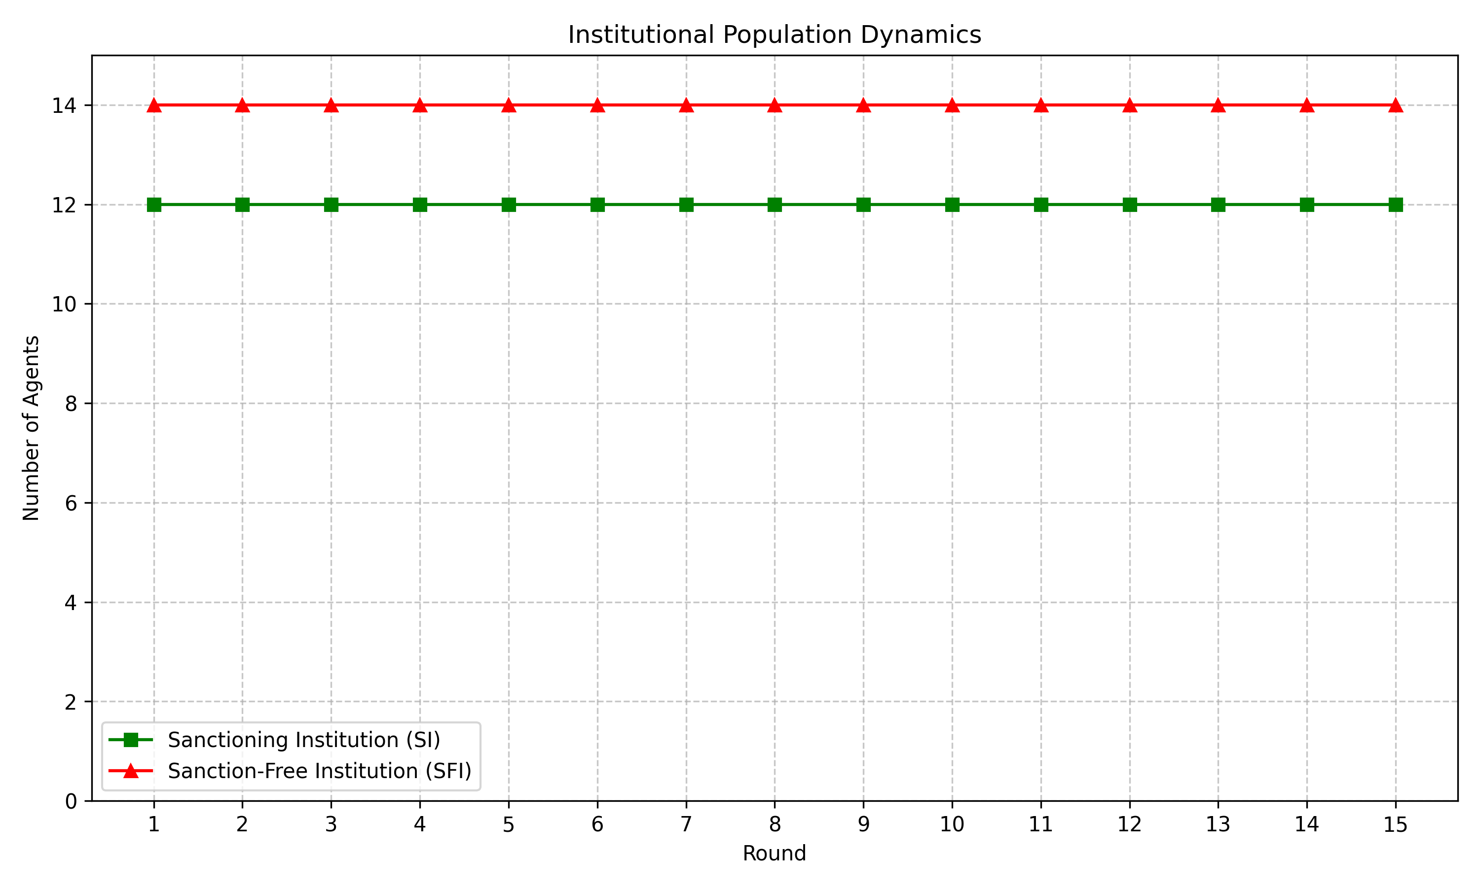
Institutional composition is fixed by design and not chosen endogenously. The figure is useful because it shows that the main action is within-group behavior, not institution switching.
The LDF can be viewed as a weak redistributive insurance pool. Throughout the simulation, overall LDF contributions are $34.500$ billion and total payouts are $424.183$ million thus a disbursal rate of just 1.2% (that is, the fund retains 98.8% of the total collected contributions), thereby making the mechanism more of a savings vehicle than a form of insurance. The developed agents contribute $34.374$ billion and receive only $94.263$ million hence are net fund providers and the developing agents contribute $125.898$ million and receive $329.920$ million hence are net beneficiaries. The pool is financed by the developed countries and is drawn by the developing countries when shocks strike yet the total transfer is modest when compared to the total contributions.

Shock-round accounting from the main JSON file. The net damage column is the post-insurance loss after the fund payout.
Round | Gross damage | Net damage | LDF payout | Pool end
9 | 175.2679 | 17.5268 | 157.7411 | 551.4445
13 | 296.0464 | 29.6046 | 266.4417 | 34,076.1831
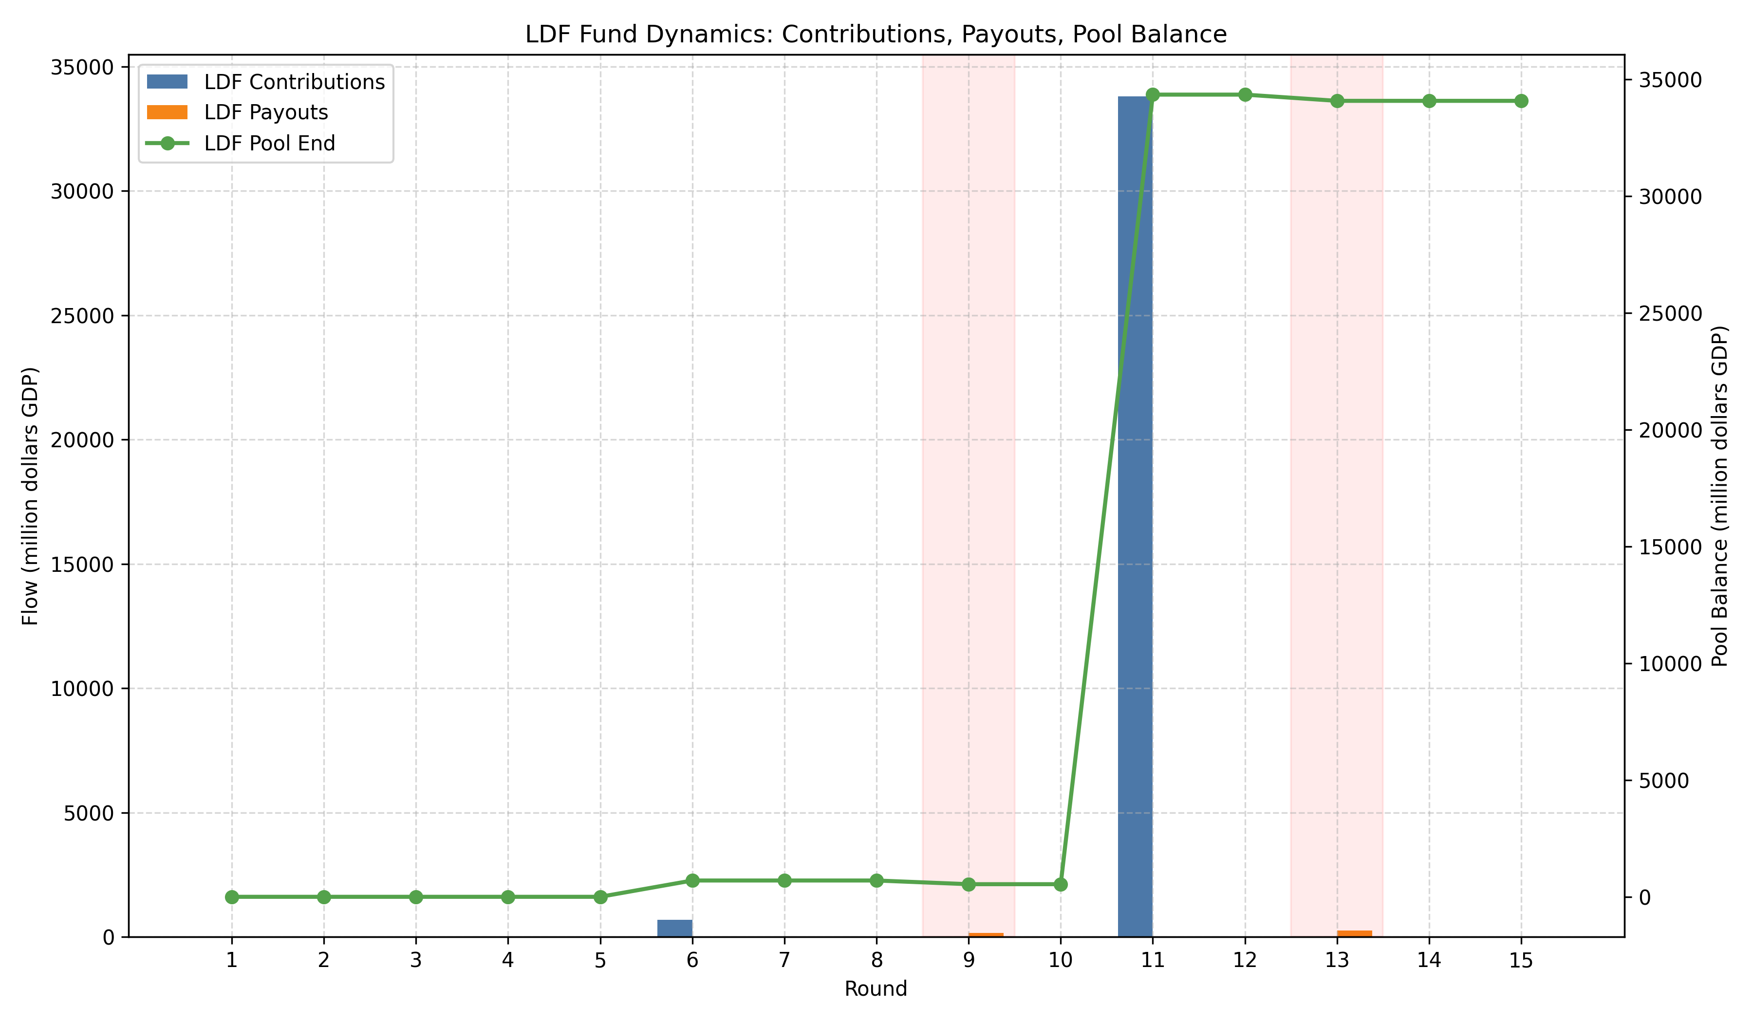
LDF pool flows. The visually important feature is the stepwise accumulation and the two payout dips in the shock rounds.
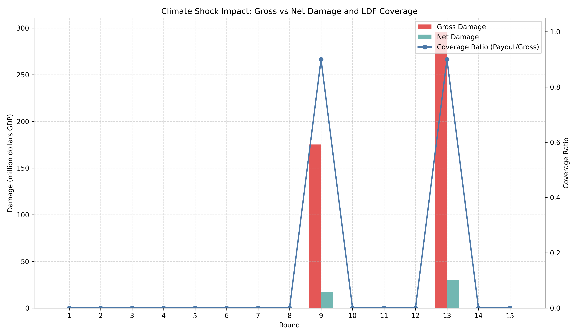
Damage coverage by the LDF. Coverage is positive but far from full insurance which is why the mechanism should be read as partial compensation rather than redistribution at scale.
Figure 5.5 reports damage coverage defined as LDF payout divided by gross damage (Coverage = LDF payout / Gross damage). Using the shock-round accounting in Table 5.3, coverage in round 9 is $157.7411/175.2679≈0.90$ (90%) and in round 13 is $266.4417/296.0464≈0.90$ (90%). This level of coverage presents considerable but partial coverage, i.e., even when the pool-end is large in round 13 (34,076.1831 million in the pool-end column), the payout rule and the participation parameters result in a partial compensation of gross damages. This proves the weak-redistributor claim - the LDF gives proper compensation in the event of shocks but does not fully cover losses according to the existing rules of payout and the participation rate.

Discussion
The substantive outcome is that the upsurge in contribution outputs is considerably greater than that of redistribution. Policywise, the simulation views contribution capacity as positive and equity as uncertain. The system is funded at scale by the developed group but the net receipt of the developing group is $204.022$ during the 15 rounds. The gross fund accumulation to net redistribution ratio is thus large.
This is one of the reasons why the contribution path and the redistribution path move differently. Contributions become visible each round in order to make the contribution outputs vary as the prompt takes larger fund-size inputs and reputational history. Redistribution only occurs when shocks hit so it is episodic and contingent. This results in a system which can build up a large pool and coincide with higher contribution outputs but this does not convert into a large transfer program.
The deterministic SI/SFI assignment also helps with the interpretation. The model isolates the impact of institutional asymmetry apart since developed agents are directed in SI and developing agents in SFI. In such environment, developed agents become more prominent contributors and the principal targets of sanctioning while the developing agents are spared punishment and also not subjected to sanctions. This aids in understanding the fact that the pattern is not institutional shopping but varied input-output reactions to fixed structure.
The same is also mentioned by the figures. Contribution, payoff, institution and LDF flow graphs depict a system with strong patterning at late stages, enduring payoff asymmetry, and limited but nonzero insurance. Each of the figures are connected to the underlying experiment trace in such a way that visual claims can be traced to the recorded CSV/JSON outputs.
Limitations: these results are conditional on model and design choices. We applied deterministic decoding of Llama 3.1 8B models that eliminate randomness that can manifest with probabilistic decoding and also underestimate the variation in agent actions. It could also be that the Llama 3.1 8B model class has systematic response tendencies to contribution and reputation prompts, so that we would not be able to distinguish between the cooperation dynamics being due to the institutional/game structure or by the behaviour of this model and prompt set. We consider the results to be scenario-dependent and suggest clear robustness checks varying seeds, decoding schemes (stochastic and deterministic), and LLM families. It is not possible to know whether we are seeing observed cooperation that is sensitive to the value of MPCR. At MPCR = 0.062, the individual irrationality of contribution and cooperation can be indicative of contribution norms inherent in the training of the model instead of actual incentive response. Future work should focus on testing across MPCR values. One issue with the LLM-agent simulations is that the observed behavioral patterns might be due to statistical regularities in training the model, and not strategic reasoning. We report regularities of input-output in contribution behavior and do not assert that the agents are in deliberate coordination.
External validity can thus be treated as a substantive outcome. The cooperative tilt of a smaller open-source model such as Llama 3.1 8B could be due to exposure to climate-policy discourse at the time of training where the language of loss-and-damage is already linked to burden sharing, vulnerability, and reciprocity which means that the model is not actually acting cooperative, it is merely re-surfacing what it has learned in the climate governance vocabulary itself. This renders the behavior intriguing as it suggests that prompt design can trigger latent normative structure in open-source models in spite of the fact that the outcome cannot be interpreted as indication of human-like strategic behavior.
The LLM-agent literature is also in line with our three guiding questions. Piatti et al.’s GOVSIM shows that communication and coordinated protocols can sustain commons provision in LLM populations. The CoOPEVaL benchmark (CoopEval) by Tewolde et al. emphasizes the use of various mechanism-design decisions to identify the most effective cooperation-sustaining strategies in agent societies. Ren et al. emphasize that reputational mechanisms have the capacity to spot and socially ostracize exploitative agents and therefore contribute to stabilizing cooperation. All this is true on our side of the contribution but we are more cautious on redistribution. The institution is capable of stabilizing cooperation without providing egalitarian results.

Conclusion
This simulation highlights that a LDF-like mechanism can be effective when it comes to stimulating contributions but only offering partial redistributive coverage. Policy-wise, it is important to differentiate between high contribution capacity and high redistribution as institutional parameters (payout rules, participation rates, and timing of shocks) are key factors when it comes to whether resources are converted into appropriate compensation or not.
Model dependency is the most significant limitation of this study. The results are conditional on the particular LLM class (Llama 3.1 8B) and deterministic decoding used which can influence strategic responses to prompts.
To proceed, future work should perform robustness checks that (1) test the GPT-4-class models and other LLM family under stochastic decoding (2) vary decoding and prompt formulations to measure sensitivity (3) execute counterfactuals wherein endogenous institutions have a choice and alternative payout formulas (such as full-coverage payout rules or increased participation rates) and (4) vary the MPCR in order to test if contribution outputs remain high even when contributions are less individually costly. The empirical test in this case is if GPT-4-class models (with more strategic reasoning) are able to bridge the contribution-redistribution gap or whether the gap is a general feature of the institutional design.

Additional Tables
Top agents by cumulative payoff. The extreme concentration at the top is another reason the dissertation should be read as contribution-rich but redistribution-poor.
Agent | Group | Avg contrib. | Cum. payoff | Avg rep.
13 | Developed | 33.1333 | 8,031,192.2623 | 6.0747
23 | Developed | 893.3333 | 1,271,881.5195 | 6.2613
21 | Developed | 51.0000 | 1,255,659.9586 | 4.9013
16 | Developed | 27.4000 | 815,701.9140 | 6.8267
14 | Developed | 61.0667 | 806,807.4656 | 5.7733
6 | Developed | 117.2667 | 715,994.1684 | 5.5493
10 | Developed | 12.0000 | 502,466.0967 | 5.9040
22 | Developed | 2,030.6667 | 500,685.9952 | 6.2000
5 | Developed | 447.6667 | 391,725.7591 | 5.8960
17 | Developing | 11.8000 | 338,096.9602 | 5.7333

Accounting summary used to verify the dissertation’s redistribution claims.
Item | Value | Unit
Total LDF contributions | 34,500.36595 | million
Total LDF payouts | 424.18287 | million
Developed contributions | 34,374.4682 | million
Developed payouts | 94.2629 | million
Developing contributions | 125.8977 | million
Developing payouts | 329.9200 | million
Net transfer to developing group | 204.0223 | million

Selected rounds (appendix). Cooperation is normalized total contribution; shocks occur in rounds 9 and 13.
Round | Cooperation | Gini | SI contrib. | SFI contrib. | Shock
1 | 0.2769 | 0.7124 | 9.67 | 2.00 | No
5 | 2.1058 | 0.6620 | 53.42 | 8.00 | No
9 | 8.1635 | 0.6238 | 650.00 | 141.43 | Yes
11 | 26.6250 | 0.6184 | 1,245.42 | 87.50 | No
13 | 216.0846 | 0.6071 | 8,244.83 | 150.00 | Yes
15 | 384.8038 | 0.6085 | 10,644.67 | 150.00 | No

Condensed group breakdown (appendix) summarizing average contributions and LDF payouts by group.
Group | $$n$$ | Avg contrib. | LDF payout
Developed | 12 | 1,730.8556 | 94.2629
Developing | 14 | 808.3143 | 329.9200
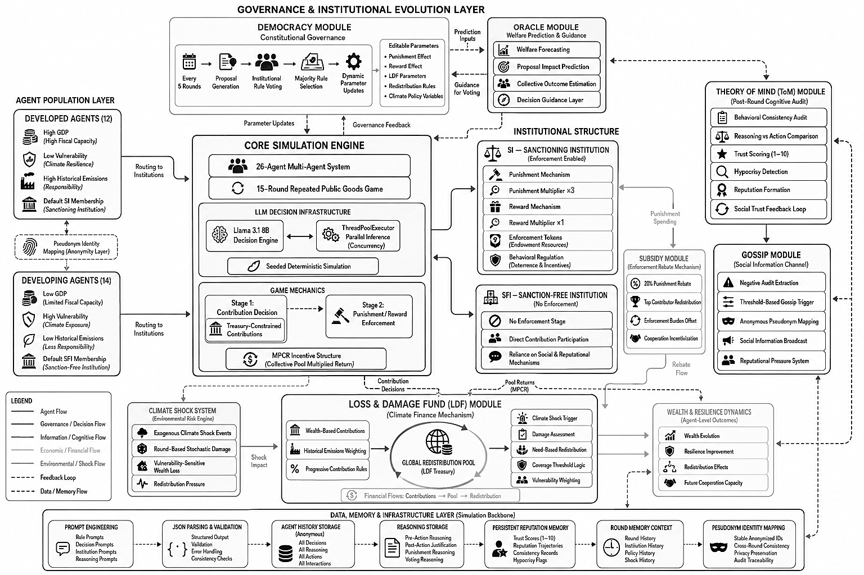
System-level pipeline diagram.

References
Ashery, A. F., Aiello, L. M., & Baronchelli, A. (2025). Emergent social conventions and collective bias in LLM populations. Science Advances, 11(20), eadu9368. https://doi.org/10.1126/sciadv.adu9368
Cross, L., Haber, N., & Yamins, D. L. K. (2025). Validating Generative Agent-Based Models of Social Norm Enforcement: From Replication to Novel Predictions. https://doi.org/10.48550/arxiv.2507.22049
De Curtö, J., De Zarzà, I., Fervier, L. S., Sanagustín-Fons, V., & Calafate, C. T. (2025). An institutional theory framework for leveraging large language models for policy analysis and intervention design. Future Internet, 17(3), 96. https://doi.org/10.3390/fi17030096
Drake, S. (2025). “Neural howlround” in large language models: a self-reinforcing bias phenomenon, and a dynamic attenuation solution. https://doi.org/10.48550/arxiv.2504.07992
Hintze, A., & Adami, C. (2026). Promoting cooperation in the public goods game using artificial intelligent agents. Npj Complexity, 3(1). https://doi.org/10.1038/s44260-025-00065-9
Hsia, Y., Yu, F., & Jiang, J. R. (2026). Neuro-Symbolic Compliance: Integrating LLMS and SMT Solvers for Automated Financial Legal Analysis. https://doi.org/10.1109/aiware69974.2025.00010
Kim, M., & Hwang, S. (2025). Dual-Scale world models for LLM agents towards Hard-Exploration problems. https://doi.org/10.48550/arxiv.2509.24116
Li, Y., & Shirado, H. (2025). Spontaneous Giving and Calculated Greed in Language Models. https://doi.org/10.18653/v1/2025.emnlp-main.267
Liang, Y., Qu, Y., Yang, J., Lin, S., & Shen, Z. M. (2025). Everyone contributes! Incentivizing strategic cooperation in Multi-LLM systems via sequential public goods games. https://doi.org/10.48550/arxiv.2508.02076
Liu, K., Hou, X., Yuan, J., & Jaques, N. (n.d.). Evaluating LLM agents as human simulators in climate social dilemmas. OpenReview. https://openreview.net/forum?id=wTgTyIgRv3
Lu, W., Dhanda, A., Chen, D. L., & Hansen, C. B. (2025). Aligning Large Language Model Agents with Rational and Moral Preferences: A Supervised Fine-Tuning Approach. https://doi.org/10.48550/arxiv.2507.20796
Madmoun, H., & Lahlou, S. (2026). Communication Enables Cooperation in LLM Agents: A Comparison with Curriculum-Based Approaches. https://doi.org/10.18653/v1/2026.eacl-short.23
Mao, S., Cai, Y., Xia, Y., Wu, W., Wang, X., Wang, F., Ge, T., & Wei, F. (2023). ALYMPICS: LLM Agents Meet Game Theory – Exploring Strategic Decision-Making with AI Agents. https://doi.org/10.48550/arxiv.2311.03220
Manik, M. M. H., & Wang, G. (2026). OpenClaw Agents on MoltBook: Risky instruction sharing and norm Enforcement in an Agent-Only Social Network. http://arxiv.org/abs/2602.02625
Moon, S. (2025). Binding large language models to virtual personas for human simulation (Publication No. 9798276022734) [Doctoral dissertation, University of California, Berkeley]. eScholarship. https://escholarship.org/uc/item/8s32x9x7
Mu, C., Zeng, Y., Zhang, Q., Shao, K., Chu, C., Guo, H., Jia, D., Wang, Z., & Hu, S. (2026). Adaptive Theory of Mind for LLM-based Multi-Agent Coordination. Proceedings of the AAAI Conference on Artificial Intelligence, 40(35), 29608–29616. https://doi.org/10.1609/aaai.v40i35.40204
Gupta, P., Zhong, Q., Yakura, H., Eisenmann, T., & Rahwan, I. (2025). The role of social learning and collective norm formation in fostering cooperation in LLM Multi-Agent Systems. https://doi.org/10.65109/czdc3237
Ospina, J. P., & Sánchez, J. F. (2025). A computational justice model for dynamic resource allocation in ad hoc networks. Complex Systems Informatics and Modeling Quarterly, 43, 53–76. https://doi.org/10.7250/csimq.2025-43.04
Piedrahita, D. G., Yang, Y., Sachan, M., Ramponi, G., Sch"olkopf, B., & Jin, Z. (2025). Corrupted by reasoning: Reasoning language models become Free-Riders in public Goods games. https://doi.org/10.48550/arxiv.2506.23276
Piatti, G., Jin, Z., Kleiman-Weiner, M., Sch"olkopf, B., Sachan, M., & Mihalcea, R. (2024). Cooperate or Collapse: Emergence of Sustainable Cooperation in a Society of LLM Agents. https://doi.org/10.48550/arxiv.2404.16698
Ren, S., Fu, W., Zou, X., Shen, C., Cai, Y., Chu, C., Wang, Z., & Hu, S. (2025). Reputation as a solution to cooperation collapse in LLM-based MASs. https://doi.org/10.48550/arxiv.2505.05029
Shi, L., Ma, C., Liang, W., Diao, X., Ma, W., & Vosoughi, S. (2025). Judging the Judges: A Systematic Study of Position Bias in LLM-as-a-Judge. In Association for Computational Linguistics (pp. 292–314). https://doi.org/10.18653/v1/2025.ijcnlp-long.18
Smit, M., & Santos, F. P. (2024). Learning Fair Cooperation in Mixed-Motive Games with Indirect Reciprocity. https://doi.org/10.48550/arxiv.2408.04549
Sumers, T. R., Yao, S., Narasimhan, K., & Griffiths, T. L. (2023). Cognitive architectures for language agents. https://doi.org/10.48550/arxiv.2309.02427
Tennant, E., Hailes, S., & Musolesi, M. (2024). Moral alignment for LLM agents. https://doi.org/10.48550/arxiv.2410.01639
Tewolde, E., Zhang, X., Piedrahita, D. G., Conitzer, V., & Jin, Z. (2026). CoOPEVaL: Benchmarking Cooperation-Sustaining Mechanisms and LLM Agents in Social Dilemmas. https://arxiv.org/abs/2604.15267
Wang, Q., & Goel, A. K. (2022). Mutual Theory of Mind for Human-AI Communication. arXiv (Cornell University). https://doi.org/10.48550/arxiv.2210.03842
Warnakulasuriya, K., Dissanayake, P., De Silva, N., Cranefield, S., Savarimuthu, B. T. R., Ranathunga, S., & De Silva, N. (2026). Evolution of Cooperation in LLM-Agent Societies: A preliminary study using different punishment strategies. In Lecture notes in computer science (pp. 115–133). https://doi.org/10.1007/978-3-032-17542-7_7
Vezhnevets, A. S., Agapiou, J. P., Aharon, A., Ziv, R., Matyas, J., Duénez-Guzmán, E. A., Cunningham, W. A., Osindero, S., Karmon, D., & Leibo, J. Z. (2023). Generative agent-based modeling with actions grounded in physical, social, or digital space using Concordia. https://doi.org/10.48550/arxiv.2312.03664
Willis, R., Zhao, J., Du, Y., & Leibo, J. Z. (2026). Evaluating collective behaviour of hundreds of LLM agents. http://arxiv.org/abs/2602.16662
Xiang, A. (2025). Diagnosing the bias iceberg in large language models: A three-level framework of explicit, evaluative, and implicit gender bias. Information Processing & Management, 63(3), 104554. https://doi.org/10.1016/j.ipm.2025.104554
Xie, Y., Gao, R., & Mei, Q. (n.d.). Distributional Alignment for Social Simulation with LLMs: A Prompt Mixture Modeling Approach. OpenReview. https://openreview.net/forum?id=6KM1siLL8a
Zhang, Y., Mei, K., Liu, M., Wang, J., Metaxas, D. N., Wang, X., Hamm, J., & Ge, Y. (2026). Agents in the Wild: Safety, Society, and the Illusion of Sociality on Moltbook. http://arxiv.org/abs/2602.13284
Zhou, Y., Zhu, W., Wen, J., Peng, W., Wu, Z., & Xue, Y. (2025). From implicit to explicit: Enhancing Self-Recognition in large language models. https://doi.org/10.48550/arxiv.2508.14408
Friedman, J. W. (1971). A non-cooperative equilibrium for supergames. Review of Economic Studies, 38(1), 1–12. https://doi.org/10.2307/2296617
Fudenberg, D., & Maskin, E. (1986). The Folk Theorem in repeated games with discounting or with incomplete information. Econometrica, 54(3), 533–554. https://doi.org/10.2307/1911307
Ledyard, J. O. (1995). 2. Public Goods: a survey of experimental research. In Princeton University Press eBooks (pp. 111–194). https://doi.org/10.1515/9780691213255-004
Isaac, R. M., & Walker, J. M. (1988). Group size effects in public goods provision: the Voluntary Contributions mechanism. The Quarterly Journal of Economics, 103(1), 179. https://doi.org/10.2307/1882648
Isaac, R., Walker, J. M., & Williams, A. W. (1994). Group size and the voluntary provision of public goods. Journal of Public Economics, 54(1), 1–36. https://doi.org/10.1016/0047-2727(94)90068-X
Fehr, E., & Gächter, S. (2000). Cooperation and punishment in public goods experiments. American Economic Review, 90(4), 980–994. https://doi.org/10.1257/aer.90.4.980
Fehr, E., & Gächter, S. (2002). Altruistic punishment in humans. Nature, 415(6868), 137–140. https://doi.org/10.1038/415137a
Andreoni, J. (1988). Why free ride? Journal of Public Economics, 37(3), 291–304. https://doi.org/10.1016/0047-2727(88)90043-6
Fischbacher, U., Gächter, S., & Fehr, E. (2001). Are people conditionally cooperative? Evidence from a public goods experiment. Economics Letters, 71(3), 397–404. https://doi.org/10.1016/S0165-1765(01)00394-9
Barrett, S. (1994). Self-Enforcing international environmental agreements. Oxford Economic Papers, 46(Supplement_1), 878–894. https://doi.org/10.1093/oep/46.supplement_1.878
Ostrom, E. (1990). Governing the Commons. In Cambridge University Press eBooks. https://doi.org/10.1017/CBO9780511807763
Ostrom, E. (2000). Collective action and the evolution of social norms. The Journal of Economic Perspectives, 14(3), 137–158. https://doi.org/10.1257/jep.14.3.137

