**1 / Add an error message to check if license file is not absent, or not empty:**

"Veuillez vérifier votre licence ou contacter le support sur contact@dsn-tools.fr!"

**2/ If license file is wrong, replace current message error by:**

"Veuillez vérifier votre licence ou contacter le support sur [contact@dsn-tools.fr](mailto:contact@dsn-tools.fr)!"

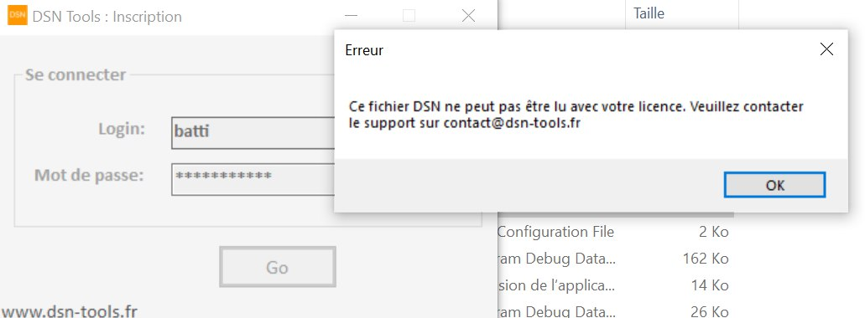

**3/ License limitation:**

if SIREN = 999999999, shunt the control on SIREN, so the User can use all dsn files without restriction on SIREN

See example on readme.txt file, by default we have 3 SIREN: 123456787; 123456788; 123456789

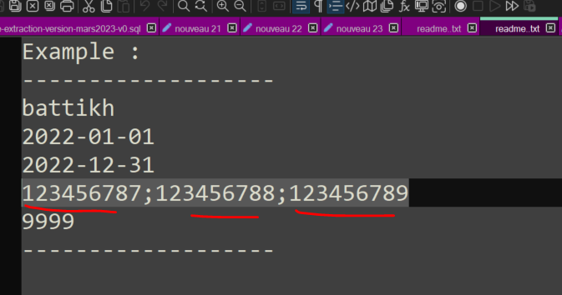

**4/ Save results files** on windows DOWNLOADS/dsn folder

**5/ Hide tmp folder** : When a template is runing, the xlsm files are visible under standalone/tmp, and user can copy them. We need to hide the tmp folder, or make user unable to copy the xlsm files

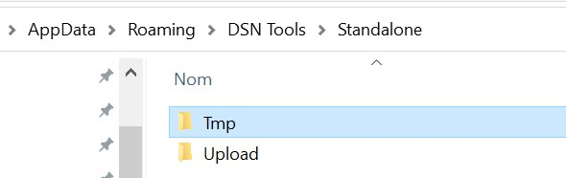

**6/ Rename files rules :**

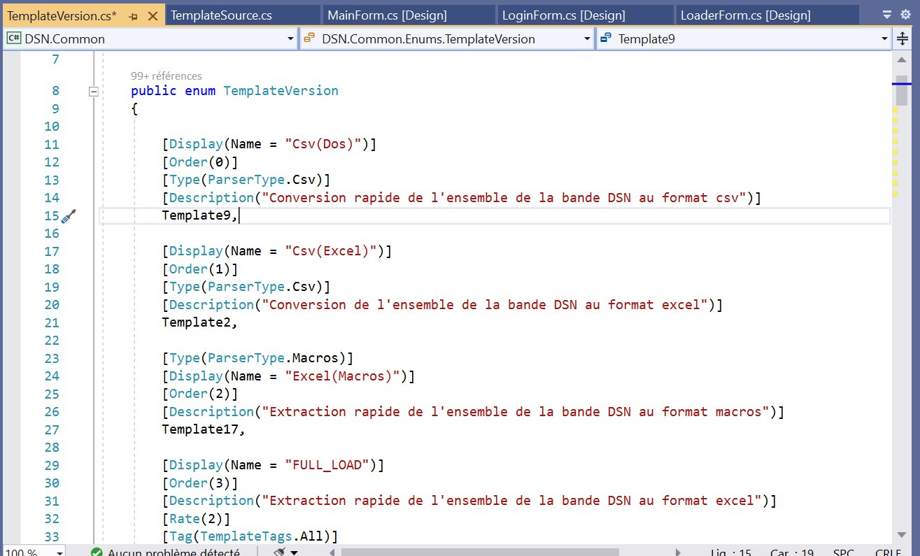

We need to add new attributs to templateversion.

Example :

[Display(Name = "Données Contractuelles")]

[Order(5)]

[Rate(5)]

[Description("Données contratctuelles des salariés déclarés (Bloc 40)")]

[Tag(TemplateTags.RH, TemplateTags.All)]

[Type(ParserType.Macros)]

[WebPage(WebPages.Aggregator, WebPages.Reporter)]

[FicName("40_Données_Contractuelles")]

[NameApp("RH : Données Contractuelles (Bloc 40)")]

[OrderApp(2)]

Template6,

* FicName : new attribut to be used to give the name of the xlsx extraction file (in both WEB and DESKTOP app's)

=>the file name will be : XXX_FicName_yyyymmddhhmiss.xlsx

XXX is the module name (REP, AGR or CTL)

Example : REP_40_Données_Contractuelles_20221112120202.xlsx if the template6 is launched in REPORTER

* NameApp : is the label of the template displayed in the Desktop app, instead of display.name attribute used in the web app.

* OrderApp will be used in the Desktop app to order the list of templates in dplTemplates.DataSource