First PoC — Visuals and Build Blueprint

1. First PoC flow
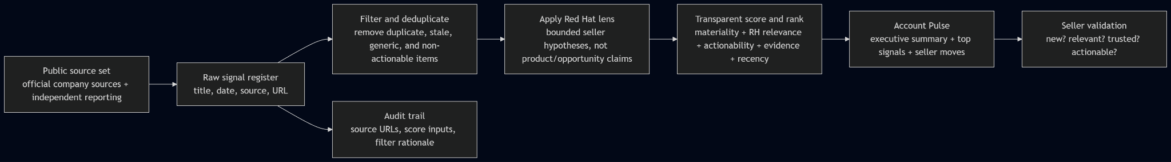

2. Clear boundary: manual POC versus coded product
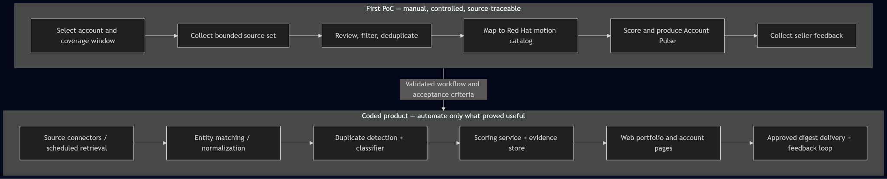

3. Seller-first information hierarchy
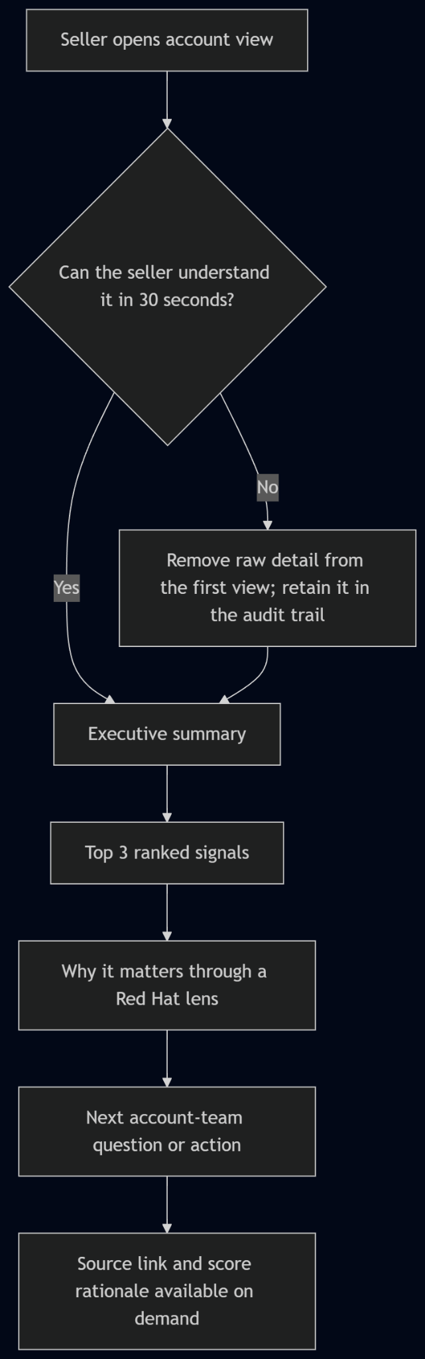

4. Product acceptance criteria
Criterion | Test
Seller usability | A seller can state: what changed, why it matters, and what should be validated next without opening the raw register.
Traceability | Every surfaced signal has a publication date, source URL, factual summary, score inputs, disposition, and a written rationale.
Relevance discipline | Generic content, duplicates, stale items, and events with no Red Hat-relevant action are retained in the audit trail but do not interrupt sellers.
No invented account claims | Product output states hypotheses and discovery questions; unproven account needs, architecture, opportunity, or buying intent remain UNKNOWN.
Automation readiness | The manual POC maps directly to the later functions: retrieval, normalize, dedupe, classify, rank, publish, and collect feedback.

5. What is deliberately not in the first PoC
- RAG or vector database
- MCP server
- Autonomous agents
- CRM writeback
- Automatic Gmail send
- Internal Red Hat account data
- Enterprise deployment, SSO, or role-based access control

Those items are only justified after the seller's output proves useful and the required access, ownership, governance, and data controls are known.

