Type help for help 1
Example 1 for how to use the Edf Converter 1
Converting the EDF File and saving it as a Matlab File 1
The edf Variable now holds all information 1
And how about just plot it? 2
Of course you can also plot in your own style: 2
Example 2 for how to use the Edf Converter 3
Converting the EDF File and saving it as a Matlab File 3
The edf Variable now holds all information 3
And how about just plot it? 4
Of course you can also plot in your own style: 4
Plot the progress of the pupil size 5
Example 2 for how to use the Edf Converter 5
Converting the EDF File and saving it as a Matlab File 5
Plot the progress of the pupil size 5

Type help for help
help Edf2Mat
Edf2Mat is a converter to convert Eyetracker data files to
Matlab file and perform some tasks on the data
The new procedure uses code from SR-Research that returns all info of
the edf and not just part of it. The new routine is based on the work
of C. Kovach 2007 and is only for non-commercial use!
Syntax: Edf2Mat(filename);
Edf2Mat(filename, verbose);
Inputs:
filename: must be of type *.edf
useOldProcedure: If you want to use the old procedure with
edf2asc.exe, you can set this argument to
true, default is false
verbose: logical, can be true or false, default is true.
If you want to supress output to console,
verbose has to be false

Example 1 for how to use the Edf Converter

Converting the EDF File and saving it as a Matlab File
edf0 = Edf2Mat('eyedata.edf');
Converting:100%

The edf Variable now holds all information
lets display it:
disp(edf0);
Edf2Mat with properties:
AUTHOR: 'Adrian Etter'
AUTHOREMAIL: 'adrian.etter@econ.uzh.ch'
COPYRIGHT: {2x1 cell}
VERSION: 1.5000
VERSIONDATE: '2013/April/11'
CHANGELOG: {3x2 cell}
filename: 'eyedata.edf'
Header: [1x265 char]
Samples: [1x1 struct]
Events: [1x613 struct]
Edf: [1x1 struct]
samplesFilename: 'not available for new procedure!'
eventsFilename: 'not available for new procedure!'
matFilename: 'eyedata.mat'

And how about just plot it?
plot(edf0);
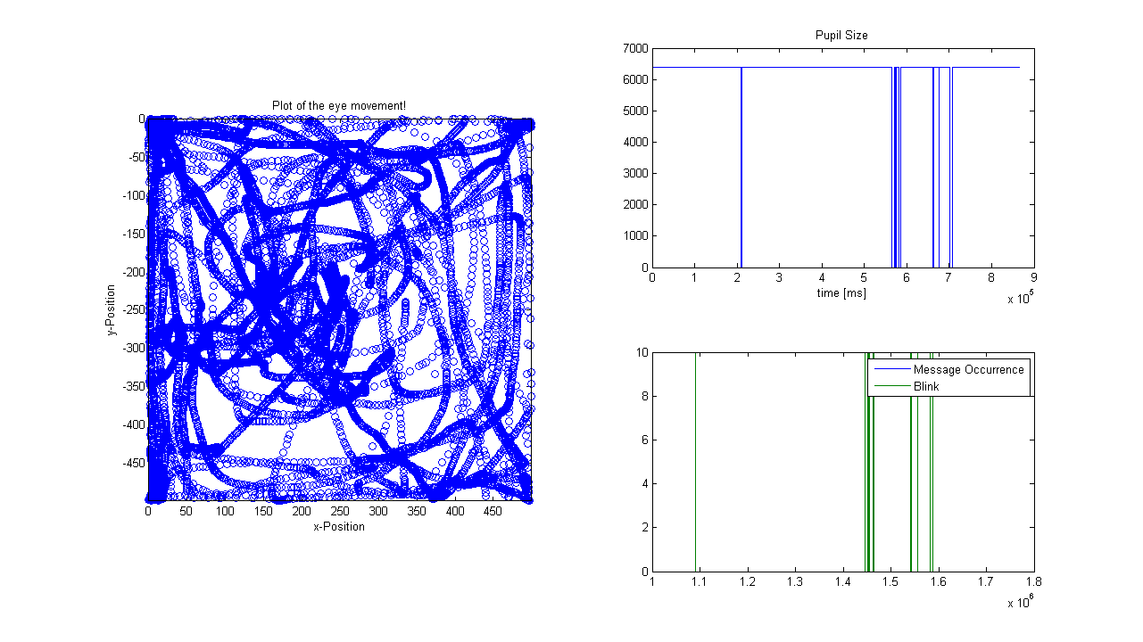

Of course you can also plot in your own style:
figure();
plot(edf0.Samples.posX(end - 2000:end), edf0.Samples.posY(end - 2000:end), 'o');
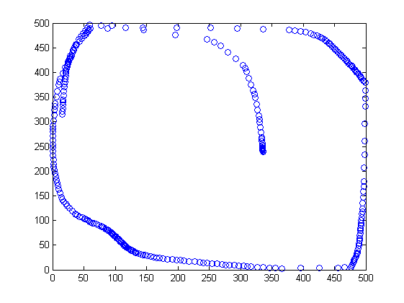

Example 2 for how to use the Edf Converter

Converting the EDF File and saving it as a Matlab File
edf1 = Edf2Mat('fMRI_Results_sub_025_270712EYE25r1.edf');
Converting:100%

The edf Variable now holds all information
lets display it:
disp(edf1);
Edf2Mat with properties:
AUTHOR: 'Adrian Etter'
AUTHOREMAIL: 'adrian.etter@econ.uzh.ch'
COPYRIGHT: {2x1 cell}
VERSION: 1.5000
VERSIONDATE: '2013/April/11'
CHANGELOG: {3x2 cell}
filename: 'fMRI_Results_sub_025_270712EYE25r1.edf'
Header: [1x273 char]
Samples: [1x1 struct]
Events: [1x6500 struct]
Edf: [1x1 struct]
samplesFilename: 'not available for new procedure!'
eventsFilename: 'not available for new procedure!'
matFilename: 'fMRI_Results_sub_025_270712EYE25r1.mat'

And how about just plot it?
plot(edf1);
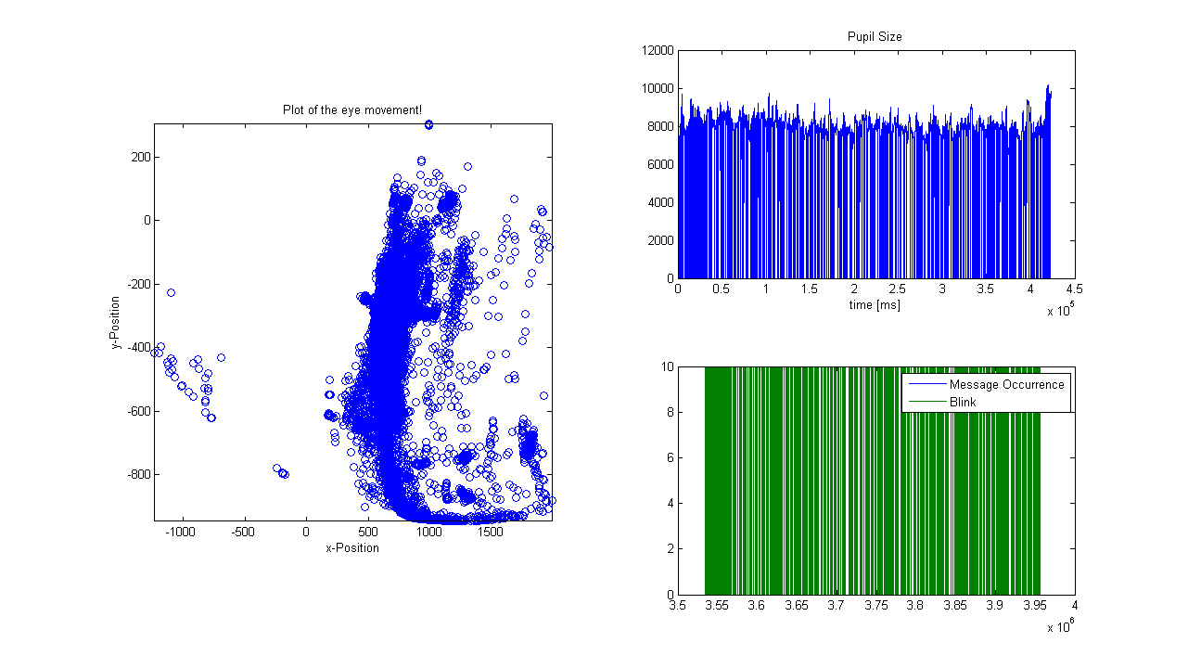

Of course you can also plot in your own style:
figure();
plot(edf1.Samples.posX(end - 2000:end), edf1.Samples.posY(end - 2000:end), 'o');
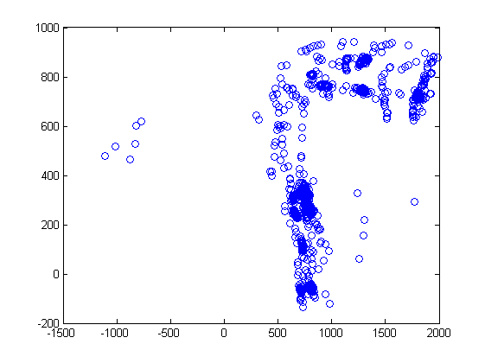

Plot the progress of the pupil size
figure();
plot(edf1.Samples.pa(2, end - 500:end));
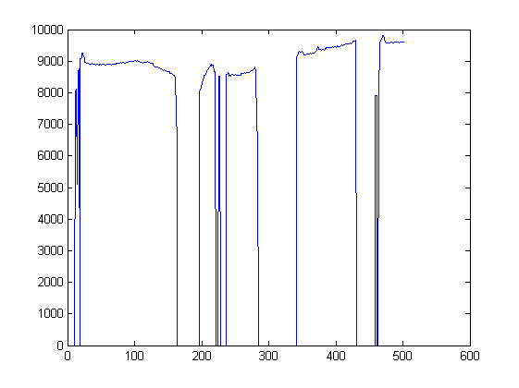

Example 2 for how to use the Edf Converter

Converting the EDF File and saving it as a Matlab File
edf2 = Edf2Mat('Pill004.edf');
Converting:100%

Plot the progress of the pupil size
figure();
plot(edf2.Samples.pa(2, 1:1500));
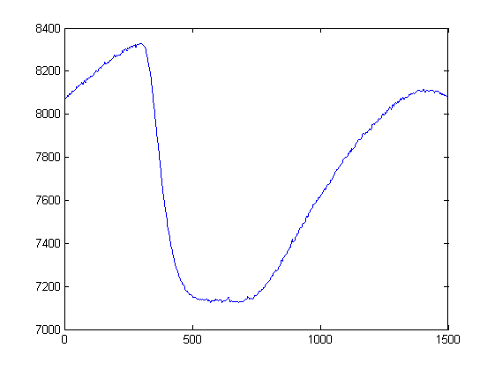
Published with MATLAB® R2013a

