

**CSE370 : Database Systems**

**PROJECT REPORT**

**“Movie Seat Reservation System”**

|  |  |  |
| --- | --- | --- |
| **Group No : 11 CSE370 Lab Section : 04 Fall 2024** | | |
| **ID** | **Name** | **Contribution** |
| 21201574 | Utsho Heaven Chowdhury | Frontend & Backend |
| 20301484 | Mohammad Muntasir Kabir | Frontend & Backend |
| 24141247 | Sakif Ferdous Khan | Backend |

Table of Contents

|  |  |  |
| --- | --- | --- |
| **Section**  **No** | **Content** | **Page No** |
| 1 | Introduction | 03 |
| 2 | Project Features | 04 |
| 3 | ER/EER Diagram | 05 |
| 4 | Schema Diagram | 06 |
| 5 | Frontend Development | 07 |
| 6 | Backend Development | 10 |
| 7 | Source Code Repository | 13 |
| 8 | Conclusion | 14 |

**Introduction**

The Movie Ticket Reservation System is a web-based application developed as part of my MySQL course project. This system combines the power of MySQL for data management with PHP, HTML, CSS, and JavaScript to create an interactive and user-friendly platform for booking movie tickets online.

The project aims to simulate a real-world ticket booking system where users can browse available movies, select showtimes, choose their seats, and complete reservations seamlessly. By leveraging the versatility of PHP for backend logic and MySQL for database operations, the system ensures data consistency and smooth functionality. The frontend, crafted using HTML, CSS, and JavaScript, delivers an intuitive user experience with responsive design and interactive elements.

This project not only highlights our understanding of relational database design and server-side scripting but also demonstrates my ability to create a cohesive application that merges back-end logic with a polished front-end interface. The Movie Ticket Reservation System is a practical showcase of how modern web technologies can come together to solve real-world problems efficiently and effectively.

Some key features of this project include:

* **User Authentication**: Secure login and registration system to manage user accounts.
* **Movie Catalog**: Dynamic listing of available movies, complete with showtimes, descriptions, and posters.
* **Seat Selection**: Interactive and real-time seat booking functionality with visual representation.
* **Booking Management**: A dashboard for users to view and manage their bookings.
* **Admin Panel**: A secure section for administrators to add movies, update schedules, and monitor reservations.

The Movie Ticket Reservation System stands as a practical demonstration of how various web technologies can be integrated to address real-world needs. It highlights my ability to develop a functional and polished application from concept to completion, showcasing my technical skills and creativity.

**Project Features**

1. **User Authentication (Login/Registration)**
   * User Registration: New customers can create an account by providing necessary details (e.g., name, email, password).
   * User Login: Existing customers can log in using their email and password.
   * User Authentication: Ensure that only registered users can access the reservation features.
2. **Movie Listings**
   * View Available Movies: Customers can view a list of available movies with details such as name, description, show timings, and movie poster images.
   * Search Movies: Allow users to search for specific movies by name or genre.
3. **Seat Reservation & Confirmation**

* Select Seats: Customers can select seats for a movie and book them for a specific showtime.
* Real-Time Updates: The seating availability is updated in real-time to ensure accurate booking (i.e., no double bookings).
* Booking Confirmation: Customers receive confirmation details with their reservation, including the movie, showtime, and selected seats.

1. **Admin Panel**

* Admin Login: Admins can log in to manage the system & can view the bookings.
* Movie Management: Admins can add, update, or remove movies from the listings.
* Admin Logout: Admins can log out after managing the system.

1. **Security**

* Session Management: Secure user sessions to prevent unauthorized access to customer accounts and dashboards.
* Data Protection: Protect sensitive customer data, especially passwords and personal information.
* User-friendly Interface: Easy-to-use interface for seamless browsing, booking, and user management.

**ER/EER Diagram**

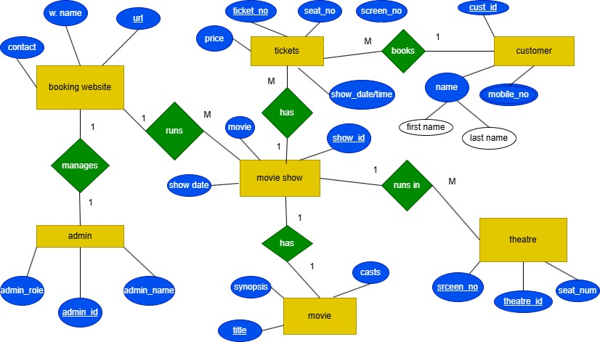

**Schema Diagram**

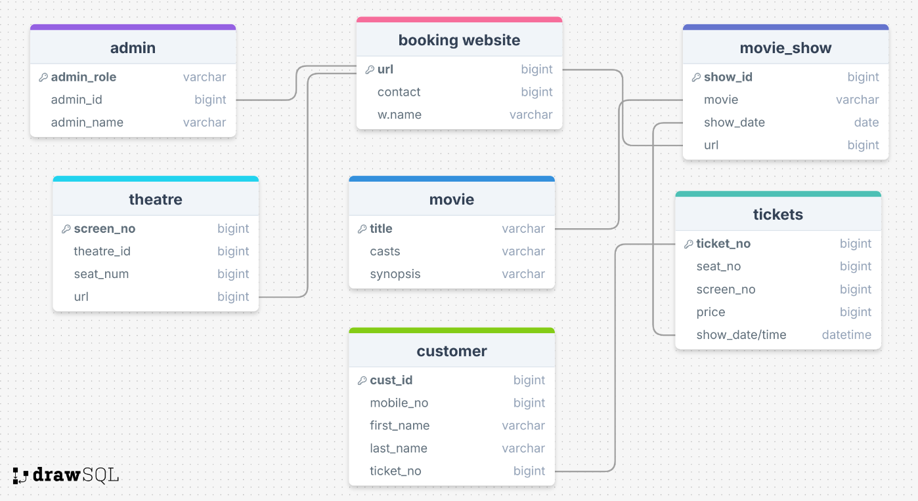

**Frontend Development**

*ID:* ***21201574***

*Name:* ***Utsho Heaven Chowdhury***

Firstly, I contributed to the first landing page where it serves as the main landing page, displaying available movies & providing navigation links to sections like login, register, or movie selection.

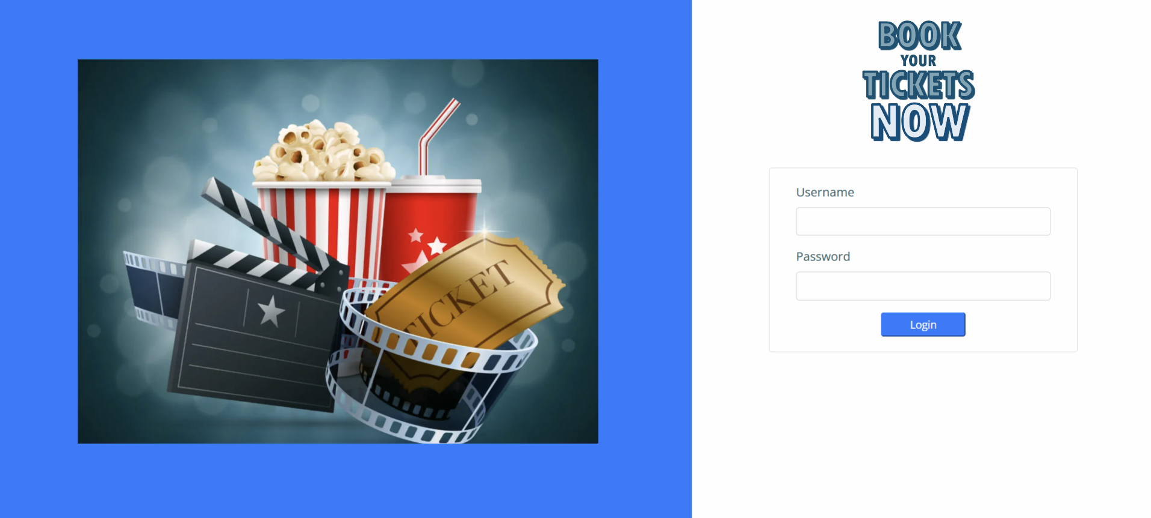

Fig: Login interphase

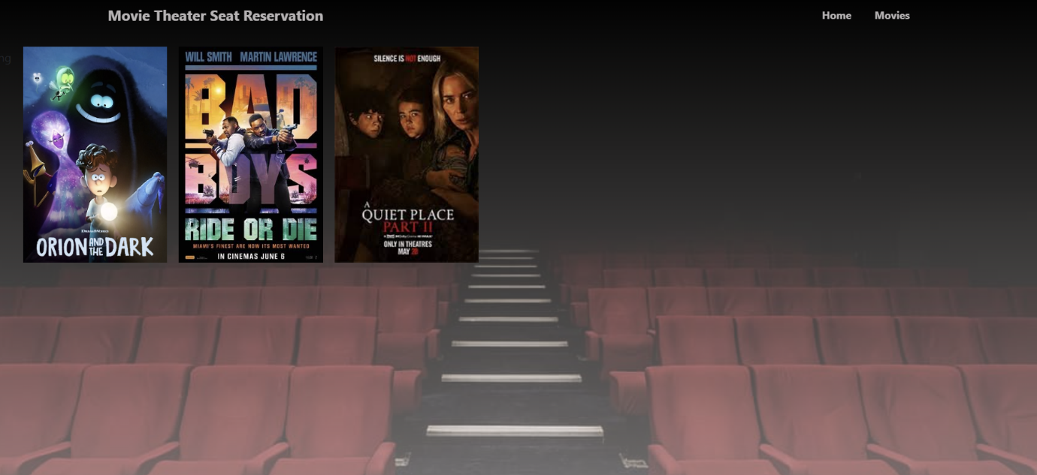

Fig: Movie carousel

*ID:* ***20301484***

*Name:* ***Mohammad Muntasir Kabir***

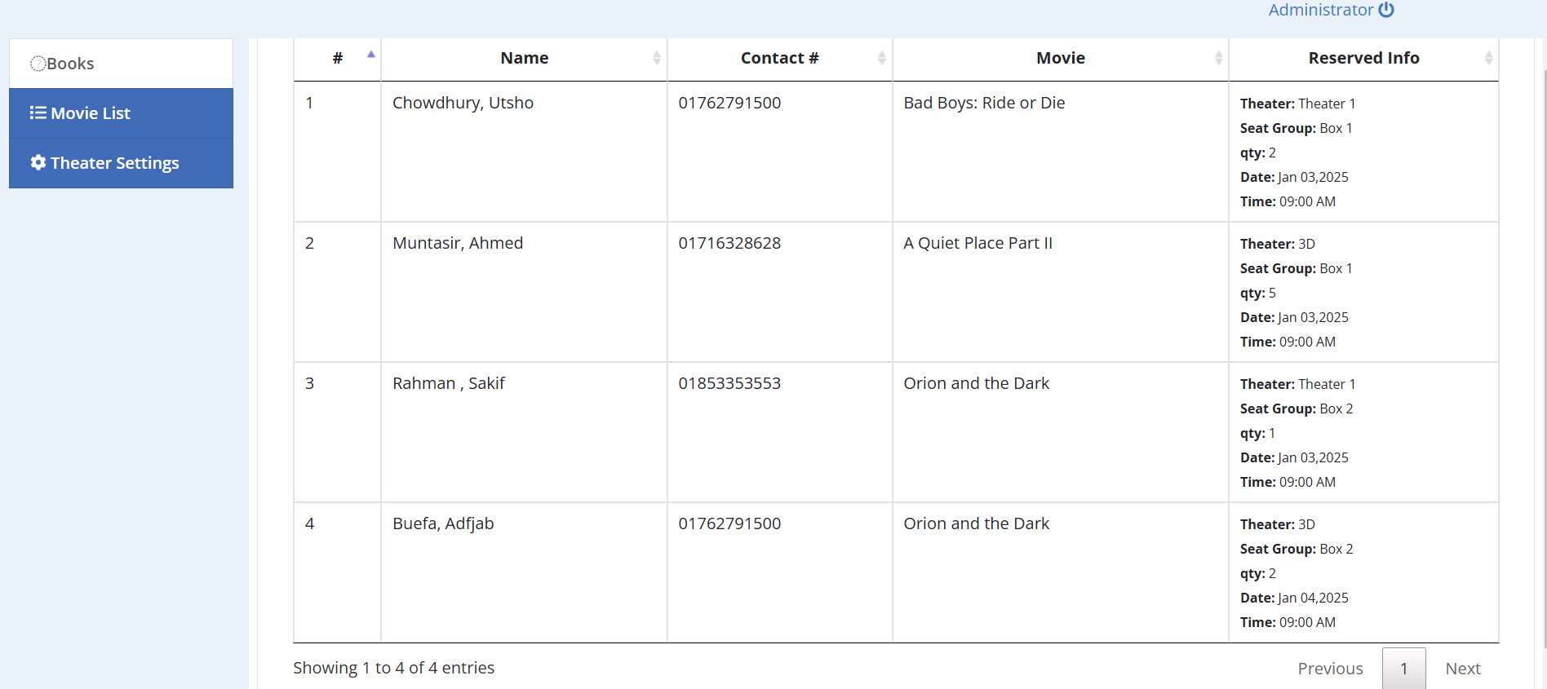

I have contributed on the HTML table formation on the bookings that the customers are assigning on the site. The details of the customers are also added with the ticket information to be taken along with shown in the Reserved Info Column.

*ID:* ***21201574***

*Name:* ***Utsho Heaven Chowdhury***

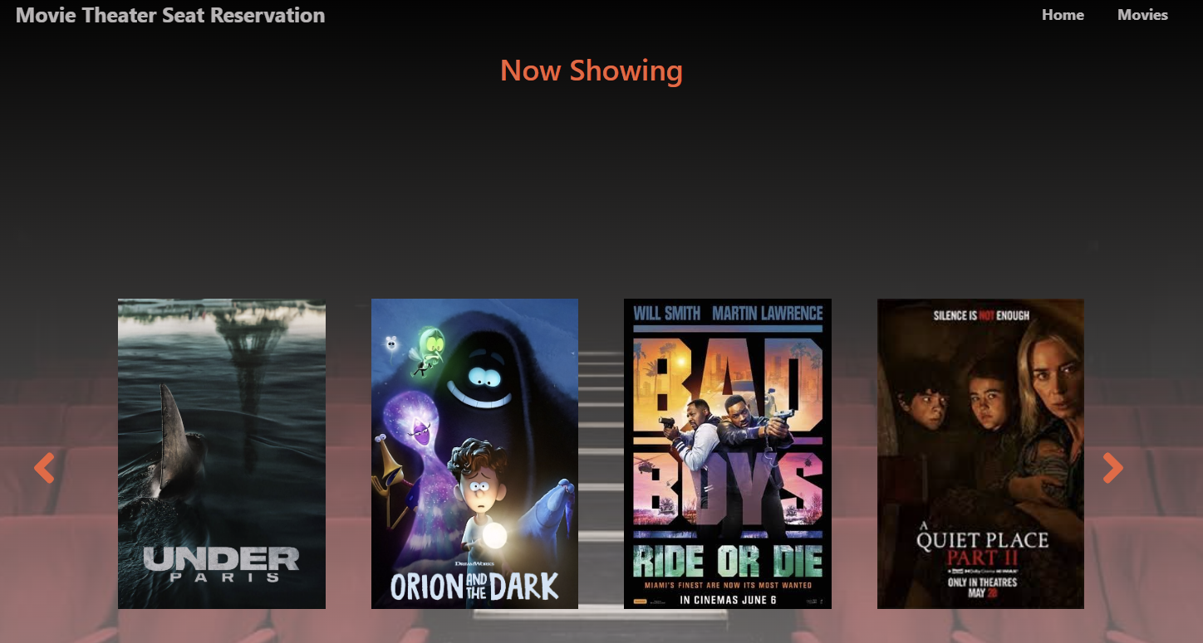

After the login I made an interphase named as “Now Showing” which displays the current movies that are being played on the theatre. This is taken from the time that given by the admins on the database as it also gets updated dynamically.

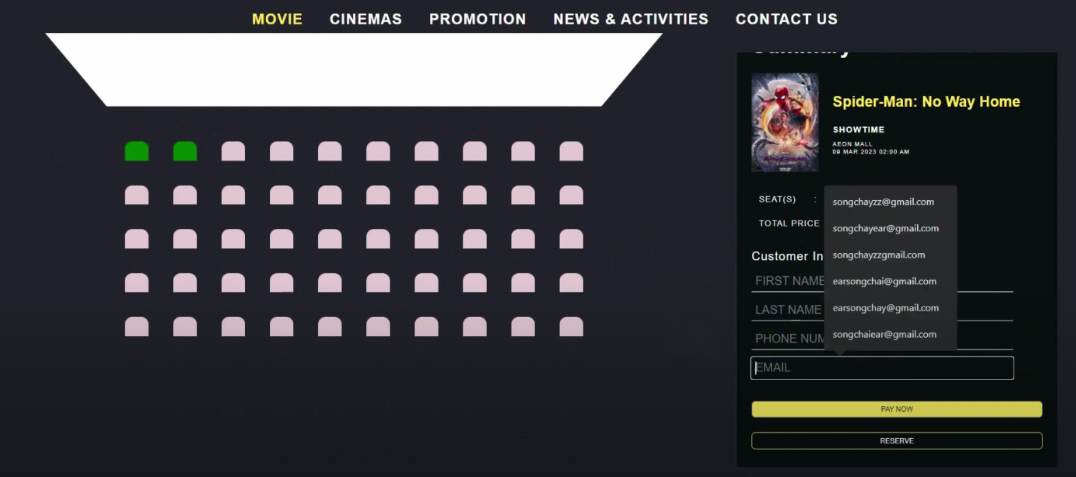

Fig: customer dashboard

On the above picture I want to demonstrate the seat reservation with the seat status, on which the customer can hover on and select with the movie meta-data with that on the right of the screen.

**Backend Development**

*ID:* ***24141247***

*Name:* ***Sakif Ferdous Khan***

I have contributed on the theatre settings of the reservation part, where the customers can see the theatres and can pick the one, they want to select and carry on the reservation.

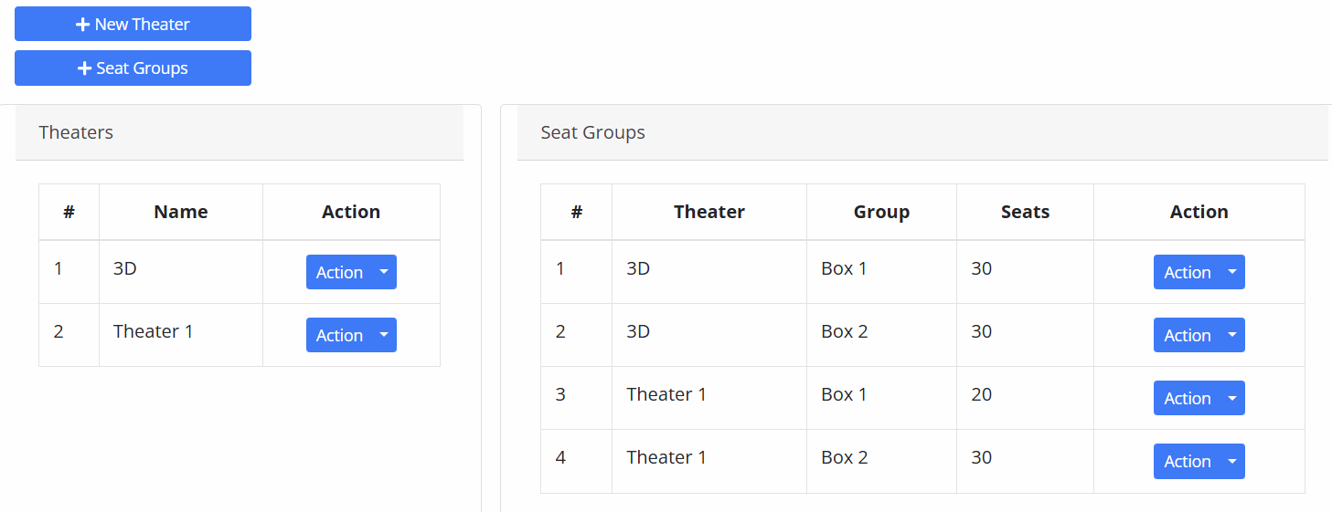

*ID:* ***21201574***

*Name:* ***Utsho Heaven Chowdhury***

As being the admin, I made the admin privileges to edit the theatres, add a new theatre also Seat groups with the seat counts.

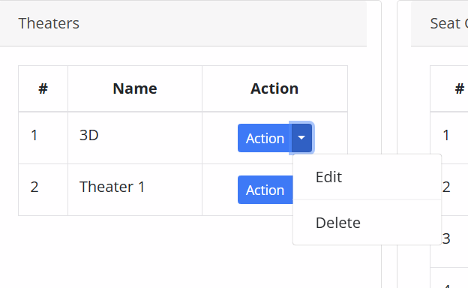 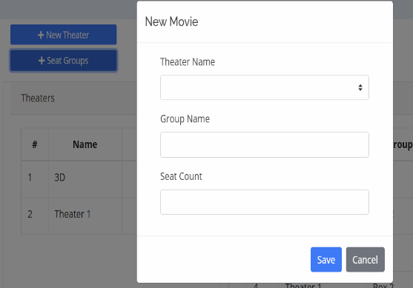

*ID:* ***20301484***

*Name:* ***Mohammad Muntasir Kabir***

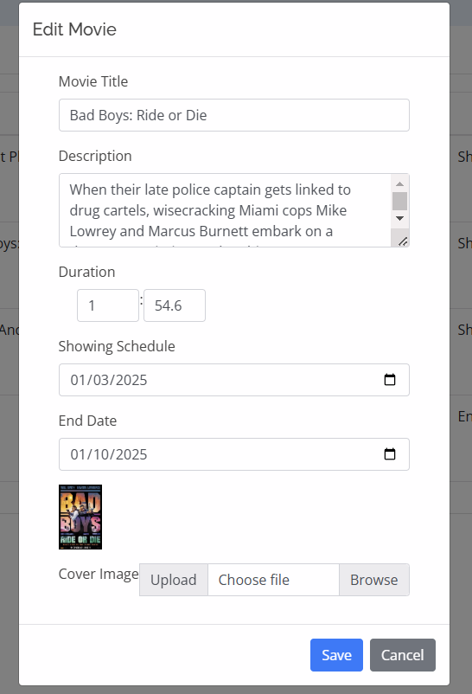

I took the role to add up the movies with its perfect description, Duration showing schedule and meta-data of the movie. This is also synced on the database automatically on real-time while editing on the site.

*ID:* ***21201574***

*Name:* ***Utsho Heaven Chowdhury***

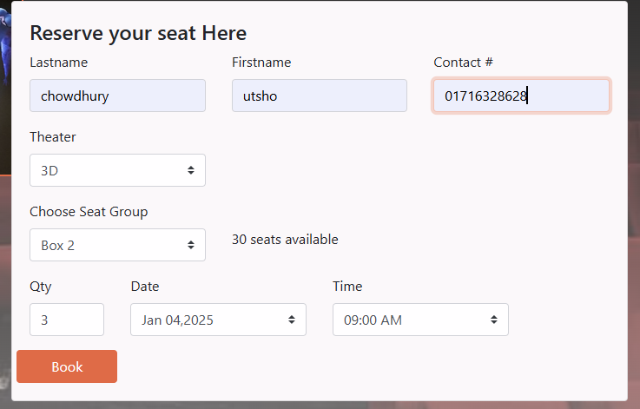

I took the role to take the information of the customer and store it to the database from the “Now Showing” page. The customer will fill up the boxes and can choose the theatre he wants & the number of tickets he wants.

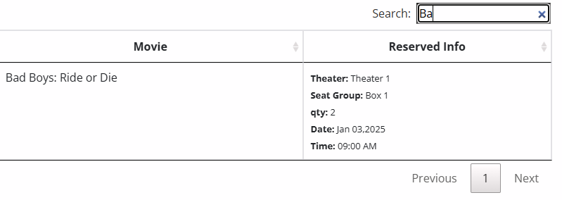

Aslo introduced a search bar to make it easy to find out customers and handle heavy traffic on the site. Added an admin privillage in “Edit” & “Delete” a movie as per the admin wants.

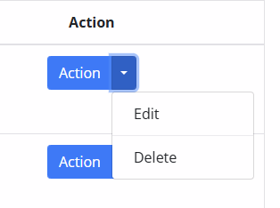

**Source Code Repository**

[**https://drive.google.com/drive/folders/143DPZNTiRsabrRTEbkTS7KaDRjt-e5j5?usp=drive_link**](https://drive.google.com/drive/folders/143DPZNTiRsabrRTEbkTS7KaDRjt-e5j5?usp=drive_link)

**Conclusion**

The Online Movie Ticket Reservation System provides a streamlined and user-friendly platform for reserving movie tickets, significantly enhancing the experience for both users and administrators. By integrating advanced web technologies, the system efficiently manages reservations, user authentication, and movie listings while ensuring real-time updates and a visually engaging interface.

For users, the platform simplifies the process of browsing movies, selecting showtimes, and booking tickets, all from the comfort of their homes. Key features like a movie carousel, personalized dashboards, and secure payment gateways make the experience seamless and enjoyable. The intuitive interface, coupled with backend automation, reduces manual efforts and eliminates the common inconveniences associated with traditional ticket booking.

From an administrative perspective, the system ensures efficient management of movie schedules, reservations, and customer data. The integration of a robust database and server-side logic guarantees data security and scalability, enabling the system to handle a large volume of users and transactions effectively.

Through this project, we gained valuable insights into both frontend and backend development. We learned how to design dynamic user interfaces using technologies like PHP, CSS, and JavaScript, as well as how to implement secure database interactions. Additionally, this project enhanced our problem-solving, teamwork, and debugging skills, preparing us for future real-world development challenges.