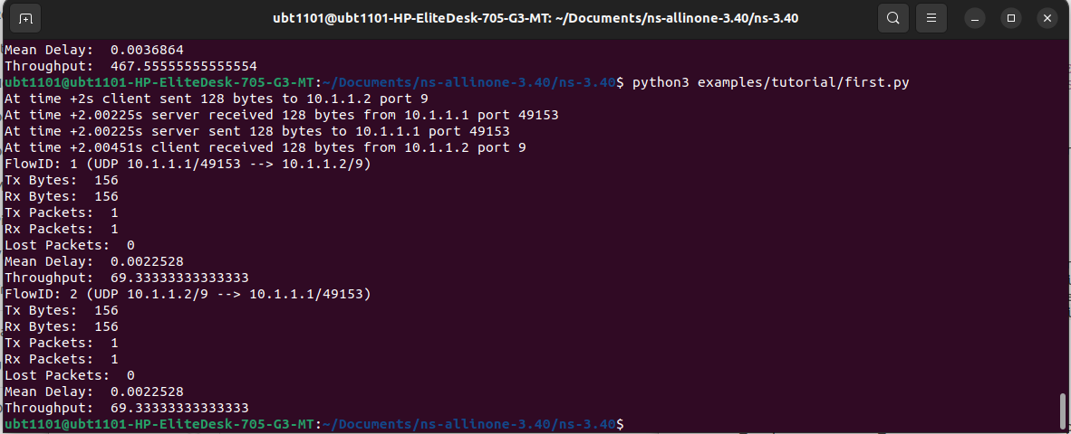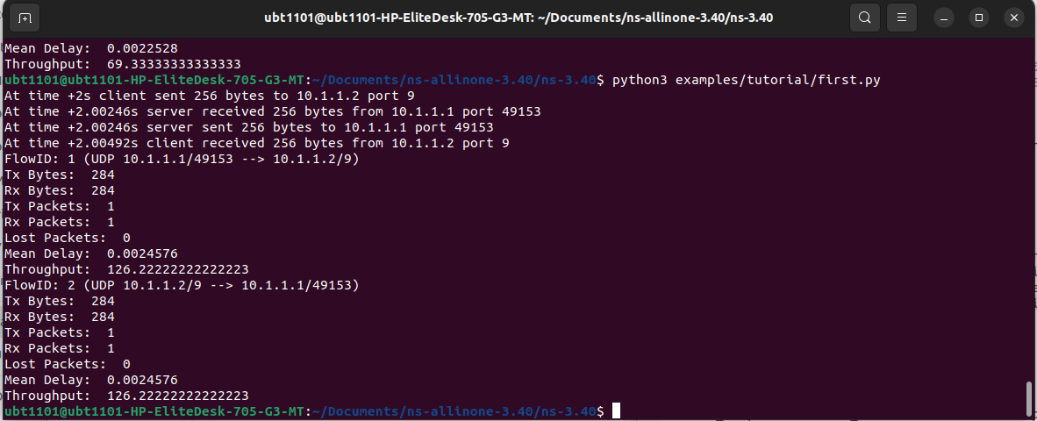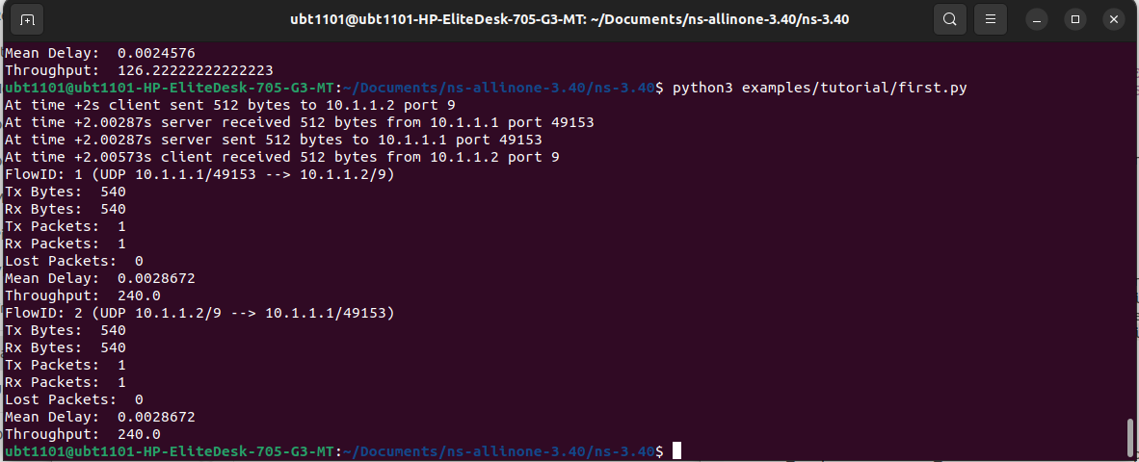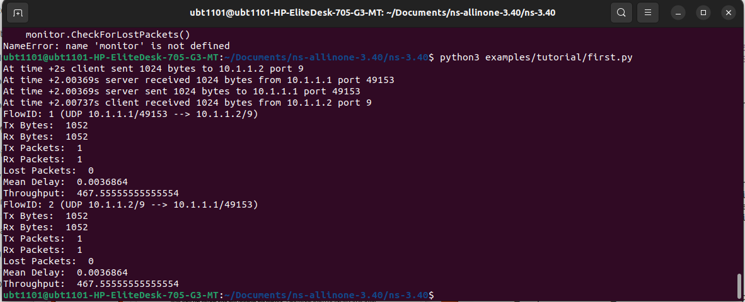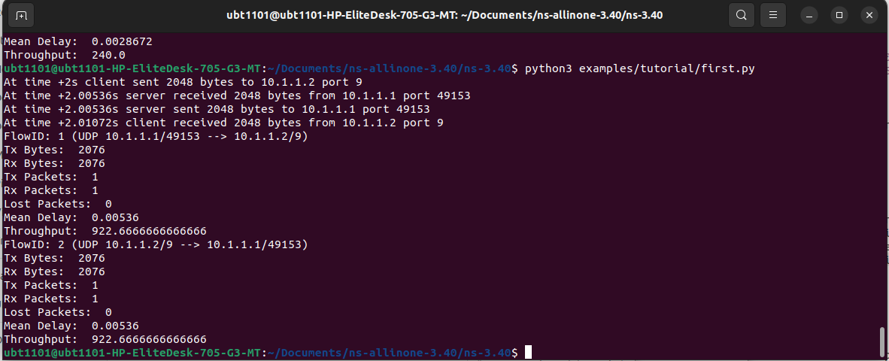

Utsho Heaven Chowdhury (21201574)

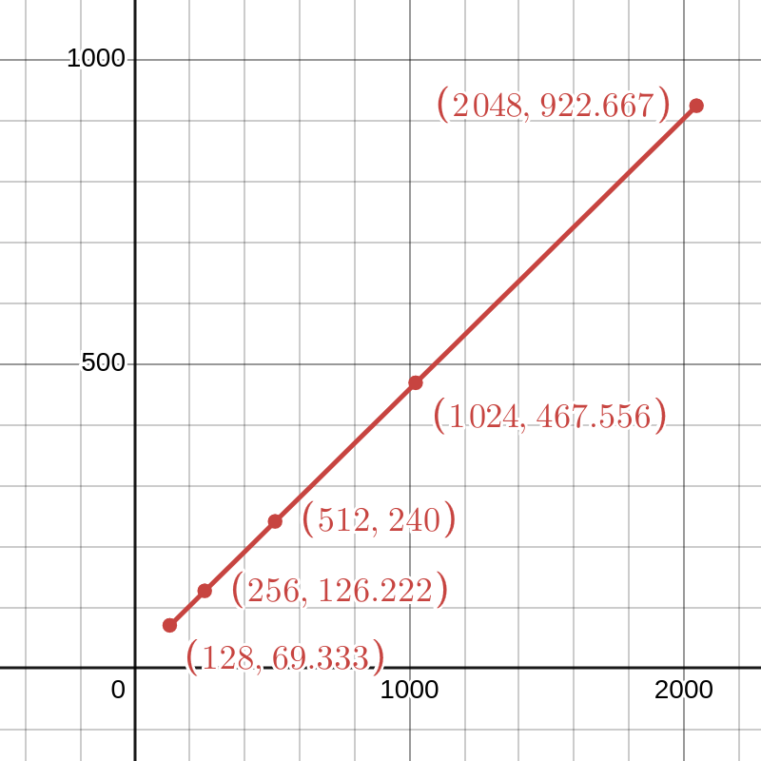

The graph demonstrates a positive correlation between packet size and throughput. As the packet size increases, the throughput generally increases as well. This is because larger packets contain more data, enabling the network to transmit more data per unit time, thereby boosting overall throughput. When a network is crowded, smaller data packets help things move faster. This graph shows optimizing network performance and choosing the most appropriate packet size for different applications and network conditions.