|  |
| --- |
| MA |
|  |
| **RADIOACTIVE WASTE MANAGEMENT PLAN**  ATOMIC ENERGY MEDICAL CENTER, Karachi  Jinnah Post Graduate Medical Center (JPMC)  Karachi |
|  |
|  |
|  |
|  |
|  |

|  |  |
| --- | --- |
| **Distribution:**   1. PNRA 2. RPO AEMC 3. Admin Officer AEMC 4. Director AEMC 5. Authors   **Reviewed By:**    Khalid Mahboob Khan (DCS)  RPO AEMC  **Approved By:**    Dr. HINA HASHMI  Director AEMC | **TITLE:**  Radioactive Waste Management Program for Atomic Energy Medical Center JPMC Karachi  **ABSTRACT:**  Under the requirement of section 8 PAK/915, licensees generating radioactive waste are required to prepare radioactive waste management program (RWMP) for their facilities. Radioisotopes are used extensively for diagnostic and therapeutic purposes in nuclear medicine centers/hospitals and radioactive waste is generated, therefore management of such waste is important. This document provides details of this management program for Atomic Energy Medical Center Karachi.  **Prepared By:**    Uzma Ilyas (PS)  Syed Abdul Haseeb Ahmad (SS) |

**Document Revision History**

|  |  |  |  |
| --- | --- | --- | --- |
| **Revision** | **Date** | **Reason for Modification** | **Approved by** |
| **00** | **August 2018** | **As directed by PNRA** | **Director** |
| **01** | **MARCH 2021** | **As directed by PNRA** | **Director** |

Contents

1. Introduction 5

2. Purpose of Radioactive Waste Management Programme 8

3. Scope of Radioactive Waste Management Programme 8

4. Responsibilities 8

6. Sources and Characteristics of Biomedical Radioactive Waste 12

7. Waste Prevention and Minimization 13

8. Collection, Segregation and Packaging of Biomedical Radioactive Waste 14

8.1. Collection of Biomedical Waste 14

8.2. Segregation of Biomedical Radioactive Waste 15

8.3. Packaging and labelling of biomedical radioactive waste 15

9. Storage of Biomedical Radioactive Waste 16

10. Radioactive Waste Disposal & Effluent Discharges 16

11. Radiation Protection 17

12. Definitions 18

1. Introduction

Atomic Energy Medical Center Karachi is the pioneer Medical Centre of PAEC, established in 1960 at the premises of JPMC, Karachi for provision of nuclear diagnostic and treatment facilities. It started in a two rooms barrack that were present at this place and with only a rectilinear scanner and a thyroid uptake probe. The facilities have been continually upgraded/ updated from time to time to keep pace with new requirements.

In its previous status up to 2010, AEMC Karachi was providing diagnostic & partial treatment facilities to 3000 patients per month and the available equipment/building was quite insufficient to meet the ever increasing diagnostic and treatment requirements of the growing number of patients. Keeping in view these requirements, up gradation of the center and shifting to a new, larger building and replacement of old conventional equipment with new modern sophisticated equipment was planned in early 2000. Moreover, modern radiotherapy facilities that were critically needed to cater to the growing number of cancer patients. Up gradation of AEMC completed in due time and new modalities of cancer treatment as well as diagnosis were included namely Radiotherapy and its allied services, Brachytherapy and expansion of Clinical Lab Services.

Thus at present AEMC Karachi has converted into a full-fledge tertiary care medical facility, providing services in sophisticated diagnosis at Nuclear Medicine and Radiology departments as well as therapy by the use of Radiations at Radiotherapy and Brachytherapy departments. In order to make these facilities available, AEMC uses various radioactive sources both natural and artificial. These include isotopes of Technetium, Iodine, Cobalt, Iridium, Barium, Caesium, Europium and Strontium. Other radiation generators comprise of Linear accelerators of Mega Voltage energy range, X-rays from diagnostic X-ray, CT Simulator, Mammography Unit and a conventional fluoroscopic radiotherapy Simulator.

Atomic Energy Medical Centre (AEMC) is located within the Jinnah Post-Graduate Medical Centre (J.P.M.C) premises, at Rafiqui Shaheed Road, Karachi. It neighbors to Ward-7 of JPMC opposite to Basic Medical Sciences Institute as depicted in the Figure 1& 2.

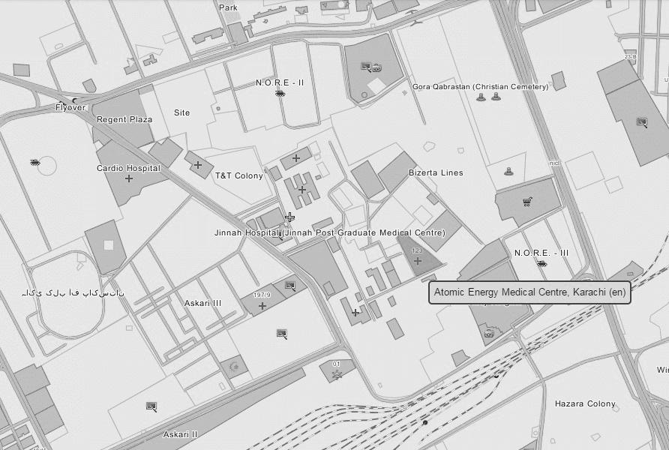

Figure 1: AEMC Location Map

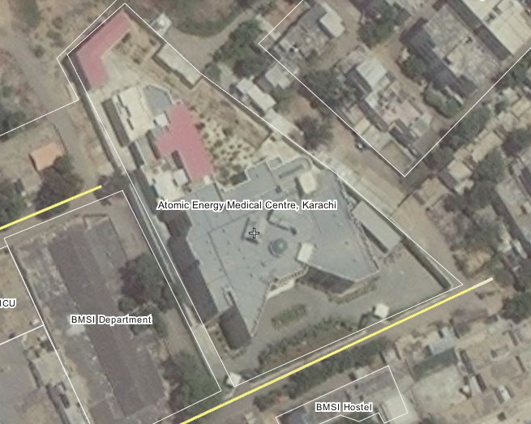

Figure 2: AEMC- A Bird Eye View

AEMC, like all other tertiary care hospitals functions six days a week for normal working hours. At present there is no facility for indoor treatments or Chemotherapy. However a small set of Isolation Rooms (Room#52 & Room#53) is managed for Radio-Iodine Ablation Therapy procedure. Moreover Human Resources details of AEMC are given in Table-2.

Table 1: Official Timings of AEMC

|  |  |  |
| --- | --- | --- |
| **Day** | **Start** | **End** |
| Monday to Thursday & Saturday | **0830** | **1430** |
| Friday | **0830** | **1230** |
| Sunday | Closed | Closed |

Table 2: Working Strength of AEMC

|  |  |  |  |  |
| --- | --- | --- | --- | --- |
| **Location** | **Officers** | **Staff** | **Visitors Official / Other** | **Total** |
| Nuclear Medicine Department | 6 | 15 | Nil | 21 |
| Radiotherapy Department | $$9$$ | 14 | Nil | 23 |
| Medical Physics Department | $$9$$ | 0 | Nil | 9 |
| RIA/Clinical Laboratories | $$2$$ | 3 | Nil | 5 |
| Admin department | $$01$$ | 20 | Nil | 21 |
| Account | 2 | 05 |  | 07 |
| Bio Medical department | $$03$$ | 06 | Nil | 09 |
| Security | $$0$$ | 7 | Nil | 07 |
| Director | 1 | 03 |  | 04 |
| Subtotal | 33 | 73 | Nil | 106 |
| **Total Number of Persons During Office Hours 106** | | | | |

A brief of Radiation Sources is given in following table.

Table 3: Types of Radiation and Maximum Strength

|  |  |  |
| --- | --- | --- |
| **Location** | **Radiation Generator** | **Source/Radiation Strength** |
| Hot Lab | Tc-99m | 600 mCi (maximum) |
| Hot Lab | I-131 | 200 mCi (maximum) |
| Source Room | Co-57 | 10 mCi (maximum) |
| Source Room | Sr-90 | 30 µCi (maximum) |
| Brachytherapy Bunker | Ir-192 | 10 Ci (maximum) |
| LINAC-I | Linear Accelerator | 15 MV Photons |
| LINAC-II | Linear Accelerator | 6 MV Photons |
| Conventional X-Ray | X-Ray Gun | 150 kV |
| CT Simulator | X-Ray Gun | 150 kV |
| Conventional Simulator | X-Ray Gun | 100 kV |
| Mammography | X-Ray Gun | 50 kV |

1. Purpose of Radioactive Waste Management Programme

Purpose of plan is to give practical guidance to responsible person for safe handling of radioactive waste, and to protect public from radiation exposure. In order to protect radiation worker general public and environment it is necessary that public is protected from unnecessary exposure. It is also necessary that radiation workers be protected from excessive radiation in course of their work.

1. Scope of Radioactive Waste Management Programme

A Radioactive Waste Management Programme (RWMP) is prepared to stream line the steps involved in the management of safe disposal of radioactive waste generated. So that safety of the mankind and environment can be achieved systematically. Several kinds of radioisotopes are being utilized while coping with cancer. These include isotopes used for medication or pharmaceuticals plus isotopes used for quality control of the instruments and systems, the handling of radioisotopes provide waste. This document deals with the safe processing of radioactive sewage resulting from excreta of injected patient’s and laboratory uses of nuclear medicine.

1. Responsibilities

This section describes classification of authorization of use, applications and production of waste from radioisotopes. Following is a general classification of radioactive waste generation on the bases of their application. These all comes under the responsibility of RPO / Nuclear Physicist at AEMC. Radioactive waste from spent sources is dealt by the RPO with cooperation of PNRA.

Figure 3: Types of Radioactive Waste generated at AEMC

Above mentioned process diagram presents the layout of the disposal work of radioactive waste. This diagram clearly shows the responsibility and domains of each individual involved in radioactive waste management.

Figure 4: Hierarchy of Responsibilities in Radioactive Waste Management

As long as the radioactive waste is generated at their respective locations, lead waste bins are present at side room in hot lab/Gamma Cam rooms. After filling of bin, concerned technologist segregates the radioactive waste under supervision of nuclear physicist and sends to radioactive waste room, Room#37, via sanitary attendant where it stored for decay in dedicated decay pits/ pre labelled plastic bags on the basis of Half Life Segregation Principle. Upon maturation of their corresponding decay period, reminder pop up can be seen by Nuclear physicist via MEM (Medical Physics Module) database, NM Physicist will survey the waste room and check the Radiation Exposure Level and after ensuring that the packages are safe to dispose off with normal waste, instruct sweeping staff to do so. Liquid waste from their corresponding locations, drains directly to decay and delay tanks whereby it is discarded into normal sewage water of the municipality.

Sweeping staff, when receive instructions from NM Physicists/Technologist to dispose off any radioactive waste (already decayed and thoroughly surveyed) picks up that radioactive waste in the trolley to keep the maximum distance and takes it to burn yard/incineration centre of JPMC. Following figure is a self illustrated flow diagram of this whole activity.

1. General Safety Considerations

General safety considerations adopted at AEMC to ensure radiation safety during management of radioactive waste fully comply with the PNRA guidelines and are routinely revisited. These implies to all officers, Technologist and Sanitary Staff:

* 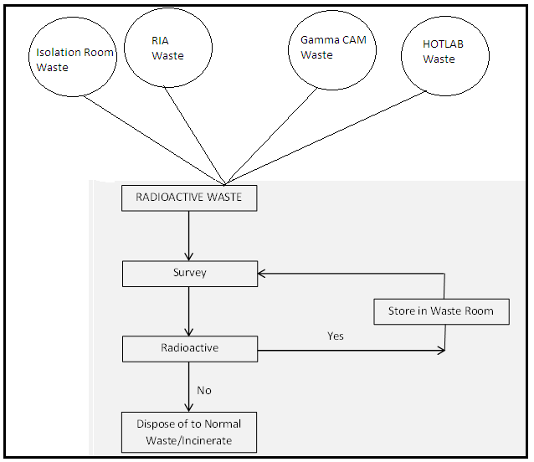Handling and management of radioactive waste in suitably ventilated and access controlled areas.

Figure 5: Radioactive Waste Management Process

* To keep exposure to ionizing radiations *As Low as Reasonably Achievable* (ALARA).
* Clearly defined and documented working procedures for the management and disposal of radioactive waste.
* Wearing laboratory coats or other protective clothing at all times in areas where radioactive materials and/or waste are used or present.
* Wearing disposable gloves at all times while handling radioactive materials and/or wastes.
* Monitoring hands for contamination in low background area after each procedure or before leaving the radiation area
* No eating, drinking, smoking, or applying cosmetics in any area where radioactive material and/or waste are stored or radioactive materials are used
* No string food, drink, or other items in areas where radioactive materials stored or used or where radioactive waste stored
* Wearing personal monitoring devices at all times while in areas where radioactive materials and/or waste or used or stored
* Disposal of radioactive waste only in designated labelled and properly shielded receptacles.
* Storing radioactive solutions in CLEARLY labelled containers.

1. Sources and Characteristics of Biomedical Radioactive Waste

AEMC offers services both in diagnostic and therapeutic sides of cancer treatment;, therefore a lot number of radioisotopes are used routinely. The tables Table-3/Table-4 is showing the data for all such important radioisotopes being utilised at AEMC and that can generate the radioactive waste.

Table 4: Radioisotopes utilised at AEMC

|  |  |  |  |  |
| --- | --- | --- | --- | --- |
| **S. No.** | **Radioisotope** | **Half Life** | **Energy** | **Mode of Application** |
|  | Tc-99m | 6 hrs | 140 keV γ-rays | Tc-labelled radiopharmaceuticals and tracers |
|  | Mo-99 | 67 hrs | 740 keV γ-rays  780 keV γ -rays  1.214 MeV β-rays (maximum) | Production of Tc-99m (decay progeny) through Moly-Generator |
|  | I-131 | 8 days | 364 keV γ-rays | Radio Iodine ablation therapy  Gamma Camera QC  Nuclear Medicine imaging |
|  | I-125 | 60.2 days | 27-30 keV X-rays | In-vitro studies at RIA |
|  | Co-57 | 270 days | 122 keV γ-rays | QC of Nuclear Medicine Instruments |
|  | Ba-133 | 10.57 years | 81 & 356 keV γ-rays | QC of Nuclear Medicine Instruments |
|  | Cs-137 | 30 years | 662 keV γ-rays | QC of Nuclear Medicine Instruments |
|  | Sr-90 | 28.5 years | 546.2 keV β-rays | EBRT of Pterygium |

Tc-99m labelled radiopharmaceuticals when injected to patients, it generates solid, biologically contaminated syringe, cotton swabs. Similarly I-131 oral administration also generates solid waste of I-131 origin e.g. vials, disposable glass, syringes and gloves etc.

Hand wash and other water dispense for routine jobs at hot lab generates liquid radioactive waste of Tc-99m origin. Similarly spent I-131 and Tc-99m containing vials, syringes, used Mo-99 (Moly-Generators), used glass wares from in-vitro studies of RIA, examined samples of human origin produces liquid radioactive waste from RIA Lab.

As such the quantity of gaseous radioactive waste in NM department is limited only to fumes of Tc-99m and I-131 that evaporates mainly during preparation of corresponding radiopharmaceuticals. These are monitored by careful adherence of procedures and safety in the fume hoods already present for this purpose.

Spent sealed sources are intact and kept in their original casing and shielding. Upon completion of their clinically useful life they are processed for safe deposit at the designated locations for this purpose.

1. Waste Prevention and Minimization

In order to achieve radioactive waste minimization at AEMC several practical measures are taken under the guide line of PNRA. These are given as follows.

* Use of short lived radio nuclides whenever possible
* Ensuring that non-essential non-radioactive materials are not taken into controlled areas hence reducing potential cross contamination and the need for decontamination or disposal
* Use of most effective and reliable technology taking due account of safety requirements for radioactive and biohazards waste control
* Segregation of radioactive materials from non-radioactive materials by design
* Procurement of minimum quantity of radioactive materials for each application, with subsequent usage supported by written procedures
* Adequate containment and packaging of radioactive materials to retain the contents without resulting in unnecessary volumes of packaging for subsequent disposal
* Assuring the contamination of areas and articles and control of the spread of contamination when persons or articles leave controlled areas
* Return whenever possible, spent sealed sources to the vendor, using the original packaging material

1. Collection, Segregation and Packaging of Biomedical Radioactive Waste
   1. Collection of Biomedical Waste

Waste collection is a continuous process at AEMC. Responsibilities of each individual involved are clearly defined and all of the steps are so integrated that the chances of failure of the process reduce to minimum. Glimpse of this process are given here.

* The collection of radioactive waste in suitable containers (Lead Bins) to receive discarded radioactive material
* Lining of each container with heavy gauge and coloured plastic bag which distinguish the Radioactive waste from normal waste.
* Marking of plastic bags with the names of radio nuclide and date of storage
* Bright Yellow/Red coloured container with the radiation symbol clearly displayed to distinguish it from bins of inactive waste
* Use of separate container for each radionuclide at the point of origin
* Different radionuclide having almost same half lives are collected in one container (Bin)
* Proper shielding is provided for the containers to keep the radiations level with in limits
* Waste bags/containers are not over filled such that their integrity is compromised
  1. Segregation of Biomedical Radioactive Waste

Segregation of radioactive waste is an essential component of radioactive waste management process. The segregation of radioactive and non-radioactive waste is applied at the point of origin. The segregation of radioactive waste may be based on

* Visual inspection (different color is used for radioactive waste)
* Radioactive and Non-radioactive
* Half lives of radionuclide
* Activity contents
* Physical and chemical form

However, at AEMC this segregation is done on the basis of visual inspection and half lives for short lived radio nuclides i.e. Tc-99m, Mo-99 and I-131. For rest of the relatively long lived radionuclides this segregation is done on the basis of activity content. Subsequent to segregation, they are processed further for safe disposal.

* 1. Packaging and labelling of biomedical radioactive waste

Biomedical radioactive waste generated from short lived radioisotopes at AEMC is packaged in plastic bags lined strong bins. These bags are sealed and stored for respective decay period, twice in a week. Mo-99 (Moly-Generator) is stored for almost 4-8 months and then returned back to supplier IPD PINSTECH Islamabad. Other long lived radioisotopes do not generates biomedical radioactive waste so they are not needed to be packaged, however upon their respective completion of useful clinical lives; they are shipped either to the supplier or to National Repository of Radioisotopes as under the rules and regulations of PNRA.

1. Storage of Biomedical Radioactive Waste

The storage for decay is particularly important for radioactive waste resulting from medical/research uses of radionuclide. Many of the radionuclides used are of small activities and short half life. The radioactive waste is stored for decay purposes until the activity decays to the background level and then considered inactive for final disposal as normal waste. The storage is suitable for wastes containing radionuclide with half lives of less than or equal to 100 days. At activity concentrations of 3.7-37 MBq/m3 (0.1-1 mCi/m3), different radionuclides having almost same half-lives are stored in one container for decay purposes. The collected radioactive waste (plastic bags) is shifted to these containers (e.g. ground pits) for decay. Each container is marked with the name of radionuclide and radiation symbol as well as the date of storage. Following are made the general practices for storage of radioactive waste for decay purposes:

* 1. Tc-99m is stored for three month or after it reaches the clearance level
  2. I-131 and Mo-99 (Moly-Generators) are stored for 6 months
  3. Radionuclides not covered in above are stored for at least 10 half lives

This temporary storage of radioactive waste is sufficiently sized and separated from other facility by dual lock system. There is another additional grilled door and lock to enter in this storage. There are no flammable materials present and only two tube lights are there to illuminate the room so that electrical fire hazard may also be prevented. This room

is solely used for storage purposes and no other utilisation of the space is allowed. Entry in this room is strictly limited and only authorised personal are allowed to work here. Proper labelling of containers is done to inform about radioactive waste.

1. Radioactive Waste Disposal & Effluent Discharges

In principle, Delay & Decay method is adopted at AEMC to declare radioactive waste as normal waste. After ensuring that the radioactive waste has completed its decay period, the radioactive waste is disposed off as normal waste while monitoring its residual activity. All the radiation symbols, if any, are removed from the radioactive waste packages (plastic bags) before disposal as normal waste. Waste disposal record is properly maintained. The radioactive waste generated due to RIA applications is disposed off as normal waste after properly measuring its residual activity.

1. Radiation Protection

A complete Radiation Protection Program is in place at AEMC, RPP . This ensures the safe working environment for the radiation workers as well as better quality treatment to its commuter at AEMC. Detailed and thorough radiation exposure survey of the supervised and controlled areas is a routine job of nuclear medical physicist. Every radiation worker is given a film badge for personal dosimetry monitoring. Necessary measure is taken to cater for increased personal doses of any radiation worker. Continuous education and emergency drill are practiced for adherence to Basic Safety Principles. Record of each step is being maintained in log books. ALARA is always emphasized at all levels of management and workmanship.

From a planning point of view it is helpful to classify accidents according to their severity, in other words the magnitude of the consequences. Geographically based classification on extent of the consequences is:

• Level 1 - Consequences are limited to a single room/laboratory/building

• Level 2 - Consequences are limited to the perimeter of the facility

• Level 3 - Consequences might have significance outside the outer perimeter of the facility involved

• Level 4 - Consequences might have a trans-boundary effect as defined in the convention on early notification of a nuclear accident.

A second possible classification is that could be used to classify accidents is to consider their radiological consequences:

• Internal contamination

• External exposure

• Potential to produce a significant collective dose.

This Radioactive Waste Management Program applies to all the facilities situated inside the Establishment name boundary. However, relevant portions of the plan will be activated according to requirements of the specific emergencies.

1. Definitions

Important terminologies that may be related with the RWMP and Radiation Protection are briefly discussed here.

* ***“Clearance”*** means the removal of radioactive materials or radioactive objects within licensed/authorized practices from any further regulatory control by the regulatory body.
* ***“Clearance Level”*** means a value, established by a regulatory body and expressed in terms of activity concentration and/or total activity, at or below which a source of radiation may be released from regulatory
* ***"Controlled Area"*** means a defined area in which specific protection measures and safety provisions are or could be required for controlling normal exposures or preventing the spread of contamination during normal working conditions, and preventing or limiting the extent of potential exposures.
* ***"Discharge"*** means a planned and controlled release of (usually gaseous or liquid) radioactive material to the environment.
* ***"Disposal"*** means replacement of waste in an appropriate facility without the intention of retrieval.
* ***“Dose Constraint”*** means a prospective restriction on the individual dose delivered by a source, which serves as an upper bound on the dose in optimization of protection and safety for the source.
* ***“Dose Constraint”*** means a prospective restriction on the individual dose delivered by a source, which serves as an upper limit on the dose in optimization of protection and safety for the source.
* ***"Dose Limit"*** means the value of the effective dose or the equivalent dose to individuals from controlled practices that shall not be exceeded.
* ***"Effective Dose, E"*** means the quantity E, defined as a summation of the tissue equivalent doses, each multiplied by the appropriate tissue weighting factor:
* ***"Exemption Level"*** means a value, established by the Authority and expressed in terms of activity concentration and/or total activity, at or below which a source of radiation may be granted exemption from regulatory control without further consideration.
* ***“Exposure”*** means the act or condition of being subject to irradiation. Exposure can be either external exposure (irradiation by source outside the body) or internal exposure (irradiation by source inside the body). Exposure can be classified as either normal exposure or potential exposure; occupational, medical or public exposure; and, in intervention situations, either emergency exposure or chronic exposure. The term exposure is also used in radio-dosimetry to express the amount of ionization produced in air by ionizing radiations.
* ***"Guidance Level"*** means a level of a specified quantity above which appropriate actions shall be considered. In some circumstances, actions may need to be considered when the specified quantity is substantially below the guidance level.
* ***"Health Professional"*** means an individual who has been accredited through appropriate national procedures to practice a profession related to health (e.g. nursing, medical physics, radiation and nuclear medical technology, radio-pharmacy, occupational health)
* ***"Licensee"*** means the holder of a current license.
* ***"Monitoring"*** means the measurement of dose or contamination for reasons related to the assessment or control of exposure to radiation or radioactive substances, and the interpretation of the results.
* ***"Monitoring"*** means the continuous or periodic measurement of radiological and other parameters or determination of the status of a system.
* ***"Potential Exposure"*** means exposure that is not expected to be delivered with certainty but that may result from an accident at a source or owing to an event or sequence of events of a probabilistic nature, including equipment failures and operating errors.
* ***“Practice”*** means any human activity that introduces additional sources of exposure or exposure pathways or extends exposure to additional people or modifies the network of exposure pathways from existing sources, so as to increase the exposure or the likelihood of exposure of people or the number of people exposed.
* ***"Qualified Expert"*** means an individual who, by virtue of certification by appropriate boards or societies, professional licensees or academic qualifications and experience, is duly recognized as having expertise in a relevant field of specialization, e.g. medical physics, radiation protection, occupational health, fire safety, quality assurance or any relevant engineering or safety specialty
* ***"Radiation Protection Officer (RPO***)" means an individual technically competent in radiation protection matters relevant for a given type of practice who is designated by the licensee to oversee the application of the requirements of these regulations.
* ***"Radioactive Waste"*** means waste that contains, or is contaminated with, radionuclide at concentrations or activities greater than clearance levels as established by the Authority.
* ***"Radioactive Waste Management"*** means all activities, administrative and operational, that are involved in the handling, pretreatment, treatment, conditioning, transport, storage and disposal of radioactive waste.
* ***"Repository"*** means a nuclear facility where waste is emplaced for disposal.
* ***"Segregation"*** means an activity where waste or materials (radioactive and exempt) are separated or are kept separate according to radiological, chemical and/or physical properties which will facilitate waste handling and/or processing.
* ***"Sealed Source"*** means radioactive material that is (i) permanently sealed in a capsule or (ii) closely bonded and in a solid form.
* ***"Source"*** means anything that may cause radiation exposure such as by emitting ionizing radiation or by releasing radioactive substances or materials and which can be treated as a single entity for protection and safety purposes.
* ***"Storage"*** means the holding of spent fuel or of radioactive waste in a facility that provides for its containment, with the intention of retrieval.
* ***"Supervised Area"*** means a defined area not designated a controlled area but for which occupational exposure conditions are kept under review, even though specific protection measures and safety provisions are not normally needed.
* ***"Unsealed Source"*** means a source that does not meet the definition of a sealed source.
* ***“Waste Acceptance Requirements”*** means quantitative or qualitative criteria specified by the Authority, or specified by an operator and approved by the Authority, for radioactive waste to be accepted by the operator of a repository for disposal, or by the operator of a storage facility for storage.
* ***"Waste Form"*** means the waste in its physical and chemical form after treatment and/or conditioning (resulting in a solid product) prior to packaging. The waste form is a component of the waste package.
* ***“Waste Inventory”*** means quantity, radionuclides, activity and waste form characteristics of wastes for which an operator is responsible.
* ***"Waste Package"*** means the product of conditioning that includes the waste form and any container(s) and internal barriers (e.g. absorbing materials and liners), prepared in accordance with the requirements for handling, transport, storage and/or disposal.
* ***"Waste Processing"*** means any operation that changes the characteristics of a waste, including pretreatment, treatment and conditioning.
* ***"Worker"*** means any individual who works, whether full time, part time or temporarily, for an employer and who has recognized rights and duties in relation to occupational radiation protection. (A self-employed person is regarded as having the duties of both an employer and a worker).

1. References
2. Regulations on radioactive waste management-PAK/915
3. PNRA Guide for development of Radioactive Waste Management Program “PNRA-WSD-GD-001”
4. Regulations on Radiation Protection-PAK/904
5. PNRA Safety guide PNRA-13002, Rev.1: GUIDELINES FOR THE MANAGEMENT OF RADIOACTIVE WASTE IN HOSPITALS/NUCLEAR MEDICAL CENTRES/RESEARCH
6. IAEA Safety Guide WS-G-2.7: Management of Waste from the Use of Radioactive Material in Medicine, Industry, Agriculture, Research and Education
7. IAEA Safety Guide GS-G-3.3: The management System for the Processing, Handling and Storage of Radioactive Waste
8. IAEA TECDOC-1183: management of Radioactive waste from the use of Radionuclides in medicine