A data flow model is diagrammatic representation of the flow and exchange of information within a system. Data flow models are used to graphically represent the flow of data in an information system by describing the processes involved in transferring data from input to file storage and reports generation.
A data flow model may also be known as a data flow diagram (DFD).
Data flow modeling can be used to identify a variety of different things, such as:
- Information that is received from or sent to other individuals, organizations, or other computer systems.
- Areas within a system where information is stored and the flows of information within the system are being modeled.
- The processes of a system that act upon information received and produce the resulting outputs.

DFD is the abbreviation for Data Flow Diagram.
- The flow of data of a system or a process is represented by DFD.
- It also gives insight into the inputs and outputs of each entity and the process itself.
- DFD does not have control flow and no loops or decision rules are present. Specific operations depending on the type of data can be explained by a flowchart.
- It is a graphical tool, useful for communicating with users ,managers and other personnel. It is useful for analyzing existing as well as proposed system.

The DFD belongs to structured-analysis modeling tools. Data Flow diagrams are very popular because they help us to visualize the major steps and data involved in software-system processes.

Characteristics of DFD
- DFDs are commonly used during problem analysis.
- DFDs are quite general and are not limited to problem analysis for software requirements specification.
- DFDs are very useful in understanding a system and can be effectively used during analysis.
- It views a system as a function that transforms the inputs into desired outputs.
- The DFD aims to capture the transformations that take place within a system to the input data so that eventually the output data is produced.
- The processes are shown by named circles and data flows are represented by named arrows entering or leaving the bubbles.
- A rectangle represents a source or sink and it is a net originator or consumer of data. A source sink is typically outside the main system of study.

Components of DFD
The Data Flow Diagram has 4 components:
- Process Input to output transformation in a system takes place because of process function. The symbols of a process are rectangular with rounded corners, oval, rectangle or a circle. The process is named a short sentence, in one word or a phrase to express its essence
- Data Flow Data flow describes the information transferring between different parts of the systems. The arrow symbol is the symbol of data flow. A relatable name should be given to the flow to determine the information which is being moved. Data flow also represents material along with information that is being moved. Material shifts are modeled in systems that are not merely informative. A given flow should only transfer a single type of information. The direction of flow is represented by the arrow which can also be bi-directional.
- Warehouse The data is stored in the warehouse for later use. Two horizontal lines represent the symbol of the store. The warehouse is simply not restricted to being a data file rather it can be anything like a folder with documents, an optical disc, a filing cabinet. The data warehouse can be viewed independent of its implementation. When the data flow from the warehouse it is considered as data reading and when data flows to the warehouse it is called data entry or data updating.
- Terminator The Terminator is an external entity that stands outside of the system and communicates with the system. It can be, for example, organizations like banks, groups of people like customers or different departments of the same organization, which is not a part of the model system and is an external entity. Modeled systems also communicate with terminator.

Rules for creating DFD
- The name of the entity should be easy and understandable without any extra assistance(like comments).
- The processes should be numbered or put in ordered list to be referred easily.
- The DFD should maintain consistency across all the DFD levels.
- A single DFD can have a maximum of nine processes and a minimum of three processes.

Symbols Used in DFD
- Square Box: A square box defines source or destination of the system. It is also called entity. It is represented by rectangle.
- Arrow or Line: An arrow identifies the data flow i.e. it gives information to the data that is in motion.
- Circle or bubble chart: It represents as a process that gives us information. It is also called processing box.
- Open Rectangle: An open rectangle is a data store. In this data is store either temporary or permanently.

Levels of DFD
DFD uses hierarchy to maintain transparency thus multilevel DFD’s can be created. Levels of DFD are as follows:
- 0-level DFD: It represents the entire system as a single bubble and provides an overall picture of the system.
- 1-level DFD: It represents the main functions of the system and how they interact with each other.
- 2-level DFD: It represents the processes within each function of the system and how they interact with each other.
- 3-level DFD: It represents the data flow within each process and how the data is transformed and stored.

Advantages of DFD
- It helps us to understand the functioning and the limits of a system.
- It is a graphical representation which is very easy to understand as it helps visualize contents.
- Data Flow Diagram represent detailed and well explained diagram of system components.
- It is used as the part of system documentation file.
- Data Flow Diagrams can be understood by both technical or nontechnical person because they are very easy to understand.

Disadvantages of DFD
- At times DFD can confuse the programmers regarding the system.
- Data Flow Diagram takes long time to be generated, and many times due to this reasons analysts are denied permission to work on it.

Rules for Data Flow Diagram

- Data can not flow between two entities. –
Data flow must be from entity to a process or a process to an entity. There can be multiple data flows between one entity and a process.

- Data can not flow between two data stores
Data flow must be from data store to a process or a process to an data store. Data flow can occur from one data store to many process.

- Data can not flow directly from an entity to data store –
Data Flow from entity must be processed by a process before going to data store and vice versa.

- A process must have atleast one input data flow and one output data flow –
Every process must have input data flow to process the data and an output data flow for the processed data.

- A data store must have atleast one input data flow and one output data flow –
Every data store must have input data flow to store the data and an output data flow for the retrieved data.

- Two data flows can not cross each other.

- All the process in the system must be linked to minimum one data store or any other process.

Levels in Data Flow Diagrams (DFD)
Data Flow Diagrams (DFD) are graphical representations of a system that illustrate the flow of data within the system. DFDs can be divided into different levels, which provide varying degrees of detail about the system. The following are the four levels of DFDs:
- Level 0 DFD: This is the highest-level DFD, which provides an overview of the entire system. It shows the major processes, data flows, and data stores in the system, without providing any details about the internal workings of these processes.
- Level 1 DFD: This level provides a more detailed view of the system by breaking down the major processes identified in the level 0 DFD into sub-processes. Each sub-process is depicted as a separate process on the level 1 DFD. The data flows and data stores associated with each sub-process are also shown.
- Level 2 DFD: This level provides an even more detailed view of the system by breaking down the sub-processes identified in the level 1 DFD into further sub-processes. Each sub-process is depicted as a separate process on the level 2 DFD. The data flows and data stores associated with each sub-process are also shown.
- Level 3 DFD: This is the most detailed level of DFDs, which provides a detailed view of the processes, data flows, and data stores in the system. This level is typically used for complex systems, where a high level of detail is required to understand the system. Each process on the level 3 DFD is depicted with a detailed description of its input, processing, and output. The data flows and data stores associated with each process are also shown.

The choice of DFD level depends on the complexity of the system and the level of detail required to understand the system. Higher levels of DFD provide a broad overview of the system, while lower levels provide more detail about the system’s processes, data flows, and data stores. A combination of different levels of DFD can provide a complete understanding of the system.
- 0-level DFD: It is also known as a context diagram. It’s designed to be an abstraction view, showing the system as a single process with its relationship to external entities. It represents the entire system as a single bubble with input and output data indicated by incoming/outgoing arrows.
- 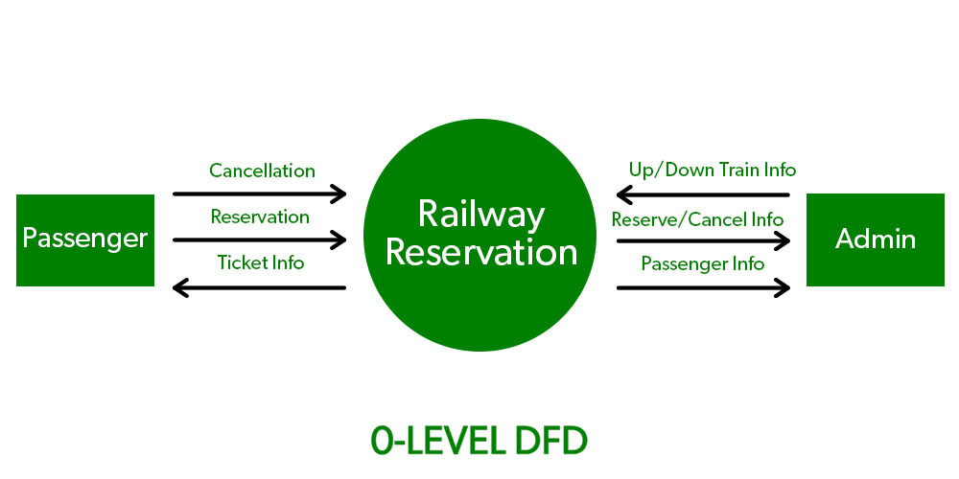

1-level DFD: In 1-level DFD, the context diagram is decomposed into multiple bubbles/processes. In this level, we highlight the main functions of the system and breakdown the high-level process of 0-level DFD into subprocesses. 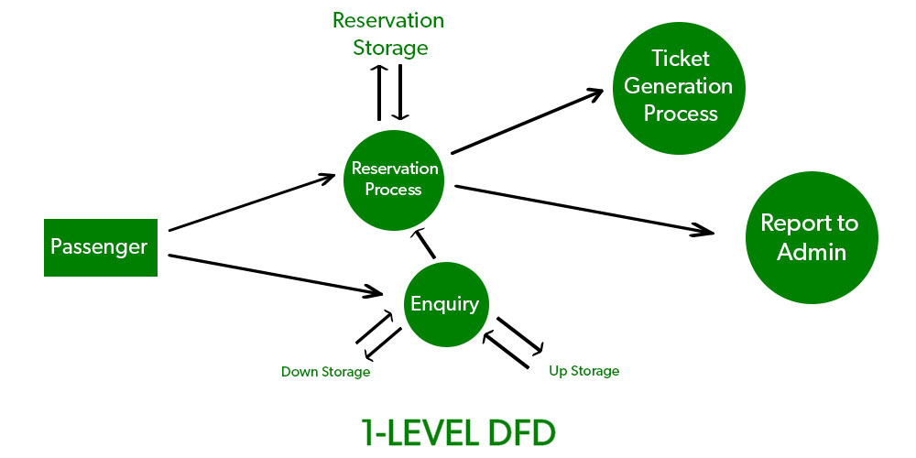
- 2-level DFD: 2-level DFD goes one step deeper into parts of 1-level DFD. It can be used to plan or record the specific/necessary detail about the system’s functioning.
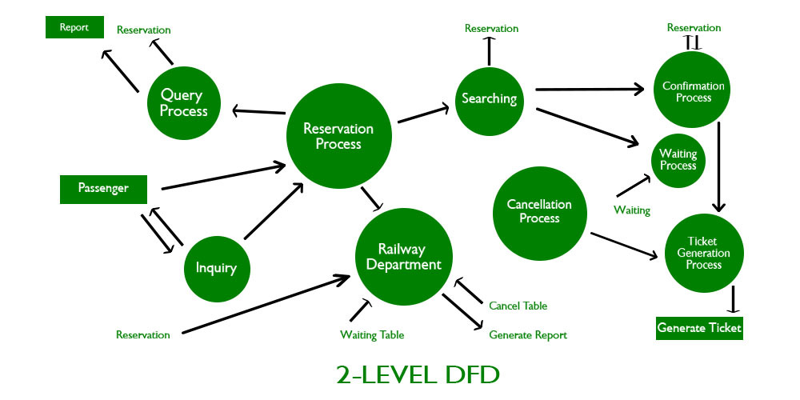

Advantages of using Data Flow Diagrams (DFD) include:
- Easy to understand: DFDs are graphical representations that are easy to understand and communicate, making them useful for non-technical stakeholders and team members.
- Improves system analysis: DFDs are useful for analyzing a system’s processes and data flow, which can help identify inefficiencies, redundancies, and other problems that may exist in the system.
- Supports system design: DFDs can be used to design a system’s architecture and structure, which can help ensure that the system is designed to meet the requirements of the stakeholders.
- Enables testing and verification: DFDs can be used to identify the inputs and outputs of a system, which can help in the testing and verification of the system’s functionality.
- Facilitates documentation: DFDs provide a visual representation of a system, making it easier to document and maintain the system over time.

Disadvantages of using DFDs include:
- Can be time-consuming: Creating DFDs can be a time-consuming process, especially for complex systems.
- Limited focus: DFDs focus primarily on the flow of data in a system, and may not capture other important aspects of the system, such as user interface design, system security, or system performance.
- Can be difficult to keep up-to-date: DFDs may become out-of-date over time as the system evolves and changes.
- Requires technical expertise: While DFDs are easy to understand, creating them requires a certain level of technical expertise and familiarity with the system being analyzed.
- Overall, the benefits of using DFDs outweigh the disadvantages. However, it is important to recognize the limitations of DFDs and use them in conjunction with other tools and techniques to analyze and design complex software systems.

