Viewpoint-oriented requirements methods

Viewpoints-oriented requirements engineering
- RE involves the capture, analysis and resolution of many ideas, perspectives and relationships at varying levels of detail
- Methods based on rigid global schemes do not adequately address the diversity of issues presented by RE problems
- Methods based on the notion of viewpoints evolved to address the problem

Example
Consider the requirements for a system to be installed on a train which will automatically bring the train to a halt when it wrongly goes through a danger signal
Some examples of viewpoints for this system and the requirements they encapsulate might be:
• Driver Requirements from the train driver on the system
• Trackside equipment: Requirements from trackside equipment which must interface with the system to be installed
• Safety engineer Safety requirements for the system
• Existing on-board systems Compatibility requirements
• Braking characteristics Requirements which are derived from the braking characteristics of a train

Advantages of viewpoint-oriented approaches

- They explicitly recognize the diversity of sources of requirements
- They provide a mechanism for organizing and structuring this diverse information
- They impart a sense of thoroughness (completeness)
- They provide a means for requirements sources or stakeholders to identify and check their contribution to the requirement
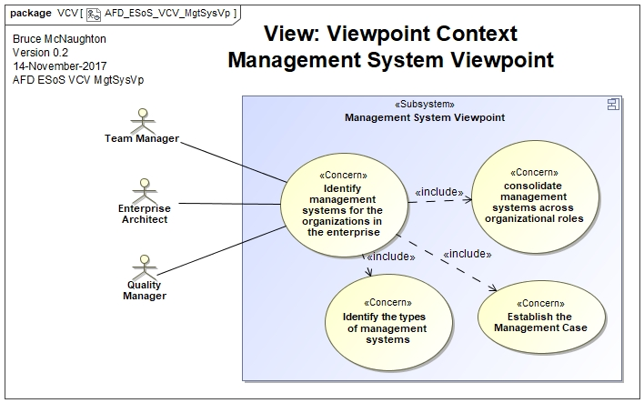

Requirement Prioritization

Requirements prioritization is used in software product management and is concerned with identifying the most valuable requirements from a given set. This is necessary to satisfy the needs of customers, to provide support for stakeholders and more importantly for release planning. Irrespective of the size of the organization (small, medium and large), requirements prioritization is important to minimize the risk during development.

The process of prioritizing requirements provides support for the following activities
• for stakeholders to decide on the core requirements for the system.
- to plan and select an ordered, optimal set of software requirements for implementation in successive releases.
- to trade off desired project scope against sometimes conflicting constraints such as schedule, budget, resources, time to market, and quality.
- to balance the business benefit of each requirement against its cost.
- to balance implications of requirements on the software architecture and future evolution of the product and its associated cost.
- to select only a subset of the requirements and still produce a system that will satisfy the customer(s).
- to estimate expected customer satisfaction.
- to get a technical advantage and optimize market opportunity.
- to minimize rework and schedule slippage (plan stability).
- to handle contradictory requirements, focus the negotiation process, and resolve disagreements between stakeholders
- to establish relative importance of each requirement to provide the greatest value at the lowest cost.

Requirements prioritization can be categorized into two categories: methods and negotiation approaches.
Methods are depending on quantitatively assigning values to various factors of requirements while negotiation approaches focus on giving priorities based on stakeholder’s views. Prioritization decisions are made by stakeholders including users, managers, developers, customers etc. considering different aspects like importance, risk, cost, customer input and value . In addition, customers and developers utilize a vast number of methods or practices to select this subset.

Factors to prioritize requirements
Factors are aspects which are taken into consideration while prioritizing requirements. Some frequently considered factors are Cost, Time, Importance, risk etc. It is always essential to consider the factors that affect the software development and those who satisfy the customers with end-product.
• Cost: The cost estimations to implement any product is done by the development team. Complexity in implementing the features, reusing the existing code, testing the product costs and documentation are few activities involved when cost is considered.
• Time: Time is interrelated to many other actors like time required to train the customers, complete all the industry standards, time need for development support of infrastructure etc..
• Importance: The importance of requirements differs from every individual and perspective of every stakeholder.
• Risk: Risks cause delays in the development of the project. Thus, based on the risk estimations, each requirement is ranked.

Characterizing Requirement Prioritization Approaches
In this section we classify some relevant approaches on requirements prioritization presented in the literature. For brevity reasons, following we only introduce the main intent and references to the approaches. Then, we proceed characterizing them through our framework’s elements.

.AGORA is an extended version of the Goal-Oriented Requirements Analysis Method [4], which uses a goal graph where attribute values (contribution values and preference matrices) are added. Each stakeholder does not only attach the preference value on his own, but also estimates the preference values of other stakeholders. As a result, these preferences are represented in the form of a matrix. The stakeholders attach the value subjectively.

· The Analytical Hierarchy Process (AHP) Model was designed by TL Saaty as a decision making aid . It involves building a hierarchy (ranking) of decision elements (candidate requirements) and then making comparisons between each possible pair in a matrix. This weights each element within a cluster (or level of the hierarchy) and a consistency ratio (useful for checking the consistency of the data). The Analytic Hierarchy Process compares alternatives in a stepwise fashion and measures their contribution to the main objective of the process .

· The Cost-Value Approach, designed by Karlsson and Ryan prioritizes requirements according to their relative value and cost. In this approach, Value is interpreted in relation to a candidate requirement’s potential contribution to customer satisfaction with the resulting system. Cost is the cost of successfully implementing the candidate requirement. To investigate candidate requirements, it uses AHP to calculate each candidate requirement’s relative value and implementation cost, and plots these on a cost–value diagram. The stakeholders use the cost–value diagram as a conceptual map for analyzing and discussing the candidate requirements. Based on this discussion, software managers prioritize the requirements.

· The Win-Win approach is a negotiation process, which enable stakeholders to work out a mutually satisfactory set of shared commitments . In this methodology stakeholders express their goals as win conditions and if everyone concurs, the win conditions become agreements. When stakeholders do not concur, they identify their conflicting win conditions and register their conflicts as issues. The stakeholders are in a Win-Win equilibrium condition when the agreements cover all of the win conditions and there are no outstanding issues.

· Quantitative Win-Win is a quantitative evaluation of alternatives of the Win-Win approach to support decision-making that uses an iterative approach. The added value of this approach is its ability to offer quantitative analysis as a backbone for actual decisions. The method consists of three components: firstly it uses the Analytical Hierarchy Process for a stepwise determination of the stakeholders’ preferences in quantitative terms. Secondly these results are combined with methods for early effort estimation. Thirdly, it reflects the increasing knowledge about the requirements at each iteration cycle.

· The Requirements Interdependencies technique uses a conjoint analysis as a tool to determine stakeholder’ preferences on an individual item, and can be used to detect conflicts among stakeholders [30]. It considers the software project as a product with attributes (functional and non-functional) that define the class of a product. The technique studies the dependencies and correlations between the attributes.

· The Quality Function Deployment method (QFD) is typically applied to small subsystems [27]. A customer’s desire is the quality demanded by the customer. A quality characteristic is a measurable attribute by which one can measure whether a customer is getting the demanded quality. Quality characteristics are defined through brainstorming to generate an affinity diagram.

· The Multi-Criteria Preference Analysis Requirements Negotiation (MPARN) is a systematic model to guide stakeholders from options to agreements using multi-criteria preference analysis techniques [28]. It cooperates with the artifacts of the win-win analysis. Each stakeholder assesses each option's performance on each criterion. Many methods can be used as direct subjective evaluation, the SMART method [23], the ratio pair-wise comparison method or a geometric progression method. At last it realizes a post-analysis for agreements.

· The Visualization technique uses visualization tools to requirement conflict identification and resolves problems with exploration of potential solution approaches [29]. The technique represents stakeholder perceptions, measures consensus among the perception, and visualizes the perceptions (support collaborative prioritization of requirements among a group of stakeholders using visualization aids). It proposes Clustering Analysis as a technique to identify stakeholder subgroups having different opinions.

· The Goals-Skills-Preference framework presented in [11] is used to generate a customizable software design. In the analysis phase, the framework takes requirements as input and generates a set of ranked alternatives for the design phase. An alternative is defined as a set of tasks that together fulfill a set of target goals. In the design phase each alternative correspond to a group of software components forming a particular architecture. Developers select a set of classes according to the user’s profile. The software configuration process can be performed by the user at run time.

· The Psychotherapy for System Requirements approach consists of a series of items that can be used to assist the analysts and quality assurance of customer requirements [1][2]. This methodology is transferred from the discipline of psychotherapy to the field of requirements engineering. It can be practiced in oral and written requirements. Although this set of rules reduces the risk of getting not well-defined requirements, it only helps the analyst in the elicitation process. It is implemented using natural language in informal notation, and is not considered as an acquisition technique since it is not supported by any specification language, or any automated tool.

Formal Method:
In software development, formal methods are mathematical approaches to solving software (and hardware) problems at the requirements, specification, and design levels. Formal methods are most likely to be applied to safety-critical or security-critical software and systems, such as avionics software.

Safety-critical systems
Safety-critical systems are those systems whose failure could result in loss of life, significant property damage, or damage to the environment. Aircraft, cars, weapons systems, medical devices, and nuclear power plants are the traditional examples of safety-critical software systems.

There are other kinds of safety-critical systems:
- code libraries, compilers, simulators, test rigs, requirements traceability tools, and other tools used to manage and build the kinds of systems we traditionally think of as safety-critical systems are safety-critical themselves
- software that provides data used to make decisions in safety-critical systems is likely safety-critical. For example, an app that calculates how much fuel to load onto a commercial jet is safety critical because an incorrect result from that app may lead to a life threatening situation
- other software running on the same system as safety-critical software may also be classified as safety-critical if it might adversely affect the safety functions of the safety-critical system (by blocking I/O, interrupts, or CPU, using up RAM, overwriting memory, etc.)

Safety-critical software systems are often distributed systems because:
- they are often large
- subsystems may be developed by different teams or companies
- many of these systems require redundancy and/or the separation of safety-critical code from non-safety critical code

