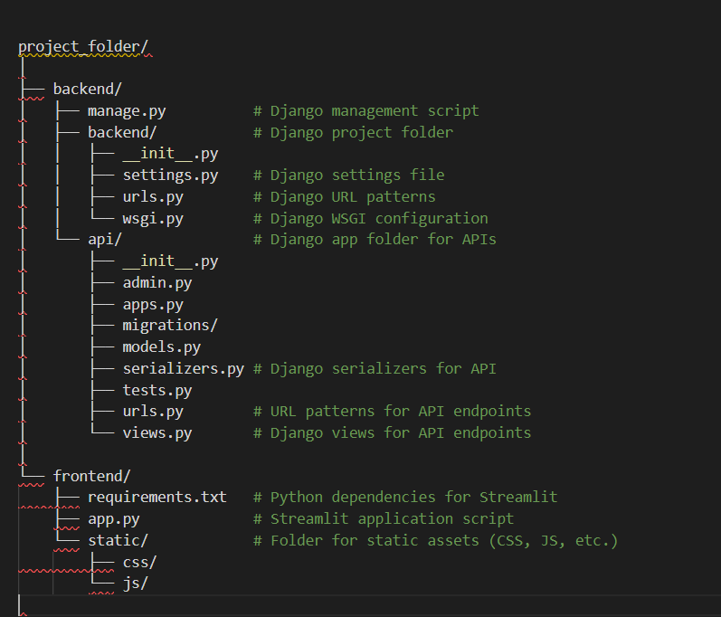

project_folder/

│

├── backend/

│ ├── manage.py # Django management script

│ ├── backend/ # Django project folder

│ │ ├── __init__.py

│ │ ├── settings.py # Django settings file

│ │ ├── urls.py # Django URL patterns

│ │ └── wsgi.py # Django WSGI configuration

│ └── api/ # Django app folder for APIs

│ ├── __init__.py

│ ├── admin.py

│ ├── apps.py

│ ├── migrations/

│ ├── models.py

│ ├── serializers.py # Django serializers for API

│ ├── tests.py

│ ├── urls.py # URL patterns for API endpoints

│ └── views.py # Django views for API endpoints

│

└── frontend/

├── requirements.txt # Python dependencies for Streamlit

├── app.py # Streamlit application script

└── static/ # Folder for static assets (CSS, JS, etc.)

├── css/

└── js/