D:\Selenium_Java\Selenium_WebDriver
What is Selenium WebDriver ?
- It is one of the component of the Selenium.
- It is an interface provided by selenium that allows you to interact with web browsers.
- It defines methods for controlling and interacting with browsers such as opening URLs, clicking elements, filling out form and extracting data.
- Selenium WebDriver is open source and portable Web Testing Frame work.
Environment Setup :
- Manual Approach
- Automatically
Manual Approach :
Step – 1 :
- WebDriver Download Process :
- Go to the selenium official website go to download section (Appear on Nav bar ) download jar file and extract all files.
- Copy the extracted file and paste on your workspace.
- Now attach WebDriver to your project by following this step.
- Go to eclipse -> right click on your project
-> go to properties
-> go to Java Build path
-> go to library section
-> go to class path
-> click on add external jar
- Downloading the jars file and attaching them to Java Project (Manually).

- Create new Java project downloaded WebDriver jars(.zip) and extract it.
Step – 2 : Create Maven Project.
Automatically Approach :
- Create Maven Project by keeping GroupId and ArtifactId same name.
- Maven Project have pom.xml file
- To configure WebDriver in pom.xml (We have dependencies) (To add dependencies go to MVN repository site search dependencies)
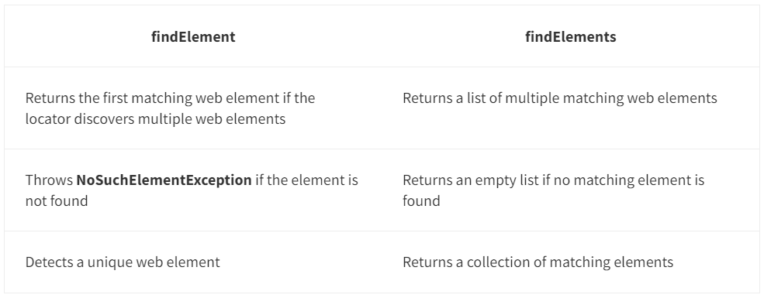
FindElement() Method:
- This command is used to access any single element on the web page
- It will return the object of the first matching element of the specified locator
- It will throw NoSuchElementException when it fails to identify the element
FindElements() Method:
- This command is used to uniquely identify the list of web elements within the web page.
- The usage of this method is very limited
- If the element doesn’t exist on the page then, then it will return value with an empty list
Scenario – 1 : Locator matching with single web element .
- FindElement() Method : Return single web element.
- FindElements() Method : Return first match web element .
Scenario – 2 : Locator matching with multiple web elements.
- FindElement() Method : It will return first web element in the list.
- FindElements() Method : Return multiple web element means list of web elements.
Scenario – 3 : Locator is not matching with any web elements.
- FindElement() Method : It will throw NoSuchElementException.
- FindElements() Method : Return 0 (zero), it will not throw any exception.
Returns an empty list if no elements are found. It is used when dealing with zero or more elements and the absence of elements is not necessarily an error.

Locators :
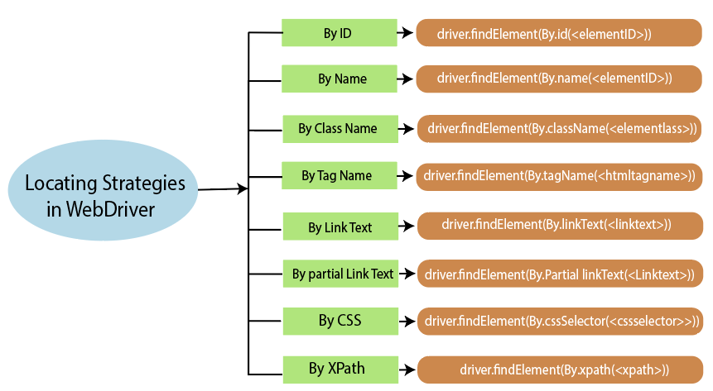
Basic Syntax for CSS Selectors
- Element Type Selector:
css
Copy code
tagname
Example: input selects all <input> elements.
- ID Selector:
css
Copy code
#id
Example: #submit selects the element with the ID submit.
- Class Selector:
css
Copy code
.classname
Example: .btn selects all elements with the class btn.
- Attribute Selector:
css
Copy code
[attribute='value']
Example: [name='username'] selects elements with the attribute name equal to username.
- Descendant Selector:
css
Copy code
parent descendant
Example: form input selects all <input> elements inside a <form>.
- Child Selector:
css
Copy code
parent > child
Example: div > p selects all <p> elements that are direct children of a <div>.
- Adjacent Sibling Selector:
css
Copy code
prev + next
Example: h1 + p selects the first <p> element immediately following an <h1>.
- General Sibling Selector:
css
Copy code
prev ~ siblings
Example: h1 ~ p selects all <p> elements that follow an <h1>.
Examples in Java with Selenium WebDriver
Here's how you can use CSS Selectors with Selenium WebDriver in Java:
java code
import org.openqa.selenium.By;
import org.openqa.selenium.WebDriver;
import org.openqa.selenium.WebElement;
import org.openqa.selenium.chrome.ChromeDriver;

public class CssSelectorExample {
public static void main(String[] args) {
// Set the path to the WebDriver executable
System.setProperty("webdriver.chrome.driver", "path/to/chromedriver");

// Initialize the WebDriver
WebDriver driver = new ChromeDriver();

try {
// Open a web page
driver.get("http://example.com");

// Example 1: Select by tag name
WebElement elementByTag = driver.findElement(By.cssSelector("input"));

// Example 2: Select by ID
WebElement elementById = driver.findElement(By.cssSelector("#submit"));

// Example 3: Select by class name
WebElement elementByClass = driver.findElement(By.cssSelector(".btn"));

// Example 4: Select by attribute
WebElement elementByAttribute = driver.findElement(By.cssSelector("[name='username']"));

// Example 5: Select by descendant
WebElement elementByDescendant = driver.findElement(By.cssSelector("form input"));

// Example 6: Select by child
WebElement elementByChild = driver.findElement(By.cssSelector("div > p"));

// Example 7: Select by adjacent sibling
WebElement elementByAdjacentSibling = driver.findElement(By.cssSelector("h1 + p"));

// Example 8: Select by general sibling
WebElement elementByGeneralSibling = driver.findElement(By.cssSelector("h1 ~ p"));

// Perform actions on the elements as needed
// For example:
// elementById.click();

} finally {
// Close the browser
driver.quit();
}
}
}

