https://testsigma.com/guides/functional-testing/
https://www.softwaretestinghelp.com/istqb-foundation-level-exam-sample-paper-i/

Manual Testing :
- What is Software Testing :
Software Testing is a part of software development process.
Software Testing is an activity to detect and identify the defects in the software.
The objective of testing is to release quality product to the client.
Software Quality :
- Bug-free.
- Delivered on time.
- Within budget.
- Meets requirement and or expectations.
- Maintainable.
Project Vs Product :
Project :
If software application is developed for specific customer based on the requirement then it is called Project.
Product :
If software application is developed for multiple customers based on market requirements then it called Product.
Error, Bug, Defect & Failure :
Error :
- An error refers to a human mistake made during the development process.
- It is typically an action or decision that leads to a flaw in the software .
- Errors can happen at any stage of development during design, coding or even when defining requirements.
- It is human mistake. It is incorrect human action.
- Error is mistake made by programmer during coding.
Example : A developer mistakenly writes a function that subtracts two numbers when it should have added them.
Key Point : Errors occur in the development process but are not directly visible to the end-user until they manifest as defects or faults in the software.

Bug :
- A bug refers to defects which means that the software product or the application is not working as per the adhered requirements set.
- A bug is an unintended problem or issue in the software caused by a defect in the code or design.
- It is the manifestation of an error and it can cause the program to behave unexpectedly.
- Bugs are often used interchangeably with “Defects” but the term “bug” is commonly used during the development and testing phase.
- Bugs raised by the Test Engineers. Bugs are often reported by testers during the testing phase or noticed by end-users. They are usually fixed by the development team once identified.
- There are different types of Bugs:
- Logical bugs.
- Algorithmic bugs.
- Resource bugs.
- Reasons behind bugs
- Missing Logic.
- Erroneous Logic.
- Redundant codes.
- Way to prevent the reasons:
- Implementing Test-driven development.
- Adjusting enhanced development practices and evaluation of cleanliness of the code.
Example :
A user tries to click a button that is supposed to submit a form, but the button doesn’t work because of a coding error.
Defect :
- A defect refers to a situation when the application is not working as per the requirements and the actual and expected result of the application or software are not in sync with each other.
- A defect is a flow pr imperfection in the software, typically resulting from an error or bug in the code. It can lead to incorrect behavior or performance issues.
- A defect is a deviation between the actual and expected output.
- Defect is a mismatch between the expected and actual result of software development detected by a software developer or end customer in the production environment.
- Example : By providing valid username and password we are able to login. But providing invalid username and password still able to login then it is bug.
- The defect is identified by the Testers and is resolved by the developers in the development phase of SDLC.
Example : A feature that was supposed to sort a list in ascending order but instead sorts it randomly due to a logic error in the code.
Key Points : A defect can be the result of a coding error, but it refers to the software not behaving as intended or not meeting its specifications.
It is often found during testing and can lead to a bug being fixed.
- Defects are classified as follows
Based on the Priority :
- High
- Medium
- Low
Based on the Severity :
- Critical
- Major
- Minor
- Trivial
- Receiving and providing incorrect input.
- Reasons : Coding / Logical Error leading to the breakdown of software.
- Way to prevent the reasons:
- Implementing Out-of-the-box programming methods.
Proper usage of primary and correct coding practices.
Severity | Description | Examples
Critical (Blocker) | Prevents the system from running or causes complete failure of key functionality | Application crashes, data loss, security vulnerabilities, critical features failing
High (Major) | Affects core functionality, preventing normal operations, but the system can still run | Payment failure, core feature not working but can be bypassed
Medium (Normal) | Impacts non-critical functionality or results in inconvenience | Minor bugs, UI glitches, features working incorrectly but not critical
Low (Minor) | Affects cosmetic or non-essential functionality, negligible impact | Typographical errors, misaligned UI elements, small design inconsistencies
Trivial (Enhancement) | Enhancements or cosmetic changes not necessary for functionality | Suggestions to add a new feature or improve user interface elements

Additional Types Of Defects :
- Missing Defects :
Occurs when certain customer wishes are not
included in the initial product requirements.
- Wrong Defects :
Wrong defects arise from a mismatch between the product requirements and user expectations, usually due to their incorrect formulation.
- Regression Defects :
Regression defects manifest as disruptions in the functioning of another module due to code changes made in a specific part of the system.
Regression testing is conducted to detect such defects.
Defect Resolution Process Are :
- Acknowledge defect.
- Prioritize Risk while fixing.
- Schedule Fix and Fix defect.
- Report Resolution
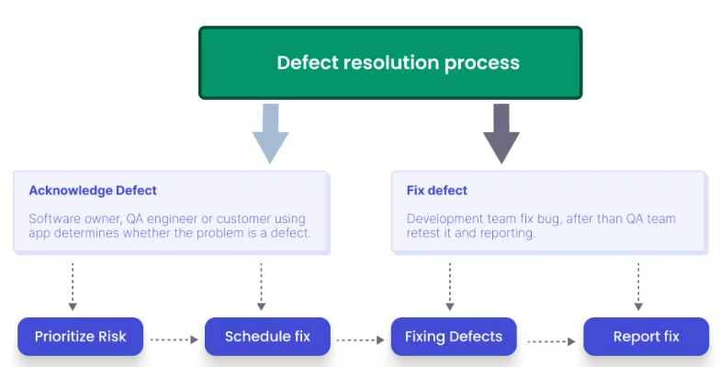
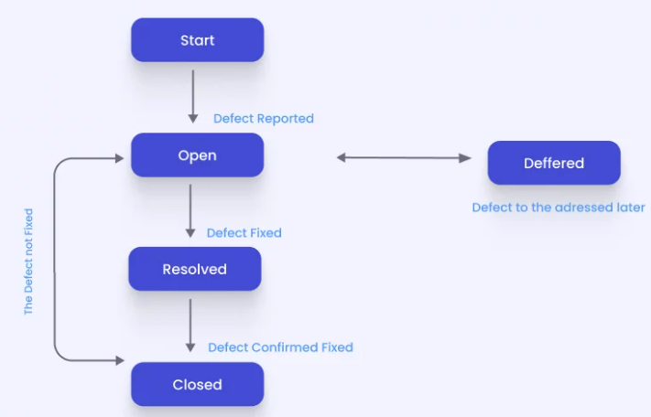
Fault :
- A fault is a state that causes the software to fail and therefore it does not achieve its necessary function.
- A fault is a defect or error in the System that is responsible for the incorrect operation or malfunctioning of a program. It is the root cause that leads to failure.
- The term fault is often used in a more technical sense, and it may refer to an issue in the design, code or hardware.
- Sometimes due to certain factors such as Lack of resources or not following proper steps Fault occurs in software which means that the logic was not incorporated to handle the errors in the application.
- This is an undesirable situation, but mainly happens due to invalid documented steps or a lack of data.
- Raised by human mistakes lead to fault.
Example : If a developer writes codes that calls the wrong variable in a algorithm that code contains a fault, which could lead to a defect.
Key Point : Faults are the underlying causes of defects. They are often
- Different types of Fault:
- Business Logic Faults.
- Functional and Logical Faults.
- Graphical User interface GUI Faults.
- Performance Faults.
- Security Faults
- Hardware Faults.
- Reasons :
- Wrong design of the data definition processes.
- An irregularity in Logic or gaps in the software leads to the non-functioning of the software.
- Way to prevent the reasons:
- Peer review of the Test documents and requirements.
- Verifying the correctness of software design and coding.

Failure :
- Failure is called an error which os founded by the end user.
- A failure occurs when the software fails to perform as expected or does not meet the required functionality when it run,
- A failure is the result of a defect(or multiple defects) in the system that affect the behavior or functionality of the software.
- It is the observable outcome of faults or defects during the execution of the system.
Example : A mobile app crashes when a user tried to open the setting menu -> this is failure
Key Point : Failures are the observable consequence of defects or faults in the software. A defect(or a set of defects) triggers a failure when the system is executed.
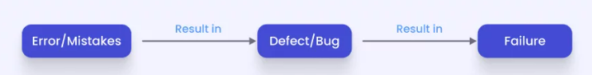

Why the software has the Bugs ?
- Miscommunication or no communication.
- Software complexity
- Programming errors
- Changing requirements
- Lack of skilled testers.
SDLC (Software Development Life Cycle) :
- Software Development Life cycle is a process used by software industry to design, develop and test software.
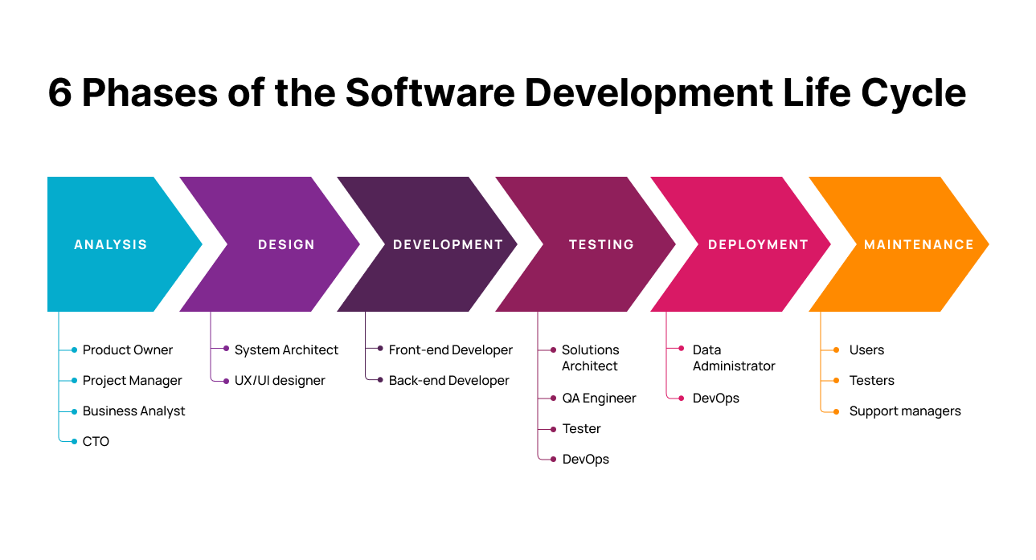
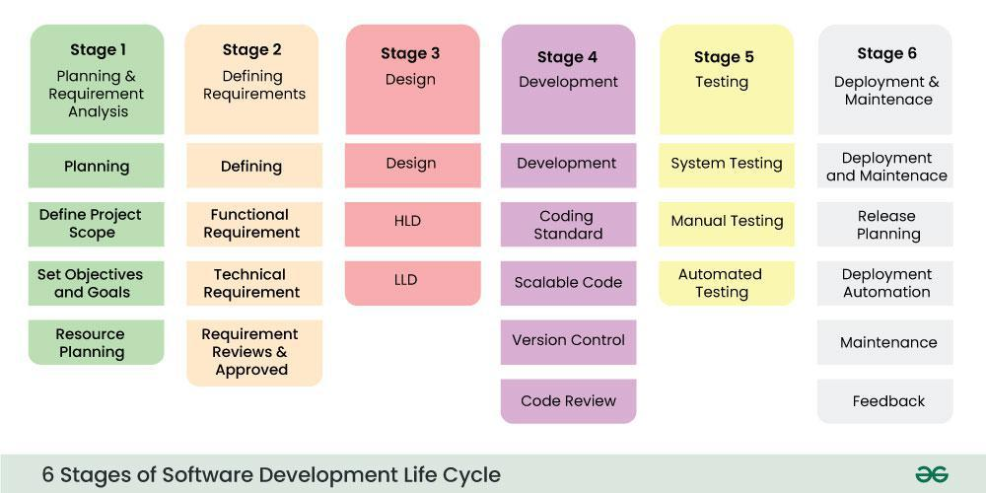
STLC (Software Testing Life Cycle ) :
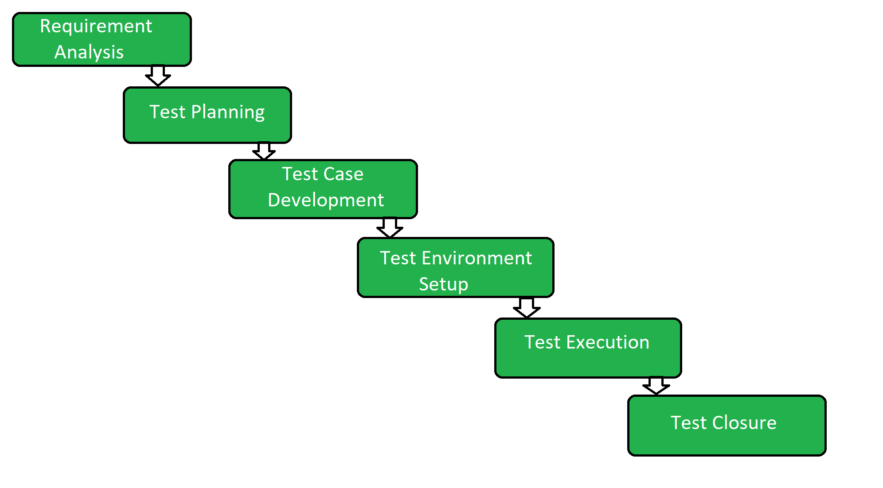
Software Design Documents :
- Software Design Document is a written document that provides a description of a software product in terms of architecture of software with various components with specified functionality.
Types of Software Testing Methodologies :
- Waterfall Model.
- Incremental Model.
- Agile Model
- RAD Model.
- Spiral Model.
- Extreme Programming.
- Scrum Model.
- V -Model.

WaterFall Model :
The SDLC refers to the phases of software development, from planning and design to the delivery of the finished product. The Waterfall Model follows a sequential, step-by-step process where each phase must be completed before moving to the next one. It's a rigid, structured approach to software development.

Phases of Waterfall Model in SDLC:
- Requirement Gathering and Analysis:
  - All the requirements for the system are collected from the client or stakeholders. These requirements are thoroughly analyzed to ensure clarity and completeness.
  - The outcome is a requirements specification document.
- System Design:
  - Based on the requirements, the system's architecture and design are created. The design phase includes both high-level design (architecture) and low-level design (component details).
  - The outcome is the design specification.
- Implementation (Coding):
  - Developers start writing the actual code based on the design specification.
  - This is the phase where the product is actually built and developed.
- Integration and Testing:
  - Once the development phase is complete, integration of various system components is done, and testing is performed.
  - Testing ensures that the system works as expected and meets the specified requirements.
- Deployment (Installation):
  - The system is deployed in the production environment and made available to end-users.
  - It is typically installed on the client’s systems or on cloud infrastructure.
- Maintenance:
  - After deployment, the system enters the maintenance phase, where issues are addressed, and updates or enhancements are made as needed.
  - It involves fixing bugs and improving the system based on user feedback.

Key Characteristics of the Waterfall Model in SDLC:
- Linear Process: Each phase depends on the completion of the previous one.
- Sequential: One phase starts only after the previous one is completed.
- Documentation-driven: Extensive documentation is created in each phase.
- Rigid: It can be difficult to go back and make changes once a phase is completed.

Advantages of Waterfall in SDLC:
- Clear structure and easy to understand.
- Well-defined stages and milestones.
- Best suited for small projects with clear and stable requirements.

Disadvantages of Waterfall in SDLC:
- Limited flexibility to make changes during development.
- Long feedback cycle; testing comes after development, so issues might not be identified until later in the process.
- It doesn’t handle well projects with evolving or unclear requirements.

2. Waterfall Model in STLC (Software Testing Life Cycle)
The STLC refers to the stages in the testing process that occur after the development phases. The Waterfall model in testing closely follows the same structure as in SDLC but focuses on testing the product after the development phase. The testing process is conducted sequentially, with each phase completed before moving to the next.

Phases of Waterfall Model in STLC:
- Requirement Analysis:
  - Testers review the requirements document to understand what needs to be tested.
  - The goal is to identify testable requirements, potential risks, and define the scope of testing.
- Test Planning:
  - Test strategies, test objectives, and test environments are defined.
  - A Test Plan document is created, outlining the approach, resources, schedule, and deliverables for testing.
- Test Case Design:
  - Detailed test cases are designed based on the requirements and specifications.
  - These test cases specify the inputs, expected results, and execution steps.
- Test Environment Setup:
  - Setting up the test environment, including hardware, software, and network configurations, to perform the testing.
- Test Execution:
  - Actual execution of the test cases to check if the system functions as expected.
  - Any defects or bugs found during this phase are reported for resolution.
- Defect Reporting and Tracking:
  - When defects are discovered during testing, they are logged, tracked, and assigned for fixing by the development team.
  - The process of fixing defects is usually iterative until all major issues are resolved.
- Test Closure:
  - After the final round of testing is complete and defects are resolved, the testing phase is concluded.
  - Testers document the testing process, results, and learnings. A Test Summary Report is created for stakeholders.
Advantage of Waterfall Model :
- Quality of the product will be good.
- Since Requirements changes are not allowed, chances of finding bugs will be less.
- Initial investment is less since the testers are hired at the later stages.
- Preferred for small projects where requirements are freezed.
Disadvantages Of Waterfall Model :
- Requirement changes are not allowed.
- If there is defect in Requirement that will be continued in later phases.
- Total investment is more because time taking for rework on defect is time consuming which leads to high investment.
- Testing will start only after coding.

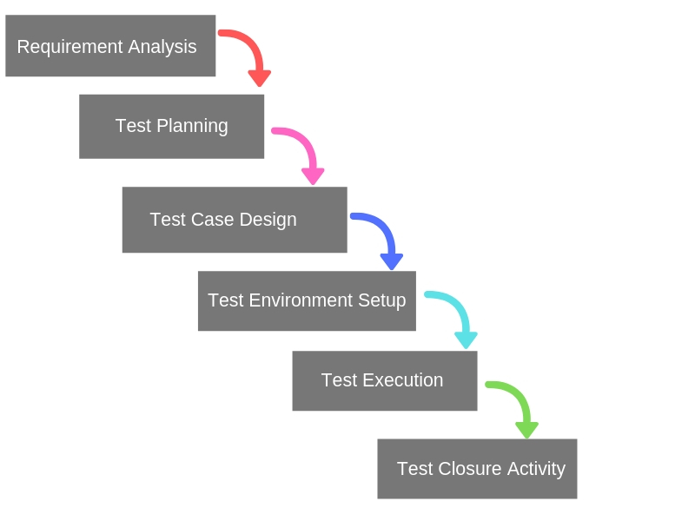

Spiral Model :
- Spiral model is iterative model.
- Spiral model overcome drawbacks of Waterfall model.
- We follow spiral model whenever there is dependency on the modules.
- In every cycle new software will be released to customer.
- Software will be released in multiple versions. So it is also called version control model.
What are the phases of the Spiral Model ?
- Objectives Defined :
In first phase of the spiral model we clarify what the projects aim to achieve, including functional and non-functional requirements.
- Risk Analysis:
In risk analysis phase, the risk associated with the project are identified and evaluated.
- Engineering :
In the engineering phase, the software is developed based on the requirements gathered in the previous iteration.
- Evaluation :
In the evaluation phase, the software is evaluated to determines if it meets the customer’s requirements and if it is of high quality.
- Planning :
The next iteration of the spiral begins with a new planning phase, based on the results of the evaluation.
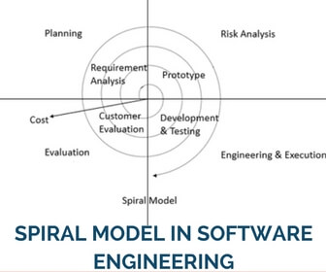

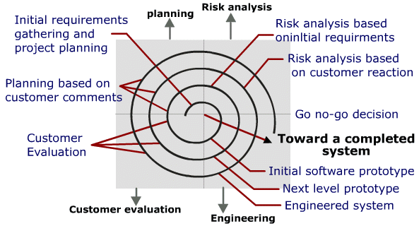
Advantages Of Spiral Model :
- Testing is done in every cycle, before going to the next cycle.
- Customer will get to use the software for every module.
- Requirement changes are allowed after every cycle before going to the next cycle.
Disadvantages of the spiral model :
- Requirement changes are not allowed in between the cycle.
- Every cycle of the spiral model looks like waterfall model.
- There is no testing in requirement & design phase.
Prototype : Blue print of the software .
Initial requirements from the customer -> Prototype -> Customer -> design, coding, testing
V – Model ( VV- Model ) :
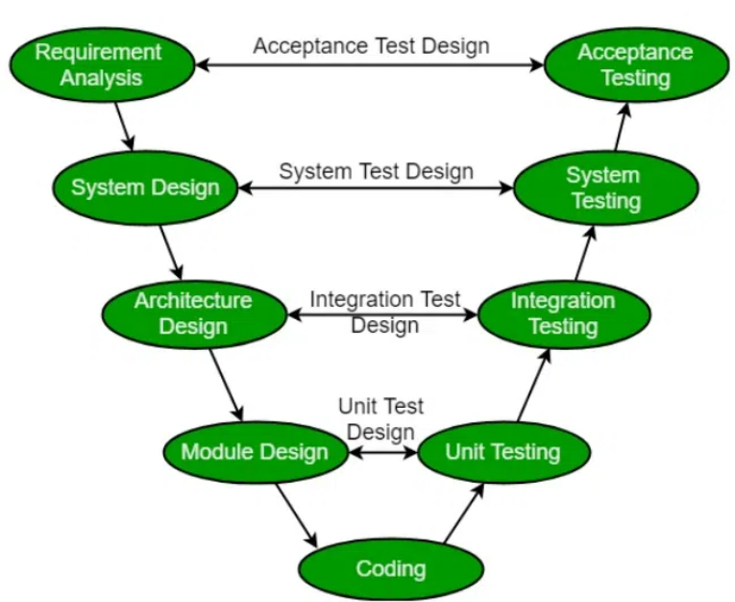

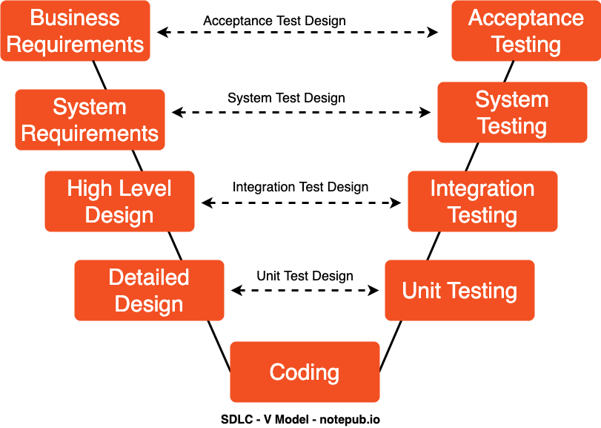

Verification Vs Validation :
Verification :
- Verification evaluates software artifacts(Such as requirements, design, Code etc.) to ensure they meet the specified requirements- and standards.
- It ensures the software is built according to the needs and design specifications.
- Are you building it Right ? (means in process, every phase we are checking)
- Verification checks whether we are building the right product.
- Focus on Documentation.
- Done by Developer.
- Method involves Review, Inspection, Unit testing and Integration testing.
- Static and Dynamic Activities.
- It is static testing.
- Verification typically involves
  - Review.
  - Walkthrough.
  - Inspections.
For Verification :
- Checklists :
To identifies necessary steps and requirements and ensures that
they are met.
- Walkthroughs:
To collaboratively review, discuss and analyze software design or documentation.
- Peer Review :
To review team members work and identify errors or inconsistencies
- Static Analysist tools :
To analyze code or documentation without executing it, detecting potential code issues or violations of coding standards.
Validations :
- Validation evaluates software to meet the user’s needs and requirements.
- It ensures the software fits its intended purpose and meets the user’s expectation.
- Have you build the Right ? (After Whole the software build we are checking)
- Validation checks whether we are building the product right.
- Take place after the verifications are completed.
- Focus on the software.
- Done by Tester.
- Involves System Testing
- Only Dynamic Activities
- Validation typically involves
  - Unit Testing .
  - Integration Testing.
  - System Testing.
  - User Acceptance Testing (UAT)
For Validation :
Test Cases :
To verify the functionality and performance of the software in formal scenarios.
Prototypes :
To gather feedback, validate requirements and iterate with early versions of the software.
Dynamic analysis tools :
To analyze software during runtime to identify potential issues like memory leaks or performance bottleneck.
Actual System Execution :
To validate the software’s behavior and performance in its intended environment and use cases.
Types of Software Testing Techniques :
There are two main categories of software testing technique.
- Static Testing Technique.
- Dynamic Testing Technique.
- Static Testing Techniques :
- It is testing techniques that is used to find defects in an application under test without executing the code.
- Static testing is done to avoid errovrs at an early stage of the development cycle thus reducing the cost of fixing them.
- Dynamic Testing Techniques :
- It is testing techniques that is used to test the dynamic behaviour of the application under test, that is by the execution of the code base.
- The main purpose of dynamic testing is to test the application with dynamic inputs- some of which may be allowed as per requirements(Positive testing) and some are not allowed (Negative testing)
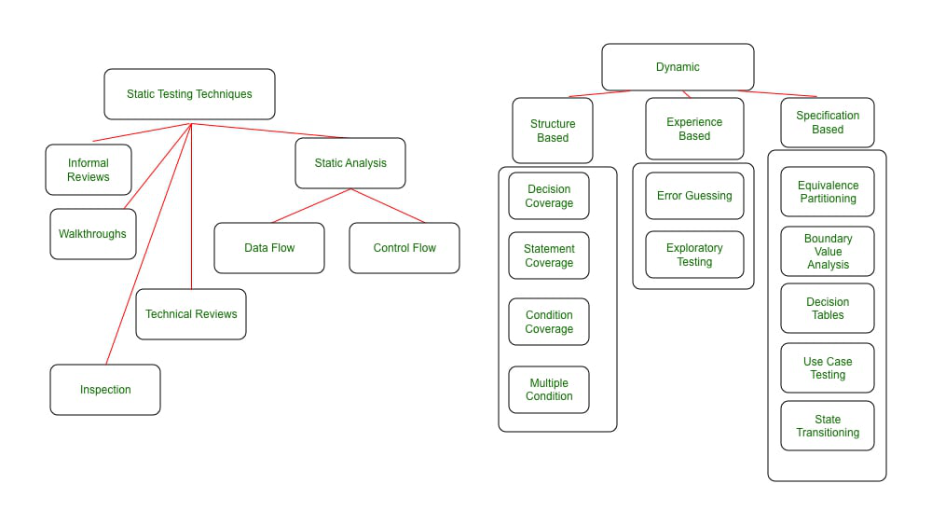
Static Testing Techniques :
Static Testing Techniques are testing technique that do not require the execution of a code base.
- Testing the project related documents is called as static testing.
- Review
- Walkthrough
- Inspection

Static Testing Techniques are divided into two major categories:
- Reviews :
They can range from purely informal peer review between two developers / testers on the artifacts(code/test cases/test data) to formal inspection which are led by moderators who can be internal / external to the organization.
- Requirement Reviews
- Design Review.
- Code Review.
- Test Plan reviews.
- Test cases reviews etc
- Peer Reviews :
Informal reviews are generally conducted without any formal setup.
It is between peers.
e.x : Two developers/Tester review each other’s artifacts like code/test cases.
- Walkthroughs :
Walkthroughs is a category where the author of work (code or test cases or document under review) walks through what she/he has done and the logic behind it to the stakeholders to achieve a common understanding or for the intent of feedback.
- It is informal review.
- Author reads the documents or code and discuss with peers.
- It’s not pre-planned and can be done whenever required.
- Also walkthrough does not have minutes of the meet.
- Technical Review :
It is a review meeting that focuses solely on the technical aspects of the document under review to achieve a consensus.
It is has less or no focus on the identification of the defects based on reference documentation.
Technical experts like architecture/ chief designers are required to do the review.
It can vary from informal to fully formal.
- Inspection :
Inspection is the most formal category of reviews.
Before the inspection, the document under review is thoroughly prepared before going for an inspection.
Defects that are identified in the Inspection meeting are logged in the defects management tool and followed up until closure.
The discussion on the defects is avoided and a separate discussion phase is used for discussions, which makes Inspection a very effective form of review.
- Its a most formal review type.
- In which at least 3-8 people will sit in the meeting
    - Reader, 2- writer, 3- moderator plus concerned .
3.Inspection will have a proper schedule which will be intimated via email to the concerned developer/tester.
- Static Analysis :
Static analysis is an examination of requirements / code or design to identify defects that may or may not cause failures.
For Example : Review the code for the following standards.
Not following the standard is a defect that may or may not cause failure.
Many tools for Static Analysis are mainly used by developers before or during Components or Integration Testing .
Even Compiler is a Static Analysis tool as it points out incorrect usage of syntax and it does not execute the code per se.
There are several aspects to the code structure-Namely data flow, Control flow and Data structure.
- Data Flow :
It means how the data trail is followed in a given program
How data gets accessed and modified as per the instructions in the program.
By Data flow analysis, you can identify the defects like a variable definition that never got used.
- Control Flow:
It is the structure of how program instructions get executed i.e. condition, iteration or loops.
Controls flow analysis helps to identify defects such as Dead code i.e. a code that never gets used under any condition.
- Data Structure :
It refers to the organization of the data irrespective of the code.
The complexity of the data structure adds to the complexity of code.
Thus it provides information on how to tests the control flow and data flow in a given code .
Dynamic Testing Techniques :
- Testing the actual software
- Unit testing
- Integration testing
- System testing
- User Acceptance Testing (UAT)

Dynamic technique are subdivided into three categories.
- Structure -based Testing :
These are also called White box technique.
Structure based testing techniques are focused on how the code structure works and test accordingly.
To understand Structure -based techniques, we first need to understand the concept of code coverage.

Code coverage :
Code coverage is normally done in Component and Integration Testing .
It establishes what code is covered by structural testing techniques out of the total code written. One drawback of code coverage is that it does not talk about code that has been written at all(missed requirement), there are tools in the market that can help measure code coverage.
There are multiple ways to test code coverage.
Code Coverage :
- Code coverage is a software testing metric also termed as code Coverage Testing which helps in determining how much code of the source is tested which helps in accessing the quality of the test suite and analyzing how comprehensively a software is verified. Actually in simple code coverage refers to the degree to which the source code of the software code has been tested.
- This code coverage is considered as one of the forms of white box testing.

3. Types of Dynamic Testing
Dynamic Testing can be classified into two main categories:

A. White-Box Testing (Structural Testing)
- Focuses on the internal structure, logic, and code of the software.
- Test cases are designed based on code coverage criteria.
- Performed by developers or testers with knowledge of programming.
- Common techniques include:
  - Unit Testing – Tests individual components or modules.
  - Integration Testing – Tests interaction between integrated modules.
  - Code Coverage Testing – Measures how much code is executed.

B. Black-Box Testing (Behavioral Testing)
- Focuses on software functionality without knowing internal code.
- Test cases are based on software requirements and specifications.
- Performed by testers or end users.
- Common techniques include:
  - Functional Testing – Validates expected behavior of features.
  - Regression Testing – Ensures new changes do not affect existing functionality.
  - User Acceptance Testing (UAT) – Confirms software meets business needs.
  - Performance Testing – Assesses speed, scalability, and responsiveness.
QA, QC and QE :
Quality Assurance (QA ):
- Quality Assurance QA is a process-oriented approach that focuses on preventing defects in software .
- It ensures that the software development process follows predefined standards, methodologies and best practices.
- QA is proactive meaning it works on improving processes to reduce defects before they occur.
- QA is Process related.
Key Characteristic of QA :
- Process-focused :
Ensures processes are well-defined and followed.
- Prevention-oriented :
Aims to reduce defects before they happen.
- Proactive approach :
Ensures quality from the beginning of development.
- Documentation-driven :
Includes test plans, checklists and guidelines.
Quality Control (QC) :
- Quality control QC is a product-oriented approach that focuses on detecting defects in the final product.
- Unlike QA which prevents issues, QC identifies and fixes issues after the development process.
- QC is the actual testing of the software.

Key Characteristic of QC :
- Product-focused :
Ensures the software meets requirements.
- Detection-oriented:
Identifies defects in code and functionality.
- Reactive approach :
Focuses on fixing defects rather than preventing them.
- Execution-driven :
Involves manual or automated testing.
Quality Engineering (QE) :
- Quality Engineering is modern automation-driven approach that integrates quality assurance into the entire software development lifecycle(Shift Left Testing) .
- QE focusses on continuos testing, automation, DevOps and AI-driven testing to enhance quality.
Key Characteristic Of QE :
- Engineering-focused :
Uses tools and automation for quality
- AI and DevOps integration :
Implements Continuous Testing in CI/CD.
- Shift-Left Testing :
Ensures early defect detection during coding.
- Proactive and automated :
Uses test automation and performance monitoring.

Key Differences Between QA, QC, and QE
Feature | QA (Quality Assurance) | QC (Quality Control) | QE (Quality Engineering)
Focus | Process & Prevention | Product & Defect Detection | Engineering & Automation
Approach | Proactive | Reactive | Continuous
Goal | Prevent defects | Detect and fix defects | Automate and integrate quality
When Applied? | Before development (Planning phase) | After development (Testing phase) | Throughout SDLC (Development & Testing)
Who Performs It? | QA engineers, Business Analysts | Testers, QA Engineers | Software Engineers, DevOps Teams
Tools Used | JIRA, TestRail | Selenium, JUnit, Postman | Jenkins, Cypress, AI-driven tools

- QA is Process related.
- QC is the actual testing of the software.
- QA focuses on building in quality.
- QC focuses on testing for quality.
- QA is process oriented.
- QC is Product oriented.
- QA for entire life cycle.
- QC for testing part in SDLC.

. Role of QA (Quality Assurance) in SDC
QA is a process-driven approach focused on preventing defects before they occur. It ensures that the right processes, methodologies, and best practices are followed throughout the SDC.

QA Responsibilities in Each SDC Phase
SDC Phase | QA Role
1. Requirement Analysis | - Define quality standards and ensure clarity in requirements.  - Perform feasibility analysis.  - Identify risks and mitigation strategies.
2. Planning | - Define testing strategy and process.  - Establish quality metrics and key performance indicators (KPIs).  - Identify test automation opportunities.
3. Design | - Review software architecture and design for quality and scalability.  - Ensure best practices for security, performance, and maintainability.
4. Development | - Implement Shift-Left Testing (early testing in the development phase).  - Define coding standards, version control, and CI/CD integration.
5. Testing | - Ensure proper test environment setup and test data preparation.  - Conduct test case reviews and audits.
6. Deployment & Maintenance | - Validate software release readiness.  - Ensure quality monitoring and incident management post-deployment.
QA Example in SDC: A QA team defines coding standards and reviews test plans before development starts to minimize defects later.

2. Role of QC (Quality Control) in SDC
QC is a product-driven approach focused on detecting defects after development through testing. QC ensures that the software meets functional and non-functional requirements before release.

QC Responsibilities in Each SDC Phase
SDC Phase | QC Role
1. Requirement Analysis | - Identify inconsistencies or missing requirements.  - Verify functional and non-functional specifications.
2. Planning | - Define test strategies and test plans.  - Identify required testing tools and frameworks.
3. Design | - Perform design validation through test case reviews.  - Identify potential risks in architecture.
4. Development | - Conduct unit testing to verify individual components.  - Detect issues early in the coding phase.
5. Testing | - Execute functional, regression, performance, security, and usability testing.  - Identify and report defects to developers.  - Perform root cause analysis (RCA) for critical issues.
6. Deployment & Maintenance | - Conduct user acceptance testing (UAT) before production release.  - Monitor software for post-deployment issues.
QC Example in SDC: A QC team runs automated regression tests after each build to catch bugs before release.

Key Differences Between QA and QC in SDC
Feature | QA (Quality Assurance) | QC (Quality Control)
Focus | Process improvement and defect prevention | Product testing and defect detection
Approach | Proactive (prevents issues) | Reactive (detects and fixes issues)
Type of Activity | Process-oriented (ensures best practices) | Execution-oriented (validates functionality)
Responsibility | Ensures software development follows quality standards | Ensures software meets functional and performance requirements
Tools Used | Test management tools (JIRA, TestRail), CI/CD pipelines | Test automation tools (Selenium, JMeter, LoadRunner)
Example | Defining test plans before development starts | Running test cases to find software defects
System Testing :
- System testing is a type of software testing that is performed on a completely integrated system to evaluate the compliance of the system with the corresponding requirements.
- In system testing integration testing passed components are taken as input.
- The goal of Integration testing is to detect any irregularity between the units that are integrated. System testing detects defects within both the integrated units and the whole system.
- System testing is carried out on the whole system in the context of either system requirement specifications or functional requirement specifications or the context of both.
- It is performed to test the system beyond the bounds mentioned in the software requirements specification (SRS)
- System testing is performed by a testing team that is independent of the development team and helps to test the quality of the system impartial.
- It has both functional and non-functional testung
- System testing is a black box testing.
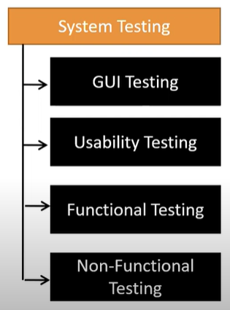
Graphical User Interface (GUI) Testing:
- GUI is a process of testing the user interface of an application.
- GUI testing is the process for ensuring proper functionality of the graphical user interface GUI for a specific application.
- GUI testing generally evaluate design of elements such as layout, color and font sizes, labels, text box etc.
- There are two types of GUI testing
    - Analog Recording.
    - Object based Recording.
- Testing the size, position, width, height of the elements.
- Testing of the error messages that are getting displayed.
- Testing the different sections of the screen.
- Testing of the font whether it is readable or not.
- Testing of the screen in different resolutions with the help of zooming in and zooming out.
- Testing the alignment of the texts and other elements like icons, button etc. like icons, button etc are in proper place or not.
- Testing the colors of the fonts.
- Testing whether the image has good clarity or not.
- Testing the alignment of the images.
- Testing of the spelling.
- The user must not get frustrated while using the system interface.
- Testing whether the interface is attractive or not.
- Testing of the scrollbars according to the size of the page if any. Testing of the disabled fields if any.
- Testing of the size of images.
- Testing of the headings whether it is properly aligned or not.
- Testing of the color of the hyperlink.
- Testing UI elements like button, textbox, text area, check box etc.
Usability Testing :
- During this testing validates application provide context sensitive help or not to the user.
- Checks how easily the end users are able to understand and operate the application is called usability testing.
- Usability testing is a method of testing the functionality of a website app, or product by observing real user as they attempt to complete tasks on it.
- Types of usability testing.
- Qualitative or Quantitative
- Moderated or unmoderated
- Remote or in_person
- Comparative Usablity Testing
- Think-Aloud Testing
Usability testing in software testing is a technique used to evaluate how user-friendly, efficient, and intuitive a software application is for end users. The goal is to identify usability problems, gather feedback, and ensure that the software meets the needs and expectations of its target audience. It focuses on the user's experience with the application, including how easily users can navigate, perform tasks, and achieve their goals without difficulty.
Key Aspects of Usability Testing:
- Ease of Use: Ensuring that the software is easy for users to understand and navigate, even if they are not tech-savvy.
- Efficiency: The software should allow users to complete tasks quickly and with minimal effort.
- Effectiveness: Users should be able to accomplish their goals successfully without errors or confusion.
- Satisfaction: The software should leave users feeling satisfied, confident, and positive about using it.
Steps in Usability Testing:
- Planning: Define the objectives, scope, and the target users. Decide on the tasks that participants will perform and how feedback will be collected.
- Recruiting Participants: Select representative users for the test. These users should resemble the real end-users of the software in terms of skill level and behavior.
- Creating Scenarios: Develop realistic tasks that users will complete during the test, focusing on key functionalities and features of the application.
- Conducting the Test: Users interact with the software while being observed by testers. This can be done in a controlled environment, remotely, or with recording tools.
- Collecting Data: During the test, gather both qualitative (user feedback, observations) and quantitative (task completion times, error rates) data.
- Analysis: Analyze the collected data to identify usability issues, such as common mistakes, frustration points, and barriers to task completion.
- Reporting Findings: Document the usability issues and provide actionable recommendations for improving the software’s design.
Methods Used in Usability Testing:
- Think-Aloud Protocol: Users are asked to verbalize their thoughts while completing tasks, which helps to understand their thought process.
- Surveys and Questionnaires: After testing, users provide feedback on their experience, which can help measure user satisfaction.
- A/B Testing: Two versions of a feature are tested with different users to see which one performs better.
- Remote Usability Testing: Users perform tasks on their own time and provide feedback, allowing for a more natural environment.
- Heuristic Evaluation: Experts assess the usability of the application against established usability principles.
Benefits of Usability Testing:
- Improved User Experience: By identifying and addressing usability issues, software can be made more intuitive and user-friendly.
- Higher Adoption Rates: Software that is easy to use and understand is more likely to be adopted by users.
- Reduced Support Costs: If users can easily navigate and operate the software, the need for customer support will decrease.
- Increased Productivity: Users can complete their tasks more efficiently, leading to better overall performance.
- Competitive Advantage: Well-designed software that is easy to use can stand out in the market and attract more users.
Qualitative or Quantitative :
Qualitative :
- Qualitative usability testing focuses on the ‘why’ understanding users experiences, thoughts and feelings while using a product.
- Qualitative data can be gathered from observation, interviews and surveys.
Quantitative :
- Quatitative usability testing focuses on collecting and analyzing numerical data.
- Likes success rates, task completion times, error rates, and satisfaction ratings.
- It’s about identifying patter, making predictions and generalizings.
Remote Usability Testing :
- Participants use a product or website from their own location whie reseatchers observe and gather feedback.
Types of Usability Testing :
1. Formative Usability Testing (Exploratory)
- Purpose: Conducted early in the development process to gather initial feedback on the design, user interface, and features.
- Goal: Identify potential usability problems while the product is still in the design or development phase, allowing for changes and improvements before the final version.
- When to Use: During the early design stages, prototyping, or wireframing.
- Example: Testing a low-fidelity wireframe or prototype with users to understand their needs and pain points.
2. Summative Usability Testing (Evaluative)
- Purpose: Conducted towards the end of the development process to evaluate the overall user experience and measure the effectiveness of the design.
- Goal: Measure how well the product meets usability goals, such as task completion time, user satisfaction, and error rates.
- When to Use: After the software is mostly developed, in the final stages before release.
- Example: A post-launch usability test to ensure users can complete tasks efficiently and are satisfied with the final product.
3. Moderated Usability Testing
- Purpose: A usability test where a moderator (facilitator) guides users through tasks and observes their actions. The moderator can also ask questions, clarify instructions, or offer help if necessary.
- Goal: Collect qualitative feedback, observe users in real time, and understand their thought process while using the product.
- When to Use: When direct interaction with users is needed, or when deep insights into the user's behavior are required.
- Example: A user testing session in which the facilitator observes the user interacting with the software and asks probing questions to understand their experience.
4. Unmoderated Usability Testing
- Purpose: The test is conducted without a facilitator present. Users complete tasks independently, often in their own environment.
- Goal: Gather quick feedback without the need for a moderator. This type of testing is typically remote.
- When to Use: When it's difficult to be physically present with users, or when you need to scale testing across a large group.
- Example: A participant testing the software on their own, providing feedback through an online platform where tasks are recorded automatically.
5. Remote Usability Testing
- Purpose: Usability testing where users interact with the system from a remote location, often via screen-sharing software or specialized usability testing platforms.
- Goal: Test the product in a natural environment (e.g., users at home or at work) and gather feedback without the logistical constraints of in-person testing.
- When to Use: When testing with users across different geographic locations or when conducting unmoderated tests.
- Example: Users test the software from their own devices, providing feedback via an online tool or survey.
6. Contextual Usability Testing
- Purpose: Conducted in the user's natural environment, such as their home, office, or a public space, to observe how the software fits into their regular routine.
- Goal: Understand how users interact with the product in real-world settings, including potential distractions or environmental factors that could affect usability.
- When to Use: When you need to understand how the product fits into the user's daily life or workflows.
- Example: Observing users in their home environment as they use a mobile app or software to understand how they interact with the interface in context.
7. A/B Testing (Split Testing)
- Purpose: A method where two versions of a feature or design are tested with different user groups to compare their effectiveness.
- Goal: Identify which version of a feature performs better in terms of user engagement, conversion, or other relevant metrics.
- When to Use: When you have two design alternatives and want to test which one yields better user performance or satisfaction.
- Example: Testing two different layouts for a website's homepage to see which one results in more clicks or conversions.
8. Guerrilla Usability Testing
- Purpose: A quick, low-cost testing method where users are approached in public places, like cafes or parks, to provide immediate feedback on a product.
- Goal: Gather informal, fast feedback from users with little planning or setup.
- When to Use: When you need fast, low-budget testing with minimal preparation.
- Example: Asking people in a coffee shop to try out a new mobile app for a few minutes and give feedback.
9. Expert Review (Heuristic Evaluation)
- Purpose: Involves usability experts evaluating a system based on established usability principles (heuristics).
- Goal: Identify potential usability issues and design flaws from an expert's perspective before conducting user testing.
- When to Use: Early in the development process or when you want a quick expert evaluation without involving real users.
- Example: An expert reviews a website or app and provides recommendations based on established usability guidelines.
10. Focus Groups
- Purpose: A moderated discussion with a group of users who provide feedback on a product. Unlike individual usability testing, focus groups involve group discussions about features, preferences, and experiences.
- Goal: Collect collective insights and opinions from users about the software, design, and functionality.
- When to Use: When you want qualitative feedback from a group and are interested in group dynamics or specific features.
- Example: A group of users discussing the pros and cons of a software feature in a structured environment.
11. Task-based Usability Testing
- Purpose: Users are asked to complete specific tasks while interacting with the software, and their ability to complete these tasks is measured.
- Goal: Identify specific usability issues that hinder task completion and gather data on the time, effort, and success rate of task completion.
- When to Use: When you need to assess how well users can perform specific tasks within the software.
- Example: Asking users to complete a purchase flow on an e-commerce website and measuring the time taken and success rate.
Functional Testing in System Testing :
- Object Properties Testing.
- Database Testing.
- Error Handling .
- Calculations/ Manipulations Testing.
- Links Existence & links Execution.
- Cookies and Session.
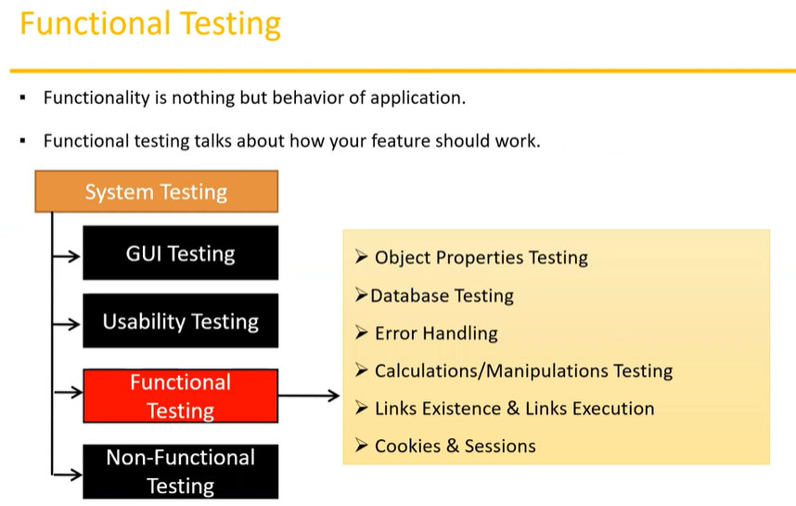
Object Properties Testing :
In functional testing, object properties testing refers to the process of verifying the properties or attributes of user interface (UI) elements (or "objects") in a software application to ensure that they function as expected. This type of testing focuses on the correctness, behavior, and attributes of UI elements such as buttons, text fields, dropdowns, checkboxes, links, and other interactive components.
Common Object Properties Tested:
- Visibility: Whether the object is visible or hidden from the user when expected. For example, ensuring a button appears when it is supposed to.
- Enabled/Disabled State: Testing whether the object (e.g., a button, checkbox) is in the correct enabled or disabled state based on the context. For example, a "Submit" button should be disabled until the user fills in all required fields.
- Text/Label: Verifying that the text displayed on a button, label, or other elements matches the expected values. For example, ensuring that a button reads "Submit" and not "Send."
- Value/Content: For input fields, verifying that the correct value is displayed or stored after user interaction. For example, checking that an entered username is stored correctly in a text field or that a selected option in a dropdown is reflected accurately.
- Font, Color, and Style: Ensuring that the visual styling (e.g., font size, color, style) of the UI elements matches the design specifications. This could include checking the background color of buttons, the font style of text in a label, etc.
- Location/Position: Verifying that the UI element is positioned correctly on the screen, based on layout specifications. This ensures that objects are properly aligned and spaced according to the design guidelines.
- Tooltips and Help Text: Testing whether any tooltips or help text that appear when hovering over UI elements function as expected. For example, a "?" icon should show a tooltip when hovered over with an explanation or description.
- Action or Event Triggering: Checking whether the correct actions are triggered when interacting with an object. For instance, clicking a button should submit a form or navigating a link should open the correct page.
- Accessibility Properties: Verifying that UI elements are accessible by tools such as screen readers. For example, ensuring that elements have correct aria-labels or alt texts for images.
- Focus Management: Ensuring that the focus behavior is consistent when interacting with UI elements. For example, when a user tabs through form fields, the focus should move sequentially from one element to the next.
Example Scenarios in Object Properties Testing:
- Button Visibility: Verifying that a "Login" button is visible when the user accesses the login page.
- Textbox Enabled/Disabled: Ensuring a text box is disabled when a user has not selected a specific option or when it should not be editable.
- Dropdown Value: Checking that the value selected from a dropdown is correctly displayed or reflected in a related field.
- Color Testing: Ensuring a button turns green when the form is correctly filled out, indicating that the user can now submit the form.
Tools for Object Properties Testing:
- Selenium: A popular tool for automating web applications and checking object properties using various functions like isDisplayed(), isEnabled(), getText(), etc.
- QTP (QuickTest Professional): An automated testing tool for functional and regression testing that can also verify object properties of UI elements.
- Appium: A tool for automating mobile applications that can be used to check object properties on mobile devices.
Database Testing In Functional Testing :
Database testing in the context of functional testing refers to the process of verifying that the database interacts correctly with the software application. It involves checking the integrity, accuracy, and consistency of data stored in the database, ensuring that the application is correctly performing database operations such as inserting, updating, deleting, and retrieving data.
Key Areas of Database Testing:
- Data Integrity:
  - Verifying that the data stored in the database is accurate, consistent, and reliable.
  - Ensuring that data is not corrupted or modified inappropriately.
  - Testing constraints like Primary Keys, Foreign Keys, and Unique Keys to make sure data relationships are correctly maintained.
- Data Consistency:
  - Ensuring that data remains consistent across different tables and is correctly updated when changes are made.
  - Verifying that the changes made in the database by the application are reflected accurately when queried.
- Data Accuracy:
  - Checking that the data inserted into the database is accurate and complete.
  - Ensuring that the data displayed or retrieved by the application matches the data stored in the database.
- Database Query Testing:
  - Verifying that SQL queries executed by the application return correct and accurate results.
  - Checking the correctness of queries, such as SELECT, INSERT, UPDATE, DELETE.
  - Testing stored procedures, functions, and triggers to ensure they work as expected.
- Database Performance:
  - Ensuring that the database performs efficiently under normal and peak loads.
  - Testing for quick query execution times and ensuring that large datasets do not degrade performance.
  - Verifying that the database maintains performance as the number of users or the volume of data increases.
- Transaction Testing:
  - Verifying that transactions are handled correctly (especially with respect to ACID properties: Atomicity, Consistency, Isolation, Durability).
  - Ensuring that the system handles commit and rollback actions correctly when transactions succeed or fail.
- Boundary Testing:
  - Checking how the database handles edge cases, such as large data volumes or boundary values for fields.
  - Ensuring that data types, such as integers or dates, are properly validated and stored.
- Database Security Testing:
  - Ensuring that only authorized users have access to the database.
  - Verifying that sensitive data (e.g., passwords, personal information) is securely stored (e.g., encrypted) and not exposed.
- Backup and Recovery Testing:
  - Ensuring that data can be correctly backed up and recovered.
  - Verifying that recovery processes work as expected and that no data is lost after restoring from a backup.
Example Scenarios in Database Testing:
- Insert Data Verification: When a user submits a form to create a new account, verifying that the user’s data (e.g., name, email, password) is inserted correctly into the database.
- Update Data Verification: After updating user information through the application (e.g., changing an address), verifying that the new data is accurately reflected in the database.
- Delete Data Verification: Ensuring that when a user deletes an item (e.g., a product or a record), the data is actually removed from the database.
- SQL Query Testing: Testing that a query like "SELECT * FROM orders WHERE status = 'shipped'" correctly retrieves the expected order records from the database.
- Performance Testing: Running queries with large datasets to check if the database can handle large volumes of data and return results within acceptable time limits.
Types of Database Testing:
- Structural Testing:
  - Focuses on testing the schema, table structures, and relationships between tables.
  - Involves verifying that the schema (tables, columns, indexes) is designed and implemented correctly according to the application requirements.
- Functional Testing:
  - Focuses on testing the functionality of database operations like insert, update, delete, and select.
  - Ensures that the software correctly interacts with the database to perform CRUD (Create, Read, Update, Delete) operations.
- Regression Testing:
  - Ensures that database operations still function as expected after code changes or updates.
  - Verifies that no new issues were introduced after modifying the database schema or application code.
- Data Migration Testing:
  - Verifies that data is correctly migrated from one database to another, especially during upgrades or system changes.
  - Ensures that data integrity and accuracy are maintained during the migration process.
- Performance Testing:
  - Tests the speed, scalability, and efficiency of the database operations.
  - Ensures that database queries are optimized and can handle large volumes of data or multiple simultaneous users.
Error Handling Testing In Functional Testing :
Error handling testing in functional testing focuses on evaluating how an application handles errors, exceptions, and unexpected inputs. The objective is to ensure that the software behaves gracefully and predictably when an error occurs, rather than crashing, giving misleading messages, or failing silently. Error handling testing is crucial to verify that the system provides appropriate feedback, logs errors correctly, and ensures the application continues functioning in a stable manner.
Key Aspects of Error Handling Testing:
- Error Detection:
  - Verifying that the application can detect errors such as invalid inputs, system failures, and unexpected conditions.
  - Ensuring that errors are flagged and logged properly when they occur.
- Error Messages:
  - Ensuring that the application provides clear, understandable, and informative error messages to the user. The messages should help users understand what went wrong and, if possible, how to resolve the issue.
  - The messages should avoid technical jargon that may confuse end users, and instead be user-friendly.
- Exception Handling:
  - Ensuring that exceptions (both system-generated and user-defined) are caught and handled appropriately without causing the application to crash.
  - Testing how the application responds when unexpected exceptions occur, such as a network failure, database connection error, or server timeout.
- Graceful Recovery:
  - Verifying that the application can recover from errors without causing data corruption, loss of functionality, or crashing.
  - For example, if a user encounters an error while filling out a form, the application should not lose the entered data after an error and should allow the user to continue after fixing the error.
- Validation of Input Fields:
  - Ensuring that the system validates inputs correctly and handles invalid inputs properly (e.g., ensuring that text fields don't accept numbers or special characters when only text is expected).
  - Testing for field boundaries, such as ensuring that a phone number field only accepts numeric values and handles incorrect formats (e.g., "123-abc-456").
- Boundary Testing:
  - Testing how the application handles boundary values (e.g., testing upper and lower limits for fields such as age, salary, or quantity) and ensuring that errors are handled appropriately when values exceed limits.
  - Verifying that the system correctly handles situations where input values are on the edge of acceptable limits.
- System and Network Failures:
  - Testing how the application behaves in cases of system failures (e.g., disk full, memory overflow) or network issues (e.g., loss of connection).
  - Ensuring the system can handle such situations without crashing, and provide a meaningful error message to the user, such as "Network connection lost."
- Rollback and Recovery:
  - Ensuring that when an error occurs, the system can rollback to a previous stable state and not leave the system in an inconsistent state.
  - For example, if a transaction fails in an online payment system, the system should ensure that no money is deducted from the user’s account.
Types of Errors to Test:
- Invalid Input: Testing how the system handles inputs that don't meet the required criteria (e.g., entering text in a numeric field).
- System Errors: Testing how the system behaves when a system-level error occurs, such as memory overflow, file not found, or permission errors.
- Network Errors: Verifying how the application responds to network issues, like a slow internet connection or a timeout error.
- Business Logic Errors: Testing whether the application correctly handles errors in business logic or calculations.
- Application Crashes: Ensuring that critical errors do not cause the application to crash and that it handles such crashes properly (e.g., error reporting, safe shutdown).
Steps in Error Handling Testing:
- Identify Potential Error Scenarios:
  - List common failure points and error-prone areas in the application (e.g., form submissions, file uploads, transactions).
  - Think about possible invalid inputs or unexpected situations (e.g., a user entering invalid data, network failure, or database connection issues).
- Test Different Error Conditions:
  - Simulate error conditions such as invalid user inputs, system failures, network disconnections, or incorrect file uploads.
  - Ensure that the system behaves appropriately in these scenarios, providing useful error messages or recovering gracefully.
- Validate Error Messages:
  - Verify that the error messages presented to users are clear, concise, and actionable.
  - Ensure the messages do not expose unnecessary technical details that could confuse or mislead the user.
- Check Application Stability:
  - Test whether the application remains stable and does not crash when errors occur.
  - Ensure the application is capable of recovering from errors without causing data loss or corruption.
- Verify Logging and Reporting:
  - Ensure that errors are logged correctly in the system for debugging and diagnostic purposes.
  - Confirm that error logs contain enough information (e.g., error codes, stack traces, user actions) to help developers resolve issues.
- Perform Boundary Tests:
  - Test how the application handles extreme values or boundary conditions (e.g., maximum allowed characters in an input field, the largest possible data entry).
  - Ensure the system properly handles edge cases without crashing or producing incorrect behavior.
Calculations / Manipulation Testing in Functional Testing :
Calculation or manipulation testing in functional testing refers to the process of verifying that the system correctly performs all required mathematical calculations, data transformations, or manipulations based on input values. This type of testing ensures that the application's logic correctly processes data, computes results accurately, and produces the expected outputs, especially when it involves numerical or data-related operations.
Link Existence Testing & Link Execution Testing :
In functional testing, link existence testing and link execution testing are two distinct tests that focus on verifying the behavior of hyperlinks within an application or website.
1. Link Existence Testing
Link existence testing focuses on verifying that all hyperlinks (both internal and external) present within the application or website are functioning, i.e., they exist and point to valid destinations. This test checks whether the links are not broken or missing.
Key Aspects of Link Existence Testing:
- Checking for Broken Links: Ensuring that links lead to valid pages or resources and not to "404 Not Found" or other error pages.
- Verifying Link Availability: Ensuring that all the expected links exist on the page and are available for user interaction. Missing links, especially in navigation menus or forms, can cause user frustration.
- Internal vs. External Links: Testing both internal links (links within the same website) and external links (links to other websites or external resources).
- Link Attributes: Verifying attributes associated with links, such as href values for HTML links, to ensure they are correct and functional.
Example Scenarios:
- A user clicks a navigation link on the homepage to navigate to the "Contact Us" page. The link should exist and point to the correct URL.
- A "Privacy Policy" link in the footer should point to an existing document or page, not result in a 404 error.
2. Link Execution Testing
Link execution testing goes beyond verifying the existence of links. It ensures that the actual behavior of the link is tested when it is clicked. This test checks that clicking on a link leads to the correct outcome (e.g., opening a new page, executing an action, or navigating to the correct URL).
Key Aspects of Link Execution Testing:
- Verifying Correct Navigation: When a user clicks a link, the system should take them to the correct destination, whether it's a different page, a new tab, or an external website.
- Validating Actions: If a link triggers an action (such as submitting a form, downloading a file, or opening a modal), the expected action should occur when the link is clicked.
- Link Behavior: Testing whether the link functions as expected in terms of opening the correct page or executing the correct task. For example, checking if a "Sign Up" link redirects users to a registration page.
- Anchor Tags and Scroll Functionality: If a link is intended to scroll to a particular section of the page (using anchor links like #section1), verify that it scrolls smoothly to the correct part of the page.
- Browser and Device Compatibility: Ensuring the link works across different browsers and devices, such as mobile phones and tablets.
Example Scenarios:
- Clicking a "Submit" button on a form should execute the form submission process and redirect the user to a confirmation page.
- Clicking a "Download PDF" link should prompt the user to download the correct PDF file.
- Clicking a link in the navigation bar should take the user to the correct page (e.g., clicking the "Products" link should lead to the product listing page).
Differences Between Link Existence and Link Execution Testing:
Aspect | Link Existence Testing | Link Execution Testing
Purpose | Verifying that links are present and lead to valid destinations. | Verifying that links behave as expected when clicked.
Focus | Focus on whether the link exists and points to a valid URL. | Focus on whether the link performs the intended action or navigation.
Tested Actions | Checking if a link is broken (e.g., 404 errors). | Checking if the link leads to the correct destination or triggers the correct action.
Example | Verifying that a "Contact Us" link exists and points to the correct page. | Verifying that clicking a "Contact Us" link navigates the user to the Contact Us page and loads correctly.
Steps in Link Existence Testing:
- Extract All Links: Identify and extract all the links from the application or website that need to be tested. This includes all anchor tags (<a> elements) and other clickable elements like buttons or images that act as links.
- Verify Link Target: Ensure each link's href attribute points to the correct URL or destination.
- Check for Broken Links: Test the link to ensure it does not lead to a 404 error or a page that doesn't exist.
- Validate External Links: For external links, ensure that they are pointing to live websites or resources.
- Test Across Different Browsers: Ensure the links are valid and working in different browsers (e.g., Chrome, Firefox, Safari).
Steps in Link Execution Testing:
- Simulate User Click: Click each link to simulate how a user would interact with the system.
- Verify Navigation or Action: Check that clicking the link takes the user to the expected destination (e.g., correct page, file, or external resource) or triggers the correct action (e.g., form submission).
- Test in Different Scenarios: Test links in different environments (e.g., mobile, desktop) and browsers to ensure consistent behavior.
- Check for Correct Behavior: If the link opens a new page, ensure that it loads the correct page and the content matches expectations. If the link opens a modal or performs an action, verify the expected behavior (e.g., form submission or download).
- Test Special Link Behavior: For links that perform special actions (e.g., opening a new tab or triggering a scroll), ensure that the behavior works correctly.
Non-Functional Testing :
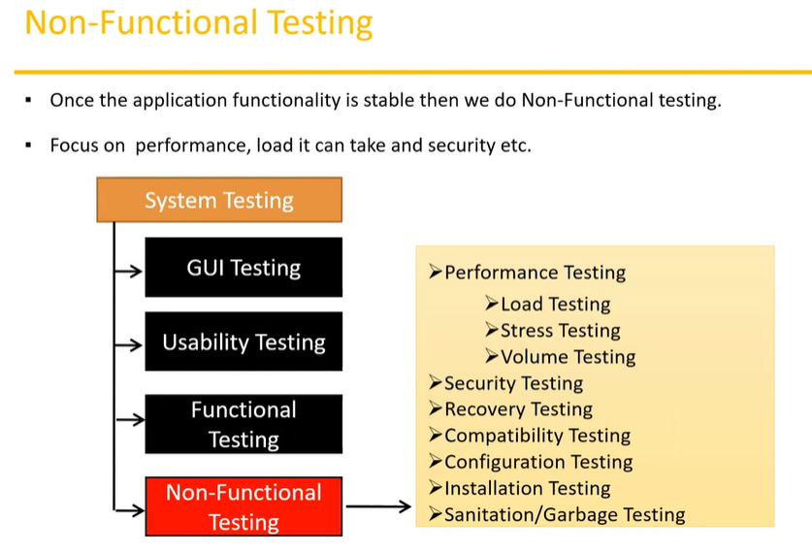
Performance Testing :
Testing speed of the Application.
Types of Performance Testing.
  - Load Testing
  - Stress Testing
  - Volume Testing
Load Testing
Gradually increasing the load on the application then check the speed of the application.
Stress Testing
Suddenly increasing / decreasing the load on the application and then check the speed of the application.
Volume Testing :
Check how much data is able to handle by the application. (size feeding the data more than it’s size )
Security Testing :
How secure the our application.
Authentication : User are valid or not .
Authorization / Access Control : Permission (to access certain feature in the application ) for the valid user.
Recovery Testing :
Check the system change to abnormal to normal.
Ex : while composing mail window got closed suddenly but the mail you are composing is save in draft section that is recovery from abnormal termination to normal state.
Compatibility Testing :
Forward Compatibility :
Suppose a software release 1.1 and successfully working . Then get another release 1.2 it should be compatible with 1.1 like it should upgrade or update successfully (upgrade old version to new version successfully)
Backward Compatibility :
Suppose a new software release 1.2 which is compatible with the older one release 1.1
Hardware Compatibility or Configuration Testing :
Software working other system like window, linux
Installation Testing :
- Check screens are clear to understand .
- Screen navigation
- Simple or not
- Un-installation
Sanitation / Garbage Testing :
- If any application provide extra feature or functionality then we consider them as bug.
Software Testing Technology :
Regression Testing :
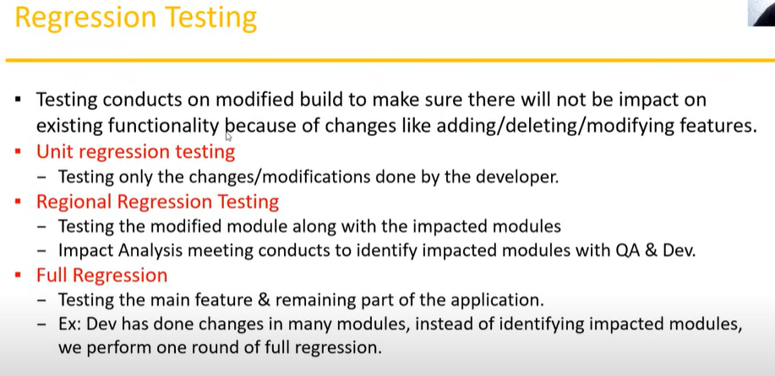

Re-Testing :
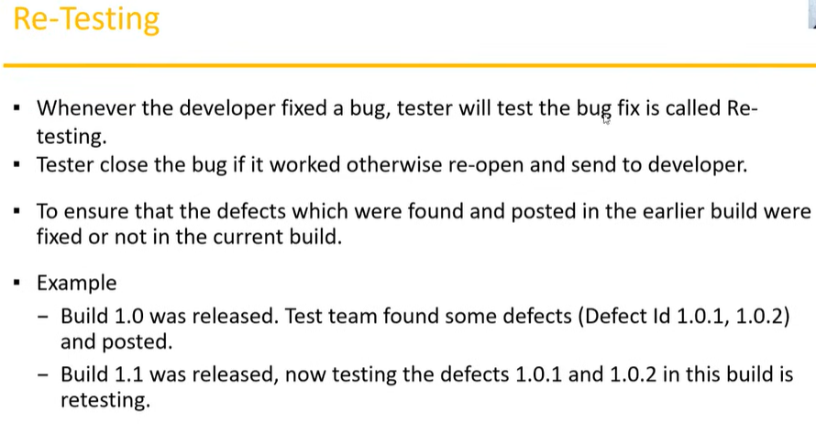
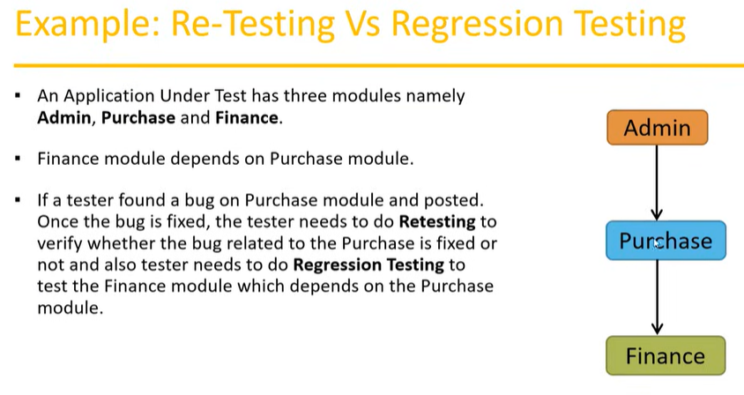
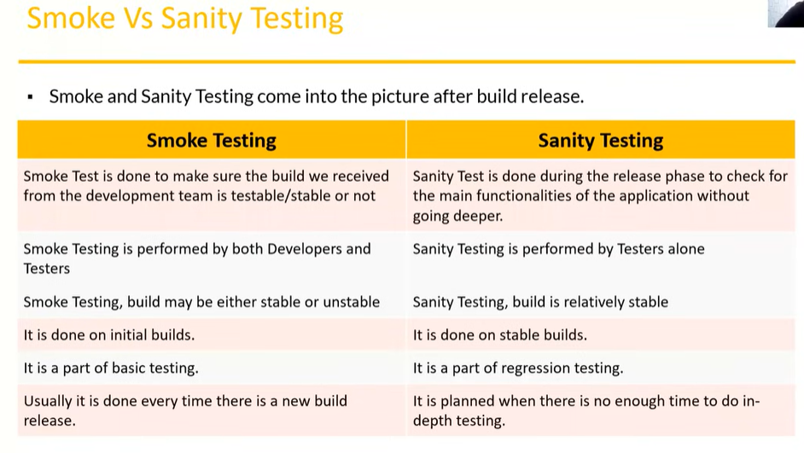
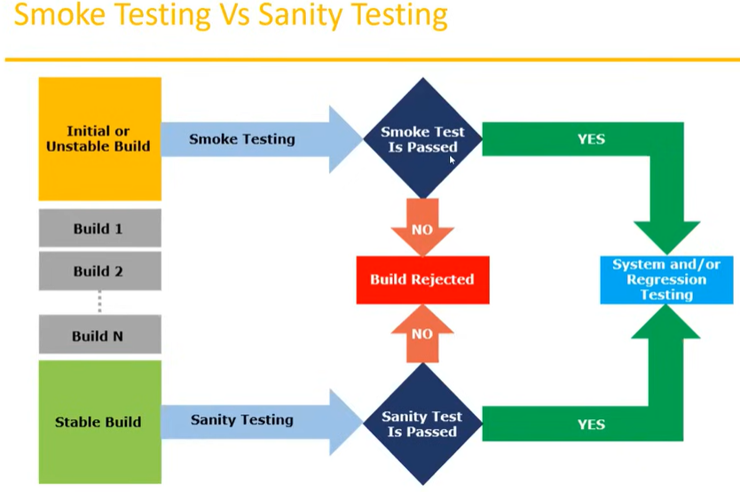
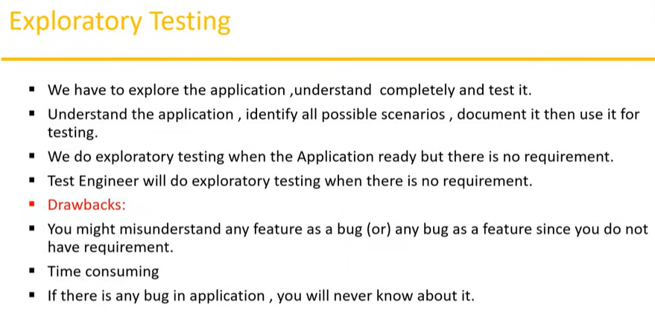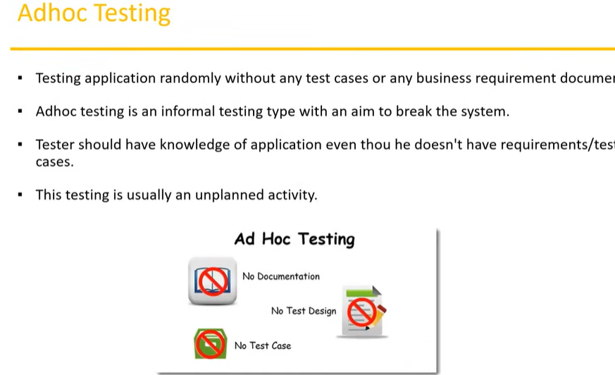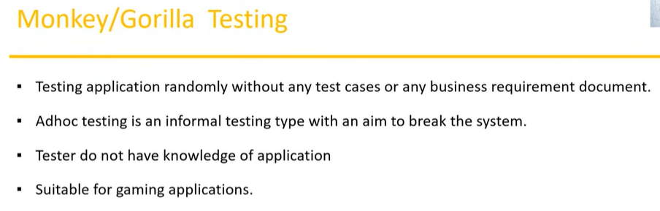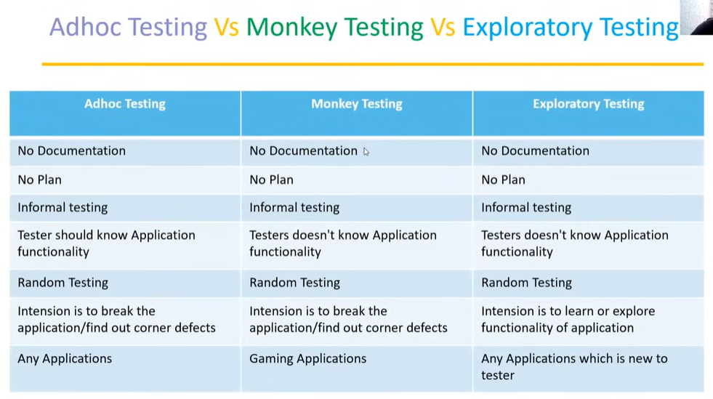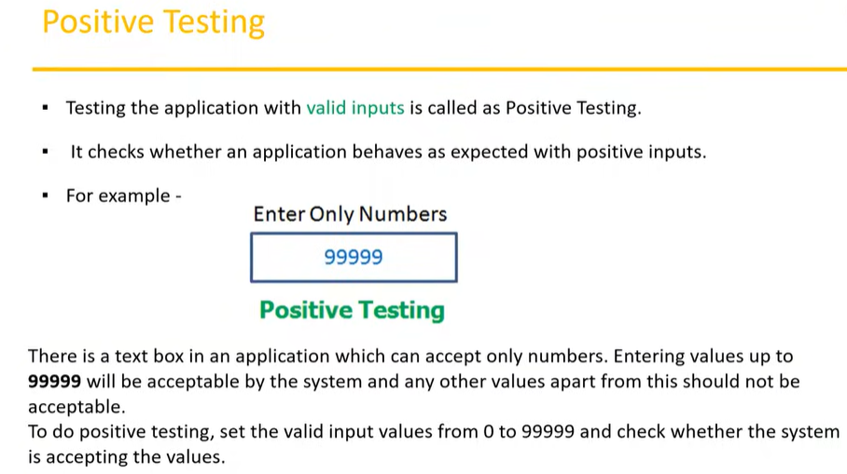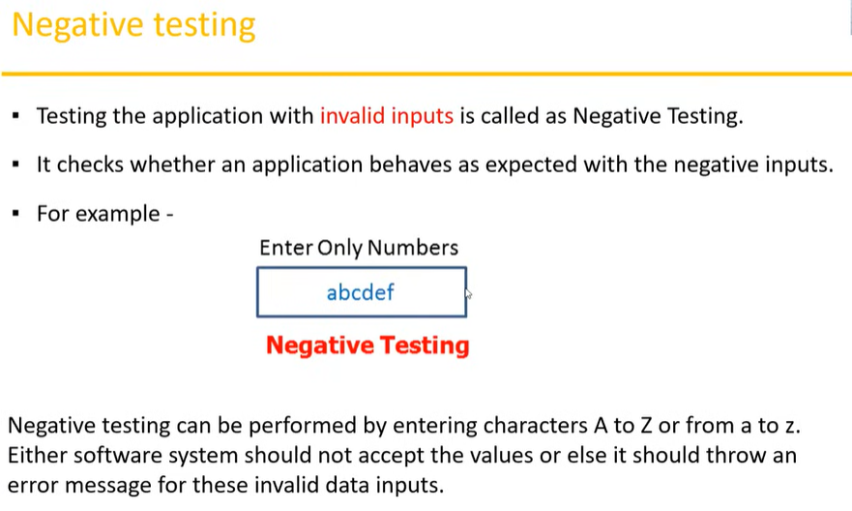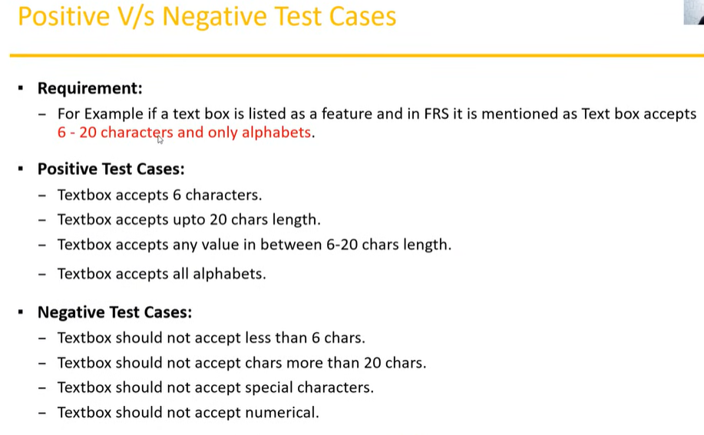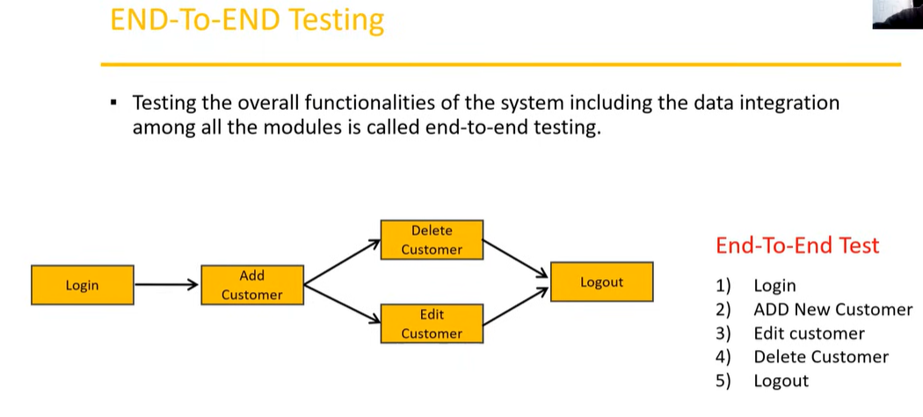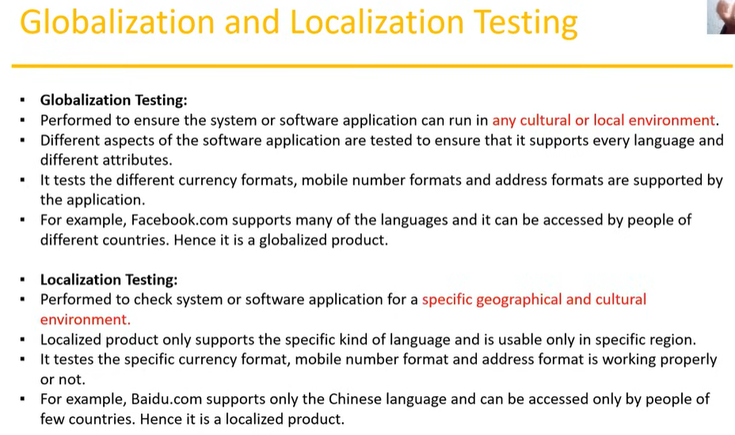
Test Design Technique :
  - Equivalence class Partition.
  - Boundary value Analysis.
  - Decision table based testing.
  - State Transition
  - Error Guessing
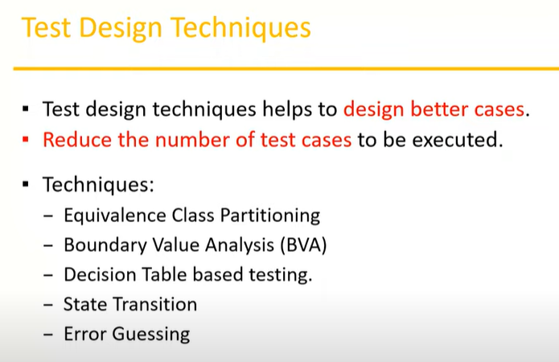

Equivalence Class Partitioning :
Clasify/divide /partition the data in to multiple classes
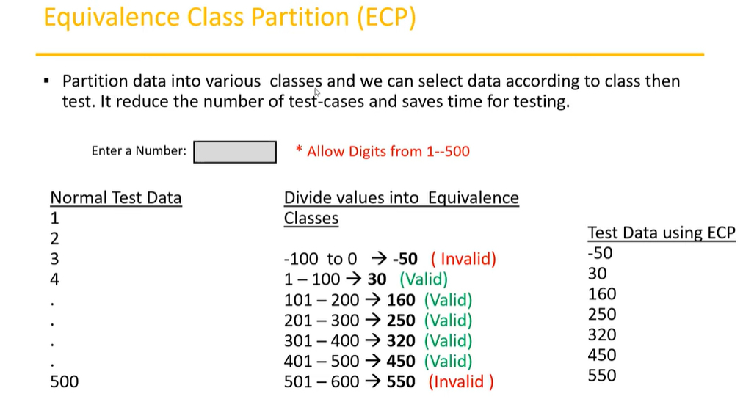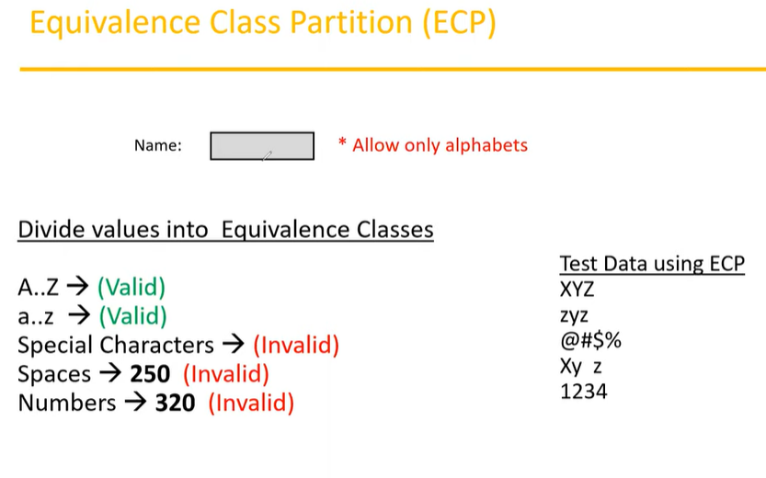
Boundary value Analysis :
Boundary of the value
Min, Min+1, Min-1
Max, Max+1, Max-1
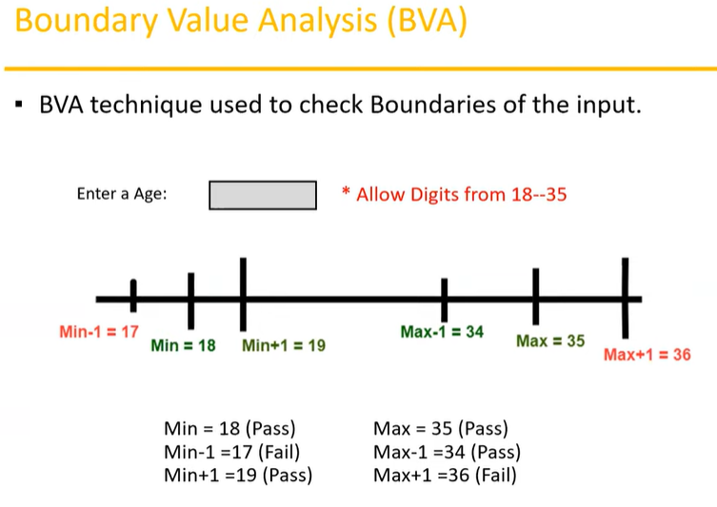
Input Domain Testing :
The value will be verified in text box or input fields . We use Equivalence class Partitioning (ECP) & Boundary value Analysis (BVA) to perform input Domain testing.
Decision Table :
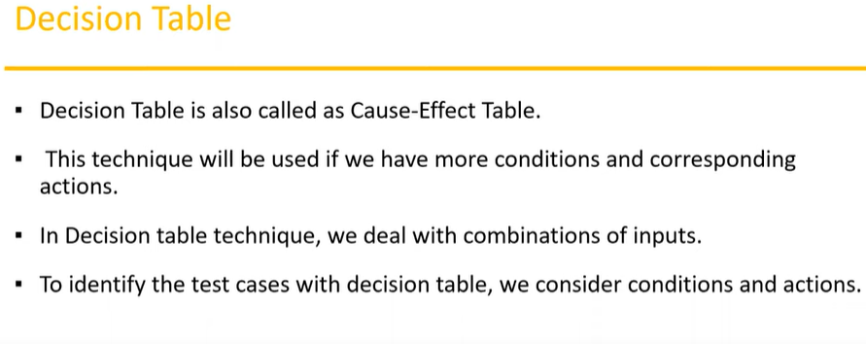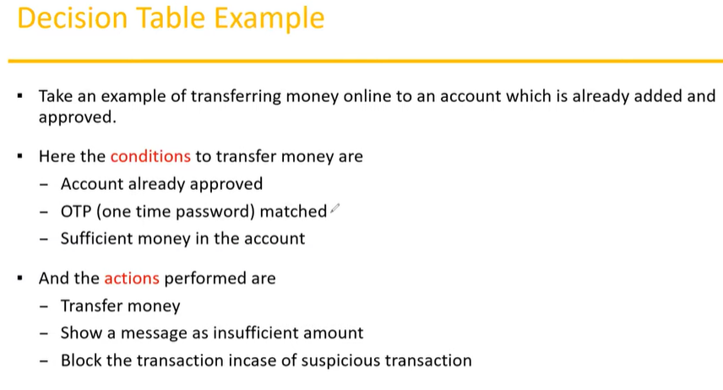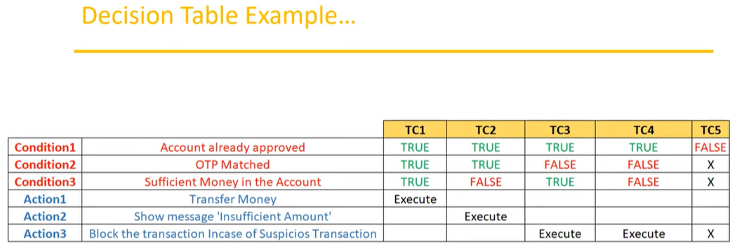
If we have more number of conditions/ actions then we use decision table technique
State Transition
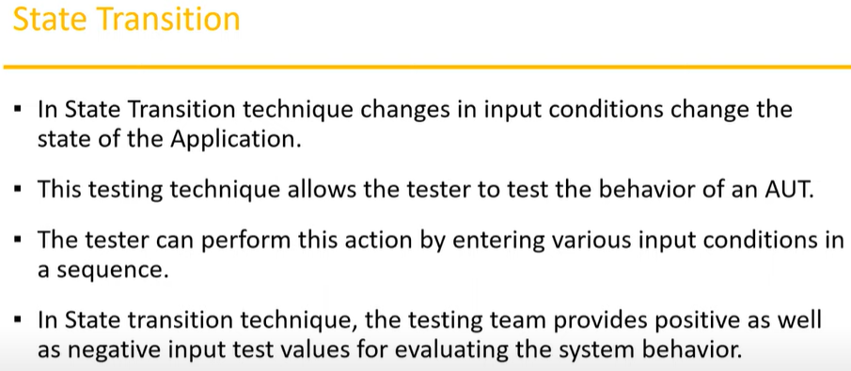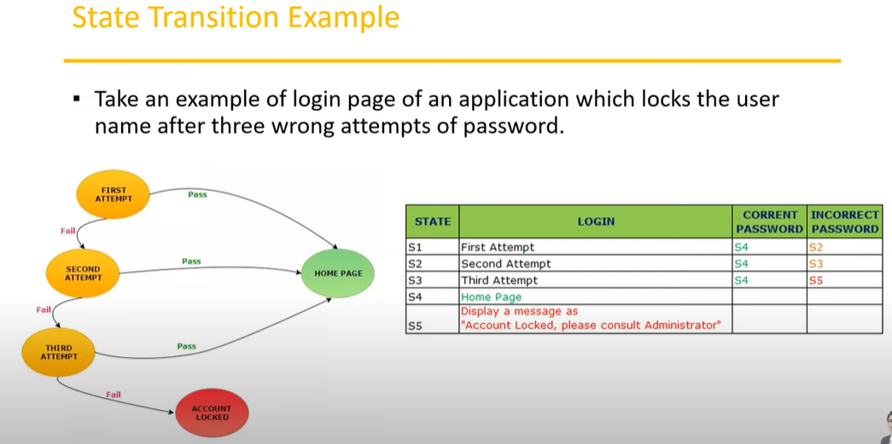
Error Guessing :
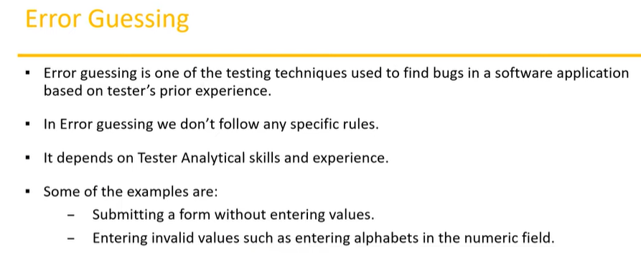

STLC (Software Testing Life Cycle ) :
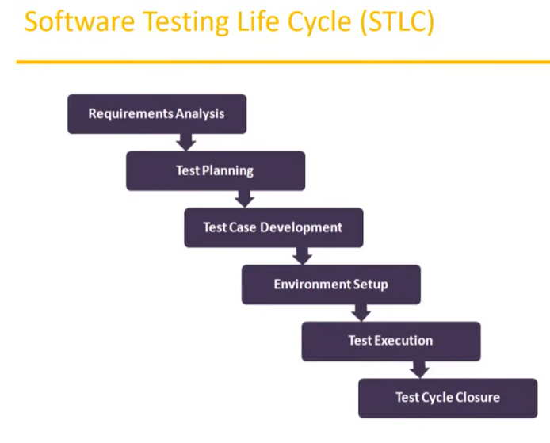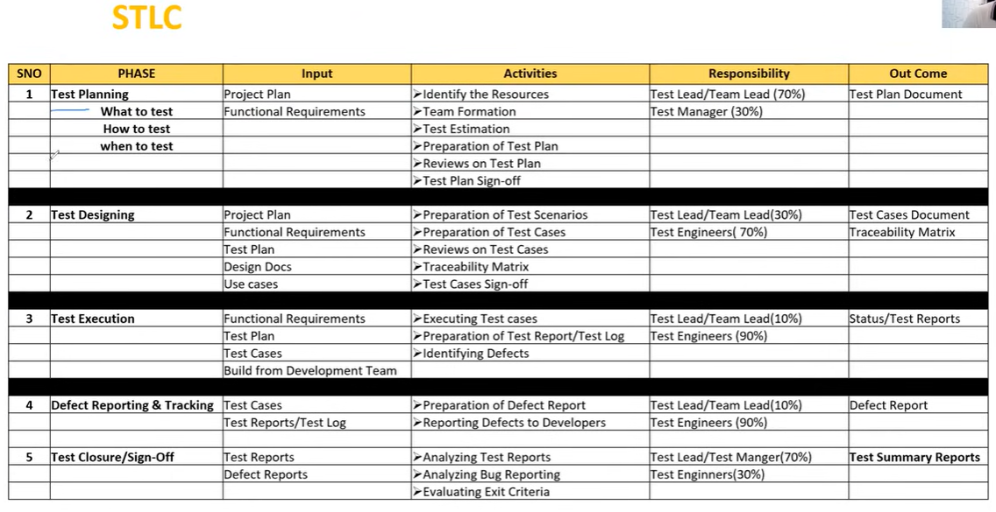
Test Plan Content : 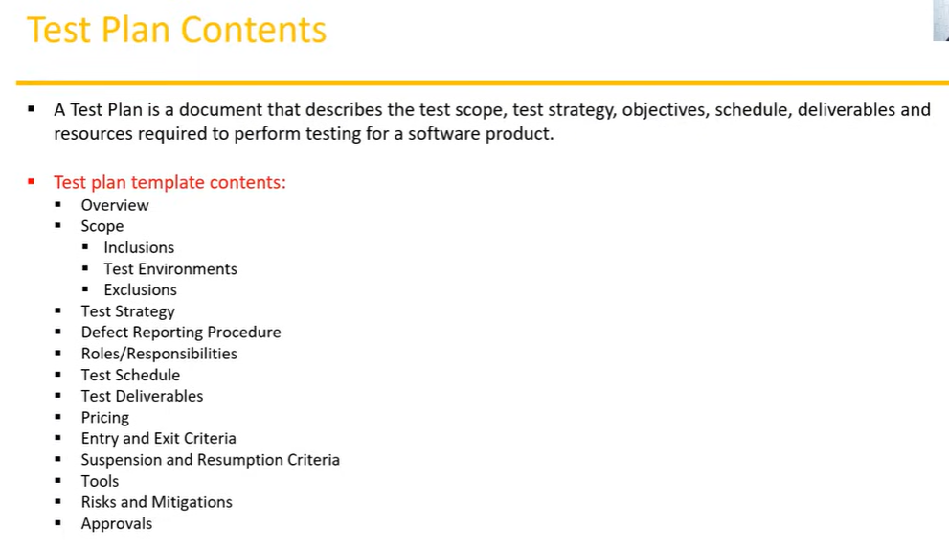
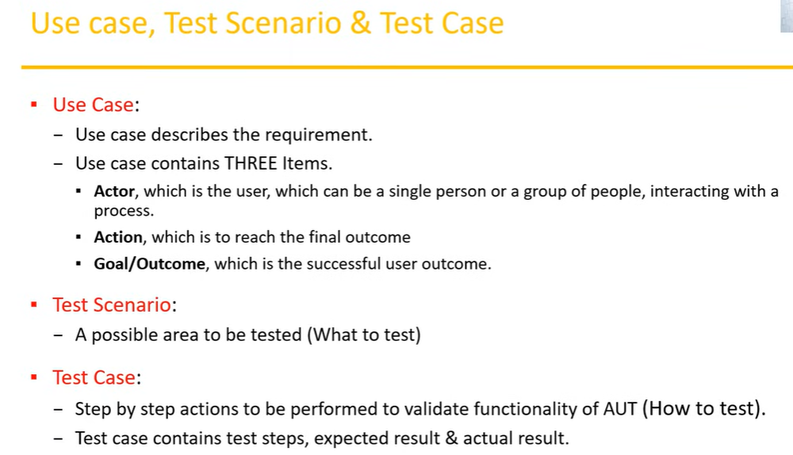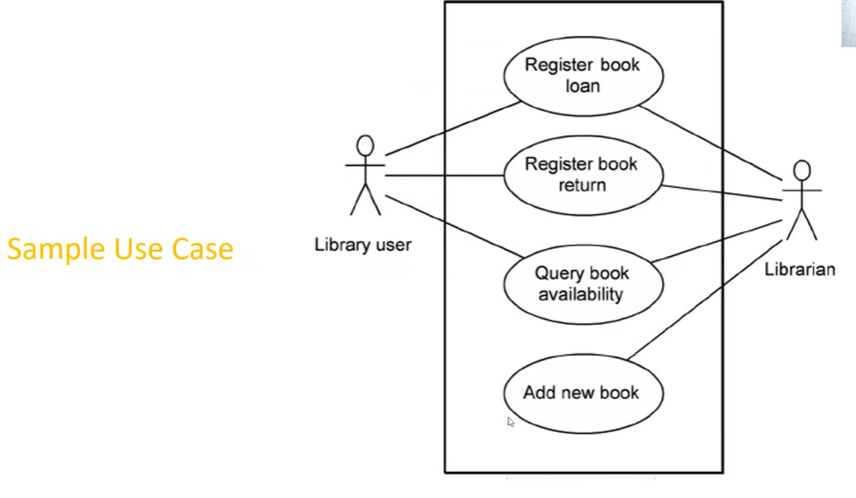
Use Case Vs Test Case :
Use Case :
Describes functional requirements, prepared by Business Analyst(BA).
Test Case :
Describes Test Steps / Procedure, prepared by Test Engineer.
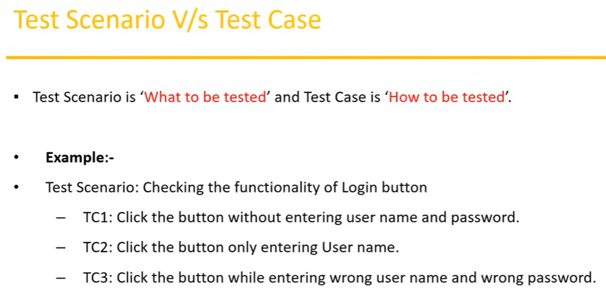
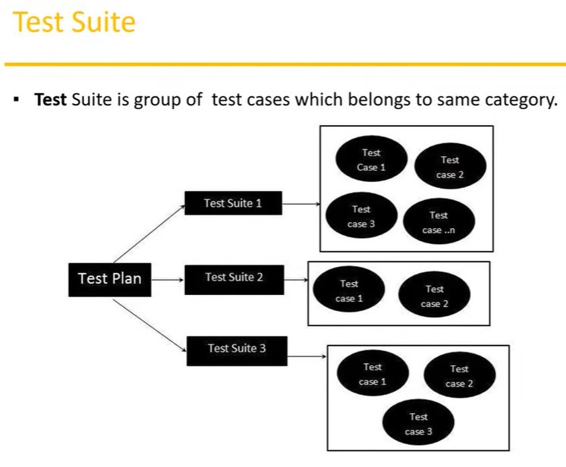
What is Test Case ?
A test case is a set of actions executed to validate particular feature or functionality of your software application.
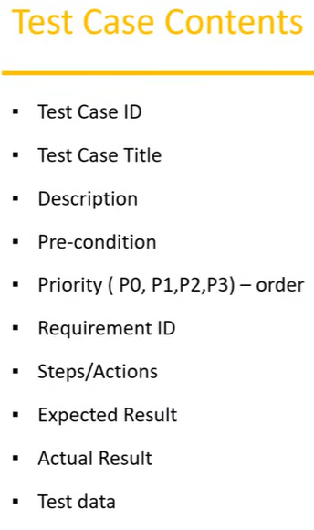
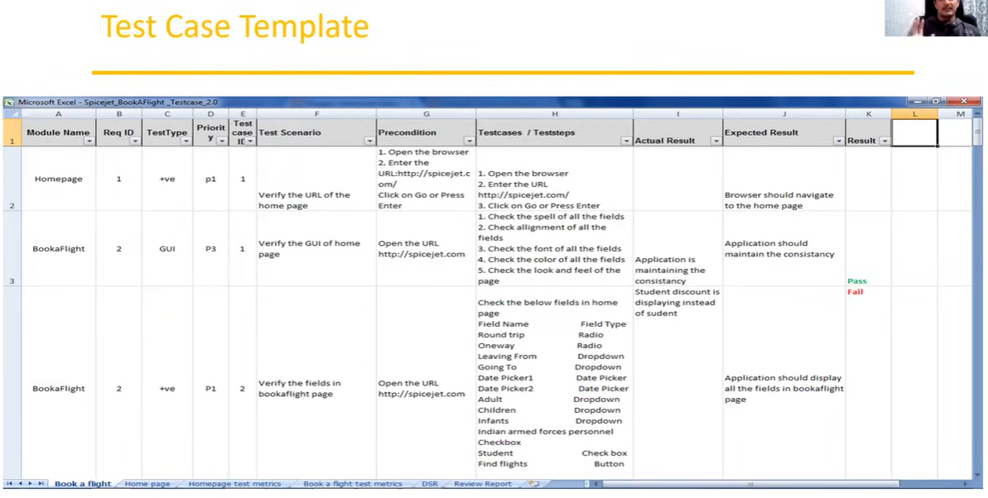
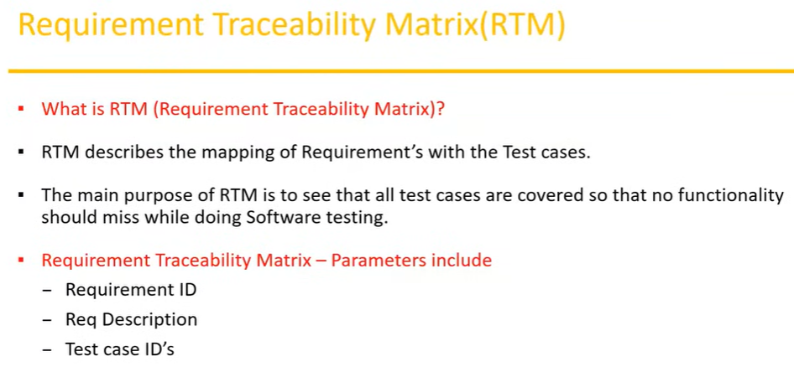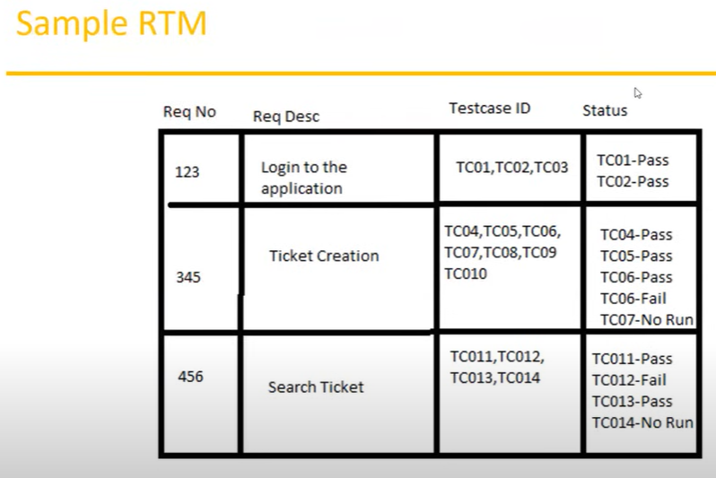
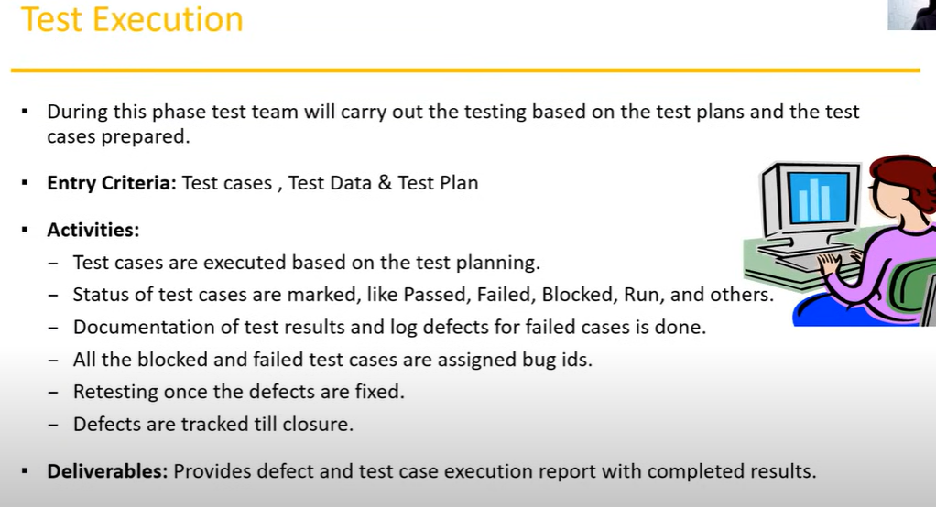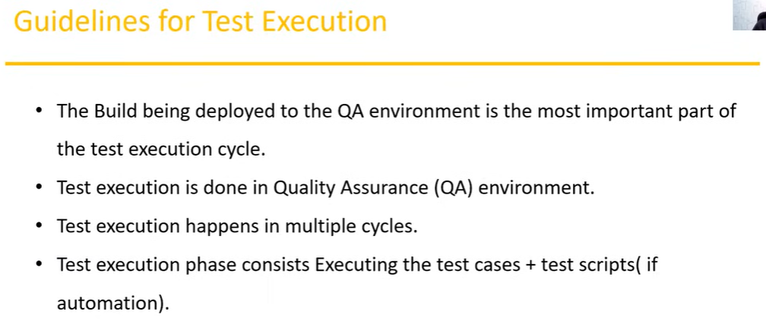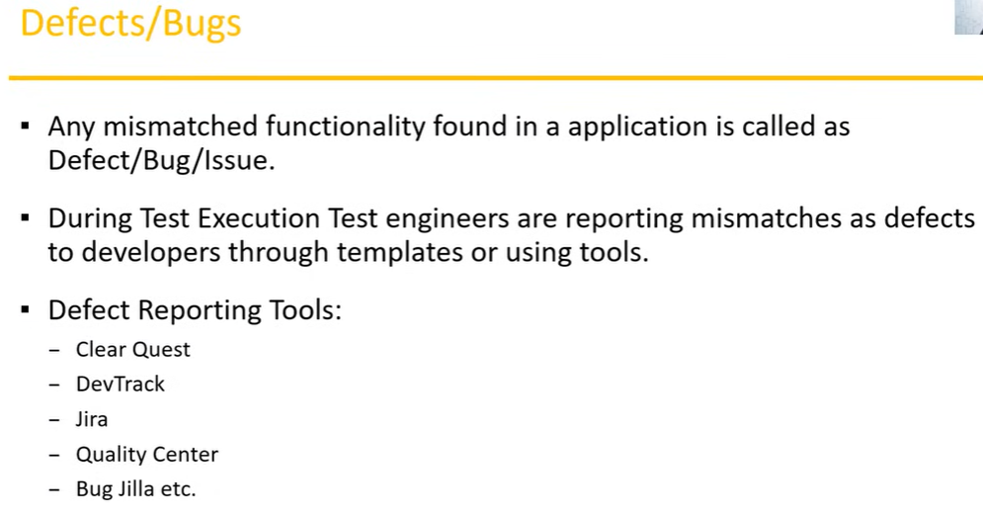
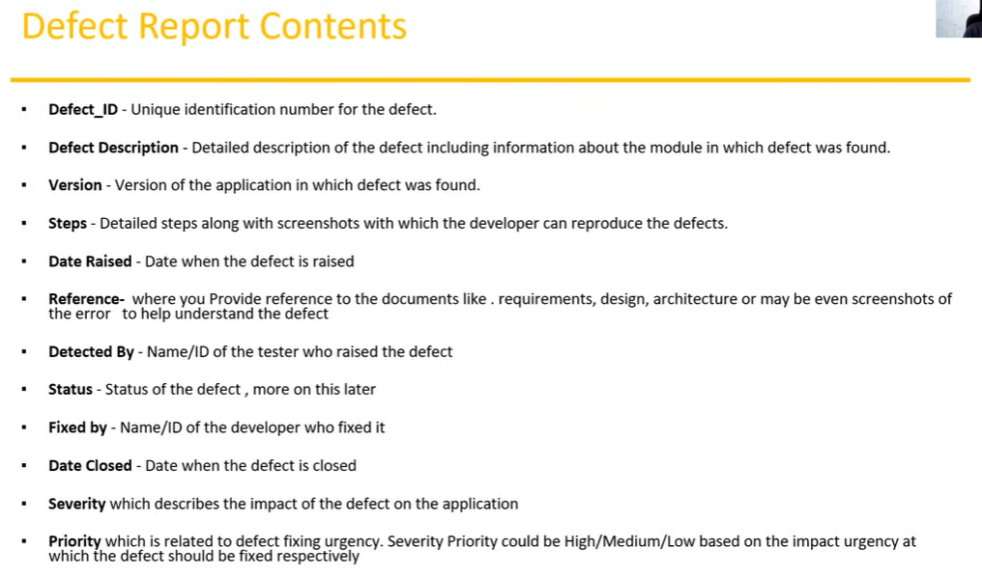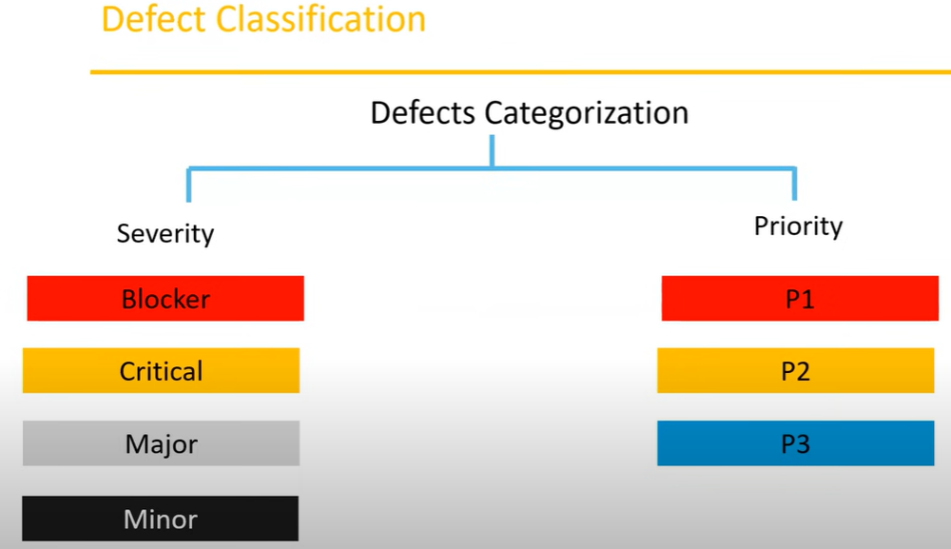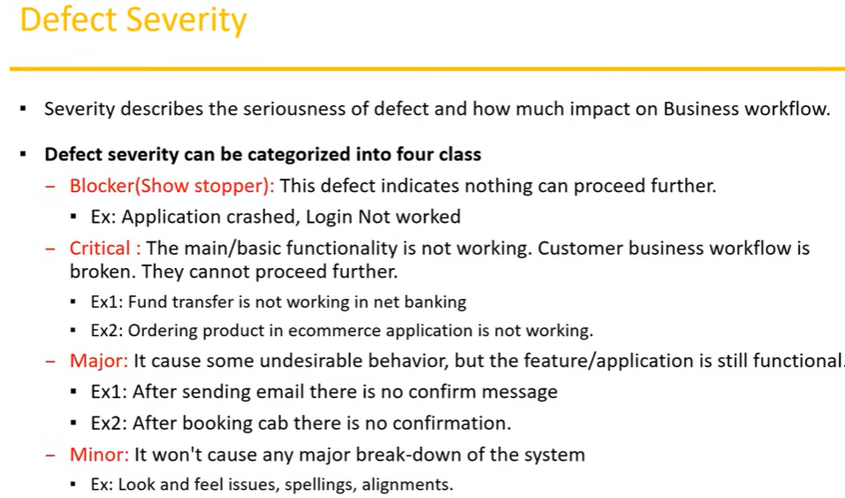
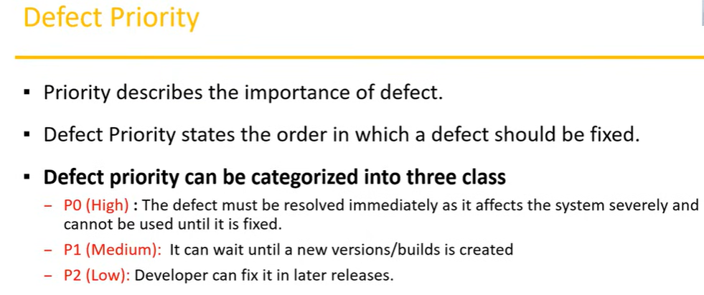
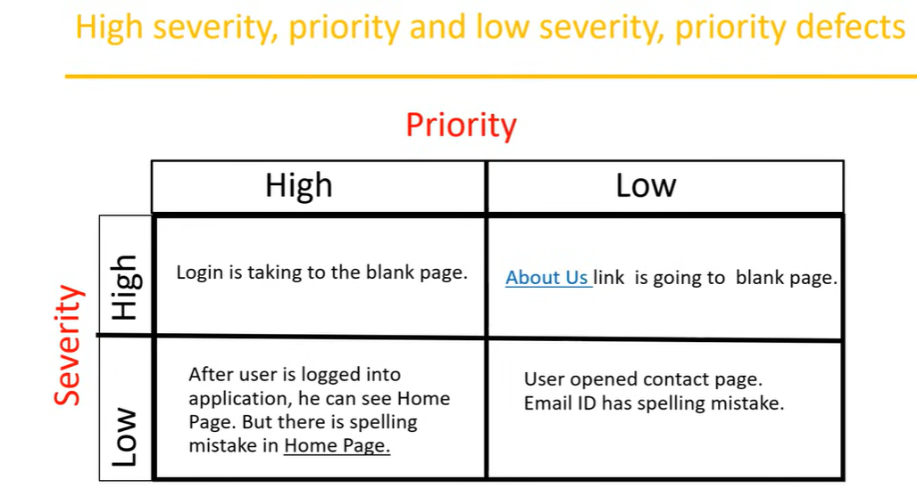
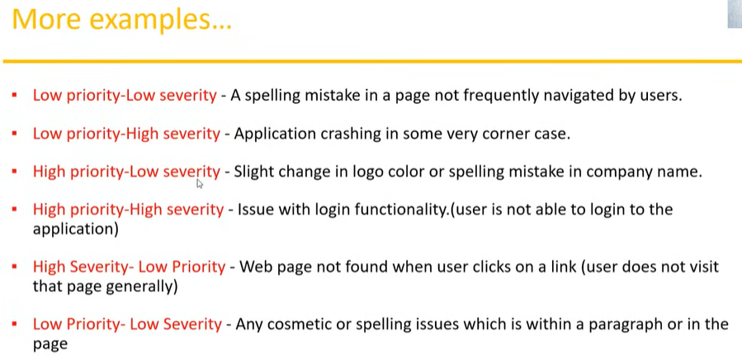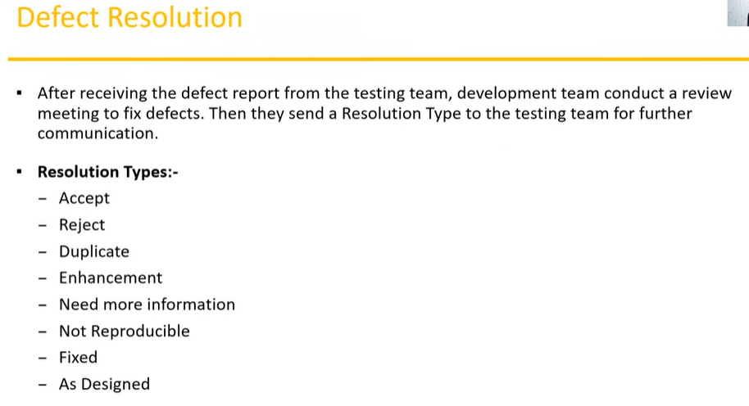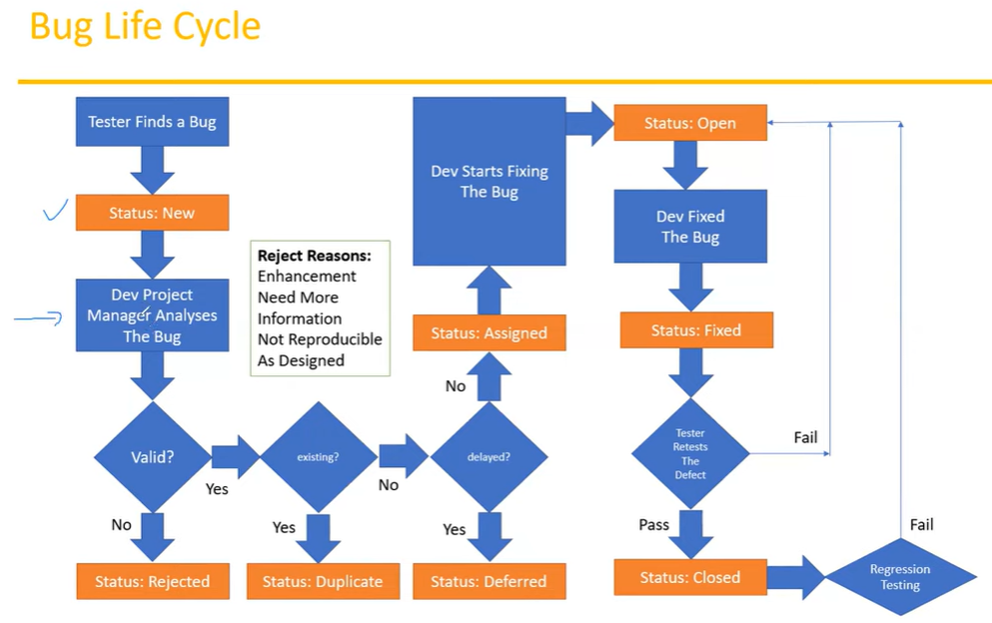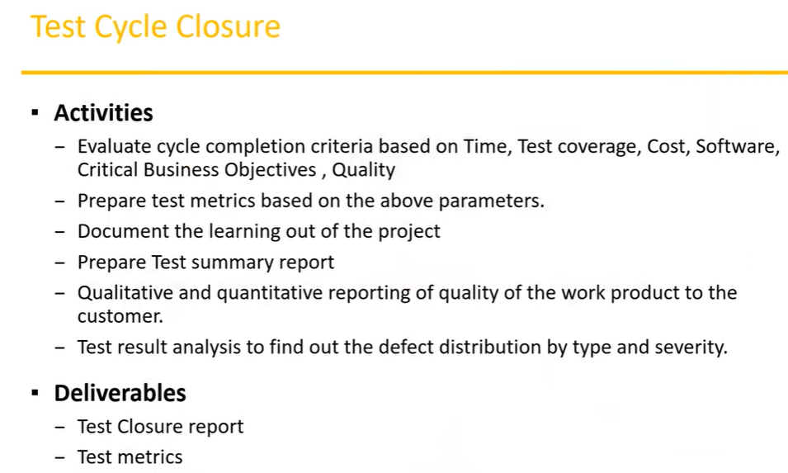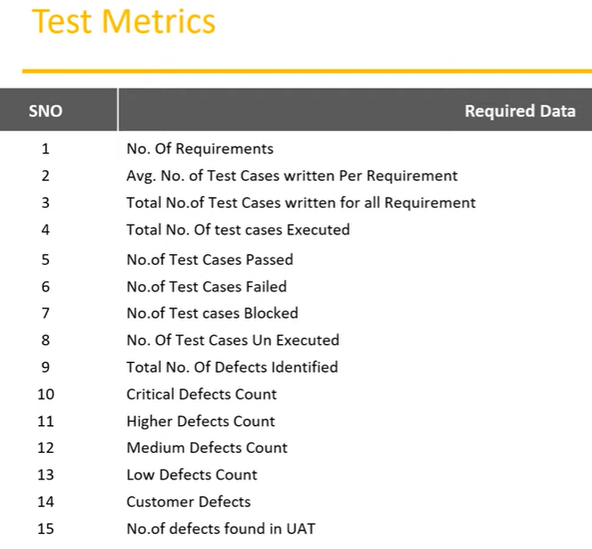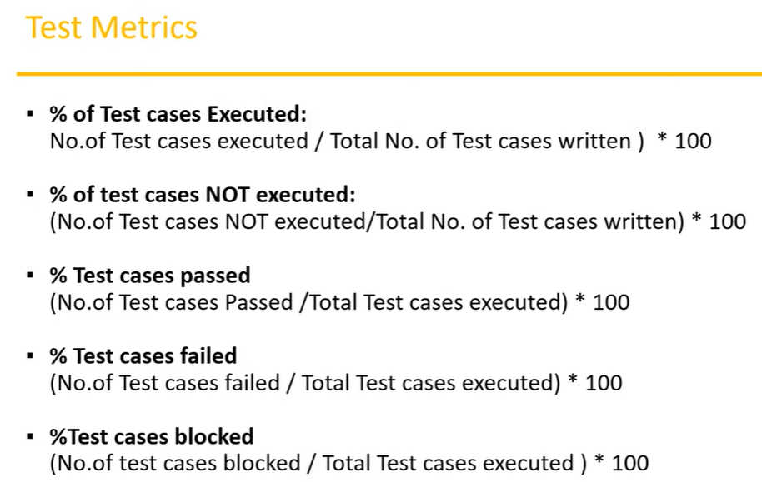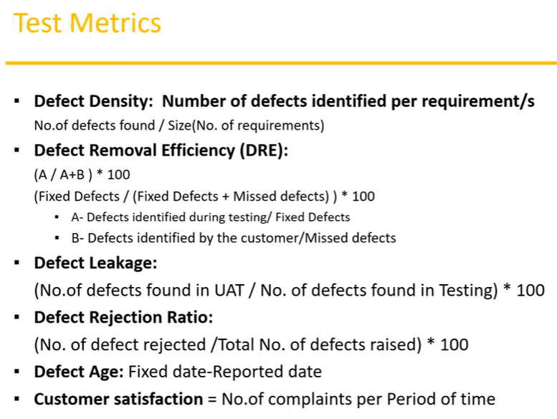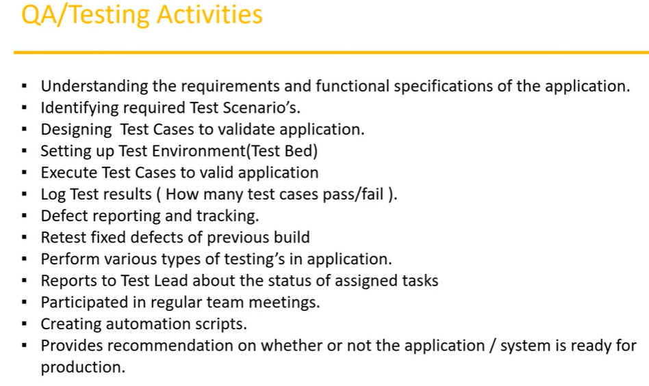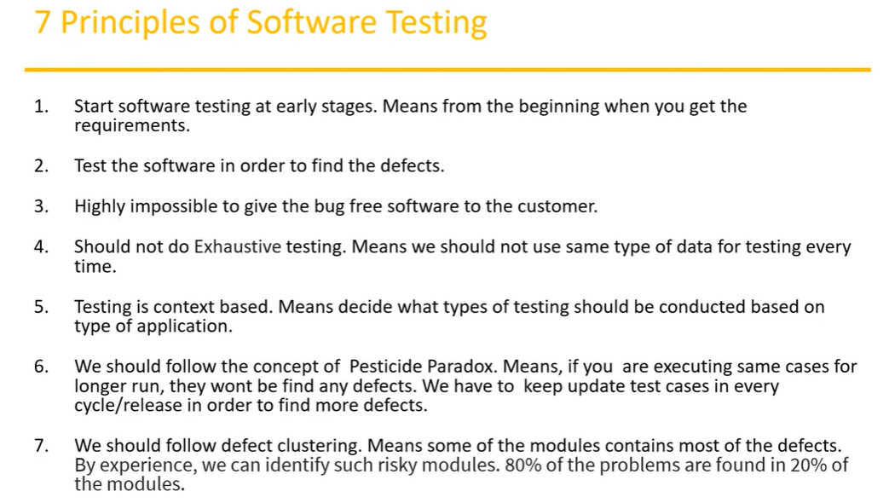

Types of Testing :
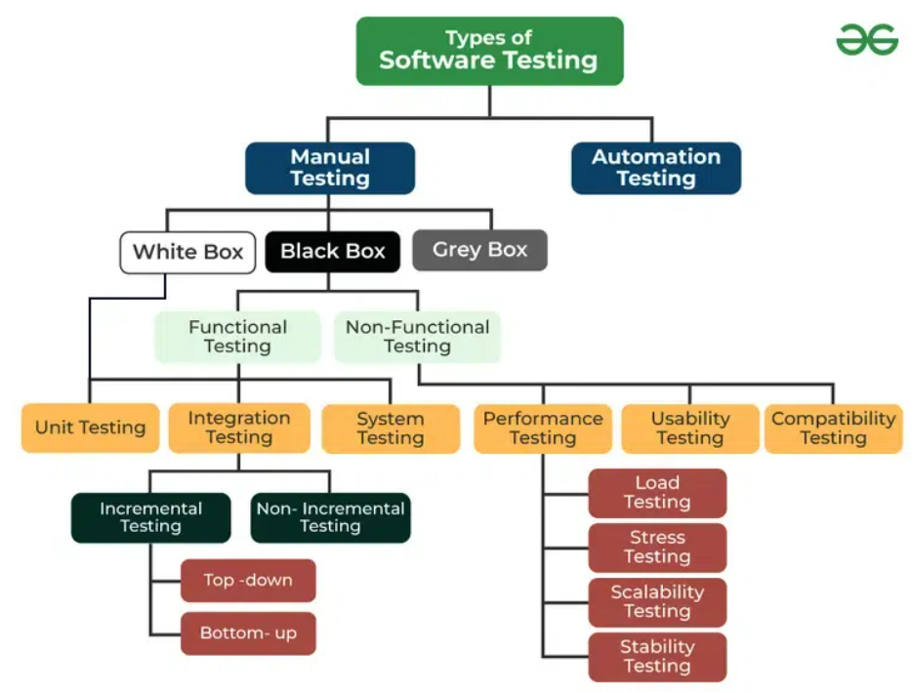

1. Functional Testing
- Unit Testing: Tests individual components or functions of the software to ensure they work correctly. Example: Testing a function that calculates user discounts.
- Integration Testing: Tests interactions between integrated components or systems to ensure they work together as expected. Example: Testing the integration between a shopping cart and payment gateway.
- System Testing: Tests the complete and integrated software system to ensure it meets the specified requirements. Example: Testing the entire e-commerce application to validate overall functionality.
- Acceptance Testing: Tests the system against user requirements and business processes to ensure it meets the acceptance criteria. Example: User acceptance testing (UAT) to validate that the software meets end-user needs.

2. Non-Functional Testing
- Performance Testing: Evaluates how the system performs under various conditions. Types include:
  - Load Testing: Tests how the system performs under expected load conditions. Example: Testing how the application handles 1,000 simultaneous users.
  - Stress Testing: Tests how the system behaves under extreme conditions or beyond normal operational capacity. Example: Testing application behavior with 10,000 simultaneous users.
  - Scalability Testing: Tests the system’s ability to scale up or down based on load. Example: Assessing if the application can handle an increase in transactions.
  - Endurance Testing: Tests how the system performs over an extended period. Example: Running the application continuously for 24 hours to check for memory leaks.
- Usability Testing: Assesses how user-friendly and intuitive the application is. Example: Observing users as they navigate the application to identify any difficulties or confusion.
- Compatibility Testing: Ensures the application works across different devices, browsers, and operating systems. Example: Testing an application on various web browsers (Chrome, Firefox, Safari) and mobile devices (iOS, Android).
- Security Testing: Identifies vulnerabilities, threats, and risks in the application to ensure data protection and security. Example: Performing penetration testing to find security weaknesses.
- Localization Testing: Ensures the software is adapted for a specific locale, including language, currency, and cultural aspects. Example: Verifying the software’s functionality in different languages or regions.

3. Maintenance Testing
- Regression Testing: Ensures that new changes or bug fixes have not adversely affected existing functionality. Example: Running previously passed test cases after a new feature is added.
- Smoke Testing: Performs basic tests to check if the new build is stable enough for further testing. Example: Verifying basic functionalities like login and navigation after a new build.
- Sanity Testing: Verifies that specific functionalities or bug fixes work correctly without affecting other parts of the application. Example: Testing a fixed bug in the checkout process to ensure it’s resolved.

4. Specialized Testing
- Alpha Testing: Conducted by internal teams to find bugs before releasing the software to external users. Example: Internal QA team testing new features before the beta release.
- Beta Testing: Conducted by a selected group of external users to gather feedback and identify issues not caught during internal testing. Example: Releasing the software to a group of end-users to gather feedback before the official launch.
- Exploratory Testing: Involves testing the application without predefined test cases to discover defects through exploration and intuition. Example: Testing an application’s functionality based on user scenarios and unexpected inputs.
- Ad-hoc Testing: Similar to exploratory testing but less formal; conducted without any formal test plan. Example: Randomly testing various parts of the application to uncover defects.

5. Automation Testing
- Scripted Testing: Involves using automated test scripts to perform repetitive and predefined test cases. Example: Using Selenium to automate web browser testing.
- Test-Driven Development (TDD): Tests are written before the actual code, and development proceeds to pass these tests. Example: Writing tests for a new feature before implementing the feature code.
Each type of testing plays a critical role in ensuring the quality, functionality, and performance of software, and the choice of testing methods depends on the specific needs and stage of the software development lifecycle.
Top of Form
Bottom of Form

Functional Testing :
- Functional testing is a type of testing in which the system is tested against the functional requirements and specifications.
- Functional testing ensures that the requirements and specification are properly satisfied by the application.
- This type of testing is particularly concerned with the result of processing .
- It is basically defined as a type of testing which verifies that each function of software application works in conformance with requirement and specification.
- This testing is not concerned about the source code of the application.
- Each functionality of the software application is tested by providing appropriate test input, expecting the output and comparing the actual output with the expected output.
Non-Functional Testing :
- Non–functional testing is a type of software testing that is performed to verify the non-functional requirements of the application.
- It verifies whether the behavior of the system is as per the requirement or not.
- It test all aspects which are not tested in functional testing .
- Non-functional testing is defined as a type of software testing to check non-functional aspects of a software application.

System testing :
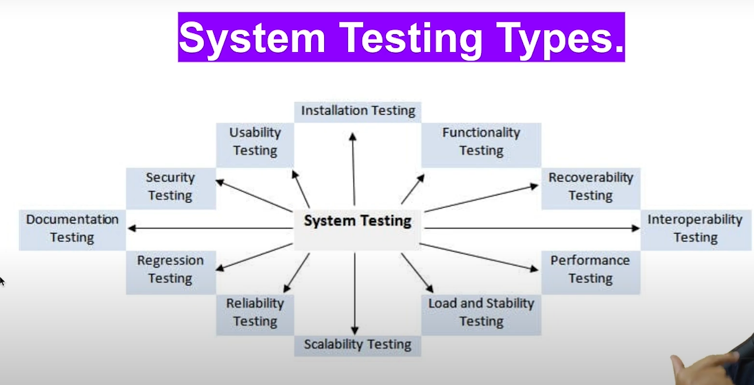System Testing Process :
System Testing is performed in the following steps :
Test Environment SetUp :
Create testing environment for the better quality testing .
Create Test Case :
Generate test case for the testing process.
Create Test Data :
Generate the data that is to be tested.
Execute Test Case :
After the generation of the test case and the test data, test cases are executed.
Defect Reporting :
Defects are fixed in this step.
Retest :
If the test is not successful then again test is performed.

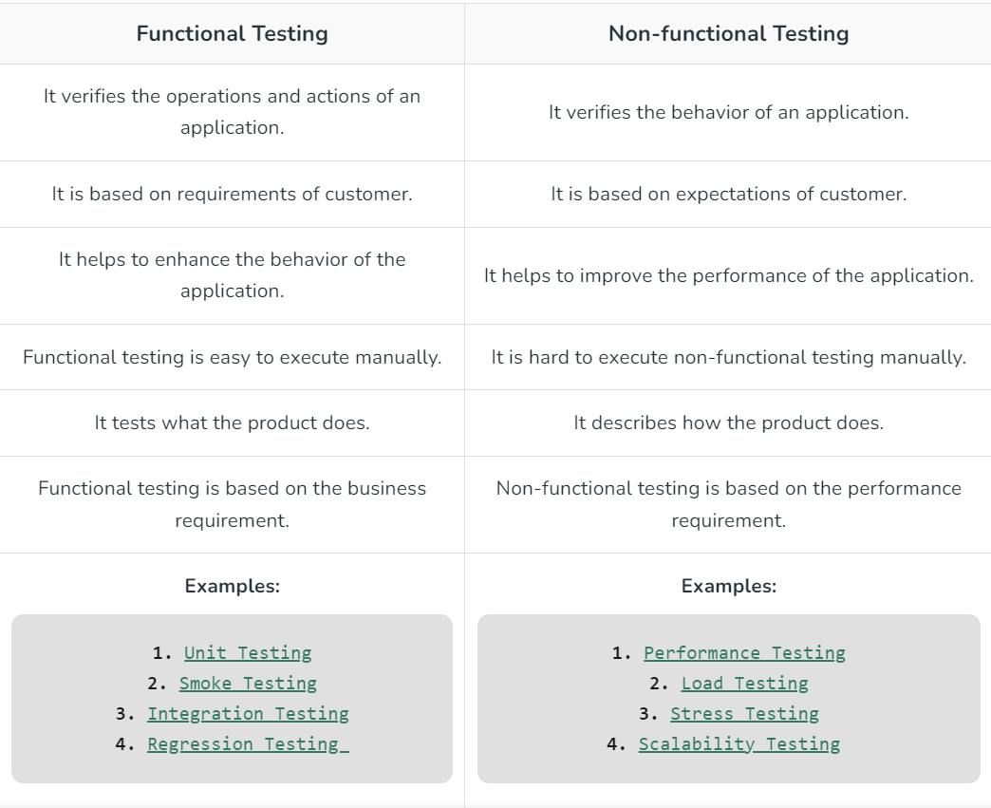

Difference between Manual Testing and Automated Testing
Parameters | Manual Testing | Automation Testing
Definition | In manual testing, the test cases are executed by the human tester. | In automated testing, the test cases are executed by the software tools.
Processing Time | Manual testing is time-consuming. | Automation testing is faster than manual testing.
Resources requirement | Manual testing takes up human resources. | Automation testing takes up automation tools and trained employees.
Exploratory testing | Exploratory testing is possible in manual testing. | Exploratory testing is not possible in automation testing.
Framework requirement | Manual testing doesn’t use frameworks. | Automation testing uses frameworks like Data Drive, Keyword, etc.
Reliability | Manual testing is not reliable due to the possibility of manual errors. | Automated testing is more reliable due to the use of automated tools and scripts.
Investment | In manual testing, investment is required for human resources. | In automated testing, investment is required for tools and automated engineers.
Test results availability | In manual testing, the test results are recorded in an excel sheet so they are not readily available. | In automated testing, the test results are readily available to all the stakeholders in the dashboard of the automated tool.
For more Refer Manual Testing vs Automated Testing

Unit Testing vs Integration Testing
S. No. | Unit Testing | Integration Testing
1. | In unit testing, each module of the software is tested separately. | In integration testing, all modules of the software are tested combined.
2. | In unit testing tester knows the internal design of the software. | Integration testing doesn’t know the internal design of the software.
3. | Unit testing is performed first of all testing processes. | Integration testing is performed after unit testing and before system testing.
4. | Unit testing is white box testing. | Integration testing is black box testing.
5. | Unit testing is performed by the developer. | Integration testing is performed by the tester.
- Branch coverage ensures that all the logical paths and conditions are covered during testing.
- Statement coverage ensures that all the statements present in the function or module are traversed at least once during testing.
- Boundary value analysis creates test data for the boundary values and also for the values that lie just before and after the boundary value and then runs the test case using all the created datasets.
- Decision coverage ensures that during the execution of control structures like “Do-While” or “Case statement,” all decision paths are tested.

Integration Testing – Software Engineering
- Integration testing is the process of testing the interface between two software units or modules.
- It focuses on determining the correctness of the interface.
- The purpose of integration testing is to expose faults in the interaction between integrated units.
- Once all the modules have been unit-tested, integration testing is performed.

What is Integration Testing?
- Integration testing is a software testing technique that focuses on verifying the interactions and data exchange between different components or modules of a software application.
- The goal of integration testing is to identify any problems or bugs that arise when different components are combined and interact with each other.
- Integration testing is typically performed after unit testing and before system testing. It helps to identify and resolve integration issues early in the development cycle, reducing the risk of more severe and costly problems later on.
Integration testing is one of the basic type of software testing and there are many other basic and advance software testing.
- Integration testing can be done by picking module by module. This can be done so that there should be a proper sequence to be followed.
- And also if you don’t want to miss out on any integration scenarios then you have to follow the proper sequence.
- Exposing the defects is the major focus of the integration testing and the time of interaction between the integrated units.

Why is Integration Testing Important?
- Integration testing is important because it verifies that individual software modules or components work together correctly as a whole system.
- This ensures that the integrated software functions as intended and helps identify any compatibility or communication issues between different parts of the system.
- By detecting and resolving integration problems early, integration testing contributes to the overall reliability, performance, and quality of the software product.

Integration test approaches
There are four types of integration testing approaches. Those approaches are the following:
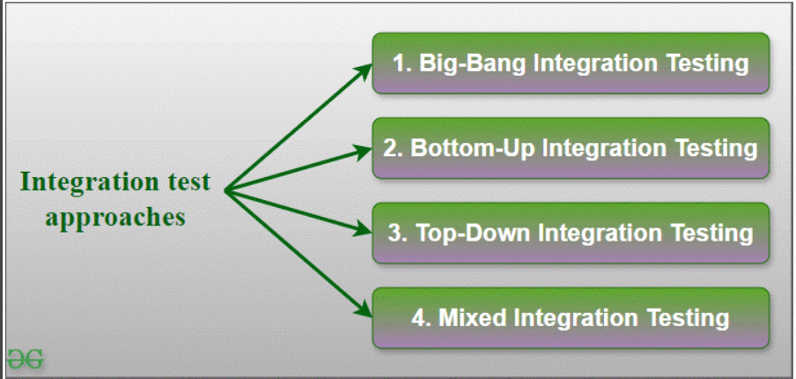

1. Big-Bang Integration Testing
- It is the simplest integration testing approach, where all the modules are combined and the functionality is verified after the completion of individual module testing.
- In simple words, all the modules of the system are simply put together and tested.
- This approach is practicable only for very small systems. If an error is found during the integration testing, it is very difficult to localize the error as the error may potentially belong to any of the modules being integrated.
- So, debugging errors reported during Big Bang integration testing is very expensive to fix.
- Big-bang integration testing is a software testing approach in which all components or modules of a software application are combined and tested at once.
- This approach is typically used when the software components have a low degree of interdependence or when there are constraints in the development environment that prevent testing individual components.
- The goal of big-bang integration testing is to verify the overall functionality of the system and to identify any integration problems that arise when the components are combined.
- While big-bang integration testing can be useful in some situations, it can also be a high-risk approach, as the complexity of the system and the number of interactions between components can make it difficult to identify and diagnose problems.
Advantages of Big-Bang Integration Testing
- It is convenient for small systems.
- Simple and straightforward approach.
- Can be completed quickly.
- Does not require a lot of planning or coordination.
- May be suitable for small systems or projects with a low degree of interdependence between components.
Disadvantages of Big-Bang Integration Testing
- There will be quite a lot of delay because you would have to wait for all the modules to be integrated.
- High-risk critical modules are not isolated and tested on priority since all modules are tested at once.
- Not Good for long projects.
- High risk of integration problems that are difficult to identify and diagnose.
- This can result in long and complex debugging and troubleshooting efforts.
- This can lead to system downtime and increased development costs.
- May not provide enough visibility into the interactions and data exchange between components.
- This can result in a lack of confidence in the system’s stability and reliability.
- This can lead to decreased efficiency and productivity.
- This may result in a lack of confidence in the development team.
- This can lead to system failure and decreased user satisfaction.

2. Bottom-Up Integration Testing
- In bottom-up testing, each module at lower levels are tested with higher modules until all modules are tested.
- The primary purpose of this integration testing is that each subsystem tests the interfaces among various modules making up the subsystem.
- This integration testing uses test drivers to drive and pass appropriate data to the lower-level modules.
- Incrementally adding the modules and testing data flow between the modules.
- Ensure the module added is the parent of the previous module.
Advantages of Bottom-Up Integration Testing
- In bottom-up testing, no stubs are required.
- A principal advantage of this integration testing is that several disjoint subsystems can be tested simultaneously.
- It is easy to create the test conditions.
- Best for applications that uses bottom up design approach.
- It is Easy to observe the test results.
Disadvantages of Bottom-Up Integration Testing
- Driver modules must be produced.
- In this testing, the complexity that occurs when the system is made up of a large number of small subsystems.
- As Far modules have been created, there is no working model can be represented.

3. Top-Down Integration Testing
- Top-down integration testing technique is used in order to simulate the behaviour of the lower-level modules that are not yet integrated.
- In this integration testing, testing takes place from top to bottom. First, high-level modules are tested and then low-level modules and finally integrating the low-level modules to a high level to ensure the system is working as intended.
- Incrementally adding the modules and testing the data flow between the modules.
- And Ensures the module added is the child of the previous module.
Advantages of Top-Down Integration Testing
- Separately debugged module.
- Few or no drivers needed.
- It is more stable and accurate at the aggregate level.
- Easier isolation of interface errors.
- In this, design defects can be found in the early stages.
Disadvantages of Top-Down Integration Testing
- Needs many Stubs.
- Modules at lower level are tested inadequately.
- It is difficult to observe the test output.
- It is difficult to stub design.

4. Mixed Integration Testing
A mixed integration testing is also called sandwiched integration testing. A mixed integration testing follows a combination of top down and bottom-up testing approaches. In top-down approach, testing can start only after the top-level module have been coded and unit tested. In bottom-up approach, testing can start only after the bottom level modules are ready. This sandwich or mixed approach overcomes this shortcoming of the top-down and bottom-up approaches. It is also called the hybrid integration testing. also, stubs and drivers are used in mixed integration testing.
Advantages of Mixed Integration Testing
- Mixed approach is useful for very large projects having several sub projects.
- This Sandwich approach overcomes this shortcoming of the top-down and bottom-up approaches.
- Parallel test can be performed in top and bottom layer tests.
Disadvantages of Mixed Integration Testing
- For mixed integration testing, it requires very high cost because one part has a Top-down approach while another part has a bottom-up approach.
- This integration testing cannot be used for smaller systems with huge interdependence between different modules.

Applications of Integration Testing
- Identify the components: Identify the individual components of your application that need to be integrated. This could include the frontend, backend, database, and any third-party services.
- Create a test plan: Develop a test plan that outlines the scenarios and test cases that need to be executed to validate the integration points between the different components. This could include testing data flow, communication protocols, and error handling.
- Set up test environment: Set up a test environment that mirrors the production environment as closely as possible. This will help ensure that the results of your integration tests are accurate and reliable.
- Execute the tests: Execute the tests outlined in your test plan, starting with the most critical and complex scenarios. Be sure to log any defects or issues that you encounter during testing.
- Analyze the results: Analyze the results of your integration tests to identify any defects or issues that need to be addressed. This may involve working with developers to fix bugs or make changes to the application architecture.
- Repeat testing: Once defects have been fixed, repeat the integration testing process to ensure that the changes have been successful and that the application still works as expected.

Test Cases For Integration Testing
- Interface Testing : Verify that data exchange between modules occurs correctly. Validate input/output parameters and formats. Ensure proper error handling and exception propagation between modules.
- Functional Flow Testing : Test end-to-end functionality by simulating user interactions. Verify that user inputs are processed correctly and produce expected outputs. Ensure seamless flow of data and control between modules.
- Data Integration Testing :
  - Validate data integrity and consistency across different modules. Test data transformation and conversion between formats. Verify proper handling of edge cases and boundary conditions.
  - Data integration testing is the process of verifying that the data from the various sources is integrated and transformed according to the business rules and requirements.
  - Data integration testing can be done at different levels such as unit testing, system testing and end-to-end testing.
  - Data integration testing can help identify and resolve data errors, inconsistencies and conflicts as well as improve the performance and reliability of the data integration system.
- Dependency Testing : Test interactions between dependent modules. Verify that changes in one module do not adversely affect others. Ensure proper synchronization and communication between modules.

What is a Dependency Testing?
Dependency testing is a testing method in which the initial states of an existing piece of software are evaluated to test the functionality.
When evaluating either new or existing functionality, the application’s impacted areas are also tested. The evaluation looks for two primary things: flaws and problems in the application. Software, like other apps or tools, has some influenced areas such as compatibility, user interface, and most crucially, no such vulnerability for information breach.

Types of Software Dependencies
Below are the different types of software dependencies:
- Logical dependency: Logical dependencies are related to the source-code files that are changed as a part of the modification request. Testers will evaluate such dependencies between the source code files by identifying the source code files that are modified mutually as part of software development. Dependencies that are not visible in syntactic dependencies are covered here while testing for logical dependencies.
- Syntactic dependency: Syntactic dependencies can be the inflow/ outflow of data or functional dependencies. Such dependencies are evaluated between the source code files by spotting the data, method, or function references crossing every source code file’s periphery.
- Work dependency: These dependencies are usually related to the workflow and are triggered by human and organizational factors on which the software’s failure proneness depends. These usually arise due to a lack of proper communication between developers, testers, and QAs which is why testers need to find them and fix them.
- Data dependency: Security tests have to check for data dependencies where the specific data structure gets modified by the function and is subsequently used in another function.
- Functional dependency: Functional dependency refers to how the elements behave in relation to others especially when a change in one element affects the functionality of the other elements coupled to it.

System Testing :
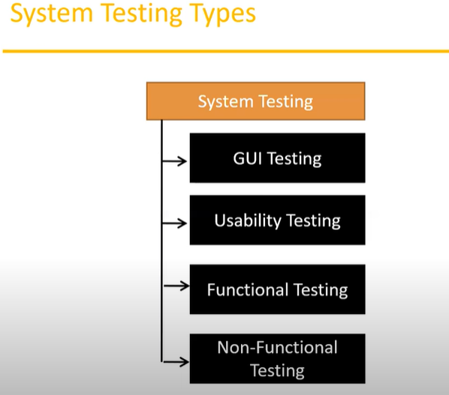

- Error Handling Testing : Validate error detection and reporting mechanisms. Test error recovery and fault tolerance capabilities. Ensure that error messages are clear and informative.
- Performance Testing : Measure system performance under integrated conditions. Test response times, throughput, and resource utilization. Verify scalability and concurrency handling between modules.
- Security Testing : Test access controls and permissions between integrated modules. Verify encryption and data protection mechanisms. Ensure compliance with security standards and regulations.
- Compatibility Testing : Test compatibility with external systems, APIs, and third-party components. Validate interoperability and data exchange protocols. Ensure seamless integration with different platforms and environments.
Smoke Testing :
- Smoke testing also known as “Build Verification Testing” or “Build Acceptance Testing” or “Confidence Testing”.
- It is type of software testing that is typically performed at the beginning of the development process to ensure that the most critical functions of a software application are working correctly.
- It is used to quickly identify and fix any major issues with the software before more detailed testing is performed.
- The goal of smoke testing is to determine whether the build is stable enough to proceed with furthere.
- Smoke testing is software testing method that determine whether the employed build is stable or not,
- It acts as a confirmation of whether the quality assurance team can proceed with further testing .
- Smoke test are minimum set of tests run on each build.
- Smoke testing is process where the software build is deployed to quality assurance environment and verified to ensure the application’s stability .
- It is performed in the initial phase of the software development life cycle(SDLC) .
- Smoke testing is done to make sure that the very basic functionality of the product works, if it all.
- Those very basic functionality or feature do not work, there is no point in continuing testing or building.
- Its intent is to detect abnormalities of the application before teams move on to further exhaustive testing.
- The purpose is to verify that the critical functionalities of the application are working and that the build is stable enough for further testing.
- Example : A team is working on an e-commerce application. After a new build is deployed, smoke testing would involve checking that the application starts successfully and that core feature like logging in, viewing products and adding items to the cart are working.
Scenario :
    - Build Deployment : A new version of the e-commerce application is deployed.
    - Smoke Test : Tester verify that :
      - The application launches without crashing.
      - Users can log in.
      - Users can navigate to the product page.
      - Users can add items to the shopping cart.
      - If these basic functionality work the build passes smoke testing and is considered stable enough for more thorough testing.
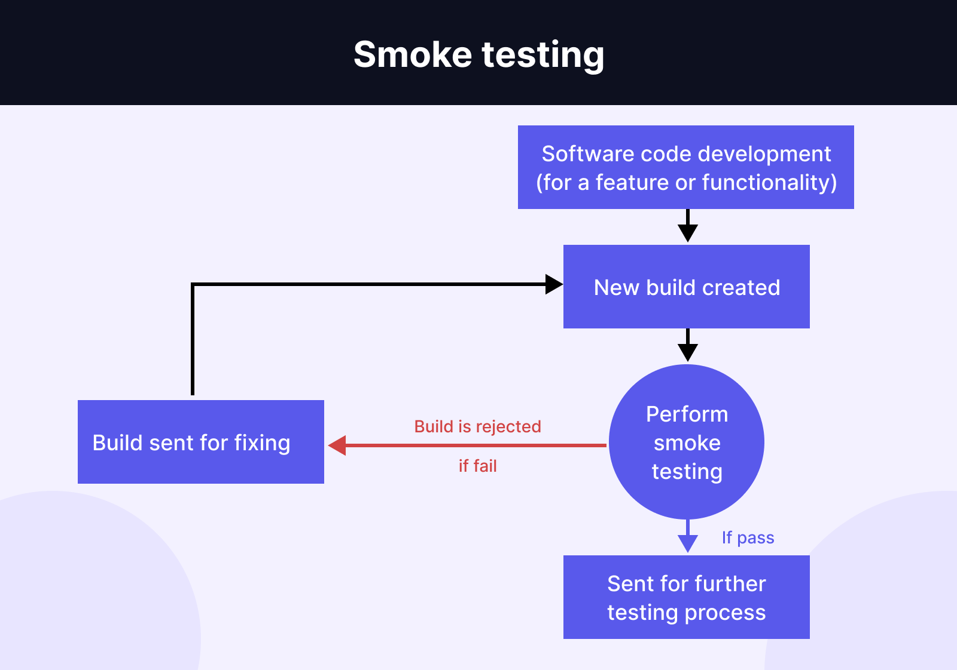
Examples of Smoke Testing:
Suppose you are a software tester working on an e-commerce website that has recently undergone some changes to its payment processing system. After the changes have been made, you need to ensure that the website is still working as expected.
In this case, you could perform smoke testing by quickly navigating to the site. If you realize that the website has crashed entirely, there is no point to continue testing. Instead, you alert the developers of this critical fault for them to troubleshoot immediately before you carry on.
Now let’s suppose that you have a desktop application to calculate tax, billing, and salary for enterprises. You import your data, and realize that the app somehow calculates 1 + 1 = 3, which is an unacceptable result for an app with calculator functionality. In this case, there is no point to test if the app can accurately calculate the Income Tax of 300 employees in the company, since it can’t even perform the most basic arithmetic calculations.
Smoke testing is simple, but it provides QA professionals with a valuable confirmation that the Application Under Test is stable enough to proceed with more detailed testing.

Difference between Sanity and Smoke Testing :
- Smoke testing , It is believed to have originated from the plumbing industry, where plumbers would blow smoke into the water pipes to identify cracks in the pipe before fixing.
- The major difference between sanity testing and smoke testing is that sanity testing is fairly more complicated. Taking the example of the plumber above. If smoke testing is about blowing smoke into the pipe to identify cracks in the pipe (i.e. verifying if the pipe works at all) then sanity testing is about checking if the valve is tight enough, then turning on the water to see if it leaks out of the pipe after they have fixed the cracks (i.e. verifying if the critical features work fine, and if the bugs have been resolved)

Sanity Testing vs Smoke Testing: In-depth Comparison

To meet the ever-rising demand for quality, businesses must continuously update their apps. After such updates, the app must undergo smoke testing and sanity testing to validate its functionality. Although the definition of sanity testing vs smoke testing is quite similar, they should not be used interchangeably.
A good distinction between sanity testing vs smoke testing is the depth of the testing objectives. Sanity testing is about making sure that the core functions of the app works fine after a code change, while smoke testing verifies that the app works at its bare minimum or not. Smoke testing has a narrower scope than sanity testing.

Key Differences Between Sanity Testing vs Smoke Testing
Smoke testing | Sanity testing
Executed on initial/unstable builds | Performed on stable builds
Verifies the very basic features | Verifies that the bugs have been fixed in the received build and no further issues are introduced
Verify if the software works at all | Verify several specific modules, or the modules impacted by code change
Can be carried out by both testers and developers | Carried out by testers
A subset of acceptance testing | A subset of regression testing
Done when there is a new build | Done after several changes have been made to the previous build
In this article, we will deep-dive into the comparison between sanity testing vs smoke testing, their benefits, challenges, as well as processes to perform both.

What Is Smoke Testing?
To understand this example, we first need to understand the concept of a software build.
In software development, a build is a set of executable code ready either for testing or deployment. A software can contain thousands of source code files depending on its sophistication. When the project reaches a certain stage of development, these files are compiled into standalone applications that can be tested and shipped.

In case there are problems with the software build, teams will return to the source code to examine and modify them. Not every build can make it to the public release. Problems such as improperly installed environments, flaky networks, build scripts, and multiple other factors can render a build unqualified for deployment or even a complete failure. Thus, software build needs to go through rigorous testing to make sure it’s fully functional.
Smoke testing, also known as build verification testing or build acceptance testing, is a non-exhaustive testing type that ensures the proper function of basic and critical components of a single build. For example, smoke tests on Gmail only include testing the composing and sending email features - the core ones.
A more illustrative example would be to look at the name of this method: smoke. The term “smoke testing” actually predates electronics. It is believed to have originated from the plumbing industry, where plumbers would blow smoke into the water pipes to identify cracks in the pipe before fixing. The term is carried into the software testing world, and it has a similar meaning. In this sense, smoke testing is done to make sure that the very basic functionality of the product works, if at all. If those very basic features do not work, there is no point in continuing testing or building.
Performed in the initial phase of the software development life cycle (SDLC), its intent is to detect abnormalities of the application before teams move on to further exhaustive testing. This leaves little room for major errors to ripple through and become harder to fix down the line.

How Does Smoke Testing Work?
Commonly takes place after code reviews, if the initial build passes the smoke tests, it is qualified for further functional testing. If the smoke tests fail, the build is rejected and handed back to the development team.
The standard process is illustrated below.
To achieve the best results when executing smoke testing, we should follow these common practices:
- Schedule smoke test suite on CI pipelines to automatically run when a new build is added
- Test early and regularly to assure the stability of the code build in every sprint
- Choosing the fitted testing method based on the requirements and resources of your project. If the budget is limited, a hybrid or an automated approach might be more optimal compared to conducting it all manually.

Examples Of Smoke Testing In Software Testing
Suppose you are a software tester working on an e-commerce website that has recently undergone some changes to its payment processing system. After the changes have been made, you need to ensure that the website is still working as expected.
In this case, you could perform smoke testing by quickly navigating to the site. If you realize that the website has crashed entirely, there is no point to continue testing. Instead, you alert the developers of this critical fault for them to troubleshoot immediately before you carry on.
Now let’s suppose that you have a desktop application to calculate tax, billing, and salary for enterprises. You import your data, and realize that the app somehow calculates 1 + 1 = 3, which is an unacceptable result for an app with calculator functionality. In this case, there is no point to test if the app can accurately calculate the Income Tax of 300 employees in the company, since it can’t even perform the most basic arithmetic calculations.
Smoke testing is simple, but it provides QA professionals with a valuable confirmation that the Application Under Test is stable enough to proceed with more detailed testing.

Advantages of Smoke Testing
- Early bug troubleshooting: It quickly evaluates the essential features at the initial stages of the project for earlier corrections
- Time and resources efficiency: Smoke test verifies the stability of a delivered build to avoid any QA efforts that may otherwise be wasted
- Reduction of regression issues: Newly introduced build is first tested to reduce the major flaws that can break the integration with the original material
- Automation potential: Automated smoke testing can significantly reduce testing time, since smoke testing is inherently quite symbol and involves only a few specific scenarios

Disadvantages of Smoke Testing
If the team only does manual testing, it will be time-consuming, much like manual regression testing. It is therefore recommended to use an automation tool to increase testing capacity and efficiency. A quality management platform like Katalon enables teams to test more scenarios in a short time.

What Is Sanity Testing?
- Sanity testing, or surface level testing, is a software testing technique to ascertain that no issues arise in the new functionalities, code changes, and bug fixes. Instead of examining the entire system, it focuses on narrower areas of the added functionalities. It is performed on the stable build of the software.
- Sanity testing is a narrow and deep testing approach performed after receiving a software build with minor changes or fixes. The aim is to verify that the changes have been correctly implemented and that they haven’t adversely affected existing functionalities.
- Purpose is to ensure that the specific issues have been fixed and no new issue have been introduced in the areas affected by the changes. It’s a targeted check rather than a broad one.
- Example : Consider the same e-commerce application where a bug was reported in the checkout process. After a fix is applied, sanity testing would focus on verifying that the checkout process is working correctly and that bug has been resolved.
Scenario :
  - Bug is Fix : A fix is applied to the checkout process.
  - Sanity Test : Testers verify that
    - The checkout process now functions correctly.
    - No other related features (like payment integration or order confirmation) are broken.
    - If the checkout process works as expected and no new issues are introduced in the related functionality the build passes sanity testing .
To understand the concept of sanity testing, we can analyze its name: sanity. The term came from the concept of “sanity check”. The goal is also to verify that the build is stable enough for further testing, similar to smoke testing. If there are obviously app-breaking bugs, there is no point to continue testing. It’s much faster to send the build back to the development team immediately than testing a build that is guaranteed to fail, which is an extremely time-consuming effort.
The major difference between sanity testing and smoke testing is that sanity testing is fairly more complicated. Taking the example of the plumber above. If smoke testing is about blowing smoke into the pipe to identify cracks in the pipe (i.e. verifying if the pipe works at all) then sanity testing is about checking if the valve is tight enough, then turning on the water to see if it leaks out of the pipe after they have fixed the cracks (i.e. verifying if the critical features work fine, and if the bugs have been resolved)
It is a rare occurrence for a sanity test to fail. However, if it actually fails, testers save themselves from the unnecessary in-depth testing on a bug-ridden software. In a way, sanity testing is essentially “testing the water” before deep-diving in.
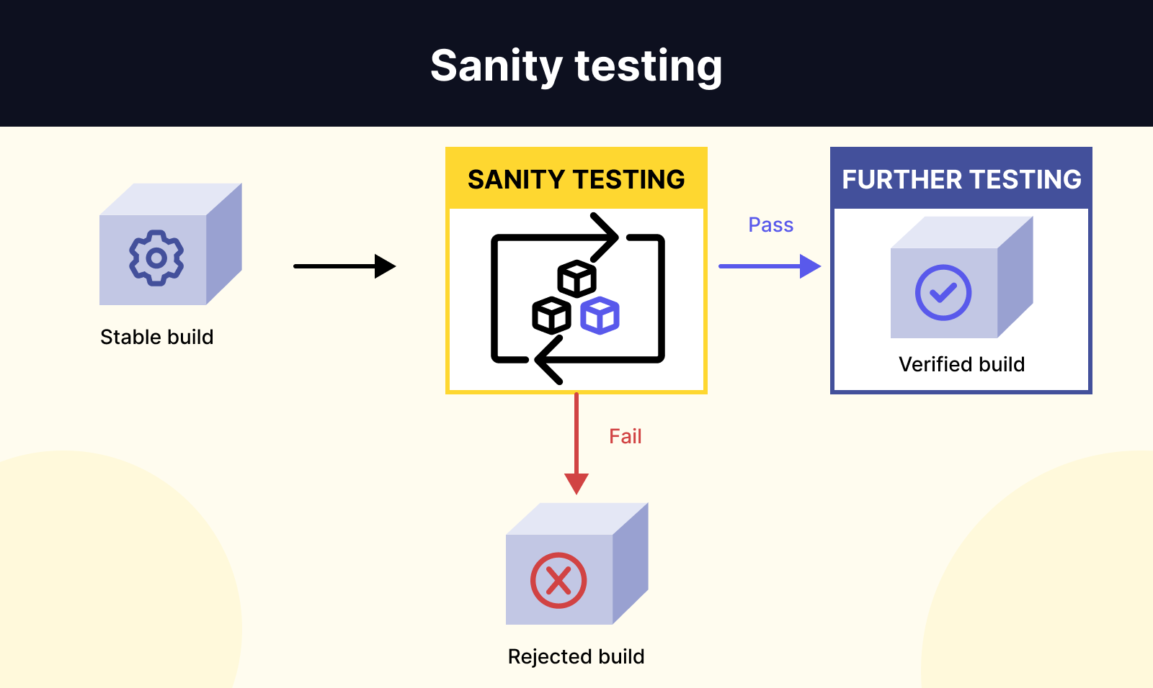
Instead of examining the entire system, sanity testing focuses on narrower areas of the added functionalities, while regression testing targets the application as a whole.

Goals Of Sanity Testing
Sanity testing is executed before the production deployment and after the build is delivered with minor code changes, to fulfill the below objectives:
- Validate basic, critical functionalities and evaluate newly added ones
- Catch defects quickly
- Ensure the introduced changes don’t clash with the current functionalities
- Test rational and logical implementations to the app from the developers
- Determine if full testing is required. If sanity testing results are negative, either we need to launch more comprehensive testing or send the build back to the development team
- Reduce business risk of introducing bugs into software without having to expend too much resources and effort from the testing team

Sanity Testing Examples
Now let’s suppose that we have a development project for a mobile banking application, which includes these features:
- Login/Verify Pin
- Transfer Money
- Change Pin
- Withdraw Money
- Display Customer Name
- Provide Bill
- Show Balance
After the first build of the software, only the most basic features have been developed. In this case, those features should be Login, as no further actions can be taken if the user cannot access the main interface, and Withdraw money - the basic functionality of an ATM application.
In the 2nd build, a new feature is added - Changing PIN. To ensure that this new feature added does not interfere with the existing functionality, testers conduct sanity testing on the Login and Withdraw money features. If those 2 features work, they know that the Changing PIN feature did not affect them negatively.
Another example would be when testers discover a bug and send the build back to the development team for troubleshooting. After fixing, testers need sanity testing to confirm that the bug has indeed been fixed. It is more specific than smoke testing.

Key Elements Of Sanity Testing
- Quick and simple: They are easily designed and performed with the aim to receive quick feedback. This immediate feedback is a great indicator for testers to know how they should proceed
- Highly targeted: One or few functionalities are covered in depth.
- Undocumented and unscripted: In general, sanity testing doesn’t require test scripts or test cases thanks to its informality and quickness. It is not mandatory to provide documentation either.
- Performed by testers: Usually, testers are the ones performing sanity testing, and they know how to provide a more in-depth perspective to the software quality than developers themselves

Advantages Of Sanity Testing
- Speedy evaluation: Sanity testing identifies defects so much faster due to the unplanned and intuitive approach on a narrow set of functionalities. This laser-focus approach is amazing in time-constraint or budget-constraint situations.
- Save time and effort: It acts as a gatekeeper by determining if the application should be further tested or not, which saves time of rigorous regression tests in case the release is in poor condition.
- Less cost-intensive: Compared to other types of testing, sanity testing is usually cost-effective.
- Identify deployment issues: Sanity tests can early detect compilation problems that may arise if the basic functionality is not working fine, or the previous bugs still exist but done from the developer’s end

Disadvantages of Sanity Testing
- Lack of future reference: As it is often carried out without script or documentation, future references are not available.
- Time inefficiency: It takes more time to verify specific components than to check the whole application at once

The Process Of Sanity Testing
- Identify the critical features: The first step in sanity testing is to identify the critical features of the software that need to be tested. These features are usually the ones that have.
  - Just undergone changes of fixes
  - High use frequency
  - High complexity
  - Customer-facing
  - High interdependence with other features
  - Strict regulatory requirements
  - High added business value.
- Develop and execute the tests: Once the critical features have been identified, testers can start writing the test cases which can either be manually or automatically executed. Here is a list of the best automation testing tools in the market currently that is helpful for sanity testing. Since sanity testing is similar to regression testing, you can also leverage those automation tools for that purpose. The selected features are then executed and verified if they meet the requirements and test objectives.
- Analyze the results and determine if full testing is required: Based on the results of the sanity testing, it is determined whether full testing is required. If the critical features are working properly, then it may not be necessary to perform full testing. However, if issues are identified, then full testing may be required to locate the defect cause.

Why Is Sanity Testing A Subset Of Regression Testing?
Regression testing is a software testing practice rather than a testing in itself. It contains multiple types of tests, with sanity tests being a checkpoint in the process to decide if the build can proceed with the next level of testing.
Basically, sanity testing works just as regression testing but deals with a smaller test suite. This subset contains critical test cases that are run first before the examination of the whole package of regression tests.
The relationship between sanity testing, smoke testing, and regression testing can be seen in the graph below.
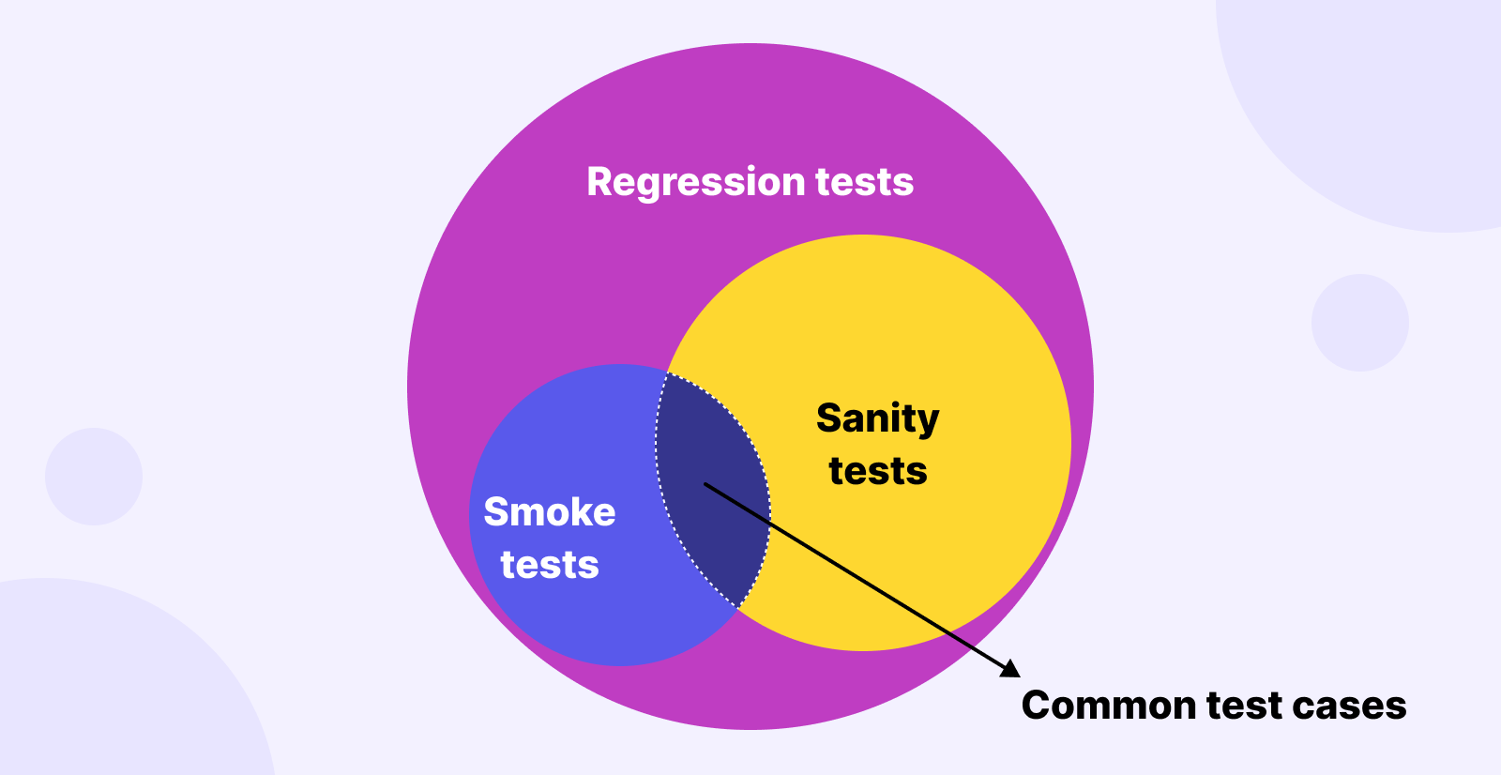

Is sanity testing done before regression testing?
Yes, regression testing is performed after executing sanity tests of any modified or added functionality. It ensures an application still works as expected after any code changes, updates, or improvements. It determines whether or not the software is eligible for further functional validation.

Which comes first, sanity or smoke testing?
Smoke testing is executed first in the early stages of the SDLC to set out a foundation of bug-free and reliable core functionalities. Once passed smoke testing, the build moves onto sanity testing to ensure its stability and flawless integration with the existing features.

It is the best practice that the testing team start with smoke testing, followed by sanity and then regression tests, based on the project’s timeline and requirements.
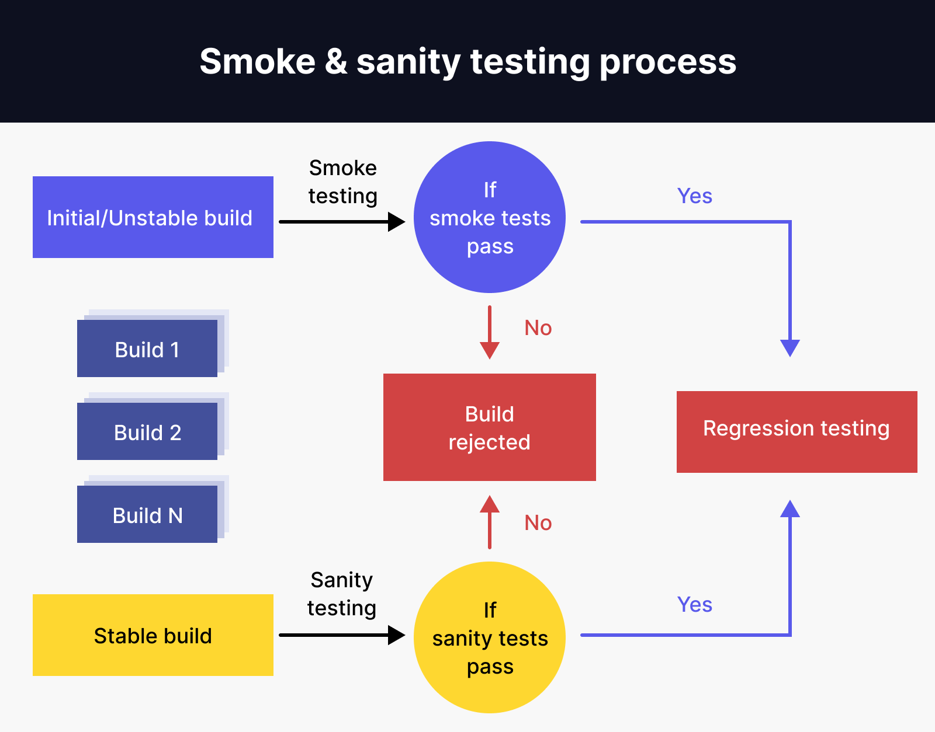

Sanity Testing :
- Instead of examining the entire system, sanity testing focuses on narrower areas of the added functionalities, while regression testing targets the application as a whole.

Sanity Testing Examples
Now let’s suppose that we have a development project for a mobile banking application, which includes these features:
- Login/Verify Pin
- Transfer Money
- Change Pin
- Withdraw Money
- Display Customer Name
- Provide Bill
- Show Balance
After the first build of the software, only the most basic features have been developed. In this case, those features should be Login, as no further actions can be taken if the user cannot access the main interface, and Withdraw money - the basic functionality of an ATM application.
In the 2nd build, a new feature is added - Changing PIN. To ensure that this new feature added does not interfere with the existing functionality, testers conduct sanity testing on the Login and Withdraw money features. If those 2 features work, they know that the Changing PIN feature did not affect them negatively.
Another example would be when testers discover a bug and send the build back to the development team for troubleshooting. After fixing, testers need sanity testing to confirm that the bug has indeed been fixed. It is more specific than smoke testing.

Key Elements Of Sanity Testing
- Quick and simple: They are easily designed and performed with the aim to receive quick feedback. This immediate feedback is a great indicator for testers to know how they should proceed
- Highly targeted: One or few functionalities are covered in depth.
- Undocumented and unscripted: In general, sanity testing doesn’t require test scripts or test cases thanks to its informality and quickness. It is not mandatory to provide documentation either.
- Performed by testers: Usually, testers are the ones performing sanity testing, and they know how to provide a more in-depth perspective to the software quality than developers themselves

User Acceptance Testing :
- User Acceptance Testing (UAT) serves the purpose of ensuring that the software meets the business requirements and is ready for deployment by validating its functionality in a real-world environment .
- It allows end-users to test the software to ensure it meets their needs and operates as expected, helping to identify and fix any issues before the final release.
Acceptance Criteria attributes for UAT :
- UAT is crucial for quality assurance and customer satisfaction, as it ensures that the software is
user-friendly, reliable and meets all criteria

Mutation Testing :
https://www.geeksforgeeks.org/software-testing-mutation-testing/

- It is type of software Testing that is performed to design new software tests and also evaluate the quality of already existing software tests.
- Mutation testing is related to modification a program in small ways.
- It focuses to help the tester develop effective tests or locate weaknesses in the test data used for the program.
- Mutation testing can be applied to design models specification, databases, tests and XML.
- It is a structural testing technique which uses the structure of the code to guide the testing process.
- It can be described as the process of rewriting the source code in small ways in order to remove the redundancies in the source code.
Objective of Mutation Testing :
- To identify pieces of code that are not tested properly.
- To identify hidden defects that can’t be detected using other testing method .
- To discover new kinds of errors or bugs.
- To calculate the mutation score.
- To study error propagation and state infection in the program.
- To assess the quality of the test cases.

Types of Mutation Testing :
- Value Mutations :
In this type of the testing the values are changed to detects errors in the program.
Example :
Initial Code:
int mod = 1000000007;
int a = 12345678;
int b = 98765432;
int c = (a + b) % mod;
Changed Code:
int mod = 1007;
int a = 12345678;
int b = 98765432;
int c = (a + b) % mod;
2. Decision Mutations:
In decisions mutations are logical or arithmetic operators are changed to detect errors in the program.
Example:
Initial Code:
if(a < b)
c = 10;
else
c = 20;
Changed Code:
if(a > b)
c = 10;
else
c = 20;
3. Statement Mutations:
In statement mutations a statement is deleted or it is replaces by some other statement.
Example:
Initial Code:
if(a < b)
c = 10;
else
c = 20;
Changed Code:
if(a < b)
d = 10;
else
d = 20;
Tools used for Mutation Testing :
- Judy
- Jester
- Jumble
- PIT
- MuClipse.
Advantages of Mutation Testing:
- It brings a good level of error detection in the program.
- It discovers ambiguities in the source code.
- It finds and solves the issues of loopholes in the program.
- It helps the testers to write or automate the better test cases.
- It provides more efficient programming source code.
Disadvantages of Mutation Testing:
- It is highly costly and time-consuming.
- It is not able for Black Box Testing.
- Some, mutations are complex and hence it is difficult to implement or run against various test cases.
- Here, the team members who are performing the tests should have good programming knowledge.
- Selection of correct automation tool is important to test the programs.

