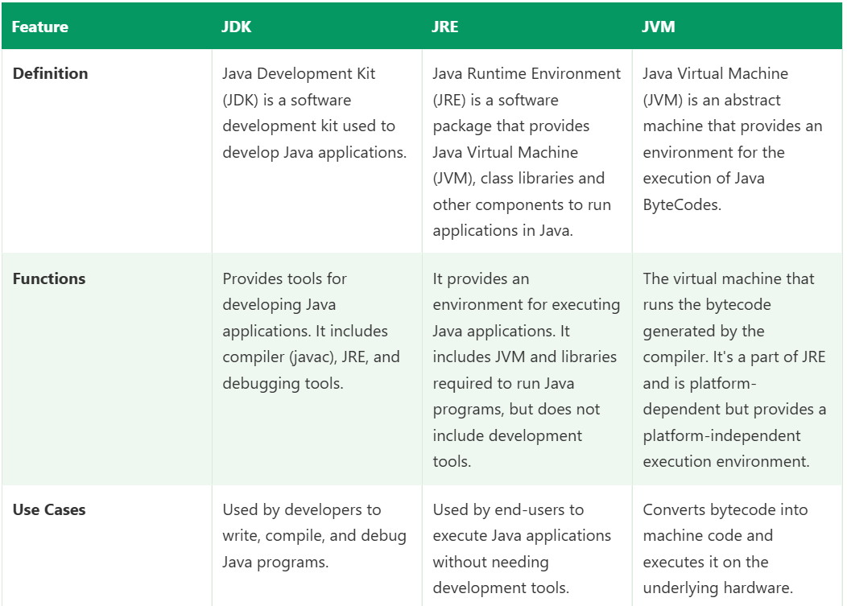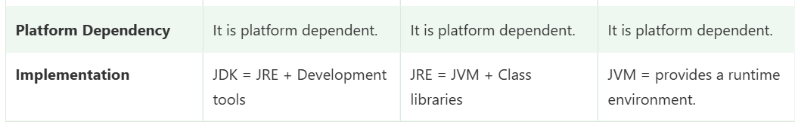class vs object with example
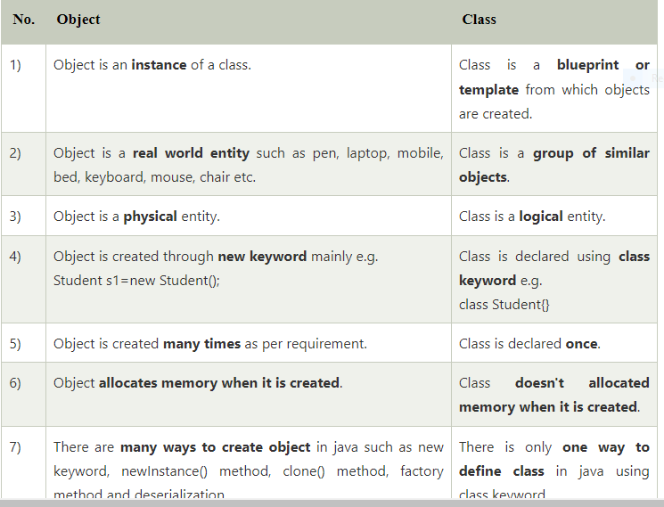
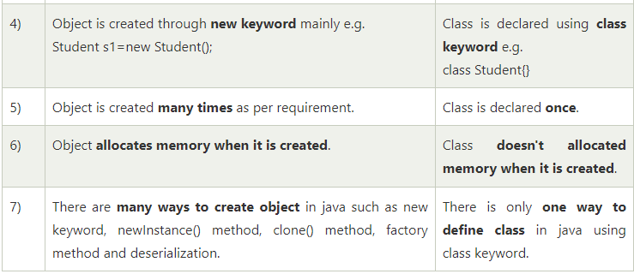

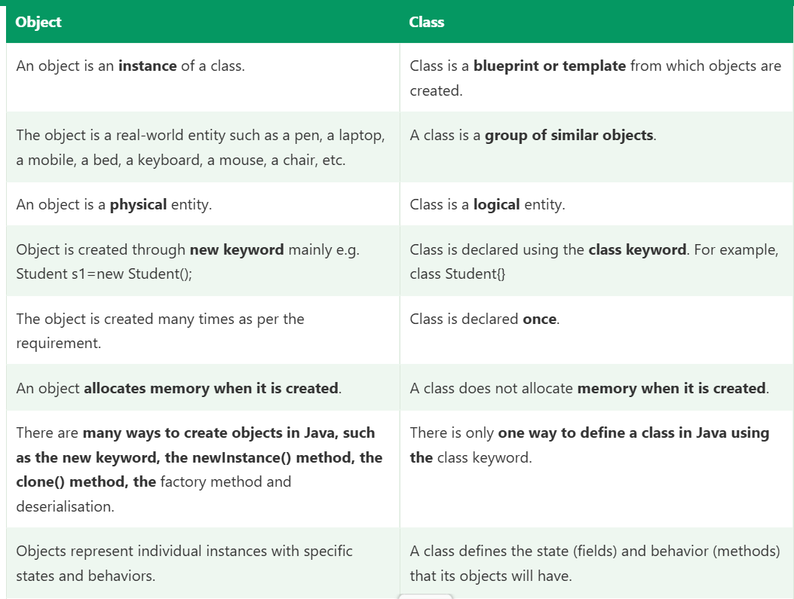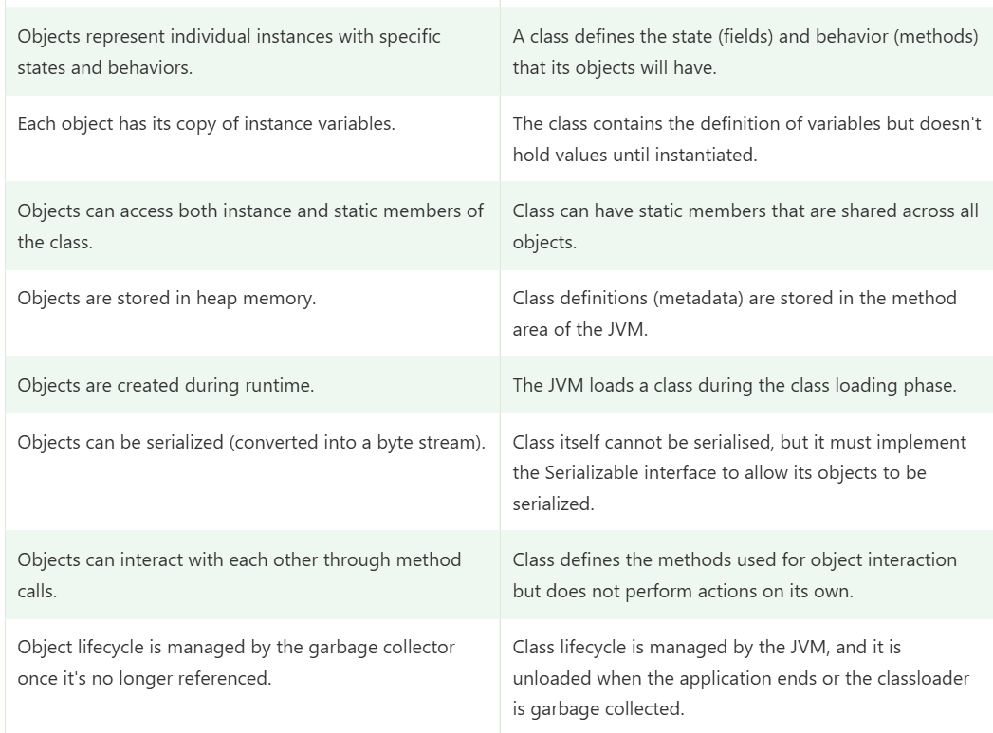

What are the different ways to create an object in Java?
There are the following ways to create an object in Java.
1. By new Keyword
The most common way to create an object in Java is using the new keyword followed by a constructor. For example,
- ClassName obj = new ClassName();
It allocates memory for the object and calls its constructor to initialize it.
2. By newInstance() Method
This method is part of the java.lang.Class class and is used to create a new instance of a class dynamically at runtime. It invokes the no-argument constructor of the class. For example,
- ClassName obj = (ClassName) Class.forName("ClassName").newInstance();.
3. By clone() Method
The clone() method creates a copy of an existing object by performing a shallow copy. It returns a new object that is a duplicate of the original object. For example,
- ClassName obj2 = (ClassName) obj1.clone();.
4. By Deserialization
Objects can be created by deserializing them from a stream of bytes. We can achieve it by using the ObjectInputStream class in Java. The serialized object is read from a file or network, and then the readObject() method is called to recreate the object.
5. By factory Method
Factory methods are static methods within a class that return instances of the class. They provide a way to create objects without directly invoking a constructor and can be used to encapsulate object creation logic. For example,
- ClassName obj = ClassName.createInstance().
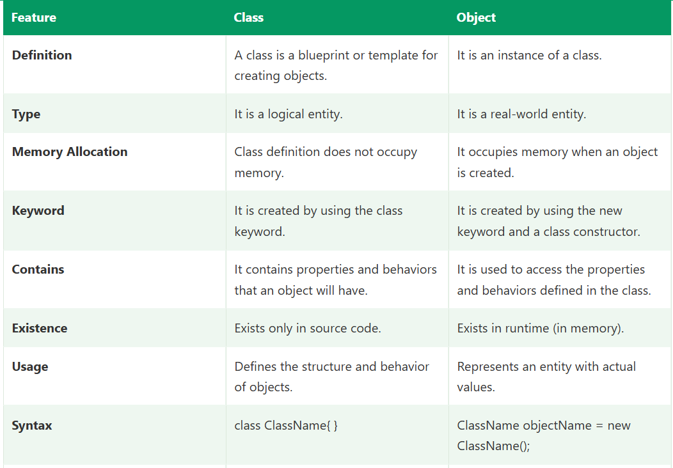
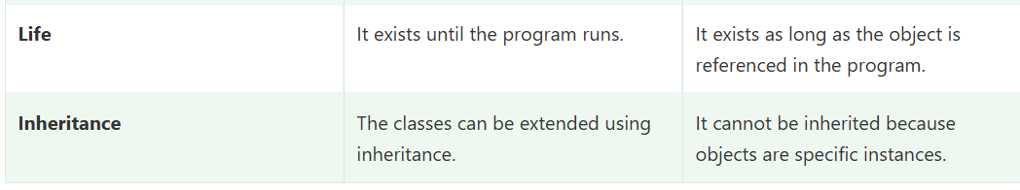

Upcasting and Downcasting in Java
Both are type casting between classes in an inheritance hierarchy (parent and child, or interface and implementing class). They change the reference type, never the actual object on the heap.
Animal (parent)
↑ upcasting (child → parent) automatic, always safe
↓ downcasting (parent → child) explicit cast, can fail at runtime
Dog (child)

Setup used in all examples
java
class Animal {
void eat() { System.out.println("Animal eats"); }
}

class Dog extends Animal {
@Override
void eat() { System.out.println("Dog eats bones"); }

void bark() { System.out.println("Dog barks"); } // only in Dog
}

class Cat extends Animal {
void meow() { System.out.println("Cat meows"); } // only in Cat
}

1. Upcasting
Definition: Assigning a child object to a parent reference.
Syntax:
java
Parent ref = new Child(); // implicit
Parent ref = (Parent) childObject; // explicit (optional, same result)
Example:
java
Animal a = new Dog(); // upcasting
a.eat(); // Dog eats bones (overridden method runs)
// a.bark(); // compile error: Animal reference doesn't know bark()
Key points:
- Automatic: no cast operator needed, because every Dog is an Animal, so it’s always safe.
- The object is still a Dog in memory, but through the Animal reference you can only access members declared in Animal.
- Overridden methods run the child’s version (runtime polymorphism).
- Fields and static methods are resolved by the reference type, not the object.
- This is what WebDriver driver = new ChromeDriver(); is. It’s upcasting.
Why we do it: to write generic code that works with any subtype.
java
static void feed(Animal a) { a.eat(); }

feed(new Dog()); // upcasting happens automatically
feed(new Cat());

2. Downcasting
Definition: Casting a parent reference back to a child type to access child-specific members.
Syntax:
java
Child ref = (Child) parentRef; // explicit cast is mandatory
Example (works):
java
Animal a = new Dog(); // upcast first
Dog d = (Dog) a; // downcast, valid because the actual object IS a Dog
d.bark(); // Dog barks
Example (fails at runtime):
java
Animal a = new Cat();
Dog d = (Dog) a; // compiles, but throws ClassCastException at runtime
Why it compiles but fails: the compiler only checks that Dog and Animal are related, so the cast is possible. The JVM checks the actual object at runtime. A Cat object can’t become a Dog.
Cannot downcast a pure parent object:
java
Animal a = new Animal();
Dog d = (Dog) a; // ClassCastException, the object is only an Animal
Unrelated classes don’t compile at all:
java
String s = (String) new Dog(); // compile error: incompatible types
Key points:
- Explicit cast required.
- Not always safe. It works only if the object was originally created as that child type (or a subclass of it).
- Downcasting only makes sense after an upcast.

3. Safe downcasting with instanceof
Always check before casting to avoid ClassCastException.
Classic way:
java
Animal a = getAnimal();

if (a instanceof Dog) {
Dog d = (Dog) a;
d.bark();
} else if (a instanceof Cat) {
Cat c = (Cat) a;
c.meow();
}
Pattern matching (Java 16+):
java
if (a instanceof Dog d) { // checks and casts in one step
d.bark();
}
Note: null instanceof Anything is false, so instanceof is also null-safe. A direct cast of null succeeds and gives null, with no exception.

4. Behaviour summary with the example
java
Animal a = new Dog();

a.eat(); // Dog's version (overriding, runtime)
// a.bark(); // not allowed through Animal reference
((Dog) a).bark(); // allowed after downcast

Difference table
 | Upcasting | Downcasting
Direction | Child to parent | Parent to child
Syntax | Parent p = new Child(); | Child c = (Child) p;
Cast operator | Not required (implicit) | Required (explicit)
Safety | Always safe | Can fail at runtime
Exception | None | ClassCastException
Checked by | Compiler | Compiler (relationship) and JVM (actual object)
Access after cast | Only parent members (child’s overrides run) | Parent and child-specific members
Purpose | Generic code, polymorphism | Access child-specific methods
Precondition | None | Object must really be of that child type
Object changed? | No, only the reference type | No, only the reference type

Framework examples
Upcasting:
java
WebDriver driver = new ChromeDriver(); // interface reference, browser-independent
Downcasting, for features not in the WebDriver interface:
java
JavascriptExecutor js = (JavascriptExecutor) driver; // downcast
js.executeScript("window.scrollTo(0, document.body.scrollHeight)");

TakesScreenshot ts = (TakesScreenshot) driver; // downcast
File src = ts.getScreenshotAs(OutputType.FILE);
WebDriver doesn’t declare executeScript() or getScreenshotAs(), but the actual ChromeDriver object implements JavascriptExecutor and TakesScreenshot. So the downcast succeeds. With RemoteWebDriver for Grid, the same casts work because it implements those interfaces too.
A safer version when the driver may be wrapped or of an unknown type:
java
if (driver instanceof TakesScreenshot) {
File src = ((TakesScreenshot) driver).getScreenshotAs(OutputType.FILE);
}
REST Assured: Response is an interface, and I use JsonPath/ResponseBody methods through that reference, which is upcasting to the interface.

Common pitfalls
- Fields are not polymorphic: with Animal a = new Dog();, a.name reads Animal’s field, even if Dog declares its own name.
- Static methods follow the reference type (method hiding), not the object.
- Casting doesn’t convert the object. It only tells the compiler how to treat the reference.
- Overusing downcasting is a design smell. If you often check instanceof and cast, consider polymorphism (move the behaviour into an overridden method) or a better design.

Short interview answer
“Upcasting is assigning a child object to a parent reference, like Animal a = new Dog(). It’s implicit and always safe, and it lets me use polymorphism, for example WebDriver driver = new ChromeDriver(). Downcasting is casting a parent reference back to a child type, like Dog d = (Dog) a. It needs an explicit cast and is only safe if the actual object is that child type, otherwise it throws ClassCastException at runtime. So I use instanceof before downcasting. In my framework, I downcast WebDriver to JavascriptExecutor for scrolling and to TakesScreenshot for failure screenshots.”

Why these casting rules work the way they do
Two checks happen on every cast:
- Compile time: the compiler looks only at the declared (reference) types. It asks, “Could this cast ever be valid?”
- Runtime: the JVM looks at the actual object on the heap. It asks, “Is this object really that type?”
Almost every question below comes down to which of these two checks applies.

1. Does the compiler or JVM catch a bad downcast?
Both, but for different cases.
Compiler catches: unrelated types (no possible inheritance relationship between the declared types).
java
class Dog extends Animal { }
class Cat extends Animal { }

Dog d = new Dog();
Cat c = (Cat) d; // compile error: incompatible types, Dog and Cat are siblings
String s = (String) d; // compile error: unrelated classes
Why? A Dog reference can only ever hold a Dog or a subclass of Dog. No object can be both a Dog and a Cat, because Java has no multiple class inheritance. So the compiler knows for sure the cast can never succeed.
JVM catches: related types where the actual object is the wrong type.
java
Animal a = new Cat(); // compiler sees Animal, JVM knows it's a Cat
Dog d = (Dog) a; // compiles fine, ClassCastException at runtime
Why does it compile? Animal is the parent of Dog, so an Animal reference might hold a Dog. The compiler only knows the declared type Animal, not what object it holds at runtime, so it gives the benefit of the doubt. At runtime, the JVM sees a Cat object and throws:
Exception in thread "main" java.lang.ClassCastException:
class Cat cannot be cast to class Dog

Case | Who catches it | Result
Unrelated classes (Dog to Cat, Dog to String) | Compiler | Compile error
Related, but object is wrong subtype (Animal holding Cat, cast to Dog) | JVM | ClassCastException
Related, object is correct subtype | Neither | Works
How to avoid the runtime failure: use instanceof before casting.
java
if (a instanceof Dog d) { d.bark(); }

2. Can we downcast with interfaces? Yes
Why it compiles even for “unrelated” types: Java allows a class to implement many interfaces. So even if a class doesn’t implement an interface, a subclass of it might.
java
interface Swimmer { void swim(); }

class Animal { }
class Dog extends Animal { }
class Fish extends Animal implements Swimmer { public void swim() { } }

Animal a = new Fish();
Swimmer s = (Swimmer) a; // compiles and works, the actual object is a Fish
Animal doesn’t implement Swimmer, but the compiler allows the cast because some subclass of Animal (like Fish) could. Whether it’s valid depends on the actual object, so the JVM checks at runtime.
java
Animal a = new Dog();
Swimmer s = (Swimmer) a; // compiles, ClassCastException at runtime: Dog isn't a Swimmer
The exception: final classes. If the class is final, it can’t have subclasses, so the compiler knows for certain whether it implements the interface.
java
final class Cat extends Animal { }

Cat c = new Cat();
Swimmer s = (Swimmer) c; // compile error: Cat is final and doesn't implement Swimmer
String is final, so (Runnable) "hello" is a compile error, but (Runnable) someNonFinalObject compiles.
Framework example:
java
WebDriver driver = new ChromeDriver();
TakesScreenshot ts = (TakesScreenshot) driver;
WebDriver is an interface that doesn’t extend TakesScreenshot. They are unrelated interfaces, yet the cast compiles, because the actual object (ChromeDriver, RemoteWebDriver) may implement both. At runtime the object really does, so it works. If the driver were a custom class that doesn’t implement TakesScreenshot, you’d get ClassCastException. Hence the safer form:
java
if (driver instanceof TakesScreenshot) { ... }

3. Does upcasting change the object? No
A reference variable is just a pointer plus a declared type. The object on the heap is created by new and keeps its real class for its whole life. Casting changes only how the compiler views it through that variable.
java
Dog original = new Dog();
Animal a = original; // upcast

System.out.println(a == original); // true, same object
System.out.println(a.getClass().getName()); // Dog, still a Dog
System.out.println(a instanceof Dog); // true

Stack Heap
original ─────┐
├──────────► [ Dog object ]
a (Animal) ───┘
Both references point to the same Dog object. Nothing is copied, converted, or lost. Even the Dog-specific fields and methods still exist in the object. They are just not visible through the Animal reference.
This is also why a later downcast works: Dog d = (Dog) a; simply gives a Dog-typed view of the same untouched object.

4. Why can’t I call bark() after upcasting?
Java is statically typed. At compile time, the compiler resolves method calls using the declared type of the reference, not the object it points to.
java
Animal a = new Dog();
a.bark(); // compile error: cannot find symbol, method bark() in Animal
The compiler reasons: “a is an Animal. Does Animal declare bark()? No, so error.” It can’t assume a holds a Dog, because a could be reassigned to a Cat anywhere in the code:
java
Animal a = new Dog();
a = new Cat(); // valid, so the compiler can't trust the object type
a.bark(); // would be a disaster if the compiler allowed this
Two-step rule for method calls:
- Compile time: the method must exist in the reference type (otherwise a compile error).
- Runtime: if the method is overridden, the actual object’s version runs.
java
a.eat(); // OK: Animal declares eat(). Runtime runs Dog's overridden eat()
Fix: downcast.
java
((Dog) a).bark(); // extra parentheses needed, cast has lower precedence than the dot
Without the parentheses, (Dog) a.bark() tries to call bark() first and then cast the result.

5. Are primitive casts the same? Similar idea, different mechanism
Primitive casting converts the actual value (possibly changing its bits). Reference casting changes only the type view of the same object.
Widening (small to large): implicit, safe, like upcasting
java
int i = 100;
long l = i; // automatic
double d = i; // automatic, 100.0
Direction: byte → short → int → long → float → double (char → int also).
Narrowing (large to small): explicit cast, like downcasting
java
double d = 9.78;
int i = (int) d; // 9, fractional part truncated (not rounded)

int big = 130;
byte b = (byte) big; // -126, overflow wraps around

long x = 3_000_000_000L;
int y = (int) x; // -1294967296, garbage value
Differences from reference casts:
 | Reference casting | Primitive casting
What changes | Only the reference’s type view | The actual value/bits
Failure mode | ClassCastException at runtime | Silent data loss, no exception
Hierarchy | Needs inheritance relationship | Based on size and type range
Object identity | Same object | A new value is produced
Safe check available | instanceof | None (you must range-check yourself)
Gotcha: float and long mix. long (64-bit) to float (32-bit) is implicit widening, but it can lose precision, so “widening” isn’t always lossless.
Wrapper trap: primitive casts don’t apply between wrapper objects.
java
Integer i = 10;
Long l = (Long) i; // compile error
Long l = (long) (int) i; // unbox, widen, then box

6. Is instanceof needed for upcasting? No
Upcasting is always valid, because every child object is a parent. There’s nothing to verify, so the compiler allows it implicitly with no check and no exception.
java
Animal a = new Dog(); // always safe, no instanceof needed
instanceof exists to answer the question “what is this object actually?”, which matters only when going from a general type to a specific type (downcasting).
Extra points:
- instanceof between unrelated types is a compile error: dog instanceof String.
- null instanceof X is always false.
- Using instanceof on an upcast expression is legal but redundant. The compiler may even flag it as always true.
- Java 16+ pattern matching: if (a instanceof Dog d) checks and casts in one step.

Summary table
Question | Answer | Core reason
Who catches a bad downcast? | Compiler for unrelated types, JVM for related-but-wrong objects | Compiler knows only declared types, JVM knows the real object
Downcast to interface? | Yes, compiles unless the class is final and doesn’t implement it | A subclass might implement the interface
Upcasting changes object? | No | Only the reference’s type view changes
bark() after upcast? | Compile error | Method lookup is against the reference type
Primitive casts same? | Similar direction, different effect | Primitive casts change the value, can silently lose data
instanceof for upcast? | Not needed | Every child is a parent, always valid

Short interview answers
Who catches a bad downcast: “The compiler rejects casts between unrelated types, like Dog to Cat. For related types it allows the cast because the reference might hold that subtype, and the JVM checks the actual object at runtime, throwing ClassCastException if it’s wrong.”
Downcasting with interfaces: “Yes. Since a subclass could implement the interface, the compiler allows the cast unless the class is final, and the JVM verifies at runtime. That’s why (TakesScreenshot) driver compiles, and I check with instanceof when I’m unsure.”
Upcasting and the object: “It doesn’t change the object. Only the reference type changes. The object stays a Dog on the heap, getClass() still returns Dog, and both references point to the same object.”
bark() after upcast: “The compiler resolves methods against the reference type, and Animal doesn’t declare bark(). I downcast to Dog to call it. Overridden methods still run the child’s version at runtime.”
Primitive casts: “Widening is implicit and safe, like upcasting. Narrowing needs an explicit cast and can silently lose data or overflow, unlike a reference downcast, which throws ClassCastException.”
instanceof for upcasting: “Not needed, because every child object is a parent type, so upcasting always succeeds.”

Likely follow-ups
- What does getClass() return vs instanceof? getClass() returns the exact runtime class. instanceof is also true for parent types and interfaces.
- Does ClassCastException apply to generics? Heap pollution with raw types can cause it. For example, adding an Integer to a raw List that is later read as List<String> fails when the element is cast.
- What is a checked vs unchecked cast warning? Casting to a generic type like (List<String>) obj gives an unchecked warning, because generics are erased at runtime and the JVM can’t verify the type argument.
- Does casting null fail? No. (Dog) null is legal and gives null.
- Can we cast an array? Yes. Object[] to String[] compiles, and the JVM checks the actual array type, throwing ClassCastException (or ArrayStoreException when storing a wrong element).
- Why is overloading resolved on reference type? For the same reason as bark(): the compiler only knows declared types, so print(Animal) is chosen for an Animal reference even when it holds a Dog

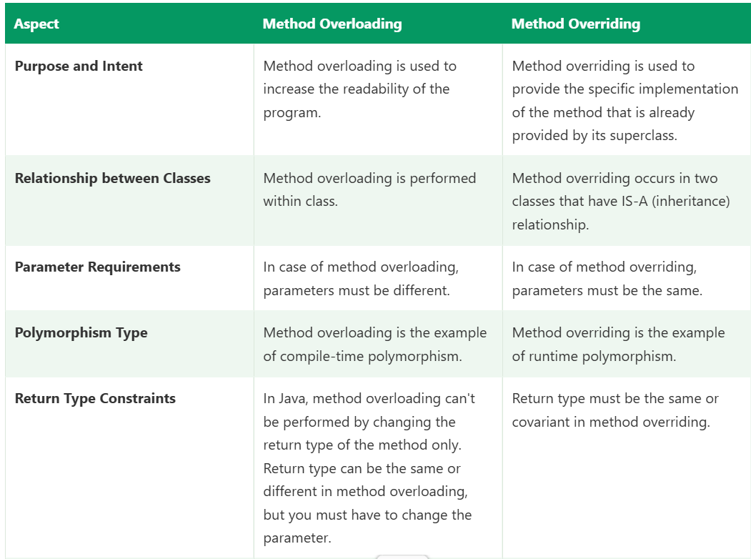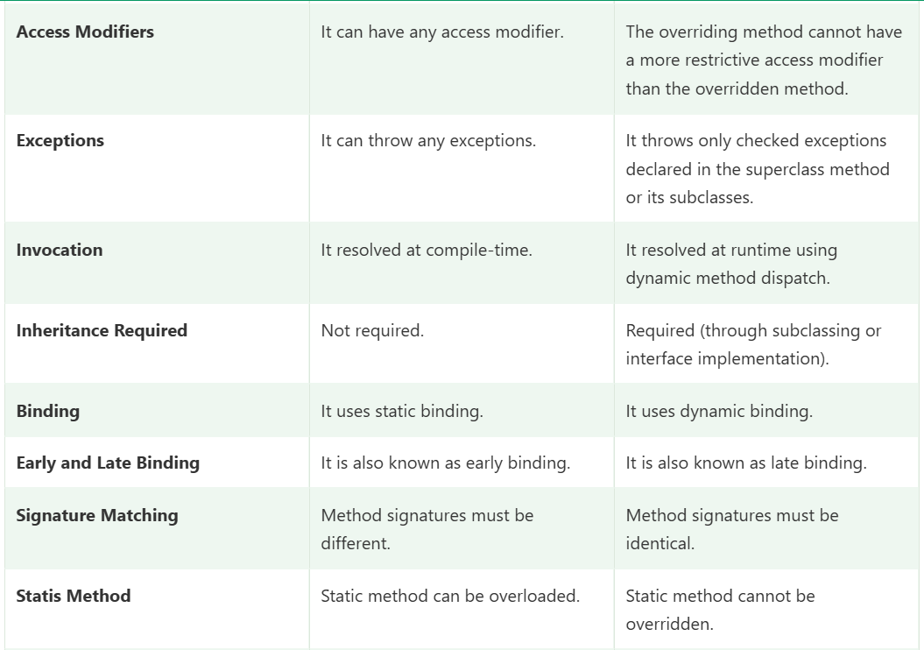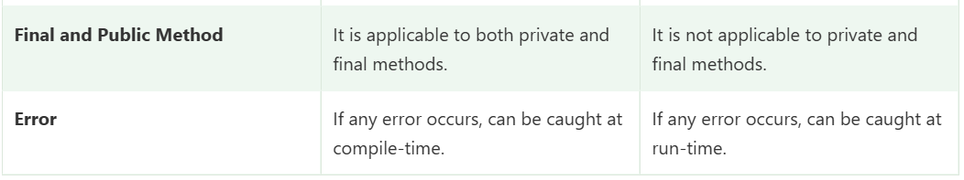

What is Dynamic Method Dispatch in Java?
Dynamic method dispatch is a technique by which a call to an overridden method is resolved at runtime based on the actual object type rather than the reference type. This technique allows runtime polymorphism through inheritance and method overriding.
Dynamic method dispatch or run-time polymorphism is the mechanism through which the correct version of an overridden method is called at runtime. When a subclass overrides a method from its superclass, the overridden method in the subclass is executed when called on an instance of the subclass, even if the reference to the object is of the superclass type.
What is Dynamic Method Dispatch in Java?

Dynamic Method Dispatch in Java
Dynamic Method Dispatch is the mechanism by which a call to an overridden method is resolved at runtime, based on the actual object type, not the reference type. It is how Java implements runtime polymorphism.
java

Parent ref = new Child();
ref.show(); // JVM decides at runtime: Child's show() runs
It is also called late binding or dynamic binding.

Example
java

class Animal {
void sound() { System.out.println("Animal makes a sound"); }
}

class Dog extends Animal {
@Override
void sound() { System.out.println("Dog barks"); }
}

class Cat extends Animal {
@Override
void sound() { System.out.println("Cat meows"); }
}

public class Test {
public static void main(String[] args) {
Animal a; // parent reference

a = new Dog();
a.sound(); // Dog barks

a = new Cat();
a.sound(); // Cat meows

a = new Animal();
a.sound(); // Animal makes a sound
}
}
The same statement a.sound() produces three different outputs. The reference type is always Animal, but the JVM checks the actual object each time and calls that class’s version.

How it works
- Compile time: the compiler checks that the method exists in the reference type (Animal must declare sound()). If not, compile error.
- Runtime: the JVM looks at the actual object on the heap and invokes the overriding method of that class. Internally it uses a virtual method table (vtable) per class, which maps each method to its implementation. For an object, the JVM follows its class’s vtable to find the right version.

Conditions for dynamic dispatch
- Inheritance (or interface implementation) must exist.
- The method must be overridden in the child.
- A parent (or interface) reference must hold a child object (upcasting).
- The method must be an instance method that is not private, static, or final.

What is NOT dynamically dispatched
These are resolved at compile time using the reference type:
Member | Binding | Why
Static methods | Compile time | Belong to the class, so they are hidden, not overridden
Private methods | Compile time | Not inherited
Final methods | Compile time | Can’t be overridden
Instance variables (fields) | Compile time | Fields are not polymorphic
Overloaded methods | Compile time | Chosen by argument types
Constructors | Compile time | Not inherited
java

class Parent { String name = "Parent"; }
class Child extends Parent { String name = "Child"; }

Parent p = new Child();
System.out.println(p.name); // Parent, field uses reference type

Dynamic dispatch with a parent method calling an overridden one
java

class Parent {
void run() { step(); }
void step() { System.out.println("Parent step"); }
}

class Child extends Parent {
@Override
void step() { System.out.println("Child step"); }
}

new Child().run(); // Child step
run() is inherited and defined in Parent, but inside it step() is called on this, which is a Child object. So dispatch picks Child.step(). This is the basis of the Template Method pattern.

Compile-time vs runtime polymorphism
 | Method Overloading | Method Overriding (Dynamic Dispatch)
Binding | Static / early | Dynamic / late
Resolved by | Compiler | JVM
Based on | Argument types | Actual object type
Signature | Different parameters | Same signature
Needs inheritance | No | Yes

Framework examples
1. WebDriver
java

WebDriver driver = new ChromeDriver();
driver.get(url); // ChromeDriver's implementation runs
Change to new FirefoxDriver() and the same driver.get() runs Firefox’s implementation. No test code changes.
2. Browser factory
java

WebDriver driver = DriverFactory.createDriver(browserName);
driver.findElement(By.id("login")).click();
The browser is decided at runtime from config, and the right implementation is called through dynamic dispatch.
3. TestNG listener
ITestListener is an interface. TestNG calls onTestFailure() on whatever implementation I registered, without knowing my class. My implementation captures the screenshot.
4. Page object base class
java

BasePage page = new CartPage(driver);
page.isPageLoaded(); // CartPage's override runs

Advantages
- Flexible, extensible code: new subclasses work without changing existing code (Open/Closed Principle).
- Loose coupling: code depends on abstractions (WebDriver), not concrete classes.
- Supports frameworks, listeners, and design patterns (Factory, Strategy, Template Method).

Short interview answer
“Dynamic method dispatch is the process where a call to an overridden method is resolved at runtime based on the actual object, not the reference type. For example, Animal a = new Dog(); a.sound(); calls Dog’s sound(), because the JVM checks the real object at runtime. It requires inheritance, overriding, and upcasting, and it’s how Java achieves runtime polymorphism. It doesn’t apply to static, private, final methods, or variables, which are resolved at compile time. In my framework, WebDriver driver = new ChromeDriver() is the best example: the same driver.get() call runs whichever browser implementation was created at runtime.”

Likely follow-ups
- Is dynamic dispatch the same as runtime polymorphism? Yes, dynamic method dispatch is the mechanism that implements runtime polymorphism.
- Can variables be overridden? No. Fields are hidden, not overridden, and accessed by reference type.
- What is the vtable? A per-class table of method pointers used by the JVM to find the correct overridden implementation quickly.
- Does dynamic dispatch work with interfaces? Yes. An interface reference holding an implementing object dispatches to the implementation’s method (via an interface method table).
- How does super.method() behave? It is bound statically to the parent’s version, bypassing dynamic dispatch.
- Does dispatch consider the argument’s runtime type? No. Java uses single dispatch: only the receiver object’s runtime type is considered, while argument types are resolved at compile time.

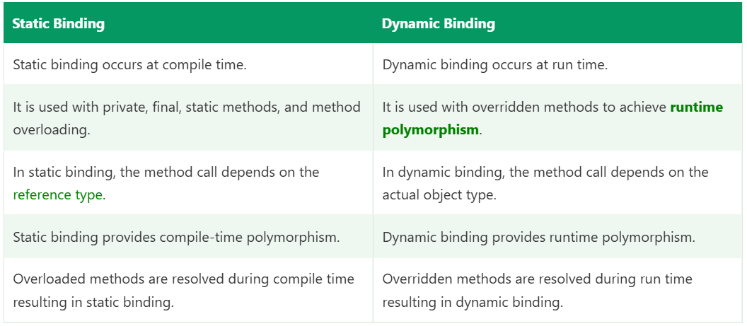

Can We Instantiate an Interface in Java?
No. You cannot create an object of an interface using new.
java
interface Browser {
void open();
}

Browser b = new Browser(); // compile error: Browser is abstract; cannot be instantiated
You can, however, create a reference variable of an interface type and assign it an object of a class that implements it. That’s what WebDriver driver = new ChromeDriver(); does.

Why an interface can’t be instantiated
1. Methods have no implementation.
An interface describes what a class must do, not how. Abstract methods have no body. If you could create an object, calling b.open() would have no code to run.
2. Interfaces are implicitly abstract.
The compiler treats every interface as abstract, and Java disallows new on any abstract type. This is the same rule that applies to abstract classes.
3. No constructor.
new works by calling a constructor to initialize the object. Interfaces have no constructors, because they hold no instance state. Their fields are implicitly public static final constants.
4. It is a contract, not a concrete type.
An interface says “any class that implements me promises these behaviours.” Only a concrete class can fulfil the promise, so objects always belong to the implementing class.

What you CAN do

1. Implement it in a class and use an interface reference (upcasting)
java
interface Browser {
void open();
}

class Chrome implements Browser {
@Override
public void open() { System.out.println("Chrome opened"); }
}

class Firefox implements Browser {
@Override
public void open() { System.out.println("Firefox opened"); }
}

public class Test {
public static void main(String[] args) {
Browser b = new Chrome(); // interface reference, class object
b.open(); // Chrome opened

b = new Firefox();
b.open(); // Firefox opened (runtime polymorphism)
}
}
The object is always a concrete class. The interface is only the reference type.

2. Use an anonymous inner class
This looks like instantiating an interface, but it isn’t. The compiler creates a nameless class that implements the interface and instantiates that.
java
Browser b = new Browser() {
@Override
public void open() { System.out.println("Anonymous browser opened"); }
};
b.open(); // Anonymous browser opened
You must implement every abstract method inside the braces. b.getClass() shows something like Test$1, not Browser, which proves a hidden class exists.

3. Use a lambda (for functional interfaces)
An interface with exactly one abstract method can be implemented with a lambda.
java
interface Greeting {
void say(String name);
}

Greeting g = name -> System.out.println("Hello " + name);
g.say("Raj"); // Hello Raj
Behind the scenes, the JVM creates an object of a generated class implementing Greeting. Built-in examples are Runnable, Comparator, Predicate, and Function.
java
Runnable r = () -> System.out.println("Running");
new Thread(r).start();

Why it matters: framework examples
java
WebDriver driver = new ChromeDriver(); // WebDriver is an interface, ChromeDriver is the class
new WebDriver() is a compile error. Only ChromeDriver, FirefoxDriver, EdgeDriver and RemoteWebDriver can be instantiated, and the interface reference keeps the test browser-independent.
java
List<String> list = new ArrayList<>(); // List is an interface, ArrayList is the class
Map<String, String> map = new HashMap<>();
Same pattern. TestNG’s ITestListener is implemented by my listener class, and REST Assured’s RequestSpecification and Response are interfaces whose implementations are created internally by the library.

Interface vs abstract class vs concrete class
 | Interface | Abstract class | Concrete class
Instantiate with new | No | No | Yes
Constructor | No | Yes (runs via super()) | Yes
Instance variables | No (only constants) | Yes | Yes
Method bodies | Only default, static, private methods | Yes, mixed | All methods
Multiple inheritance | A class can implement many | A class extends only one | Extends one class
Reference variable allowed | Yes | Yes | Yes

Common mistake
java
Browser[] browsers = new Browser[3]; // valid, creates an array of references (all null)
browsers[0] = new Chrome(); // objects still need a concrete class
Creating an array of an interface type is allowed because it holds references, not objects of the interface itself.

Short interview answer
“No, we can’t instantiate an interface with new, because it’s abstract. It has no constructor and its methods have no implementation, so there would be nothing to run. What we can do is create a reference of the interface type and assign it an object of a class that implements it, like WebDriver driver = new ChromeDriver(), or List<String> list = new ArrayList<>(). We can also use an anonymous inner class or a lambda for functional interfaces, but in both cases the compiler creates a hidden class that implements the interface, so we are still instantiating a concrete class, not the interface.”

Likely follow-ups
- Can an abstract class be instantiated? No, same reason, but it can have constructors that run when a subclass object is created.
- Can an interface have a constructor? No, it holds no instance state.
- What is a functional interface? An interface with exactly one abstract method, optionally marked @FunctionalInterface, usable with lambdas.
- Can an interface have method bodies? Yes, from Java 8 as default and static methods, and from Java 9 as private methods.
- Can an interface extend another interface? Yes, and it can extend multiple interfaces (interface A extends B, C).
- What is a marker interface? An interface with no methods, such as Serializable or Cloneable, used to tag classes.
- Why interface over abstract class? Interfaces allow multiple inheritance of type and define pure contracts, while abstract classes are better when you need shared state or constructor logic.
#===============================================
Can an interface have a constructor?

Can an Interface Have a Constructor?
No. An interface cannot declare a constructor. Writing one gives a compile error.
java
interface Browser {
Browser() { } // compile error: invalid method declaration; return type required
}
The compiler reads Browser() as a method with no return type, which is illegal. Even adding a return type just makes it an ordinary method, not a constructor.

Why an interface can’t have a constructor
1. A constructor initializes instance state, and interfaces have none.
The job of a constructor is to set up the fields of a new object. Interface fields are implicitly public static final, which means they are constants that belong to the interface itself, set once when the interface is initialized. There are no instance variables, so nothing needs initializing per object.
java
interface Config {
int TIMEOUT = 30; // implicitly public static final
}
2. An interface can’t be instantiated.
A constructor runs only as part of new. Since new Browser() is not allowed, a constructor could never be called.
3. Constructors work through inheritance chaining, which interfaces don’t take part in.
When you create an object, each class in the chain calls super(...) to run its parent’s constructor. A class that implements an interface doesn’t call anything on the interface. Its super() goes to the parent class (Object by default).
java
interface Browser { void open(); }

class Chrome implements Browser {
Chrome() {
super(); // calls Object(), NOT any Browser constructor
}
public void open() { System.out.println("Chrome opened"); }
}
4. An interface is a contract, not a blueprint of an object.
It declares what a class can do. How an object is built and what state it holds is the implementing class’s responsibility.

What interfaces can have instead
Member | Allowed? | Notes
Constructor | No | No instance state, can’t be instantiated
Constants | Yes | public static final by default
Abstract methods | Yes | public abstract by default
default methods (Java 8) | Yes | Have a body, inherited by implementing classes
static methods (Java 8) | Yes | Called as InterfaceName.method()
private methods (Java 9) | Yes | Helpers for default and static methods
Instance variables | No | All fields are constants
Static initializer block | No | Not allowed in interfaces
java
interface Browser {
String NAME = "Generic"; // constant

void open(); // abstract method

default void close() { // default method
System.out.println("Browser closed");
}

static Browser of(String type) { // static factory, replaces the need for a constructor
return type.equals("chrome") ? new Chrome() : new Firefox();
}
}
A static factory method inside the interface is the usual way to get “construction-like” behaviour.

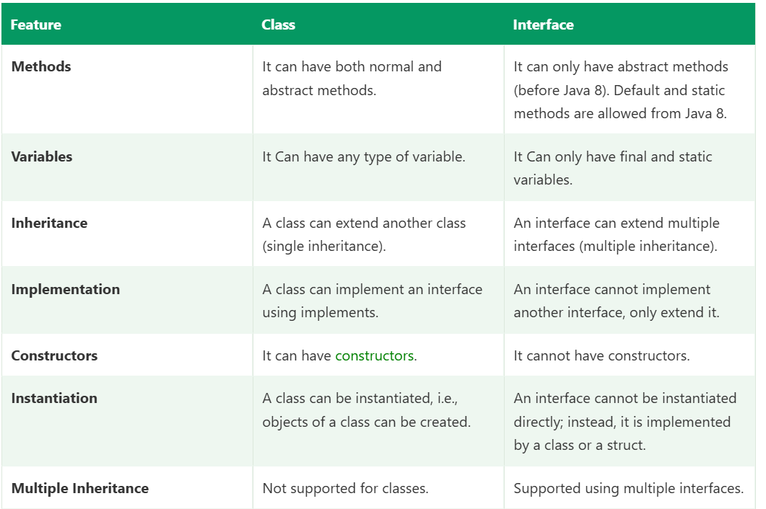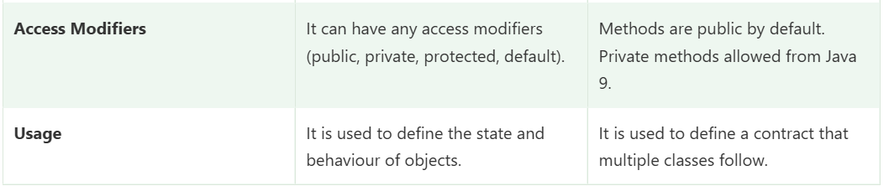

Interface vs abstract class
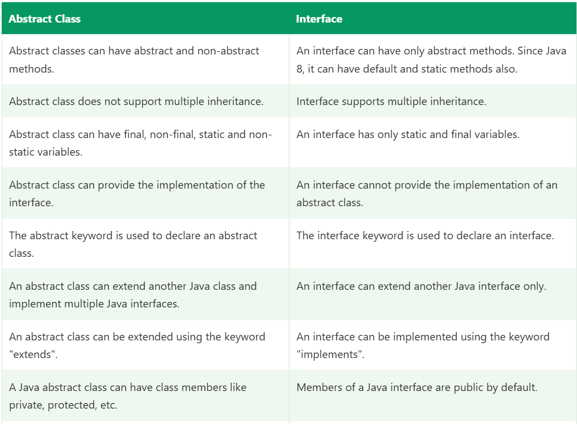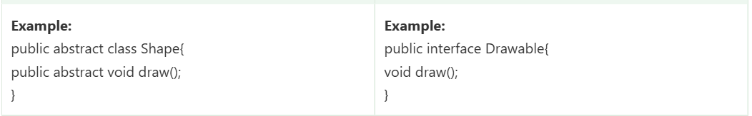
An abstract class can have a constructor. It cannot be called with new directly, but it runs when a subclass object is created, through super(...).
java
abstract class BasePage {
protected WebDriver driver;

BasePage(WebDriver driver) { // allowed
this.driver = driver;
}
}

class LoginPage extends BasePage {
LoginPage(WebDriver driver) {
super(driver); // runs the BasePage constructor
}
}

 | Interface | Abstract class
Constructor | No | Yes
Instance variables | No (constants only) | Yes
Instantiate with new | No | No
Multiple inheritance | A class can implement many | A class can extend only one
Use when | Defining a pure contract | Sharing state and constructor logic

Framework example
WebDriver is an interface, so it has no constructor. The constructors live in ChromeDriver, FirefoxDriver and EdgeDriver, which is why we write new ChromeDriver() and never new WebDriver(). Likewise, shared setup like storing the driver goes in my BasePage abstract class constructor, not in an interface.

Short interview answer
“No, an interface can’t have a constructor. A constructor initializes the instance state of an object, but interfaces have no instance variables, since their fields are public static final constants, and they can’t be instantiated. A class implementing the interface has its own constructor, and its super() call goes to the parent class, not the interface. If I need constructor logic shared across implementations, I use an abstract class instead, like a BasePage that stores the driver in its constructor.”

Likely follow-ups
- Can an abstract class have a constructor? Yes. It runs through super() when a concrete child is created.
- Can an interface have a static block? No. Constants are initialized directly at declaration.
- Can an interface have instance variables? No. Any field declared is automatically public static final, so it must be initialized.
- Can an interface have a main method? Yes, since a static method is allowed, and the JVM can run it.
- When does an interface get initialized? Only when one of its constants or static methods is first used, not when a class merely implements it.
- How do you share initialization logic across implementations? Use an abstract base class, or a default method that works on state provided by abstract getters.
#==================================================================

Can an Interface Have a Constructor?
No. An interface cannot declare a constructor. Trying to write one gives a compile error.
java
interface Browser {
Browser() { } // compile error: invalid method declaration; return type required
}
The compiler reads Browser() as a method with no return type, which is illegal. Even if you add a return type, it is just an ordinary method, not a constructor.

Why an interface can’t have a constructor
1. A constructor initializes instance state, and interfaces have none.
A constructor sets up the fields of a new object. Interface fields are implicitly public static final, so they are constants that belong to the interface itself, not to any object. There is nothing to initialize per object.
java
interface Config {
int TIMEOUT = 30; // implicitly public static final
}
2. An interface can’t be instantiated.
A constructor runs only as part of new. Since new Browser() is not allowed, a constructor could never be called.
3. Interfaces are not part of the constructor chain.
When a class implements an interface, its super() call goes to the parent class (Object by default), never to the interface.
java
interface Browser { void open(); }

class Chrome implements Browser {
Chrome() {
super(); // calls Object(), NOT anything in Browser
}
public void open() { System.out.println("Chrome opened"); }
}
4. An interface is a contract, not an object blueprint.
It says what a class can do. How the object is built and what state it holds is the implementing class’s job.

What an interface can have instead
Member | Allowed? | Notes
Constructor | No | No instance state, can’t be instantiated
Constants | Yes | public static final by default
Abstract methods | Yes | public abstract by default
default methods (Java 8) | Yes | Have a body, inherited by implementers
static methods (Java 8) | Yes | Called as InterfaceName.method()
private methods (Java 9) | Yes | Helpers for default/static methods
Instance variables | No | All fields are constants
Static initializer block | No | Not allowed in interfaces
java
interface Browser {
String NAME = "Generic"; // constant

void open(); // abstract method

default void close() { // default method
System.out.println("Browser closed");
}

static Browser of(String type) { // static factory instead of a constructor
return type.equals("chrome") ? new Chrome() : new Firefox();
}
}
A static factory method inside the interface is the usual way to get construction-like behaviour.

Interface vs abstract class
An abstract class can have a constructor, which runs through super(...) when a subclass object is created.
java
abstract class BasePage {
protected WebDriver driver;

BasePage(WebDriver driver) { // allowed
this.driver = driver;
}
}

class LoginPage extends BasePage {
LoginPage(WebDriver driver) {
super(driver); // runs BasePage constructor
}
}

 | Interface | Abstract class
Constructor | No | Yes
Instance variables | No (constants only) | Yes
new allowed | No | No
Multiple inheritance | A class can implement many | A class can extend only one
Use when | Pure contract | Shared state and constructor logic

Framework example
WebDriver is an interface, so it has no constructor. The constructors live in ChromeDriver, FirefoxDriver and EdgeDriver, which is why we write new ChromeDriver() and never new WebDriver(). Shared setup, like storing the driver, goes in my BasePage abstract class constructor.

Short interview answer
“No, an interface can’t have a constructor. A constructor initializes the instance state of an object, but interfaces have no instance variables, since their fields are public static final constants, and they can’t be instantiated. A class that implements an interface has its own constructor, and its super() goes to the parent class, not the interface. If I need shared constructor logic, I use an abstract class, like a BasePage that stores the driver in its constructor.”

Likely follow-ups
- Can an abstract class have a constructor? Yes, it runs via super() when a concrete child is created.
- Can an interface have a static block? No, constants are initialized at declaration.
- Can an interface have instance variables? No, every field is automatically public static final.
- Can an interface have a main method? Yes, since static methods are allowed.
- How do you share initialization logic across implementations? Use an abstract base class, or default methods that rely on abstract getters.

#==============================================================

Can an Abstract Class Have a Constructor?
Yes. An abstract class can have one or more constructors, with any access modifier. You cannot call new on the abstract class directly, but the constructor runs when a concrete subclass object is created, through super(...).
java
abstract class Animal {
Animal() {
System.out.println("Animal constructor");
}
abstract void sound();
}

class Dog extends Animal {
Dog() {
super(); // optional, compiler adds it
System.out.println("Dog constructor");
}
void sound() { System.out.println("Dog barks"); }
}

new Dog();
// Animal constructor
// Dog constructor

new Animal(); // compile error: Animal is abstract; cannot be instantiated

Why an abstract class needs a constructor
1. It can have instance variables that need initializing.
Unlike an interface, an abstract class holds state (fields). Something must set that state up, and that is the constructor.
2. A subclass object contains the parent part inside it.
When you create a Dog, the object includes the Animal portion. Java builds objects top-down: the parent part must be constructed before the child’s part. So the child’s constructor always calls the parent’s constructor first, whether the parent is abstract or not.
3. Constructor chaining.
Every constructor starts with super(...) (inserted by the compiler if you don’t write it). It continues up the chain to Object. An abstract class is part of that chain, so it needs to be constructible this way.
4. Shared setup logic in one place.
Common initialization is written once in the abstract class instead of being duplicated in every child.

Example with state: the BasePage pattern
java
abstract class BasePage {
protected WebDriver driver;
protected WebDriverWait wait;

protected BasePage(WebDriver driver) {
this.driver = driver;
this.wait = new WebDriverWait(driver, Duration.ofSeconds(10));
PageFactory.initElements(driver, this);
}

abstract boolean isPageLoaded();
}

class LoginPage extends BasePage {
LoginPage(WebDriver driver) {
super(driver); // required: BasePage has no no-arg constructor
}

boolean isPageLoaded() {
return driver.getTitle().equals("Swag Labs");
}
}
Every page class gets the driver, the wait, and element initialization from one constructor. This is exactly how I use it in my framework.

Rules
- Cannot be called with new directly. It runs only through a subclass’s super(...).
- Default constructor: if you write no constructor, the compiler adds a default no-arg one (same as any class).
- Parameterized-only constructor: if the abstract class has only a parameterized constructor, every subclass constructor must call super(args) explicitly, otherwise a compile error.
java
abstract class Base {
Base(String name) { }
}

class Child extends Base {
Child() { } // compile error: Base() doesn't exist
}
- protected is the common choice, since only subclasses should call it. public is allowed but meaningless. private is legal but then no outside subclass can extend it, unless the subclass is nested in the same class.
- Cannot be abstract, static, final: the usual constructor restrictions.
- Can be overloaded, and can use this(...) to chain to another constructor in the same abstract class.
- Can throw exceptions: the subclass constructor must declare any checked exception.

Initialization order with an abstract class
java
abstract class Parent {
static { System.out.println("1. Parent static"); }
{ System.out.println("3. Parent instance block"); }
Parent() { System.out.println("4. Parent constructor"); }
}

class Child extends Parent {
static { System.out.println("2. Child static"); }
{ System.out.println("5. Child instance block"); }
Child() { System.out.println("6. Child constructor"); }
}

new Child();
The order is the same as for normal classes: static blocks (parent, then child), then parent instance blocks and constructor, then child instance blocks and constructor.

The danger: calling an abstract method from the constructor
java
abstract class Base {
Base() {
init(); // calls the child's version
}
abstract void init();
}

class Impl extends Base {
private String name = "Raj";

void init() {
System.out.println(name); // prints null
}
}

new Impl(); // null
name is still null because the parent constructor runs before the child’s fields are initialized. Avoid calling abstract or overridable methods from a constructor.

Abstract class vs interface
 | Abstract class | Interface
Constructor | Yes | No
Instance variables | Yes | No (constants only)
Instantiate with new | No | No
Method bodies | Abstract and concrete mix | Only default, static, private
Inheritance | A class extends only one | A class can implement many
Use when | Shared state and common init logic | Pure contract

Anonymous subclass note
You can instantiate an abstract class through an anonymous subclass, and the abstract constructor still runs:
java
Animal a = new Animal() {
void sound() { System.out.println("Anonymous sound"); }
};
// prints "Animal constructor", then a.sound() works
This isn’t instantiating the abstract class itself. The compiler creates a hidden concrete subclass.

Short interview answer
“Yes, an abstract class can have constructors. We can’t call new on it directly, but the constructor runs when a concrete subclass is created, through super(). It’s needed because an abstract class can have instance fields to initialize, and Java always builds an object from the top of the hierarchy down. If the abstract class has only a parameterized constructor, each subclass must call super(args) explicitly. In my framework, my BasePage abstract class has a constructor that stores the driver, creates the wait, and calls PageFactory.initElements, and every page class reuses it through super(driver).”

Likely follow-ups
- Why can’t an interface have one but an abstract class can? Interfaces have no instance state and are not part of the constructor chain. Abstract classes are.
- Can an abstract class be final? No. final stops inheritance and abstract requires it.
- Can an abstract class have no abstract methods? Yes. It’s still non-instantiable, which is sometimes used to force subclassing.
- Can an abstract class have a main method or static methods? Yes, and the JVM can run main from it.
- Can an abstract method be private, static or final? No, because each blocks overriding, which an abstract method requires.
- When do you pick an abstract class over an interface? When subclasses share state, constructor logic, or non-public members, such as BasePage or BaseTest.
#=====================================================================

Can an Abstract Class Be Instantiated?
No. You cannot create an object of an abstract class directly using new.
java
abstract class Animal {
abstract void sound();
}

Animal a = new Animal(); // compile error: Animal is abstract; cannot be instantiated
You can still create a reference variable of the abstract type and point it to an object of a concrete subclass.
java
Animal a = new Dog(); // valid, upcasting

Why it can’t be instantiated
1. It may have incomplete methods.
An abstract class can declare abstract methods with no body. If you could create an object, calling a.sound() would have nothing to execute.
2. abstract means “incomplete by design”.
The keyword tells the compiler this class is meant to be a base for other classes. The compiler enforces it by rejecting new on any abstract class, even if it has no abstract methods at all.
java
abstract class Utility {
void print() { System.out.println("Hello"); } // fully implemented
}

new Utility(); // still a compile error
3. It forces a proper design.
A generic idea like Animal or BasePage doesn’t represent a real, complete thing. Only a concrete class like Dog or LoginPage does.

What you CAN do

1. Extend it with a concrete class
The subclass must implement all abstract methods, otherwise it must also be declared abstract.
java
abstract class Animal {
abstract void sound();
void sleep() { System.out.println("Sleeping"); }
}

class Dog extends Animal {
void sound() { System.out.println("Dog barks"); }
}

public class Test {
public static void main(String[] args) {
Animal a = new Dog(); // abstract reference, concrete object
a.sound(); // Dog barks (runtime polymorphism)
a.sleep(); // Sleeping
}
}

2. Use an anonymous inner class
This looks like instantiating the abstract class, but the compiler creates a hidden concrete subclass.
java
Animal a = new Animal() {
@Override
void sound() { System.out.println("Anonymous sound"); }
};
a.sound(); // Anonymous sound
System.out.println(a.getClass().getName()); // Test$1, not Animal
The class name Test$1 proves the object belongs to a generated subclass, not Animal.

3. Create an array of the abstract type
java
Animal[] animals = new Animal[3]; // valid, holds references (all null)
animals[0] = new Dog();
This creates an array of references, not objects of Animal.

The constructor still runs
An abstract class can have a constructor. It isn’t called with new directly, but it runs when a subclass object is created.
java
abstract class BasePage {
protected WebDriver driver;

BasePage(WebDriver driver) {
this.driver = driver;
}
}

class LoginPage extends BasePage {
LoginPage(WebDriver driver) {
super(driver); // BasePage constructor runs here
}
}

BasePage page = new LoginPage(driver); // valid
new BasePage(driver); // compile error

Framework example
BasePage and BaseTest are abstract in my framework. I never create new BasePage(). I create new LoginPage(driver), which inherits the shared driver and wait setup. Declaring them abstract also prevents anyone from accidentally instantiating the base class.

Abstract class vs concrete class vs interface
 | Abstract class | Concrete class | Interface
new allowed | No | Yes | No
Abstract methods | Optional | Not allowed | Yes (by default)
Concrete methods | Yes | Yes | Only default/static/private
Constructor | Yes | Yes | No
Reference variable | Yes | Yes | Yes

Short interview answer
“No, an abstract class can’t be instantiated with new, because it’s incomplete by design and may contain abstract methods with no implementation. The compiler blocks it even if the class has no abstract methods. We can create a reference of the abstract type and assign a concrete subclass object, like Animal a = new Dog(), or use an anonymous subclass, which creates a hidden concrete class. The abstract class’s constructor still runs when a subclass object is created. In my framework, BasePage is abstract, and I always instantiate concrete page classes like LoginPage.”

Likely follow-ups
- Why have a constructor if it can’t be instantiated? It initializes the parent part of a subclass object through super().
- Can an abstract class have no abstract methods? Yes, it just stops direct instantiation.
- What if a subclass doesn’t implement all abstract methods? It must be declared abstract itself, or the compiler reports an error.
- Can an abstract class be final? No, final prevents inheritance while abstract requires it.
- Can abstract and static methods combine? No, static can’t be overridden, abstract must be.
- Abstract class vs interface? Use an abstract class for shared state and constructor logic, an interface for a pure contract and multiple inheritance.
#======================================================================

Use of a Constructor in an Abstract Class
An abstract class can’t be instantiated directly, but it is still the parent part of every subclass object. Its constructor exists to initialize that parent part whenever a concrete child is created, through super(...).
new LoginPage(driver)
└─ LoginPage constructor
└─ super(driver) ──► BasePage constructor runs (initializes shared state)

Main uses

1. Initialize instance variables of the abstract class
The abstract class can hold fields (state). The constructor sets them up so every subclass starts with valid data.
java
abstract class BasePage {
protected WebDriver driver;
protected WebDriverWait wait;

protected BasePage(WebDriver driver) {
this.driver = driver;
this.wait = new WebDriverWait(driver, Duration.ofSeconds(10));
}
}

class LoginPage extends BasePage {
LoginPage(WebDriver driver) {
super(driver); // driver and wait are ready
}
}
Without the constructor, every page class would repeat these lines.

2. Avoid code duplication (common setup in one place)
Shared setup like PageFactory.initElements(driver, this), logging, reading config, or creating a wait is written once and reused by all children.
java
protected BasePage(WebDriver driver) {
this.driver = driver;
PageFactory.initElements(driver, this); // works for every child's @FindBy fields
}

3. Force subclasses to provide required data
A parameterized constructor makes the child supply mandatory values. If it doesn’t, the code doesn’t compile.
java
abstract class Employee {
private final String name;
protected Employee(String name) { this.name = name; }
}

class Tester extends Employee {
Tester() { } // compile error: must call super(name)
Tester(String n) { super(n); } // OK
}
This guarantees no subclass object exists without a valid name.

4. Validate input
java
protected BasePage(WebDriver driver) {
if (driver == null) {
throw new IllegalArgumentException("Driver cannot be null");
}
this.driver = driver;
}
Bad objects fail early, in one place, for all subclasses.

5. Support final fields
Final fields can be assigned only in a constructor (or initializer). A constructor in the abstract class lets it keep immutable state.
java
abstract class BaseApi {
protected final String baseUrl;
protected BaseApi(String baseUrl) { this.baseUrl = baseUrl; }
}

6. Complete the constructor chain
Java builds objects top-down: Object → abstract parent → child. The abstract class is a link in that chain, so it needs its own constructor (the compiler adds a default one if you don’t write any).

Framework example (REST Assured)
java
abstract class BaseApiTest {
protected RequestSpecification spec;

protected BaseApiTest() {
spec = new RequestSpecBuilder()
.setBaseUri(ConfigReader.get("baseUrl"))
.setContentType(ContentType.JSON)
.build();
}
}

class BookingApiTest extends BaseApiTest {
// spec is already built when the object is created
}

Caution
Don’t call abstract or overridable methods from the constructor. The parent constructor runs before the child’s fields are initialized, so the child’s override may see null values.
java
abstract class Base {
Base() { init(); } // risky
abstract void init();
}

Short interview answer
“Even though an abstract class can’t be instantiated, its constructor runs when a concrete subclass object is created, through super(). Its use is to initialize the abstract class’s own fields, put common setup in one place instead of duplicating it in every child, force subclasses to pass required values, validate input, and support final fields. In my framework, my BasePage constructor stores the driver, creates the explicit wait and calls PageFactory.initElements, and every page class just calls super(driver).”

Likely follow-ups
- Who calls the abstract class constructor? The subclass constructor, through super(...), either explicit or compiler-inserted.
- What if the abstract class has no constructor? The compiler provides a default no-arg one.
- What if it has only a parameterized constructor? Every child must call super(args) explicitly.
- Why protected for the constructor? Only subclasses should call it, and public adds nothing since new is blocked anyway.
- Does an interface have this ability? No, interfaces have no constructors or instance state.

Call by Value and Call by Reference in Java

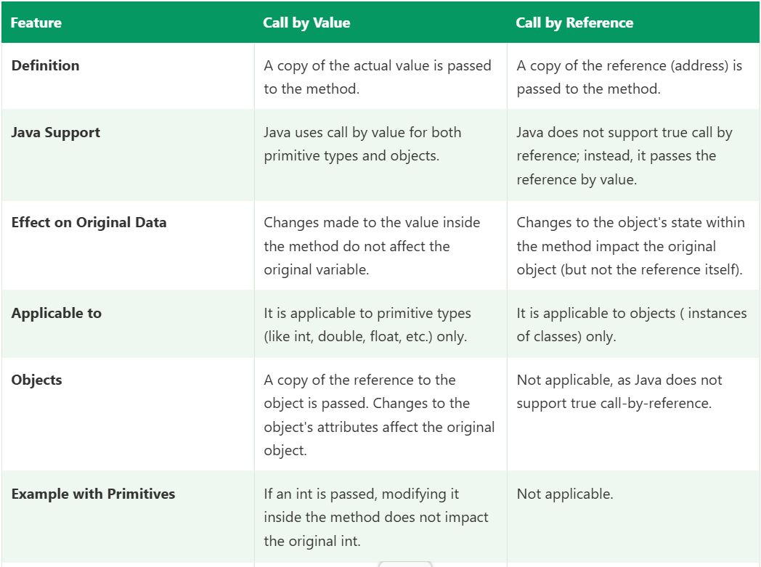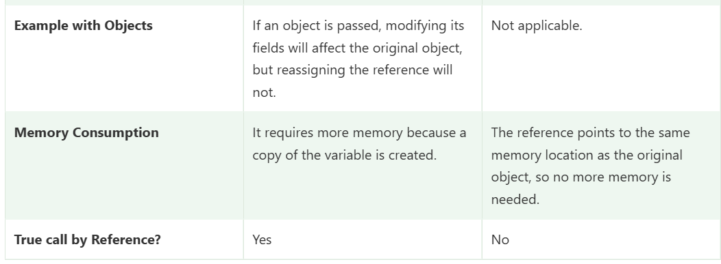
Java is call by value or call by refernce explain in detail with example

Java is always call by value
Java is strictly pass-by-value. There is no call by reference in Java. This confuses many people because when you pass an object, the method can change that object’s contents, which looks like call by reference. It isn’t.

What “value” means
Type | What the variable holds | What gets copied into the method
Primitive (int, double, boolean...) | The actual value | A copy of the value
Object (String, List, Page...) | A reference (address) to the object on the heap | A copy of the reference
In both cases, the method receives a copy. For objects, the copy points to the same object as the original reference.

Example 1: Primitives
java

public class Demo {
static void change(int x) {
x = 100;
System.out.println("Inside method: " + x);
}

public static void main(String[] args) {
int a = 10;
change(a);
System.out.println("After method: " + a);
}
}
Output:
Inside method: 100
After method: 10
x is a separate copy of a. Changing x has no effect on a.

Example 2: Objects, modifying the state (looks like call by reference)
java

class Student {
String name;
Student(String name) { this.name = name; }
}

public class Demo {
static void rename(Student s) {
s.name = "Raj"; // changes the object that both references point to
}

public static void main(String[] args) {
Student st = new Student("Amit");
rename(st);
System.out.println(st.name); // Raj
}
}
Memory view:
main: st ──────────┐
├──► [ Student object | name = "Raj" ]
rename: s (copy) ────┘
st and s are two different variables holding the same address. Through s, the method modifies the shared object, so the change is visible to the caller.

Example 3: Objects, reassigning the reference (proves it is NOT call by reference)
java

static void reassign(Student s) {
s = new Student("Kiran"); // s now points to a NEW object
System.out.println("Inside: " + s.name);
}

public static void main(String[] args) {
Student st = new Student("Amit");
reassign(st);
System.out.println("After: " + st.name);
}
Output:
Inside: Kiran
After: Amit
Memory view:
main: st ──────────► [ Student | name = "Amit" ]

reassign: s (copy) ───► [ Student | name = "Kiran" ] (new object, st untouched)
Inside the method, s was repointed to a new object. The caller’s st is a separate variable, so it still points to the original. In a true call-by-reference language like C++ (void f(Student& s)), reassigning s would change the caller’s variable. In Java it doesn’t. This example is the proof.

Example 4: Swap method (classic interview question)
java

static void swap(Student a, Student b) {
Student temp = a;
a = b;
b = temp;
}

public static void main(String[] args) {
Student s1 = new Student("Amit");
Student s2 = new Student("Raj");
swap(s1, s2);
System.out.println(s1.name + " " + s2.name); // Amit Raj (not swapped)
}
Only the local copies a and b were swapped. s1 and s2 are unchanged. A true swap isn’t possible in Java through a method like this.

Example 5: Strings and wrappers
java

static void change(String s) {
s = s + " World";
}

String str = "Hello";
change(str);
System.out.println(str); // Hello
Two reasons: String is immutable, so concatenation creates a new object, and reassigning s only repoints the local copy. The same applies to wrapper classes (Integer, Double), which are also immutable.

Example 6: Arrays and collections
java

static void modify(int[] arr, List<String> list) {
arr[0] = 99; // modifies the shared array
list.add("Added"); // modifies the shared list
arr = new int[]{1, 2}; // only repoints the local copy, no effect on caller
}
After the call, the caller sees arr[0] == 99 and the list containing “Added”, but the caller’s arr still points to the original array.

Framework example
java

public void login(WebDriver driver, String user) {
driver.get("https://example.com"); // acts on the same browser object
driver = new ChromeDriver(); // only changes the local copy
}



Difference Between enum and Enum
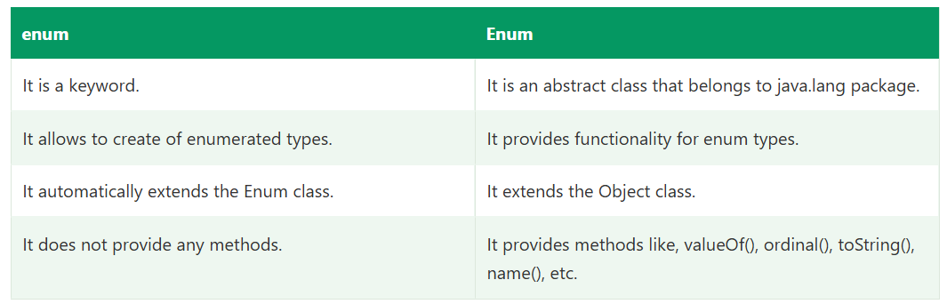

Java Enum Class :
An enum class is a special type of class used to define a fixed set of constants. Unlike regular classes, each constant in an enum is automatically created as an instance (object) of the enum class by the compiler. All enum constants are implicitly public, static, and final, so they cannot be changed once defined.
Every enum class implicitly extends the Enum class.

Syntax
It has the following syntax:
- public abstract class Enum<E extends Enum<E>> extends Object implements Comparable<E>, Serializable

Methods of Enum Class
Enum classes have a few predefined methods that are easily accessible. They are as follows.
Method | Description
clone() | It throws CloneNotSupportedException.
compareTo(E o) | It compares this enum with the specified object for order.
equals(Object others) | It returns true if the specified object is equal to this enum constant.
finalize() | Enum classes cannot have finalize methods.
getDeclaringClass() | It returns the Class object corresponding to this enum constant's enum type.
hashCode() | It returns a hash code for this enum constant.
name() | It returns the name of this enum constant, exactly as declared in its enum declaration.
ordinal() | It returns the ordinal of this enumeration constant (its position in its enum declaration, where the initial constant is assigned an ordinal of zero).
toString() | It returns the name of this enum constant, as contained in the declaration.
valueOf(Class<T> enumType, String name) | It returns the enum constant of the specified enum type with the specified name.
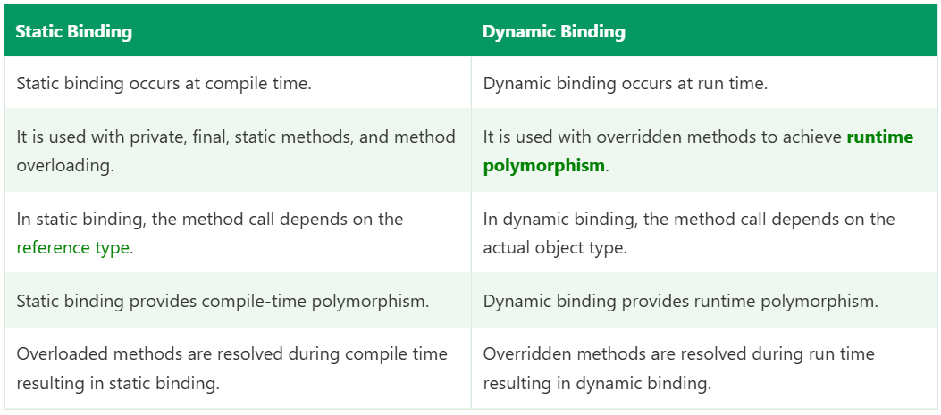
#=========================================================

Why String is Immutable in Java
Immutable means that once a String object is created, its content cannot be changed. Any operation that seems to modify it actually creates a new String object.
java
String s = "Hello";
s.concat(" World"); // creates a new object, result discarded
System.out.println(s); // Hello (unchanged)

s = s.concat(" World"); // s now points to the NEW object
System.out.println(s); // Hello World

Before: s ──► [ "Hello" ]

After: s ──► [ "Hello World" ] (new object)
[ "Hello" ] (old object untouched, eligible for GC if unreferenced)

How Java enforces it
- The String class is declared final, so nobody can subclass it and break immutability.
- Its internal data (a private final byte[] value in Java 9+, char[] before) is private and final, with no setter methods.
- Methods like toUpperCase(), replace(), substring(), concat() all return a new String instead of modifying the existing one.

Reasons for immutability

1. String Pool (memory efficiency)
Java stores string literals in a String Constant Pool. If two variables use the same literal, they share one object.
java
String a = "Java";
String b = "Java";
System.out.println(a == b); // true, same object in the pool

a ──┐
├──► [ "Java" ] (one object in the pool)
b ──┘
This sharing is only safe because strings can’t change. If a could modify the object, b would silently change too. Immutability makes sharing safe and saves a lot of memory.

2. Security
Strings carry sensitive data: file paths, URLs, database connection strings, usernames, passwords, class names loaded by the class loader.
java
void connect(String host) {
checkPermission(host); // security check passes for "safe-host"
// if another thread could change host here to "malicious-host", the check is useless
open(host);
}
If a String were mutable, a value could be changed after validation but before use. Immutability guarantees the checked value is the used value. Class loading (Class.forName("name")) and network connections rely on this.

3. Thread safety
An immutable object can’t change state, so it can be shared across threads with no synchronization. No locks, no race conditions. This matters in parallel TestNG execution, where config values and test data strings are shared by many threads.

4. Hashcode caching (performance)
String is the most common key in HashMap and HashSet. Because the content never changes, its hashcode is calculated once and cached in the object (the hash field). Every later hashCode() call is a quick lookup.
java
Map<String, String> map = new HashMap<>();
map.put("username", "admin");
map.get("username"); // uses the cached hashcode
If strings were mutable, changing a key after inserting it would change its hashcode, and the map would never find the entry again.

5. Class loading and reliability
The JVM uses strings to represent class names, method names and field names. A mutable name could load the wrong class or break the linking process.

6. Safe as constants and parameters
Passing a String to a method guarantees the method can’t alter the caller’s value. This ties in with pass-by-value: the callee can’t modify the caller’s String through the reference.
java
static void change(String s) { s = s + "X"; }

String name = "Raj";
change(name);
System.out.println(name); // Raj

Cost of immutability
Repeated modification creates many temporary objects.
java
String result = "";
for (int i = 0; i < 10000; i++) {
result += i; // new String every iteration: slow, high memory
}
Solution: use StringBuilder (not thread-safe, fastest) or StringBuffer (thread-safe, synchronized).
java
StringBuilder sb = new StringBuilder();
for (int i = 0; i < 10000; i++) {
sb.append(i); // modifies the same object
}
String result = sb.toString();

String vs StringBuilder vs StringBuffer
 | String | StringBuilder | StringBuffer
Mutable | No | Yes | Yes
Thread-safe | Yes (immutable) | No | Yes (synchronized)
Performance | Slow for repeated changes | Fastest | Slower than StringBuilder
Use when | Fixed values, keys, constants | Single-thread string building | Multi-thread string building

Related points
- new String("Java") always creates a new object on the heap, even if the pool already has “Java”. intern() returns the pooled version.
java
String a = "Java";
String b = new String("Java");
System.out.println(a == b); // false
System.out.println(a.equals(b)); // true
System.out.println(a == b.intern()); // true
- Passwords: because Strings stay in memory until garbage collected (and may sit in the pool), char[] is preferred for passwords, as you can overwrite the array after use.
- Reflection can technically modify a String’s internal array, but that’s a hack and breaks the guarantees above.
- Wrapper classes (Integer, Long, Double) and LocalDate are immutable too.

Framework example
In my framework, ConfigReader values such as baseUrl, browser, and the API endpoints are Strings shared across all parallel threads. Because they’re immutable, no thread can accidentally change them, so I need no synchronization. Likewise, using strings like "Content-Type" as map keys for headers is reliable because their hashcode never changes.

Why String Objects are Immutable in Java?
Java uses the concept of string literals, where multiple reference variables can point to the same string object stored in the string pool.
For example, if several reference variables refer to the same string value "Sachin", and that string were mutable, a change made through one reference would affect all others. This could lead to unexpected behavior in programs.
To prevent such issues and ensure safe and predictable behavior, String objects are immutable in Java.
The following features of the String class contribute to its immutability:
- ClassLoader
The ClassLoader uses String objects as arguments to load classes. If strings were mutable, their values could be changed after being passed to the class loader that may cause a different or incorrect class to be loaded. To prevent such misinterpretation and ensure that the correct class is always loaded, String objects are made immutable.
- Thread Safety
Since String objects are immutable, they can be safely shared between multiple threads without requiring synchronization. Because their values cannot be changed so there is no risk of data inconsistency when the same string object is accessed by multiple threads.
- Security
As seen in class loading, immutable strings prevent unauthorized changes to critical values. For example, in banking applications, sensitive data such as usernames and passwords are stored as strings. Because strings cannot be modified, this helps protect the application from malicious alterations and enhances overall security.
- Heap Memory Optimization
The immutability of strings also helps optimize heap memory usage. When a new string is created, the JVM checks whether the same value already exists in the string pool. If it does, the existing string object is reused instead of creating a new one. This reuse of string objects reduces memory consumption and improves performance.

Short interview answer
“String is immutable, meaning its value can’t change after creation. It’s a final class with a private final character array, and every modification returns a new object. Java did this for several reasons: it allows the String Constant Pool, where identical literals share one object and save memory; it provides security, since values like file paths, URLs and class names can’t be altered after validation; it makes strings automatically thread-safe; and it allows the hashcode to be cached, which makes String a reliable and fast HashMap key. The downside is that frequent modification creates many objects, so for that I use StringBuilder, or StringBuffer if thread safety is needed.”

Likely follow-ups
- How can you make your own class immutable?
-> Declare it final, make all fields private final, no setters, initialize through the constructor, and make defensive copies of mutable fields (lists, dates) on input and in getters.
- What is the difference between == and equals() for Strings? == compares references, equals() compares content.
- How many objects does String s = new String("abc") create?
-> Up to two: one in the pool (if “abc” isn’t already there) and one on the heap.
- Is StringBuilder faster than +?
-> Yes in loops. The compiler optimizes a single + expression using StringBuilder (or invokedynamic in Java 9+), but not across loop iterations.
- Where is the String pool located?
- -> In the heap since Java 7 (earlier it was in PermGen), so pooled strings can be garbage collected.
- Can a final String reference be changed?
-> final String s stops reassigning the reference, which is different from immutability, which stops changing the object’s content

Difference between String and StringBuffer

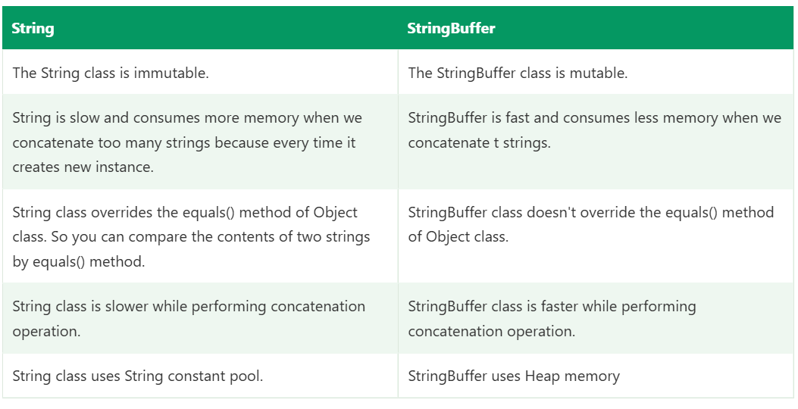

Difference Between StringBuffer and StringBuilder Classes
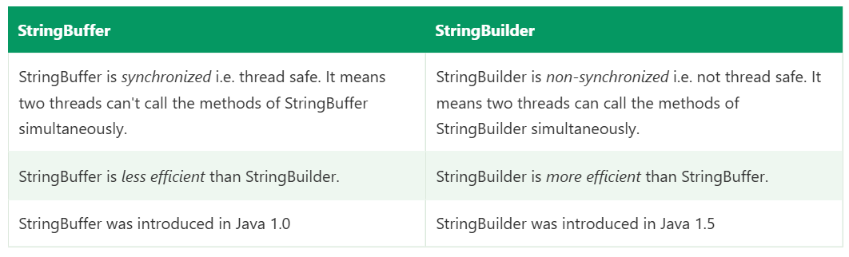

What is the difference between == and equals() for Strings? == compares references, equals() compares content.

== vs equals() for Strings
 | == | equals()
What it is | Operator | Method (Object.equals, overridden by String)
What it compares | Reference (are both variables pointing to the same object in memory?) | Content (do both strings have the same characters in the same order?)
Case sensitive | Not applicable | Yes (equalsIgnoreCase() ignores case)
Null handling | Works with null | null.equals(...) throws NullPointerException

Why they differ
A String variable doesn’t hold the text itself. It holds a reference to a String object. So there are two separate questions you can ask:
- Are these the same object? ==
- Do these objects contain the same text? equals()
The default Object.equals() also compares references, but String overrides it to compare content: first it checks the references, then the length, then each character.

Example 1: String literals (String Pool)
java
String a = "Java";
String b = "Java";

System.out.println(a == b); // true
System.out.println(a.equals(b)); // true
Both literals are stored in the String Constant Pool. The second literal reuses the first object, so both references point to the same object.
a ──┐
├──► [ "Java" ] (one object in the pool)
b ──┘
This is why beginners wrongly conclude == is “fine for Strings”. It only works here by pool sharing.

Example 2: new keyword
java
String a = "Java";
String b = new String("Java");

System.out.println(a == b); // false
System.out.println(a.equals(b)); // true
new String("Java") always creates a fresh object on the heap, even if the pool already has “Java”.
a ──► [ "Java" ] (pool)
b ──► [ "Java" ] (heap, separate object)
Same content, different objects, so == is false and equals() is true.

Example 3: Two new objects
java
String x = new String("Java");
String y = new String("Java");

System.out.println(x == y); // false
System.out.println(x.equals(y)); // true

Example 4: intern()
intern() returns the pooled version of a string.
java
String a = "Java";
String b = new String("Java");

System.out.println(a == b.intern()); // true

Example 5: Runtime-created strings
java
String a = "Hello";
String b = "Hel";
String c = b + "lo"; // built at runtime

System.out.println(a == c); // false
System.out.println(a.equals(c)); // true
Concatenation with a variable happens at runtime and creates a new heap object.
Compile-time constants are different:
java
String d = "Hel" + "lo"; // compiler folds into "Hello"
System.out.println(a == d); // true

final String e = "Hel"; // final constant variable
String f = e + "lo";
System.out.println(a == f); // true (also compile-time constant)
This inconsistent behaviour is exactly why == is unreliable for Strings.

Example 6: Other runtime sources
Strings coming from user input, files, APIs, substring(), StringBuilder.toString() and scanner.nextLine() are new objects, so == fails against literals.
java
String s1 = "admin";
String s2 = new StringBuilder("admin").toString();
String s3 = "ADMIN".toLowerCase();

System.out.println(s1 == s2); // false
System.out.println(s1 == s3); // false
System.out.println(s1.equals(s2)); // true
System.out.println(s1.equals(s3)); // true

Example 7: Case sensitivity and null
java
String a = "Java";
String b = "java";

System.out.println(a.equals(b)); // false
System.out.println(a.equalsIgnoreCase(b)); // true
java
String s = null;

System.out.println(s == null); // true, safe
System.out.println(s.equals("Java")); // NullPointerException

System.out.println("Java".equals(s)); // false, safe
System.out.println(Objects.equals(s, "Java")); // false, null-safe
Putting the literal first ("Java".equals(s)) avoids the NullPointerException. This is a standard best practice.

Framework example
java
String actualTitle = driver.getTitle(); // runtime string
String expectedTitle = "Swag Labs";

if (actualTitle == expectedTitle) { ... } // unreliable, may fail
if (actualTitle.equals(expectedTitle)) { ... } // correct

Assert.assertEquals(actualTitle, expectedTitle); // TestNG uses equals() internally
driver.getTitle() and response.jsonPath().getString("name") return runtime-created strings, never pooled literals. Using == would give false failures even when the text matches.
When I validate API responses or compare UI text, I always use equals() or equalsIgnoreCase(), and "expected".equals(actual) when the actual value might be null.

When == is acceptable
- Checking for null: if (s == null).
- Comparing enum constants or primitives.
- Intentionally checking whether two references are the same object (rare).

Quick reference table
Code | Result | Reason
"a" == "a" | true | Same pooled object
"a" == new String("a") | false | Different objects
"a".equals(new String("a")) | true | Same content
new String("a") == new String("a") | false | Two heap objects
"a" == new String("a").intern() | true | intern() returns pooled object
"a".equals("A") | false | Case sensitive
"a".equalsIgnoreCase("A") | true | Ignores case

Short interview answer
“== compares references, meaning whether two variables point to the same object in memory. equals() compares the actual content. String overrides equals() to compare characters. Two literals with the same text are equal with == too, because the String Pool shares one object, but new String("Java") creates a separate heap object, so == gives false while equals() gives true. Strings built at runtime, like driver.getTitle() or API response values, are also new objects, so I always use equals() or equalsIgnoreCase() for comparison, and put the literal first, like "expected".equals(actual), to avoid a NullPointerException.”

Likely follow-ups
- Does equals() need hashCode()?
-> Yes. If you override equals(), override hashCode() too. Equal objects must have equal hash codes, otherwise HashMap and HashSet break. String already does both.
- What does compareTo() do?
-> It compares Strings lexicographically and returns 0 if equal, a negative number if smaller, a positive number if larger.
- equals() vs contentEquals()?
-> ontentEquals() compares a String with any CharSequence, such as a StringBuilder. equals() requires the argument to be a String.
- Why is StringBuilder.equals() not content-based?
-> StringBuilder doesn’t override equals(), so it uses the Object version (reference comparison). Use sb1.toString().equals(sb2.toString()).
- Do wrapper classes behave the same way?
Integer a = 127, b = 127; a == b is true because of the Integer cache (-128 to 127). With 128, it’s false. Always use equals() for wrappers.
- What is the contract of equals()? Reflexive, symmetric, transitive, consistent, and x.equals(null) must return false.

How to Create an Immutable Class?
The following are the key rules to create an immutable class:
- Declare the class as final
This prevents the class from being extended and modified by subclasses.
- Make all fields private and final
This ensures that fields cannot be changed once they are initialized.
- Initialize fields using a constructor
Set all values at the time of object creation.
- Do not provide setter methods
Avoid methods that can modify the state of the object.
- Return copies of mutable fields (deep copy)
If the class contains mutable objects, return a copy instead of the original reference.

Syntax to Create an Immutable Class
Use the following syntax to create an immutable class by following the above mentioned rules:
- final class ClassName {
- private final dataType field1;
- private final dataType field2;

- public ClassName(dataType field1, dataType field2) {
- this.field1 = field1;
- this.field2 = field2;
- }

- public dataType getField1() {
- return field1;
- }

- public dataType getField2() {
- return field2;
- }
- }

Example of an Immutable Class
The following example demonstrates how to create an immutable Student class:
Java
- final class Student {
- private final int id;
- private final String name;
- private final String course;

- public Student(int id, String name, String course) {
- this.id = id;
- this.name = name;
- this.course = course;
- }

- public int getId() {
- return id;
- }

- public String getName() {
- return name;
- }

- public String getCourse() {
- return course;
- }
- }

- public class TestImmutable {
- public static void main(String[] args) {
- Student s = new Student(101, "Rahul", "Java");
- System.out.println(s.getId() + " " + s.getName() + " " + s.getCourse());
- }
- }
Output:
101 Rahul Java

Explanation:
The Student class is declared as final, its fields are private and final, and no setter methods are provided. This ensures that once a Student object is created, its data cannot be modified, making the class immutable.

Limitations of Immutable Classes
Although immutable classes provide many benefits, they also have some limitations:
- Higher Memory Usage: Every modification creates a new object that can increase memory consumption.
- Performance Overhead: Frequent object creation may affect performance in applications that require many changes.
- Complex Design: Creating immutable classes with mutable fields requires deep copying, which can make the code more complex.
- Not Suitable for All Scenarios: Immutable objects are not ideal when data needs to be updated frequently.

Importance of Deep Copy in Immutable Classes
When an immutable class contains mutable objects (such as arrays, lists, or custom objects), it returns direct references that can break immutability. To prevent this, deep copying is used so that the internal state cannot be modified from outside the class.

Syntax
It has the following syntax:
- public returnType getField() {
- return new returnType(originalField);
- }

Example: Immutable Class Using Deep Copy
The following example demonstrates how deep copy helps maintain immutability:
Java
- final class Student {
- private final int id;
- private final String name;
- private final int[] marks;

- public Student(int id, String name, int[] marks) {
- this.id = id;
- this.name = name;
- this.marks = marks.clone(); // deep copy
- }

- public int getId() {
- return id;
- }

- public String getName() {
- return name;
- }

- public int[] getMarks() {
- return marks.clone(); // deep copy
- }
- }

- public class TestDeepCopy {
- public static void main(String[] args) {
- int[] marks = {80, 85, 90};
- Student s = new Student(101, "Amit", marks);

- marks[0] = 50; // modifying original array
- System.out.println(s.getMarks()[0]); // remains unchanged
- }
- }
Output:
80

Explanation:
In this above example, even though the original array is modified, the internal state of the Student object remains unchanged because deep copies are used.

Java toString() Method :
The toString() method in Java is a built-in method defined in the java.lang.Object class. It is used to represent an object as a string. It returns the string representation of an object.
When we print an object by using the System.out.println() method, the Java compiler internally calls the toString() method on that object. By overriding the toString() method, we can return a meaningful output, such as the current state or data of the object, instead of the default class name and hash code.

Syntax: public String toString()
The method returns the ClassName@HexHashCode.
Note that the Object class is the parent class of every class. All the classes inherit the object class methods directly or indirectly. Therefore, every single object in Java has access to this method.

Understanding the Problem Without toString() Method
By default, if we print an object in Java, it prints the reference value of that object instead of actual data. It happens because Java internally calls the toString() method of the Object class that returns the class name followed by a hashcode.

Example: Converting Object into String
Java
- class Main {
- int rollno;
- String name;
- String city;
- Main (int rollno, String name, String city) {
- this.rollno = rollno;
- this.name = name;
- this.city = city;
- }
- public static void main(String args[]) {
- Main s1 = new Main(101, "James", "London");
- Main s2 = new Main(102, "Jennifer", "Canada");
- System.out.println(s1); // internally calls s1.toString()
- System.out.println(s2); // internally calls s2.toString()
- }
- }
Output:
Main@d716361
Main@6ff3c5b5

As we can see, printing s1 and s2 displays only the class name and hashcode, not the actual values of the object fields. This output is not very useful when we want to see the object’s data.

How the toString() Method Improves Object Output?
To print meaningful information, we can override the toString() method in our class and return the desired object details.

Example: Overriding toString() Method
Java
- class Main {
- int rollno;
- String name;
- String city;
- Main(int rollno, String name, String city) {
- this.rollno = rollno;
- this.name = name;
- this.city = city;
- }
- // Overriding the toString() method
- public String toString() {
- return rollno + " " + name + " " + city;
- }
- public static void main(String args[]) {
- Main s1 = new Main(101, "James", "London");
- Main s2 = new Main(102, "Jennifer", "Canada");
- System.out.println(s1); // internally calls s1.toString()
- System.out.println(s2); // internally calls s2.toString()
- }
- }
Output:
101 James London
102 Jennifer Canada

Explanation
In this program, the toString() method is overridden to return the values of rollno, name, and city. When the object is printed, Java internally calls the overridden toString() method, which results in a clear and meaningful output instead of a reference value.

Important Points to Remember
- Always override the toString() in custom classes.
- Include key fields that describe the object’s state.
- Use String.format() or StringBuilder for readability.
- Avoid exposing sensitive data (like passwords).
- Keep output concise but informative.

Exception Handling in Java :
In Java, an exception is an event that occurs during the execution of a program and disrupts the normal flow of instructions. Exception Handling is a mechanism that allows a program to handle runtime errors such as ClassNotFoundException, IOException, SQLException, RemoteException, and others, so that the normal flow of the application can be maintained.

Hierarchy of Java Exception Classes
Exceptions are represented by classes, and all exception classes are part of the java.lang package. They are organized in a hierarchical structure with Throwable at the top. The main hierarchy is as follows:
- Throwable: The superclass of all errors and exceptions in Java.
  - Error: Represents serious system errors that applications usually cannot handle (e.g., OutOfMemoryError).
  - Exception: Represents conditions that a program might want to catch.
    - Checked Exceptions: Must be either handled using try-catch or declared using throws (e.g., IOException, SQLException).
    - Unchecked Exceptions (RuntimeException): Do not need explicit handling, typically caused by programming errors (e.g., NullPointerException, ArithmeticException).
The following diagram demonstrates the same:
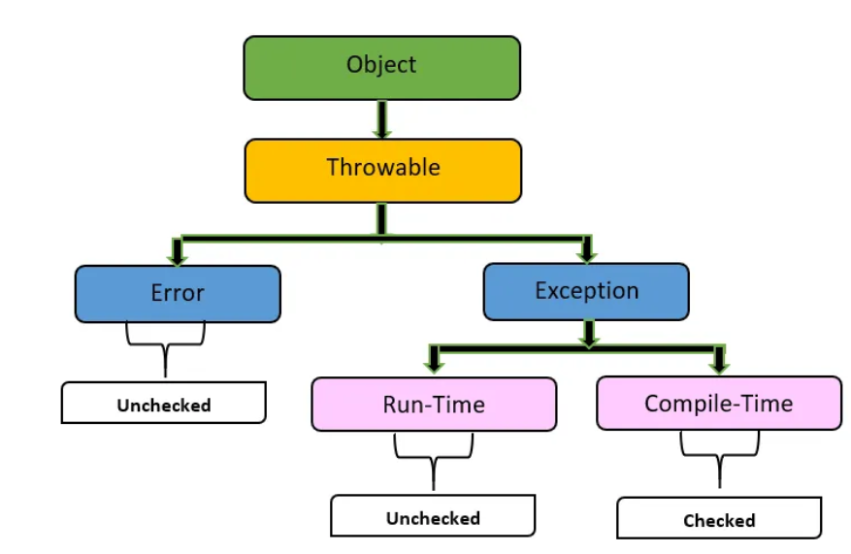
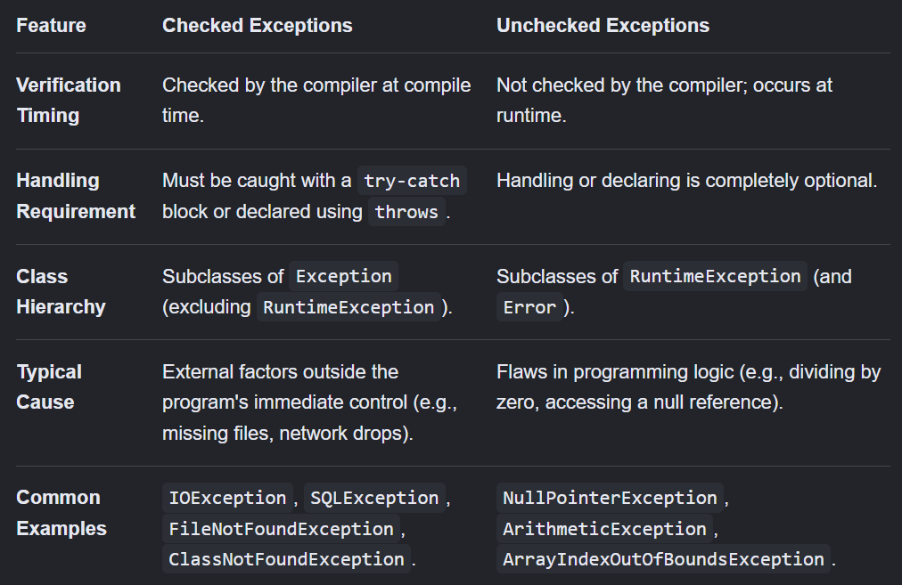
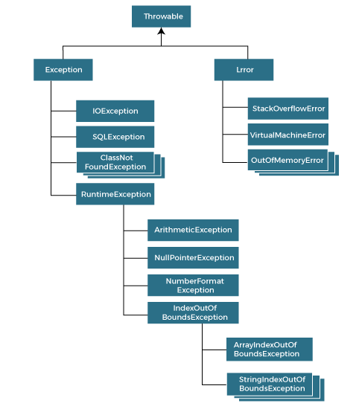

Types of Java Exceptions
The exceptions are categorized into two main types: checked exceptions and unchecked exceptions. Additionally, there is a third category known as errors. Let's delve into each of these types:
- Checked Exception: Exceptions that must be handled or declared in the code.
- Unchecked Exception: Exceptions that do not require explicit handling and usually occur due to programming errors.
- Error: Serious problems that are not meant to be caught by applications, usually system-related.

Types of exceptions

1. Checked exceptions
Checked by the compiler. You must either handle them (try-catch) or declare them (throws). Otherwise it’s a compile error. They are subclasses of Exception but not of RuntimeException.
Examples: IOException, FileNotFoundException, SQLException, InterruptedException, ClassNotFoundException.
java
FileReader fr = new FileReader("data.txt"); // compile error: unreported FileNotFoundException

2. Unchecked exceptions
Subclasses of RuntimeException. The compiler doesn’t force handling. They usually indicate programming bugs.
Examples: NullPointerException, ArithmeticException, ArrayIndexOutOfBoundsException, ClassCastException, NumberFormatException, IllegalArgumentException.
In Selenium, NoSuchElementException, TimeoutException, StaleElementReferenceException and WebDriverException are all unchecked.

3. Errors
Subclasses of Error. They represent serious JVM-level problems, such as OutOfMemoryError and StackOverflowError. You normally don’t catch them, because the program can’t recover.
 | Checked | Unchecked | Error
Parent | Exception | RuntimeException | Error
Compiler enforces handling | Yes | No | No
Typical cause | External problem (file, network, DB) | Programming bug | JVM / system failure
Recoverable | Usually | Often avoidable | No

The five keywords

1. try
Contains the code that may throw an exception. Must be followed by catch or finally.

2. catch
Handles a specific exception type.

3. finally
Always runs, whether or not an exception occurred (used for cleanup).

4. throw
Explicitly throws an exception object.

5. throws
Declares in the method signature that the method may throw an exception.
java
public class Demo {
static void divide(int a, int b) {
try {
int result = a / b;
System.out.println("Result: " + result);
} catch (ArithmeticException e) {
System.out.println("Cannot divide by zero: " + e.getMessage());
} finally {
System.out.println("Cleanup done");
}
}

public static void main(String[] args) {
divide(10, 2);
divide(10, 0);
}
}
Output:
Result: 5
Cleanup done
Cannot divide by zero: / by zero
Cleanup done

Multiple catch blocks
Order matters: specific exceptions first, general last. A parent catch before a child catch is a compile error, because the child block would be unreachable.
java
try {
String s = null;
s.length();
} catch (NullPointerException e) {
System.out.println("NPE");
} catch (RuntimeException e) {
System.out.println("Runtime");
} catch (Exception e) {
System.out.println("General");
}
Multi-catch (Java 7+): handle several unrelated exceptions in one block with |.
java
catch (NullPointerException | ArithmeticException e) {
System.out.println("Handled: " + e);
}
The types in multi-catch can’t be related by inheritance.

Nested try-catch
java
try {
try {
int[] arr = new int[3];
arr[5] = 10; // inner catch handles this
} catch (ArrayIndexOutOfBoundsException e) {
System.out.println("Inner: " + e.getMessage());
}
int x = 10 / 0; // outer catch handles this
} catch (ArithmeticException e) {
System.out.println("Outer: " + e.getMessage());
}

throw vs throws
java
// throw: actually throws an exception object, inside a method body
static void checkAge(int age) {
if (age < 18) {
throw new IllegalArgumentException("Age must be 18+");
}
}

// throws: declares that the method may pass the exception to its caller
static void readFile() throws IOException {
FileReader fr = new FileReader("data.txt");
}

 | throw | throws
Purpose | Throws an exception | Declares possible exceptions
Location | Inside method body | Method signature
Followed by | An exception object | Exception class names (one or more)
Count | One at a time | Multiple, comma separated
Checked exceptions | Must be handled or declared | Passes handling responsibility to the caller

finally block
Runs whether an exception occurs or not, used for cleanup.
java
WebDriver driver = null;
try {
driver = new ChromeDriver();
driver.get("https://example.com");
} catch (Exception e) {
System.out.println("Test failed: " + e.getMessage());
} finally {
if (driver != null) driver.quit(); // always closes the browser
}
It does not run if System.exit() is called or the JVM crashes. A return inside finally overrides the try return and swallows exceptions, so avoid it.

try-with-resources (Java 7+)
Automatically closes resources that implement AutoCloseable, with no finally needed.
java
try (FileInputStream fis = new FileInputStream("testdata.xlsx");
Workbook wb = new XSSFWorkbook(fis)) {
// use workbook
} catch (IOException e) {
e.printStackTrace();
}
// fis and wb are closed automatically, in reverse order of creation
If both the body and close() throw, the body’s exception is primary and the close exception is attached as a suppressed exception (e.getSuppressed()).

Custom (user-defined) exceptions
Create your own by extending Exception (checked) or RuntimeException (unchecked).
java
class InvalidResponseException extends RuntimeException {
public InvalidResponseException(String message) {
super(message);
}
public InvalidResponseException(String message, Throwable cause) {
super(message, cause);
}
}

static void validate(int statusCode) {
if (statusCode != 200) {
throw new InvalidResponseException("Expected 200 but got " + statusCode);
}
}
Use custom exceptions to give meaningful names to business or framework failures, such as ConfigNotFoundException or ElementNotLoadedException.

Exception propagation
If a method doesn’t handle an exception, it passes to the caller, and so on up the call stack, until something catches it or it reaches the JVM, which prints the stack trace and terminates the thread.
java
static void m3() { int x = 10 / 0; }
static void m2() { m3(); }
static void m1() { try { m2(); } catch (ArithmeticException e) { System.out.println("Handled in m1"); } }
- Unchecked exceptions propagate automatically.
- Checked exceptions propagate only if each method declares throws.

Useful Throwable methods
Method | Use
getMessage() | The error message
getCause() | The underlying exception
printStackTrace() | Prints the full stack trace to stderr
getStackTrace() | Stack trace as an array
toString() | Class name plus message
getSuppressed() | Suppressed exceptions from try-with-resources

Common exceptions and causes
Exception | Cause
NullPointerException | Using a reference that is null
ArithmeticException | Divide by zero
ArrayIndexOutOfBoundsException | Invalid array index
StringIndexOutOfBoundsException | Invalid string index
NumberFormatException | Integer.parseInt("abc")
ClassCastException | Invalid downcast
IllegalArgumentException | Invalid method argument
ConcurrentModificationException | Modifying a collection while iterating
FileNotFoundException | File doesn’t exist
InterruptedException | Thread interrupted while sleeping/waiting

Framework usage
Selenium
java
try {
wait.until(ExpectedConditions.visibilityOfElementLocated(By.id("login")));
} catch (TimeoutException e) {
takeScreenshot("login_timeout");
throw e; // rethrow so the test still fails
}
java
try {
element.click();
} catch (StaleElementReferenceException e) {
element = driver.findElement(locator); // re-locate and retry
element.click();
}
REST Assured
java
try {
String id = response.jsonPath().getString("bookingid");
} catch (JsonPathException e) {
throw new InvalidResponseException("Invalid JSON: " + response.asString(), e);
}
Utilities: ConfigReader wraps IOException in a RuntimeException with a clear message. TestNG: failed assertions throw AssertionError, which the listener catches to capture screenshots.

Best practices
- Catch specific exceptions, not Exception or Throwable, unless at the top level.
- Never leave an empty catch block. At least log it.
- Don’t swallow exceptions in tests. A catch that only prints can make a failed test pass. Rethrow or fail the test.
- Use finally or try-with-resources for cleanup.
- Preserve the cause when wrapping: throw new RuntimeException("msg", e).
- Don’t use exceptions for normal flow control. They are slow and hard to read.
- Use unchecked exceptions for programming errors, checked for recoverable conditions the caller must handle.
- Log once, at the point where you handle it, to avoid duplicate stack traces.

Short interview answer
“Exception handling is the mechanism to handle runtime errors so the program doesn’t terminate abnormally. All exceptions come from Throwable, which splits into Error, for JVM problems we don’t handle, and Exception. Exceptions are either checked, which the compiler forces us to handle or declare, like IOException, or unchecked, which extend RuntimeException, like NullPointerException. We use try for risky code, catch to handle it with specific exceptions first, finally for cleanup that always runs, throw to throw an exception explicitly, and throws to declare it in the method signature. Java 7 added try-with-resources and multi-catch. In my framework, I use finally to quit the driver, catch TimeoutException to capture screenshots and rethrow, wrap IOException from config loading in a custom runtime exception, and never leave empty catch blocks so test failures aren’t hidden.”

Likely follow-ups
- Checked vs unchecked? Checked are enforced by the compiler, unchecked are not.
- final vs finally vs finalize? final is a modifier, finally is a block that always runs, finalize() is a deprecated GC hook.
- Can try exist without catch? Yes, with finally or as try-with-resources.
- Can we catch Throwable or Error? Yes, but we shouldn’t, apart from top-level logging.
- What happens if both catch and finally throw? The exception from finally replaces the earlier one, hiding the original.
- Rules for overriding with exceptions? An overriding method can’t throw broader checked exceptions than the parent’s, but can throw any unchecked one, or none.
- What is exception chaining? Passing the original exception as the cause when throwing a new one, so the root cause is kept.
- What is StackOverflowError caused by? Infinite or very deep recursion.
- Can we rethrow an exception? Yes, throw e; inside the catch block, optionally wrapped in another exception.

finally Block in Java :
In Java, the finally block is used to execute important code such as closing files or releasing resources, regardless of whether an exception occurs or not. In this chapter, we will learn about the finally block along with the examples.

What is the Finally Block in Java?
The finally block is a block of code that always executes after a try block, whether an exception is thrown or not. The finally block is useful when you want to cleanup activities or free the resources, like closing files, streams, or database connections.

Key Points
The following key points of the finally block are as follows:
- A finally block is optional, but when present, it always executes after the try and catch blocks.
- It executes even if a return statement is encountered in the try or catch blocks.
The finally block contains code that always executes after the try (and catch) block, whether or not an exception occurred. Its main purpose is cleanup: closing the browser, files, streams and DB connections.

Syntax
java
try {
// risky code
} catch (ExceptionType e) {
// handle exception
} finally {
// always runs
}
Valid combinations:
Combination | Allowed?
try + catch | Yes
try + finally | Yes (exception still propagates after finally runs)
try + catch + finally | Yes
try alone | No (except try-with-resources)
finally without try | No

Example 1: No exception
java
try {
System.out.println("In try");
int a = 10 / 2;
} catch (ArithmeticException e) {
System.out.println("In catch");
} finally {
System.out.println("In finally");
}
Output:
In try
In finally

Example 2: Exception occurs and is handled
java
try {
System.out.println("In try");
int a = 10 / 0;
} catch (ArithmeticException e) {
System.out.println("In catch");
} finally {
System.out.println("In finally");
}
Output:
In try
In catch
In finally

Example 3: Exception occurs and is NOT handled
java
try {
int a = 10 / 0;
} finally {
System.out.println("In finally");
}
System.out.println("After"); // never reached
Output:
In finally
Exception in thread "main" java.lang.ArithmeticException: / by zero
finally runs first, then the exception propagates and the program stops.

Example 4: return in try
java
static int test() {
try {
return 1;
} finally {
System.out.println("finally runs");
}
}

System.out.println(test());
Output:
finally runs
1
The return value is evaluated and saved, then finally runs, then the method returns.

Example 5: Return inside finally overrides
java
static int test() {
try {
return 1;
} finally {
return 2; // overrides, and discards any exception
}
}
System.out.println(test()); // 2
Never return from finally. It hides exceptions and the original return value.

Example 6: Modifying a variable in finally
java
static int test() {
int x = 10;
try {
return x; // value 10 is saved
} finally {
x = 20; // does not change the returned value
}
}
System.out.println(test()); // 10
For a mutable object (like a list or StringBuilder), the change would be visible, because the reference is returned.

Example 7: Framework usage
java
WebDriver driver = null;
try {
driver = new ChromeDriver();
driver.get("https://www.saucedemo.com");
// test steps
} catch (Exception e) {
System.out.println("Test failed: " + e.getMessage());
} finally {
if (driver != null) {
driver.quit(); // browser always closed, no orphan processes
}
}
REST Assured cleanup:
java
String bookingId = null;
try {
bookingId = given().body(payload).post("/booking").jsonPath().getString("bookingid");
given().get("/booking/" + bookingId).then().statusCode(200);
} finally {
if (bookingId != null) {
given().header("Cookie", "token=" + token).delete("/booking/" + bookingId);
}
}



When finally does NOT run :
- System.exit() is called in try or catch.
- The JVM crashes (fatal error, power failure, killed process).
- The thread is killed, or it is a daemon thread and the JVM exits.
- An infinite loop or a deadlock occurs inside try/catch.
java
try {
System.exit(0);
} finally {
System.out.println("Never printed");
}

Execution flow
try ─── no exception ───────────────► finally ──► continue
│
└── exception ── matching catch ──► finally ──► continue
│
└── exception ── no matching catch ─► finally ──► exception propagates

Interview questions and answers
1. Is finally always executed?
Almost always. It runs whether or not an exception occurs, and even if try or catch has a return. The exceptions are System.exit(), a JVM crash, or the thread being killed.
2. Can we have try without catch?
Yes, if there is a finally block (or it’s try-with-resources). The exception propagates after finally runs.
3. Can we have multiple finally blocks for one try?
No. A try can have only one finally. Multiple catch blocks are allowed.
4. What happens if there is a return in both try and finally?
The finally return wins and overrides the one in try. It also swallows any exception thrown in try, so avoid it.
5. What happens if finally throws an exception?
It replaces any exception from try or catch, so the original exception is lost. Keep cleanup code defensive:
java
finally {
try { if (fis != null) fis.close(); } catch (IOException ignored) { }
}
6. Does finally run if an exception is not caught?
Yes. finally runs, then the exception propagates to the caller.
7. Can we write code between try, catch and finally?
No. They must be placed together, with nothing in between, or it’s a compile error.
8. Difference between final, finally and finalize()?
 | final | finally | finalize()
Type | Keyword / modifier | Block | Method of Object
Purpose | Restrict variable, method or class | Always-run cleanup | Called by GC before object removal
Status | Active | Active | Deprecated (Java 9), don’t use
9. Can finally change the value being returned?
Not for primitives or immutable types, because the return value is already saved. For mutable objects, changes to the object’s state are visible through the returned reference.
10. Can we skip finally?
Only by System.exit() or killing the JVM. There is no other way.
11. What is the order when try, catch and finally all have print statements and an exception occurs?
try (up to the failing line), then catch, then finally.
12. Can finally be used with try-with-resources?
Yes. The resources are closed first, then any catch runs, then finally.
java
try (FileInputStream fis = new FileInputStream("a.txt")) {
// use
} catch (IOException e) {
System.out.println("catch");
} finally {
System.out.println("finally"); // runs after the resource is closed
}
13. What if an exception occurs in catch, and there is a finally?
finally still runs, then the new exception propagates.
14. Can we nest try-catch-finally?
Yes. Each inner finally runs when its inner try completes.
15. Why use finally instead of putting cleanup after the try-catch?
Code after try-catch is skipped if an exception isn’t caught, or if try/catch returns or rethrows. finally runs in all those cases.
16. finally vs try-with-resources?
Try-with-resources auto-closes AutoCloseable objects, is shorter, and keeps the original exception (close exceptions become suppressed). Use finally for non-AutoCloseable cleanup such as quitting a driver or deleting test data.
17. Output of this? (classic)
java
static int test() {
try {
throw new RuntimeException();
} catch (Exception e) {
return 1;
} finally {
System.out.println("finally");
}
}
System.out.println(test());
Output: finally then 1. The catch return value is saved, finally runs, then the value is returned.
18. Where have you used finally in your framework?
To quit the WebDriver, close Excel and file streams, delete test data created through API calls, switch back from iframes, and call ThreadLocal.remove() after parallel execution.

Best practices
- Use it for cleanup only, not for business logic.
- Never return or throw from finally.
- Null-check resources before closing.
- Prefer try-with-resources for AutoCloseable objects.
- In TestNG, @AfterMethod or @AfterClass is the better place for driver teardown. Use finally in utilities and standalone code.

Short interview answer
“The finally block holds code that always executes after try and catch, whether or not an exception occurred, and even if there is a return in try or catch. It’s used for cleanup such as quitting the WebDriver, closing files and DB connections, and deleting test data. It does not run only when System.exit() is called or the JVM crashes. A try can have one finally, and it can be used without catch. I avoid return or throw inside finally, because they override the original return value and hide exceptions. For AutoCloseable resources I prefer try-with-resources.”

Difference Between throw and throws Keywords:

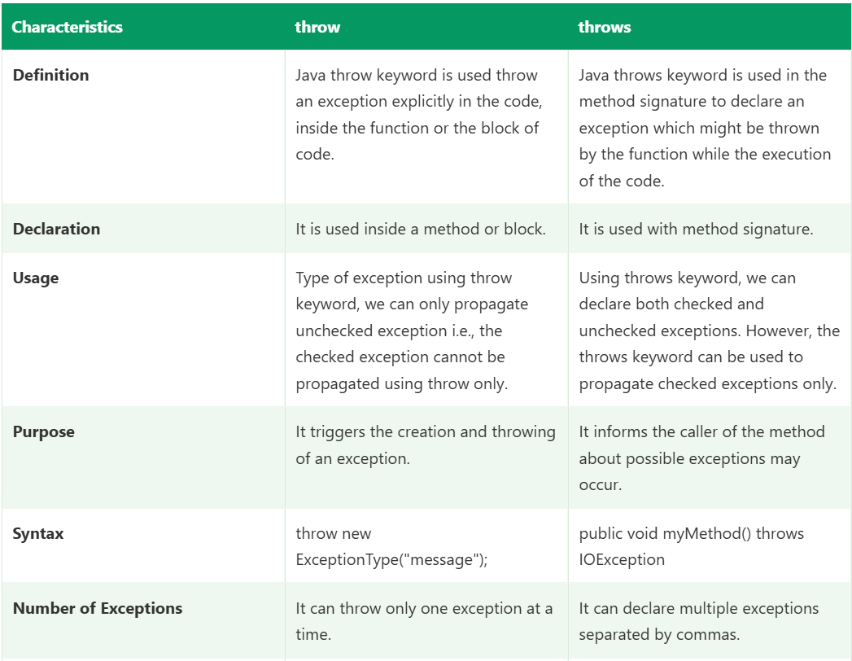
Difference Between final Vs. finally Vs finalize() :
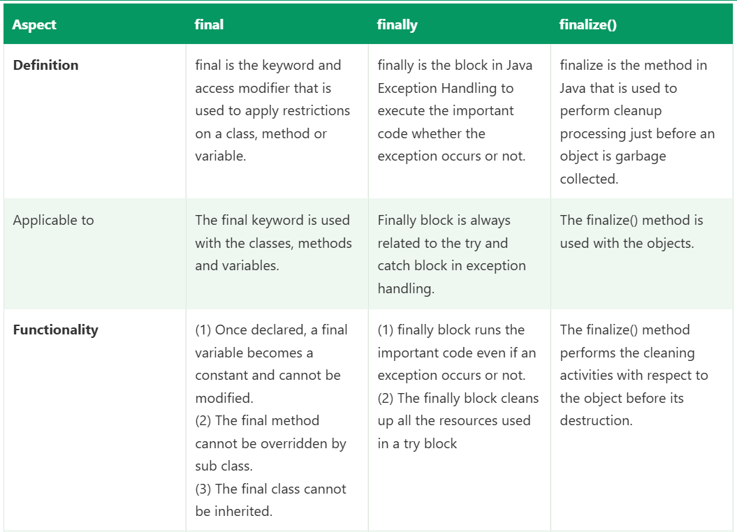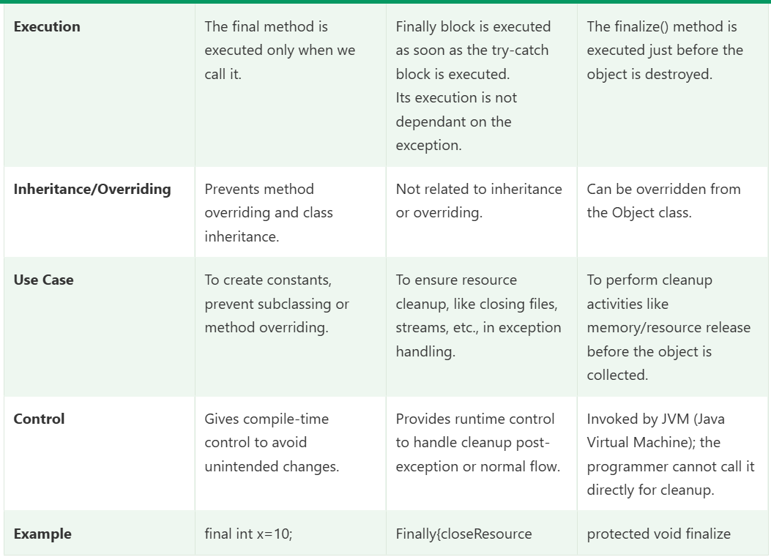

Exception Propagation in Java
Exception propagation is the process by which an exception that is not handled in the method where it occurred is passed to the calling method, then to that method’s caller, and so on down the call stack, until a matching catch block handles it or it reaches the JVM.
main() ──► m1() ──► m2() ──► m3() exception occurs here
│
not handled in m3 ──► passed to m2 ──► passed to m1 ──► passed to main ──► JVM
If nobody handles it, the default exception handler of the JVM prints the stack trace and terminates the thread (the program, if it’s the main thread).

Call stack basics
Each method call adds a frame to the call stack. When a method finishes, its frame is removed. When an exception is thrown, the JVM looks for a handler in the current frame. If none is found, the frame is popped and the search continues in the caller’s frame.

Example 1: Propagation of an unchecked exception
java
public class Demo {
static void m3() {
int x = 10 / 0; // exception occurs here
}

static void m2() {
m3(); // no handling, propagates
}

static void m1() {
try {
m2();
} catch (ArithmeticException e) { // handled here
System.out.println("Handled in m1: " + e.getMessage());
}
}

public static void main(String[] args) {
m1();
System.out.println("Program continues");
}
}
Output:
Handled in m1: / by zero
Program continues
The exception started in m3, passed through m2 (which had no handler), and was caught in m1. The code after the exception point in m3 and m2 never ran, but the program continued normally after m1.

Example 2: Not handled anywhere
java
static void m3() { int x = 10 / 0; }
static void m2() { m3(); }
static void m1() { m2(); }

public static void main(String[] args) {
m1();
System.out.println("Never printed");
}
Output:
Exception in thread "main" java.lang.ArithmeticException: / by zero
at Demo.m3(Demo.java:2)
at Demo.m2(Demo.java:3)
at Demo.m1(Demo.java:4)
at Demo.main(Demo.java:7)
The stack trace shows exactly the path of propagation, from where it occurred (top) to main (bottom). The JVM terminates the program.

Checked vs unchecked propagation
 | Unchecked (RuntimeException, Error) | Checked (IOException, SQLException...)
Propagates automatically | Yes, no declaration needed | No, each method must declare throws (or handle it)
Compiler enforcement | None | Compile error if neither handled nor declared

Checked exception example
java
static void m3() throws IOException {
throw new IOException("File problem");
}

static void m2() throws IOException { // must declare, else compile error
m3();
}
static void m1() {
try {
m2();
} catch (IOException e) {
System.out.println("Handled in m1: " + e.getMessage());
}
}
If m2 neither declares throws IOException nor catches it, the compiler reports “unreported exception IOException”. So a checked exception propagates only when every method in the chain declares it.

What stops propagation
- A matching catch block (same type or a parent type).
- Reaching the JVM, which terminates the thread.
A catch for an unrelated type does not stop it:
java
try {
int x = 10 / 0;
} catch (NullPointerException e) { // wrong type
System.out.println("NPE");
}
// ArithmeticException keeps propagating

Propagation with finally
finally blocks run in each method as the exception passes through.
java
static void m2() {
try {
int x = 10 / 0;
} finally {
System.out.println("m2 finally");
}
}
static void m1() {
try {
m2();
} catch (ArithmeticException e) {
System.out.println("m1 catch");
} finally {
System.out.println("m1 finally");
}
}
Output:
m2 finally
m1 catch
m1 finally

Rethrowing and wrapping
A method can catch an exception, do something (log, screenshot, cleanup), then continue the propagation by rethrowing it or wrapping it.
java
static void readConfig() {
try {
new FileInputStream("config.properties");
} catch (FileNotFoundException e) {
throw new RuntimeException("Config file missing", e); // wrapped, cause preserved
}
}
java
catch (TimeoutException e) {
takeScreenshot();
throw e; // rethrow, still propagates upward
}
Wrapping a checked exception in an unchecked one lets it propagate without throws clauses in every method.

Propagation across overriding
An overriding method cannot declare a broader checked exception than the parent method. This keeps propagation predictable for callers using the parent type.

Framework example
java
// Page object: no handling, lets the failure propagate
public void clickLogin() {
driver.findElement(loginBtn).click(); // may throw NoSuchElementException
}
// Test method
@Test
public void loginTest() {
loginPage.clickLogin(); // exception propagates up to TestNG
}
NoSuchElementException is thrown in the page method, passes through the test method, and reaches TestNG, which marks the test as failed and calls my ITestListener.onTestFailure() to capture a screenshot. Letting it propagate is correct here, because the test should fail. Handling it in the page class and printing it would hide the failure.
A utility layer, however, might handle it:
java
public boolean isElementPresent(By locator) {
try {
return driver.findElement(locator).isDisplayed();
} catch (NoSuchElementException e) {
return false; // handled where a decision can be made
}
}
Rule of thumb: handle an exception at the level that can do something meaningful about it, and let it propagate otherwise.

Summary table
Point | Detail
Definition | An unhandled exception moves up the call stack to the caller
Direction | From the method where it occurred, back through callers, to main, then the JVM
Unchecked | Propagates automatically
Checked | Propagates only if each method declares throws
Stops at | A matching catch block
If never caught | JVM prints the stack trace and terminates the thread
finally | Runs in every method along the way

Short interview answer
“Exception propagation is when an exception that isn’t handled in the method where it occurred is passed to the caller, and then to that caller’s caller, down the call stack, until a matching catch block handles it. If nothing handles it, it reaches the JVM, which prints the stack trace and terminates the thread. Unchecked exceptions propagate automatically, while checked exceptions propagate only if each method in the chain declares them with throws. finally blocks run in each method as the exception passes through. In my framework I let Selenium exceptions like NoSuchElementException propagate from page methods to TestNG so the test fails and my listener captures a screenshot, and I handle exceptions only where I can act on them, such as an isElementPresent utility.”

Likely follow-ups
- Do checked exceptions propagate automatically? No, they need throws in each method signature, or must be handled.
- What is the stack trace? The list of method calls, from the point of the exception back to main, showing the propagation path.
- What is the JVM’s default handler? It prints the exception name, message and stack trace, then terminates the thread.
- Where should you handle an exception? At the layer that can recover or report meaningfully, not necessarily where it occurs.
- What is exception chaining? Passing the original exception as the cause when throwing a new one, so the root cause is preserved while propagating.
- Does propagation work across threads? No. An uncaught exception in one thread terminates only that thread and does not propagate to the thread that started it. Use Future.get() (which throws ExecutionException) or an UncaughtExceptionHandler.
- What happens to code after the exception point? It is skipped in every method along the propagation path, except finally blocks.

Exception Handling with Method Overriding in Java
Exception handling in Java with method overriding defines the rules for how a subclass can handle, restrict, or extend exceptions thrown by an overridden method.

Rules of Exception Handling with Method Overriding
There are many rules if we talk about method overriding with exception handling.
Some of the rules are listed below:
- If the superclass method does not declare an exception
  - If the superclass method does not declare an exception, subclass overridden method cannot declare the checked exception but it can declare unchecked exception.
- If the superclass method declares an exception
  - If the superclass method declares an exception, subclass overridden method can declare same, subclass exception or no exception but cannot declare parent exception.

If the superclass method does not declare an exception

Rule 1
If the superclass method does not declare an exception, subclass overridden method cannot declare the checked exception.

Example
In the following example, the child class attempts to override a parent class method by declaring a checked exception, which results in a compile-time error because the parent method does not throw any exception.
- import java.io.*;
- class Parent{

- // defining the method
- void msg() {
- System.out.println("parent method");
- }
- }

- public class TestExceptionChild extends Parent{

- // overriding the method in child class
- // gives compile time error
- void msg() throws IOException {
- System.out.println("TestExceptionChild");
- }

- public static void main(String args[]) {
- Parent p = new TestExceptionChild();
- p.msg();
- }
- }
Output:
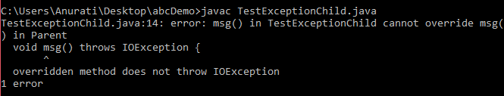

Rule 2
If the superclass method does not declare an exception, subclass overridden method cannot declare the checked exception but can declare unchecked exception.

Example
In the following example, the child class successfully overrides the parent class method by throwing an unchecked exception, which is allowed even though the parent method does not declare any exception.
- import java.io.*;
- class Parent{
- void msg() {
- System.out.println("parent method");
- }
- }

- class TestExceptionChild1 extends Parent{
- void msg()throws ArithmeticException {
- System.out.println("child method");
- }

- public static void main(String args[]) {
- Parent p = new TestExceptionChild1();
- p.msg();
- }
- }
Output:
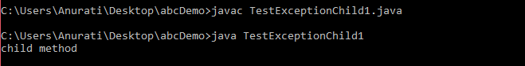

If the superclass method declares an exception
If the superclass method declares an exception, subclass overridden method can declare the same subclass exception or no exception but cannot declare parent exception.

Example: Subclass Overridden Method Declares Parent Exception
In the following example, the child class attempts to override the parent method by declaring a broader checked exception, which causes a compile-time error because an overridden method cannot throw a wider exception than the parent method.
- import java.io.*;
- class Parent{
- void msg()throws ArithmeticException {
- System.out.println("parent method");
- }
- }

- public class TestExceptionChild2 extends Parent{
- void msg()throws Exception {
- System.out.println("child method");
- }

- public static void main(String args[]) {
- Parent p = new TestExceptionChild2();

- try {
- p.msg();
- }
- catch (Exception e){}

- }
- }
Output:
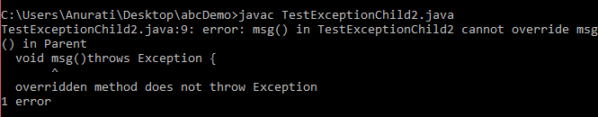

Example: Subclass Overridden Method Declares Same Exception
In the following example, the child class overrides the parent class method by declaring the same exception, which is valid and does not cause any compile-time error.
- import java.io.*;
- class Parent{
- void msg() throws Exception {
- System.out.println("parent method");
- }
- }

- public class TestExceptionChild3 extends Parent {
- void msg()throws Exception {
- System.out.println("child method");
- }

- public static void main(String args[]){
- Parent p = new TestExceptionChild3();

- try {
- p.msg();
- }
- catch(Exception e) {}
- }
- }
Output:
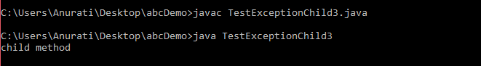

Example: Subclass Overridden Method Declares Subclass Exception
In the following example, the child class overrides the parent method by declaring a subclass (narrower) exception, which is allowed in Java method overriding.
- import java.io.*;
- class Parent{
- void msg()throws Exception {
- System.out.println("parent method");
- }
- }

- class TestExceptionChild4 extends Parent{
- void msg()throws ArithmeticException {
- System.out.println("child method");
- }

- public static void main(String args[]){
- Parent p = new TestExceptionChild4();

- try {
- p.msg();
- }
- catch(Exception e) {}
- }
- }
Output:
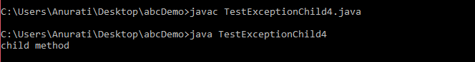

Example: Subclass Overridden Method Declares No Exception
In the following example, the child class overrides the parent method without declaring any exception, which is valid even though the parent method throws an exception.
- import java.io.*;
- class Parent {
- void msg()throws Exception{
- System.out.println("parent method");
- }
- }

- class TestExceptionChild5 extends Parent{
- void msg() {
- System.out.println("child method");
- }

- public static void main(String args[]){
- Parent p = new TestExceptionChild5();

- try {
- p.msg();
- }
- catch(Exception e) {}

- }
- }
Output:
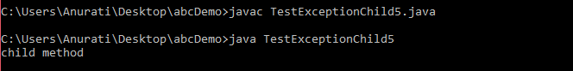

finalize() Method :
A finalize() is a method called by the garbage collector before an object is destroyed. It's used to perform cleanup operations like releasing resources, but it is deprecated and not recommended in modern Java.

Characteristics of finalize() Method
There are several characteristics of the finalize() method.
- Defined in java.lang.Object class: Can be overridden by any class.
- Called by the garbage collector: Just before destroying an object.
- Used for cleanup: Freeing resources like file handles or network sockets.
- Not reliable: No guarantee it will be executed timely or at all.

finalize() Method Example
The following example demonstrate the finalize() method.
- public class Main {
- @Override
- protected void finalize() throws Throwable {
- System.out.println("finalize() method called before object is garbage collected.");
- }
- public static void main(String[] args) {
- Main obj = new Main();
- obj = null; // Eligible for garbage collection
- // Request JVM to run Garbage Collector
- System.gc();
- System.out.println("Main method completed.");
- }
- }
Output:
Main method completed.
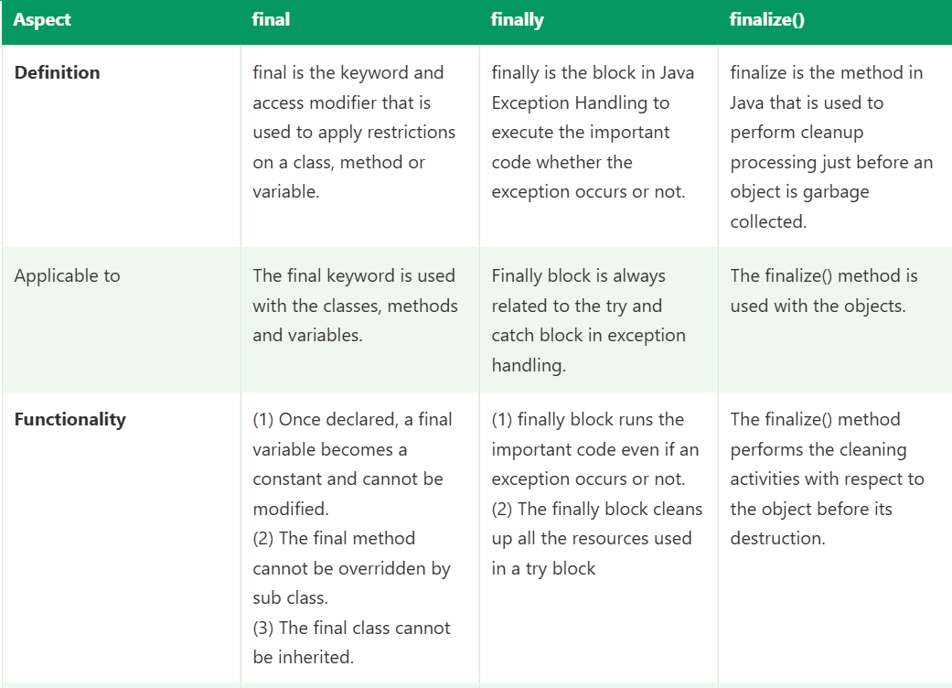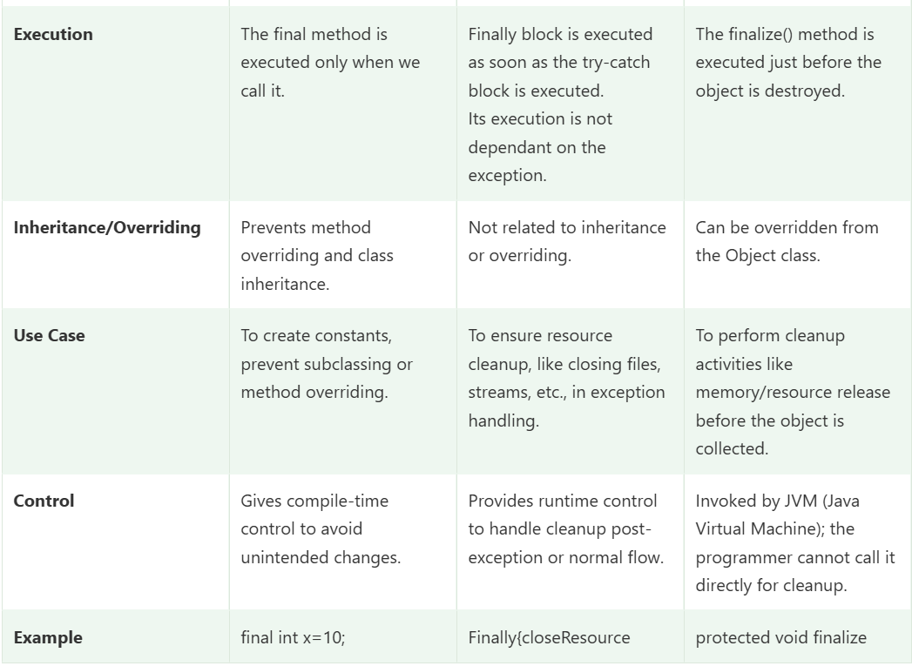

Collections in Java :

Collections are used to store and manage a group of objects. They make it easy to perform common tasks like adding, removing, searching, and sorting data.
In this chapter, you will learn what collections are, how the collection framework works, and why it is important in Java.

What is Collection?
A Collection represents a group of objects. It is used to store multiple values in a single unit so that they can be managed easily.

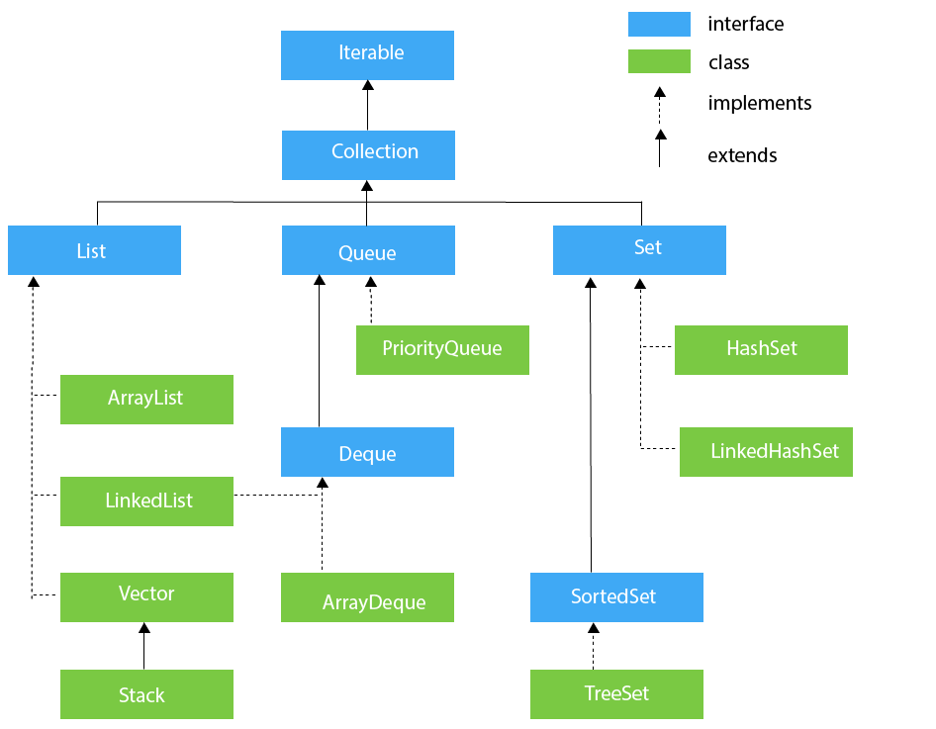

Collection Interface
The Collection interface is the interface which is implemented by all the classes in the collection framework. It declares the methods that every collection will have. In other words, we can say that the Collection interface builds the foundation on which the collection framework depends.
Some of the methods of Collection interface are Boolean add (Object obj), Boolean addAll (Collection c), void clear(), etc. that are implemented by all the subclasses of Collection interface.

Points to Remember
The following are some important points to remember regarding an ArrayList and a LinkedList.
- When the rate of addition or removal rate is more than the read scenarios, then go for the LinkedList. On the other hand, when the frequency of the read scenarios is more than the addition or removal rate, then ArrayList takes precedence over LinkedList.
- Since the elements of an ArrayList are stored more compactly as compared to a LinkedList; therefore, the ArrayList is more cache-friendly as compared to the LinkedList. Thus, the chances of a cache miss are less in an ArrayList as compared to a LinkedList. Generally, it is considered that a LinkedList is poor in cache locality.
- Memory overhead in the LinkedList is more than compared of the ArrayList. It is because, in a LinkedList, we have two extra links (next and previous) as it is required to store the address of the previous and the next nodes, and these links consume additional Such links are not present in an ArrayList.
Difference between Array & ArrayList :
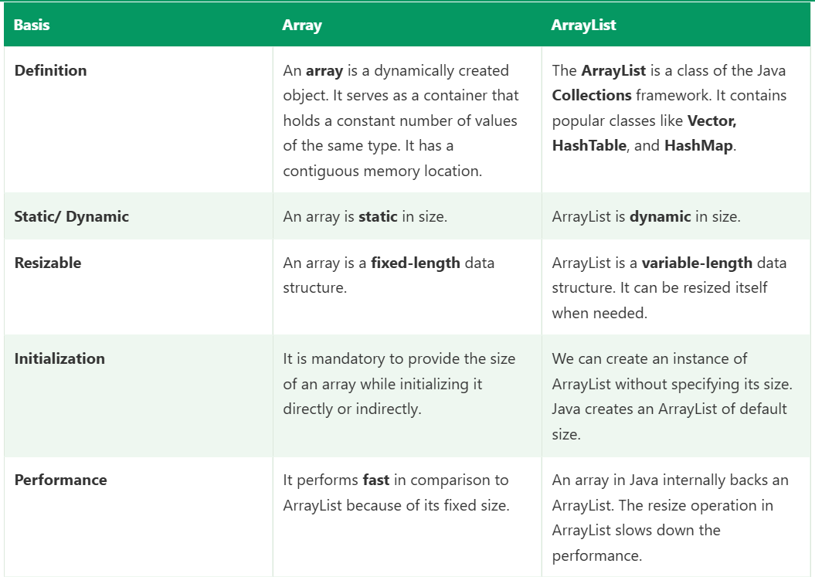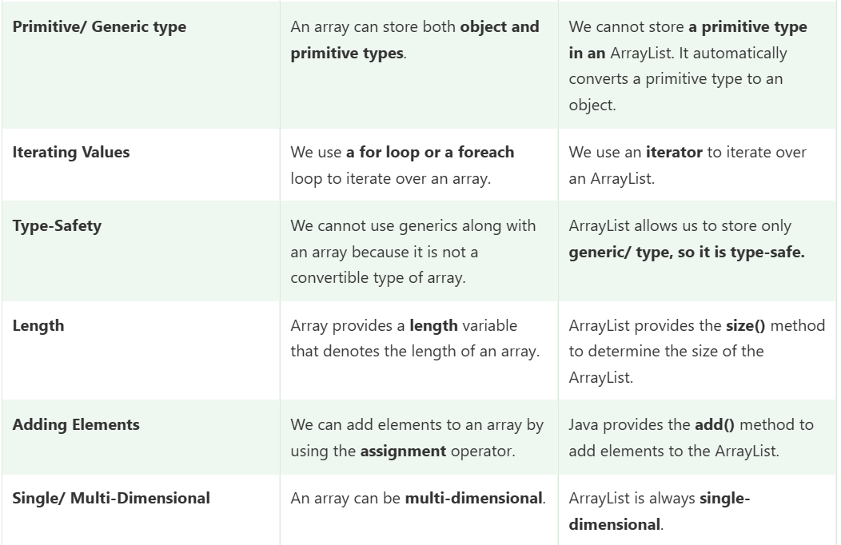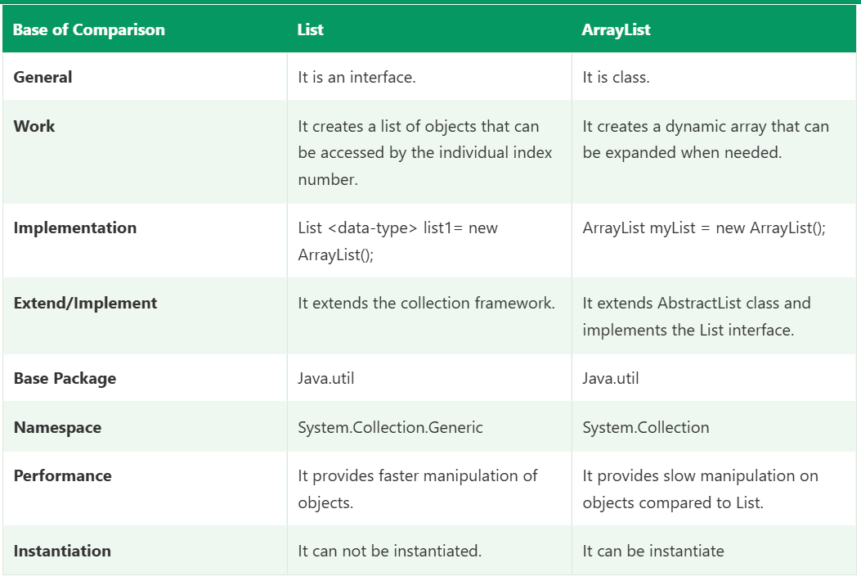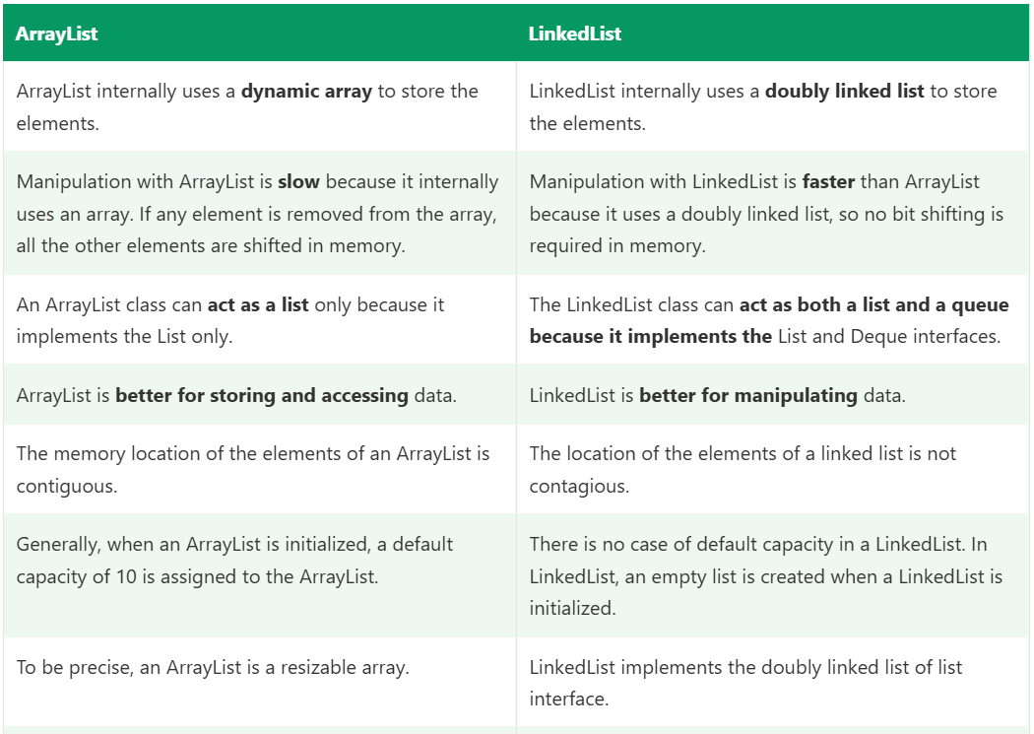

Difference Between HashMap and Hashtable :

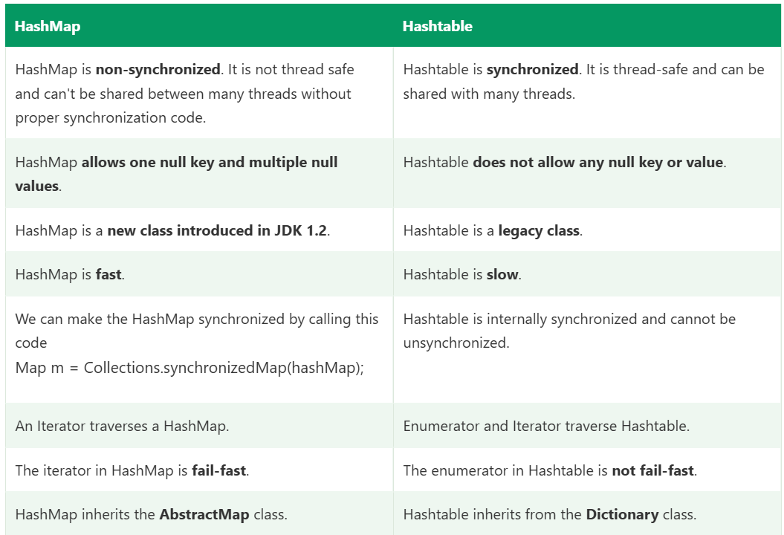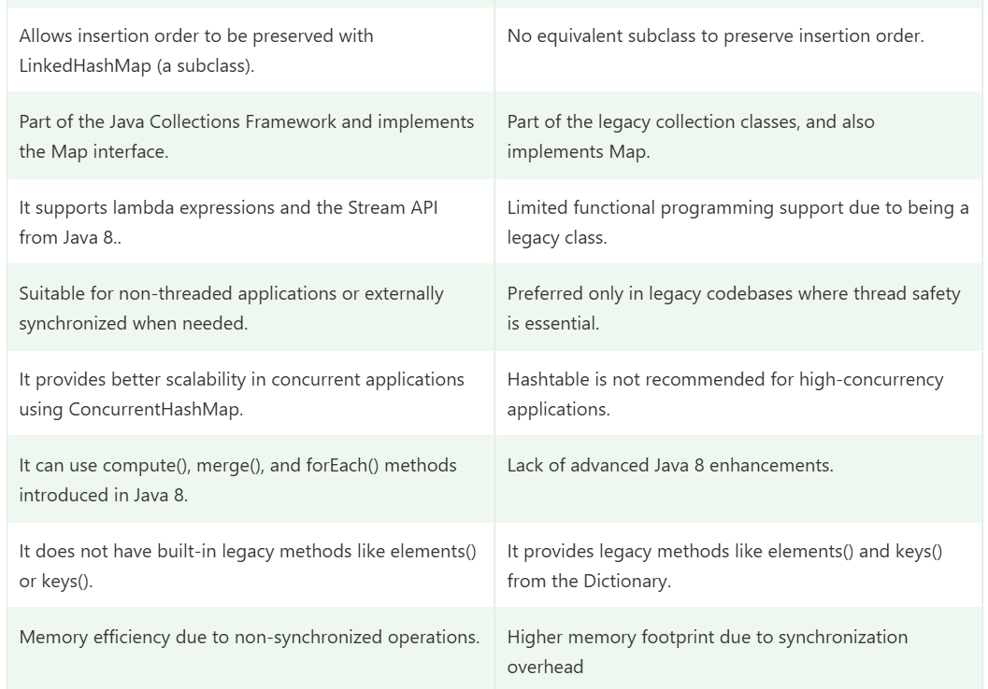

Difference Between Hashmap and ConcurrentHashMap

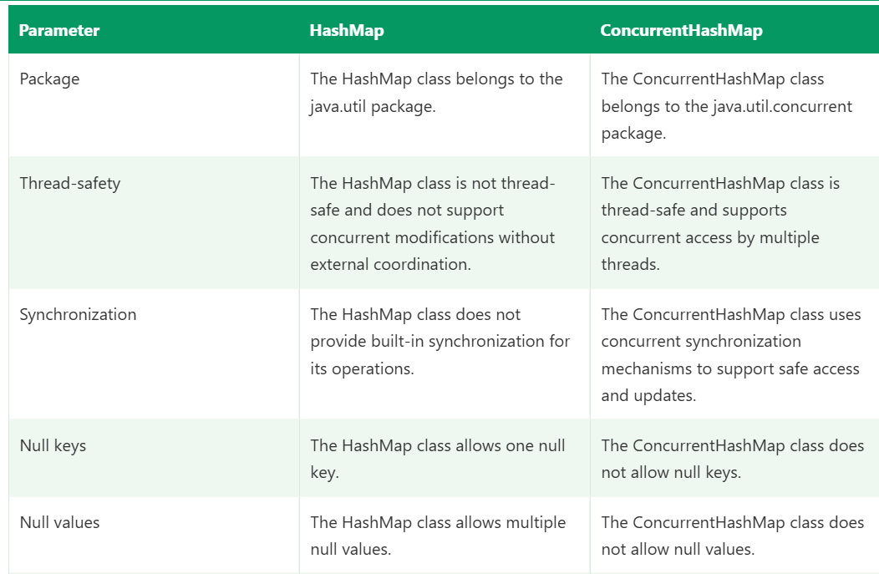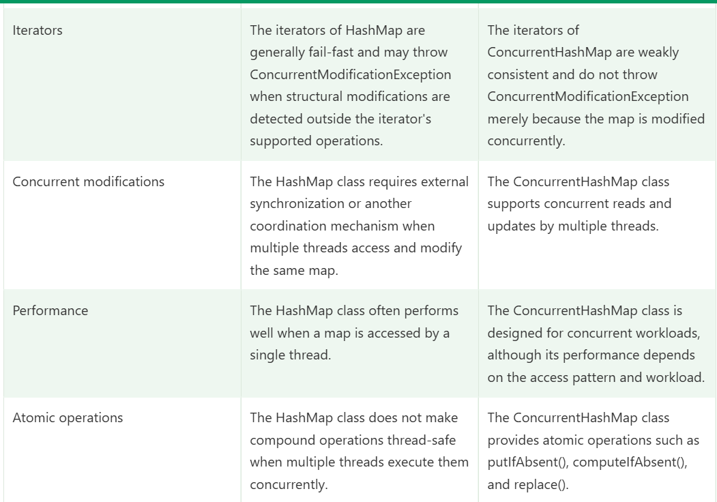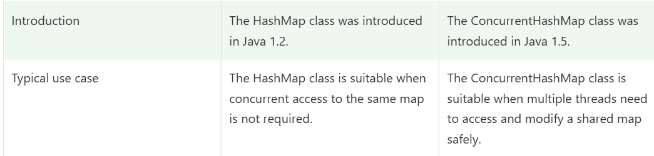

Difference Between Map and HashMap :
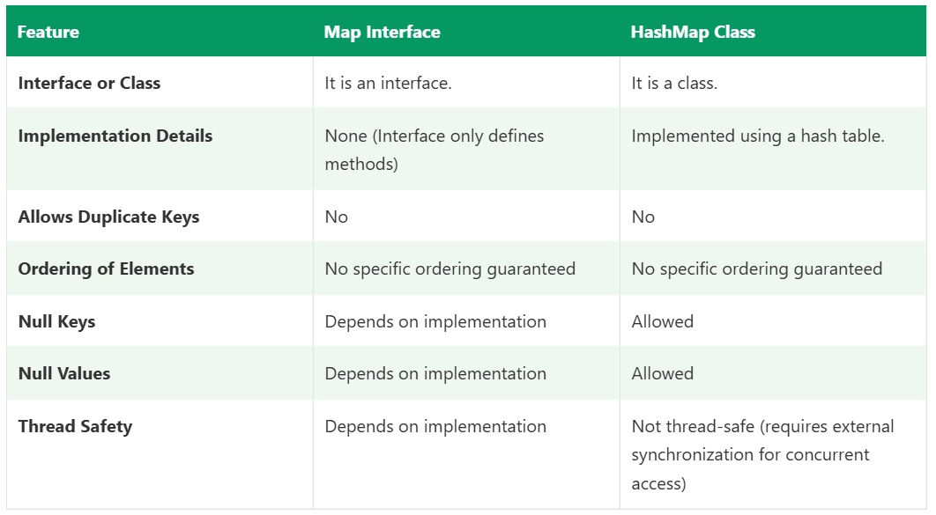

LinkedHashMap Vs. HashMap
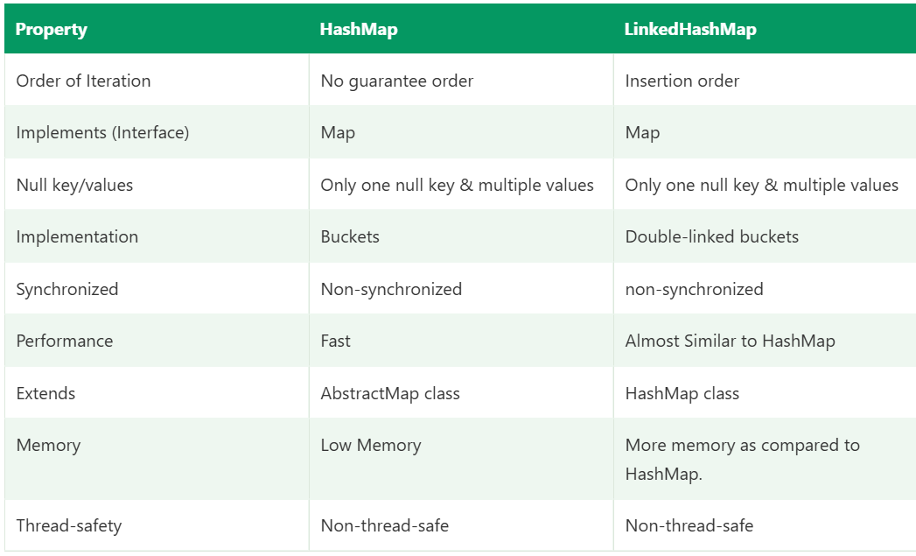

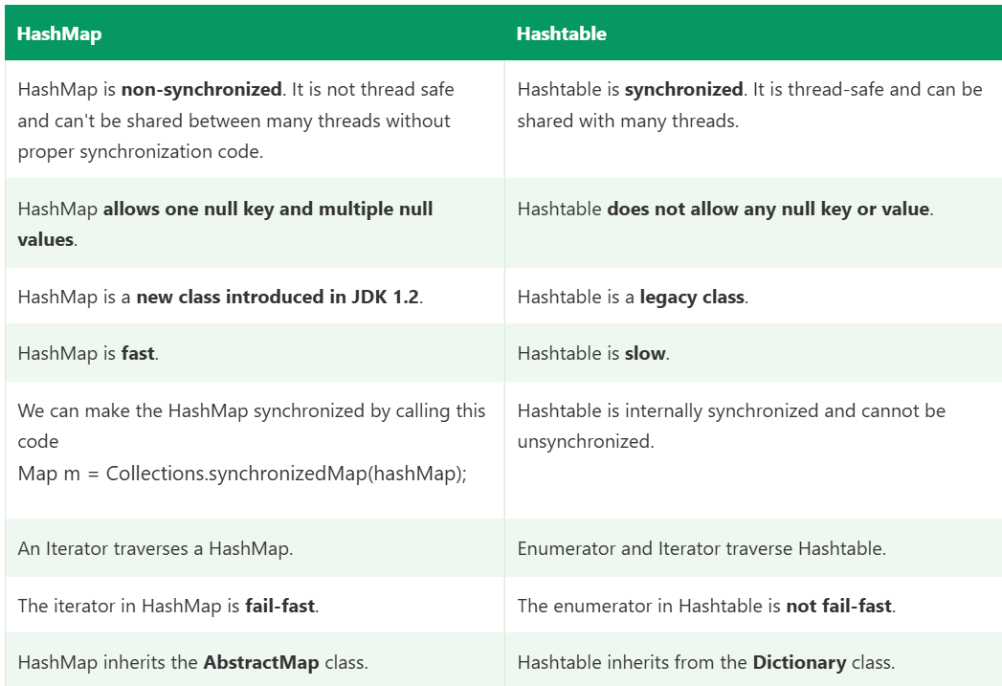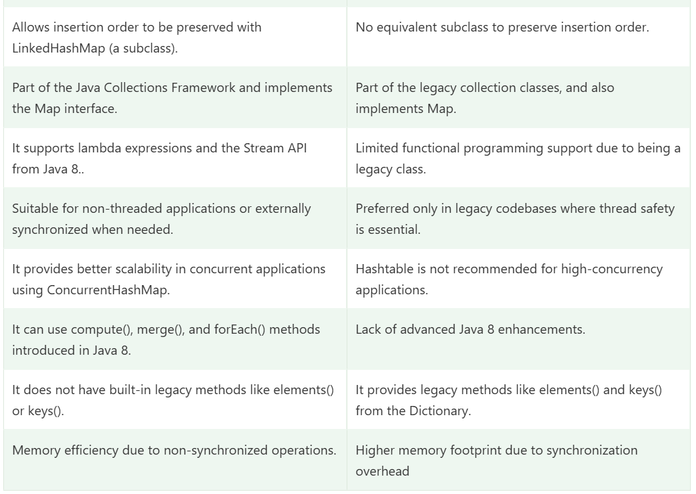

Difference Between ArrayList and Vector :
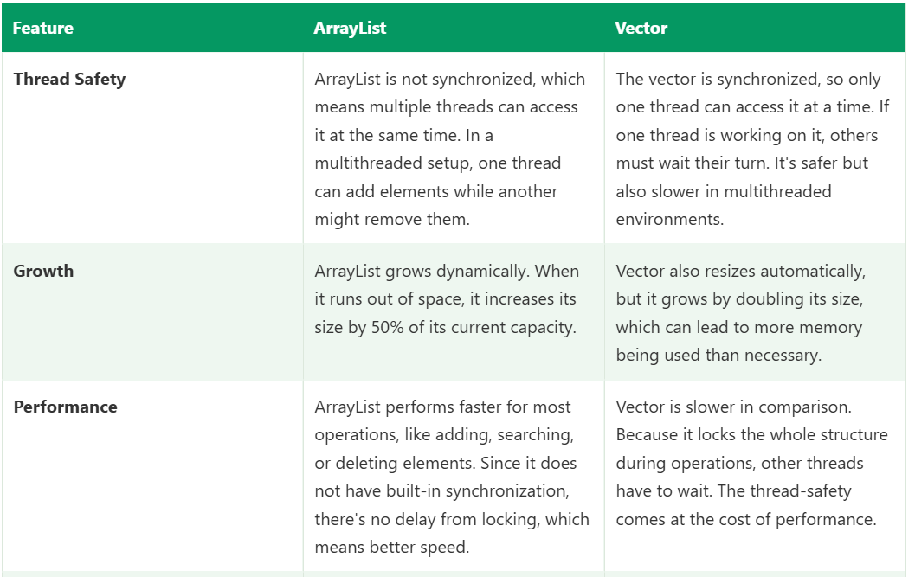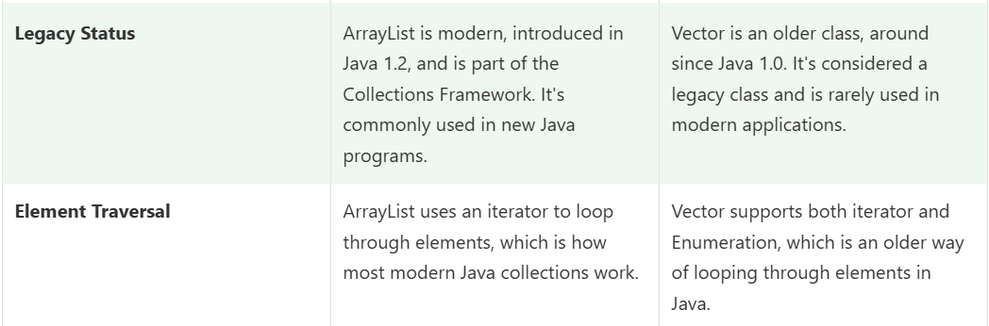

Difference between HashMap and TreeMap :
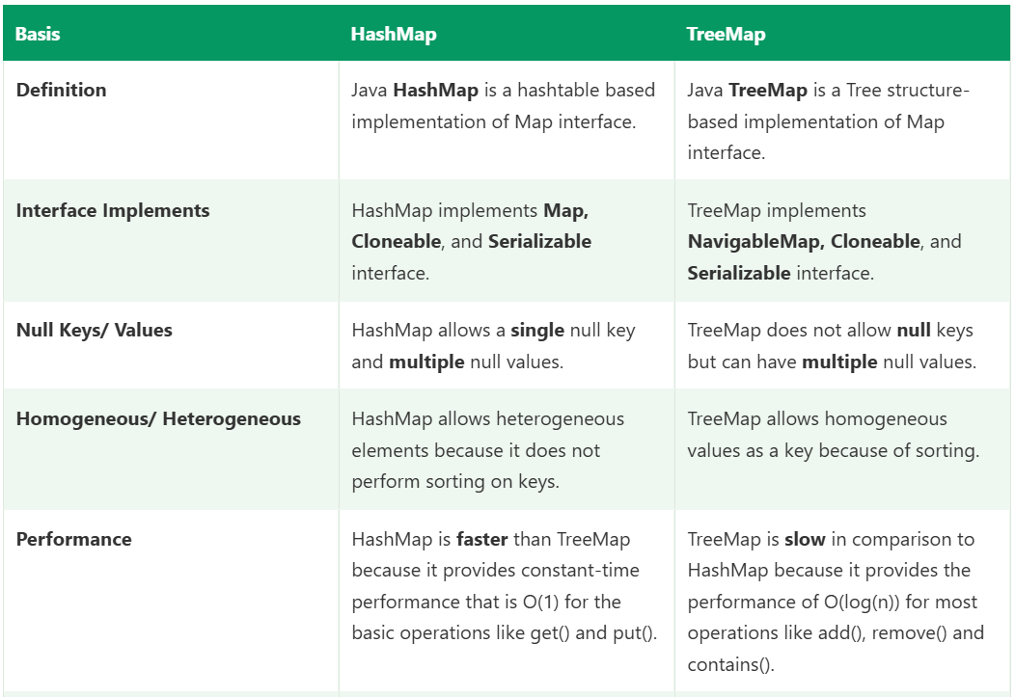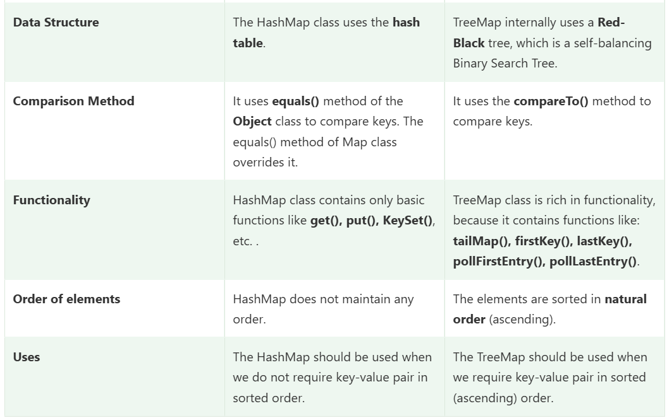

Difference Between HashSet and HashMap Class :
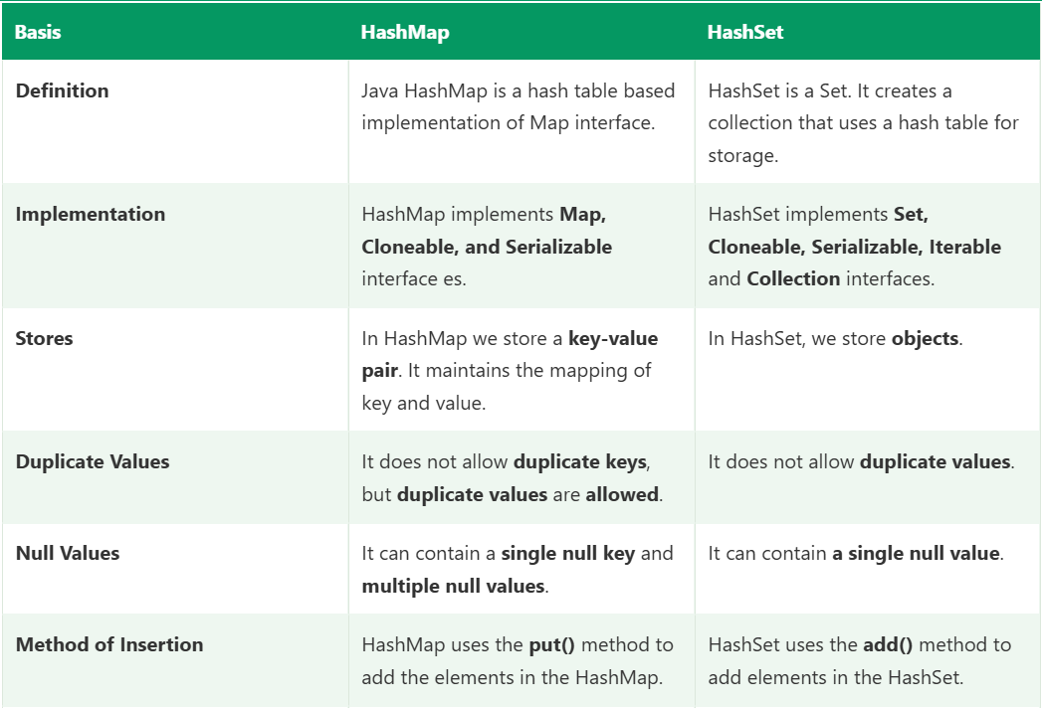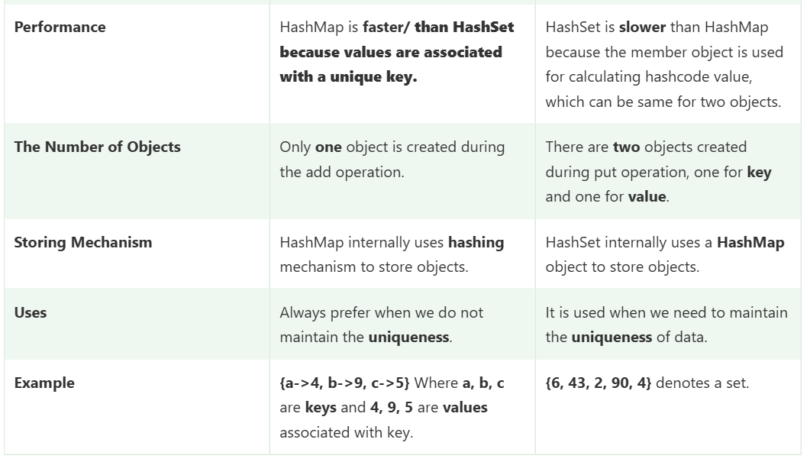

Difference between ArrayList and HashMap
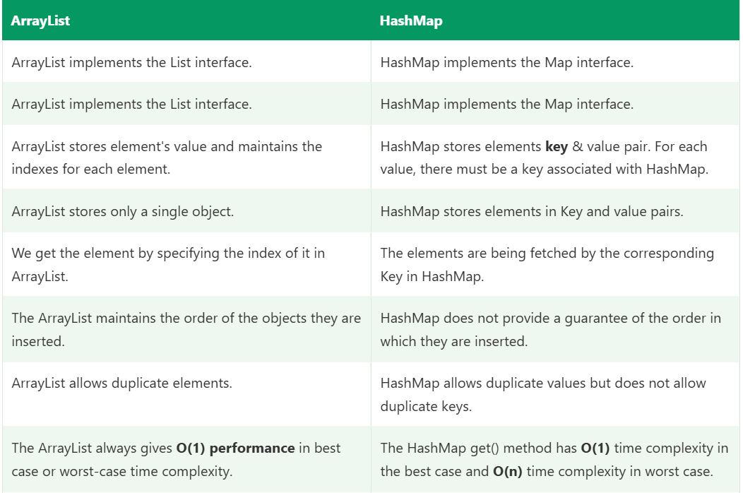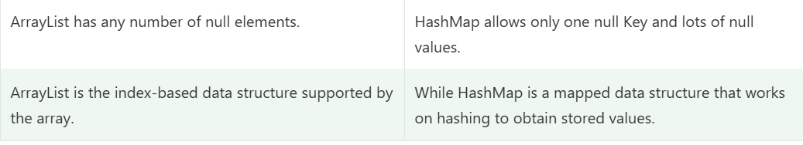

Differences Between final and Immutability
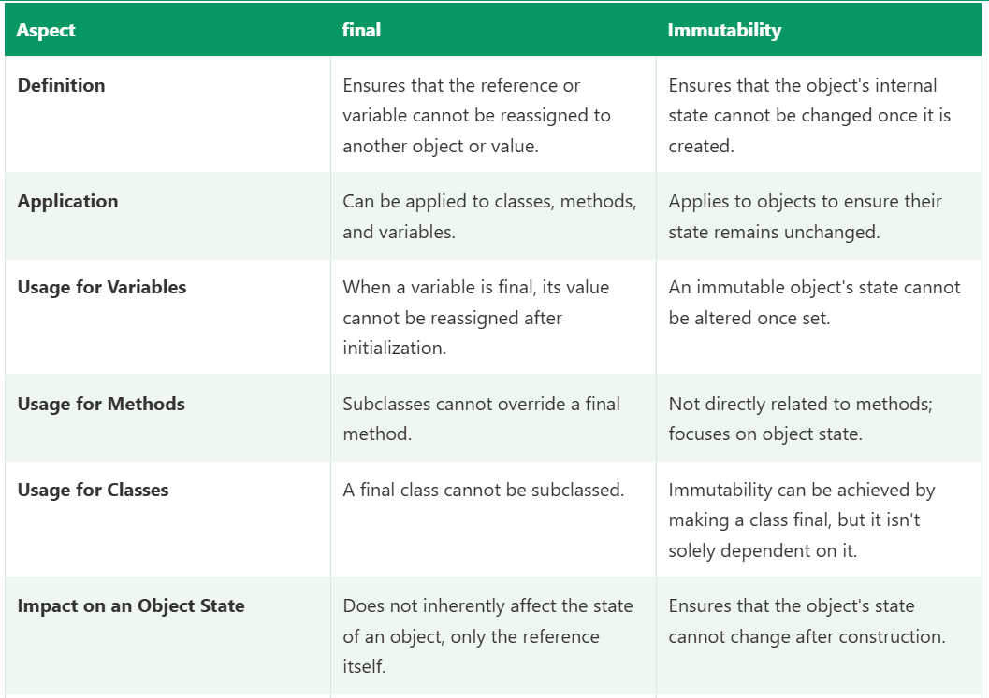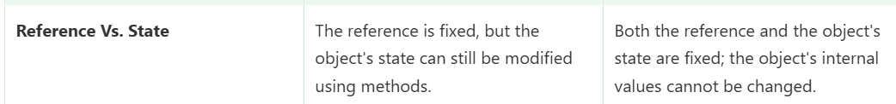

Differences Between Generics and Wildcards
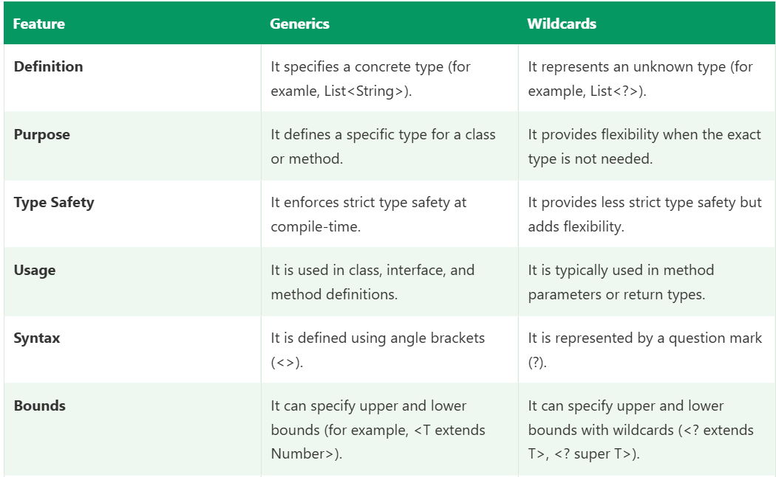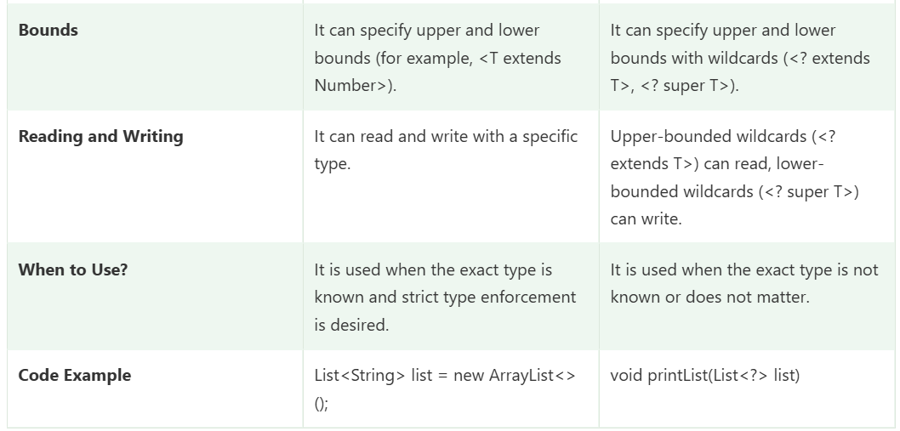

Stack Vs Heap
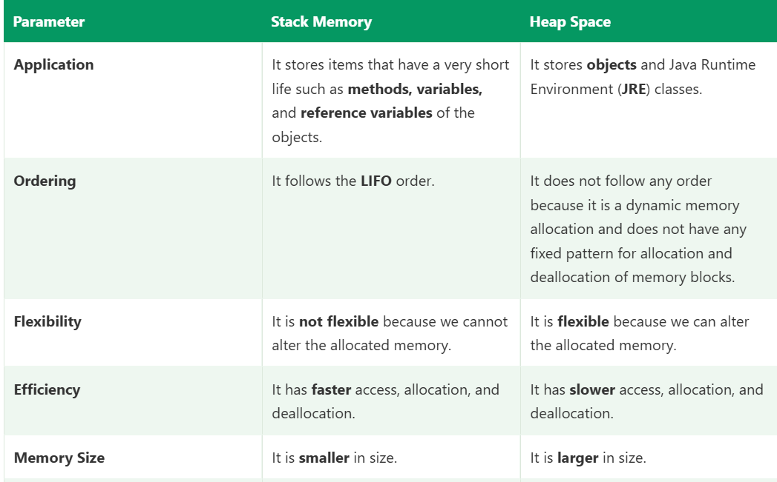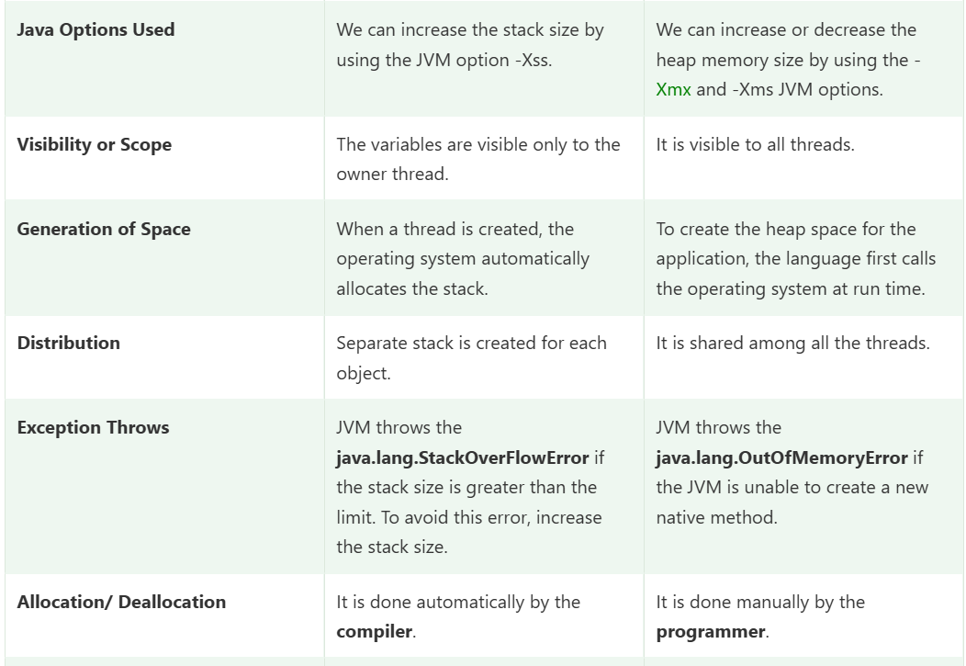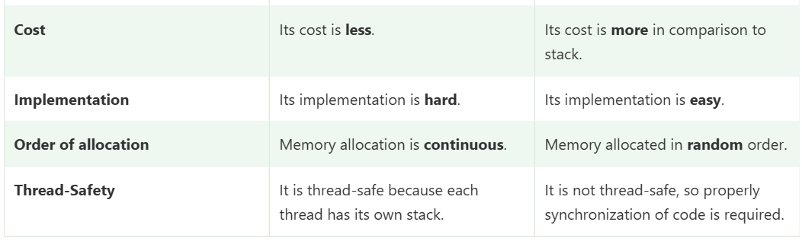

Abstraction Vs Encapsulation :
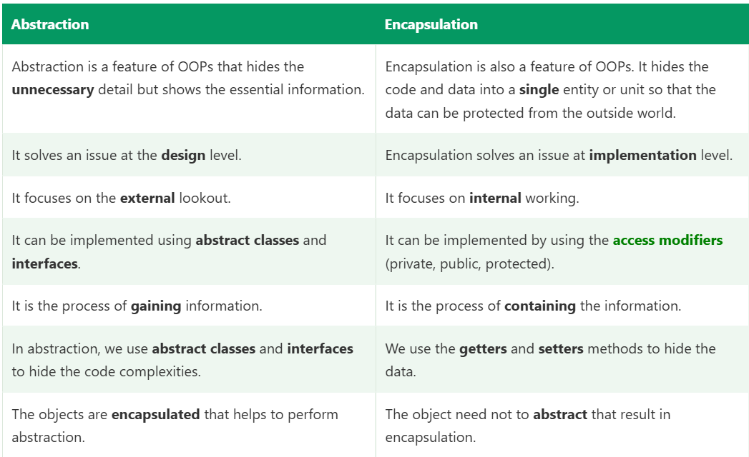

public Vs. private Keyword
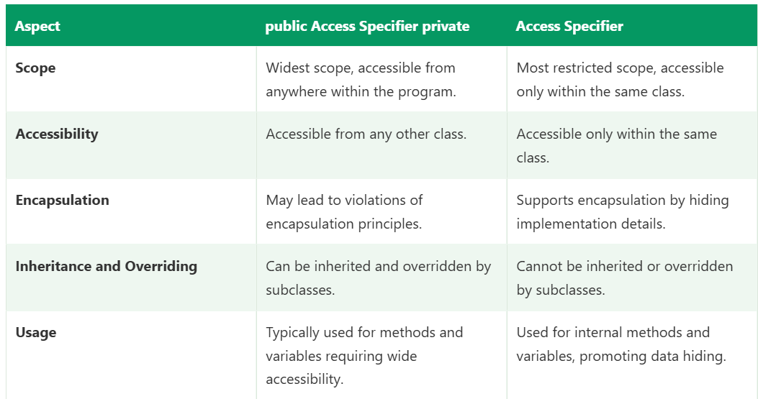

ArrayList in Java
An ArrayList is a class in java.util that implements the List interface using a resizable (dynamic) array internally. It stores elements in insertion order, allows duplicates and nulls, and gives fast access by index.
Iterable → Collection → List → ArrayList
├→ LinkedList
└→ Vector → Stack

Key characteristics
Feature | ArrayList
Order | Insertion order maintained
Duplicates | Allowed
Null | Allowed (multiple)
Index access | Yes, get(i) is O(1)
Thread-safe | No (not synchronized)
Internal structure | Resizable Object[] array
Default capacity | 10 (allocated on first add)
Growth | About 1.5x when full
Implements | List, RandomAccess, Cloneable, Serializable
Iterator | Fail-fast
Stores | Objects only (primitives via wrappers: Integer, Double)

Syntax
java
import java.util.ArrayList;
import java.util.List;

List<String> list = new ArrayList<>(); // preferred: interface reference
ArrayList<String> list2 = new ArrayList<>(); // class reference
List<String> list3 = new ArrayList<>(50); // initial capacity
List<String> list4 = new ArrayList<>(Arrays.asList("A", "B")); // from another collection
List<Integer> nums = new ArrayList<>(); // wrapper type, not int

Example 1: Basic operations
java
List<String> list = new ArrayList<>();

list.add("Java"); // add at end
list.add("Selenium");
list.add("Java"); // duplicate allowed
list.add(1, "RestAssured"); // insert at index 1, shifts others right

System.out.println(list); // [Java, RestAssured, Selenium, Java]
System.out.println(list.get(2)); // Selenium
System.out.println(list.size()); // 4

list.set(0, "Core Java"); // replace element at index 0
list.remove(1); // remove by index
list.remove("Java"); // remove first matching object
System.out.println(list); // [Core Java, Selenium]

System.out.println(list.contains("Selenium")); // true
System.out.println(list.indexOf("Selenium")); // 1
System.out.println(list.isEmpty()); // false
list.clear();

Example 2: The remove(int) vs remove(Object) trap
java
List<Integer> nums = new ArrayList<>(Arrays.asList(10, 20, 30, 1));

nums.remove(1); // removes at INDEX 1, so 20 is removed
nums.remove(Integer.valueOf(1)); // removes the VALUE 1
System.out.println(nums); // [10, 30]
With List<Integer>, a plain int argument is treated as an index. Use Integer.valueOf() to remove by value.

Example 3: Iterating
java
for (int i = 0; i < list.size(); i++) { // index loop
System.out.println(list.get(i));
}

for (String s : list) { // enhanced for
System.out.println(s);
}

list.forEach(System.out::println); // lambda

Iterator<String> it = list.iterator(); // safe removal
while (it.hasNext()) {
if (it.next().equals("Java")) it.remove();
}

list.removeIf(s -> s.equals("Java")); // cleanest way to remove by condition
Removing inside a for-each loop throws ConcurrentModificationException.

Example 4: Sorting and searching
java
List<Integer> nums = new ArrayList<>(Arrays.asList(5, 2, 9, 1));

Collections.sort(nums); // [1, 2, 5, 9]
nums.sort(Comparator.reverseOrder()); // [9, 5, 2, 1]
Collections.reverse(nums);
Collections.max(nums); // 9
Collections.min(nums); // 1
Collections.frequency(nums, 5); // 1
Collections.shuffle(nums);

Example 5: Custom objects
java
class Employee {
int id; String name;
Employee(int id, String name) { this.id = id; this.name = name; }
@Override public String toString() { return id + ":" + name; }
}

List<Employee> emps = new ArrayList<>();
emps.add(new Employee(2, "Raj"));
emps.add(new Employee(1, "Amit"));

emps.sort(Comparator.comparingInt(e -> e.id)); // sort by id
System.out.println(emps); // [1:Amit, 2:Raj]
contains() and indexOf() use equals(), so override equals() and hashCode() in the class to search by content.

Example 6: Converting
java
String[] arr = list.toArray(new String[0]); // list to array
List<String> fixed = Arrays.asList(arr); // array to fixed-size list
List<String> copy = new ArrayList<>(list); // independent copy
List<String> sub = list.subList(0, 2); // view of range [0, 2), not a copy
String joined = String.join(",", list); // "Java,Selenium"

How ArrayList works internally
- It holds an Object[] array (elementData) and an int size.
- The first add() creates an array of capacity 10.
- When full, it creates a new array of about 1.5x the capacity (old + old >> 1) and copies the elements with Arrays.copyOf.
- get(i) is direct array access, so it is O(1).
- add(index, e) and remove(index) shift the elements after that position, so they are O(n).
- remove doesn’t shrink the array. Use trimToSize() to release extra capacity.
If you know the approximate size, new ArrayList<>(n) avoids repeated resizing.

Time complexity
Operation | Complexity
get(i) / set(i, e) | O(1)
add(e) at end | O(1) amortized (O(n) when resizing)
add(i, e) / remove(i) | O(n) (shifting)
contains() / indexOf() | O(n)
size() / isEmpty() | O(1)

When to use ArrayList
Use it when | Example
You need ordered data with duplicates | Test data rows, results in sequence
You read by index frequently | Picking the nth element
Mostly adding at the end and iterating | Collecting web elements or API values
Size is not known in advance | Results of findElements
General-purpose list (the default choice) | Most framework code

When NOT to use it
Need | Use instead
Frequent insert/delete at the start or middle | LinkedList or ArrayDeque
Unique elements only | HashSet / LinkedHashSet
Sorted unique elements | TreeSet
Key-value lookups | HashMap
Thread safety | CopyOnWriteArrayList or Collections.synchronizedList()
Fixed size, primitives, best performance | Plain array

Framework examples
1. Web elements (Selenium)
java
List<WebElement> items = driver.findElements(By.className("inventory_item_name"));
List<String> names = new ArrayList<>();
for (WebElement e : items) {
names.add(e.getText());
}
2. Validating sorted data on the UI
java
List<String> actual = items.stream().map(WebElement::getText).collect(Collectors.toList());
List<String> expected = new ArrayList<>(actual);
Collections.sort(expected);
Assert.assertEquals(actual, expected);
3. Test data from Excel or JSON
java
List<Map<String, String>> rows = new ArrayList<>();
// each Map is one row: column name to cell value
4. REST Assured response values
java
List<String> ids = response.jsonPath().getList("bookingid");
Assert.assertTrue(ids.size() > 0);
Assert.assertTrue(ids.contains("1"));
5. TestNG DataProvider often builds an Object[][] from an ArrayList of rows.

Common pitfalls
- ConcurrentModificationException: modifying the list during a for-each loop. Use Iterator.remove() or removeIf().
- IndexOutOfBoundsException: accessing an invalid index, for example get(size()).
- remove(int) vs remove(Object) confusion with List<Integer>.
- Arrays.asList() is fixed-size: add() and remove() throw UnsupportedOperationException, so wrap it in new ArrayList<>(...).
- subList() is a view: changing the parent list structurally breaks it.
- Not thread-safe: don’t share one ArrayList between parallel threads without synchronization.
- Memory: it never shrinks automatically, and holds extra capacity.

ArrayList vs LinkedList vs Vector
 | ArrayList | LinkedList | Vector
Structure | Dynamic array | Doubly linked list | Dynamic array
get(i) | O(1) | O(n) | O(1)
Insert/delete in middle | O(n) | O(1) after reaching the node | O(n)
Memory | Low | Higher (node objects) | Low
Thread-safe | No | No | Yes (synchronized)
Growth | 1.5x | Not applicable | 2x
Status | Default choice | Special cases | Legacy

ArrayList vs Array
 | Array | ArrayList
Size | Fixed | Dynamic
Types | Primitives and objects | Objects only (wrappers)
Length | arr.length | list.size()
Generics | No | Yes
Utility methods | Few | Many (add, remove, contains)
Speed | Slightly faster | Slight overhead

Interview questions
1. How does ArrayList grow?
Default capacity is 10 (on first add). When full, a new array about 1.5 times larger is created and the elements are copied.
2. Why is get() fast but add(index) slow?
get() is direct array indexing. add(index) shifts every element after that position.
3. ArrayList vs LinkedList: which is faster?
ArrayList for reads and iteration. LinkedList only wins for frequent insert/remove at the ends with no index access, and in practice ArrayList is often faster even then because of cache locality. I use ArrayList by default.
4. Is ArrayList thread-safe? How do you make it so?
No. Use Collections.synchronizedList(), CopyOnWriteArrayList, or Vector.
5. Can ArrayList hold null and duplicates?
Yes, both.
6. What is the difference between size() and capacity?
size() is the number of elements stored. Capacity is the length of the internal array. There is no public capacity() method, but ensureCapacity() and trimToSize() exist.
7. How do you remove duplicates from an ArrayList?
java
List<Integer> unique = new ArrayList<>(new LinkedHashSet<>(list)); // keeps order
8. How do you remove elements while iterating?
Use Iterator.remove() or list.removeIf(...), not list.remove() inside a for-each.
9. What is the difference between Arrays.asList() and new ArrayList<>()?
Arrays.asList() returns a fixed-size list backed by the array (set allowed, add/remove not). new ArrayList<>() is fully resizable.
10. Why List<String> list = new ArrayList<>() instead of ArrayList<String> list?
Programming to the interface makes it easy to switch the implementation later without changing the rest of the code (polymorphism).
11. Can ArrayList store primitives?
No, only objects. Primitives are autoboxed to wrappers (int to Integer).
12. What is fail-fast?
The iterator throws ConcurrentModificationException if the list is structurally modified during iteration (detected via an internal modCount).
13. How do you convert an ArrayList to an array and back?
list.toArray(new String[0]) and new ArrayList<>(Arrays.asList(arr)).
14. How do you sort an ArrayList of objects?
Implement Comparable in the class, or pass a Comparator: list.sort(Comparator.comparing(Employee::getName)).

Short interview answer
“ArrayList is a List implementation backed by a resizable array. It keeps insertion order, allows duplicates and nulls, and gives O(1) access by index, but insertion or removal in the middle is O(n) because elements shift. It starts with capacity 10 and grows by about 1.5 times when full. It isn’t thread-safe. I use it as the default list when order matters, size is unknown and I mostly read or append, and I prefer LinkedList only for heavy insert/delete at the ends, HashSet for unique values and CopyOnWriteArrayList for thread safety. In my framework I use it for findElements results, Excel and JSON test data rows as List<Map<String,String>>, and API response values, and I declare it as List<String> list = new ArrayList<>().”
Internal Working Of ArrayList :

Short interview answer
“ArrayList is backed by an Object[] array called elementData, plus a size field. With the no-arg constructor the array is empty, and on the first add() it is created with the default capacity of 10. When the array is full, it creates a new array about 1.5 times larger using Arrays.copyOf and copies the elements, which is why adding at the end is amortized O(1). get() is direct indexing, O(1). Inserting or removing in the middle uses System.arraycopy to shift elements, O(n), and removal nulls the last slot so the object can be garbage collected, but the array never shrinks unless I call trimToSize(). A modCount counter is incremented on every structural change, and iterators compare it to detect concurrent modification and throw ConcurrentModificationException. It isn’t thread-safe.”
LinkedList :

LinkedList in Java
A LinkedList is a class in java.util that implements both the List and Deque interfaces using a doubly linked list. Each element is stored in a separate node that holds the data plus references to the previous and next nodes. It keeps insertion order, allows duplicates and nulls.
Iterable → Collection ┬→ List ┐
└→ Queue → Deque ┴→ LinkedList

Internal structure
java
private static class Node<E> {
E item;
Node<E> next;
Node<E> prev;
}

null ◄─ [prev|A|next] ⇄ [prev|B|next] ⇄ [prev|C|next] ─► null
▲ ▲
first last
The list keeps references to first, last and a size field. Elements are not stored in contiguous memory, so there is no index arithmetic like in an array.

Key characteristics
Feature | LinkedList
Order | Insertion order
Duplicates | Allowed
Null | Allowed (multiple)
Index access | Yes, but O(n) (walks from the nearer end)
Thread-safe | No
Internal structure | Doubly linked list
Implements | List, Deque, Queue, Cloneable, Serializable
Does NOT implement | RandomAccess
Iterator | Fail-fast
Capacity | No capacity, grows one node at a time

Syntax
java
import java.util.LinkedList;
import java.util.List;
import java.util.Deque;
import java.util.Queue;

List<String> list = new LinkedList<>(); // as a List
Deque<String> deque = new LinkedList<>(); // as a Deque (stack or queue both ends)
Queue<String> queue = new LinkedList<>(); // as a Queue
LinkedList<String> ll = new LinkedList<>(); // class reference, to use all methods
LinkedList<String> ll2 = new LinkedList<>(Arrays.asList("A", "B")); // from a collection
There is no initial-capacity constructor, since nodes are created on demand.

Example 1: List operations
java
LinkedList<String> list = new LinkedList<>();

list.add("Java"); // add at end
list.add("Selenium");
list.add(1, "RestAssured"); // insert at index 1
list.addFirst("Core"); // add at head
list.addLast("TestNG"); // add at tail

System.out.println(list); // [Core, Java, RestAssured, Selenium, TestNG]
System.out.println(list.get(2)); // RestAssured
System.out.println(list.getFirst()); // Core
System.out.println(list.getLast()); // TestNG
System.out.println(list.indexOf("Selenium")); // 3

list.set(0, "Advanced"); // replace
list.remove(1); // remove by index
list.remove("TestNG"); // remove by object
list.removeFirst(); // remove head
list.removeLast(); // remove tail
System.out.println(list); // [RestAssured, Selenium]

Example 2: As a Queue (FIFO)
java
Queue<Integer> queue = new LinkedList<>();

queue.offer(10); // enqueue at tail
queue.offer(20);
queue.offer(30);

System.out.println(queue.peek()); // 10, view head without removing
System.out.println(queue.poll()); // 10, remove head
System.out.println(queue); // [20, 30]

Example 3: As a Stack (LIFO)
java
Deque<String> stack = new LinkedList<>();

stack.push("A"); // adds at head
stack.push("B");
stack.push("C");

System.out.println(stack.peek()); // C
System.out.println(stack.pop()); // C
System.out.println(stack); // [B, A]

Example 4: Iterating
java
for (String s : list) { System.out.println(s); }

list.forEach(System.out::println);

Iterator<String> it = list.iterator();
while (it.hasNext()) {
if (it.next().equals("Selenium")) it.remove(); // safe removal
}

Iterator<String> desc = list.descendingIterator(); // reverse order (Deque feature)
Avoid for (int i = 0; i < list.size(); i++) list.get(i) on a LinkedList. Each get(i) walks the nodes, making the loop O(n²).

How it works internally
add(e) at end (O(1)):
java
void linkLast(E e) {
Node<E> l = last;
Node<E> newNode = new Node<>(l, e, null);
last = newNode;
if (l == null) first = newNode;
else l.next = newNode;
size++;
modCount++;
}
Only a new node is created and two references are updated. There is no resizing and no shifting.
get(index) (O(n)):
java
Node<E> node(int index) {
if (index < (size >> 1)) { // first half: walk from head
Node<E> x = first;
for (int i = 0; i < index; i++) x = x.next;
return x;
} else { // second half: walk from tail
Node<E> x = last;
for (int i = size - 1; i > index; i--) x = x.prev;
return x;
}
}
It starts from whichever end is closer, so the worst case is about n/2 steps, still O(n).
Insert/remove in the middle: finding the node is O(n), but the actual re-linking is O(1):
before: A ⇄ B ⇄ D insert C between B and D
after: A ⇄ B ⇄ C ⇄ D only B.next, C.prev, C.next, D.prev change

Time complexity
Operation | LinkedList | ArrayList
get(i) / set(i) | O(n) | O(1)
add(e) at end | O(1) | O(1) amortized
addFirst / removeFirst | O(1) | O(n)
addLast / removeLast | O(1) | O(1)
add(i, e) / remove(i) in middle | O(n) to find + O(1) to link | O(n) shifting
Insert/remove through an Iterator at current position | O(1) | O(n)
contains / indexOf | O(n) | O(n)
Memory per element | High (node + 2 references) | Low

When to use LinkedList
Use it when | Example
Frequent add/remove at the beginning or end | Queue or deque of tasks
You need a Queue, Stack or Deque with List features | Processing requests in FIFO order
Frequent insert/remove while iterating with an iterator | Filtering out items in a pass
Size changes a lot and you rarely access by index | Dynamic pipelines

When NOT to use it
Need | Use instead
Frequent access by index | ArrayList
General-purpose list | ArrayList
Pure stack or queue | ArrayDeque (faster, less memory)
Memory efficiency | ArrayList
Unique elements | HashSet
Thread safety | ConcurrentLinkedQueue, CopyOnWriteArrayList
Practical note: In real code ArrayList is usually faster, even for inserts, because arrays are cache-friendly and System.arraycopy is very fast. LinkedList needs a node object for every element, which adds memory and garbage collection cost. Even for a queue, ArrayDeque is generally the better choice. LinkedList is mainly justified when you need both List and Deque behaviour, or null elements in a queue (ArrayDeque rejects nulls).

Framework examples
1. Retry or task queue
java
Queue<String> pendingTests = new LinkedList<>();
pendingTests.offer("loginTest");
pendingTests.offer("cartTest");
while (!pendingTests.isEmpty()) {
String test = pendingTests.poll();
// run test; re-add with offer(test) if it needs a retry
}
2. Browser navigation history (back/forward)
java
Deque<String> history = new LinkedList<>();
history.push(driver.getCurrentUrl());
3. Processing log lines or API responses in order, removing entries as they are handled.
4. Undo/redo style flows that add and remove at one end.

Common pitfalls
- Indexed loops over a LinkedList are O(n²). Use for-each or an iterator.
- remove(int) vs remove(Object) with List<Integer>, same as ArrayList.
- ConcurrentModificationException when modifying during a for-each. Use Iterator.remove() or removeIf().
- Not thread-safe.
- Higher memory use per element.
- peek(), poll(), pop() behave differently on an empty list: peek()/poll() return null, while pop()/remove()/element()/getFirst() throw NoSuchElementException.

ArrayList vs LinkedList
 | ArrayList | LinkedList
Structure | Resizable array | Doubly linked list
Random access | O(1) | O(n)
Insert/delete at start | O(n) | O(1)
Insert/delete in middle | O(n) | O(n) to find, O(1) to link
Memory | Lower | Higher (node overhead)
Implements | List, RandomAccess | List, Deque, Queue
Cache friendliness | Good | Poor
Best for | Read-heavy, general use | Queue/deque style, frequent end operations

Interview questions
1. How does LinkedList work internally?
It is a doubly linked list of Node objects, each with item, prev and next. The list holds first, last and size. Adding or removing re-links references instead of shifting elements.
2. Why is get(index) slow in LinkedList?
There’s no direct indexing. It must traverse from the head or tail, whichever is closer, so it is O(n).
3. When is LinkedList better than ArrayList?
For frequent insert/remove at the beginning or end, or when used as a Queue/Deque. For general use, ArrayList is better.
4. Is LinkedList thread-safe?
No. Use Collections.synchronizedList() or concurrent collections.
5. Can LinkedList hold null and duplicates?
Yes, both.
6. Does LinkedList implement RandomAccess?
No, because index access is O(n). This also tells algorithms like Collections.binarySearch to use an iterator-based approach.
7. Singly or doubly linked?
Doubly linked, which allows traversal in both directions and O(1) removal at both ends.
8. LinkedList vs ArrayDeque as a queue/stack?
ArrayDeque is faster and uses less memory, but disallows nulls. LinkedList allows nulls and also provides List methods.
9. Why is inserting in the middle not truly O(1)?
Linking the node is O(1), but locating the position takes O(n). It is O(1) overall only when you already hold an iterator at that position.
10. What is the initial capacity?
None. It has no capacity concept, because each element gets its own node.
11. How do you reverse a LinkedList?
Collections.reverse(list), or iterate with descendingIterator().

Short interview answer
“LinkedList is a doubly linked list implementation of both List and Deque. Each element sits in a node with references to the previous and next nodes, so adding or removing at the ends or at an iterator position only re-links references, which is O(1), with no shifting or resizing. The downside is that access by index is O(n), because it must walk the nodes, and each element carries node overhead, so it uses more memory than ArrayList. It allows duplicates and nulls and isn’t thread-safe. I use ArrayList by default, and choose LinkedList when I need a queue, stack or deque with frequent insertions and removals at the ends, for example a queue of pending or retry tests, although ArrayDeque is usually the better pure queue or stack.”
Set Interface :

Set in Java
A Set is an interface in java.util that represents a collection of unique elements. It extends Collection and adds one rule on top: no duplicates. It has no index-based access, and add() simply returns false if the element already exists.
Iterable → Collection → Set ┬→ HashSet ──→ LinkedHashSet
└→ SortedSet → NavigableSet → TreeSet
Since Set is an interface, you can’t write new Set<>(). You use one of its implementations (HashSet, LinkedHashSet, TreeSet).

Key characteristics
Feature | Set
Duplicates | Not allowed
Index access (get(i)) | No
Order | Depends on the implementation
Null | Depends on the implementation
Duplicate detection | equals() and hashCode() (HashSet, LinkedHashSet) or compareTo() (TreeSet)
Extends | Collection (so add, remove, contains, size, isEmpty, clear, iterator...)

Syntax
java
import java.util.*;

Set<String> hashSet = new HashSet<>(); // no order, fastest
Set<String> linkedSet = new LinkedHashSet<>(); // insertion order
Set<String> treeSet = new TreeSet<>(); // sorted order

Set<String> fromList = new HashSet<>(Arrays.asList("A", "B", "A")); // [A, B]
Set<String> immutable = Set.of("A", "B", "C"); // Java 9+, immutable, no nulls, no duplicates
Always declare the variable with the interface type (Set<String>), so you can swap the implementation later without changing the rest of the code.

Example 1: Basic operations
java
Set<String> set = new HashSet<>();

set.add("Java");
set.add("Selenium");
set.add("RestAssured");
boolean added = set.add("Java"); // false, duplicate rejected

System.out.println(set); // order not guaranteed
System.out.println(added); // false
System.out.println(set.size()); // 3
System.out.println(set.contains("Selenium")); // true
set.remove("Selenium");
System.out.println(set.isEmpty()); // false
set.clear();

Example 2: The three implementations side by side
java
List<String> data = Arrays.asList("Raj", "Amit", "Zara", "Amit", "Kiran");

System.out.println(new HashSet<>(data)); // arbitrary order, e.g. [Amit, Zara, Kiran, Raj]
System.out.println(new LinkedHashSet<>(data)); // [Raj, Amit, Zara, Kiran] insertion order
System.out.println(new TreeSet<>(data)); // [Amit, Kiran, Raj, Zara] sorted
All three drop the duplicate Amit. Only the ordering differs.

Example 3: Iterating
java
for (String s : set) { System.out.println(s); }

set.forEach(System.out::println);

Iterator<String> it = set.iterator();
while (it.hasNext()) {
if (it.next().equals("Java")) it.remove(); // safe removal
}

set.removeIf(s -> s.startsWith("R"));
There is no get(index). To use positions, convert it: new ArrayList<>(set).

Example 4: Mathematical set operations
java
Set<Integer> a = new HashSet<>(Arrays.asList(1, 2, 3, 4));
Set<Integer> b = new HashSet<>(Arrays.asList(3, 4, 5, 6));

Set<Integer> union = new HashSet<>(a);
union.addAll(b); // [1, 2, 3, 4, 5, 6]

Set<Integer> intersection = new HashSet<>(a);
intersection.retainAll(b); // [3, 4]

Set<Integer> difference = new HashSet<>(a);
difference.removeAll(b); // [1, 2]

a.containsAll(intersection); // true, a is a superset of the intersection
Copy the set first, because addAll, retainAll and removeAll modify the set they are called on.

Example 5: Removing duplicates from a list
java
List<Integer> list = Arrays.asList(5, 1, 3, 1, 5, 2);

new HashSet<>(list); // unique, any order
new ArrayList<>(new LinkedHashSet<>(list)); // unique, original order [5, 1, 3, 2]
new ArrayList<>(new TreeSet<>(list)); // unique, sorted [1, 2, 3, 5]

Example 6: Custom objects (override equals() and hashCode())
java
class Employee {
int id; String name;
Employee(int id, String name) { this.id = id; this.name = name; }

@Override public boolean equals(Object o) {
if (this == o) return true;
if (!(o instanceof Employee)) return false;
Employee e = (Employee) o;
return id == e.id && name.equals(e.name);
}
@Override public int hashCode() { return Objects.hash(id, name); }
}

Set<Employee> set = new HashSet<>();
set.add(new Employee(1, "Raj"));
set.add(new Employee(1, "Raj")); // duplicate, rejected
System.out.println(set.size()); // 1
Without both overrides, the two objects count as different (identity comparison) and the size would be 2. For TreeSet, implement Comparable or pass a Comparator instead.

Choosing the right implementation
 | HashSet | LinkedHashSet | TreeSet
Order | None | Insertion order | Sorted
Internal structure | HashMap | LinkedHashMap | TreeMap (Red-Black tree)
add / remove / contains | O(1) | O(1) | O(log n)
Null | One allowed | One allowed | Not allowed
Memory | Lowest | Higher | Higher
Extra features | None | Predictable iteration | first(), last(), floor(), ceiling(), headSet(), subSet()
Use when | Only uniqueness and speed matter | Uniqueness plus original order | Uniqueness plus sorted order or range queries

When to use a Set
Use a Set when | Example
Elements must be unique | Distinct user IDs, links, window handles
You need fast membership checks (contains) | “Have I seen this URL before?”
Order is unimportant (or you pick the right type for it) | Collecting distinct values
You need set maths | Compare UI data with API data, find missing items

When NOT to use a Set
Need | Use instead
Duplicates are valid | List (ArrayList)
Access by index | List
Key-value pairs | Map
FIFO/LIFO processing | Queue / Deque
Thread safety | ConcurrentHashMap.newKeySet(), ConcurrentSkipListSet, or Collections.synchronizedSet()

Framework examples
1. Window handles in Selenium (getWindowHandles() returns a Set)
java
String parent = driver.getWindowHandle();
Set<String> handles = driver.getWindowHandles();
for (String h : handles) {
if (!h.equals(parent)) driver.switchTo().window(h);
}
2. Unique links on a page
java
Set<String> links = new LinkedHashSet<>();
for (WebElement a : driver.findElements(By.tagName("a"))) {
String href = a.getAttribute("href");
if (href != null && !href.isEmpty()) links.add(href);
}
3. Checking for duplicate IDs in an API response
java
List<String> ids = response.jsonPath().getList("id");
Assert.assertEquals(new HashSet<>(ids).size(), ids.size(), "Duplicate IDs found");
4. Comparing UI and API data ignoring order
java
Assert.assertEquals(new HashSet<>(uiList), new HashSet<>(apiList));
5. Finding what is missing
java
Set<String> missing = new HashSet<>(expected);
missing.removeAll(actual);
Assert.assertTrue(missing.isEmpty(), "Missing: " + missing);

Common pitfalls
- Mutating an element after adding it can change its hashCode(), so contains() and remove() stop finding it. Use immutable elements.
- Missing equals()/hashCode() in custom classes lets “duplicates” in.
- ConcurrentModificationException when removing inside a for-each loop. Use Iterator.remove() or removeIf().
- Relying on HashSet order in assertions. It isn’t guaranteed.
- Set.of() is immutable: add() throws UnsupportedOperationException, and duplicates or nulls throw at creation.
- Not thread-safe by default.

Interview questions
1. What is a Set and how is it different from a List?
A Set holds unique elements and has no index access. A List is ordered, allows duplicates and supports index access.
2. How does a Set detect duplicates?
HashSet and LinkedHashSet use hashCode() then equals(). TreeSet uses compareTo() or compare() returning 0.
3. Which Set maintains insertion order? Which sorts?
LinkedHashSet keeps insertion order, TreeSet sorts.
4. Can a Set contain null?
HashSet and LinkedHashSet allow one null. TreeSet doesn’t. Set.of() doesn’t.
5. How does HashSet work internally?
It is backed by a HashMap. Elements are stored as keys, with a dummy constant as the value.
6. What does add() return?
true if the element was added, false if it was already present.
7. How do you get an element by index from a Set?
You can’t. Convert to a List first.
8. How do you make a Set thread-safe?
Collections.synchronizedSet(set), ConcurrentHashMap.newKeySet() or ConcurrentSkipListSet.
9. How do you do union, intersection and difference?
addAll(), retainAll() and removeAll() on a copy of the set.
10. Why must you override both equals() and hashCode()?
Equal objects must have equal hash codes, or the set may place them in different buckets and keep logical duplicates.

Short interview answer
“Set is an interface in the Collections Framework that stores unique elements and has no index-based access. Its main implementations are HashSet, which has no order and O(1) operations, LinkedHashSet, which keeps insertion order, and TreeSet, which keeps elements sorted with O(log n) operations. Duplicates are detected through equals() and hashCode(), or compareTo() for TreeSet, so custom classes must implement them properly. I use a Set when I need unique values or fast lookups, for example window handles in Selenium, unique links on a page, checking for duplicate IDs in an API response, and comparing UI and API data irrespective of order. I declare it as Set<String> set = new HashSet<>() and choose LinkedHashSet or TreeSet when I also need insertion order or sorting.”

Java HashSet :
In Java, a HashSet class is a part of the Collections Framework that uses a hashing mechanism to store elements uniquely, whereas it does not maintain insertion order and focuses on fast search and retrieval operations.

What is Java HashSet?
Java HashSet class is used to create a collection that uses a hash table for storage. It inherits the AbstractSet class and implements the Set interface.
HashSet stores elements based on their hash codes, which allows fast operations such as insertion, deletion, and searching.
The important points about the Java HashSet class are:
- It stores the elements by using a mechanism called
- It contains unique elements only.
- It allows a null value.
- HashSet class is non-synchronized. If we need a synchronized (thread-safe) version of HashSet, we can use the synchronizedSet() method to wrap the HashSet with a synchronized set.
- It does not maintain the insertion order. Here, elements are inserted on the basis of their hashcode. If we need to maintain the insertion order, we can use a LinkedHashSet, which is another implementation of the Set interface that keeps the insertion order of its elements.
- It is the best approach for search operations.
- The initial default capacity of HashSet is 16, and the load factor is 0.75.

Hierarchy of HashSet Class
The HashSet class extends the AbstractSet class and implements the Set interface, which further inherits from the Collection and Iterable interfaces. In simple terms, the hierarchy follows this order: Iterable → Collection → Set → AbstractSet → HashSet.
Internally, it uses a HashMap where each element is stored as a key. It uses the hash code of elements to store and retrieve data efficiently, which makes operations like add, remove, and search very fast.
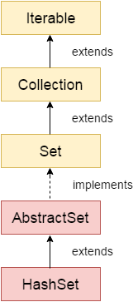
Another important point is that HashSet does not maintain insertion order, so elements may appear in random order. If we need to maintain order, we can use LinkedHashSet. Also, if a duplicate element is added, it is ignored, and the add() method returns false.

HashSet Class Declaration
public class HashSet<E> extends AbstractSet<E> implements Set<E>, Cloneable, Serializable
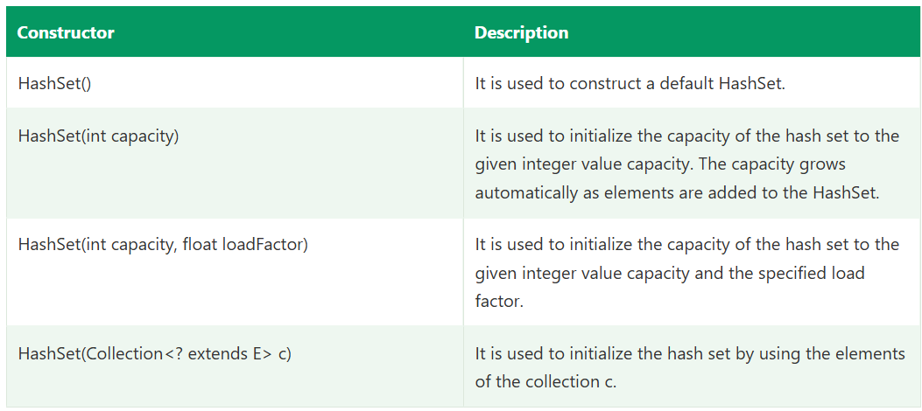
A HashSet is a collection in java.util that stores unique elements with no guaranteed order. It implements the Set interface and is backed internally by a HashMap, which gives it very fast add, remove and search operations (O(1) on average).
Iterable → Collection → Set → HashSet
└→ LinkedHashSet (extends HashSet)

Key characteristics
Feature | HashSet
Duplicates | Not allowed (second add is ignored)
Order | No guarantee (not insertion order, not sorted)
Null | One null allowed
Thread-safe | No (not synchronized)
Internal structure | HashMap (elements stored as keys)
add / remove / contains | O(1) average
Initial capacity / load factor | 16 / 0.75
Iterator | Fail-fast

Syntax
java
import java.util.HashSet;
import java.util.Set;

Set<String> set = new HashSet<>(); // default (preferred: interface reference)
HashSet<String> set2 = new HashSet<>(); // class reference
Set<String> set3 = new HashSet<>(50); // initial capacity
Set<String> set4 = new HashSet<>(50, 0.8f); // capacity + load factor
Set<String> set5 = new HashSet<>(Arrays.asList("A", "B")); // from another collection

Example 1: Basic operations
java
Set<String> set = new HashSet<>();

set.add("Java");
set.add("Selenium");
set.add("RestAssured");
boolean added = set.add("Java"); // false, duplicate rejected

System.out.println(set); // e.g. [Java, RestAssured, Selenium] (order not guaranteed)
System.out.println(added); // false
System.out.println(set.size()); // 3
System.out.println(set.contains("Selenium")); // true
set.remove("Selenium");
System.out.println(set.isEmpty()); // false
set.clear();
add() returns true if the element was added and false if it already existed.

Example 2: Removing duplicates from a list
java
List<Integer> list = Arrays.asList(1, 2, 2, 3, 4, 4, 5);

Set<Integer> unique = new HashSet<>(list);
System.out.println(unique); // [1, 2, 3, 4, 5]

// keep original order
Set<Integer> ordered = new LinkedHashSet<>(list);

Example 3: Iterating
java
for (String s : set) {
System.out.println(s);
}

set.forEach(System.out::println);

Iterator<String> it = set.iterator();
while (it.hasNext()) {
if (it.next().equals("Java")) it.remove(); // safe removal during iteration
}
There is no get(index), because a set has no index.

Example 4: Set operations
java
Set<Integer> a = new HashSet<>(Arrays.asList(1, 2, 3, 4));
Set<Integer> b = new HashSet<>(Arrays.asList(3, 4, 5, 6));

Set<Integer> union = new HashSet<>(a);
union.addAll(b); // [1, 2, 3, 4, 5, 6]

Set<Integer> intersection = new HashSet<>(a);
intersection.retainAll(b); // [3, 4]

Set<Integer> difference = new HashSet<>(a);
difference.removeAll(b); // [1, 2]

a.containsAll(intersection); // true, subset check

Example 5: HashSet with custom objects (equals and hashCode)
HashSet uses hashCode() and then equals() to detect duplicates. For custom classes you must override both.
java
class Employee {
int id;
String name;

Employee(int id, String name) { this.id = id; this.name = name; }

@Override
public boolean equals(Object o) {
if (this == o) return true;
if (!(o instanceof Employee)) return false;
Employee e = (Employee) o;
return id == e.id && name.equals(e.name);
}

@Override
public int hashCode() {
return Objects.hash(id, name);
}
}

Set<Employee> emps = new HashSet<>();
emps.add(new Employee(1, "Raj"));
emps.add(new Employee(1, "Raj")); // duplicate, rejected
System.out.println(emps.size()); // 1
Without overriding them, both objects would be treated as different (default identity comparison), and the size would be 2.

How HashSet works internally
java
// simplified from the JDK
private HashMap<E, Object> map = new HashMap<>();
private static final Object PRESENT = new Object();

public boolean add(E e) {
return map.put(e, PRESENT) == null;
}
- add(e) calls e.hashCode() and finds the bucket index.
- If the bucket is empty, the element is stored.
- If occupied, equals() compares with existing elements. A match means a duplicate, so it is rejected (put returns the old value, so add returns false).
- When size exceeds capacity × 0.75 (12 for 16), the table doubles and elements are rehashed.
So uniqueness comes from HashMap key uniqueness.

When to use HashSet
Use it when | Example
You need unique elements | Removing duplicate IDs or links
You need fast lookup (contains) | Checking if a value was seen before
Order doesn’t matter | Collecting distinct values
Set math (union, intersection, difference) | Comparing two lists of data

When NOT to use it
Need | Use instead
Keep insertion order | LinkedHashSet
Sorted elements | TreeSet
Access by index, allow duplicates | ArrayList
Thread safety | ConcurrentHashMap.newKeySet() or Collections.synchronizedSet()
Key-value pairs | HashMap

Framework examples
1. Window handles (Selenium)
java
Set<String> handles = driver.getWindowHandles(); // returns a Set
String parent = driver.getWindowHandle();
for (String h : handles) {
if (!h.equals(parent)) driver.switchTo().window(h);
}
2. Unique and broken links on a page
java
Set<String> uniqueLinks = new HashSet<>();
for (WebElement link : driver.findElements(By.tagName("a"))) {
String href = link.getAttribute("href");
if (href != null && !href.isEmpty()) uniqueLinks.add(href); // no duplicate checks
}
3. Verifying data without duplicates (UI/API)
java
List<String> ids = response.jsonPath().getList("id");
Assert.assertEquals(new HashSet<>(ids).size(), ids.size(), "Duplicate IDs found");
4. Comparing UI and API data regardless of order
java
Set<String> uiItems = new HashSet<>(uiList);
Set<String> apiItems = new HashSet<>(apiList);
Assert.assertEquals(uiItems, apiItems); // set equality ignores order
5. Finding missing items
java
Set<String> missing = new HashSet<>(expected);
missing.removeAll(actual); // what was expected but not found

Common pitfalls
- Mutating an object after adding it changes its hashCode(), so contains() and remove() fail. Use immutable elements such as String and Integer.
- Printing order is not stable, so never write assertions that depend on iteration order.
- ConcurrentModificationException if you remove elements inside a for-each loop. Use Iterator.remove() or removeIf().
- Not thread-safe, so avoid sharing one HashSet across parallel threads without synchronization.

HashSet vs LinkedHashSet vs TreeSet
 | HashSet | LinkedHashSet | TreeSet
Order | None | Insertion order | Sorted
Speed | Fastest, O(1) | O(1), slightly slower | O(log n)
Null | One allowed | One allowed | Not allowed (natural ordering)
Internal | HashMap | HashMap + linked list | Red-Black tree

Interview questions
1. How does HashSet maintain uniqueness?
It is backed by a HashMap. The element is stored as a key, and a constant dummy object is the value. HashMap keys are unique, using hashCode() and equals().
2. What does add() return for a duplicate?
false, and the set is unchanged.
3. Does HashSet maintain insertion order?
No. Use LinkedHashSet for that.
4. Can HashSet store null?
Yes, exactly one null.
5. What is the time complexity?
O(1) average for add, remove and contains. Worst case O(log n) in Java 8+, because heavy buckets become trees (O(n) before Java 8).
6. What if hashCode() is overridden but equals() isn’t?
Equal-looking objects land in the same bucket but are not detected as equal, so duplicates are stored. Always override both together.
7. Can we get an element by index?
No. Convert to a list: new ArrayList<>(set).
8. Is HashSet thread-safe?
No. Use Collections.synchronizedSet(new HashSet<>()) or ConcurrentHashMap.newKeySet().
9. Why is contains() faster in a HashSet than in an ArrayList?
HashSet goes straight to the bucket through the hash (O(1)), while ArrayList scans every element (O(n)).
10. What happens when you add a mutable object and change it?
Its hashcode changes, so it sits in the wrong bucket and can no longer be found or removed.

Short interview answer
“HashSet is a Set implementation that stores unique elements with no guaranteed order. Internally it’s backed by a HashMap, where the elements are the keys, so uniqueness is checked using hashCode() and equals(), and add, remove and contains are O(1) on average. It allows one null and isn’t thread-safe. I use it when I need to remove duplicates or do fast lookups and order doesn’t matter, and for custom objects I override equals() and hashCode(). If I need insertion order I use LinkedHashSet, and for sorted data TreeSet. In my framework I use sets for window handles, collecting unique links on a page, checking for duplicate IDs in API responses, and comparing UI and API data irrespective of order.”

LinkedHashSet Class :
Java LinkedHashSet class is a Hashtable and Linked List implementation of the Set interface. It inherits the HashSet class and implements the Set interface.

Key Features of Java LinkedHashSet
The important points about the Java LinkedHashSet class are:
- Java LinkedHashSet class contains unique elements only, just like HashSet.
- Java LinkedHashSet class provides all optional set operations and permits null elements.
- Java LinkedHashSet class is non-synchronized.
- Java LinkedHashSet class maintains insertion order.
Note: Keeping the insertion order in LinkedHashSet has some additional costs, both in terms of extra memory and extra CPU cycles.

Constructors of LinkedHashSet Class
Java LinkedHashSet class provides different constructors to create and initialize a LinkedHashSet.

1. LinkedHashSet()
It is used to construct a default LinkedHashSet.
Syntax: LinkedHashSet<E> set = new LinkedHashSet<E>();

2. LinkedHashSet(Collection c)
It is used to construct a LinkedHashSet containing the elements of the specified collection.
Syntax: LinkedHashSet<E> set = new LinkedHashSet<E>(Collection c);

3. LinkedHashSet(int capacity)
It is used to construct a LinkedHashSet with the specified initial capacity and default load factor.
Syntax: LinkedHashSet<E> set = new LinkedHashSet<E>(int capacity);

4. LinkedHashSet(int capacity, float loadFactor)
It is used to construct a LinkedHashSet with the specified capacity and load factor.
Syntax:
LinkedHashSet<E> set = new LinkedHashSet<E>(int capacity, float loadFactor);
A LinkedHashSet is a class in java.util that stores unique elements and maintains insertion order. It extends HashSet and implements Set. Internally it is a HashMap combined with a doubly linked list running through all entries, so you get HashSet’s speed plus a predictable iteration order.
Iterable → Collection → Set → HashSet → LinkedHashSet

Key characteristics
Feature | LinkedHashSet
Duplicates | Not allowed
Order | Insertion order maintained
Null | One null allowed
Thread-safe | No
Internal structure | HashMap + doubly linked list (LinkedHashMap internally)
add / remove / contains | O(1) average
Initial capacity / load factor | 16 / 0.75
Iterator | Fail-fast
Re-insertion | Adding an existing element does not change its position

Syntax
java
import java.util.LinkedHashSet;
import java.util.Set;

Set<String> set = new LinkedHashSet<>(); // default (preferred)
LinkedHashSet<String> set2 = new LinkedHashSet<>(); // class reference
Set<String> set3 = new LinkedHashSet<>(50); // initial capacity
Set<String> set4 = new LinkedHashSet<>(50, 0.8f); // capacity + load factor
Set<String> set5 = new LinkedHashSet<>(Arrays.asList("A", "B")); // from a collection

Example 1: Basic operations and order
java
Set<String> set = new LinkedHashSet<>();

set.add("Java");
set.add("Selenium");
set.add("RestAssured");
boolean added = set.add("Java"); // false, duplicate ignored

System.out.println(set); // [Java, Selenium, RestAssured] (insertion order)
System.out.println(added); // false
System.out.println(set.size()); // 3
System.out.println(set.contains("Selenium")); // true
set.remove("Selenium");
System.out.println(set); // [Java, RestAssured]
Compare with HashSet, where the same code may print in any order.

Example 2: Re-adding does not change order
java
Set<Integer> set = new LinkedHashSet<>();
set.add(10);
set.add(20);
set.add(30);
set.add(10); // already present, position unchanged
System.out.println(set); // [10, 20, 30]
To move an element to the end, remove it first and add it again.

Example 3: Removing duplicates while keeping order
This is the most common use.
java
List<Integer> list = Arrays.asList(5, 1, 3, 1, 5, 2, 3);

Set<Integer> unique = new LinkedHashSet<>(list);
System.out.println(unique); // [5, 1, 3, 2] order preserved

List<Integer> result = new ArrayList<>(unique); // back to a list
With HashSet you’d get [1, 2, 3, 5] or another arbitrary order, and with TreeSet it would be sorted.

Example 4: Iterating
java
for (String s : set) { System.out.println(s); }

set.forEach(System.out::println);

Iterator<String> it = set.iterator();
while (it.hasNext()) {
if (it.next().equals("Java")) it.remove(); // safe removal
}
There is no get(index). Convert with new ArrayList<>(set) if you need positions. (Java 21 adds getFirst(), getLast() and reversed() through SequencedSet.)

Example 5: Custom objects
Like HashSet, it relies on hashCode() and equals().
java
class Employee {
int id; String name;
Employee(int id, String name) { this.id = id; this.name = name; }

@Override public boolean equals(Object o) {
if (this == o) return true;
if (!(o instanceof Employee)) return false;
Employee e = (Employee) o;
return id == e.id && name.equals(e.name);
}
@Override public int hashCode() { return Objects.hash(id, name); }
@Override public String toString() { return id + ":" + name; }
}

Set<Employee> emps = new LinkedHashSet<>();
emps.add(new Employee(2, "Raj"));
emps.add(new Employee(1, "Amit"));
emps.add(new Employee(2, "Raj")); // duplicate, rejected
System.out.println(emps); // [2:Raj, 1:Amit]

How it works internally
java
public class LinkedHashSet<E> extends HashSet<E> {
public LinkedHashSet() {
super(16, .75f, true); // calls a special HashSet constructor
}
}

// inside HashSet:
HashSet(int initialCapacity, float loadFactor, boolean dummy) {
map = new LinkedHashMap<>(initialCapacity, loadFactor);
}
- HashSet normally uses a HashMap. LinkedHashSet makes it use a LinkedHashMap instead.
- Each entry has before and after references linking it to the previously and subsequently inserted entries.
- Hashing finds the bucket (uniqueness check, O(1)), and the linked list gives iteration in insertion order.
- Elements are stored as keys, with a dummy constant as the value.
Buckets (hash): [ ] [B] [ ] [A] [C] ...
Linked order: A ⇄ B ⇄ C (iteration follows this chain)
Cost: each entry carries two extra references, so it uses a bit more memory and is slightly slower than HashSet. Iteration is actually faster than HashSet for sparse tables, because it walks the linked list rather than all buckets.

When to use LinkedHashSet
Use it when | Example
You need unique elements and insertion order | Distinct values in the order first seen
De-duplicating a list without reordering it | Clean up scraped links or IDs
Predictable output for reports and logs | Stable, repeatable results
Fast contains plus ordered iteration | Visited URLs in crawl order

When NOT to use it
Need | Use instead
Uniqueness only, order irrelevant, least memory | HashSet
Sorted order | TreeSet
Duplicates allowed | ArrayList
Access by index | ArrayList
Key-value pairs | LinkedHashMap
Thread safety | Collections.synchronizedSet(new LinkedHashSet<>())

Framework examples
1. Unique links in page order
java
Set<String> links = new LinkedHashSet<>();
for (WebElement a : driver.findElements(By.tagName("a"))) {
String href = a.getAttribute("href");
if (href != null && !href.isEmpty()) links.add(href);
}
2. De-duplicate API values but keep response order
java
List<String> ids = response.jsonPath().getList("id");
List<String> uniqueIds = new ArrayList<>(new LinkedHashSet<>(ids));
3. Window handles in the order opened
java
Set<String> handles = new LinkedHashSet<>(driver.getWindowHandles());
4. Readable failure messages: collect the missing items in a LinkedHashSet so the assertion message lists them in a stable order.
java
Set<String> missing = new LinkedHashSet<>(expected);
missing.removeAll(actual);
Assert.assertTrue(missing.isEmpty(), "Missing items: " + missing);

Common pitfalls
- Re-adding doesn’t move the element, so insertion order is the order of first insertion.
- Mutable elements whose hashCode() changes after insertion can’t be found or removed.
- Not thread-safe.
- No index access. get(i) doesn’t exist.
- ConcurrentModificationException if you remove inside a for-each loop. Use Iterator.remove() or removeIf().
- Don’t assume equals() between a Set and List works: new LinkedHashSet<>(a).equals(new ArrayList<>(a)) is false. Also, Set.equals() ignores order, so two LinkedHashSets with the same elements in different order are equal.

HashSet vs LinkedHashSet vs TreeSet
 | HashSet | LinkedHashSet | TreeSet
Order | None | Insertion order | Sorted (natural or Comparator)
Internal | HashMap | LinkedHashMap | Red-Black tree
add / contains | O(1) | O(1) | O(log n)
Null | One allowed | One allowed | Not allowed (natural ordering)
Memory | Lowest | Higher | Higher
Speed | Fastest | Slightly slower | Slowest
Use for | Fast unique lookups | Unique + keep order | Unique + sorted

Interview questions
1. What is LinkedHashSet?
A Set that keeps unique elements in insertion order, implemented as a hash table plus a doubly linked list (it extends HashSet and uses a LinkedHashMap internally).
2. How does it maintain insertion order?
Each entry in the underlying LinkedHashMap has before and after references forming a doubly linked list in the order of insertion. Iteration follows that list.
3. How does it differ from HashSet?
Same uniqueness and O(1) operations, but LinkedHashSet preserves insertion order and uses slightly more memory.
4. Does re-inserting an existing element change its order?
No. The original position stays.
5. Can it store null?
Yes, one null.
6. Time complexity?
O(1) average for add, remove and contains.
7. Is it thread-safe?
No. Wrap it with Collections.synchronizedSet().
8. How do you remove duplicates from a list and keep order?
new ArrayList<>(new LinkedHashSet<>(list)).
9. Why is iteration faster than HashSet in some cases?
HashSet walks every bucket, including empty ones, while LinkedHashSet follows the linked list of only the actual entries, so cost depends on size, not capacity.
10. Which is the parent class?
HashSet. LinkedHashSet extends HashSet and implements Set (and SequencedSet in Java 21).
11. Can LinkedHashSet maintain access order like LinkedHashMap?
No. LinkedHashSet supports insertion order only. Access-order mode is available only in LinkedHashMap.

Short interview answer
“LinkedHashSet is a Set implementation that stores unique elements and maintains insertion order. It extends HashSet, but internally uses a LinkedHashMap, which is a hash table plus a doubly linked list, so add, remove and contains are O(1) on average, and iteration follows the order in which elements were first inserted. It allows one null, isn’t thread-safe, and re-adding an existing element doesn’t change its position. It uses slightly more memory than HashSet. I use it when I need uniqueness and order together, most commonly to remove duplicates from a list without changing the order, like new ArrayList<>(new LinkedHashSet<>(list)), and for collecting unique links or IDs in the order they appear on a page or in an API response. If order doesn’t matter I use HashSet, and if I need sorted order, TreeSet.

TreeSet Class :
Java TreeSet class implements the Set interface that uses a tree for storage. It inherits AbstractSet class and implements the NavigableSet interface. The objects of the TreeSet class are stored in ascending order.
The ordering is maintained automatically using a self-balancing tree structure, which makes the TreeSet particularly useful when sorted data is needed. TreeSet does not allow insertion of unordered or duplicate values, and any attempt to do so is simply ignored by the set.
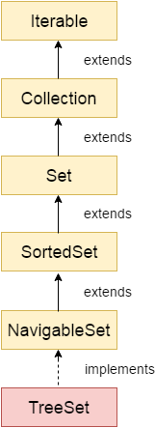

Features of TreeSet Class
- Java TreeSet class contains unique elements only, just like HashSet.
- Java TreeSet class provides fast access and retrieval.
- Java TreeSet class does not allow null elements.
- Java TreeSet class is non-synchronized.
- Java TreeSet class maintains ascending order.
- TreeSet allows only those elements that are comparable (i.e., implement the Comparable interface).

Internal Working of TreeSet Class
TreeSet is implemented using a self-balancing binary search tree (like a Red-Black Tree). Because of this, operations like search, add, and remove take O(log N) time.
The tree automatically keeps itself balanced, so its height remains small. This makes TreeSet efficient for storing large amounts of sorted data and performing operations quickly.

TreeSet in Java
A TreeSet is a class in java.util that stores unique elements in sorted order. It implements NavigableSet (which extends SortedSet) and is backed internally by a TreeMap, which is a Red-Black tree (a self-balancing binary search tree).
Iterable → Collection → Set → SortedSet → NavigableSet → TreeSet

Key characteristics
Feature | TreeSet
Duplicates | Not allowed
Order | Sorted (natural ordering or a custom Comparator)
Null | Not allowed (throws NullPointerException with natural ordering)
Thread-safe | No
Internal structure | TreeMap (Red-Black tree)
add / remove / contains | O(log n)
Elements must be | Comparable, or a Comparator must be supplied
Uniqueness decided by | compareTo() / compare() returning 0, not equals()
Iterator | Fail-fast

Syntax
java
import java.util.TreeSet;
import java.util.Set;

Set<Integer> set = new TreeSet<>(); // natural ordering
TreeSet<Integer> set2 = new TreeSet<>(); // class reference (needed for NavigableSet methods)
TreeSet<String> desc = new TreeSet<>(Comparator.reverseOrder()); // custom ordering
TreeSet<String> set3 = new TreeSet<>(Arrays.asList("B", "A")); // from a collection
TreeSet<Integer> set4 = new TreeSet<>(sortedSet); // from a SortedSet (keeps its comparator)
Use the class reference (TreeSet<...>) when you want navigation methods like first(), floor(), headSet().

Example 1: Basic operations (sorted, unique)
java
TreeSet<Integer> set = new TreeSet<>();
set.add(50);
set.add(10);
set.add(40);
set.add(20);
boolean added = set.add(10); // false, duplicate

System.out.println(set); // [10, 20, 40, 50] sorted
System.out.println(added); // false
System.out.println(set.size()); // 4
System.out.println(set.contains(40)); // true
set.remove(40);
System.out.println(set); // [10, 20, 50]
Strings are sorted alphabetically (case-sensitive, uppercase before lowercase):
java
TreeSet<String> names = new TreeSet<>(Arrays.asList("Raj", "Amit", "kiran", "Zara"));
System.out.println(names); // [Amit, Raj, Zara, kiran]

Example 2: Navigation methods
java
TreeSet<Integer> set = new TreeSet<>(Arrays.asList(10, 20, 30, 40, 50));

set.first(); // 10 smallest
set.last(); // 50 largest
set.lower(30); // 20 strictly less than 30
set.floor(30); // 30 less than or equal to 30
set.higher(30); // 40 strictly greater than 30
set.ceiling(35); // 40 greater than or equal to 35
set.floor(5); // null nothing smaller

set.pollFirst(); // 10 removes and returns the smallest
set.pollLast(); // 50 removes and returns the largest
System.out.println(set); // [20, 30, 40]

Example 3: Range views
java
TreeSet<Integer> set = new TreeSet<>(Arrays.asList(10, 20, 30, 40, 50));

set.headSet(30); // [10, 20] elements < 30
set.headSet(30, true); // [10, 20, 30] inclusive
set.tailSet(30); // [30, 40, 50] elements >= 30
set.tailSet(30, false); // [40, 50] exclusive
set.subSet(20, 40); // [20, 30] from inclusive, to exclusive
set.subSet(20, true, 40, true); // [20, 30, 40]
set.descendingSet(); // [50, 40, 30, 20, 10]
These are views backed by the original set. Changing one changes the other.

Example 4: Custom ordering with Comparator
java
TreeSet<String> byLength = new TreeSet<>(Comparator.comparing(String::length)
.thenComparing(Comparator.naturalOrder()));
byLength.addAll(Arrays.asList("Java", "TestNG", "API", "Selenium", "Java"));
System.out.println(byLength); // [API, Java, TestNG, Selenium]

TreeSet<Integer> desc = new TreeSet<>(Collections.reverseOrder());
desc.addAll(Arrays.asList(3, 1, 2));
System.out.println(desc); // [3, 2, 1]

Example 5: Custom objects
Option A: implement Comparable (natural order inside the class)
java
class Employee implements Comparable<Employee> {
int id; String name;
Employee(int id, String name) { this.id = id; this.name = name; }

@Override
public int compareTo(Employee o) {
return Integer.compare(this.id, o.id); // sort by id
}
@Override public String toString() { return id + ":" + name; }
}

TreeSet<Employee> emps = new TreeSet<>();
emps.add(new Employee(3, "Raj"));
emps.add(new Employee(1, "Amit"));
emps.add(new Employee(2, "Kiran"));
System.out.println(emps); // [1:Amit, 2:Kiran, 3:Raj]
Option B: pass a Comparator
java
TreeSet<Employee> byName = new TreeSet<>(Comparator.comparing(e -> e.name));
If the class is not Comparable and no Comparator is supplied, add() throws ClassCastException:
java
class Plain { }
new TreeSet<Plain>().add(new Plain()); // ClassCastException: Plain cannot be cast to Comparable

Important: uniqueness uses compareTo, not equals
java
TreeSet<Employee> set = new TreeSet<>(Comparator.comparingInt(e -> e.id));
set.add(new Employee(1, "Amit"));
set.add(new Employee(1, "Raj")); // compare returns 0, treated as duplicate, rejected
System.out.println(set.size()); // 1
Two objects with the same sort key are considered duplicates even if their other fields differ. Keep compareTo() consistent with equals(), or you’ll lose data silently.

How it works internally
java
private transient NavigableMap<E, Object> m; // a TreeMap
private static final Object PRESENT = new Object();

public boolean add(E e) {
return m.put(e, PRESENT) == null;
}
- Elements are stored as keys in a TreeMap with a dummy value.
- Each tree node has left, right, parent, key and a colour (red/black).
- To insert, it compares the new element with nodes from the root (smaller goes left, larger goes right, equal means duplicate). After insertion, rotations and recolouring keep the tree balanced.
- A balanced tree has height about log₂(n), so add, remove and search are all O(log n) in the worst case.
- Iteration is an in-order traversal, which yields elements in sorted order.
 30
/ \
20 40
/ \
10 50 in-order: 10, 20, 30, 40, 50

Time complexity
Operation | TreeSet | HashSet
add / remove / contains | O(log n) | O(1) average
first / last / floor / ceiling | O(log n) | Not available
Iteration | O(n), sorted | O(n), unordered

When to use TreeSet
Use it when | Example
You need unique elements in sorted order | Distinct prices sorted ascending
You need range or neighbour queries | Nearest value, all items between A and B
You need the min or max quickly | first(), last()
You want an auto-sorted collection as data arrives | Leaderboard of unique scores

When NOT to use it
Need | Use instead
Uniqueness only, fastest operations | HashSet
Unique + insertion order | LinkedHashSet
Duplicates allowed, sorted | ArrayList + Collections.sort()
Null elements | HashSet / LinkedHashSet
Thread safety | ConcurrentSkipListSet
Key-value sorted | TreeMap

Framework examples
1. Unique sorted values from the UI
java
TreeSet<Double> prices = new TreeSet<>();
for (WebElement e : driver.findElements(By.className("inventory_item_price"))) {
prices.add(Double.parseDouble(e.getText().replace("$", "")));
}
System.out.println("Lowest: " + prices.first() + ", Highest: " + prices.last());
2. Verifying sorting on a page
java
List<String> actual = driver.findElements(By.className("inventory_item_name"))
.stream().map(WebElement::getText).collect(Collectors.toList());
List<String> expected = new ArrayList<>(new TreeSet<>(actual)); // sorted, unique
(Use Collections.sort(new ArrayList<>(actual)) instead if duplicates are valid, since TreeSet would drop them.)
2. API data: unique sorted booking IDs from a REST Assured response with new TreeSet<>(ids).
3. Case-insensitive unique values
java
Set<String> set = new TreeSet<>(String.CASE_INSENSITIVE_ORDER);
set.add("Java"); set.add("JAVA"); // second is a duplicate

Common pitfalls
- Null elements throw NullPointerException (with natural ordering, and with most comparators).
- Not Comparable and no Comparator gives ClassCastException.
- Inconsistent compareTo and equals causes elements to be silently dropped.
- Mixed types (Integer and String) in one set throws ClassCastException.
- Mutating a sort key after insertion corrupts the ordering, so contains() and remove() can fail.
- Slower than HashSet (O(log n) vs O(1)), so don’t use it if you don’t need sorting.
- Not thread-safe.
- headSet, tailSet, subSet are views, and adding an out-of-range element to a view throws IllegalArgumentException.

HashSet vs LinkedHashSet vs TreeSet
 | HashSet | LinkedHashSet | TreeSet
Order | None | Insertion | Sorted
Internal | HashMap | LinkedHashMap | TreeMap (Red-Black tree)
add / contains | O(1) | O(1) | O(log n)
Null | One allowed | One allowed | Not allowed
Duplicates decided by | hashCode() + equals() | hashCode() + equals() | compareTo() / compare()
Navigation methods | No | No | Yes

Interview questions
1. How does TreeSet keep elements sorted?
It is backed by a TreeMap, a Red-Black tree. Each insertion compares the element with existing nodes using compareTo() or the Comparator and places it in the correct position, rebalancing as needed. In-order traversal gives sorted output.
2. Can TreeSet hold null?
No, because comparing null throws NullPointerException. (Even the first add(null) fails in modern Java.)
3. How does TreeSet detect duplicates?
Through compareTo() / compare() returning 0, not equals() or hashCode().
4. Comparable vs Comparator in TreeSet?
Comparable defines the natural order inside the class. Comparator is passed to the constructor and overrides it, allowing multiple orderings.
5. What happens if the class isn’t Comparable?
ClassCastException at the first add(), unless a Comparator is given.
6. Time complexity?
O(log n) for add, remove, contains, first, last, floor and ceiling.
7. HashSet vs TreeSet, which to choose?
HashSet for fastest unique storage, TreeSet when sorted order or range queries are needed.
8. What is a Red-Black tree?
A self-balancing binary search tree that uses node colours and rotations to keep the height at O(log n).
9. floor() vs lower() vs ceiling() vs higher()?
lower is strictly less, floor is less than or equal, ceiling is greater than or equal, higher is strictly greater.
10. Is TreeSet thread-safe?
No. Use ConcurrentSkipListSet or Collections.synchronizedSortedSet().
11. How do you sort in descending order?
new TreeSet<>(Comparator.reverseOrder()) or set.descendingSet().
12. Can you store null in TreeSet with a custom comparator?
Only if the comparator handles nulls (for example Comparator.nullsFirst(...)).
13. Why does TreeSet drop my object even though equals() says it’s different?
Because compareTo() returned 0 for the sort key, and TreeSet treats that as a duplicate.

Short interview answer
“TreeSet is a NavigableSet implementation that stores unique elements in sorted order. It’s backed by a TreeMap, which is a Red-Black tree, so add, remove and contains are O(log n), and iteration returns elements in sorted order. Sorting uses the natural order via Comparable, or a custom Comparator passed to the constructor. Duplicates are detected using compareTo() returning 0, not equals(). It doesn’t allow null and isn’t thread-safe. It also gives navigation methods like first(), last(), floor(), ceiling(), headSet() and subSet(). I use it when I need unique values in sorted order or range queries, for example collecting product prices from the UI and getting the lowest and highest, and I use HashSet if I don’t need ordering and LinkedHashSet if I need insertion order.”

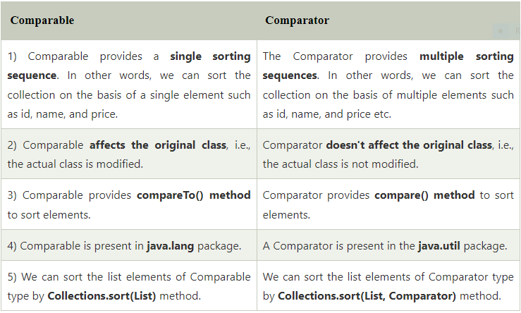
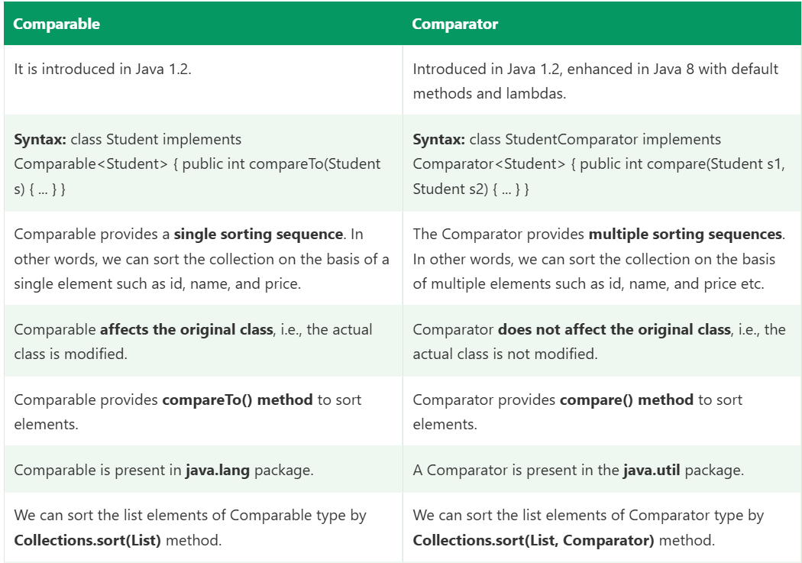
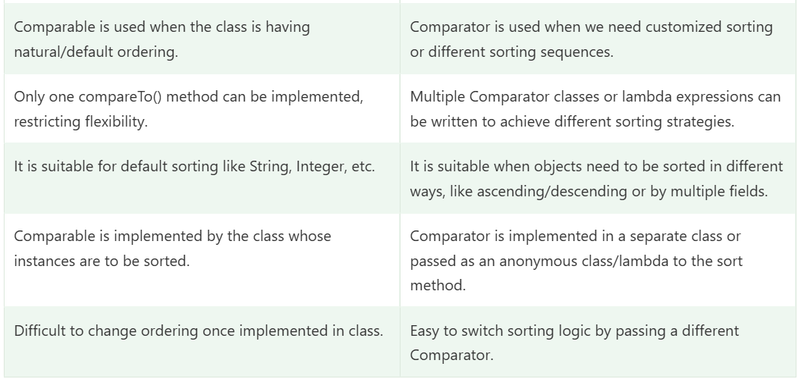
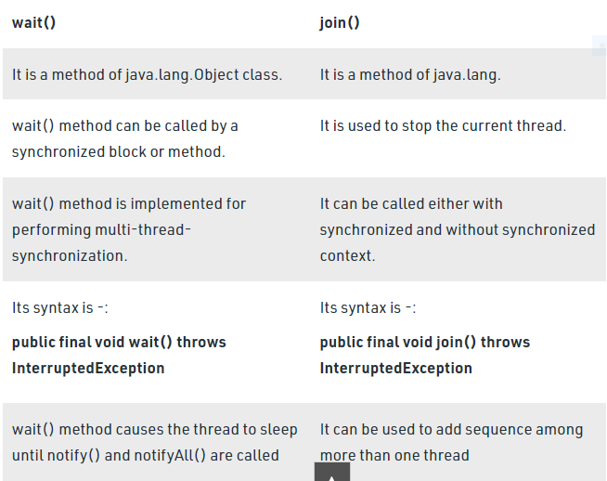

Feature | Collection (Interface) | Collections (Utility Class)
Type | Interface | Utility Class (final)
Purpose | Used to declare, store, and pass around a group of data. | Used to perform operations (sorting, searching, etc.) on existing data.
Hierarchy | The root interface of the Java Collections Framework (extended by List, Set, Queue). | Inherits directly from java.lang.Object; it does not implement the Collection interface.
Methods | Contains instance methods like add(), remove(), size(), and clear(). | Contains exclusively static methods like sort(), reverse(), shuffle(), and min().
Instantiation | Cannot be instantiated directly because it is an interface. | Cannot be instantiated because its constructor is private.

Collection | Collections
It is an interface. | It is a utility class.
It is used to represent a group of individual objects as a single unit. | It defines several utility methods that are used to operate on collection.
The Collection is an interface that contains a static method since java8. The Interface can also contain abstract and default methods. | It contains only static methods.

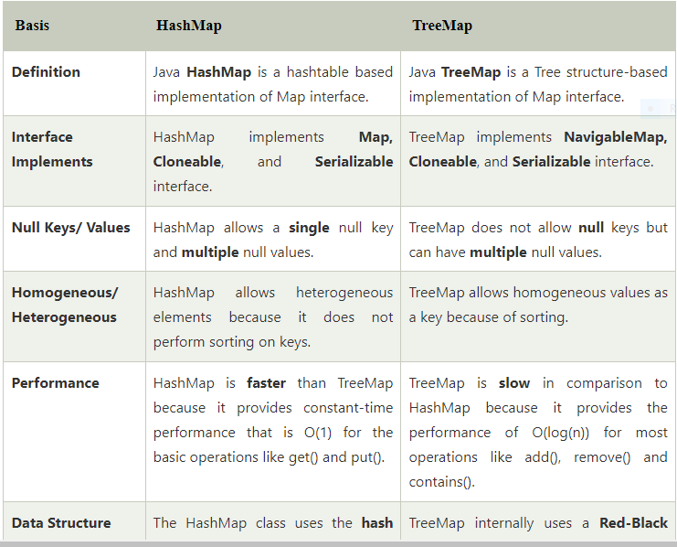
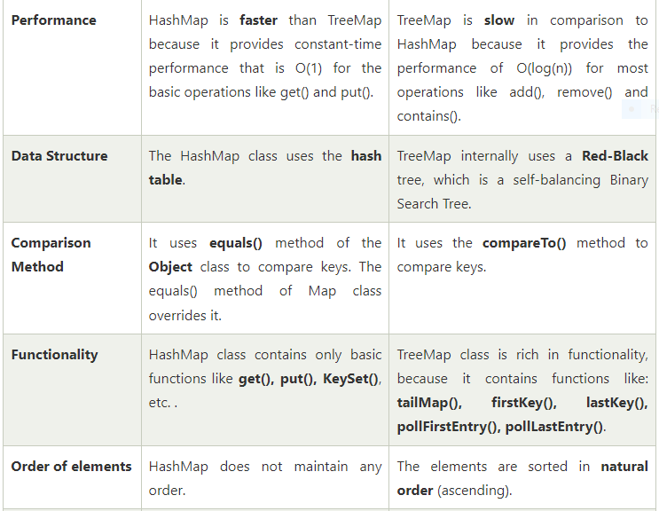
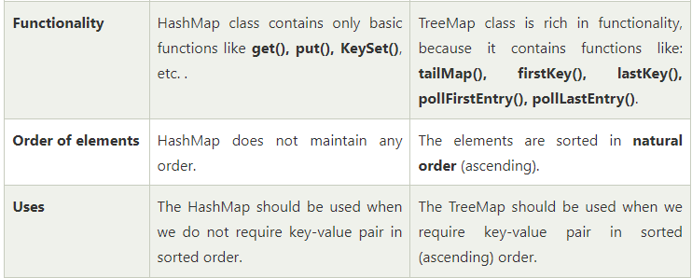
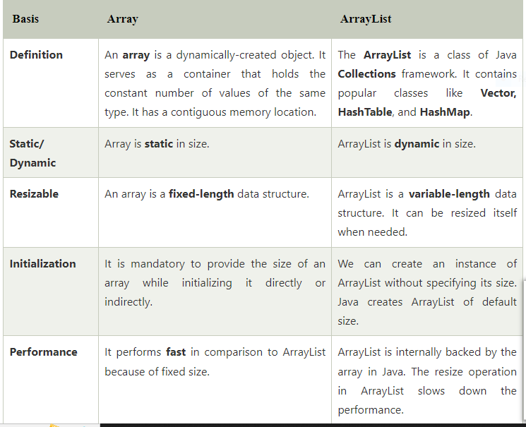
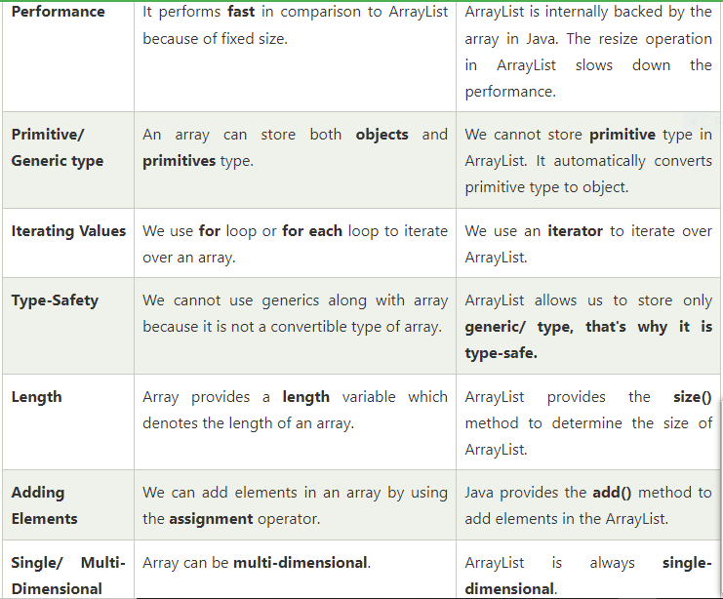
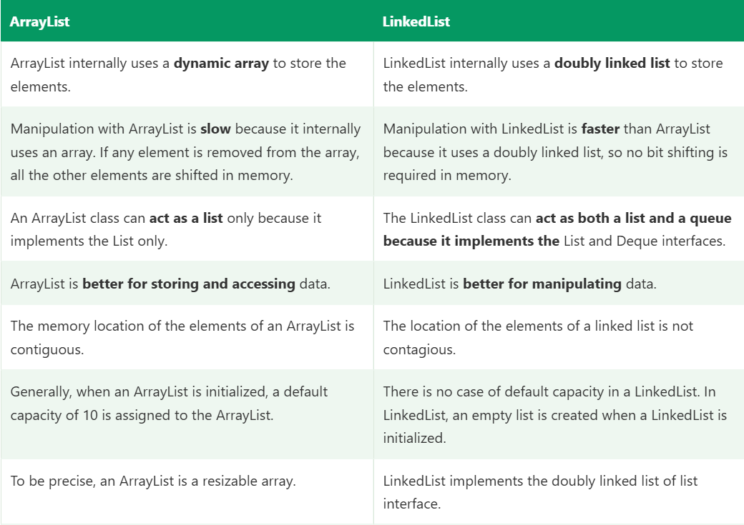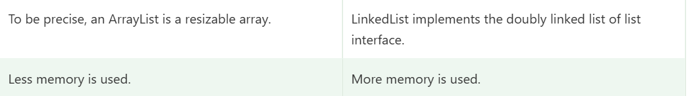

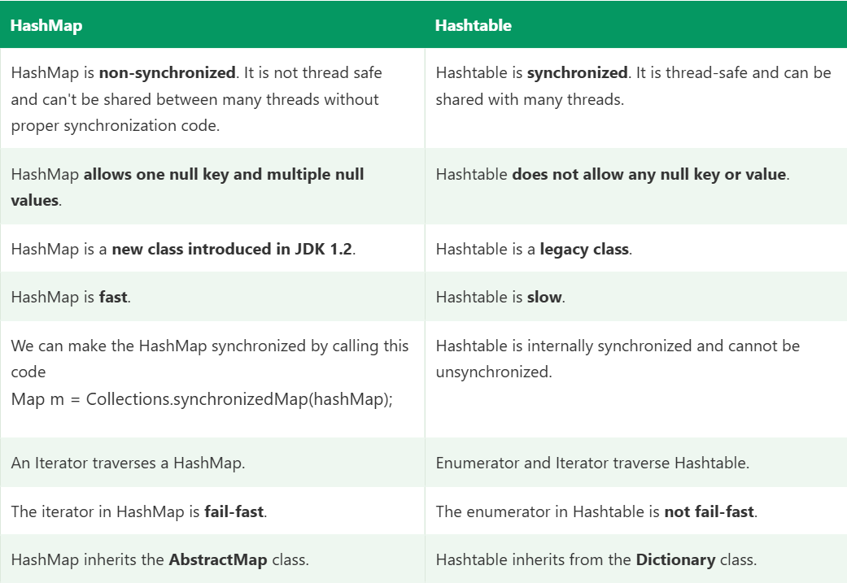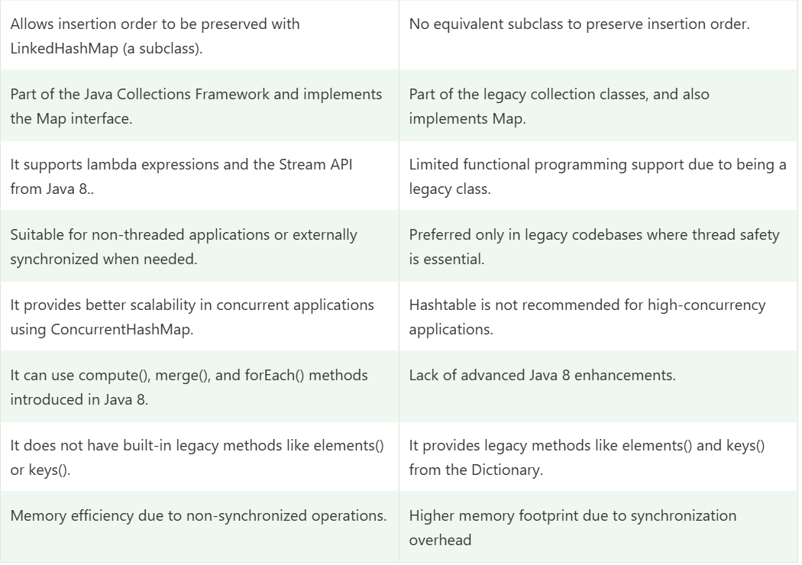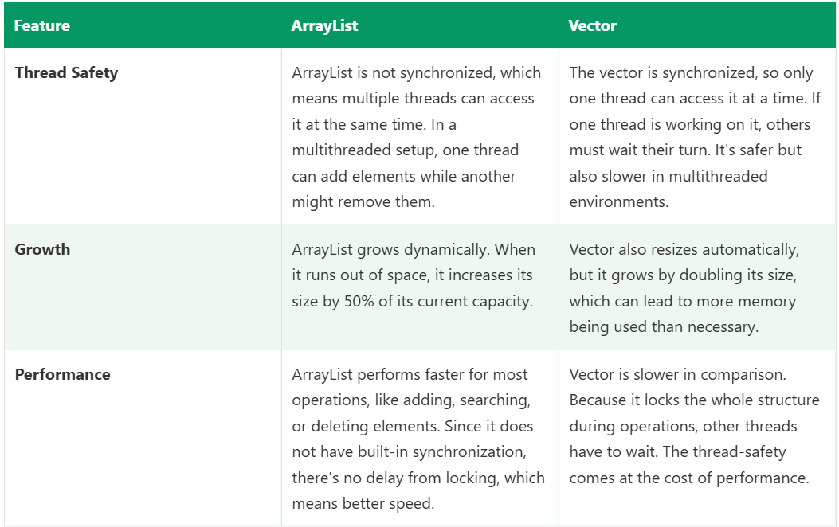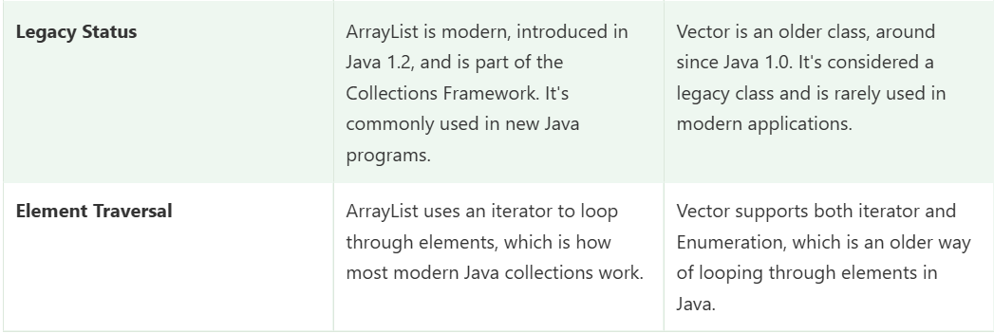
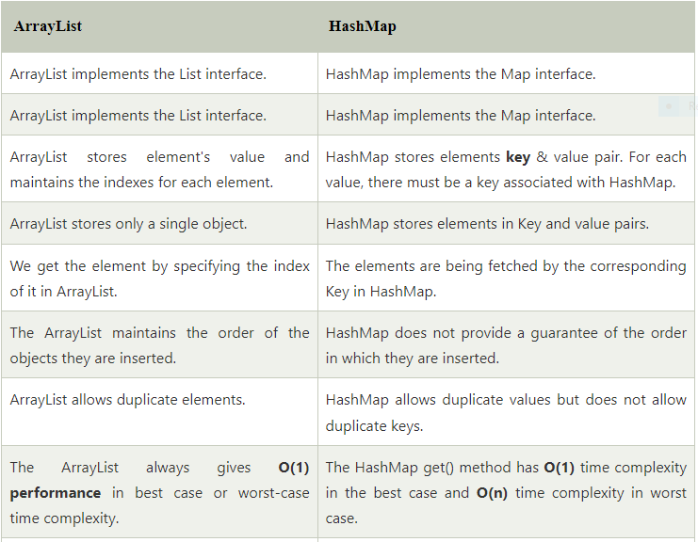
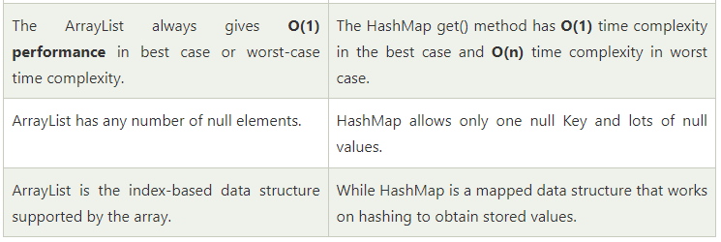
When I pass driver to a page object or utility, the method receives a copy of the reference to the same browser session, so driver.get() affects the caller’s browser. But if the method reassigns driver = new ChromeDriver(), the caller’s driver is unaffected. This is also why a utility method like static void setDriver(WebDriver d) works only because it assigns to a static field, not to the parameter.

Summary
Scenario | Effect on caller
Change a primitive parameter | None
Modify an object’s fields or contents through the parameter | Visible (same object)
Reassign the parameter to a new object | None (only the local copy changes)
Immutable objects (String, Integer) | Can’t be modified, so no visible effect

Short interview answer
“Java is always pass by value. For primitives, a copy of the value is passed. For objects, a copy of the reference is passed. Both the caller’s variable and the method’s parameter point to the same object, so if the method modifies the object’s state, the caller sees it. But if the method reassigns the parameter to a new object, the caller’s reference is unaffected. That’s why Java isn’t call by reference: in true call by reference, reassigning the parameter would change the caller’s variable. A swap method that tries to exchange two objects doesn’t work in Java for the same reason.”

Likely follow-ups
- Why does it look like call by reference for objects? Because both references point to the same heap object, so state changes are shared.
- How would you return a new object from a method then? Use the return value: st = create();.
- How to swap two values in Java? Wrap them in an array or object and swap the contents, or return them in a new structure.
- Is final parameter relevant? final Student s stops reassigning s inside the method, but the object’s fields can still be modified.
- What about String being passed? The reference is passed by value too, but because String is immutable, the caller never sees a change.
- Where is the object stored? Objects live on the heap, local variables and parameters (primitives and references) live on the stack.

Scenario | Effect on caller
Change a primitive parameter | None
Modify an object’s fields or contents through the parameter | Visible (same object)
Reassign the parameter to a new object | None (only the local copy changes)
Immutable objects (String, Integer) | Can’t be modified, so no visible effect

Short interview answer
“Java is always pass by value. For primitives, a copy of the value is passed. For objects, a copy of the reference is passed. Both the caller’s variable and the method’s parameter point to the same object, so if the method modifies the object’s state, the caller sees it. But if the method reassigns the parameter to a new object, the caller’s reference is unaffected. That’s why Java isn’t call by reference: in true call by reference, reassigning the parameter would change the caller’s variable. A swap method that tries to exchange two objects doesn’t work in Java for the same reason.”

Likely follow-ups
- Why does it look like call by reference for objects? Because both references point to the same heap object, so state changes are shared.
- How would you return a new object from a method then? Use the return value: st = create();.
- How to swap two values in Java? Wrap them in an array or object and swap the contents, or return them in a new structure.
- Is final parameter relevant? final Student s stops reassigning s inside the method, but the object’s fields can still be modified.
- What about String being passed? The reference is passed by value too, but because String is immutable, the caller never sees a change.
- Where is the object stored? Objects live on the heap, local variables and parameters (primitives and references) live on the stack.
#======================================================================

Collections in Java
The Java Collections Framework (JCF) is a unified architecture in java.util for storing, retrieving and manipulating groups of objects. It provides interfaces (what), implementations (concrete classes) and algorithms (sorting, searching via the Collections utility class).
Why use it: dynamic size (unlike arrays), ready-made data structures, type safety with generics, and high-performance, well-tested code.

Hierarchy
Iterable
│
Collection
├── List ── ArrayList, LinkedList, Vector (Stack)
├── Set ── HashSet, LinkedHashSet, TreeSet (SortedSet/NavigableSet)
└── Queue ── PriorityQueue, ArrayDeque, LinkedList (Deque)

Map (NOT part of Collection)
└── HashMap, LinkedHashMap, TreeMap, Hashtable, ConcurrentHashMap
Map is separate because it stores key-value pairs, not single elements.

1. List (ordered, allows duplicates, index access)
 | ArrayList | LinkedList | Vector
Internal structure | Dynamic array | Doubly linked list | Dynamic array
Get by index | O(1) | O(n) | O(1)
Add/remove in middle | O(n) | O(1) once positioned | O(n)
Thread-safe | No | No | Yes (synchronized)
Use when | Read-heavy, most cases | Frequent insert/delete at ends | Legacy
java
List<String> list = new ArrayList<>();
list.add("Java");
list.add("Selenium");
list.add("Java"); // duplicate allowed
list.get(1); // Selenium
list.remove("Java"); // removes first match
System.out.println(list); // [Selenium, Java]

2. Set (no duplicates)
 | HashSet | LinkedHashSet | TreeSet
Order | None | Insertion order | Sorted (natural or Comparator)
Internal | HashMap | HashMap + linked list | Red-Black tree
add/contains | O(1) | O(1) | O(log n)
Null | One null allowed | One null allowed | Not allowed (natural ordering)
java
Set<String> set = new HashSet<>();
set.add("A"); set.add("B"); set.add("A");
System.out.println(set); // [A, B], duplicate ignored
Duplicates are detected using hashCode() and equals().

3. Queue / Deque
java
Queue<Integer> q = new LinkedList<>();
q.offer(10); q.offer(20);
q.peek(); // 10, looks at head without removing
q.poll(); // 10, removes head (FIFO)

PriorityQueue<Integer> pq = new PriorityQueue<>(); // min-heap
pq.add(30); pq.add(10); pq.add(20);
pq.poll(); // 10, smallest first

Deque<Integer> stack = new ArrayDeque<>(); // preferred over Stack
stack.push(1); stack.push(2);
stack.pop(); // 2 (LIFO)

4. Map (key-value, unique keys)
 | HashMap | LinkedHashMap | TreeMap | Hashtable | ConcurrentHashMap
Order | None | Insertion/access | Sorted by key | None | None
Null key/values | 1 null key, many null values | Same | No null key | No nulls | No nulls
Thread-safe | No | No | No | Yes (whole-map lock) | Yes (fine-grained)
Performance | O(1) | O(1) | O(log n) | Slow | Fast
java
Map<String, Integer> map = new HashMap<>();
map.put("Raj", 25);
map.put("Amit", 30);
map.put("Raj", 26); // replaces the old value
map.get("Raj"); // 26
map.getOrDefault("Kiran", 0); // 0
map.putIfAbsent("Amit", 99); // no change, key exists

for (Map.Entry<String, Integer> e : map.entrySet()) {
System.out.println(e.getKey() + " = " + e.getValue());
}

Iterating collections
java
for (String s : list) { } // enhanced for
list.forEach(System.out::println); // lambda
Iterator<String> it = list.iterator();
while (it.hasNext()) {
if (it.next().equals("Java")) it.remove(); // safe removal
}

Utility classes
java
Collections.sort(list);
Collections.reverse(list);
Collections.max(list);
Collections.unmodifiableList(list);
Collections.synchronizedList(list);
Arrays.asList(1, 2, 3); // fixed-size list
List.of("a", "b"); // immutable (Java 9+)

Interview Questions and Answers
1. Difference between Collection and Collections?
Collection is the root interface of List, Set and Queue. Collections is a utility class with static methods like sort(), reverse(), max() and synchronizedList().
2. ArrayList vs LinkedList?
ArrayList uses a dynamic array: fast random access (O(1)), slow insert/delete in the middle (shifting). LinkedList uses a doubly linked list: fast insert/delete when you already hold the node, slow access by index (O(n)), and more memory per element. I use ArrayList in nearly all framework code, for example holding a list of web elements or test data rows.
3. How does ArrayList grow internally?
Default capacity is 10 (allocated on first add). When full, it creates a new array of about 1.5x the size and copies the elements. If you know the size, new ArrayList<>(n) avoids repeated resizing.
4. How does HashMap work internally?
It’s an array of buckets (default 16). For put(key, value): compute hashCode() of the key, spread the bits, find the index (n-1) & hash. If the bucket is empty, store the node. If not, compare keys using equals(): same key means replace the value, otherwise add to the bucket’s linked list. For get, the same hash locates the bucket, then equals() finds the key. Since Java 8, a bucket converts from a linked list to a red-black tree when it has 8 or more nodes (and the table has at least 64 buckets), making the worst case O(log n).
5. What is a hash collision and how is it handled?
Two different keys land in the same bucket. HashMap handles it by chaining (a linked list, or a tree in Java 8+).
6. What are load factor and rehashing?
Load factor (default 0.75) is how full the map can get before resizing. When size exceeds capacity × loadFactor (12 for 16), the table doubles and all entries are redistributed (rehashing).
7. Why must hashCode() and equals() be overridden together?
The contract: if two objects are equal, they must return the same hash code. If you override only equals(), two equal objects may land in different buckets, so HashMap/HashSet fail to find them or allow logical duplicates.
8. HashMap vs Hashtable?
HashMap is not synchronized, allows one null key and null values, and is faster. Hashtable is synchronized (whole-map lock), allows no nulls, and is legacy. For thread safety use ConcurrentHashMap.
9. HashMap vs ConcurrentHashMap?
ConcurrentHashMap is thread-safe with fine-grained locking (CAS and per-bin synchronization in Java 8+) rather than locking the whole map, so concurrent reads and writes scale well. It disallows null keys and values. I’d use it for data shared across parallel TestNG threads.
10. HashSet vs TreeSet vs LinkedHashSet?
HashSet: no order, O(1). LinkedHashSet: insertion order, O(1). TreeSet: sorted order, O(log n), needs Comparable or a Comparator.
11. How does HashSet avoid duplicates?
Internally it is backed by a HashMap. Elements are stored as keys with a dummy constant value, so key uniqueness gives set uniqueness. add() returns false if the element exists.
12. Comparable vs Comparator?
 | Comparable | Comparator
Package | java.lang | java.util
Method | compareTo(T o) | compare(T a, T b)
Where | Inside the class itself | Separate class or lambda
Sort orders | One natural order | Many custom orders
java
class Employee implements Comparable<Employee> {
int id; String name;
public int compareTo(Employee o) { return Integer.compare(this.id, o.id); }
}

list.sort(Comparator.comparing((Employee e) -> e.name).thenComparing(e -> e.id));
13. What is fail-fast vs fail-safe?
Fail-fast iterators (ArrayList, HashMap) throw ConcurrentModificationException if the collection is structurally modified during iteration, except through the iterator’s own remove(). Fail-safe collections (CopyOnWriteArrayList, ConcurrentHashMap) iterate over a snapshot or weakly consistent view and don’t throw.
java
for (String s : list) {
if (s.equals("Java")) list.remove(s); // ConcurrentModificationException
}
list.removeIf(s -> s.equals("Java")); // correct
14. Iterator vs ListIterator?
Iterator moves forward only and works on all collections. ListIterator works on Lists only, moves both ways, and can add(), set() and give indexes.
15. How do you make a collection thread-safe?
Collections.synchronizedList(list), concurrent classes (ConcurrentHashMap, CopyOnWriteArrayList), or legacy Vector and Hashtable.
16. Why is Map not part of the Collection interface?
Collection methods like add(E) deal with single elements, while Map deals with key-value pairs. The contracts don’t fit, so it has its own hierarchy.
17. How do you remove duplicates from a list?
java
List<Integer> unique = new ArrayList<>(new LinkedHashSet<>(list)); // keeps order
List<Integer> unique2 = list.stream().distinct().collect(Collectors.toList());
18. How do you sort a Map by value?
java
map.entrySet().stream()
.sorted(Map.Entry.comparingByValue())
.forEach(e -> System.out.println(e.getKey() + " " + e.getValue()));
19. How do you count word frequency?
java
Map<String, Integer> freq = new HashMap<>();
for (String w : text.split("\\s+")) {
freq.merge(w, 1, Integer::sum);
}
20. Arrays.asList() vs List.of() vs new ArrayList<>()?
Arrays.asList() returns a fixed-size list: set is allowed, add/remove throws UnsupportedOperationException, and it is backed by the array. List.of() is fully immutable and rejects nulls. new ArrayList<>() is fully mutable.
21. Can a HashMap key be mutable?
It can, but it’s dangerous. If a field used in hashCode() changes after insertion, the entry lands in the wrong bucket and can’t be found. Use immutable keys like String or Integer.
22. What is the difference between poll()/remove() and peek()/element() in Queue?
poll() and peek() return null on an empty queue. remove() and element() throw NoSuchElementException.
23. What is PriorityQueue ordering?
A min-heap by natural order (or a Comparator). poll() returns the smallest element, but iteration order is not sorted.
24. ArrayList allows null? Duplicates?
Yes to both.
25. Why prefer ArrayDeque over Stack?
Stack extends Vector, so every method is synchronized (slow) and its API is outdated. ArrayDeque is faster and is the recommended LIFO/FIFO structure.

Collections in my framework
Use | Collection
Web elements from findElements | List<WebElement>
Excel/JSON test data rows | List<Map<String, String>>
Request headers and query params in REST Assured | Map<String, String>
Unique links or IDs on a page | Set<String> (LinkedHashSet for order)
Window handles | Set<String> from getWindowHandles()
Per-thread driver | ThreadLocal, or ConcurrentHashMap<Long, WebDriver>
Validating a sorted column in UI | Copy to a list, Collections.sort(), compare with equals()
java
List<WebElement> items = driver.findElements(By.className("inventory_item_name"));
List<String> names = items.stream().map(WebElement::getText).collect(Collectors.toList());

List<String> sorted = new ArrayList<>(names);
Collections.sort(sorted);
Assert.assertEquals(names, sorted);

Short interview answer
“The Collections Framework is a set of interfaces and classes in java.util for storing and processing groups of objects. The main interfaces are List, which is ordered and allows duplicates, with ArrayList and LinkedList; Set, which has unique elements, with HashSet, LinkedHashSet and TreeSet; Queue, with PriorityQueue and ArrayDeque; and Map, which is separate and stores key-value pairs, with HashMap, LinkedHashMap, TreeMap and ConcurrentHashMap. HashMap works with an array of buckets using hashCode() and equals(), resizes at a 0.75 load factor, and converts long buckets to trees in Java 8. In my framework I use List<WebElement> for element groups, List<Map<String,String>> for test data, Map for headers and payloads in REST Assured, and Set for window handles.”

More follow-up topics to prepare
- Time complexity table for ArrayList, LinkedList, HashMap, TreeMap.
- CopyOnWriteArrayList: how it works and when to use it.
- equals()/hashCode() contract with a custom class as a HashMap key.
- LinkedHashMap as an LRU cache using removeEldestEntry.
- WeakHashMap, IdentityHashMap, EnumMap and their use cases.
- Streams with collections: filter, map, collect, groupingBy.

Queue Interface in Java
A Queue is an interface in java.util that represents a collection designed for holding elements before processing. It follows FIFO (First In, First Out) by default: the element added first is removed first, like a line at a ticket counter.
It extends Collection, so it has all collection methods, plus special methods for inserting at the tail and removing from the head.
Iterable → Collection → Queue ┬→ PriorityQueue
├→ LinkedList (also a List)
└→ Deque ┬→ ArrayDeque
└→ LinkedList

(BlockingQueue → LinkedBlockingQueue, ArrayBlockingQueue: java.util.concurrent)

tail (offer) ──► [ C | B | A ] ──► head (poll / peek)
add here remove from here
Queue is an interface, so you can’t write new Queue<>(). You use an implementation.

Key characteristics
Feature | Queue
Order | FIFO (except PriorityQueue, which orders by priority)
Duplicates | Allowed
Null | Not allowed in most implementations (PriorityQueue, ArrayDeque); LinkedList allows it but avoid it, since poll() returns null to mean “empty”
Index access | No
Thread-safe | No (use BlockingQueue / ConcurrentLinkedQueue)

Queue methods: two forms for each operation
Operation | Throws exception if it fails | Returns special value
Insert at tail | add(e) | offer(e) returns false
Remove from head | remove() | poll() returns null
Examine head | element() | peek() returns null
add, remove and element throw (IllegalStateException for a full bounded queue, NoSuchElementException for an empty one). The offer, poll and peek forms are preferred, because they don’t throw.

Syntax
java
import java.util.*;

Queue<String> q1 = new LinkedList<>(); // FIFO, allows null
Queue<String> q2 = new ArrayDeque<>(); // FIFO, faster, no null
Queue<Integer> q3 = new PriorityQueue<>(); // ordered by priority (min-heap)
Queue<Integer> q4 = new PriorityQueue<>(Comparator.reverseOrder()); // max-heap

Example 1: Basic FIFO operations
java
Queue<String> queue = new LinkedList<>();

queue.offer("Login");
queue.offer("Search");
queue.offer("Checkout");

System.out.println(queue); // [Login, Search, Checkout]
System.out.println(queue.peek()); // Login (head, not removed)
System.out.println(queue.poll()); // Login (head, removed)
System.out.println(queue.poll()); // Search
System.out.println(queue); // [Checkout]
System.out.println(queue.size()); // 1
System.out.println(queue.isEmpty()); // false

Example 2: Empty queue behaviour
java
Queue<Integer> q = new LinkedList<>();

System.out.println(q.poll()); // null
System.out.println(q.peek()); // null
q.remove(); // NoSuchElementException
q.element(); // NoSuchElementException

Example 3: Processing until empty
java
Queue<String> tasks = new ArrayDeque<>();
tasks.offer("T1"); tasks.offer("T2"); tasks.offer("T3");

while (!tasks.isEmpty()) {
String t = tasks.poll();
System.out.println("Processing " + t);
}

Example 4: PriorityQueue (not FIFO)
Elements come out by priority, not by insertion order. By default it is a min-heap (smallest first).
java
Queue<Integer> pq = new PriorityQueue<>();
pq.offer(30); pq.offer(10); pq.offer(20);

System.out.println(pq.poll()); // 10
System.out.println(pq.poll()); // 20
System.out.println(pq.poll()); // 30

Queue<Integer> max = new PriorityQueue<>(Collections.reverseOrder());
max.addAll(Arrays.asList(30, 10, 20));
System.out.println(max.poll()); // 30
Custom objects need Comparable or a Comparator:
java
class Task {
String name; int priority;
Task(String n, int p) { name = n; priority = p; }
}

Queue<Task> tq = new PriorityQueue<>(Comparator.comparingInt(t -> t.priority));
tq.offer(new Task("Low", 5));
tq.offer(new Task("Critical", 1));
System.out.println(tq.poll().name); // Critical
printing a PriorityQueue or iterating does not give sorted order, only poll() does, because it is a heap.

Example 5: Iterating
java
for (String s : queue) { System.out.println(s); } // head to tail, doesn't remove
queue.forEach(System.out::println);

Example 6: BlockingQueue (producer-consumer, multi-threaded)
java
BlockingQueue<String> bq = new LinkedBlockingQueue<>(10); // bounded

new Thread(() -> {
try { bq.put("data"); } catch (InterruptedException e) { } // waits if full
}).start();

new Thread(() -> {
try { System.out.println(bq.take()); } catch (InterruptedException e) { } // waits if empty
}).start();

Common implementations
Class | Order | Null | Thread-safe | Notes
LinkedList | FIFO | Allowed | No | Also a List and Deque
ArrayDeque | FIFO (and LIFO) | No | No | Fastest general-purpose queue/stack
PriorityQueue | By priority | No | No | Heap, O(log n) offer/poll
ConcurrentLinkedQueue | FIFO | No | Yes (lock-free) | Non-blocking concurrent
LinkedBlockingQueue | FIFO | No | Yes | Blocking put/take, optional bound
ArrayBlockingQueue | FIFO | No | Yes | Fixed capacity
PriorityBlockingQueue | By priority | No | Yes | Blocking priority queue

Time complexity
Operation | LinkedList / ArrayDeque | PriorityQueue
offer | O(1) | O(log n)
poll | O(1) | O(log n)
peek | O(1) | O(1)
contains / remove(Object) | O(n) | O(n)

When to use a Queue
Use it when | Example
Items must be processed in arrival order | Request or job processing
Producer-consumer handoff | Threads producing and consuming tasks
Breadth-first traversal | Walking pages or a tree level by level
Priority-based processing | Run critical tests first
Buffering work | Pending or retry tests

When NOT to use it
Need | Use instead
Access by index | List
Unique elements | Set
Add/remove at both ends, or a stack | Deque (ArrayDeque)
Key-value lookups | Map

Framework examples
1. Retry or pending test queue
java
Queue<String> pending = new LinkedList<>();
pending.offer("loginTest");
pending.offer("cartTest");
while (!pending.isEmpty()) {
String test = pending.poll();
boolean passed = run(test);
if (!passed && retries.get(test) < 2) pending.offer(test); // re-queue
}
2. Crawling site links (BFS) to find broken links
java
Queue<String> toVisit = new LinkedList<>();
Set<String> visited = new HashSet<>();
toVisit.offer(baseUrl);
while (!toVisit.isEmpty()) {
String url = toVisit.poll();
if (!visited.add(url)) continue;
driver.get(url);
for (WebElement a : driver.findElements(By.tagName("a"))) {
toVisit.offer(a.getAttribute("href"));
}
}
3. Parallel execution: a ConcurrentLinkedQueue or BlockingQueue of test data or available browser sessions shared between threads.
4. Priority test execution: a PriorityQueue ordered by test priority.

Common pitfalls
- Using add/remove/element on possibly empty or full queues throws exceptions. Prefer offer/poll/peek.
- Inserting null into a LinkedList queue makes poll() ambiguous. ArrayDeque and PriorityQueue throw NullPointerException.
- Printing a PriorityQueue doesn’t show priority order.
- PriorityQueue is not FIFO for equal priorities (no stability guarantee).
- Plain queues aren’t thread-safe. Use BlockingQueue or ConcurrentLinkedQueue.
- queue.remove(obj) vs queue.remove() are different: one removes a specific object, the other removes the head.
- Iterating while polling causes ConcurrentModificationException.

Queue vs Stack vs List
 | Queue | Stack (Deque) | List
Order | FIFO | LIFO | By index
Add | Tail (offer) | Top (push) | Anywhere
Remove | Head (poll) | Top (pop) | Anywhere
Index access | No | No | Yes

Interview questions
1. What is a Queue?
An interface for holding elements before processing, usually FIFO, with methods to insert at the tail and remove from the head.
2. Difference between add() and offer()?
Both insert. If it fails (bounded queue is full), add() throws IllegalStateException and offer() returns false.
3. Difference between remove() and poll()?
On an empty queue, remove() throws NoSuchElementException, while poll() returns null.
4. Difference between element() and peek()?
Both view the head without removing. element() throws on empty, peek() returns null.
5. Is PriorityQueue FIFO?
No. It orders by natural order or a Comparator, and poll() returns the highest priority (smallest by default) element. It is implemented as a binary heap.
6. How does PriorityQueue work internally?
A binary min-heap stored in an array. offer sifts up and poll sifts down, both O(log n), and peek is O(1).
7. Queue vs Deque?
A Queue works at one end for insertion (tail) and the other for removal (head). A Deque (double-ended queue) supports insertion and removal at both ends, so it can act as a queue or a stack.
8. ArrayDeque vs LinkedList as a queue?
ArrayDeque is faster and uses less memory but doesn’t allow null. LinkedList allows null and also supports List methods.
9. How do you make a Queue thread-safe?
Use ConcurrentLinkedQueue, a BlockingQueue such as LinkedBlockingQueue, or wrap with Collections.synchronizedCollection().
10. What is a BlockingQueue?
A queue whose put() waits when full and take() waits when empty, used for producer-consumer designs.
11. Can a Queue have duplicates?
Yes.
12. How do you implement a stack using a Queue (or the reverse)?
Classic coding question: use two queues, or rotate a single queue after each push so the newest element reaches the head.

Short interview answer
“Queue is an interface in the Collections Framework for holding elements before processing, typically in FIFO order. It adds at the tail and removes from the head, and provides two forms of each operation: add/remove/element, which throw exceptions, and offer/poll/peek, which return false or null. Main implementations are LinkedList and ArrayDeque for plain FIFO, PriorityQueue for priority order using a heap, and concurrent ones like LinkedBlockingQueue for producer-consumer scenarios. It allows duplicates, has no index access, and isn’t thread-safe by default. I use it for things like a retry queue of failed tests, breadth-first crawling of page links, and sharing work between parallel threads. I prefer ArrayDeque as the default queue, and a Deque when I need to work at both ends.”

PriorityQueue in Java
A PriorityQueue is a class in java.util that implements the Queue interface. Unlike a normal queue (FIFO), it orders elements by priority: poll() and peek() always give you the highest-priority element, which by default is the smallest one (natural ordering). It is backed by a binary heap stored in an array.
Iterable → Collection → Queue → PriorityQueue

Key characteristics
Feature | PriorityQueue
Order | By priority (natural order or Comparator), not FIFO
Default behaviour | Min-heap (smallest element at the head)
Duplicates | Allowed
Null | Not allowed (NullPointerException)
Thread-safe | No (use PriorityBlockingQueue)
Internal structure | Binary heap in an Object[] array
Initial capacity | 11, grows dynamically
offer / add | O(log n)
poll / remove() | O(log n)
peek | O(1)
contains / remove(Object) | O(n)
Elements must be | Comparable, or a Comparator must be supplied
Iterator | Fail-fast, and does not return sorted order

Syntax
java
import java.util.PriorityQueue;
import java.util.Queue;

Queue<Integer> pq1 = new PriorityQueue<>(); // min-heap, natural order
PriorityQueue<Integer> pq2 = new PriorityQueue<>(); // class reference
Queue<Integer> pq3 = new PriorityQueue<>(20); // initial capacity
Queue<Integer> max = new PriorityQueue<>(Collections.reverseOrder()); // max-heap
Queue<Task> pq4 = new PriorityQueue<>(Comparator.comparingInt(t -> t.priority)); // custom
Queue<Integer> pq5 = new PriorityQueue<>(Arrays.asList(5, 1, 3)); // from a collection

Example 1: Min-heap (default)
java
Queue<Integer> pq = new PriorityQueue<>();
pq.offer(30);
pq.offer(10);
pq.offer(20);
pq.offer(5);

System.out.println(pq.peek()); // 5 smallest, not removed
System.out.println(pq.poll()); // 5
System.out.println(pq.poll()); // 10
System.out.println(pq.poll()); // 20
System.out.println(pq.poll()); // 30
System.out.println(pq.poll()); // null, queue is empty
Elements come out in ascending order, regardless of insertion order.

Example 2: Max-heap
java
Queue<Integer> max = new PriorityQueue<>(Collections.reverseOrder());
max.addAll(Arrays.asList(30, 10, 20, 5));

System.out.println(max.poll()); // 30
System.out.println(max.poll()); // 20

Example 3: Strings
java
Queue<String> names = new PriorityQueue<>();
names.addAll(Arrays.asList("Raj", "Amit", "Zara", "Kiran"));

while (!names.isEmpty()) {
System.out.print(names.poll() + " "); // Amit Kiran Raj Zara
}

Example 4: Printing does NOT show sorted order
java
Queue<Integer> pq = new PriorityQueue<>(Arrays.asList(30, 10, 20, 5, 15));
System.out.println(pq); // e.g. [5, 10, 20, 30, 15] heap order, not sorted
Only the head is guaranteed to be the smallest. The rest follows the heap structure. Iteration and toString() follow the array, so to get sorted output you must poll() repeatedly.
Heap as a tree for [5, 10, 20, 30, 15]:

5
/ \
10 20
/ \
30 15
Each parent is smaller than or equal to its children.

Example 5: Custom objects with Comparator
java
class Task {
String name;
int priority; // 1 = highest
Task(String name, int priority) { this.name = name; this.priority = priority; }
@Override public String toString() { return name + "(" + priority + ")"; }
}

Queue<Task> tasks = new PriorityQueue<>(Comparator.comparingInt(t -> t.priority));
tasks.offer(new Task("Report", 3));
tasks.offer(new Task("Login fix", 1));
tasks.offer(new Task("Cleanup", 5));

while (!tasks.isEmpty()) {
System.out.println(tasks.poll()); // Login fix(1), Report(3), Cleanup(5)
}

Example 6: Custom objects with Comparable
java
class Job implements Comparable<Job> {
String name; int priority;
Job(String n, int p) { name = n; priority = p; }

@Override
public int compareTo(Job o) { return Integer.compare(this.priority, o.priority); }
}

Queue<Job> jobs = new PriorityQueue<>();
jobs.offer(new Job("A", 2));
jobs.offer(new Job("B", 1));
If the class is not Comparable and no Comparator is given, offer() throws ClassCastException.

Example 7: Top-K elements (classic use)
java
int[] nums = {7, 2, 9, 4, 11, 5};
int k = 3;

Queue<Integer> minHeap = new PriorityQueue<>(); // keeps the k largest
for (int n : nums) {
minHeap.offer(n);
if (minHeap.size() > k) minHeap.poll(); // drop the smallest
}
System.out.println(minHeap); // the 3 largest: 7, 9, 11 (heap order)
// kth largest = minHeap.peek() → 7
Memory and time stay at O(k) and O(n log k).

How it works internally
- Stored in an array. For a node at index i: parent is (i - 1) / 2, left child is 2i + 1, right child is 2i + 2.
- offer(e): place the element at the end, then sift up: swap with its parent while it’s smaller than the parent. O(log n).
- poll(): take the root, move the last element to the root, then sift down: swap with the smaller child while it’s larger. O(log n).
- peek(): returns queue[0]. O(1).
- It grows by about 2x when small (under 64), then 1.5x.
- The constructor with a collection uses heapify in O(n).
offer(3) into [5, 10, 20]: [5, 10, 20, 3] → sift up → [3, 5, 20, 10]
poll(): remove 3, move 10 to the root, sift down → [5, 10, 20]

Time complexity
Operation | Complexity
offer / add | O(log n)
poll / remove() | O(log n)
peek / element | O(1)
remove(Object) | O(n)
contains | O(n)
Build from a collection | O(n)

When to use PriorityQueue
Use it when | Example
You repeatedly need the smallest or largest element | Always process the most urgent task
Processing by priority, not arrival order | Critical tests first
Top-K / Kth largest or smallest problems | Top 5 slowest tests
Scheduling and event simulation | Task schedulers
Algorithms: Dijkstra, merge K sorted lists, Huffman coding | Shortest path
Running median using two heaps | Streaming data

When NOT to use it
Need | Use instead
FIFO order | ArrayDeque / LinkedList
Fully sorted iteration | TreeSet (unique) or ArrayList + sort
Index access | List
Fast contains or removal of arbitrary items | HashSet / TreeSet
Thread safety | PriorityBlockingQueue
Nulls | Not supported by any priority queue

Framework examples
1. Run tests by priority
java
Queue<TestCase> queue = new PriorityQueue<>(Comparator.comparingInt(TestCase::getPriority));
queue.addAll(allTests);
while (!queue.isEmpty()) {
execute(queue.poll()); // critical tests run first
}
2. Top 3 slowest API responses
java
Queue<Long> times = new PriorityQueue<>(); // min-heap of size 3
for (long t : responseTimes) {
times.offer(t);
if (times.size() > 3) times.poll();
}
3. Retry queue where failed high-priority tests go first.
4. Find the lowest price quickly while elements keep arriving, with peek().
5. Ordering test-data records or log events by timestamp.

Common pitfalls
- Iterating or printing does not give sorted order. Use poll().
- Null elements throw NullPointerException.
- Non-Comparable objects without a Comparator throw ClassCastException.
- Mutating an element’s priority after insertion doesn’t re-heapify. Remove and re-add it.
- Not stable: equal-priority elements may come out in any order. Add a sequence number to the comparator if insertion order matters.
- Not thread-safe. Use PriorityBlockingQueue.
- remove(Object) and contains are O(n), so avoid them in hot loops.
- Max-heap confusion: the default is a min-heap. For largest-first use Collections.reverseOrder().
- Integer overflow in comparators: (a, b) -> a - b can overflow. Use Integer.compare(a, b).

PriorityQueue vs other collections
 | PriorityQueue | LinkedList / ArrayDeque | TreeSet
Order | Head is min/max only | FIFO | Fully sorted
Duplicates | Allowed | Allowed | Not allowed
offer | O(log n) | O(1) | O(log n)
Get min/max | O(1) | O(n) | O(log n)
Fully sorted iteration | No | No | Yes
Null | No | LinkedList yes | No

Interview questions
1. What is a PriorityQueue?
A Queue implementation where elements are ordered by priority, using natural ordering or a Comparator, rather than insertion order. The head is always the least (highest-priority) element.
2. How does it work internally?
As a binary heap in an array. offer sifts up and poll sifts down, both O(log n), and peek is O(1).
3. Is it min-heap or max-heap by default?
Min-heap. Use Collections.reverseOrder() or a reversed Comparator for a max-heap.
4. Does it maintain sorted order when iterating?
No, only the head is guaranteed. Polling repeatedly gives sorted order.
5. Can it store null or duplicates?
Duplicates yes, null no.
6. Is it thread-safe?
No. Use PriorityBlockingQueue.
7. Is it FIFO for equal priorities?
No, it isn’t stable.
8. Time complexity of its operations?
offer and poll are O(log n), peek is O(1), remove(Object) and contains are O(n).
9. How do you find the Kth largest element?
Keep a min-heap of size K. After processing all elements, peek() is the Kth largest.
10. How do you build a max-heap?
new PriorityQueue<>(Collections.reverseOrder()).
11. PriorityQueue vs TreeSet?
PriorityQueue allows duplicates and gives O(1) access to the min, but isn’t fully sorted. TreeSet is unique and fully sorted, with O(log n) access.
12. What happens if elements aren’t Comparable?
ClassCastException, unless a Comparator is supplied.

Short interview answer
“PriorityQueue is a Queue implementation that orders elements by priority instead of insertion order. It’s backed by a binary heap in an array, and by default it’s a min-heap, so peek() and poll() return the smallest element. I can pass a Comparator, such as Collections.reverseOrder(), to change the order, and custom objects must be Comparable or use a Comparator. offer and poll are O(log n), peek is O(1). It allows duplicates but not null, isn’t thread-safe, isn’t stable, and iterating over it doesn’t give sorted order. I use it when I always need the most important element next, for example running tests by priority, finding top-K results like the slowest API responses, and in algorithms like Dijkstra’s. For FIFO I use ArrayDeque, and for a fully sorted unique collection, TreeSet.”

Map Interface :
Java Map interface holds a set of key-value pairs where each key is unique and points to one value only. It belongs to java.util package. A Map is useful if one has to search, update, or delete elements on the basis of a key.
In this chapter, you will learn about the Java Map interface, its features, and examples.

Hierarchy of Map Interface
The following image shows the hierarchy of the Map interface and its implementations:

Why to Use Map Interface?
The following points explain why the Map interface is useful:
- Efficient Data Retrieval: Map allows fast searching of values using keys. It is very useful when you need to quickly access data from a large dataset.
- No Duplicate Keys: Each key in a Map is unique and maps to only one value. This helps maintain data consistency and avoids duplicate entries.
- Flexible Data Types: We can store different types of objects as keys and values in a Map. This makes it flexible for representing different types of relationships.
- Associative Structure: Map works like a dictionary where each key is linked to a value. It helps in organizing data in a meaningful and structured way.
- Caching and Memoization: Map can store results of operations so they can be reused later. It improves performance by avoiding repeated calculations.

Features of Map Interface
The following points describe the key features of the Map interface:
- Key-Value Pair Structure: Map stores data in the form of key and value pairs. Each key is used to access its corresponding value.
- No Duplicate Keys: A Map does not allow duplicate keys, but it can have duplicate values. If you add a duplicate key, the old value is replaced with the new value.
- Allows Null Values: Some Map implementations allow null keys and values. For example, HashMap allows one null key and multiple null values.
- Not a Subtype of Collection: Map is not a part of the Collection interface. It is a separate interface in the Java Collections Framework.
- Traversal Using Set: A Map cannot be traversed directly. To iterate over it, you need to use keySet(), values(), or entrySet() methods.
- Different Implementations: Map has different implementations like HashMap, LinkedHashMap, and TreeMap. Each implementation works differently based on ordering and performance.
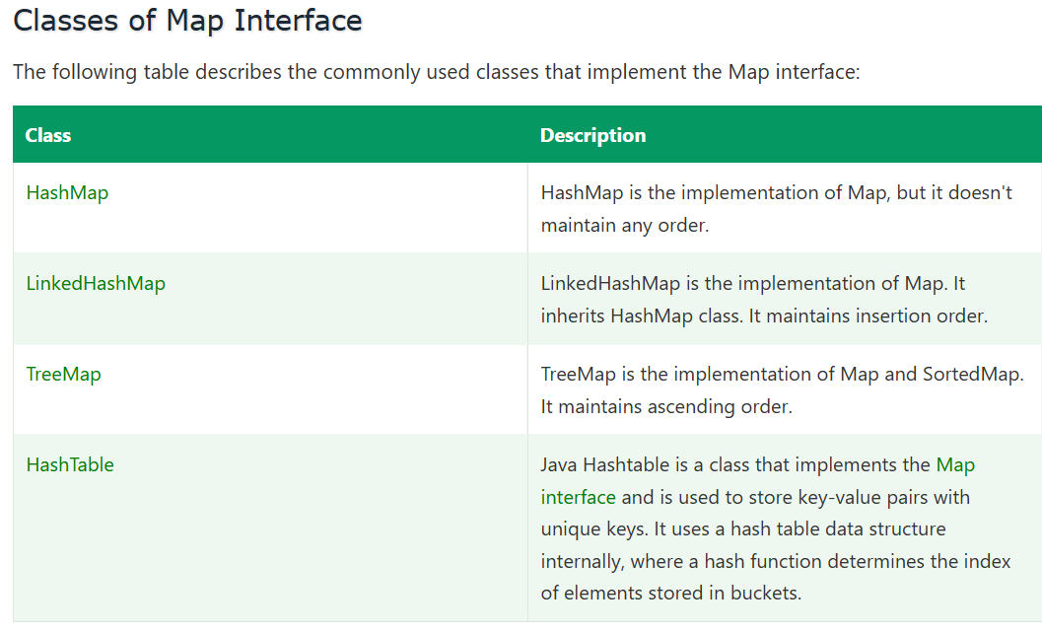

Map Interface in Java
A Map is an interface in java.util that stores data as key-value pairs. Each key is unique and maps to exactly one value. You look up a value by its key, not by an index. Duplicate values are allowed, but a duplicate key replaces the old value.
Map does not extend Collection, because Collection methods like add(E) deal with single elements, while a Map deals with pairs. It has its own hierarchy.
Map ┬→ HashMap ──→ LinkedHashMap
├→ Hashtable
├→ SortedMap → NavigableMap → TreeMap
└→ ConcurrentMap → ConcurrentHashMap
Since Map is an interface, you use an implementation: HashMap, LinkedHashMap, TreeMap, etc.

Key characteristics
Feature | Map
Structure | Key-value pairs (Map.Entry<K, V>)
Keys | Unique (duplicate key overwrites the value)
Values | Duplicates allowed
Index access | No, access by key
Order | Depends on the implementation
Null | Depends on the implementation
Key uniqueness decided by | equals() and hashCode() (Hash maps) or compareTo() (TreeMap)

Syntax
java
import java.util.*;

Map<String, Integer> map1 = new HashMap<>(); // no order, fastest
Map<String, Integer> map2 = new LinkedHashMap<>(); // insertion order
Map<String, Integer> map3 = new TreeMap<>(); // sorted by key
Map<String, Integer> map4 = new HashMap<>(32); // initial capacity
Map<String, Integer> map5 = new HashMap<>(otherMap); // copy of another map
Map<String, Integer> immutable = Map.of("A", 1, "B", 2); // Java 9+, immutable
Keys and values must be objects (use wrappers like Integer, not int).

Core methods
Method | Purpose
put(k, v) | Add or replace; returns the old value or null
get(k) | Value for the key, or null
getOrDefault(k, d) | Value, or default if the key is missing
putIfAbsent(k, v) | Add only if the key is missing
containsKey(k) / containsValue(v) | Existence checks (containsKey is O(1) in HashMap, containsValue is O(n))
remove(k) | Remove the entry
size() / isEmpty() / clear() | Basic info
keySet() | Set of keys
values() | Collection of values
entrySet() | Set of Map.Entry pairs
merge(k, v, fn) | Combine with an existing value
computeIfAbsent(k, fn) | Create the value if the key is missing
compute, computeIfPresent, replaceAll, forEach | Functional-style updates

Example 1: Basic operations
java
Map<String, Integer> map = new HashMap<>();

map.put("Raj", 25);
map.put("Amit", 30);
map.put("Kiran", 28);
Integer old = map.put("Raj", 26); // replaces; returns 25

System.out.println(map.get("Raj")); // 26
System.out.println(map.get("Zara")); // null
System.out.println(map.getOrDefault("Zara", 0)); // 0
System.out.println(map.containsKey("Amit")); // true
System.out.println(map.containsValue(28)); // true
map.putIfAbsent("Amit", 99); // no change, key exists
map.remove("Kiran");
System.out.println(map.size()); // 2

Example 2: Iterating
java
for (Map.Entry<String, Integer> e : map.entrySet()) { // best: key and value together
System.out.println(e.getKey() + " = " + e.getValue());
}

for (String key : map.keySet()) { System.out.println(key); }
for (Integer v : map.values()) { System.out.println(v); }

map.forEach((k, v) -> System.out.println(k + " = " + v));
Looping over keySet() and calling get(key) inside does an extra lookup each time, so entrySet() is better.

Example 3: Counting frequency
java
String text = "java selenium java testng java";
Map<String, Integer> freq = new HashMap<>();

for (String w : text.split("\\s+")) {
freq.merge(w, 1, Integer::sum);
}
System.out.println(freq); // {java=3, selenium=1, testng=1}
The older way: freq.put(w, freq.getOrDefault(w, 0) + 1);

Example 4: Grouping values
java
Map<Integer, List<String>> byLength = new HashMap<>();
for (String s : Arrays.asList("Java", "API", "TestNG", "Rest")) {
byLength.computeIfAbsent(s.length(), k -> new ArrayList<>()).add(s);
}
System.out.println(byLength); // {3=[API], 4=[Java, Rest], 6=[TestNG]}

Example 5: Three main implementations compared
java
Map<String, Integer> hm = new HashMap<>();
Map<String, Integer> lhm = new LinkedHashMap<>();
Map<String, Integer> tm = new TreeMap<>();
for (String k : new String[]{"Raj", "Amit", "Zara", "Kiran"}) { hm.put(k, 1); lhm.put(k, 1); tm.put(k, 1); }

System.out.println(hm); // arbitrary order
System.out.println(lhm); // {Raj=1, Amit=1, Zara=1, Kiran=1}
System.out.println(tm); // {Amit=1, Kiran=1, Raj=1, Zara=1}

Example 6: Custom object as a key
Override both equals() and hashCode(), otherwise lookups fail. Better still, use an immutable key.
java
class Point {
final int x, y;
Point(int x, int y) { this.x = x; this.y = y; }
@Override public boolean equals(Object o) {
if (!(o instanceof Point)) return false;
Point p = (Point) o;
return x == p.x && y == p.y;
}
@Override public int hashCode() { return Objects.hash(x, y); }
}

Map<Point, String> grid = new HashMap<>();
grid.put(new Point(1, 2), "A");
System.out.println(grid.get(new Point(1, 2))); // A

Choosing the implementation
 | HashMap | LinkedHashMap | TreeMap | Hashtable | ConcurrentHashMap
Order | None | Insertion (or access) | Sorted by key | None | None
Null key | One | One | No | No | No
Null values | Yes | Yes | Yes | No | No
Thread-safe | No | No | No | Yes (whole-map lock) | Yes (fine-grained)
get / put | O(1) | O(1) | O(log n) | O(1) | O(1)
Internal | Array of buckets + list/tree | HashMap + linked list | Red-Black tree | Array of buckets | Buckets + CAS / locking
Use when | Default choice | Predictable order, LRU cache | Sorted keys, range queries | Legacy | Shared across threads

How HashMap works (short version)
- put(k, v) computes k.hashCode(), spreads the bits, and finds the bucket index (n - 1) & hash.
- Empty bucket: store the node. Occupied: compare keys with equals(). Same key replaces the value, otherwise the node is chained.
- When a bucket reaches 8 nodes (and the table has at least 64 buckets), it becomes a red-black tree (Java 8+).
- Default capacity is 16 and load factor is 0.75. When size exceeds 12, the table doubles and entries are rehashed.

When to use a Map
Use it when | Example
You look up data by a unique key | Username to user details
You need to count or group things | Word frequency, tests by status
Associating names with values | Config properties, headers, query params
You need fast lookups instead of scanning a list | Caching results
Representing a row of data with column names | Excel row as Map<String, String>

When NOT to use a Map
Need | Use instead
Only unique single values | Set
Ordered items accessed by index | List
FIFO / LIFO processing | Queue / Deque
Keys are small consecutive ints or enums | Array or EnumMap

Framework examples
1. REST Assured headers, query and path params
java
Map<String, String> headers = new HashMap<>();
headers.put("Content-Type", "application/json");
headers.put("Authorization", "Bearer " + token);

given().headers(headers).queryParams(params).when().get("/booking");
2. Request payload as a Map (instead of a POJO)
java
Map<String, Object> body = new HashMap<>();
body.put("firstname", "Raj");
body.put("totalprice", 500);
given().body(body).post("/booking");
3. Excel / JSON test data: each row is a Map
java
List<Map<String, String>> rows = new ArrayList<>();
Map<String, String> row = new LinkedHashMap<>();
row.put("username", "standard_user");
row.put("password", "secret_sauce");
rows.add(row);
4. Parsing a response
java
Map<String, Object> booking = response.jsonPath().getMap("booking");
String name = (String) booking.get("firstname");
5. Parallel drivers: ConcurrentHashMap<Long, WebDriver> keyed by thread id.
6. Cucumber DataTable.asMaps() gives List<Map<String, String>>.

Common pitfalls
- get() returns null for a missing key (and also if the value is null). Use containsKey() or getOrDefault().
- Unboxing NPE: int x = map.get("missing"); throws NullPointerException.
- Mutable keys: changing a key’s fields after insertion breaks lookups.
- Missing equals()/hashCode() in custom key classes.
- ConcurrentModificationException when you add or remove inside iteration. Use Iterator.remove(), entrySet().removeIf(), or ConcurrentHashMap.
- HashMap isn’t thread-safe. Concurrent writes can lose data.
- Ordering assumptions: HashMap order is not guaranteed.
- Map.of() is immutable and rejects nulls and duplicate keys.
- TreeMap rejects null keys and needs comparable keys.

Interview questions
1. Why isn’t Map part of the Collection interface?
Collection methods work on single elements, while Map stores key-value pairs, so the contracts don’t fit.
2. Can a Map have duplicate keys or values?
Keys no (the new value overwrites the old one). Values yes.
3. HashMap vs Hashtable?
HashMap is unsynchronized, allows one null key and null values, and is faster. Hashtable is synchronized, allows no nulls, and is legacy.
4. HashMap vs ConcurrentHashMap?
ConcurrentHashMap is thread-safe with fine-grained locking, so concurrent reads and writes scale well. It disallows nulls.
5. HashMap vs LinkedHashMap vs TreeMap?
No order and fastest; insertion order; sorted by key with O(log n).
6. How does HashMap work internally?
Buckets chosen by hash of the key; collisions chained as a list, converted to a tree at 8 nodes; resize at 0.75 load factor.
7. What happens when two keys have the same hash code?
They land in the same bucket. equals() then decides whether it’s the same key (replace) or a different one (chain).
8. Why override both equals() and hashCode() for keys?
Equal keys must hash to the same bucket, or lookups fail.
9. Can you use null as a key?
HashMap and LinkedHashMap allow one null key. TreeMap, Hashtable and ConcurrentHashMap don’t.
10. keySet() vs values() vs entrySet()?
Set of keys, Collection of values, Set of key-value entries. These are views backed by the map.
11. How do you sort a Map by value?
java
map.entrySet().stream()
.sorted(Map.Entry.comparingByValue())
.forEach(e -> System.out.println(e.getKey() + " " + e.getValue()));
12. put() vs putIfAbsent()?
put always overwrites. putIfAbsent writes only when the key is absent (or mapped to null).
13. How do you make a Map thread-safe?
ConcurrentHashMap (preferred) or Collections.synchronizedMap().
14. What is Map.Entry?
A nested interface representing one key-value pair, with getKey(), getValue() and setValue().

Short interview answer
“Map is an interface in the Collections Framework that stores data as unique-key to value pairs. It isn’t part of the Collection hierarchy because it deals with pairs rather than single elements. Keys must be unique, so putting an existing key overwrites its value, but values can repeat. The main implementations are HashMap, which is unordered and O(1), LinkedHashMap, which keeps insertion order, TreeMap, which sorts by key in O(log n), and ConcurrentHashMap for thread safety. HashMap uses the key’s hashCode() and equals() to find the bucket, so custom keys must override both. I use a Map whenever I need fast lookup by a key, to count or group data, and to represent name-value data. In my framework I use it for request headers, query parameters and payloads in REST Assured, for Excel and JSON test data rows as Map<String, String>, and for a thread-keyed driver map in parallel runs.”
HashTable Class :

Hashtable in Java
A Hashtable is a class in java.util that stores key-value pairs using a hash table. It is one of the oldest collection classes (Java 1.0, before the Collections Framework) and was later retrofitted to implement Map. Its defining feature is that every method is synchronized, so it is thread-safe. It is now considered a legacy class.
Dictionary (abstract, obsolete)
└── Hashtable (also implements Map, Cloneable, Serializable)
└── Properties

Key characteristics
Feature | Hashtable
Structure | Key-value pairs
Keys | Unique (duplicate key replaces the value)
Values | Duplicates allowed
Null key | Not allowed (NullPointerException)
Null value | Not allowed (NullPointerException)
Order | None guaranteed (and not insertion order)
Thread-safe | Yes, every method is synchronized (one lock for the whole table)
Internal structure | Array of buckets with linked-list chaining (no tree conversion)
Default capacity / load factor | 11 / 0.75
Growth | newCapacity = old * 2 + 1
Bucket index | (hash & 0x7FFFFFFF) % capacity (modulo, not bit masking)
Iterator | Fail-fast; also legacy Enumeration (not fail-fast)
Performance | O(1) average, but slower than HashMap because of locking
Status | Legacy. Prefer ConcurrentHashMap

Syntax
java
import java.util.Hashtable;
import java.util.Map;

Hashtable<String, Integer> ht1 = new Hashtable<>(); // default capacity 11
Hashtable<String, Integer> ht2 = new Hashtable<>(50); // initial capacity
Hashtable<String, Integer> ht3 = new Hashtable<>(50, 0.8f); // capacity + load factor
Hashtable<String, Integer> ht4 = new Hashtable<>(someMap); // copy of another map
Map<String, Integer> ht5 = new Hashtable<>(); // interface reference
Note the class name is Hashtable (lowercase “t”), not HashTable.

Example 1: Basic operations
java
Hashtable<String, Integer> ht = new Hashtable<>();

ht.put("Raj", 25);
ht.put("Amit", 30);
ht.put("Kiran", 28);
Integer old = ht.put("Raj", 26); // replaces, returns 25

System.out.println(ht.get("Raj")); // 26
System.out.println(ht.get("Zara")); // null (missing key)
System.out.println(ht.getOrDefault("Zara", 0));// 0
System.out.println(ht.containsKey("Amit")); // true
System.out.println(ht.containsValue(28)); // true
System.out.println(ht.size()); // 3
ht.remove("Kiran");
System.out.println(ht); // order not predictable, e.g. {Amit=30, Raj=26}

Example 2: Nulls are not allowed
java
Hashtable<String, String> ht = new Hashtable<>();

ht.put(null, "value"); // NullPointerException (null key)
ht.put("key", null); // NullPointerException (null value)
ht.get(null); // NullPointerException
Reason: Hashtable calls key.hashCode() and value methods directly with no null handling. Also, because the whole design is for concurrent use, a null return from get() is meant to mean only “key not found”, with no ambiguity.

Example 3: Iterating
java
for (Map.Entry<String, Integer> e : ht.entrySet()) {
System.out.println(e.getKey() + " = " + e.getValue());
}

ht.forEach((k, v) -> System.out.println(k + " = " + v));

// legacy Enumeration (original Hashtable API)
Enumeration<String> keys = ht.keys();
while (keys.hasMoreElements()) {
String k = keys.nextElement();
System.out.println(k + " = " + ht.get(k));
}
Enumeration<Integer> vals = ht.elements();
Enumeration is read-only (no remove) and not fail-fast. The entrySet()/keySet() iterators are fail-fast and throw ConcurrentModificationException if the table is modified during iteration, except through the iterator’s own remove().

Example 4: Thread safety demonstration
java
Hashtable<String, Integer> counter = new Hashtable<>();
counter.put("hits", 0);

Runnable task = () -> {
for (int i = 0; i < 1000; i++) {
synchronized (counter) { // needed for compound actions
counter.put("hits", counter.get("hits") + 1);
}
}
};
Each single method (put, get) is synchronized, but a compound action like “read, then write” is not atomic. Without the external synchronized block, two threads can both read the same value and lose an update. This is a key limitation of Hashtable and the reason ConcurrentHashMap provides merge(), compute() and putIfAbsent() as atomic operations.

Example 5: Properties, a subclass of Hashtable
java
Properties props = new Properties();
props.load(new FileInputStream("config.properties"));
String url = props.getProperty("baseUrl");
Properties extends Hashtable<Object, Object>, and it’s the most common place Hashtable shows up in framework code (the ConfigReader that loads config.properties).

How it works internally
- put(k, v) throws NullPointerException if the key or value is null.
- Index = (k.hashCode() & 0x7FFFFFFF) % table.length. The mask removes the sign bit to keep the index non-negative.
- If the bucket has entries, equals() is checked along the chain. A matching key gets its value replaced, otherwise a new entry is added at the head of the chain.
- When count >= threshold (capacity x load factor, i.e. 8 for capacity 11), the table is rehashed to 2 * old + 1.
- Every public method is synchronized, so only one thread at a time can use the table (read or write).
- Unlike HashMap in Java 8+, long chains are never converted to trees.
Using a prime-ish capacity like 11 with modulo spreads keys reasonably when hash codes are poor, but modulo is slower than HashMap’s bit masking.

Hashtable vs HashMap vs ConcurrentHashMap
 | Hashtable | HashMap | ConcurrentHashMap
Thread-safe | Yes (every method locked) | No | Yes (fine-grained)
Locking | One lock for the whole table | None | CAS + per-bin locks
Null key | No | One | No
Null values | No | Yes | No
Default capacity | 11 | 16 | 16
Growth | 2n + 1 | 2n | 2n
Performance | Slow under contention | Fastest (single thread) | Fast, scales with threads
Iterator | Fail-fast (+ Enumeration) | Fail-fast | Weakly consistent (never throws CME)
Atomic helpers (merge, compute) | Inherited, but locked on the whole table | Not atomic | Yes
Introduced | Java 1.0 | Java 1.2 | Java 1.5
Status | Legacy | Standard | Preferred concurrent map

When to use Hashtable
Realistically, rarely. Valid cases:
Use it when | Example
Maintaining legacy code or APIs that require it | Old libraries returning Hashtable
Working with Properties (it is a Hashtable) | Loading config.properties
A tiny shared map with very low contention and simplicity matters | Small config registry
You need no nulls and thread safety with minimal code, and performance isn’t a concern | Quick synchronized map

When NOT to use it
Need | Use instead
Single-threaded code | HashMap
Concurrent access, good performance | ConcurrentHashMap
Nulls allowed | HashMap
Insertion order | LinkedHashMap
Sorted keys | TreeMap
Simple synchronized wrapper over any map | Collections.synchronizedMap(new HashMap<>())

Framework examples
1. Properties for configuration (the realistic one)
java
Properties props = new Properties(); // a Hashtable underneath
try (FileInputStream fis = new FileInputStream("config.properties")) {
props.load(fis);
}
String browser = props.getProperty("browser");
2. Shared data across parallel threads
java
// legacy style
Hashtable<Long, WebDriver> drivers = new Hashtable<>();
// preferred today
ConcurrentHashMap<Long, WebDriver> drivers2 = new ConcurrentHashMap<>();
I avoid the Hashtable version, since every get and put blocks all other threads and parallel test threads would queue on the single lock.
3. A map passed to older APIs, such as JNDI environment settings (Hashtable<String, String> for InitialContext) or some legacy JDBC and LDAP utilities.

Common pitfalls
- Null key or value throws NullPointerException, unlike HashMap.
- Compound operations are not atomic, so “check then put” still needs external synchronization.
- Poor scalability: one lock means readers block readers.
- Fail-fast iterators throw ConcurrentModificationException if another thread (or the same one) modifies the table while iterating.
- Naming mistake: Hashtable, not HashTable.
- Order is unpredictable, and differs from HashMap’s order for the same data.
- Properties inherits Hashtable methods like put(Object, Object), which can insert non-String values and cause getProperty() to return null. Use setProperty().

Interview questions
1. What is Hashtable?
A legacy, synchronized, hash-based Map implementation from Java 1.0 that doesn’t allow null keys or values.
2. HashMap vs Hashtable?
HashMap is unsynchronized (faster), allows one null key and null values, and is the modern default. Hashtable is synchronized on every method, allows no nulls, and is legacy.
3. Why doesn’t Hashtable allow null keys or values?
It calls hashCode() on the key and uses the value directly without null checks, and the design wants a null result from get() to unambiguously mean “absent”. HashMap special-cases a null key by using hash 0.
4. Is Hashtable thread-safe? Is it enough?
Each method is individually thread-safe, but compound operations (check-then-act) are not atomic, so you still need external synchronization for them.
5. Why is Hashtable slow?
A single lock guards the entire table, so all threads, even readers, serialize on it.
6. Hashtable vs ConcurrentHashMap?
ConcurrentHashMap uses CAS and per-bin locking (Java 8+) so reads are mostly lock-free and writes lock only a bucket, giving far better concurrency, plus atomic methods like merge(). Both reject nulls.
7. What is the default capacity and growth?
11, growing to 2 * old + 1 when the load factor 0.75 is exceeded.
8. How do you make a HashMap thread-safe instead?
Collections.synchronizedMap(new HashMap<>()) (still one lock) or, better, ConcurrentHashMap.
9. Is Hashtable ordered?
No. Use LinkedHashMap for insertion order or TreeMap for sorted order.
10. What is the relationship between Hashtable and Properties?
Properties extends Hashtable<Object, Object> and adds String-focused methods (getProperty, setProperty, load, store).
11. Does Hashtable use Enumeration or Iterator?
Both. keys()/elements() return the legacy Enumeration, while keySet(), values() and entrySet() give fail-fast iterators.
12. Does Hashtable convert long chains to trees like HashMap?
No. That optimization exists only in HashMap (and ConcurrentHashMap) from Java 8.

Short interview answer
“Hashtable is a legacy key-value collection from Java 1.0 that was later made to implement the Map interface. Its main feature is that every method is synchronized, so it is thread-safe, but it uses a single lock for the whole table, which makes it slow under concurrency. It doesn’t allow null keys or null values, keeps no guaranteed order, starts with capacity 11 and a 0.75 load factor, and grows to 2n + 1. Compared to HashMap, it is synchronized and rejects nulls, and compared to ConcurrentHashMap it is much less scalable and has no atomic compound operations. I don’t choose it for new code. I use HashMap for single-threaded work and ConcurrentHashMap for shared data across parallel threads. The place I still meet it is Properties, which extends Hashtable and is what my ConfigReader uses to load config.properties.”

Hashtable Class Parameters
The following are the parameters used in the java.util.Hashtable class.
- K: It represents the type of keys maintained by the map.
- V: It represents the type of values mapped to the keys.

Features of Hashtable
Several features of Hashtable are as follows:
- Key-Value Mapping: Hashtable stores data in key-value pairs that allows direct access to values using their corresponding keys.
- Synchronization: Hashtable is synchronized, which makes it thread-safe. Multiple threads can access and modify it without causing data inconsistency, although this may impact performance.
- No Null Keys or Values: Hashtable does not allow null keys or null values. Attempting to insert them results in a NullPointerException.
- Hashtable Iteration: Elements of a Hashtable can be traversed using methods like keySet(), values(), and entrySet(), which provide collections for iteration.
- Performance: Hashtable generally provides constant-time performance for operations like get() and put(), but it may be slower compared to non-synchronized collections like HashMap in highly concurrent scenarios.
- Resizing: Hashtable automatically resizes itself when the number of elements exceeds a certain threshold, increasing capacity and rehashing existing entries.
- Enumeration: Hashtable supports the Enumeration interface for iterating over elements, mainly for compatibility with older Java code

Working of HashMap in Java :

What is Hashing
Hashing is the process of converting an object into an integer value. This integer value helps in indexing and enables faster searching.
In other words, hashing is a technique used to uniquely identify an object from a group of similar objects.

What is HashMap
HashMap is a part of the Java Collection Framework. It uses a technique called hashing and implements the Map interface.
It stores data in the form of key-value pairs. Internally, HashMap uses an array of nodes, where each node represents a key-value pair. It uses an array and LinkedList data structure for storing data.
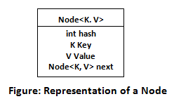

Working of HashMap in Java
Before understanding the internal working of HashMap, we must know about hashCode() and equals() methods.
- equals():
It checks whether two objects are equal or not by comparing their keys. It is a method of the Object class and can be overridden. If you override equals(), then it is mandatory to override hashCode() as well.
- hashCode():
It is a method of the Object class that returns an integer value for the object. This value is used to determine the bucket location in HashMap. The hash code of a null key is always 0.
- Buckets:
Buckets are an array of nodes used in HashMap. Each bucket can store multiple nodes using a LinkedList structure. More than one element can be stored in the same bucket.
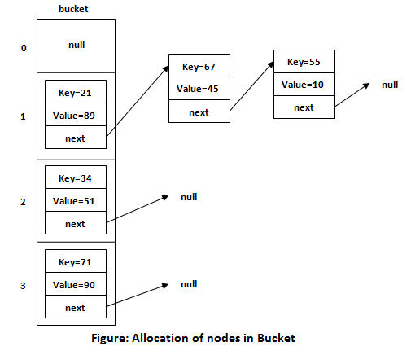

Hash Function
A hash function takes an input (or key) and returns a fixed-length value, usually an integer called a hash code.
This hash code is used to index data in a hash table (like the array used in HashMap). The main goal of a hash function is to distribute data evenly and reduce collisions.

Insert Key, Value Pair in HashMap
We use the put() method to insert key-value pairs into a HashMap. By default, HashMap has an initial capacity of 16 (index range 0 to 15).

Example
In this example, we are inserting three key-value pairs into a HashMap.
- HashMap<String, Integer> map = new HashMap<>();
- map.put("Aman", 19);
- map.put("Sunny", 29);
- map.put("Ritesh", 39);
When we call the put() method, it calculates the hash code of the key. For example, suppose the hash code of "Aman" is 2657860. To store the key in memory, an index is calculated.

Calculating Index
The index is used to determine the position where the key-value pair will be stored in the array.
The formula for calculating the index is:
- Index = hashcode(Key) & (n-1)
Where n is the size of the array.
So, for the key "Aman":
- Index = 2657860 & (16-1) = 4
The value 4 is the computed index value where the Key and value will store in HashMap.
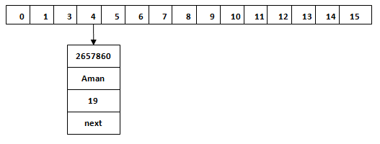

Hash Collision
This is the case when the calculated index value is the same for two or more Keys. Let's calculate the hash code for another Key, "Sunny." Suppose, the hash code for "Sunny" is 63281940. To store the Key in the memory, we have to calculate the index by using the index formula.
- Index=63281940 & (16-1) = 4
The value 4 is the computed index value where the Key will be stored in HashMap. In this case, equals() method check that both Keys are equal or not. If Keys are same, replace the value with the current value. Otherwise, connect this node object to the existing node object through the LinkedList. Hence both Keys will be stored at index 4.
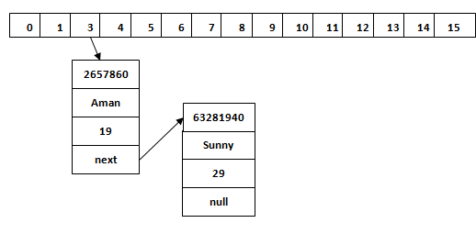
Similarly, we will store the Key "Ritesh." Suppose, hash code for the Key is 2349873. The index value will be 1. Hence, this Key will be stored at index 1.
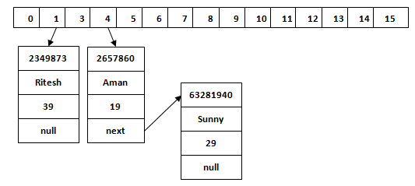

Handling Collisions
Despite efforts to minimize them, collisions are inevitable. Two main strategies to handle collisions are:
- Chaining: Storing all elements that hash to the same index in a linked list or tree at that
- Open Addressing: Finding another open slot within the hash table by probing (for example, linear probing, quadratic probing) when a collision occurs.

HashMap.get() Method
The get() method is used to get the value by its Key. It will not fetch the value if we do not know the Key. When the get(K Key) method is called, it calculates the hash code of the Key.
Suppose, we have to fetch the Key "Aman." The following method will be called.
- map.get(new Key("Aman"));
It generates the hash code as 2657860. Now calculate the index value of 2657860 by using index formula. The index value will be 4, as we have calculated above. The get() method search for the index value 4. It compares the first element Key with the given Key. If both keys are equal, it returns the value else check for the next element in the node if it exists. In our scenario, it is found as the first element of the node and return the value 19.
Let's fetch another Key "Sunny."
The hash code of the Key "Sunny" is 63281940. The calculated index value of 63281940 is 4, as we have calculated for put() method. Go to index 4 of the array and compare the first element's Key with the given Key. It also compares Keys. In our scenario, the given Key is the second element, and the next of the node is null. It compares the second element Key with the specified Key and returns the value 29. It returns null if the next of the node is null.

HashMap Traversal
Java provides various methods such as entrySet(), keySet(), and values() to traverse over hash map. These methods allow us to iterate over the keys, values, or key-value pairs of the HashMap. Consider the following code snippet.
- for (Map.Entry<String, Integer> entry : map.entrySet()) {
- System.out.println("Key: " + entry.getKey() + ", Value: " + entry.getValue());
- }

Rehashing and Load Factor
To maintain performance, a HashMap needs to resize itself (rehash) when the number of elements grows significantly. It is controlled by the load factor that is a measure of how full the hash table is allowed to get before its capacity is automatically increased.
- Load Factor: HashMap's default load factor is 0.75. It means that when the hash table is 75% full, it will resize by doubling its current capacity.
- Rehashing: When rehashing occurs, a new, larger array is created, and all the existing entries are rehashed to new indices in the new array. It ensures that the hash table maintains a good balance between time and space complexity
Working Of HashMap :
HashMap stores key-value pairs in an array of buckets. It uses the key’s hashCode() to decide which bucket an entry goes to, and equals() to identify the exact key inside that bucket. This gives O(1) average time for put and get.

Core structure (simplified from the JDK)
java
public class HashMap<K, V> {
transient Node<K, V>[] table; // the bucket array (capacity is always a power of 2)
transient int size; // number of key-value pairs
int threshold; // capacity * loadFactor, resize trigger
final float loadFactor; // default 0.75
transient int modCount; // structural change counter (fail-fast)

static class Node<K, V> {
final int hash; // cached hash of the key
final K key;
V value;
Node<K, V> next; // next node in the same bucket (linked list)
}
}
Defaults: capacity 16, load factor 0.75, so the threshold is 12. The table is created lazily on the first put().

Step 1: Hash calculation
java
static final int hash(Object key) {
int h;
return (key == null) ? 0 : (h = key.hashCode()) ^ (h >>> 16);
}
- A null key always gets hash 0, so it goes to bucket 0 (this is why HashMap allows one null key).
- h ^ (h >>> 16) mixes the high 16 bits into the low 16 bits. Since the bucket index uses only the low bits, this reduces collisions from poorly distributed hash codes.

Step 2: Finding the bucket index
java
index = (n - 1) & hash; // n = table length (power of 2)
This is a fast replacement for hash % n. For n = 16, (n - 1) is 1111 in binary, so the index is just the lowest 4 bits of the hash. That is why capacity is always kept a power of 2.

Step 3: put(key, value) flow
put(k, v)
│
▼
hash = hash(k); table empty? → resize() to create it (capacity 16)
│
▼
index = (n - 1) & hash
│
├── bucket empty ─────────────────────► place new Node here
│
└── bucket occupied
│
├── first node: same hash AND (same reference OR equals())
│ └─► same key → REPLACE the value, return old value
│
├── first node is a TreeNode ──► insert into the red-black tree
│
└── walk the linked list
├── key found ──► replace value
└── reached the end ──► append new Node at the TAIL
└─ if list length ≥ 8 → treeifyBin()
│
▼
modCount++, ++size > threshold ? → resize() (double the table)
Key detail: the key match test is hash equality first, then == or equals(). Comparing the stored hash first avoids calling equals() on most non-matching nodes.

Step 4: get(key) flow
- Compute hash(key) and the index.
- Look at the first node in that bucket: if hash matches and the key is == or equals(), return its value.
- Otherwise, walk the linked list (or search the tree) comparing hash and equals().
- Not found: return null.
Without collisions, this is a direct array access plus one comparison, hence O(1).

Worked example
java
Map<String, Integer> map = new HashMap<>();
map.put("Raj", 25);
map.put("Amit", 30);
map.put("Raj", 26);

Bucket array (capacity 16):

[0] → null
[3] → ["Amit"=30]
[7] → ["Raj"=26] second put("Raj") found the same key and replaced 25 with 26
[...]
If "Amit" and "Kiran" ended up in the same bucket (collision), they would chain:
[3] → ["Amit"=30] → ["Kiran"=28] → null

Collision handling
A collision happens when different keys map to the same bucket.
Java version | Handling
Up to Java 7 | Linked list only (worst case O(n)), new nodes inserted at the head
Java 8+ | Linked list, converted to a red-black tree when long (worst case O(log n)), new nodes added at the tail
Treeify rule: a bucket becomes a tree when its list reaches 8 nodes (TREEIFY_THRESHOLD) and the table capacity is at least 64 (MIN_TREEIFY_CAPACITY). If the table is smaller than 64, HashMap resizes instead. When a tree shrinks to 6 nodes or fewer (UNTREEIFY_THRESHOLD) during resize or removal, it converts back to a linked list.
Before: [5] → A → B → C → D → E → F → G → H (8 nodes)
After: [5] → red-black tree of A..H (when capacity ≥ 64)
Trees are ordered by hash, then by compareTo() if the keys are Comparable, then by an identity tie-breaker.

Resizing and rehashing
When size > threshold (12 for capacity 16):
- A new array of double capacity is created (16 → 32 → 64 ...), and the threshold doubles too.
- Entries are redistributed. In Java 8+, because capacity doubles, each node either stays at the same index or moves to oldIndex + oldCapacity. Which one depends on a single extra bit of the hash (hash & oldCap), so no hash recomputation is needed, and the relative order within a bucket is preserved.
oldCap = 16, node with hash bits ...0 0101 → (hash & 16) == 0 → stays at index 5
oldCap = 16, node with hash bits ...1 0101 → (hash & 16) != 0 → moves to index 5 + 16 = 21
Resizing is O(n) and expensive, so if you know the size, pre-size the map: new HashMap<>(expectedSize / 0.75f + 1).

hashCode() and equals() contract
- If a.equals(b), then a.hashCode() == b.hashCode(). Equal keys must land in the same bucket.
- Unequal objects may share a hash code (collision), which is allowed but slows things down.
- Override both in custom key classes, and use immutable keys (such as String and Integer). If a key’s fields change after insertion, its hash changes and the entry becomes unreachable.
java
class Emp {
int id;
@Override public boolean equals(Object o) { /* compare id */ }
// hashCode() NOT overridden → equal Emps hash differently → get() returns null
}

Other internals
- Fail-fast iteration: every structural change increments modCount. Iterators compare it with their expected value and throw ConcurrentModificationException on mismatch.
- Not thread-safe: concurrent puts can overwrite each other or lose data. In Java 7, concurrent resizing could even cause an infinite loop in a bucket chain. Use ConcurrentHashMap.
- Capacity rounding: new HashMap<>(20) rounds up to the next power of 2 (32).
- Null handling: one null key (bucket 0), any number of null values.
- Iteration order is by bucket index, then chain order, so it is arbitrary and can change after a resize.

Time complexity
Operation | Average | Worst case
put / get / remove / containsKey | O(1) | O(log n) in Java 8+ (tree bucket), O(n) before
containsValue | O(n) | O(n)
Iteration | O(capacity + n)
Resize | O(n)

Interview questions
1. How does HashMap work internally?
It’s an array of buckets. put hashes the key, computes (n - 1) & hash, and stores a node in that bucket. Collisions are chained in a linked list, and treeified at 8 nodes (capacity at least 64). get repeats the same hashing, then uses equals() within the bucket. It resizes at 0.75 load factor.
2. What happens when two keys have the same hash code?
They go to the same bucket, and equals() decides whether it’s the same key (replace) or a different one (chain).
3. What happens if the same key is put twice?
The existing node’s value is replaced and the old value is returned. Size doesn’t change.
4. Why is capacity always a power of 2?
So the index can be calculated with the fast (n - 1) & hash bitmask, and so resizing can split buckets with a single bit check.
5. Why h ^ (h >>> 16)?
To spread the upper bits of the hash into the lower bits, because only the low bits are used for the index. It reduces collisions for poor hash functions.
6. What are load factor and threshold?
Load factor (0.75) is how full the table can get before it resizes. Threshold = capacity x load factor (12 for 16).
7. When does a bucket become a tree?
When it reaches 8 nodes and the table has at least 64 buckets. It reverts to a list at 6 nodes or fewer.
8. How does a null key work?
hash(null) returns 0, so it’s stored in bucket 0.
9. What happens if hashCode() always returns the same value?
Every key lands in one bucket, so it degrades to a list, or a tree in Java 8+ (O(log n) for Comparable keys, otherwise slower).
10. Why use immutable keys?
A key whose hash changes after insertion is looked up in the wrong bucket and can’t be found or removed.
11. Is HashMap thread-safe? What goes wrong?
No. Concurrent puts can lose entries, and concurrent resizing can corrupt the structure (infinite loop in Java 7). Use ConcurrentHashMap.
12. HashMap vs Hashtable vs ConcurrentHashMap?
HashMap: unsynchronized, allows a null key, fastest. Hashtable: fully synchronized, no nulls, legacy. ConcurrentHashMap: thread-safe with fine-grained locking, no nulls.
13. How does resizing work in Java 8?
The table doubles, and each node either stays at its index or moves by oldCapacity, based on hash & oldCap. Order within the bucket is preserved.
14. Can you store a HashMap key as a mutable object?
You can, but it’s unsafe if the fields used in hashCode() change.

Short interview answer
“HashMap is backed by an array of buckets, with a default capacity of 16 and a load factor of 0.75. On put, it calls the key’s hashCode(), spreads the bits with h ^ (h >>> 16), and finds the bucket using (n - 1) & hash. If the bucket is empty, the node is stored there. If not, it compares the hash and equals() along the chain: a matching key has its value replaced, otherwise the node is appended. When a chain reaches 8 nodes and the table has at least 64 buckets, it converts to a red-black tree, so the worst case is O(log n). get follows the same hash and bucket lookup. When the size exceeds capacity times 0.75, the table doubles and entries are redistributed, each staying at the same index or moving by the old capacity. That’s why keys need consistent hashCode() and equals() and should be immutable. It allows one null key, isn’t thread-safe, and I use ConcurrentHashMap for shared data in parallel runs.”

LinkedHashMap class :

What is LinkedHashMap in Java?
Java LinkedHashMap class is a Hashtable and Linked List implementation of the Map interface. It extends the HashMap class and implements the Map interface.
It stores data as key-value pairs and maintains the order in which elements are inserted.
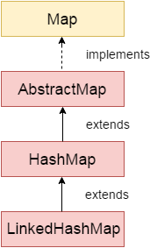

Features of LinkedHashMap
Here are some of the key features of LinkedHashMap:
- Java LinkedHashMap stores values based on keys.
- It contains unique keys.
- It allows one null key and multiple null values.
- It is non-synchronized.
- It maintains insertion order.
- The default capacity is 16 with a load factor of 0.75.

LinkedHashMap class declaration
Let's see the declaration for java.util.LinkedHashMap class.
- public class LinkedHashMap<K,V> extends HashMap<K,V> implements Map<K,V>

LinkedHashMap class Parameters
Let's see the parameters for java.util.LinkedHashMap class:
- K: It is the type of keys maintained by this map.
- V: It is the type of mapped values.

Constructors of LinkedHashMap Class
Java LinkedHashMap class provides different constructors to create and initialize a LinkedHashMap.

1. LinkedHashMap()
It is used to construct a default LinkedHashMap.
Here is the syntax:
- LinkedHashMap<K,V> map = new LinkedHashMap<K,V>();

2. LinkedHashMap(int capacity)
It is used to construct a LinkedHashMap with the specified initial capacity.
Here is the syntax:
- LinkedHashMap<K,V> map = new LinkedHashMap<K,V>(int capacity);

3. LinkedHashMap(int capacity, float loadFactor)
It is used to construct a LinkedHashMap with the specified capacity and load factor.
Here is the syntax:
- LinkedHashMap<K,V> map = new LinkedHashMap<K,V>(int capacity, float loadFactor);

4. LinkedHashMap(int capacity, float loadFactor, boolean accessOrder)
It is used to construct a LinkedHashMap with the specified capacity, load factor, and ordering mode (insertion order or access order).
Here is the syntax:
- LinkedHashMap<K,V> map = new LinkedHashMap<K,V>(int capacity, float loadFactor, boolean accessOrder);

5. LinkedHashMap(Map m)
It is used to construct a LinkedHashMap containing the elements of the specified Map.
Here is the syntax:
- LinkedHashMap<K,V> map = new LinkedHashMap<K,V>(Map<? extends K, ? extends V> m);
A LinkedHashMap is a class in java.util that stores key-value pairs like a HashMap, but also remembers the order of entries. It extends HashMap and adds a doubly linked list running through all entries, so iteration follows a predictable order (insertion order by default, or access order if configured).
Map → HashMap → LinkedHashMap

Key characteristics
Feature | LinkedHashMap
Keys | Unique (duplicate key replaces the value)
Values | Duplicates allowed
Order | Insertion order (default) or access order
Null key | One allowed
Null values | Allowed
Thread-safe | No
Internal structure | HashMap buckets + doubly linked list of entries
get / put / remove | O(1) average
Default capacity / load factor | 16 / 0.75
Iterator | Fail-fast
Re-inserting an existing key | Does not change its position (in insertion-order mode)

Syntax
java
import java.util.LinkedHashMap;
import java.util.Map;

Map<String, Integer> m1 = new LinkedHashMap<>(); // insertion order
Map<String, Integer> m2 = new LinkedHashMap<>(50); // initial capacity
Map<String, Integer> m3 = new LinkedHashMap<>(50, 0.75f); // capacity + load factor
Map<String, Integer> m4 = new LinkedHashMap<>(16, 0.75f, true); // true = ACCESS order
Map<String, Integer> m5 = new LinkedHashMap<>(otherMap); // copy, keeps source iteration order

Example 1: Insertion order
java
Map<String, Integer> map = new LinkedHashMap<>();
map.put("Raj", 25);
map.put("Amit", 30);
map.put("Kiran", 28);
map.put("Raj", 26); // replaces value, position unchanged

System.out.println(map); // {Raj=26, Amit=30, Kiran=28}

for (Map.Entry<String, Integer> e : map.entrySet()) {
System.out.println(e.getKey() + " = " + e.getValue()); // always Raj, Amit, Kiran
}
A HashMap with the same data could print in any order.

Example 2: Access order
java
Map<String, Integer> map = new LinkedHashMap<>(16, 0.75f, true);
map.put("A", 1);
map.put("B", 2);
map.put("C", 3);

map.get("A"); // A becomes the most recently accessed
System.out.println(map); // {B=2, C=3, A=1}
In access-order mode, every get, put of an existing key, and putIfAbsent moves that entry to the end. The least recently used entry is at the front.

Example 3: LRU cache (the classic use)
Override removeEldestEntry to drop the oldest entry automatically.
java
class LRUCache<K, V> extends LinkedHashMap<K, V> {
private final int capacity;

LRUCache(int capacity) {
super(16, 0.75f, true); // access order
this.capacity = capacity;
}

@Override
protected boolean removeEldestEntry(Map.Entry<K, V> eldest) {
return size() > capacity; // evict least recently used
}
}

LRUCache<String, String> cache = new LRUCache<>(3);
cache.put("A", "1");
cache.put("B", "2");
cache.put("C", "3");
cache.get("A"); // A is now most recent
cache.put("D", "4"); // exceeds 3, evicts B (least recently used)
System.out.println(cache); // {C=3, A=1, D=4}

Example 4: Preserving order from other sources
java
Map<String, String> row = new LinkedHashMap<>(); // keeps Excel column order
row.put("username", "standard_user");
row.put("password", "secret_sauce");
row.put("role", "admin");
Iterating gives the columns in the same order as the sheet.

How it works internally
java
static class Entry<K, V> extends HashMap.Node<K, V> {
Entry<K, V> before, after; // links to the previous and next entry
}
transient LinkedHashMap.Entry<K, V> head; // eldest
transient LinkedHashMap.Entry<K, V> tail; // youngest
- Lookup and storage work exactly like HashMap (hash, bucket, equals()), so get and put stay O(1).
- Every new entry is also linked at the tail of the doubly linked list.
- Iteration walks the linked list, not the bucket array. That makes iteration cost proportional to the number of entries, not the capacity, so it can be faster than HashMap for sparse tables.
- In access-order mode, a hook (afterNodeAccess) moves the accessed entry to the tail.
- After each insertion, afterNodeInsertion calls removeEldestEntry(), which enables the LRU behaviour.
- Cost: two extra references per entry, so slightly more memory and slightly slower puts than HashMap.

HashMap vs LinkedHashMap vs TreeMap
 | HashMap | LinkedHashMap | TreeMap
Order | None | Insertion / access | Sorted by key
get / put | O(1) | O(1) | O(log n)
Null key | One | One | No
Memory | Lowest | Higher | Higher
Iteration | Over buckets | Over linked list | In-order tree walk
Use for | General lookups | Predictable order, LRU | Sorted keys, range queries

When to use LinkedHashMap
Use it when | Example
You need fast lookups and predictable iteration order | Config values shown in a fixed order
Output must match input order | Excel columns, JSON fields, report rows
Building an LRU cache | Cache of recent API responses
Stable, repeatable results in logs or assertions | Same order every run
Grouping while keeping first-seen order | Counting items in order of appearance

When NOT to use it
Need | Use instead
Fastest, least memory, order irrelevant | HashMap
Sorted by key | TreeMap
Thread safety | ConcurrentHashMap (no order) or Collections.synchronizedMap(new LinkedHashMap<>())
Concurrent LRU cache | A dedicated cache library such as Caffeine
Only unique values | LinkedHashSet

Framework examples
1. Test data rows keeping column order
java
List<Map<String, String>> data = new ArrayList<>();
Map<String, String> row = new LinkedHashMap<>();
row.put("username", "standard_user");
row.put("password", "secret_sauce");
data.add(row);
2. Count in order of appearance
java
Map<String, Integer> freq = new LinkedHashMap<>();
for (String w : words) freq.merge(w, 1, Integer::sum);
3. REST Assured request payloads where JSON field order should be stable
java
Map<String, Object> body = new LinkedHashMap<>();
body.put("firstname", "Raj");
body.put("lastname", "Kumar");
body.put("totalprice", 500);
given().body(body).post("/booking");
4. Readable failure messages and reports (same key order every run).
5. Caching frequently used lookups (such as auth tokens per user) with an LRU limit.

Common pitfalls
- Re-putting an existing key doesn’t move it in insertion-order mode. Remove it first to move it to the end.
- Access-order mode changes the map on reads, so get() is a structural modification. Iterating while calling get() throws ConcurrentModificationException.
- Not thread-safe, including LRU caches shared across threads.
- Mutable keys break lookups, as in any hash map.
- More memory than HashMap.
- Equality ignores order: two LinkedHashMaps with the same entries in different order are equals().

Interview questions
1. What is LinkedHashMap?
A HashMap subclass that keeps a doubly linked list of its entries, so iteration follows insertion order (or access order).
2. How does it differ from HashMap?
Same O(1) operations and null handling, but it keeps order and uses slightly more memory.
3. How does it maintain order internally?
Each entry has before and after references, forming a linked list through the entries, with head and tail pointers.
4. Does re-inserting a key change its order?
Not in insertion-order mode. In access-order mode, yes, it moves to the end.
5. What is access order?
Constructed with new LinkedHashMap<>(cap, lf, true), entries are ordered from least to most recently accessed.
6. How do you build an LRU cache?
Use access order and override removeEldestEntry() to return size() > capacity.
7. Can it hold null keys or values?
One null key and any number of null values.
8. Time complexity?
O(1) average for get, put and remove. Iteration is O(n) in the number of entries.
9. Is it thread-safe?
No. Wrap with Collections.synchronizedMap().
10. Why can iteration be faster than HashMap?
It walks only the actual entries through the linked list, whereas HashMap scans every bucket, including empty ones.

Short interview answer
“LinkedHashMap is a HashMap subclass that also maintains a doubly linked list of its entries, so it keeps predictable iteration order, insertion order by default, or access order if I pass true as the third constructor argument. Lookups, puts and removes are still O(1) because it uses the HashMap bucket structure, but each entry carries two extra references, so it uses a bit more memory. It allows one null key, is not thread-safe, and re-putting an existing key doesn’t change its position. I use it when I need fast key lookups and a stable order, for example Excel rows as Map<String, String> keeping column order, REST Assured payloads with consistent field order, counting items in order of appearance, and as an LRU cache by using access order and overriding removeEldestEntry(). If order doesn’t matter I use HashMap, and for sorted keys TreeMap.”

What is Java TreeMap?
Java TreeMap is a class in the java.util package that implements the NavigableMap interface and extends the AbstractMap class. It is based on a red-black tree data structure and stores key-value pairs in sorted (ascending) order.
TreeMap allows only unique keys, does not permit null keys, but can contain multiple null values. It is non-synchronized and is mainly used when sorted data is required.

TreeMap Class Hierarchy
The TreeMap is part of the Collections Framework and follows a hierarchical structure where it extends the AbstractMap class and implements the NavigableMap interface. NavigableMap further extends SortedMap, which is a part of the Map interface. This hierarchy enables TreeMap to store elements in a sorted manner and provide navigation methods such as finding higher, lower, or nearest keys efficiently.
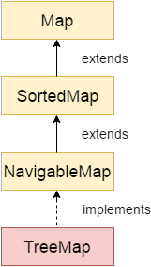
Key Points about TreeMap
The important points about Java TreeMap class are:
- The TreeMap stores data in the form of key-value pairs, where each key is associated with a specific value.
- It ensures that all keys are unique, which means duplicate keys are not allowed.
- It maintains elements in ascending order automatically using a red-black tree data structure.
- It provides efficient performance for operations such as search, insertion, and deletion.
- It does not allow null keys, but it supports multiple null values.
- It is non-synchronized, which makes it faster but not thread-safe by default.
A TreeMap is a class in java.util that stores key-value pairs sorted by key. It implements NavigableMap (which extends SortedMap) and is backed by a Red-Black tree, a self-balancing binary search tree. Keys are kept in natural order or in the order of a Comparator you supply.
Map → SortedMap → NavigableMap → TreeMap

Key characteristics
Feature | TreeMap
Keys | Unique, always sorted
Values | Duplicates allowed, nulls allowed
Null key | Not allowed (NullPointerException) with natural ordering
Order | Sorted by key (ascending by default)
Thread-safe | No
Internal structure | Red-Black tree
get / put / remove / containsKey | O(log n)
Keys must be | Comparable, or a Comparator must be supplied
Key uniqueness decided by | compareTo() / compare() returning 0, not equals()
Iterator | Fail-fast

Syntax
java
import java.util.*;

Map<String, Integer> m1 = new TreeMap<>(); // natural order
TreeMap<String, Integer> m2 = new TreeMap<>(); // class ref, needed for navigation methods
TreeMap<String, Integer> m3 = new TreeMap<>(Comparator.reverseOrder()); // descending
TreeMap<String, Integer> m4 = new TreeMap<>(String.CASE_INSENSITIVE_ORDER);
TreeMap<String, Integer> m5 = new TreeMap<>(otherMap); // copy, natural order

Example 1: Sorted by key
java
TreeMap<Integer, String> map = new TreeMap<>();
map.put(30, "Raj");
map.put(10, "Amit");
map.put(20, "Kiran");
map.put(10, "Zara"); // replaces the value for key 10

System.out.println(map); // {10=Zara, 20=Kiran, 30=Raj}
System.out.println(map.get(20)); // Kiran
Strings sort alphabetically, uppercase before lowercase:
java
TreeMap<String, Integer> names = new TreeMap<>();
names.put("Raj", 1); names.put("amit", 2); names.put("Zara", 3);
System.out.println(names); // {Raj=1, Zara=3, amit=2}

Example 2: Navigation methods
java
TreeMap<Integer, String> map = new TreeMap<>();
map.put(10, "A"); map.put(20, "B"); map.put(30, "C"); map.put(40, "D"); map.put(50, "E");

map.firstKey(); // 10
map.lastKey(); // 50
map.firstEntry(); // 10=A
map.lastEntry(); // 50=E

map.lowerKey(30); // 20 strictly less than 30
map.floorKey(30); // 30 less than or equal to 30
map.higherKey(30); // 40 strictly greater than 30
map.ceilingKey(35); // 40 greater than or equal to 35
map.floorEntry(25); // 20=B

map.pollFirstEntry(); // removes and returns 10=A
map.pollLastEntry(); // removes and returns 50=E

Example 3: Range views
java
TreeMap<Integer, String> map = new TreeMap<>();
for (int i = 10; i <= 50; i += 10) map.put(i, "v" + i);

map.headMap(30); // {10=v10, 20=v20} keys < 30
map.headMap(30, true); // {10, 20, 30} inclusive
map.tailMap(30); // {30, 40, 50} keys >= 30
map.subMap(20, 40); // {20, 30} from inclusive, to exclusive
map.descendingMap(); // {50, 40, 30, 20, 10}
map.descendingKeySet(); // [50, 40, 30, 20, 10]
These are views backed by the original map. Changes write through.

Example 4: Custom ordering
java
TreeMap<String, Integer> byLength = new TreeMap<>(
Comparator.comparing(String::length).thenComparing(Comparator.naturalOrder()));
byLength.put("Java", 1); byLength.put("API", 2); byLength.put("TestNG", 3);
System.out.println(byLength); // {API=2, Java=1, TestNG=3}

Example 5: Custom object as key
java
class Employee implements Comparable<Employee> {
int id; String name;
Employee(int id, String name) { this.id = id; this.name = name; }
public int compareTo(Employee o) { return Integer.compare(id, o.id); }
public String toString() { return id + ":" + name; }
}

TreeMap<Employee, String> map = new TreeMap<>();
map.put(new Employee(2, "Raj"), "QA");
map.put(new Employee(1, "Amit"), "Dev");
System.out.println(map); // {1:Amit=Dev, 2:Raj=QA}
Not Comparable and no Comparator means ClassCastException on the first put.

Important: uniqueness uses compareTo, not equals
java
TreeMap<Employee, String> map = new TreeMap<>(Comparator.comparingInt(e -> e.id));
map.put(new Employee(1, "Amit"), "Dev");
map.put(new Employee(1, "Raj"), "QA"); // compare returns 0, so same key: value replaced
System.out.println(map.size()); // 1
Keep compareTo() consistent with equals() or entries get silently overwritten.

How it works internally
- Each node (Entry) holds key, value, left, right, parent and a colour (red or black).
- put: start at the root, compare the new key with each node (smaller goes left, larger goes right, equal replaces the value), attach it as a leaf, then rotate and recolour to keep the tree balanced.
- A balanced tree has height about log₂(n), so every operation is O(log n) in the worst case.
- Iteration is an in-order traversal, which produces keys in sorted order.
- It uses no hashCode() at all.
 30
/ \
20 40
/ \
10 50 in-order: 10, 20, 30, 40, 50

HashMap vs LinkedHashMap vs TreeMap
 | HashMap | LinkedHashMap | TreeMap
Order | None | Insertion / access | Sorted by key
get / put | O(1) | O(1) | O(log n)
Null key | One | One | No
Key matching | hashCode() + equals() | hashCode() + equals() | compareTo() / compare()
Navigation methods | No | No | Yes
Memory | Lowest | Higher | Higher

When to use TreeMap
Use it when | Example
Keys must stay sorted | Report sorted by date or name
You need range queries | All entries between two dates
You need the nearest key (floor, ceiling) | Find the closest price tier or time slot
You need the first or last key quickly | Earliest or latest record
Sorted output without a separate sort step | Word frequency in alphabetical order
Case-insensitive key lookups | HTTP headers with String.CASE_INSENSITIVE_ORDER

When NOT to use it
Need | Use instead
Fastest lookups, order irrelevant | HashMap
Insertion order | LinkedHashMap
Null keys | HashMap / LinkedHashMap
Thread safety | ConcurrentSkipListMap
Sort by value | Sort the entries with streams (TreeMap sorts only by key)

Framework examples
1. Case-insensitive headers (REST Assured response headers)
java
Map<String, String> headers = new TreeMap<>(String.CASE_INSENSITIVE_ORDER);
headers.put("Content-Type", "application/json");
headers.get("content-type"); // application/json
2. Word or status-code frequency in sorted order
java
Map<Integer, Integer> statusCount = new TreeMap<>();
for (int code : statusCodes) statusCount.merge(code, 1, Integer::sum);
// {200=12, 404=2, 500=1}
3. Sorted test report: results keyed by test name, printed alphabetically.
4. Verifying API data sorted by key and comparing two maps with stable ordering for readable assertion diffs.
5. Time-based lookups: floorEntry(timestamp) to find the latest event before a time.

Common pitfalls
- Null key throws NullPointerException (null values are fine).
- Non-Comparable keys with no Comparator throw ClassCastException.
- compareTo inconsistent with equals silently merges distinct keys.
- Mixed key types throw ClassCastException.
- Mutating a key’s sort field after insertion corrupts ordering.
- Slower than HashMap (O(log n)).
- Not thread-safe.
- Sorting is by key only. For sorting by value:
java
map.entrySet().stream()
.sorted(Map.Entry.comparingByValue())
.forEach(e -> System.out.println(e.getKey() + " " + e.getValue()));

Interview questions
1. What is TreeMap?
A NavigableMap implementation backed by a Red-Black tree that keeps entries sorted by key.
2. How does it keep keys sorted?
By comparing keys using compareTo() or a Comparator during insertion, placing them in a balanced binary search tree. In-order traversal returns sorted keys.
3. Time complexity?
O(log n) for put, get, remove and containsKey.
4. Can TreeMap have null keys or values?
Null values yes, null keys no (with natural ordering).
5. How does it detect duplicate keys?
Through compareTo() / compare() returning 0, not equals().
6. TreeMap vs HashMap?
HashMap is O(1) and unordered. TreeMap is O(log n), sorted, with navigation methods, and disallows null keys.
7. Comparable vs Comparator in TreeMap?
Comparable defines the natural order inside the key class. A Comparator is passed to the constructor and overrides it.
8. floorKey() vs lowerKey() vs ceilingKey() vs higherKey()?
lower is strictly less, floor is less than or equal, ceiling is greater than or equal, higher is strictly greater.
9. Can you sort a TreeMap by value?
No. It always sorts by key. Use a stream over entrySet().
10. Is TreeMap thread-safe?
No. Use ConcurrentSkipListMap or Collections.synchronizedSortedMap().
11. What is a Red-Black tree?
A self-balancing BST that uses node colours and rotations to keep the height at O(log n).

Short interview answer
“TreeMap is a NavigableMap implementation backed by a Red-Black tree that keeps its entries sorted by key, either by natural ordering through Comparable or by a Comparator passed to the constructor. Put, get and remove are O(log n). It doesn’t allow null keys, though null values are fine, and it isn’t thread-safe. Key uniqueness is decided by compareTo() returning 0, not equals(), so those two must be consistent. It also provides navigation methods like firstKey(), floorKey(), ceilingKey(), headMap() and subMap(). I use it when I need sorted keys, range or nearest-key queries, or case-insensitive keys such as HTTP headers with String.CASE_INSENSITIVE_ORDER. If order doesn’t matter I use HashMap, and for insertion order LinkedHashMap.”

What is Java Hashtable?
Java Hashtable is a class in the java.util package that implements the Map interface and is used to store key-value pairs with unique keys. It uses a hash table data structure internally, where a hash function determines the index of elements stored in buckets.
When a key-value pair is inserted, the hash code of the key is calculated to identify the appropriate bucket. If multiple elements map to the same bucket, a collision resolution technique is applied to store them properly.
Hashtable is similar to HashMap but is synchronized which makes it thread-safe. This allows multiple threads to access it without data inconsistency. However, due to synchronization, its performance may be slower compared to HashMap when thread safety is not required.

Hashtable Class Declaration
The following is the declaration of the java.util.Hashtable class:
- public class Hashtable<K,V> extends Dictionary<K,V> implements Map<K,V>, Cloneable, Serializable

Hashtable Class Parameters
The following are the parameters used in the java.util.Hashtable class.
- K: It represents the type of keys maintained by the map.
- V: It represents the type of values mapped to the keys

Java Hashtable: What It Is, How It Works Internally, When to Use It
A Hashtable is a class in java.util that stores key-value pairs in a hash table. It dates from Java 1.0 (before the Collections Framework) and was later retrofitted to implement Map. Its defining feature is that every public method is synchronized, so it is thread-safe. Today it is a legacy class.
Dictionary (abstract, obsolete)
└── Hashtable (also implements Map, Cloneable, Serializable)
└── Properties

Key features
Feature | Hashtable
Keys | Unique (duplicate key replaces the value)
Values | Duplicates allowed
Null key / null value | Neither allowed (NullPointerException)
Order | Not guaranteed
Thread-safe | Yes, all methods synchronized (one lock for the whole table)
Default capacity / load factor | 11 / 0.75
Growth | newCapacity = old * 2 + 1
Collision handling | Linked-list chaining (never converted to trees)
Iterators | Fail-fast (keySet, entrySet) plus legacy Enumeration (keys(), elements())

Syntax
java
Hashtable<String, Integer> ht = new Hashtable<>(); // capacity 11
Hashtable<String, Integer> ht2 = new Hashtable<>(50); // initial capacity
Hashtable<String, Integer> ht3 = new Hashtable<>(50, 0.8f); // capacity + load factor
Map<String, Integer> ht4 = new Hashtable<>(); // interface reference
The class name is Hashtable (lowercase “t”).

Example
java
Hashtable<String, Integer> ht = new Hashtable<>();
ht.put("Raj", 25);
ht.put("Amit", 30);
ht.put("Raj", 26); // replaces 25, returns old value

System.out.println(ht.get("Raj")); // 26
System.out.println(ht.containsKey("Amit")); // true
ht.put(null, 1); // NullPointerException
ht.put("Kiran", null); // NullPointerException

Enumeration<String> keys = ht.keys(); // legacy iteration
while (keys.hasMoreElements()) {
String k = keys.nextElement();
System.out.println(k + " = " + ht.get(k));
}

How it works internally
Structure (simplified):
java
public class Hashtable<K, V> {
private transient Entry<?, ?>[] table; // bucket array, default length 11
private transient int count; // number of entries
private int threshold; // capacity * loadFactor (8 for 11)
private float loadFactor; // 0.75

private static class Entry<K, V> {
final int hash;
final K key;
V value;
Entry<K, V> next; // chain for collisions
}
}
put(key, value) step by step:
- The method is synchronized, so the calling thread takes the lock on the whole Hashtable.
- If value == null, throw NullPointerException.
- Compute hash = key.hashCode() (a null key throws NullPointerException here).
- Compute the index:
java
 index = (hash & 0x7FFFFFFF) % table.length;
The mask clears the sign bit so the index is never negative. It uses modulo, not HashMap’s bit mask, which is slower.
5. Walk the chain at that bucket. If a node has the same hash and equals() key, replace its value and return the old one.
6. Otherwise, if count >= threshold, rehash (grow) and recompute the index.
7. Create a new Entry and insert it at the head of the chain; count++.
Bucket array (capacity 11):
[0] → null
[3] → ["Amit"=30]
[6] → ["Raj"=26] → ["Kiran"=28] collision: chained, newest at the head
[...]
get(key): synchronized; compute the index the same way; walk the chain comparing hash and equals(); return the value or null.
Rehashing: when count >= threshold, the table grows to old * 2 + 1 (11 → 23 → 47 ...), and every entry is re-indexed with the new length, since modulo depends on the table size. This is O(n).
Locking: there is one lock for the entire table, so only one thread at a time can run any method (even two reads). That makes it safe, but it does not scale.

Important limitation: compound operations
Each method is atomic, but a check-then-act sequence is not.
java
if (!ht.containsKey("hits")) {
ht.put("hits", 0); // another thread may insert between the two calls
}
You need an external synchronized (ht) { ... } block for such sequences. ConcurrentHashMap offers atomic putIfAbsent(), merge() and compute() instead.

Hashtable vs HashMap vs ConcurrentHashMap
 | Hashtable | HashMap | ConcurrentHashMap
Thread-safe | Yes (whole-table lock) | No | Yes (CAS + per-bin locks)
Null key / values | No / No | One / Yes | No / No
Default capacity | 11 | 16 | 16
Index calculation | % length | (n - 1) & hash | (n - 1) & hash
Growth | 2n + 1 | 2n | 2n
Treeification (Java 8+) | No | Yes | Yes
Performance | Slowest under contention | Fastest single-threaded | Best concurrent
Status | Legacy | Standard | Preferred concurrent map

When to use Hashtable
Realistically, rarely.
Use it when | Example
Maintaining or integrating legacy code | Old APIs that take or return Hashtable (JNDI InitialContext environment)
Working with Properties, which extends Hashtable | Loading config.properties in ConfigReader
A tiny shared map, low contention, and you want simple built-in thread safety | Small registry

When NOT to use it
Need | Use instead
Single-threaded code | HashMap
Concurrent access with good performance | ConcurrentHashMap
Null keys or values | HashMap
Insertion order / sorted keys | LinkedHashMap / TreeMap
Synchronize an existing map | Collections.synchronizedMap(...)

Framework example
java
Properties props = new Properties(); // a Hashtable underneath
try (FileInputStream fis = new FileInputStream("config.properties")) {
props.load(fis);
}
String browser = props.getProperty("browser"); // use getProperty/setProperty, not put/get
For per-thread drivers in parallel runs I use ConcurrentHashMap<Long, WebDriver> or ThreadLocal, not Hashtable, because its single lock would make threads queue on every access.

Interview questions
1. Why doesn’t Hashtable allow nulls?
It calls key.hashCode() and uses the value directly with no null handling, and it wants a null from get() to mean only “absent”. HashMap special-cases a null key as hash 0.
2. Is Hashtable fully thread-safe?
Individual methods are, but compound operations are not atomic and need external synchronization.
3. Why is it slow?
One lock guards the whole table, so even concurrent reads wait on each other.
4. Why is the default capacity 11?
It is a prime number, which suits the modulo-based index and distributes keys better when hash codes are poorly spread.
5. How is Hashtable different from Collections.synchronizedMap(new HashMap<>())?
Both use a single lock. The wrapper allows null keys and values (because HashMap does), and it is a flexible wrapper for any map, while Hashtable is a legacy class with its own fixed implementation.
6. Does it convert long chains to trees?
No, only HashMap and ConcurrentHashMap do (Java 8+).
7. Iterator vs Enumeration in Hashtable?
keySet()/entrySet() iterators are fail-fast. keys()/elements() return a legacy Enumeration, which is not fail-fast and cannot remove.
8. What is the relation with Properties?
Properties extends Hashtable<Object, Object> and adds getProperty, setProperty, load and store.

Short interview answer
“Hashtable is a legacy key-value class from Java 1.0 that implements Map, where every method is synchronized, so it is thread-safe but uses one lock for the whole table. Internally it is an array of buckets, default capacity 11 and load factor 0.75, and the index is (hash & 0x7FFFFFFF) % length. Collisions are chained in a linked list, with new entries inserted at the head, and when the count reaches the threshold the table grows to 2n + 1 and all entries are rehashed. It allows no null keys or values, guarantees no order, and doesn’t treeify long chains. Compound operations still need external synchronization. I don’t use it in new code: HashMap for single-threaded work and ConcurrentHashMap for shared data. The place I still meet it is Properties, which extends Hashtable and is what my ConfigReader uses to load config.properties.”
#-----------------------------------------------------------
How HashMap Works Internally Explain in detail :
A HashMap in Java works on the principles of hashing, array indexing, and collision resolution. Internally, it uses an array of node objects, where each node can become the head of a linked list or a balanced tree.
Here is the exact step-by-step breakdown of how data is stored, resolved, and retrieved inside a HashMap.
1. The Core Structure: Nodes and Buckets
The backbone of a HashMap is an internal array called the table. Each slot in this array is called a bucket.
- In Java 8+, each bucket holds a node (Node<K, V>) that implements Map.Entry<K, V>.
- A node contains four fields: int hash, K key, V value, and Node<K, V> next (a reference to the next node if a chain forms).
java
// Simplified internal Node class
static class Node<K,V> implements Map.Entry<K,V> {
final int hash;
final K key;
V value;
Node<K,V> next;
// ...
}

2. How put(key, value) Works Internally
When you call map.put("Alice", 95), Java executes the following process:
- Calculate the Hash:
Java calls the key’s built-in hashCode() method to get an integer. To minimize collisions, HashMap applies an extra supplementary hashing function (called shifting or xoring) to spread out higher bits:
hash = (key == null) ? 0 : (h = key.hashCode()) ^ (h >>> 16)
- Calculate the Bucket Index:
The hash value is converted into a valid array index using the formula:
index = hash & (n - 1) (where n is the current size/capacity of the array).
- Insert the Node:
  - Case A (Bucket is empty): The node is created and placed directly into that array index.
  - Case B (Collision occurs): If a node already exists at that index, Java traverses the list/tree at that bucket to check if the exact same key exists using equals().
    - If key.equals(existingKey) is true, it overrides the old value.
    - If it is false, it appends the new node to the end of the chain.
3. Collision Resolution & The Java 8 Optimization
When two different keys map to the exact same index, it is called a hash collision.
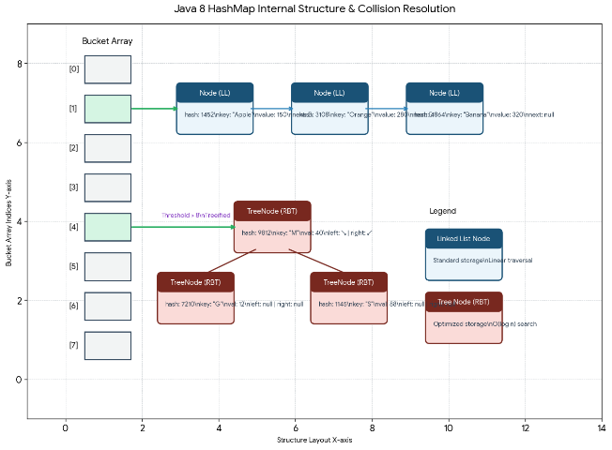
Threshold Rules:
- Treeify Threshold (8): If a single bucket's linked list grows to more than 8 elements (and the overall map capacity is at least 64), Java automatically transforms the linked list into a Red-Black Tree (TreeNode). This reduces lookup times from O(n) to $O(logn)$.
- Untreeify Threshold (6): If elements are removed and the tree shrinks to 6 elements or fewer, Java converts it back into a standard linked list to save memory.
4. How get(key) Works Internally
When you call map.get("Alice"):
- It calculates the hash of the key and determines the target index = hash & (n - 1).
- It looks at the first node in that bucket.
- It checks if the search key matches the first node's key using both hash equality and equals().
- If it doesn't match, it checks if the bucket is a TreeNode (searches the tree in $O(logn)$) or a standard Node (loops through the next links in O(n)).
5. Capacity, Load Factor, and Resizing
To prevent buckets from getting overcrowded, the HashMap automatically resizes itself.
- Initial Capacity (Default: 16): The starting length of the internal array. It is always a power of 2 because the bitwise index math hash & (n-1) only works cleanly with powers of 2.
- Load Factor (Default: 0.75): A measure of how full the map is allowed to get before it expands.
- Threshold: Calculated as Capacity × Load Factor (e.g., 16 × 0.75 = 12).
What happens during Resizing (Rehashing)?
When the number of elements exceeds the threshold, the array size doubles (e.g., from 16 to 32). Because the array length n changes, the formula hash & (n-1) yields new indices. Every single element in the map is re-evaluated and moved to its new appropriate bucket. This is an expensive O(n) operation.
Summary of Best Practices
- Provide an Initial Capacity: If you know you are storing 1,000 items, initialize the map with a custom capacity (e.g., new HashMap<>(1500)) to avoid multiple costly resizing cycles.
- Implement hashCode() and equals() correctly: If you use a custom Object as a HashMap key, you must override both methods. If two objects are equal according to equals(), they must return the exact same hashCode().
Would you like to see a code example showing how to properly override hashCode() and equals() for custom keys, or explore how ConcurrentHashMap achieves thread safety?
#-----------------------------------------------------------
How Hashtable Works Internally Explain in detail :
K A Hashtable in Java is a legacy, synchronized collection from the java.util package that stores data in key-value pairs. While it shares conceptual similarities with HashMap, its internal implementation, design rules, and data structures are significantly different and older.
Here is the detailed breakdown of how a Hashtable works internally.
1. The Internal Structure
Like HashMap, a Hashtable uses an array of buckets to store entries. Each slot in the array holds an entry object (HashtableEntry<K, V> or Entry<K, V>), which forms a singly linked list if collisions occur.
java
// Simplified internal Entry class used by Hashtable
private static class Entry<K,V> implements Map.Entry<K,V> {
final int hash;
final K key;
V value;
Entry<K,V> next;
// ...
}

Unlike HashMap, Hashtable never converts buckets into Red-Black Trees. If multiple keys hash to the same bucket, it remains a linked list indefinitely, meaning worst-case lookup performance can degrade to O(n).
2. Thread Safety: The Monolithic Lock
The defining characteristic of Hashtable is that it is completely thread-safe.
It achieves this by applying the synchronized keyword directly to almost all its core public methods (put(), get(), remove(), etc.).
java
public synchronized V put(K key, V value) { ... }
public synchronized V get(Object key) { ... }

- How it works: When a thread calls a method on a Hashtable, it acquires a lock on the entire Hashtable object instance.
- The Downside: Any other thread trying to read or write to any part of the table must wait until the first thread finishes. This causes massive thread contention and performance bottlenecks in multi-threaded applications.
3. How put(key, value) and Indexing Work Internally
When you call hashtable.put(key, value), the following sequential steps take place:
Step 1: Null Check (Strict Policy)
Hashtable does not allow null keys or null values.
- If the value is null, it explicitly throws a NullPointerException.
- If the key is null, calling key.hashCode() instantly triggers a NullPointerException.
Step 2: Hashing and Index Calculation
Unlike HashMap, which performs extra bit-shifting operations to spread out the hash, Hashtable uses the key's native hashCode() directly.
It calculates the target bucket index using the modulo operator (%):
java
int hash = key.hashCode();
int index = (hash & 0x7FFFFFFF) % tab.length;

- Why 0x7FFFFFFF? In Java, hashCode() can return a negative integer. Masking it with 0x7FFFFFFF turns off the sign bit, ensuring the integer is positive before running the modulo operation.
- Why Modulo? Hashtable capacity does not have to be a power of two. It can be any integer, so it relies on basic modulo arithmetic to map the hash into the array boundaries.
Step 3: Collision Handling (Chaining)
- It navigates to the calculated index in the array.
- It loops through the existing linked list at that slot, using equals() to see if the key already exists.
- If key.equals(existingKey) is true, it replaces the old value and returns it.
- If the key is not found, it creates a new Entry object and inserts it at the front (head) of the linked list.
4. Resizing and Rehashing
Hashtable maintains an Initial Capacity (Default: 11) and a Load Factor (Default: 0.75).
When the total number of elements exceeds the threshold (Capacity × Load Factor), the Hashtable calls its internal rehash() method:
- It creates a new array that is roughly double the size plus one (newCapacity = (oldCapacity << 1) + 1). Choosing an odd number (or ideally a prime number) for the capacity helps distribute keys more evenly when using modulo indexing.
- It loops through every single entry in the old array and re-calculates its index relative to the new capacity using the formula (hash & 0x7FFFFFFF) % newCapacity.
- It rebuilds all the linked list chains in the new array. This is a very heavy, synchronized block execution.

Architectural Differences: Hashtable vs. HashMap
Feature | Hashtable | HashMap
Thread Safety | Thread-safe (Synchronized on the whole object). | Not thread-safe (Unsynchronized).
Null Support | No null keys or null values allowed. | Allows one null key and multiple null values.
Collision Strategy | Singly Linked List only (O(n) worst case). | Linked List converts to a Red-Black Tree after 8 elements ($O(logn)$).
Default Capacity | 11 (Usually grows to odd numbers). | 16 (Always grows by powers of 2).
Index Math | (hash & 0x7FFFFFFF) % length | Bitwise AND: hash & (length - 1) (Faster).
Iteration | Uses Enumeration and Iterator. | Uses Iterator only.
Hashtable is rarely used in modern Java development. Would you like to explore ConcurrentHashMap, which replaced Hashtable by offering thread safety without locking the entire map, or see how Enumeration differs from Iterator
#----------------------------------------------------------------------------------------------#
How HashSet Works Internally Explain in detail Syntax :
=> A HashSet in Java is a collection that stores unique elements and allows at most one null value. It belongs to the java.util package, implements the Set interface, and does not guarantee any specific order of its elements. [1, 2, 3]
The single most critical concept behind HashSet is that it does not have its own storage mechanism. Internally, a HashSet is just a wrapper around a HashMap. [1, 2]
1. Basic Syntax & Usage
java
import java.util.HashSet;
import java.util.Set;

public class HashSetExample {
public static void main(String[] args) {
// Declaration and instantiation
Set<String> uniqueNames = new HashSet<>();

// Adding elements
uniqueNames.add("Alice");
uniqueNames.add("Bob");

// This duplicate entry will be ignored, and add() will return false
boolean isAdded = uniqueNames.add("Alice");
System.out.println("Was second Alice added? " + isAdded); // Output: false

// Checking presence
System.out.println(uniqueNames.contains("Bob")); // Output: true

// Removing an element
uniqueNames.remove("Bob");
}
}
2. The Internal Source Code Architecture
If you open the JDK source code for java.util.HashSet, you will find two primary private fields defined at the top of the class: [1]
java
public class HashSet<E> extends AbstractSet<E> implements Set<E>, Cloneable, java.io.Serializable {

// 1. The backing HashMap storage
private transient HashMap<E, Object> map;

// 2. A dummy value to associate with an Object in the backing Map
private static final Object PRESENT = new Object();

// Default constructor
public HashSet() {
map = new HashMap<>();
}

// ...
}

- private transient HashMap<E, Object> map;
Every time you create a HashSet, a hidden HashMap object is instantiated alongside it. The elements you add to your HashSet are stored as the keys of this internal HashMap. [1]
- private static final Object PRESENT = new Object();
A HashMap requires both a key and a value. Since a HashSet only cares about keys (elements), Java allocates a single global dummy object called PRESENT. Every single key in the map points to this exact same dummy object to save memory. [1, 2, 3]
3. Step-by-Step Mechanics of Core Methods
How add(E e) Works Internally
When you invoke uniqueNames.add("Alice"), the HashSet delegates the operation to the internal HashMap using this single line: [1]
java
public boolean add(E e) {
return map.put(e, PRESENT) == null;
}

- Step 1: The element "Alice" is passed into map.put("Alice", PRESENT) as the key, alongside the dummy PRESENT object as the value.
- Step 2: The HashMap calculates the element's hash code and bucket index.
- Step 3:
  - If "Alice" is a new key, HashMap.put() processes the insertion and returns null. Because null == null evaluates to true, HashSet.add() returns true.
  - If "Alice" already exists, the HashMap overrides the old value with PRESENT and returns the previous value (which is also the PRESENT object). Because PRESENT == null evaluates to false, HashSet.add() returns false, effectively discarding the duplicate.

How contains(Object o) Works Internally
Since elements are keys, checking if a set contains an item is highly optimized. It bypasses values entirely and runs a direct key lookup: [1, 2]
java
public boolean contains(Object o) {
return map.containsKey(o);
}
The internal map executes a fast O(1) hashing calculation to find the bucket index and checks if the key matches via equals(). [1, 2]
How remove(Object o) Works Internally
Removing an element simply removes the key-value pair from the backing map: [1]
java
public boolean remove(Object o) {
return map.remove(o) == PRESENT;
}

If the key existed, map.remove(o) returns its associated value (PRESENT). Since PRESENT == PRESENT evaluates to true, the method safely outputs true confirming the deletion.
4. Collision Resolution and Performance
Because HashSet depends entirely on HashMap, it inherits all of its core performance benefits and data behaviors: [1]
- Hashing and Indexing: The map uses (hash_value & (n - 1)) to assign elements to internal array buckets.
- Collisions (Java 8+ Optimization): If two completely different elements generate the same bucket index, they are chained together. If a single bucket's linked list grows beyond 8 elements, Java transforms that specific bucket from a linked list into a Red-Black Tree to keep search times down to $O(logn)$.
- Time Complexity: Average performance for add(), remove(), and contains() is O(1).
Would you like to explore why you must always override equals() and hashCode() when storing custom objects in a HashSet, or see how LinkedHashSet differs by preserving insertion order?

#---------------------------------------------------------------------
How LinkedHashSet Works Internally Explain in detail Syntax:
=> A LinkedHashSet in Java is a collection from the java.util package that extends HashSet and implements the Set interface. While a standard HashSet does not guarantee any specific order of its elements, LinkedHashSet maintains a predictable iteration order—specifically, the exact sequence in which elements were inserted.
Just like HashSet is a wrapper around HashMap, LinkedHashSet is a direct wrapper around a LinkedHashMap.
Basic Syntax & Code Example
java
import java.util.LinkedHashSet;
import java.util.Set;
public class LinkedHashSetExample {
public static void main(String[] args) {
// 1. Declaration and Initialization
Set<String> fruits = new LinkedHashSet<>();

// 2. Adding elements (Insertion order is tracked chronologically)
fruits.add("Mango");
fruits.add("Apple");
fruits.add("Banana");

// Duplicate entry is ignored, maintaining the original position of "Apple"
fruits.add("Apple");

// 3. Iteration
// Output will reliably match the exact insertion order: Mango, Apple, Banana
for (String fruit : fruits) {
System.out.println(fruit);
}
}
}
Detailed Internal Architecture
If you look into the JDK source code for java.util.LinkedHashSet, you will discover that it is surprisingly sparse. It relies almost entirely on a package-private constructor hidden inside its parent class, HashSet.
1. The Package-Private Super Constructor
When you instantiate a LinkedHashSet, it calls this hidden constructor in HashSet:
java
// Package-private constructor inside HashSet.java called by LinkedHashSet
HashSet(int initialCapacity, float loadFactor, boolean dummy) {
map = new LinkedHashMap<>(initialCapacity, loadFactor);
}
Instead of instantiating a regular HashMap, this constructor allocates a LinkedHashMap to the private map storage variable.
2. The Backing Data Structure
Because it uses a LinkedHashMap under the hood, every element you add to a LinkedHashSet becomes a key mapping to a global dummy object (PRESENT).
The nodes created inside this backing map are LinkedHashMap.Entry objects, which feature six distinct structural fields:
- int hash
- K key (stores your Set element)
- V value (stores the dummy PRESENT object)
- Node<K,V> next (links to the next node inside the same hash bucket to resolve collisions)
- Entry<K,V> before (points to the chronologically prior element added to the Set)
- Entry<K,V> after (points to the chronologically next element added to the Set)
Step-by-Step Mechanics of Core Operations
A. How add(E e) Works Internally
When you invoke fruits.add("Mango"), the call flows through the exact same path as a normal HashSet, but acts on the underlying LinkedHashMap:
java
public boolean add(E e) {
return map.put(e, PRESENT) == null;
}

Use code with caution.
- Hashing & Storage: The LinkedHashMap calculates the hash of "Mango" and places it into the appropriate array index bucket using hash & (n-1). If a collision occurs, it links via the next pointer.
- Maintaining Order: As the node is created, LinkedHashMap updates its global doubly linked list. The before pointer of the new node points to the current tail of the Set, and the new node becomes the new global tail.
- Duplicate Check: If "Mango" already exists as a key in the map, LinkedHashMap simply overwrites the value with PRESENT and returns the old value. The structural insertion order of the existing element remains completely unchanged.
B. How Iteration Works Internally
When you use a for-each loop on a standard HashSet, Java has to scan every single bucket index in the underlying hash table array—even empty ones—to find elements.
For a LinkedHashSet, iteration completely bypasses the bucket array. The iterator jumps directly to the head pointer of the doubly linked list and moves linearly from node to node using the after pointer. This guarantees that elements are printed exactly as they were entered, and makes iteration performance depend strictly on the number of elements (size) rather than the overall capacity of the set.
Comparison: HashSet vs. LinkedHashSet
Feature | HashSet | LinkedHashSet
Backing Structure | HashMap | LinkedHashMap
Iteration Order | Chaotic / Unpredictable | Strict Insertion Order
Memory Consumption | Lower (4 fields per node) | Higher (6 fields per node to maintain dual chronological pointers)
Performance (add/contains) | Maximally fast O(1) | Slightly slower O(1) due to updating linked-list pointers on write
Performance (Iteration) | Depends on capacity + size | Proportional purely to element size
#----------------------------------------------------------------------------------------------#
How TreeSet Works Internally Explain in detail Syntax :
=> A TreeSet in Java is a collection from the java.util package that implements the Set, SortedSet, and NavigableSet interfaces. Like all sets, it ensures that every element remains completely unique.
The defining characteristic of TreeSet is that it does not use hashing at all. Instead, internally, a TreeSet is a direct wrapper around a TreeMap. Because it uses a TreeMap under the hood, all its elements are stored inside a self-balancing Red-Black Tree, ensuring that elements are kept in a strictly sorted order (either by natural ordering or a custom Comparator).
Basic Syntax & Code Example
java
import java.util.TreeSet;
import java.util.Set;
import java.util.Comparator;

public class TreeSetExample {
public static void main(String[] args) {
// 1. Creation with Natural Ordering (Ascending order)
Set<Integer> numbers = new TreeSet<>();

// 2. Adding elements
numbers.add(40);
numbers.add(10);
numbers.add(30);
numbers.add(20);

// This duplicate entry is silently ignored
numbers.add(10);

// Elements are automatically printed in sorted order: [10, 20, 30, 40]
System.out.println("Natural Order: " + numbers);

// 3. Checking presence and removing: O(log n)
System.out.println("Contains 30? " + numbers.contains(30)); // true
numbers.remove(20);

// 4. Custom Ordering (e.g., Reverse Order)
TreeSet<String> reverseNames = new TreeSet<>(Comparator.reverseOrder());
reverseNames.add("Charlie");
reverseNames.add("Alice");
reverseNames.add("Bob");

// Output will be reverse sorted: [Charlie, Bob, Alice]
System.out.println("Reverse Order: " + reverseNames);
}
}
Detailed Internal Architecture
If you inspect the JDK source code for java.util.TreeSet, you will find that it acts as a structural facade over a TreeMap, sharing a design pattern identical to HashSet’s wrapper architecture:
java
public class TreeSet<E> extends AbstractSet<E> implements NavigableSet<E>, Cloneable, java.io.Serializable {

// 1. The backing NavigableMap instance (instantiated as a TreeMap)
private transient NavigableMap<E,Object> m;

// 2. A dummy value to associate with an Object in the backing Map
private static final Object PRESENT = new Object();

// Default constructor instantiates the backing TreeMap
public TreeSet() {
this(new TreeMap<>());
}

// Package-private constructor used to bind the map
TreeSet(NavigableMap<E,Object> m) {
this.m = m;
}
// ...
}
- private transient NavigableMap<E,Object> m;
Every element added to the TreeSet is physically stored as a key inside this internal TreeMap.
- private static final Object PRESENT = new Object();
Since a TreeMap physically requires both a key and a value, TreeSet uses a single static dummy object called PRESENT. Every element (key) in the set maps to this exact same dummy object to save memory.
- The Strict Null Policy: Because it relies on TreeMap, TreeSet does not allow null elements. Attempting to add null will throw a NullPointerException because the tree needs to compare elements to find their correct position.
Step-by-Step Mechanics of Core Operations
A. How add(E e) Works Internally
When you call numbers.add(30), the TreeSet delegates the insertion directly to the underlying TreeMap:
java
public boolean add(E e) {
return m.put(e, PRESENT) == null;
}

- Step 1: The element 30 is passed to m.put(30, PRESENT) as the key.
- Step 2: The TreeMap engine starts at the root node of the Red-Black tree and compares 30 using compareTo() or compare(). It traverses left if the element is smaller or right if it is larger.
- Step 3:
  - If 30 is a new element, it hits a leaf node, inserts a new Entry<E, Object>, auto-balances the tree using rotations and node recoloring, and returns null. The condition null == null evaluates to true, so TreeSet.add() returns true.
  - If 30 already exists, the comparison method returns 0. The map overwrites the value with PRESENT and returns the old value (PRESENT). Because PRESENT == null is false, TreeSet.add() returns false, safely ignoring the duplicate.
B. How contains(Object o) and remove(Object o) Work Internally
Both methods map directly to the corresponding key methods in TreeMap:
java
public boolean contains(Object o) {
return m.containsKey(o);
}

public boolean remove(Object o) {
return m.remove(o) == PRESENT;
}

The tree is traversed from the root node downward based on element comparisons until the matching node is either found or a leaf node is hit.
Performance Profile & Time Complexity
Because TreeSet relies on a self-balancing Red-Black binary search tree, the maximum depth of the tree is bounded to approximately $2×\log_{2}(n)$. This ensures exceptionally stable performance metrics:
Operation | Time Complexity | Details
add(E e) | $O(logn)$ | Must traverse tree height to find insertion spot, plus occasional node rotations.
contains(Object o) | $O(logn)$ | Fast binary search elimination path from the root.
remove(Object o) | $O(logn)$ | Node extraction plus tree re-balancing logic.

Specialized Navigable Operations
Since the underlying tree is physically sorted, TreeSet exposes highly useful positional methods that HashSet cannot execute efficiently:
- first() / last(): Instantly retrieves the absolute lowest or highest element in the set ($O(logn)$ complexity).
- higher(e) / lower(e): Returns the least element strictly greater than e, or the greatest element strictly less than e.
- ceiling(e) / floor(e): Similar to higher/lower, but matches the element itself if it is already present in the set.

#----------------------------------------------------------------------------------------------#
How TreeMap Works Internally Explain in detail Syntax :
=> A TreeMap in Java is a collection from the java.util package that implements the Map, SortedMap, and NavigableMap interfaces. Unlike HashMap and Hashtable, which rely on hashing algorithms and internal arrays, TreeMap does not use hashing at all.
Instead, a TreeMap stores its key-value pairs in a Red-Black Tree, which is a self-balancing Binary Search Tree (BST). This guarantees that all keys are kept in a strict sorted order (either by their natural order or via a custom Comparator).
Basic Syntax & Code Example
java
import java.util.TreeMap;
import java.util.Map;
import java.util.Comparator;

public class TreeMapExample {
public static void main(String[] args) {
// 1. Creation with Natural Ordering (Ascending for Integers)
TreeMap<Integer, String> map = new TreeMap<>();

// 2. Inserting elements
map.put(30, "Thirty");
map.put(10, "Ten");
map.put(20, "Twenty");

// Elements are automatically printed in sorted order: 10, 20, 30
System.out.println("Natural Order: " + map);

// 3. Creation with Custom Ordering (e.g., Reverse Order)
TreeMap<Integer, String> reverseMap = new TreeMap<>(Comparator.reverseOrder());
reverseMap.put(30, "Thirty");
reverseMap.put(10, "Ten");
reverseMap.put(20, "Twenty");

System.out.println("Reverse Order: " + reverseMap); // Output: 30, 20, 10
}
}
Detailed Internal Architecture
1. The Core Data Structure: Entry<K, V>
Every key-value pair added to a TreeMap is instantiated as a node of the static inner class Entry<K, V>. A single node contains pointers to traverse upwards or downwards through the tree
java
static final class Entry<K,V> implements Map.Entry<K,V> {
K key;
V value;
Entry<K,V> left; // Pointer to the left child
Entry<K,V> right; // Pointer to the right child
Entry<K,V> parent; // Pointer to the parent node
boolean color = BLACK; // Color attribute: RED or BLACK
}
2. The Strict Null Policy
TreeMap does not allow null keys (though it does allow multiple null values). [1]
- When you call put(key, value), the map immediately performs a logical comparison (compareTo() or compare()).
- Attempting to compare any object against null triggers a NullPointerException.
Step-by-Step Mechanics of Core Operations
A. How put(K key, V value) Works Internally
When you add a new entry, the TreeMap treats it exactly like a binary search tree insertion: [1]
- First Element (The Root): If the tree is entirely empty, the new entry becomes the root node of the tree and its color is set to BLACK. [1, 2]
- Subsequent Elements (Traversal): For any following element, TreeMap starts at the root node and compares the incoming key against the current node's key using the designated sorting mechanism:
  - If incomingKey < currentNodeKey, the traversal moves to the left child.
  - If incomingKey > currentNodeKey, the traversal moves to the right child.
  - If the comparison returns 0 (the keys are identical), the old value is overwritten with the new value, and the method exits. [1, 2, 3]
- Placement: This comparison continues down the tree until a null leaf pointer is reached. The new entry is then attached there as a RED node. [1, 2]
- Balancing: Appending a new node can break Red-Black tree properties (e.g., two adjacent RED nodes). The map triggers a private helper method called fixAfterInsertion(Entry<K,V> x), which restores balance via left/right rotations and node recoloring.
B. How get(Object key) Works Internally
Looking up an item is simple binary traversal:
- It starts searching at the root node.
- It compares the requested key against the current node's key.
- It moves left or right depending on whether the target key is smaller or larger.
- If a match is found, it returns the value; if it hits a dead end (null), it returns null.
Why a Red-Black Tree? (Performance & Time Complexity)
In a basic Binary Search Tree, if you insert elements that are already sorted (e.g., 1, 2, 3, 4, 5), the tree degrades into a straight single-line sequence similar to a linked list. This causes lookup speeds to slow down dramatically to O(n). [1]
Because a Red-Black Tree continuously auto-balances its own height, the path from the root to the furthest leaf is never more than roughly twice as long as the path to the nearest leaf. This rigid balancing guarantees an exceptionally predictable time complexity profile: [1, 2]
Operation | Time Complexity
put(K key, V value) | $O(logn)$
get(Object key) | $O(logn)$
remove(Object key) | $O(logn)$
containsKey(Object key) | $O(logn)$
Specialized Navigable Methods
Because the data is organized structurally as a sorted tree, TreeMap provides unique positional operations that HashMap cannot execute efficiently: [1]
- firstKey() / lastKey(): Instantly grabs the absolute leftmost (smallest) or rightmost (largest) node in the tree ($O(logn)$ time).
- higherKey(key) / lowerKey(key): Returns the closest key that is strictly greater than or less than the specified key.
- subMap(startKey, endKey): Returns a structural view of the segment of the tree falling between the specified boundaries
#----------------------------------------------------------------------------------------------#
How LinkedHashMap Works Internally Explain in detail Syntax:
=> A LinkedHashMap in Java is a collection from the java.util package that extends HashMap and implements the Map interface. While a standard HashMap offers fast O(1) operations, it provides no guarantees regarding the iteration order of its elements. LinkedHashMap fixes this by maintaining a predictable iteration order—typically the exact sequence in which keys were inserted into the map. [1, 2, 3, 4]
Basic Syntax & Code Example
java
import java.util.LinkedHashMap;
import java.util.Map;

public class LinkedHashMapExample {
public static void main(String[] args) {
// 1. Initialization (Maintains chronological insertion order)
Map<String, Integer> stock = new LinkedHashMap<>();

// 2. Adding elements: put(key, value)
stock.put("Apples", 50);
stock.put("Bananas", 20);
stock.put("Oranges", 35);

// Updating an existing key overrides the value but preserves its position
stock.put("Bananas", 25);

// 3. Iteration
// Output will reliably match the exact insertion order: Apples, Bananas, Oranges
for (Map.Entry<String, Integer> entry : stock.entrySet()) {
System.out.println(entry.getKey() + " -> " + entry.getValue());
}
}
}
Detailed Internal Architecture
The core magic of a LinkedHashMap is that it relies entirely on HashMap's structural bucket array for data lookup, but threads a global Doubly Linked List across those exact same nodes to preserve order. [1, 2, 3]
1. The Extended Node Structure: Entry<K,V>
In a standard HashMap, a node contains four fields: hash, key, value, and a next pointer to resolve hash collisions in a bucket.
LinkedHashMap introduces a static inner class Entry<K,V> that explicitly extends HashMap.Node<K,V>. It adds two additional pointer fields, bringing the total properties of every single node to six:
java
static class Entry<K,V> extends HashMap.Node<K,V> {
// Inherited from HashMap.Node:
// final int hash;
// final K key;
// V value;
// Node<K,V> next; // Points to the next node inside the SAME hash bucket

// Added by LinkedHashMap:
Entry<K,V> before; // Points to the chronologically prior map entry globally
Entry<K,V> after; // Points to the chronologically next map entry globally
}
2. Dual Pointers: next vs. before/after
- The next pointer is strictly structural. It handles hash collisions inside the internal bucket array (chaining nodes that happen to have the same hash index). [1, 2]
- The before and after pointers are ordering pointers. They ignore bucket boundaries completely and chain entries together across the entire map, tracking the macro timeline of operations. [1, 2, 3, 4]
- The map tracks the extremities of this order using two top-level references: head (pointing to the oldest entry) and tail (pointing to the newest entry). [1]
Step-by-Step Mechanics of Core Operations
A. How put(K key, V value) Works Internally
- Delegation to HashMap: LinkedHashMap doesn't override the massive structural layout of HashMap.put(). It calls it directly.
- Finding the Bucket: The key's hashCode() maps the node to a specific array index bucket (hash & (n-1)). If a key collision happens, it chains onto the bucket via the next pointer.
The Callback Linkage (newNode()): When HashMap instantiates a node, it fires a callback method newNode(). LinkedHashMap overrides this method. While creating the node, it executes an internal tracking logic:
java
// Conceptual depiction of tail linkage
newNode.before = tail;
if (tail != null) {
tail.after = newNode;
}
tail = newNode; // The new node becomes the new global tail
- Use code with caution.
- Treeification: Just like HashMap, if a bucket's collision chain exceeds 8 entries, that specific bucket converts into a Red-Black Tree for efficiency. The before and after pointers remain unaffected by this transformation. [1, 2]
B. How Iteration Works Internally
When iterating over a HashMap, the runtime must scan every single row index of the underlying array table and step through collision paths. If the table size is 10,000 but holds only 3 items, it takes time to step over empty buckets. [1]
For a LinkedHashMap, iteration completely ignores the array table. It goes directly to the head node and linearly follows the after pointers sequentially until it hits the tail. This makes iteration faster and proportional only to the number of entries (size), rather than the capacity of the map.
Advanced Configuration: Access Order Mode (LRU Cache)
By default, LinkedHashMap tracks insertion order. However, it offers a specialized constructor that allows you to change its behavior to track access order instead: [1, 2]
java
// Syntax: LinkedHashMap(initialCapacity, loadFactor, accessOrder)
LinkedHashMap<K, V> lruMap = new LinkedHashMap<>(16, 0.75f, true);

- How Access Order works: When accessOrder is set to true, every single time you call get(key) or modify an existing entry via put(), an internal callback hooks into the operation and dynamically removes that specific node from its current spot in the before/after list, appending it to the very end of the line as the new tail.
- Building an LRU Cache: This feature makes it trivial to create a Least Recently Used (LRU) Cache. By overriding a protected hook method called removeEldestEntry(), you can instruct the map to automatically drop the head entry (the oldest/least accessed item) whenever the cache exceeds a predefined size.
Resource Trade-offs
Feature | HashMap | LinkedHashMap
Iteration Order | Completely unordered / unpredictable. | Strictly guaranteed (Insertion or Access order).
Memory Footprint | Low (4 properties per node). | Higher (6 properties per node to store object references).
Performance (put/get) | Slightly faster. | Slightly slower due to updating dual reference loops on write.
Performance (Iteration) | Dependent on map Capacity + size. | Dependent purely on map Size.
#----------------------------------------------------------------------------------------------------------#
How ArrayList Works Internally Explain in detail Syntax :
=> An ArrayList in Java is a resizable-array implementation of the List interface. Unlike a standard Java array, which has a fixed length, an ArrayList automatically expands its storage capacity when elements are added. [1, 2, 3]
Internally, it acts as a direct wrapper around a standard, contiguous raw array of type Object[].
1. Basic Syntax & Operations
java
import java.util.ArrayList;
import java.util.List;

public class ArrayListExample {
public static void main(String[] args) {
// 1. Declaration and Initialization
List<String> items = new ArrayList<>();

// 2. Adding elements: O(1) amortized
items.add("Laptop");
items.add("Mouse");
items.add("Keyboard");

// 3. Positional Insert: O(n) due to shifting elements
items.add(1, "Monitor"); // Inserts at index 1

// 4. Accessing elements: O(1) random access
String component = items.get(2);
System.out.println("Element at index 2: " + component);

// 5. Removing elements: O(n) due to left-shifting gaps
items.remove("Mouse"); // Removes by value or index

// 6. Checking current size
System.out.println("Total items: " + items.size());
}
}
2. The Internal Architecture fields
If you look into the open-source JDK implementation for java.util.ArrayList, it tracks its properties via two foundational fields: [1, 2]
java
public class ArrayList<E> extends AbstractList<E> implements List<E>, RandomAccess, Cloneable, java.io.Serializable {

// 1. The internal backing array buffer where elements are physically stored
transient Object[] elementData;

// 2. The active count of elements currently inside the ArrayList
private int size;
}
.
- elementData: A standard fixed-size array. Because its type is Object[], it can hold a reference to any Java object.
- size: Tracks the dynamic element boundary. Size is not the same as Capacity. size is how many items exist, while capacity is the physical length of the elementData array (elementData.length).
3. Deep Dive: Dynamic Growth Mechanisms
Lazy Initialization (Java 8+)
When you initialize an ArrayList using the default no-arg constructor (new ArrayList<>()), Java does not allocate a 10-slot memory buffer right away. Instead, it references a shared, zero-length static empty array instance to save memory. [1, 2]
The actual default initial capacity of 10 slots is assigned only when you append your very first element via .add(). [1, 2]
Step-by-Step Execution of .add(E e)
Every time you invoke .add(), the structural flow steps through these validation routines: [1]
- Capacity Evaluation: The method passes size + 1 into an internal validation method called ensureCapacityInternal(). [1, 2]
- The grow() Method: If size + 1 exceeds the current capacity of the elementData array, the class fires its internal resizing engine called grow(). [1, 2]
The 1.5x Scaling Formula: The grow() method calculates a larger capacity configuration using a bitwise right-shift bit-operator:
java
int oldCapacity = elementData.length;
int newCapacity = oldCapacity + (oldCapacity >> 1); // 50% increase
- Use code with caution.
For example, if your capacity is full at 10 slots, the application updates the new bounds to 15 (10 + 5). [1, 2, 3]
- Memory Reallocation: A brand new, completely discrete Object[] array is instantiated with the newCapacity bounds. [1, 2]
- Array Migration: Java invokes Arrays.copyOf(elementData, newCapacity). This copies the reference pointers out of the old array into the new one. The original array is detached and flagged for standard Garbage Collection.
- Insertion: The new element is appended at the position index tracked by size, and size increments by 1]
4. What Happens During Positional Operations?
Because an ArrayList relies entirely on memory alignment across contiguous arrays, modifying data in the middle requires index adjustments.
Shifting on Index-Based Insert / Delete
- add(int index, E element): To wedge a new element into index 2, every element from index 2 to the current end must be picked up and moved one position to the right to clear space. [1, 2]
- remove(int index): To drop an element from the middle, all remaining items on the right must slide one slot to the left to ensure no empty gaps break sequential tracking. [1, 2]
Mechanic: Java uses the optimized native block utility System.arraycopy() to perform these bulk shifting routines efficiently. [1]
5. Why ArrayList is "Cache Friendly"
A massive engineering advantage of ArrayList over structural alternatives like LinkedList is its spatial locality of data. [1]
- Because elementData is a raw array, its data chunks are stored in contiguous, side-by-side blocks of physical memory.
- When a CPU requests a single element, it naturally pulls an entire block of adjacent elements into its high-speed L1/L2 CPU Cache.
- Sequential iteration over an ArrayList results in fast access speeds and minimal CPU cache misses compared to a LinkedList, whose nodes are scattered randomly across the heap.
Performance Matrix Summary
Operation | Time Complexity | Structural Behavior
get(int index) | O(1) | Direct mathematical index lookups.
add(E element) | O(1) Amortized | Instant allocation into the next slot. Occasional O(n) footprint when hitting capacity limits to execute a grow() resize.
add(int index, E e) | O(n) | Must shift trailing items forward/backward to make space.
remove(int index) | O(n) | Elements to the right shift left to close the gap.
#---------------------------------------------------------------------------------------------------------#
How LinkedList Works Internally Explain in detail Syntax :
=> A LinkedList in Java is a linear data structure that implements both the List and Deque interfaces. Unlike an ArrayList, which uses a contiguous array under the hood, a LinkedList does not use an array to store elements.
Instead, it relies on a Doubly Linked List structure, where each element is an independent object called a Node that is linked to its neighbors via pointer references.

1. Basic Syntax & Operations
java
import java.util.LinkedList;
import java.util.List;

public class LinkedListExample {
public static void main(String[] args) {
// 1. Declaration and Initialization
List<String> playlist = new LinkedList<>();

// 2. Appending elements: O(1)
playlist.add("Song A");
playlist.add("Song B");
playlist.add("Song C");

// 3. Inserting at a specific position: O(n) traversal, O(1) pointer change
playlist.add(1, "Song D"); // Inserts at index 1

// 4. Accessing elements: O(n) due to linear traversal
String track = playlist.get(2);
System.out.println("Track at index 2: " + track);

// 5. Removing elements: O(n) to find, O(1) to unbind pointers
playlist.remove("Song B");

// 6. Using Deque specific features (Cast to LinkedList or Deque)
LinkedList<String> queueView = (LinkedList<String>) playlist;
queueView.addFirst("Intro Song"); // O(1) operational complexity
queueView.removeLast(); // O(1) operational complexity
}
}
2. The Internal Node Architecture
Inside the java.util.LinkedList source code, each element is wrapped inside a private static inner class called Node<E>. Every node occupies its own separate spot on the memory heap and contains three structural fields:
java
private static class Node<E> {
E item; // The actual data element stored in the list
Node<E> next; // Pointer reference to the next node in the chain
Node<E> prev; // Pointer reference to the previous node in the chain

Node(Node<E> prev, E element, Node<E> next) {
this.item = element;
this.next = next;
this.prev = prev;
}
}
To manage this chain of scattered nodes, the LinkedList class keeps track of three main variables at the top level:
java
transient int size = 0; // Total number of nodes in the list
transient Node<E> first; // Pointer to the absolute first node (Head)
transient Node<E> last; // Pointer to the absolute last node (Tail)
3. Step-by-Step Mechanics of Core Operations
A. Appending an Element via add(E e) (O(1) Complexity)
When you add a new item to the end of a LinkedList, Java executes a fast pointer update using its internal linkLast(E e) method:
- Creation: A new Node object is allocated on the heap.
- Link to Tail: The new node’s prev pointer is directed to target the current last node.
- Shift Tail: The last pointer variable of the main LinkedList class is updated to reference the new node.
- Backward Link: The old tail node's next pointer is updated to point forward to the new node.
Because the map explicitly tracks the last node reference, appending to the end requires zero loop traversal.
B. Positional Access via get(int index) (O(n) Complexity)
Because nodes are distributed randomly across heap memory, you cannot jump directly to a specific memory index like an array. The list must step through nodes sequentially using a smart traversal optimization:
java
Node<E> node(int index) {
// If the index is in the first half of the list, search from Head forward
if (index < (size >> 1)) {
Node<E> x = first;
for (int i = 0; i < index; i++) x = x.next;
return x;
} else { // If the index is in the second half, search from Tail backward
Node<E> x = last;
for (int i = size - 1; i > index; i--) x = x.prev;
return x;
}
}
C. Removing a Node (O(1) Pointer Unbinding)
Once the target node is located, unlinking it is a simple matter of breaking and shifting references:
- The node before it has its next pointer changed to point directly to the node after the deleted node.
- The node after it has its prev pointer changed to point directly to the node before the deleted node.
- The target node's internal item, next, and prev values are set to null so it can be cleaned up by the Garbage Collector.
Architectural Trade-offs: ArrayList vs. LinkedList
Operation / Feature | ArrayList | LinkedList
Data Layout | Contiguous memory block (Backing Array) | Scattered memory addresses (Chained Nodes)
get(int index) | O(1) (Instant random access) | O(n) (Must traverse from head or tail)
add(E element) | O(1) Amortized (Can trigger O(n) resize) | O(1) (Always instant, zero resizing)
add(int index, E e) | O(n) (Must shift array blocks) | O(n) to find position, but O(1) to insert
Memory Overhead | Low (Stores only data pointers) | High (Stores data pointer + 2 reference links per node)
Cache Friendliness | High (Leverages CPU cache pre-fetching) | Low (Causes CPU cache misses due to pointer hopping)

what are the rules for overriding in java?
Overriding and Access-Modifiers : The access modifier for an overriding method can allow more, but not less, access than the overridden method. For example, a protected instance method in the super-class can be made public, but not private, in the subclass. Doing so, will generate compile-time error.
what is NullPointerException

what is java?

what is automatic garbage collection
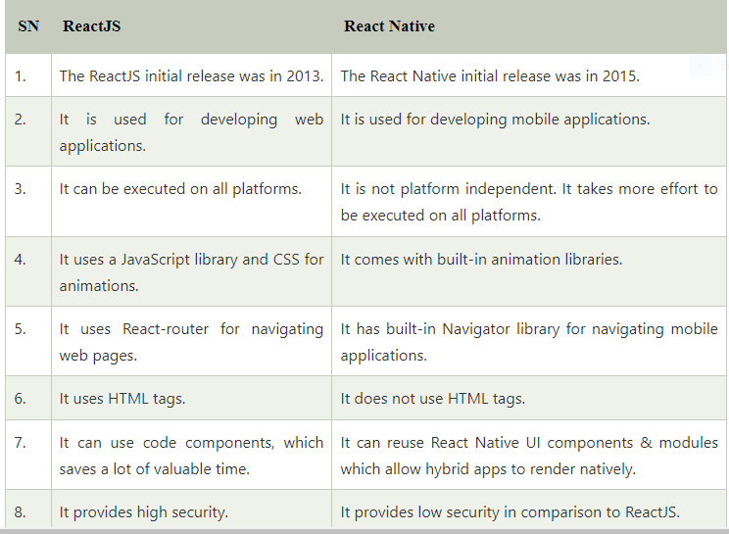
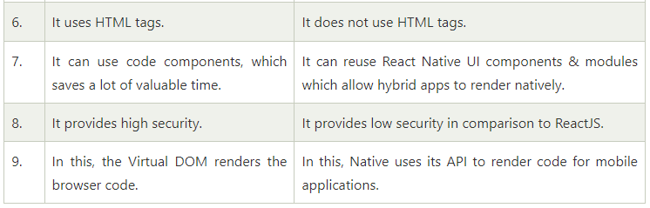
Exception Handling in Java is one of the effective means to handle the runtime errors so that the regular flow of the application can be preserved. Java Exception Handling is a mechanism to handle runtime errors such as ClassNotFoundException, IOException, SQLException, RemoteException, etc.
Exception is an unwanted or unexpected event, which occurs during the execution of a program, i.e. at run time, that disrupts the normal flow of the program’s instructions. Exceptions can be caught and handled by the program. When an exception occurs within a method, it creates an object. This object is called the exception object. It contains information about the exception, such as the name and description of the exception and the state of the program when the exception occurred.

Major reasons why an exception Occurs
- Invalid user input
- Device failure
- Loss of network connection
- Physical limitations (out of disk memory)
- Code errors
- Opening an unavailable file
Errors represent irrecoverable conditions such as Java virtual machine (JVM) running out of memory, memory leaks, stack overflow errors, library incompatibility, infinite recursion, etc. Errors are usually beyond the control of the programmer, and we should not try to handle errors.
Let us discuss the most important part which is the differences between Error and Exception that is as follows:
- Error: An Error indicates a serious problem that a reasonable application should not try to catch.
- Exception: Exception indicates conditions that a reasonable application might try to catch.

Exception Hierarchy
All exception and error types are subclasses of class Throwable, which is the base class of the hierarchy. One branch is headed by Exception. This class is used for exceptional conditions that user programs should catch. NullPointerException is an example of such an exception. Another branch, Error is used by the Java run-time system(JVM) to indicate errors having to do with the run-time environment itself(JRE). StackOverflowError is an example of such an error.
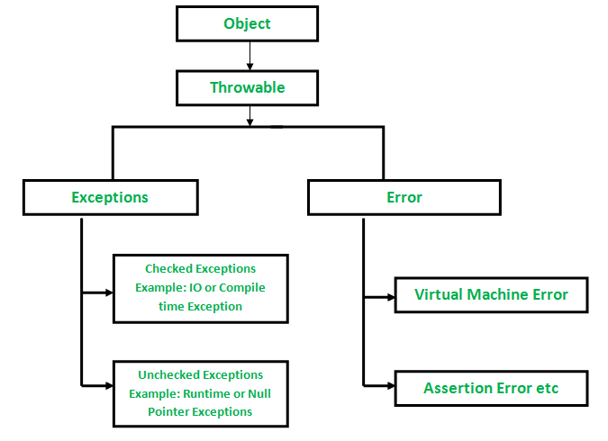

Types of Exceptions
Java defines several types of exceptions that relate to its various class libraries. Java also allows users to define their own exceptions.
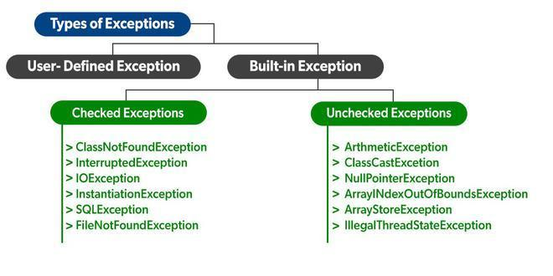
Exceptions can be categorized in two ways:
- Built-in Exceptions
  - Checked Exception
  - Unchecked Exception
- User-Defined Exceptions
Let us discuss the above-defined listed exception that is as follows:

A. Built-in Exceptions:
Built-in exceptions are the exceptions that are available in Java libraries. These exceptions are suitable to explain certain error situations.
- Checked Exceptions: Checked exceptions are called compile-time exceptions because these exceptions are checked at compile-time by the compiler.
- Unchecked Exceptions: The unchecked exceptions are just opposite to the checked exceptions. The compiler will not check these exceptions at compile time. In simple words, if a program throws an unchecked exception, and even if we didn’t handle or declare it, the program would not give a compilation error.
Note: For checked vs unchecked exception, see Checked vs Unchecked Exceptions

B. User-Defined Exceptions:
Sometimes, the built-in exceptions in Java are not able to describe a certain situation. In such cases, users can also create exceptions, which are called ‘user-defined Exceptions’.
The advantages of Exception Handling in Java are as follows:
- Provision to Complete Program Execution
- Easy Identification of Program Code and Error-Handling Code
- Propagation of Errors
- Meaningful Error Reporting
- Identifying Error Types
Methods to print the Exception information:
1.printStackTrace()– This method prints exception information in the format of Name of the exception: description of the exception, stack
trace.
- Java
//program to print the exception information using printStackTrace() method

import java.io.*;

class GFG {
public static void main (String[] args) {
int a=5;
int b=0;
try{
System.out.println(a/b);
}
catch(ArithmeticException e){
e.printStackTrace();
}
}
}
Output:
java.lang.ArithmeticException: / by zero
at GFG.main(File.java:10)
2.toString() – This method prints exception information in the format of Name of the exception: description of the exception.
- Java
//program to print the exception information using toString() method

import java.io.*;

class GFG1 {
public static void main (String[] args) {
int a=5;
int b=0;
try{
System.out.println(a/b);
}
catch(ArithmeticException e){
System.out.println(e.toString());
}
}
}
Output:
java.lang.ArithmeticException: / by zero
3.getMessage() -This method prints only the description of the exception.
- Java
//program to print the exception information using getMessage() method
import java.io.*;
class GFG1 {
public static void main (String[] args) {
int a=5;
int b=0;
try{
System.out.println(a/b);
}
catch(ArithmeticException e){
System.out.println(e.getMessage());
}
}
}
Output:
/ by zero

How Does JVM handle an Exception?
Default Exception Handling: Whenever inside a method, if an exception has occurred, the method creates an Object known as an Exception Object and hands it off to the run-time system(JVM). The exception object contains the name and description of the exception and the current state of the program where the exception has occurred. Creating the Exception Object and handling it in the run-time system is called throwing an Exception. There might be a list of the methods that had been called to get to the method where an exception occurred. This ordered list of the methods is called Call Stack. Now the following procedure will happen.
- The run-time system searches the call stack to find the method that contains a block of code that can handle the occurred exception. The block of the code is called an Exception handler.
- The run-time system starts searching from the method in which the exception occurred, and proceeds through the call stack in the reverse order in which methods were called.
- If it finds an appropriate handler, then it passes the occurred exception to it. An appropriate handler means the type of the exception object thrown matches the type of the exception object it can handle.
- If the run-time system searches all the methods on the call stack and couldn’t have found the appropriate handler, then the run-time system handover the Exception Object to the default exception handler, which is part of the run-time system. This handler prints the exception information in the following format and terminates the program abnormally.

- int a=50/0;//ArithmeticException
- String s=null;
- System.out.println(s.length());//NullPointerException

3) A scenario where NumberFormatException occurs
If the formatting of any variable or number is mismatched, it may result into NumberFormatException. Suppose we have a string variable that has characters; converting this variable into digit will cause NumberFormatException.
- String s="abc";
- int i=Integer.parseInt(s);//NumberFormatException

4) A scenario where ArrayIndexOutOfBoundsException occurs
When an array exceeds to it's size, the ArrayIndexOutOfBoundsException occurs. there may be other reasons to occur ArrayIndexOutOfBoundsException. Consider the following statements.
- int a[]=new int[5];
- a[10]=50; //ArrayIndexOutOfBoundsException
- InputMismatchException.
- System.out.println("Enter value of a to get its square value:");
- Integer a = sc.nextInt(); // we give any float value as input
- System.out.println((a*a));
- -----------------------------------------------------------------------------------

Exceptions in Main Thread

In this section, we will see some common main thread exceptions that may occur in different scenarios. They are as follows:
1. Exception in thread main java.lang.UnsupportedClassVersionError: This exception occurs in a program when a java class is compiled from another JDK version and we are trying to run it from another java version.
The UnsupportedClassVersionError is present java.lang package.
2. Exception in thread main java.lang.NoClassDefFoundError: This exception occurs in two flavors. The first scenario is where we provide class full name with .class extension. The second scenario comes when Class is not found.
3. Exception in thread main java.lang.NoSuchMethodError: main: This exception occurs in a Java program when a class is trying to run without the main method declaration.
4. Exception in thread main java.lang.ArithmeticException: When any exception is thrown from main method, it prints the exception in the console.
The first part explains that exception is thrown from the main method, second part prints the exception class name and then after a colon, it prints an

Why java.lang.VerifyError Occurs in Java and How to Solve this?
- Last Updated : 30 May, 2022
• Read
• Discuss
The Java Virtual Machine (JVM) distrusts all loaded bytecode as a core tenet of the Java Security Model. During runtime, the JVM will load .class files and attempt to link them together to form an executable — but the validity of these loaded .class files is unknown. To ensure that the loaded .class files do not pose a threat to the final executable, a verification process is done on the .class files by the JVM.
Additionally, the JVM ensures that binaries are well-formed. For example, the JVM will verify classes do not subtype final classes. In many cases, verification fails on valid, non-malicious bytecode because a newer version of Java has a stricter verification process than older versions. For example, JDK 13 may have added a verification step that was not enforced in JDK 7. Thus, if we run an application with JVM 13 and include dependencies compiled with an older version of the Java Compiler (javac), the JVM may consider the outdated dependencies to be invalid.
Thus, when linking older .class files with a newer JVM, the JVM may throw a java.lang.VerifyError.
The VerifyError exists since the 1.0 version of Java.
The Structure of VerifyError:
Constructors
VerifyError()
This constructor creates an instance of the VerifyError class, setting null as its message.
VerifyError(String s)
This constructor creates an instance of the VerifyError class, using the specified string as message. Here the class which threw the error is indicated through string argument.
The three most common reasons upon which this error may occur as follows:
Reason 1: “This error will be thrown whenever a class which is declared as final is extended.”
Program:
- Java
// Java program to show the occurrence
// of java.lang.VerifyError

class B extends A {

public static void main(String args[])

{

System.out.println("my super class name:-"
+ myname);
}
}

public class A

{

static String myname = "A";
}
As you see if you compile these two programs and execute it, it must have to work fine without showing any error. Now after changing the class A as follows and compile it alone.
final public class A
{
static String myname="A";
}
Note that here we have recompiled the “class A” alone. Now if we execute the class B (class that contains main() method) then an error message like below will be thrown at run-time.
Exception in thread "main" java.lang.VerifyError: Cannot inherit from final class
at java.lang.ClassLoader.defineClass1(Native Method)
at java.lang.ClassLoader.defineClassCond(Unknown Source)
at java.lang.ClassLoader.defineClass(Unknown Source)
at java.security.SecureClassLoader.defineClass(Unknown Source)
at java.net.URLClassLoader.defineClass(Unknown Source)
at java.net.URLClassLoader.access$000(Unknown Source)
at java.net.URLClassLoader$1.run(Unknown Source)
at java.security.AccessController.doPrivileged(Native Method)
at java.net.URLClassLoader.findClass(Unknown Source)
at java.lang.ClassLoader.loadClass(Unknown Source)
at sun.misc.Launcher$AppClassLoader.loadClass(Unknown Source)
at java.lang.ClassLoader.loadClass(Unknown Source)
Could not find the main class: B.
This error was caused because that we changed the definition of class TestClassA, but class TestClassB was compiled using an older version of the class TestClassA.
Reason 2: “Consider a class that extends another class before and if it no longer extends that class now, then this error may be thrown at run-time.”
Program:

How to deal with the VerifyError?
In order to avoid the VerifyError, you must compile all your classes using the same version of Java. Also, once a change is done to a class, then make sure that you re-compile your project from scratch. Finally, if your application makes use of external libraries, verify that you use the appropriate version of every library and of course, consult the corresponding javadocs, in order to be sure that everything is correct.
Whenever possible, use the latest versions of dependencies rather than disabling verification.

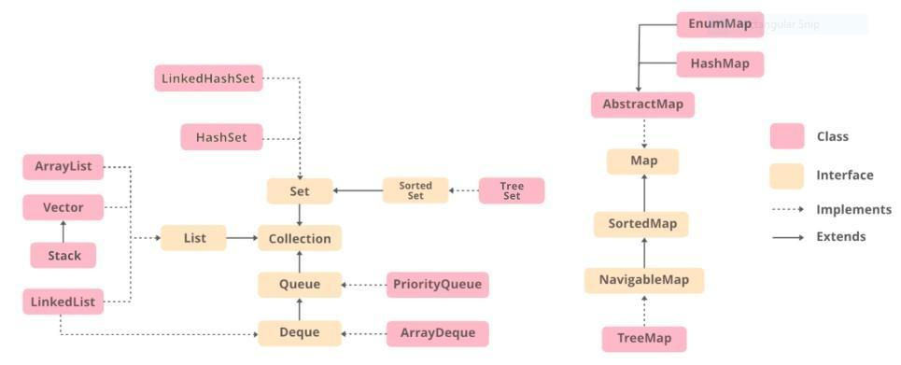

Method Overloading | Method Overriding
Method overloading is a compile-time polymorphism. | Method overriding is a run-time polymorphism.
It helps to increase the readability of the program. | It is used to grant the specific implementation of the method which is already provided by its parent class or superclass.
It occurs within the class. | It is performed in two classes with inheritance relationships.
Method overloading may or may not require inheritance. | Method overriding always needs inheritance.
In method overloading, methods must have the same name and different signatures. | In method overriding, methods must have the same name and same signature.
In method overloading, the return type can or can not be the same, but we just have to change the parameter. | In method overriding, the return type must be the same or co-variant.
Static binding is being used for overloaded methods. | Dynamic binding is being used for overriding methods.
It gives better performance. The reason behind this is that the binding of overridden methods is being done at runtime. | Poor performance
Private and final methods can be overloaded. | Private and final methods can’t be overridden.
Argument list should be different while doing method overloading. | Argument list should be same in method overriding.

he default version of the clone method creates a shallow copy of an object. In java being object-oriented, object copying is creating a copy of the existing object, so the object copied can be a similar copy of the exact copy of the object of which it is copied. There are 2 ways to copy an object as follows:
In C/C++ there
Methods of Copying
Now, copying can be of three types as follows:
- Shallow copy
- Deep copy
- Cloning
Generally, deep copy and cloning is referred to as the same deep cloning as the difference between them is a thin line where focus is laid to ease for copying objects manually using the clone() method.

1. Shallow Copy/ Cloning
- Default implementation while using the clone() method a shallow copy of the object is created. It means it creates a new instance and copies all the fields of the object to that new instance where both are referencing to the same memory in heap memory.
- clone() method of the object class supports the shallow copy of the object. If the object contains primitive as well as non-primitive or reference type variable in shallow copy, the cloned object also refers to the same object to which the original object refers as only the object references get copied and not the referred objects themselves. In simpler terms, One object is being created here while two references in the stack memory.
- It returns it as an object type, we need to explicitly cast it back to our original object. This is a shallow copy of the object.
Illustration: Shallow copying object ‘t2’
class GFG
{
int i,j;
}
main(String[] args)
{
// Copying
GFG object1 = new GFG() ;
object.i = 5;
object.j = 6;
GFG object2 = object1 ; // shallow copying object
}
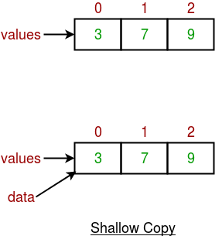
Example 1
- Java
// Java Program to show shallow cloning

// Importing java input/output classes
import java.io.*;

// Class
class GFG {

// Main driver method
public static void main(String[] args)
{
// t1 and t2 objects are used to
// illustrate shallow copy

// t1 is first object created in heap memory
GFG t1 = new GFG();

// Creating only one object(t1) and
// both objects (t1,t2) are pointing to only one
// object
GFG t2 = t1;

// Display message
// return true if reference is same that is shallow copy
// false if different
// Should be returning - true
System.out.print(
"Output: False if Deepcopy & True if shallow : ");
System.out.println(t1 == t2);
}
}

Output
Output: False if Deepcopy & True if shallow : true

Output explanation:

- As seen above there were two reference variables t1, t2. Whenever the object of GFG class is created the t1 (reference variable) is pointing to one object.
- Afterward, assigning the t1 reference variable into the new reference variable t2 of the same class pointing to the same object in heap memory. Both t1 and t2 reference variables are pointing to only one object.
- It does not create a new duplicate object. The above two statements prove that both t1 and t2 reference variables are point only one object.

2. Deep copy/ cloning is the process of creating exactly the independent duplicate objects in the heap memory and manually assigning the values of the second object where values are supposed to be copied is called deep cloning.

- Whenever there is a need self copy not using default implementation is referred to as deep copy where the object to be needed is implemented as per needs. Therefore, for the deep copy, it needs to ensure that all the member classes also implement the Cloneable interface because of overriding the clone() method of the object class.
GFG object1 = new GFG() ; || Creating object of GFG class
object.i = 5;
object.j = 6;
GFG object2 = new GFG; || Creating another object class
object2.i = object1.i ; || Deep copying
object2.j = object1.j ; || Deep copying
Note: In can not directly call clone() method using object.clone() as clone method in Object class of java is protected. So override the function by making access modifier as public in return super.clone() from the class created to override
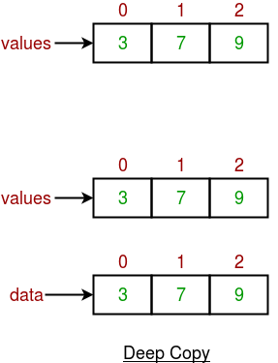

Example 2

- Java
// Java Program to show Deep Cloning

// Importing java input/output libraries
import java.io.*;

// Class
public class GFG implements Cloneable {

// Defining a method as clone method is protected
// Defining within the class called cloneable interface
public Object clone() throws CloneNotSupportedException
{
return (GFG)super.clone();
}

// Main driver method
public static void main(String[] args) throws CloneNotSupportedException
{
// Creating first object of GFG class
GFG t1 = new GFG();

// Using clone() method to create duplicate object
// of t1 reference variable
// else for every object manually object needs
// to be copied in deep copying
// clone() ease this manual effort
GFG t2 = (GFG)t1.clone();

// Comparing two objects just after deep copying
// Returning true for shallow(by default) copying
// Returning false for deep copying
System.out.println(t1 == t2);
}
}
Output
false
Output explanation:
- Here, there are two reference variables t1, t2. When the object of GFG class is created, the t1 (reference variable) is pointing to one object.
- Afterward, t1 is assigned as a reference variable and calls clone() method into a new reference variable t2 of the same class. Both t1 and t2 reference variables are pointing to different objects. Here t2 has created a new duplicate object and t1 also.
- The above two statements prove that both t1 and t2 reference variable are point difference object if t1 point to O1 object than t2 point to O2 object.

Java 8 Features
Oracle released a new version of Java as Java 8 in March 18, 2014. It was a revolutionary release of the Java for software development platform. It includes various upgrades to the Java programming, JVM, Tools and libraries.

Java 8 Programming Language Enhancements
Java 8 provides following features for Java Programming:
- Lambda expressions,
- Method references,
- Functional interfaces,
- Stream API,
- Default methods,
- Base64 Encode Decode,
- Static methods in interface,
- Optional class,
- Collectors class,
- ForEach() method,
- Nashorn JavaScript Engine,
- Parallel Array Sorting,
- Type and Repating Annotations,
- IO Enhancements,
- Concurrency Enhancements,
- JDBC Enhancements etc.

Java Lambda Expressions
Lambda expression is a new and important feature of Java which was included in Java SE 8. It provides a clear and concise way to represent one method interface using an expression. It is very useful in collection library. It helps to iterate, filter and extract data from collection.
The Lambda expression is used to provide the implementation of an interface which has functional interface. It saves a lot of code. In case of lambda expression, we don't need to define the method again for providing the implementation. Here, we just write the implementation code.
Java lambda expression is treated as a function, so compiler does not create .class file.

Functional Interface
Lambda expression provides implementation of functional interface. An interface which has only one abstract method is called functional interface. Java provides an anotation @FunctionalInterface, which is used to declare an interface as functional interface.
46.5M
791
History of Java
Next
Stay

Why use Lambda Expression
- To provide the implementation of Functional interface.
- Less coding.

Java Lambda Expression Syntax

- (argument-list) -> {body}
Java lambda expression is consisted of three components.
1) Argument-list: It can be empty or non-empty as well.
2) Arrow-token: It is used to link arguments-list and body of expression.
3) Body: It contains expressions and statements for lambda expression.
No Parameter Syntax

- () -> {
- //Body of no parameter lambda
- }
One Parameter Syntax

- (p1) -> {
- //Body of single parameter lambda
- }
Two Parameter Syntax

- (p1,p2) -> {
- //Body of multiple parameter lambda
- }
Let's see a scenario where we are not implementing Java lambda expression. Here, we are implementing an interface without using lambda expression.

Without Lambda Expression

- interface Drawable{
- public void draw();
- }
- public class LambdaExpressionExample {
- public static void main(String[] args) {
- int width=10;

- //without lambda, Drawable implementation using anonymous class
- Drawable d=new Drawable(){
- public void draw(){System.out.println("Drawing "+width);}
- };
- d.draw();
- }
- }
Test it Now

Output:
Drawing 10

Java Lambda Expression Example
Now, we are going to implement the above example with the help of Java lambda expression.

- @FunctionalInterface //It is optional
- interface Drawable{
- public void draw();
- }

- public class LambdaExpressionExample2 {
- public static void main(String[] args) {
- int width=10;

- //with lambda
- Drawable d2=()->{
- System.out.println("Drawing "+width);
- };
- d2.draw();
- }
- }
Test it Now

Output:
Drawing 10

A lambda expression can have zero or any number of arguments. Let's see the examples:

Java Lambda Expression Example: No Parameter

- interface Sayable{
- public String say();
- }
- public class LambdaExpressionExample3{
- public static void main(String[] args) {
- Sayable s=()->{
- return "I have nothing to say.";
- };
- System.out.println(s.say());
- }
- }
Test it Now

Output:
I have nothing to say.

Java Lambda Expression Example: Single Parameter

- interface Sayable{
- public String say(String name);
- }

- public class LambdaExpressionExample4{
- public static void main(String[] args) {

- // Lambda expression with single parameter.
- Sayable s1=(name)->{
- return "Hello, "+name;
- };
- System.out.println(s1.say("Sonoo"));

- // You can omit function parentheses
- Sayable s2= name ->{
- return "Hello, "+name;
- };
- System.out.println(s2.say("Sonoo"));
- }
- }
Test it Now

Output:
Hello, Sonoo
Hello, Sonoo

Java Lambda Expression Example: Multiple Parameters

- interface Addable{
- int add(int a,int b);
- }

- public class LambdaExpressionExample5{
- public static void main(String[] args) {

- // Multiple parameters in lambda expression
- Addable ad1=(a,b)->(a+b);
- System.out.println(ad1.add(10,20));

- // Multiple parameters with data type in lambda expression
- Addable ad2=(int a,int b)->(a+b);
- System.out.println(ad2.add(100,200));
- }
- }
Test it Now

Output:
30
300

Java Lambda Expression Example: with or without return keyword
In Java lambda expression, if there is only one statement, you may or may not use return keyword. You must use return keyword when lambda expression contains multiple statements.

- interface Addable{
- int add(int a,int b);
- }

- public class LambdaExpressionExample6 {
- public static void main(String[] args) {

- // Lambda expression without return keyword.
- Addable ad1=(a,b)->(a+b);
- System.out.println(ad1.add(10,20));

- // Lambda expression with return keyword.
- Addable ad2=(int a,int b)->{
- return (a+b);
- };
- System.out.println(ad2.add(100,200));
- }
- }
Test it Now

Output:
30
300

Java Lambda Expression Example: Foreach Loop

- import java.util.*;
- public class LambdaExpressionExample7{
- public static void main(String[] args) {

- List<String> list=new ArrayList<String>();
- list.add("ankit");
- list.add("mayank");
- list.add("irfan");
- list.add("jai");

- list.forEach(
- (n)->System.out.println(n)
- );
- }
- }
Test it Now

Output:
ankit
mayank
irfan
jai

Java Lambda Expression Example: Multiple Statements

- @FunctionalInterface
- interface Sayable{
- String say(String message);
- }

- public class LambdaExpressionExample8{
- public static void main(String[] args) {

- // You can pass multiple statements in lambda expression
- Sayable person = (message)-> {
- String str1 = "I would like to say, ";
- String str2 = str1 + message;
- return str2;
- };
- System.out.println(person.say("time is precious."));
- }
- }
Test it Now

Output:
I would like to say, time is precious.

Java Lambda Expression Example: Creating Thread
You can use lambda expression to run thread. In the following example, we are implementing run method by using lambda expression.

- public class LambdaExpressionExample9{
- public static void main(String[] args) {

- //Thread Example without lambda
- Runnable r1=new Runnable(){
- public void run(){
- System.out.println("Thread1 is running...");
- }
- };
- Thread t1=new Thread(r1);
- t1.start();
- //Thread Example with lambda
- Runnable r2=()->{
- System.out.println("Thread2 is running...");
- };
- Thread t2=new Thread(r2);
- t2.start();
- }
- }
Test it Now

Output:
Thread1 is running...
Thread2 is running...

Java lambda expression can be used in the collection framework. It provides efficient and concise way to iterate, filter and fetch data. Following are some lambda and collection examples provided.

Java Method References
Java provides a new feature called method reference in Java 8. Method reference is used to refer method of functional interface. It is compact and easy form of lambda expression. Each time when you are using lambda expression to just referring a method, you can replace your lambda expression with method reference. In this tutorial, we are explaining method reference concept in detail.

Types of Method References
There are following types of method references in java:
- Reference to a static method.
- Reference to an instance method.
- Reference to a constructor.
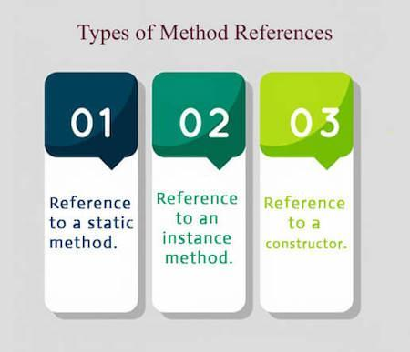

1) Reference to a Static Method
You can refer to static method defined in the class. Following is the syntax and example which describe the process of referring static method in Java.
Syntax
63M
1.3K
OOPs Concepts in Java
- ContainingClass::staticMethodName

Example 1
In the following example, we have defined a functional interface and referring a static method to it's functional method say().
- interface Sayable{
- void say();
- }
- public class MethodReference {
- public static void saySomething(){
- System.out.println("Hello, this is static method.");
- }
- public static void main(String[] args) {
- // Referring static method
- Sayable sayable = MethodReference::saySomething;
- // Calling interface method
- sayable.say();
- }
- }
Test it Now
Output:
Hello, this is static method.

Example 2
In the following example, we are using predefined functional interface Runnable to refer static method.
- public class MethodReference2 {
- public static void ThreadStatus(){
- System.out.println("Thread is running...");
- }
- public static void main(String[] args) {
- Thread t2=new Thread(MethodReference2::ThreadStatus);
- t2.start();
- }
- }
Test it Now
Output:

Java Method References
Java provides a new feature called method reference in Java 8. Method reference is used to refer method of functional interface. It is compact and easy form of lambda expression. Each time when you are using lambda expression to just referring a method, you can replace your lambda expression with method reference. In this tutorial, we are explaining method reference concept in detail.

Types of Method References
There are following types of method references in java:
- Reference to a static method.
- Reference to an instance method.
- Reference to a constructor.

1) Reference to a Static Method
You can refer to static method defined in the class. Following is the syntax and example which describe the process of referring static method in Java.
Syntax
- ContainingClass::staticMethodName

Example 1
In the following example, we have defined a functional interface and referring a static method to it's functional method say().
- interface Sayable{
- void say();
- }
- public class MethodReference {
- public static void saySomething(){
- System.out.println("Hello, this is static method.");
- }
- public static void main(String[] args) {
- // Referring static method
- Sayable sayable = MethodReference::saySomething;
- // Calling interface method
- sayable.say();
- }
- }
Test it Now
Output:
Hello, this is static method.

Example 2
In the following example, we are using predefined functional interface Runnable to refer static method.
- public class MethodReference2 {
- public static void ThreadStatus(){
- System.out.println("Thread is running...");
- }
- public static void main(String[] args) {
- Thread t2=new Thread(MethodReference2::ThreadStatus);
- t2.start();
- }
- }
Test it Now
Output:
Thread is running...

Example 3
You can also use predefined functional interface to refer methods. In the following example, we are using BiFunction interface and using it's apply() method.
- import java.util.function.BiFunction;
- class Arithmetic{
- public static int add(int a, int b){
- return a+b;
- }
- }
- public class MethodReference3 {
- public static void main(String[] args) {
- BiFunction<Integer, Integer, Integer>adder = Arithmetic::add;
- int result = adder.apply(10, 20);
- System.out.println(result);
- }
- }
Test it Now
Output:
30

Java Default Methods
Java provides a facility to create default methods inside the interface. Methods which are defined inside the interface and tagged with default are known as default methods. These methods are non-abstract methods.

Java Default Method Example
In the following example, Sayable is a functional interface that contains a default and an abstract method. The concept of default method is used to define a method with default implementation. You can override default method also to provide more specific implementation for the method.
Let's see a simple
- interface Sayable{
- // Default method
- default void say(){
- System.out.println("Hello, this is default method");
- }
- // Abstract method
- void sayMore(String msg);
- }
- public class DefaultMethods implements Sayable{
- public void sayMore(String msg){ // implementing abstract method
- System.out.println(msg);
- }
- public static void main(String[] args) {
- DefaultMethods dm = new DefaultMethods();
- dm.say(); // calling default method
- dm.sayMore("Work is worship"); // calling abstract method

- }
- }
Output:
Play Videox
Hello, this is default method
Work is worship

Static Methods inside Java 8 Interface
You can also define static methods inside the interface. Static methods are used to define utility methods. The following example explain, how to implement static method in interface?
- interface Sayable{
- // default method
- default void say(){
- System.out.println("Hello, this is default method");
- }
- // Abstract method
- void sayMore(String msg);
- // static method
- static void sayLouder(String msg){
- System.out.println(msg);
- }
- }
- public class DefaultMethods implements Sayable{
- public void sayMore(String msg){ // implementing abstract method
- System.out.println(msg);
- }
- public static void main(String[] args) {
- DefaultMethods dm = new DefaultMethods();
- dm.say(); // calling default method
- dm.sayMore("Work is worship"); // calling abstract method
- Sayable.sayLouder("Helloooo..."); // calling static method
- }
- }
Output:
Hello there
Work is worship
Helloooo...

Abstract Class vs Java 8 Interface
After having default and static methods inside the interface, we think about the need of abstract class in Java. An interface and an abstract class is almost similar except that you can create constructor in the abstract class whereas you can't do this in interface.
- abstract class AbstractClass{
- public AbstractClass() { // constructor
- System.out.println("You can create constructor in abstract class");
- }
- abstract int add(int a, int b); // abstract method
- int sub(int a, int b){ // non-abstract method
- return a-b;
- }
- static int multiply(int a, int b){ // static method
- return a*b;
- }
- }
- public class AbstractTest extends AbstractClass{
- public int add(int a, int b){ // implementing abstract method
- return a+b;
- }
- public static void main(String[] args) {
- AbstractTest a = new AbstractTest();
- int result1 = a.add(20, 10); // calling abstract method
- int result2 = a.sub(20, 10); // calling non-abstract method
- int result3 = AbstractClass.multiply(20, 10); // calling static method
- System.out.println("Addition: "+result1);
- System.out.println("Substraction: "+result2);
- System.out.println("Multiplication: "+result3);
- }
- }
Output:
You can create constructor in abstract class
Addition: 30
Substraction: 10
Multiplication:

Java forEach loop
Java provides a new method forEach() to iterate the elements. It is defined in Iterable and Stream interface. It is a default method defined in the Iterable interface. Collection classes which extends Iterable interface can use forEach loop to iterate elements.
This method takes a single parameter which is a functional interface. So, you can pass lambda expression as an argument.

forEach() Signature in Iterable Interface
- default void forEach(Consumer<super T>action)

Java 8 forEach() example 1
- import java.util.ArrayList;
- import java.util.List;
- public class ForEachExample {
- public static void main(String[] args) {
- List<String> gamesList = new ArrayList<String>();
- gamesList.add("Football");
- gamesList.add("Cricket");
- gamesList.add("Chess");
- gamesList.add("Hocky");
- System.out.println("------------Iterating by passing lambda expression--------------");
- gamesList.forEach(games -> System.out.println(games));

- }
- }
Output:
------------Iterating by passing lambda expression--------------
Football
Cricket
Chess
Hocky

Java 8 forEach() example 2
- import java.util.ArrayList;
- import java.util.List;
- public class ForEachExample {
- public static void main(String[] args) {
- List<String> gamesList = new ArrayList<String>();
- gamesList.add("Football");
- gamesList.add("Cricket");
- gamesList.add("Chess");
- gamesList.add("Hocky");
- System.out.println("------------Iterating by passing method reference---------------");
- gamesList.forEach(System.out::println);
- }
- }
Output:
49.3M
880
Prime Ministers of India | List of Prime Minister of India (1947-2020)
------------Iterating by passing method reference---------------
Football
Cricket
Chess
Hocky

Java Stream forEachOrdered() Method
Along with forEach() method, Java provides one more method forEachOrdered(). It is used to iterate elements in the order specified by the stream.

Singnature:
- void forEachOrdered(Consumer<? super T> action)

Java Stream forEachOrdered() Method Example
- import java.util.ArrayList;
- import java.util.List;
- public class ForEachOrderedExample {
- public static void main(String[] args) {
- List<String> gamesList = new ArrayList<String>();
- gamesList.add("Football");
- gamesList.add("Cricket");
- gamesList.add("Chess");
- gamesList.add("Hocky");
- System.out.println("------------Iterating by passing lambda expression---------------");
- gamesList.stream().forEachOrdered(games -> System.out.println(games));
- System.out.println("------------Iterating by passing method reference---------------");
- gamesList.stream().forEachOrdered(System.out::println);
- }

- }
Output:
------------Iterating by passing lambda expression---------------
Football
Cricket
Chess
Hocky
------------Iterating by passing method reference---------------
Football
Cricket
Chess
Hocky

Java Stream Filter
Java stream provides a method filter() to filter stream elements on the basis of given predicate. Suppose you want to get only even elements of your list then you can do this easily with the help of filter method.
This method takes predicate as an argument and returns a stream of consisting of resulted elements.

Signature
The signature of Stream filter() method is given below:

- Stream<T> filter(Predicate<? super T> predicate)

Parameter
predicate: It takes Predicate reference as an argument. Predicate is a functional interface. So, you can also pass lambda expression here.
Play Videox

Return
It returns a new stream.

Java Stream filter() example
In the following example, we are fetching and iterating filtered data.

- import java.util.*;
- class Product{
- int id;
- String name;
- float price;
- public Product(int id, String name, float price) {
- this.id = id;
- this.name = name;
- this.price = price;
- }
- }
- public class JavaStreamExample {
- public static void main(String[] args) {
- List<Product> productsList = new ArrayList<Product>();
- //Adding Products
- productsList.add(new Product(1,"HP Laptop",25000f));
- productsList.add(new Product(2,"Dell Laptop",30000f));
- productsList.add(new Product(3,"Lenevo Laptop",28000f));
- productsList.add(new Product(4,"Sony Laptop",28000f));
- productsList.add(new Product(5,"Apple Laptop",90000f));
- productsList.stream()
- .filter(p ->p.price> 30000) // filtering price
- .map(pm ->pm.price) // fetching price
- .forEach(System.out::println); // iterating price
- }
- }
Output:
90000.0

Java Stream filter() example 2
In the following example, we are fetching filtered data as a list.

- import java.util.*;
- import java.util.stream.Collectors;
- class Product{
- int id;
- String name;
- float price;
- public Product(int id, String name, float price) {
- this.id = id;
- this.name = name;
- this.price = price;
- }
- }
- public class JavaStreamExample {
- public static void main(String[] args) {
- List<Product> productsList = new ArrayList<Product>();
- //Adding Products
- productsList.add(new Product(1,"HP Laptop",25000f));
- productsList.add(new Product(2,"Dell Laptop",30000f));
- productsList.add(new Product(3,"Lenevo Laptop",28000f));
- productsList.add(new Product(4,"Sony Laptop",28000f));
- productsList.add(new Product(5,"Apple Laptop",90000f));
- List<Float> pricesList = productsList.stream()
- .filter(p ->p.price> 30000) // filtering price
- .map(pm ->pm.price) // fetching price
- .collect(Collectors.toList());
- System.out.println(pricesList);
- }
- }

Iterator
Iterators are used in Collection framework in Java to retrieve elements one by one. It can be applied to any Collection object. By using Iterator, we can perform both read and remove operations. Iterator must be used whenever we want to enumerate elements in all Collection framework implemented interfaces like Set, List, Queue, Deque and also in all implemented classes of Map interface. Iterator is the only cursor available for entire collection framework.
Iterator object can be created by calling iterator() method present in Collection interface.
// Here "c" is any Collection object. itr is of
// type Iterator interface and refers to "c"
Iterator itr = c.iterator();
ListIterator
It is only applicable for List collection implemented classes like arraylist, linkedlist etc. It provides bi-directional iteration. ListIterator must be used when we want to enumerate elements of List. This cursor has more functionality(methods) than iterator.
ListIterator object can be created by calling listIterator() method present in List interface.
// Here "l" is any List object, ltr is of type
// ListIterator interface and refers to "l"
ListIterator ltr = l.listIterator();
Differences between Iterator and ListIterator:
- Iterator can traverse only in forward direction whereas ListIterator traverses both in forward and backward directions.
Example:
import java.io.*;
import java.util.*;

class IteratorDemo1 {
public static void main(String[] args)
{
ArrayList<Integer> list
= new ArrayList<Integer>();

list.add(1);
list.add(2);
list.add(3);
list.add(4);
list.add(5);

// Iterator
Iterator itr = list.iterator();

System.out.println("Iterator:");
System.out.println("Forward traversal: ");

while (itr.hasNext())
System.out.print(itr.next() + " ");

System.out.println();

// ListIterator
ListIterator i = list.listIterator();

System.out.println("ListIterator:");
System.out.println("Forward Traversal : ");

while (i.hasNext())
System.out.print(i.next() + " ");

System.out.println();

System.out.println("Backward Traversal : ");

while (i.hasPrevious())
System.out.print(i.previous() + " ");

System.out.println();
}
}
Output:
Iterator:
Forward traversal:
1 2 3 4 5

ListIterator:
Forward Traversal :
1 2 3 4 5
Backward Traversal :
5 4 3 2 1
- ListIterator can help to replace an element whereas Iterator cannot.
Example:
import java.util.ArrayList;
import java.util.ListIterator;

public class ListIteratorDemo2 {
public static void main(String[] args)
{

ArrayList<Integer> aList
= new ArrayList<Integer>();
aList.add(1);
aList.add(2);
aList.add(3);
aList.add(4);
aList.add(5);

System.out.println("Elements of ArrayList: ");
for (Integer i : aList) {
System.out.println(i);
}
ListIterator<Integer> l
= aList.listIterator();
l.next();
l.set(80000);

System.out.println("\nNow the ArrayList"
+ " elements are: ");
for (Integer i : aList) {
System.out.println(i);
}
}
}
Output:
Elements of ArrayList:
1
2
3
4
5

Now the ArrayList elements are:
80000
2
3
4
5
OUTPUT
Table showing Difference between Iterator and ListIterator
Iterator | ListIterator
Can traverse elements present in Collection only in the forward direction. | Can traverse elements present in Collection both in forward and backward directions.
Helps to traverse Map, List and Set. | Can only traverse List and not the other two.
Indexes cannot be obtained by using Iterator. | It has methods like nextIndex() and previousIndex() to obtain indexes of elements at any time while traversing List.
Cannot modify or replace elements present in Collection | We can modify or replace elements with the help of set(E e)
Cannot add elements and it throws ConcurrentModificationException. | Can easily add elements to a collection at any time.
Certain methods of Iterator are next(), remove() and hasNext(). | Certain methods of ListIterator are next(), previous(), hasNext(), hasPrevious(), add(E e).

Difference between Iterator and Enumeration in Java with Examples
- Last Updated : 28 Jan, 2021
• Read
• Discuss
Iterator: It is a universal iterator as we can apply it to any Collection object. By using Iterator, we can perform both read and remove operations. It is an improved version of Enumeration with the additional functionality of remove-ability of an element.
Iterator must be used whenever we want to enumerate elements in all Collection framework implemented interfaces like Set, List, Queue, Deque and also in all implemented classes of Map interface. Iterator is the only cursor available for entire collection framework.
Syntax:
// Here "c" is any Collection object. itr is of
// type Iterator interface and refers to "c"
Iterator itr = c.iterator();
Enumeration: Enumeration (or enum) is a user-defined data type. It is mainly used to assign names to integral constants, the names make a program easy to read and maintain. In Java (from 1.5), enums are represented using the enum data type. Java enums are more powerful than C/C++ enums. In Java, we can also add variables, methods and constructors to it. The main objective of the enum is to define our own data types(Enumerated Data Types).
Syntax:
// A simple enum example where enum is declared
// outside any class (Note enum keyword instead of
// class keyword)
enum Color
{
RED, GREEN, BLUE;
}
Difference between Iterator and Enumeration:
The functionality of Enumeration and the Iterator are same. Using Enumeration you can only traverse and fetch the objects, where as using Iterator we can also add and remove the objects. So Iterator can be useful if you want
to manipulate the list and Enumeration is for read-only access.
Iterator | Enumeration
Iterator is a universal cursor as it is applicable for all the collection classes. | Enumeration is not a universal cursor as it applies only to legacy classes.
Iterator has the remove() method. | Enumeration does not have the remove() method.
Iterator can do modifications (e.g using remove() method it removes the element from the Collection during traversal). | Enumeration interface acts as a read only interface, one can not do any modifications to Collection while traversing the elements of the Collection.
Iterator is not a legacy interface. Iterator can be used for the traversal of HashMap, LinkedList, ArrayList, HashSet, TreeMap, TreeSet .

Property | Enumeration | Iterator | ListIterator
1. Where we can apply? | It can be applied only to the legacy classes. | It can be applied to any collection interface. | It can be applied to the only list interface.
2. Is it a legacy? | Yes (introduced in 1.0 V). | No (introduced in 1.2 V). | No (introduced in 1.2 V).
3. Allowed Movement | Single direction, i.e we can traverse elements present in the collection only in the forward direction. | Single direction, i.e we can traverse elements present in the collection only in the forward direction. | Bidirectional, i.e we can traverse elements present in the collection both in forward and backward directions.
4. Allowed Operation | We can only perform the read operation. | We can perform read and remove operation. | We can perform read, remove, add, and replace operations.
5. How can we get it? | By calling elements() method present in the vector class. | By calling iterator() method present in any collection interface. | By calling listIterator() method present in the list interface.
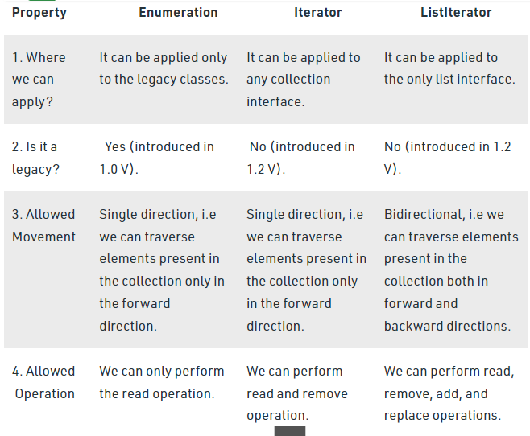
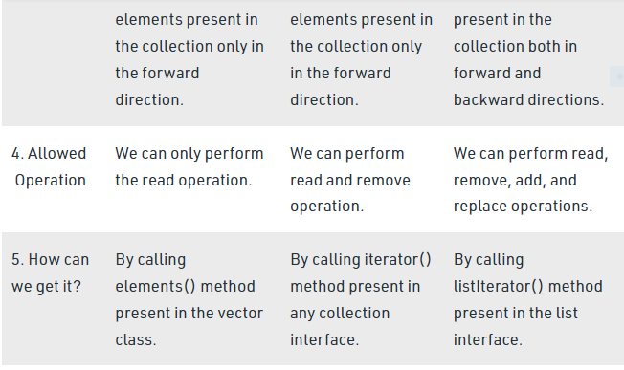

How to Avoid ConcurrentModificationException in Java?
- Difficulty Level : Medium
- Last Updated : 16 Jun, 2021
• Read
• Discuss
ConcurrentModificationException is a predefined Exception in Java, which occurs while we are using Java Collections, i.e whenever we try to modify an object concurrently without permission ConcurrentModificationException occurs which is present in java.util package.
Procedure: Some steps are required in order to avoid the occurrence of this exception in a single-threaded environment. They are as follows:
- Instead of iterating through collections classes, we can iterate through the arrays. This works perfectly fine for smaller lists what about the bigger list? It’s very basic we know that if the array size is huge then it affects the performance. Hence, this method is only effective for smaller size arrays.
- The next method is the Synchronized block method, Here we actually lock the list in a synchronized block to avoid the exception. Isn’t that cool? but guess what this is also not an effective method to avoid Exception Why? Because the purpose of multithreading is not being used.
- The better way is we have ConcurrentHashMap and CopyOnWriteArrayList Which is the best among the above Methods.
Methods:
Here two ways are proposed of which starting with the naive one and ending up with the optimal approach to reach the goal.
- Using Loops: We used the Iterator remove() method instead of that we can use a for loop to avoid ConcurrentModificationException in a Single-threaded environment. If we add any extra objects then we can ensure that our code takes care of them.
- Using the remove() Method: We can use the remove method to remove the object from the collection. Here there is a problem that is you can only remove the same object and not any other from the list
Example 1:
- Java
// Java Program to Avoid
// AvoidConcurrentModificationException

// Importing Map and List utility classes
// from java.util package
import java.util.List;
import java.util.Map;

// Importing classes from java.util.concurrent package
import java.util.concurrent.ConcurrentHashMap;
import java.util.concurrent.CopyOnWriteArrayList;

// Main class
public class GFG {

// Main driver method
public static void main(String[] args)
{

// Creating an object of List class
// Declaring object of string type
List<String> marvel
= new CopyOnWriteArrayList<String>();

// Adding elements to the above object created
// Custom input entries
marvel.add("IronMan");
marvel.add("BlackWidow");
marvel.add("Hulk");
marvel.add("DoctorStrange");
marvel.add("SpiderMan");

// Iterating over object created using size() method
for (int i = 0; i < marvel.size(); i++) {

// Print and display the object elements
// using get() method
System.out.println("Avenger : "
+ marvel.get(i));

// Condition check over object elements

// If specific element is matched
if (marvel.get(i).equals("BlackWidow")) {

marvel.remove(i);
i--;

// Add this specific element
marvel.add("CaptianAmerica");
}
}

// Now getting the final total size by checking
// how many elements are there inside object
System.out.println("Total Avengers : "
+ marvel.size());
}
}

Output
Avenger : IronMan
Avenger : BlackWidow
Avenger : Hulk
Avenger : DoctorStrange
Avenger : SpiderMan
Avenger : CaptianAmerica
Total Avengers :5
Note: The Exception can also occur if we try to modify the structure of original list with sublist. An example for the same is below,

Example 2:

- Java
// Java Program to Illustrate ConcurrentModificationException
// WithArrayListSubList

// Importing List and Arraylist classes utility classes
// from java.util package
import java.util.ArrayList;
import java.util.List;

// Main class
public class GFG {

// Main driver method
public static void main(String[] args) {

// Creating a List class object
// Declaring object of string type
List <String> names = new ArrayList <>();

// Adding elements to the object of List class

// Custom input entries
names.add("Java");
names.add("C++");
names.add("Phython");
names.add("JavaScript");

List < String > first2Names = names.subList(0, 2);

System.out.println(names + " , " + first2Names);

names.set(1, "Ruby");

// check the output below.

System.out.println(names + " , " + first2Names);

// Now we add another string to
// get ConcurrentModificationException
names.add("SQL");

// This line throws an exception
System.out.println(names + " , " + first2Names);

}
}

Output:

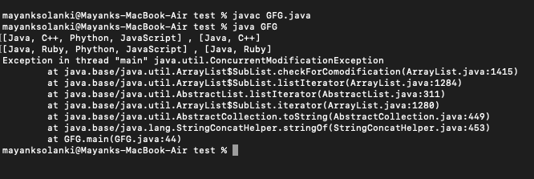
Why we cannot create a generic array in Java?
Java does not allow creation of array with generics as elements. In Java an array has to know the type information of its elements at runtime. This information is used at runtime to throw ArrayStoreException if data type of an element to be inserted does not match the type of Array. In case of Generics, the type information of a collection is erased at runtime by Type Erasure. Due to this array cannot use generics as elements
Can you explain how HashMap works in Java?
In Java, a HashMap works on the concept of hashing. A HashMap in Java stores both key and value objects, in a bucket. It is stored as an Entry object that implements Map.Entry interface. The key object used in a HashMap has to provide implementation for hashCode() and equals() methods. When put() method is used to store a key-value pair, the HashMap implementation calls hashCode() method on Key object to calculate a hash that is used to find a bucket where Entry object will be stored. When get() method is used to retrieve a value stored against a key object, we first calculate a hash of Key object. Then we use this hash to find the bucket in which that particular key is stored. Once Key object’s location is found, it may happen that more than one Key is stored in same location. So now we use equals() method to find the exact Key object. Once the exact Key object is found we use it to get Value object.

import java.util.* ;
class HelloWorld {
public static int sumOfTwo(int[] a)
{
int sum = 0;
int count = 0 ;
for(int i=0 ; i <a.length ; i++ )
{
if(count != 2)
{
if(a[i]<0)
{
sum = sum + a[i];
count ++ ;
}
}
}
return sum ;
}
public static void main(String[] args) {

//int n1 = sc.nextInt();
int n1 = 10;
int n2 = 9 ;
int n3 = 6 ;
int n4 = 1;
int[] a = new int[4];
a[0] = n1 ;
a[1] = n2 ;
a[2] = n3 ;
a[3] = n4 ;

System.out.println("Sum of negative numbers : "+sumOfTwo(a));
}
}
Can we mark a constructor as synchronized in Java?
No. We cannot mark a constructor as synchronized. This will lead to compiler error. The reasoning behind this is that, in this case, only the constructing thread would have access to the object being constructed.
What is the data type of a Lambda expression?
A Lambda expression fulfills the purpose of passing code as data. The data type of a Lambda expression is a Functional interface. In most of the cases this is java.lang.Runnable interface.

Volatile Keyword in Java
Volatile keyword is used to modify the value of a variable by different threads. It is also used to make classes thread safe. It means that multiple threads can use a method and instance of the classes at the same time without any problem. The volatile keyword can be used either with primitive type or objects.
The volatile keyword does not cache the value of the variable and always read the variable from the main memory. The volatile keyword cannot be used with classes or methods. However, it is used with variables. It also guarantees visibility and ordering. It prevents the compiler from the reordering of code.
The contents of the particular device register could change at any time, so you need the volatile keyword to ensure that such accesses are not optimized away by the compiler.

Example

- class Test
- {
- static int var=5;
- }
In the above example, assume that two threads are working on the same class. Both threads run on different processors where each thread has its local copy of var. If any thread modifies its value, the change will not reflect in the original one in the main memory. It leads to data inconsistency because the other thread is not aware of the modified value.
47.2M
802
History of Java

- class Test
- {
- static volatile int var =5;
- }
In the above example, static variables are class members that are shared among all objects. There is only one copy in the main memory. The value of a volatile variable will never be stored in the cache. All read and write will be done from and to the main memory.

When to use it?
- You can use a volatile variable if you want to read and write long and double variable automatically.
- It can be used as an alternative way of achieving synchronization in Java.
- All reader threads will see the updated value of the volatile variable after completing the write operation. If you are not using the volatile keyword, different reader thread may see different values.
- It is used to inform the compiler that multiple threads will access a particular statement. It prevents the compiler from doing any reordering or any optimization.
- If you do not use volatile variable compiler can reorder the code, free to write in cache value of volatile variable instead of reading from the main memory.

Important points
- You can use the volatile keyword with variables. Using volatile keyword with classes and methods is illegal.
- It guarantees that value of the volatile variable will always be read from the main memory, not from the local thread cache.
- If you declared variable as volatile, Read and Writes are atomic
- It reduces the risk of memory consistency error.
- Any write to volatile variable in Java establishes a happen before the relationship with successive reads of that same variable.
- The volatile variables are always visible to other threads.
- The volatile variable that is an object reference may be null.
- When a variable is not shared between multiple threads, you do not need to use the volatile keyword with that variable.

Difference between synchronization and volatile keyword
Volatile keyword is not a substitute of synchronized keyword, but it can be used as an alternative in certain cases. There are the following differences are as follows:
Volatile Keyword | Synchronization Keyword
Volatile keyword is a field modifier. | Synchronized keyword modifies code blocks and methods.
The thread cannot be blocked for waiting in case of volatile. | Threads can be blocked for waiting in case of synchronized.
It improves thread performance. | Synchronized methods degrade the thread performance.
It synchronizes the value of one variable at a time between thread memory and main memory. | It synchronizes the value of all variables between thread memory and main memory.
Volatile fields are not subject to compiler optimization. | Synchronize is subject to compiler optimization.

Example of Volatile Keyword
In the following example, we have defined a class which increases the counter value. The run () method in the VolatileThread.java gets the updated value and old value when the thread begins execution. In the main class, we define the array of thread.
VolatileData.java

- public class VolatileData
- {
- private volatile int counter = 0;
- public int getCounter()
- {
- return counter;
- }
- public void increaseCounter()
- {
- ++counter; //increases the value of counter by 1
- }
- }
VolatileThread.java

- VolatileThread.java
- public class VolatileThread extends Thread
- {
- private final VolatileData data;
- public VolatileThread(VolatileData data)
- {
- this.data = data;
- }
- @Override
- public void run()
- {
- int oldValue = data.getCounter();
- System.out.println("[Thread " + Thread.currentThread().getId() + "]: Old value = " + oldValue);
- data.increaseCounter();
- int newValue = data.getCounter();
- System.out.println("[Thread " + Thread.currentThread().getId() + "]: New value = " + newValue);
- }
- }
VolatileMain.java

- public class VolatileMain
- {

- private final static int noOfThreads = 2;
- public static void main(String[] args) throws InterruptedException
- {
- VolatileData volatileData = new VolatileData(); //object of VolatileData class
- Thread[] threads = new Thread[noOfThreads]; //creating Thread array
- for(int i = 0; i < noOfThreads; ++i)
- threads[i] = new VolatileThread(volatileData);
- for(int i = 0; i < noOfThreads; ++i)
- threads[i].start(); //starts all reader threads
- for(int i = 0; i < noOfThreads; ++i)
- threads[i].join(); //wait for all threads
- }
- }
Output:
[Thread 9]: Old value = 0
[Thread 9]: New value = 1
[Thread 10]: Old value = 1
[Thread 10]: New value = 2

PATH | CLASSPATH
PATH is an environment variable. | CLASSPATH is also an environment variable.
It is used by the operating system to find the executable files (.exe). | It is used by Application ClassLoader to locate the .class file.
You are required to include the directory which contains .exe files. | You are required to include all the directories which contain .class and JAR files.
PATH environment variable once set, cannot be overridden. | The CLASSPATH environment variable can be overridden by using the command line option -cp or -CLASSPATH to both javac and java command.

How to Set CLASSPATH in Windows Using Command Prompt
Type the following command in your Command Prompt and press enter.
- set CLASSPATH=%CLASSPATH%;C:\Program Files\Java\jre1.8\rt.jar;
In the above command, The set is an internal DOS command that allows the

  - what does JDK contain?
Java Development Kit (JDK) is a software development environment used for developing Java applications and applets. It includes the Java Runtime Environment (JRE), an interpreter/loader (Java), a compiler (javac), an archiver (jar), a documentation generator (Javadoc), and other tools needed in Java development.
Now we need an environment to make a run of our program. Henceforth, JRE stands for “Java Runtime Environment” and may also be written as “Java RTE.” The Java Runtime Environment provides the minimum requirements for executing a Java application; it consists of the Java Virtual Machine (JVM), core classes, and supporting files.
Now let us discuss JVM, which stands out for java virtual machines. It is as follows:
- A specification where the working of Java Virtual Machine is specified. But implementation provider is independent to choose the algorithm. Its implementation has been provided by Sun and other companies.
- An implementation is a computer program that meets the requirements of the JVM specification.
- Runtime Instance Whenever you write a java command on the command prompt to run the java class, an instance of JVM is created.
Before proceeding to the differences between JDK, JRE, and JVM, let us discuss them in brief first and interrelate them with the image below proposed.
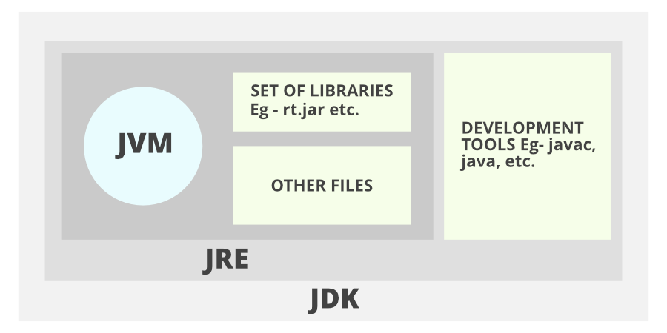
Don’t get confused as we are going to discuss all of them one by one.
1. JDK (Java Development Kit) is a Kit that provides the environment to develop and execute(run) the Java program. JDK is a kit(or package) that includes two things
- Development Tools(to provide an environment to develop your java programs)
- JRE (to execute your java program).
2. JRE (Java Runtime Environment) is an installation package that provides an environment to only run(not develop) the java program(or application)onto your machine. JRE is only used by those who only want to run Java programs that are end-users of your system.
3. JVM (Java Virtual Machine) is a very important part of both JDK and JRE because it is contained or inbuilt in both. Whatever Java program you run using JRE or JDK goes into JVM and JVM is responsible for executing the java program line by line, hence it is also known as an interpreter.
Now let us discuss the components of JRE in order to understand its importance of it and perceive how it actually works. For this let us discuss components.
The components of JRE are as follows:
- Deployment technologies, including deployment, Java Web Start, and Java Plug-in.
- User interface toolkits, including Abstract Window Toolkit (AWT), Swing, Java 2D, Accessibility, Image I/O, Print Service, Sound, drag, and drop (DnD), and input methods.
- Integration libraries, including Interface Definition Language (IDL), Java Database Connectivity (JDBC), Java Naming and Directory Interface (JNDI), Remote Method Invocation (RMI), Remote Method Invocation Over Internet Inter-Orb Protocol (RMI-IIOP), and scripting.
- Other base libraries, including international support, input/output (I/O), extension mechanism, Beans, Java Management Extensions (JMX), Java Native Interface (JNI), Math, Networking, Override Mechanism, Security, Serialization, and Java for XML Processing (XML JAXP).
- Lang and util base libraries, including lang and util, management, versioning, zip, instrument, reflection, Collections, Concurrency Utilities, Java Archive (JAR), Logging, Preferences API, Ref Objects, and Regular Expressions.
- Java Virtual Machine (JVM), including Java HotSpot Client and Server Virtual Machines.
After having an adequate understanding of the components, now let us discuss the working of JDK. In order to understand how JDK works, let us consider an illustration below as follows:
Illustration:
Consider a java source file saved as ‘Example.java’. The file is compiled into a set of Byte Code that is stored in a “.class” file. Here it will be “Example.class“.
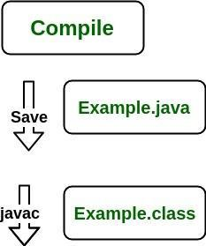
Note: From above, media operation computing during the compile time can be interpreted.
The following actions occur at runtime as listed below:
- Class Loader
- Byte Code Verifier
- Interpreter
  - Execute the Byte Code
  - Make appropriate calls to the underlying hardware
Now let us discuss in brief how JVM works out. It is as follows:
JVM becomes an instance of JRE at the runtime of a Java program. It is widely known as a runtime interpreter.JVM largely helps in the abstraction of inner implementation from the programmers who make use of libraries for their programs from JDK.
It is mainly responsible for three activities.
- Loading
- Linking
- Initialization
Similarly, now let us discuss the working of JRE which is as follows:
- JVM(Java Virtual Machine) acts as a run-time engine to run Java applications. JVM is the one that actually calls the main method present in a java code. JVM is a part of JRE(Java Runtime Environment).
- Java applications are called WORA (Write Once Run Anywhere). This means a programmer can develop Java code on one system and can expect it to run on any other Java-enabled system without any adjustments. This is all possible because of JVM.
- When we compile a .java file, .class files(contains byte-code) with the same class names present in .java file are generated by the Java compiler. This .class file goes into various steps when we run it. These steps together describe the whole JVM.

what does jar file contain?

what are the things developer needs to share with client?

explain "System.out.println"

what happens when u create an object.

what is constructor? types. what is special about default constructor?

what is "this" and what is its importance?

what is static block? Where have u seen an application of static block inside JDK?

what is binding? how many types of bindings are there?
Binding is a mechanism creating link between method call and method actual implementation. As per the polymorphism concept in Java , object can have many different forms. Object forms can be resolved at compile time and run time. If linking between method call and method implementation is resolved at compile time then we call it static binding or If it is resolved at run time then it dynamic binding. Dynamic binding uses object to resolve binding but static binding use type of the class and fields.
Sr. No. | Key | Static Binding | Dynamic Binding
1 | Basic | It is resolved at compile time | It is resolved at run time
2 | Resolve mechanism | static binding use type of the class and fields | Dynamic binding uses object to resolve binding
3 | Example | Overloading is an example of static binding | Method overriding is the example of Dynamic binding
4. | Type of Methods | private, final and static methods and variables uses static binding | Virtual methods use dynamic binding

what is upcasting? what is the purpose of upcasting?

how many types of inheritance are alld in java? describe them

when to use abstract class and when to use interface

what is downcasting? what is the need of downcasting?

what is ClassCastException? what is its solution ?

what are the scenarios in which we have early binding in java?

program to implementation vs interface explain with example.

how does co-variant return type works in java ?

checked vs unchecked exceptions

handle vs declare rule

what is finally block ? what is its use? what r the scenarios where finally block does not get executed?

what is ARM

access modifiers in java

boxing and unboxing. ltd only to compiler level

explain "extends Thread"

explain "implements Runnable"

what is synchronization

what happens when u use synchronization

what is class lock

what is Thread Safe class

What is ReEntrantLock? what are the pros and cons of using it.

wait vs sleep

rules for serialization

how does put work in HashMap

how does get work in HashMap

if you want to store object of any user defined class as a key inside TreeMap or as an element inside TreeSet, what care u will take?

how does set work internally

what is Fail-Fast and Fail-safe iterator

difference between Hashtable,HashMap and ConcurrentHashMap

what do u mean by Type-erasure? explain with the example.

how generics are type-safe

? extends FourWheeler vs ? super Car

List<?> vs List<Object>

what is Class-Wins Rule in Java8

some times synchronized collections are not sufficient why

Iterator itr=mylist.iterator()
how does it work?

how do u iterate on the map

