CHAPTER-1

INTRODUCTION
Traffic accidents remain a major public safety issue in India, causing thousands of deaths and injuries every year. Karnataka is a huge state with millions of people owning vehicles, which makes high chances of causing accidents and increases the death toll. The government and the police have the traffic records and draw conclusions from that. Hence, it is very important to have an advanced, data-driven, flexible, and easy-to-use system to control and understand the reason behind these accidents.
Recently, data analytics and machine learning have become important tools for addressing real-world issues like transportation, huge traffic, and traffic safety. These technologies are very important and help us find accident-prone areas and the severity of the accident based on the weather condition. These technologies help to build advanced systems that can look into specific problems and give solutions for that specific problem. In this system it is focusing on accident analysis. This system, Accident Hotspot Analysis, takes Karnataka accident data from 2021 to 2025 and analyzes it. This system helps improve road management and policy decisions and gives prevention measures by turning raw and noisy data into clear, interactive data. The main goal of this system is to create an interactive, flexible, and easy-to-use Karnataka Hotspot Analysis dashboard. This dashboard helps us analyze the 5 years of data and gives clear graphs for us to understand and analyze it. The dashboard uses both analytical and visual methods to display accident trends by location, severity, weather, and vehicle type. By presenting the results in a straightforward way, the project aims to help researchers, policymakers, and officials better understand accident patterns and promote safer practices.

Problem Statement
Although Karnataka possesses extensive records on road accidents, there is still no efficient system to convert this data into meaningful insights for decision-making. Most reports present the information only in tables or summary statistics, which makes it difficult for users to explore patterns or gain deeper understanding. Without proper analytical models and visual tools, recognizing high-risk locations, vulnerable vehicle groups, or the influence of factors like weather remains challenging. As a result, researchers and policy-makers struggle to design truly data-driven programs to improve road safety

1.2 Objectives of this Project

The project's primary objectives are as follows:
- Gather recent or real-time road accident data from public APIs, open datasets, or official sources, ensuring accuracy and coverage.
- Clean and structure the collected data in Python by addressing inconsistencies, filling gaps, and organizing it for advanced analysis.
- Explore the dataset to reveal accident hotspots and recurring trends based on time, severity, vehicle types, weather, and road categories.
- Build an interactive dashboard in Streamlit that lets users easily filter, view, and interpret accident data without needing coding skills.
- Produce summaries at both state and district levels to enable regional comparisons and pinpoint vulnerable groups or zones.
- Apply mapping tools such as Folium to visualize accident-prone regions, supporting awareness and better decision-making for safety initiatives.
- Lay the groundwork for future predictive models that could estimate accident likelihood and guide proactive prevention measures.to aid in the implementation of evidence-based strategies by the public, traffic authorities, and urban planners in order to reduce accident rates and improve road safety

1.3 Scope / Limitations

1.3.1 Scope of this Project

The goal of this project is to employ data-driven methodologies to analyze Karnataka traffic incidents from 2021 to 2025. Its scope consists of:
- Accident Trend Monitoring: Look at how accidents change over time, emphasizing times when they happen a lot.
- Geographic Hotspot Identification: Use maps and clustering techniques to identify high-risk roads, highways, and accident-prone locations.
- Severity Analysis: Divide accidents into mild, moderate, severe, and fatal cases in order to ascertain the impact of different risk factors.
- Vehicle Type-Based Analysis: Identify the types of vehicles that are most likely to be engaged in collisions in specific areas, such as cars, trucks, buses, two-wheelers, etc.
- Weather and Environmental Impact: Analyze the effects of rain, fog, or clear weather on accident frequency and severity.
- Road Type and Infrastructure Analysis: To illustrate the influence of infrastructure, look at accident trends on city, rural, and highway routes.
- Time-Based Views Identify the riskiest times to drive, such as rush hour, after dark, or on holidays.
- Interactive Dashboard: Provide an easy-to-use web application for real-time accident data exploration, visualization, and filtering.
- Downloadable Insights: Give interested parties, like traffic police, researchers, and lawmakers, CSV files and PDF summary reports for offline analysis.
- Policy and Safety Recommendations: Provide evidence-based recommendations for remedies such more road lighting, more police presence in high-crime zones, or public awareness initiatives.
- Adaptability for Growth The project can be extended to other states or the entire nation if relevant datasets are available.
- Support from stakeholders aids in the educated safety decision-making of government organizations, researchers, traffic officers, and urban planners.
- Public Awareness: By visually representing risk zones and accident patterns.

1.3.2 Limitations the Project
While the system is useful and practical, it also has some limitations:
- Data Dependency: The accuracy of insights is greatly influenced on the completeness and quality of accident data. Missing or inaccurate entries (such location or weather) could affect the results.
- Real-time Updates: The system currently makes use of collected datasets. Live feeds and IoT-based traffic sensors are not integrated in real-time.
- Geographic Focus: The system's development is solely focused on Karnataka. Applying it to other regions would require gathering and preprocessing similar datasets.
- Simplified Assumptions: Some factors are not included in the dataset and are therefore not investigated, such as driver behavior, vehicle condition, and emergency response times.
- Simplified Assumptions: Some factors are not included in the dataset and are therefore not investigated, such as driver behavior, vehicle condition, and emergency response times.
- Performance Restrictions: Sampling is required to maintain dashboard responsiveness for very large datasets, which may slightly reduce visual detail.

CHAPTER-2

LITERATURE SURVEY/ REVIEW

2.1 Summary of Existing Research and Solutions

In order to determine the causes and severity aspects of accidents, previous road safety research has mostly relied on statistical methods including regression models, frequency distributions, and correlation analysis. According to these research , factors including the type of vehicle, driver conduct, road design, and weather have a big impact on how accidents turn out. More recently, more sophisticated predictions of accident hotspots and severity levels have been made possible by the application of machine learning techniques (decision trees, random forests, and clustering models). High-risk areas have also been visualized using geospatial mapping tools like GIS and Folium, which have made the information easier for politicians and urban planners to understand. While some research institutes and traffic agencies throughout the world have created dashboards and monitoring systems, many are still only able to perform descriptive analysis without interactively.

2.2 Comparative Analysis of Different Approaches

- Traditional Statistical Models: These methods are effective in identifying certain relationships (e.g., the relationship between weather and accident severity). However, they struggle with large datasets and non-linear interactions.

- Machine learning approaches demand clean, structured data and may be hard for non-technical users to understand, even while methods like decision trees and clustering techniques provide more accurate and scalable insights.

- GIS-Based Mapping: Geospatial solutions often function independently without being connected into bigger analytics dashboards, despite being useful for displaying accident densities and hotspots.

- Interactive Dashboards: Although some recent projects have switched to real-time monitoring platforms, most still lack region-specific customization and are inaccessible to local traffic authorities who require focused, practical solutions.

2.3 Identified Research Gap

- Interactive data exploration is not available in the static reports produced by many previous studies.
- The majority of research is based on national statistics, paying little attention to trends that are specific to a state or city, as those in Karnataka.
- Techniques for geographic visualization, machine learning, and statistical analysis are commonly applied independently rather than in a coherent, integrated framework.
- Current technologies rarely translate research findings into recommendations that the public, lawmakers, or traffic authorities can implement.
- The usability of systems for non-technical people is limited because few are designed to be both scalable and user-friendly.

CHAPTER-3

SYSTEM ANALYSIS

The Karnataka Road Safety and Accident Analytics system is intended to provide a comprehensive, interactive, and actionable platform for traffic authorities, policymakers, and researchers to analyze traffic accidents and make informed decisions.

3.1 Requirement Analysis

Data Acquisition: Gather recent accident reports from government portals, open databases, and APIs.

Data preprocessing involves cleaning, transforming, and structuring raw data to address missing values, inconsistencies, and categorization mappings.

Visualization and analytics: Create trend analysis for accidents by year, severity, vehicle type, road type, and weather variables.

Geospatial analysis involves mapping accident hotspots with markers, clusters, and heatmaps to identify high-risk locations.

Interactive Dashboard: Users should be able to filter data by year, city, road type, weather, severity, and vehicle type to receive insights tailored to their needs.
- Reporting: Generate reports in CSV and PDF formats that include summaries, charts, and recommendations.
- User management: Basic login and access control are necessary to ensure authorized use.

3.2 Dataset description
The system uses Karnataka road accident data from 2021 to 2025 to provide a comprehensive overview of traffic incidents across districts, cities, roadways, and rural areas. This dataset serves as the core for the analytics platform, enabling for in-depth research of accident trends, severity,
and contributory causes.

3.2.1 Source
- The information was gathered from a number of trustworthy sources, including:
- State and federal traffic agencies' open government datasets.
- true and accurate official records from the Karnataka Traffic Department.
- Additional real-time or nearly real-time accident data can be found through public APIs and accident reporting platforms.

3.2.2 Size and Coverage

- Tens of thousands of accident records are included in the collection, which covers:
- Karnataka's various rural and urban areas.
- junctions, rural roads, highways, and arterial routes.
- a range of car models, environmental factors, and accident levels.

3.2.3 Key Features
The dataset has multiple attributes for every record:
- Accident ID: A special number given to every accident for convenient access.
- Date & Time: Enables temporal analysis by capturing the precise day, time, and hour of the accident.
- Location: Latitude, longitude, city, and district data to facilitate accurate geographic mapping.
- Details of the accident: Indicators for fatal accidents, severity levels, and the number of casualties.
- Environmental factors include the type of road (intersection, freeway, rural, etc.) and the weather at the time of the accident.
- Vehicle Details: The kind of vehicle or vehicles—cars, trucks, buses, or two-wheelers—involved.

3.2.4 Preprocessing Requirements
Before the dataset can be analyzed and shown, it must undergo several preparation steps:
- Managing missing values: Ensuring proper handling of records that contain null or erroneous information, such as location, weather, or vehicle type.
- Data type conversion is the process of transforming times and dates into the appropriate formats for temporal trend analysis.
- Converting numerical severity codes into descriptive phrases such as Minor, Moderate, Severe, and Fatal is known as categorical mapping.
- The practice of ensuring consistency among category variables, like road type, weather, and vehicle type, is known as standardization.
- Visualization sampling: For very large datasets, representative samples are selected in order to maintain visualization performance while maintaining crucial information.

3.2.5 Significance of the Dataset
This dataset's quantity of multidimensional data allows us to:
- identifying accident hotspots in urban and rural regions.
- analysis of accident severity based on vehicle type, weather, and road conditions.
- Use temporal trend analysis to look at trends spanning months, seasons, or years.
- production of recommendations and helpful data for decision-makers and traffic officers.

3.3 Problem Formulation
The goal of this project is to transform raw data on traffic accidents into intelligible, practical insights that would improve road safety in Karnataka. By looking for trends in the data, the system aims to help researchers, policymakers, and traffic cops make informed decisions.

3.3.1 Given:
Each entry in the dataset D = {d₁, d₂, …, dₙ} has the following information:
- The city, district, latitude, and longitude of the accident
- The time and date of the incident
- The accident's severity
- Type of vehicle involved
- Type and state of the road
- Conditions at the time of the mishap
- The quantity of casualties and the status of deaths

3.3.2 Goals:
The main goal of this project is to transform raw and unorganized road accident data into meaningful, actionable insights that can directly support decision-making for traffic safety and management.

- Determine High-Risk Areas (H):
Identify accident-prone zones across Karnataka using clustering and geospatial mapping techniques. These “hotspots” can help authorities prioritize areas for increased surveillance, improved road design, or awareness campaigns.
- Examine Trends (T):
Study accident patterns across various dimensions — such as time (year, month, day, hour), location (districts, highways, rural/urban areas), and context (vehicle type, road category, weather conditions). Understanding these recurring trends can help reveal when and where accidents are most likely to occur.
- Provide Actionable Recommendations (R):
Based on identified trends and hotspots, propose practical strategies for improving road safety — such as installing warning systems, improving lighting in risky zones, or targeting educational campaigns for vulnerable driver groups. These insights aim to support data-informed policymaking and evidence-based planning.

3.3.3Method:
The project follows a systematic approach to ensure that the analysis is accurate, comprehensive, and easy to interpret.
- • Data Collection and Cleaning:
Accident data is gathered from open sources, government APIs, and public databases. The dataset is cleaned by handling missing values, removing duplicates, and ensuring all date, time, and categorical values follow a uniform format.
- • Exploratory Analysis:
The cleaned data is explored through visual and statistical analysis to uncover hidden relationships. Patterns are examined across time (day/night, weekday/weekend), location, vehicle type, and environmental conditions to identify significant risk factors.
- • Visualization and Mapping:
Using libraries like Matplotlib, Seaborn, and Folium, the project generates interactive charts and heatmaps that highlight accident-prone areas. The visual representation makes complex data understandable even for non-technical users.
- • Insight Generation and Recommendations:
Based on observed patterns, meaningful insights are drawn. These include which cities experience frequent accidents, what weather conditions increase risk, and which types of vehicles are most vulnerable. Actionable recommendations are then developed to guide future road safety measures.
- • Output and Reporting:
The final outcome is a Streamlit-based interactive dashboard that allows users to visualize accident data dynamically. Users can apply filters for city, year, weather, or severity and download PDF or CSV reports generated automatically using ReportLab.

CHAPTER-4
METHODOLOGY

The approach used for this project is a structured pipeline that starts with gathering unprocessed accident data and concludes with creating an intuitive, interactive display. Every stage aims to ensure that the data is accurate, the insights are meaningful, and the final output is reliable enough to aid in real decision-making.

4.1 Data Preprocessing
The initial step was to make the raw dataset clean, consistent, and usable. Duplicate records, missing information, or unusual formats are common features of accident data. Preprocessing ensures that the information more accurately reflects reality.
- Handling Missing Data: Gaps in accident records are common, and include things like missing location information and unknown meteorological conditions. Rows that were missing information were either removed or replaced with logical theories (for instance, inserting "Clear" for missing weather if data indicated dry season).
- Removing Duplicates: Accident reports may occasionally be logged more than once by different authorities. Duplicate entries were discovered and eliminated.
- Data Normalization: Severity codes, dates, and timings were all standardized. For example, times were separated into morning, afternoon, evening, and night to better illustrate accident trends.
- Feature Engineering: New and useful features, such "urban vs. rural" zones or "weekday vs. weekend" incidences, were produced through feature engineering. These attributes allowed for deeper insights.
- Coding Categorical Data: Since machine learning algorithms depend on numbers, non-numeric data—like the types of roads or vehicles—were transformed into numerical values without losing their significance.
Raw records were transformed into a dataset in this step so that it could be examined and analyzed.

4.2 Exploratory Data Analysis (EDA)
Prior to a detailed analysis, the dataset needed to be cleaned and processed. Exploratory data analysis (EDA), the detective work of data science, allows us to see past the numbers and uncover fascinating stories. Instead than just having you look at tables full of statistics, EDA turns data into easily understood patterns, trends, and visualizations.
4.2.1 Graphical Analysis
First, straightforward yet effective visualizations were made, including line plots, bar charts, and histograms.
- Histograms: It displayed the distribution of accident severity across time, showing if incidents were rising, falling, or remaining constant.
- Bar charts: They were particularly helpful when comparing groups, such as the types of cars that were involved in crashes the most frequently. For example, it became clear that two-wheelers were involved in a sizable portion of all occurrences, underscoring their vulnerability.
- Line plots: Finding monthly or seasonal trends in accidents was made easier with the use of line graphs. For instance, some months often saw a rise in accidents, which could be connected to events like festivals, wet seasons, or periods of heavy traffic.
At this point, the distribution of incidents by category, time, and location was first made evident.

4.2.2 Correlation Study
To find out if there were any meaningful connections between the different variables, correlations were looked at because statistics don't always describe how variables interact.
- Heatmaps: They provided a quick way to look at correlations, including whether accidents increased during bad weather or at specific times of the day.
- Correlation matrices: which showed the extent to which one factor (such vehicle type or road type) influenced another (like severity), offered more precise figures.
- Example: As an illustration of how poor vision and slick roads increase dangers, it was discovered that adverse weather conditions (such rain or fog) were associated with the severity of accidents.
Selecting which features should be kept for upcoming modeling was made simpler as a result.

4.2.3 Geospatial Analysis
Accidents happen at specific areas, thus location-based analysis was crucial. Using latitude and longitude information, the recordings were plotted on interactive maps using Folium and Plotly.
- These maps made it simple to identify hotspots, or areas where incidents occurred frequently.
- Hotspots for accidents, like crowded city crossroads or busy highway intersections, were visually represented using heatmaps and cluster markers.
- For example, highways and arterial routes appeared to have a higher concentration of serious accidents than smaller city roads.
Authorities benefit from this kind of mapping since it transforms raw coordinates into distinct pictures that draw attention to high-risk locations.

4.2.4 Generation of Insight
After analysis and visualization, several noteworthy patterns and insights surfaced:
- Highways and arterial roads were significantly more likely to be involved in accidents than smaller routes due to their greater speeds.
- Nighttime collisions were more frequent and often more severe; they were likely caused by fatigue, poor lighting, or drunk driving.
- The regular results showing two-wheelers are more deadly underscore the need for stricter safety standards for motorcycle riders.
- Seasonal statistics show that accidents tended to increase during the rainy season, a sign of the dangers posed by wet roads and low visibility.
These findings went beyond simple statistics; they shed light on the ways that environmental factors, human behavior, and infrastructural issues impact traffic safety.

4.2.5 Role of EDA in the Project
EDA was more than just an initial step; it was the foundation of the project. It made the dataset more understandable, revealed hidden trends, and had an impact on the dashboard design and modeling process. The following is an explanation of its function:
- Highlighting Crucial Elements: EDA helped identify the dataset characteristics that had the biggest influence on accidents. Variables like vehicle type, weather, time of day, and route classification frequently showed strong patterns. These insights made it clear which aspects should be prioritized for additional research.
- Defining Data Transformations: Visualization made it evident that raw numbers needed to be categorized or altered in order to enhance understanding. Time was separated into day, evening, and night rather than exact timestamps to facilitate the understanding of patterns. Similarly, severity codes were mapped using descriptive categories like mild, moderate, severe, and lethal.
- Impacting Dashboard Design: The dashboard's design was directly influenced by the patterns discovered during EDA. For example, since these factors were found to be significant, filters were added for vehicle type and road type. Similarly, EDA clearly demonstrated the importance of temporal and spatial trends, which led to the selection of time-series charts and hotspot maps.
- Guiding Machine Learning Models: By looking at correlations and variable relevance, EDA suggested which traits to use in predictive modeling. The models may have contained irrelevant variables if this step hadn't been done, which would have reduced their accuracy.
- Ensuring Practical Relevance: Rather than being just a technical exercise, EDA ensured that the system was actually data-driven and relevant for stakeholders. Researchers, policymakers, and traffic officials would have access to a dashboard that reflected the actual trends found during EDA.
The project's compass was EDA. It clarified the most crucial components, suggested the direction the inquiry should go, and ensured that the dashboard and machine learning models were based on factual findings rather than speculation. In a nutshell, it was the procedure that transformed raw accident reports into insightful information.

4.3 Model Selection
Following data exploration and cleansing, selecting suitable analytical models that may help achieve the project's goals was a crucial next step. Because our objectives involved both finding accident hotspots and projecting accident severity, the task required a combination of classification and clustering methods. The chosen models were carefully evaluated for accuracy, interpretability, and practical utility so that the outcomes may be useful to real-world stakeholders such as policymakers and traffic authorities.
4.3.1 Clustering Models (Hotspot Detection)
- K-Means Clustering: Using geographic coordinates (latitude and longitude), this model was used to cluster accident-prone locations. Its scalability and efficiency, which enable it to process thousands of accident records rapidly, are its main advantages. K-Means, for instance, was successful in dividing rural areas, highways, and metropolitan centers into significant risk clusters.
- DBSCAN: Density-Based Spatial Clustering of Applications with Noise, or DBSCAN, does not require a predetermined number of clusters, in contrast to K-Means. Rather, it automatically detects accident-heavy areas and marks isolated spots as noise. This was particularly helpful in identifying atypical hotspots, including highway segments that frequently have accidents or intersections where accidents occur occasionally but are nevertheless important.
4.3.2 Classification Models (Severity Prediction)
- Logistic Regression: The baseline model was chosen to be logistic regression due to its interpretability and simplicity of usage. It made it easy to understand the probability that an accident would be classified as mild, moderate, or severe. Policymakers value this type of transparency because it offers a concise justification for a forecast.
- Decision Trees: Decision trees provided clear recommendations that illustrated which factors, including vehicle type, weather, and road type, had the most influence on accident severity. For instance, a tree might say, "If the road type is a highway and the weather is rainy, then the likelihood of a severe accident is higher."
- Random Forests: To improve prediction performance, random forests were employed. This model averages the output of multiple decision trees to improve accuracy and reduce overfitting. The severity estimates were more accurate, but we were still able to determine the features' relevance. For instance, it showed that utilizing a two-wheeler or driving at night were important risk factors.
4.3.3 Justification for Model Choices
The selected models provide a balance between technical strength and interpretability. While neural networks and other advanced machine learning techniques may have been used, they are often "black boxes," which makes it difficult for non-technical stakeholders to understand them. Instead, the chosen models produce the following results:
- Enough precision to produce reliable projections
- Decision-makers can understand it easily.
- Adaptable to hotspot detection and severity classification
In other words, rather than just optimizing metrics like accuracy or recall, the models were selected to ensure that the insights could be instantly turned into safety measures, policy decisions, and useful recommendations.

4.4 Model Training & Hyperparameter Tuning
In order for the models to detect important patterns and generate accurate predictions, it was essential to train them effectively on the dataset after they were selected. In contrast to just memorizing the data, the process was carefully crafted to ensure that the models learned general rules that could be applied to new, untested scenarios.
    - Train-Test Split
The dataset was divided into two sections:
- Training Set: To "teach" the model, it is given examples of past accidents along with their characteristics.
- Testing Set: Used to assess how well the model performs on data that hasn't been seen before.
This distinction was crucial because it emulated real-world scenarios when a model needs to make predictions on newly reported accidents.

    - Cross-Validation
To further improve reliability, cross-validation was employed. Several smaller folds were created from the dataset, and the model was trained and assessed more than once. By doing this, consistent evaluation results were ensured and the likelihood of the model overfitting—performing well on training data but badly on real-world data—was decreased.

    - Hyperparameter Tuning
The behavior of each model is controlled by a set of parameters. For instance:
- The number of clusters in K-Means dictates the number of accident-prone areas that are found.
- The maximum depth in decision trees determines how intricate and comprehensive the tree gets.
- Accuracy and stability in Random Forests are influenced by the number of trees.
- In other models, the rate at which the model adapts to input patterns is determined by parameters such as learning rate.
These values weren't set at random; rather, the optimal settings were found using strategies like Random Search (testing random but varied combinations) and Grid Search (systematically trying every conceivable combination).

The outcome :-
The accuracy, stability, and generalizability of the models were enhanced by adjusting these hyperparameters. This step ensured that not only were the predictions and clustering results correct for the training data, they also worked well on fresh accident reports.

  - Evaluation Metrics
After training and fine-tuning the models, it was critical to assess their performance. A variety of assessment measures were used to guarantee a comprehensive and impartial understanding of the model's effectiveness. Each metric highlighted a different aspect of performance for datasets like accident records, where minor accidents vastly outnumber catastrophic or fatal ones.

1. Accuracy: Accuracy is defined as the model's proportion of correct forecasts among all forecasts. Despite providing a concise overview, accuracy alone may be misleading in unbalanced datasets, such as those where small accidents are far more frequent than catastrophic ones.
2. Precision: The quality of optimistic projections is the primary focus of precision. Precision, for example, measures how often the model's prediction of a serious or fatal accident was correct. The model's high precision results in fewer false alarms, which is critical for effectively directing preventive activities.
3. Sensitivity Recall: Recall measures the fraction of actual severe or fatal accidents that the model correctly identified. Planning for safety and allocating resources rely on great recall since it ensures that critical situations are not neglected.
4. F1 Score: The F1-Score is the harmonic mean of precision and recall, resulting in a single metric that balances both. This is especially useful in accident statistics, where minor incidents far outnumber serious ones. A high F1-score indicates that the model can accurately forecast major incidents while avoiding too many false positives.
5. Root Mean Squared Error (RMSE): RMSE is used for continuous forecasts, such as the number of accidents in a year or a certain city. Lower RMSE values indicate that expected counts are more similar to actual values, which is useful for planning traffic management and safety interventions.
6. Area Under the ROC Curve (AUC): The AUC measures the model's ability to distinguish across classes (for example, small versus catastrophic accidents). A higher AUC indicates that the classification model is more robust and has stronger discriminatory power.
7. The significance of employing many metrics: A single metric cannot accurately represent a model's performance, especially in real-world applications like accident prediction. We tested the models for correctness and dependability using accuracy, precision, recall, F1-score, RMSE, and AUC, providing actionable information to traffic authorities and policymakers.

  - Tools & Technologies Used
This project leveraged a combination of modern tools and libraries, chosen to ensure efficient data processing, insightful analysis, and interactive visualization:

- Python: was our main programming language because it is flexible, has many useful libraries, and works well for both data analysis and web applications.
- We used Pandas and NumPy to handle and transform data. These libraries helped us clean, filter, and work with large datasets, as well as perform the calculations needed for our analysis.
- Matplotlib and Seaborn helped us make charts and graphs like bar charts, histograms, line plots, and heatmaps. These visuals made it easier to spot patterns and trends in the accident data.
- Scikit-Learn: The primary library for building machine learning models. It was used for clustering (K-Means, DBSCAN) and classification (Logistic Regression, Decision Trees, Random Forests), including tasks like model training, cross-validation, and hyperparameter tuning.
- Folium & Plotly: Provided interactive maps and geospatial visualizations. Folium allowed plotting accident locations and hotspots, while Plotly enabled dynamic, zoomable charts for deeper exploration.
- Streamlit helped us quickly build an easy-to-use, interactive dashboard. Users like traffic authorities, policymakers, and researchers could filter data by city, road type, vehicle, or weather and see trends right away.
- ReportLab: Automated the generation of PDF reports containing executive summaries, charts, and key findings, making it easy to share insights with stakeholders.
- We also used Jupyter Notebooks for trying out ideas, VS Code for writing code, and Git and GitHub to manage versions and work together.

CHAPTER-5
SYSTEM DESIGN

5.1 System architecture diagram

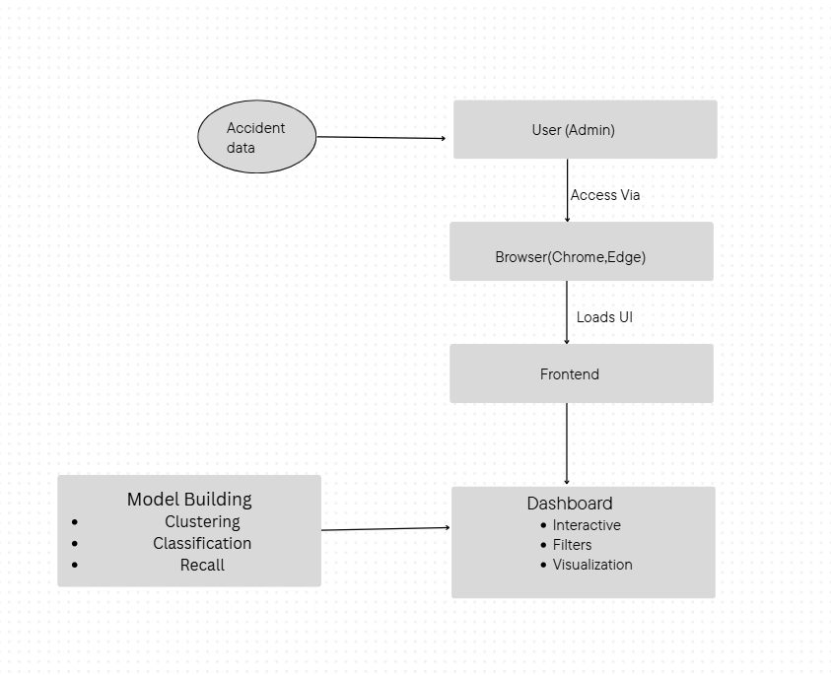

Figure 5.1.1

The architecture diagram of this project provides a clear picture of how different components of the accident dashboard interact with each other to create a complete accident analysis and prediction system. It acts like a way of showing the flow or working of data from its raw form to meaningful insights presented on the dashboard.
At the bottom of the architecture lies the data layer, where raw accident datasets are collected from multiple sources such as CSV files, government portals, and APIs. This raw data is often messy, so it flows into the data preprocessing layer, where cleaning, transformation, and feature engineering are performed to make it ready for analysis.
Next comes the analytical layer, where machine learning models are applied. Here, clustering algorithms (like K-Means and DBSCAN) detect accident hotspots, while classification models (such as Logistic Regression, Decision Trees, and Random Forests) predict the severity of accidents. Hyperparameter tuning and evaluation ensure these models are both accurate and reliable.
On top of this lies the visualization and interaction layer, which is powered by tools like Streamlit, Folium, and Plotly. This is where users can interact with maps, graphs, and filters, exploring accident data in an intuitive way. Policymakers, traffic authorities, or researchers can directly use the dashboard without needing technical expertise.
Finally, the reporting and output layer provides automated reports, charts, and data exports, ensuring findings can be shared easily with stakeholders.

5.2 UML Diagram

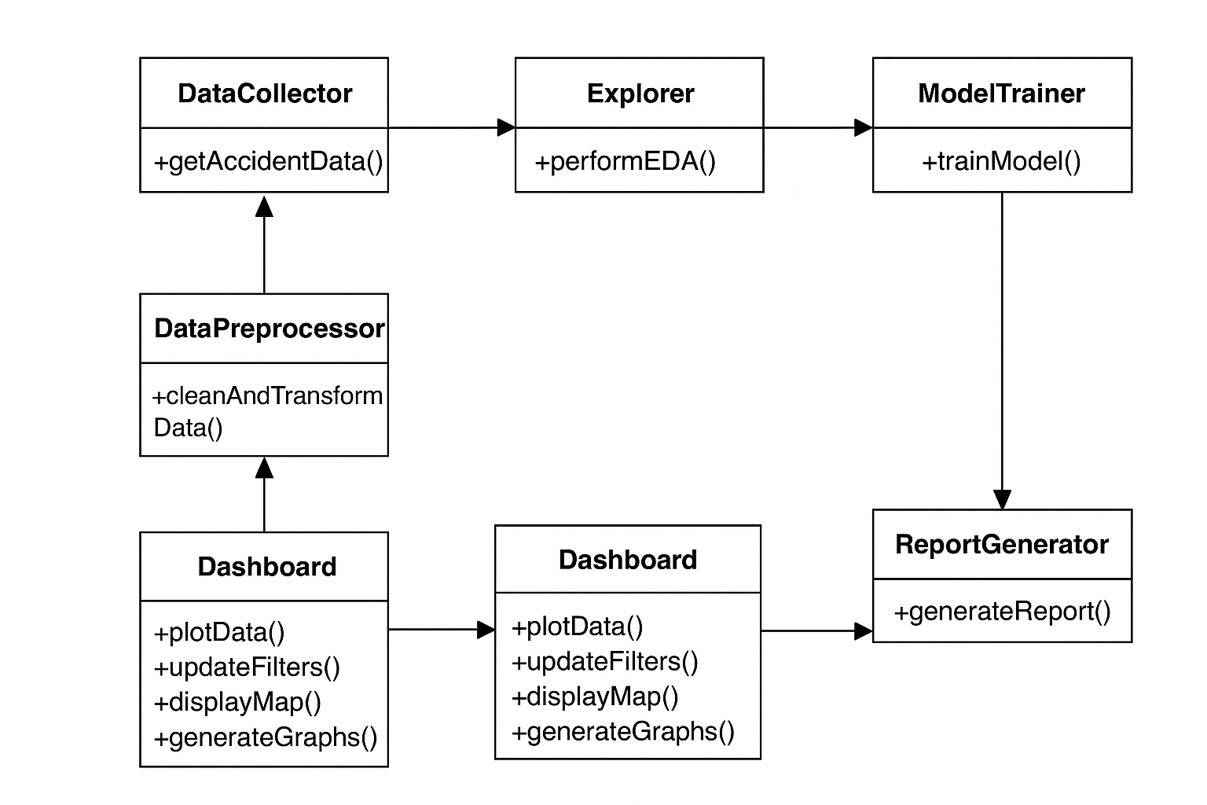
Figure 5.2.1

UML diagram in this project works like a map of the system’s inner workings, showing how the different parts connect and interact with each other. Instead of focusing on code, it presents the design in a visual, structured way so that both technical and non-technical people can understand the system flow.
In the context of this accident analysis project, the UML diagram highlights key components such as:
- Data Input Module – responsible for importing datasets from files or APIs.
- Preprocessing Module – handles cleaning, transformation, and feature engineering.
- Analysis & Modeling Module – where clustering and classification models are applied to identify hotspots and predict accident severity.
- Visualization Module – generates maps, charts, and dashboards for easy interpretation.
- Report Generation Module – automates the creation of PDF/CSV summaries for policymakers and researchers.
The diagram also shows the relationships between these modules, such as how cleaned data flows into the modeling stage, or how results from the analysis are passed into the dashboard for visualization.

5.3 Work-Flow Diagram

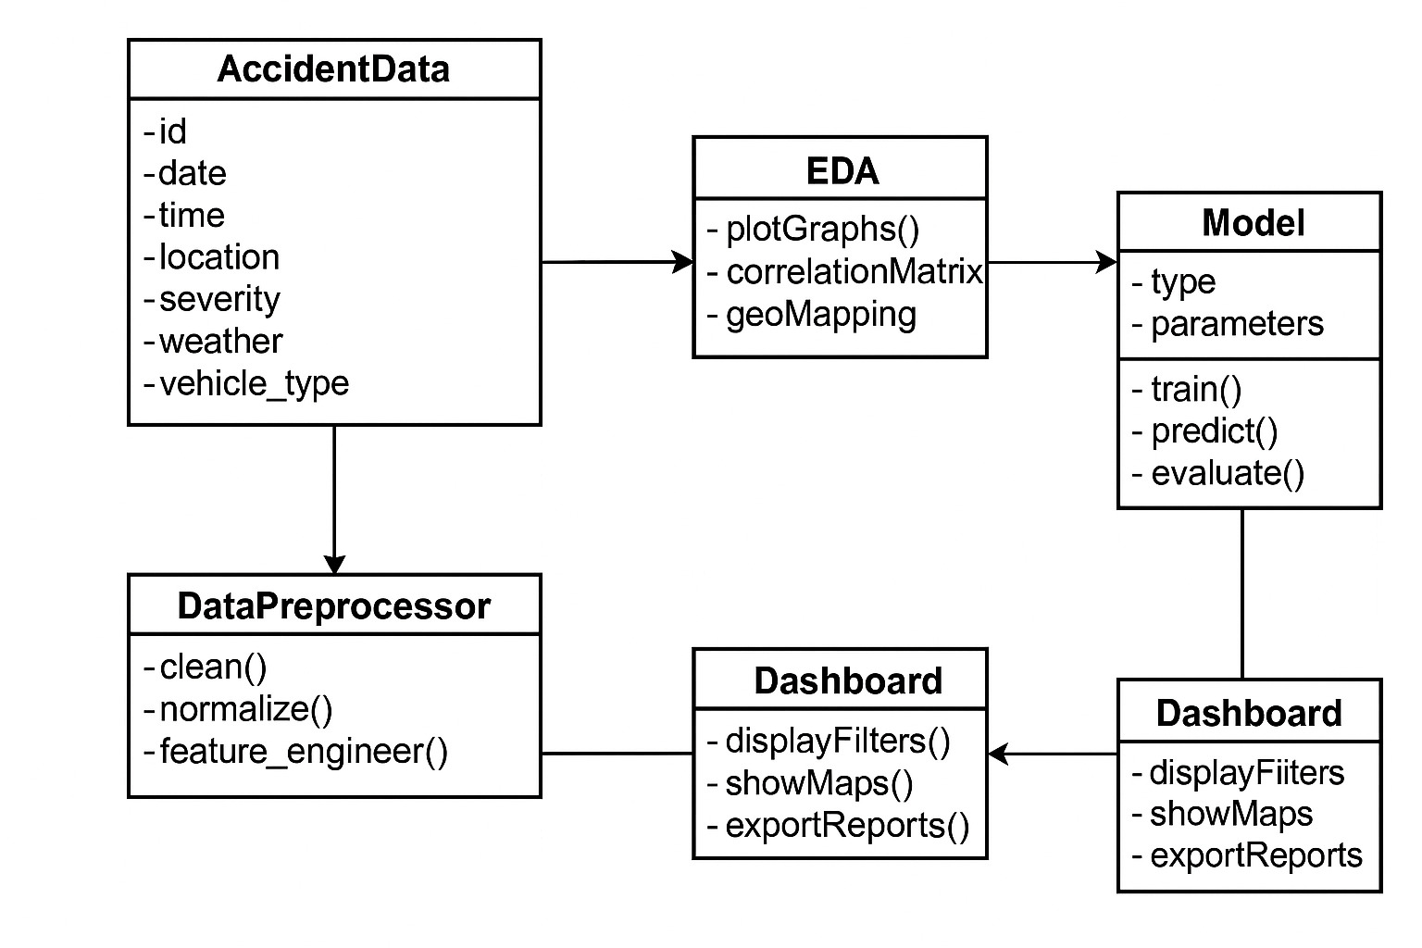
Figure 5.3.1
The workflow diagram illustrates the step-by-step journey of how accident data is transformed into actionable insights. The workflow highlights the sequence of activities and how one step naturally leads to the next.

- Data Collection: The process begins with gathering raw accident datasets from various sources such as government records, open databases, and CSV files. At this stage, the data is unstructured and often inconsistent.
- Data Preprocessing: Once collected, the data goes through cleaning and preparation. Missing values are handled, duplicates are removed, and categorical variables (like vehicle types or severity levels) are standardized. Time and location details are also formatted for easier analysis.
- Exploratory Data Analysis (EDA): In this stage, charts, heatmaps, and geospatial plots are generated to uncover hidden patterns. For example, visualizations reveal accident-prone highways, seasonal spikes, or high-risk vehicle categories. This stage acts as a “discovery phase,” helping shape later modeling steps.
- Model Building: Based on the insights, machine learning models are applied.
  - Clustering models (K-Means, DBSCAN) help identify accident hotspots.
  - Classification models (Logistic Regression, Decision Trees, Random Forests) predict severity.
These models are trained, validated, and optimized to perform well on unseen data.
- Model Evaluation: Metrics such as accuracy, precision, recall, F1-score, and AUC are used to check how well the models perform. This ensures that the system does not just work on training data but generalizes effectively to real-world cases.
- Dashboard Development: The workflow then moves toward creating a user-friendly interface. Using Streamlit and visualization libraries, an interactive dashboard is built where users can filter data by year, city, weather condition, or vehicle type and instantly see results in charts or maps.
- Report Generation: Automated reporting is included in the workflow. Policymakers or traffic officials can generate PDF summaries containing hotspot maps, severity statistics, and key recommendations without needing to manually analyze raw data.
- End-User Interaction:Finally, the workflow ends with the stakeholders—traffic authorities, policymakers, researchers, or the general public—who can use the dashboard and reports to make informed decisions, plan interventions, or run awareness campaigns.

CHAPTER-6
IMPLEMENTATION

The objective of this project was to build a comprehensive accident analysis pipeline that starts with untidy real-world data and finishes with an interactive dashboard that is easy and flexible to use that helps the admin to understand the analysis. To guarantee correctness, maintainability, and usability for both technical and non-technical stakeholders, each stage was meticulously completed in an organized manner.

6.1 Steps of coding/implementation
The coding and development process was broken down into logical phases, where each phase built upon the previous one. This modular approach ensured that changes could be easily managed without disturbing the overall workflow.
6.1.1 Data Import and Exploration
- The accident dataset was imported using Pandas, which provided a robust way to handle large CSV files efficiently.
- An initial round of data exploration was performed, which included checking the number of records, available attributes, data types, and missing values.
- This stage helped in identifying data quality issues such as incomplete records, inconsistent formats, and redundant entries.
6.1.2 Preprocessing Data
- Every missing value was either addressed using imputation techniques or removed when required.
- Duplicate items were eliminated to avoid biased analysis.
- The date and time parameters were converted into meaningful categories, such as day, month, season, and day/night classification.
- Categorical variables, including car types, accident causes, and severity levels, were standardized for uniformity.
- Among the newly developed aspects that offered deeper insights into accident-prone places was "accident density per district."

6.1.3 Exploratory Data Analysis (EDA)
- Matplotlib and Seaborn were used to create visualizations in order to identify patterns.
- Heatmaps showed the correlations between variables such road type, weather, and accident severity.
- The distribution of accidents by month, district, and kind of vehicle was displayed using line graphs and bar charts.
- Folium maps were used to construct an interactive representation of accident hotspots across Karnataka, allowing for the rapid identification of regional trends.

6.1.4 Model Building
- Accident-prone locations were identified using clustering technologies like DBSCAN and K-Means.
- The severity of accidents was predicted using classification methods such as Random Forests, Decision Trees, and Logistic Regression.
- The dataset was split between training and testing sets to ensure the models could generalize well.
- Cross-validation was utilized to minimize overfitting and ensure forecast reliability.

6.1.5 Evaluation
- Variables that are important for working were used to judge or measure the model's working.
- To increase prediction accuracy, Grid Search and Random Search were used to adjust the hyperparameters.
- To choose the best model for predicting accident severity, the outcomes of several models were evaluated.
6.1.6 Dashboard Development
- An entirely interactive dashboard was created using Streamlit.
- By incorporating options like drop-down filters, year and district selectors, and map views, the study became accessible.
- Users (traffic cops, lawmakers, or researchers) may select filters to view accident trends by time, location, and weather without knowing any code.
6.1.7 Report Generation
- Automated reporting was achieved using ReportLab, which generated professional PDF reports containing charts, graphs, and insights.
- These reports included policy recommendations, hotspot maps, and accident summaries.
- The system also allowed exporting filtered data into CSV format, making it useful for researchers and government departments.

6.2 Model Building Process
After the data had been prepared and cleaned up, building the model was an important step. Beyond merely making observations, this stage sought to create prediction and clustering models that would provide valuable insights about accident trends. "Looking at what happened" became, to put it simply, "predicting and understanding what could happen" at this point in the project.

6.2.1 Defining the Objective
- The model building had two main goals, which were:
- Clustering accident-prone zones is the process of identifying Karnataka regions that commonly show high accident densities (hotspots).
- collision severity prediction is the process of estimating the probability of a minor, severe, or fatal collision based on information that is currently accessible, such as time, location, weather, and vehicle type.

6.2.2 Selecting the Right Algorithms
Depending on the issue, several models were employed:
- Models for Clustering
- K-Means Districts or locations with comparable accident rates are grouped using clustering.
- Density-Based Clustering, or DBSCAN, helps identify anomalous hotspot patterns that K-Means could miss.
- Models of Classification
- A baseline model for predicting the severity of accidents is logistic regression.
- Using straightforward yes/no concepts, decision trees can be helpful in describing the causes of accidents.
- Random Forests: An ensemble method that combined several decision trees to increase accuracy.

6.2.3 Splitting and Preparing Data for Training
- To assess performance, the dataset was split into training (70%) and testing (30%) sets.
- To ensure that the models could do more than simply memorize training data, cross-validation was used.
- Feature scaling (normalization/standardization) was done to make algorithms like K-Means work properly, since raw data (like accident counts and time) were on very different scales.

6.2.4 Model Training
- Each algorithm used the processed dataset as its training set.
- DBSCAN and K-Means clustered areas to find accident hotspots.
- Random Forests, Decision Trees, and Logistic Regression were trained to classify the severity of accidents.
- Hyperparameters such as the maximum depth and the number of trees were changed to achieve the best accuracy for Random Forests.

6.2.5 Model Evaluation
- The models were assessed and judged using a wide range of variables that are important for understanding , such as accuracy variable, precision, recall, F1-score, and AUC, to confirm fairness, reliability and proper working of the model.
- The results demonstrated that Random Forests performed better for severity prediction because they can handle complex linkages in the data.
- DBSCAN was highly useful for clustering since it was able to identify accident-prone regions even when the data distribution was uneven.

6.2.6 Interpreting Results
- Hotspots: Busy city intersections and highways were identified as high-risk locations by the clustering models.
- Severity Prediction: According to the classification models, the type of road, weather, and driving at night all had a major impact on how serious accidents were.

6.3 Frameworks and libraries
To bring this project to life, several frameworks and libraries were carefully chosen. Each tool had a specific role, from cleaning the raw data to building the final interactive dashboard. Rather than being just a list of technologies, they worked together like different members of a team – each contributing its strengths to the overall workflow.

1. Python
- The backbone of the project.
- Provided a flexible environment to handle everything – data preprocessing, visualization, model building, and deployment.
- Its wide community support and vast ecosystem made it the natural choice for this kind of data-driven project.

2. Pandas & NumPy
- Pandas: Managed messy accident records by allowing easy filtering, grouping, and reshaping of data.
- NumPy: Handled the numerical side, such as performing matrix operations and speeding up mathematical calculations behind the scenes.

3. Matplotlib & Seaborn
- Used for static visualizations.
- Matplotlib created detailed plots such as line graphs and bar charts.
- Seaborn added aesthetics and simplicity, making it easier to spot trends and correlations in accident severity, weather, and vehicle types.
4. Scikit-Learn
- Powered the machine learning part of the project.
- Provided ready-to-use implementations of clustering models (K-Means, DBSCAN) and classification models (Logistic Regression, Decision Trees, Random Forests).
- Also supported data splitting, cross-validation, and hyperparameter tuning.
5. Folium & Plotly
- Added an interactive mapping layer to the project.
- Folium helped in plotting accident locations on real maps, showing accident-prone zones and hotspots.
- Plotly created dynamic charts and visualizations that users could interact with (zoom, hover, filter).
6. Streamlit
- Used to design the web-based dashboard.
- Allowed quick integration of models, charts, and filters into an interactive interface.
- Enabled non-technical users (like policymakers or police officers) to interact with the data without needing programming skills.
7. ReportLab
- Focused on automated reporting.
- Generated downloadable PDF summaries containing key findings, charts, and insights.
- Helped in documenting results so they could be shared with stakeholders without needing to access the dashboard.

6.4 Dashboard Screenshots

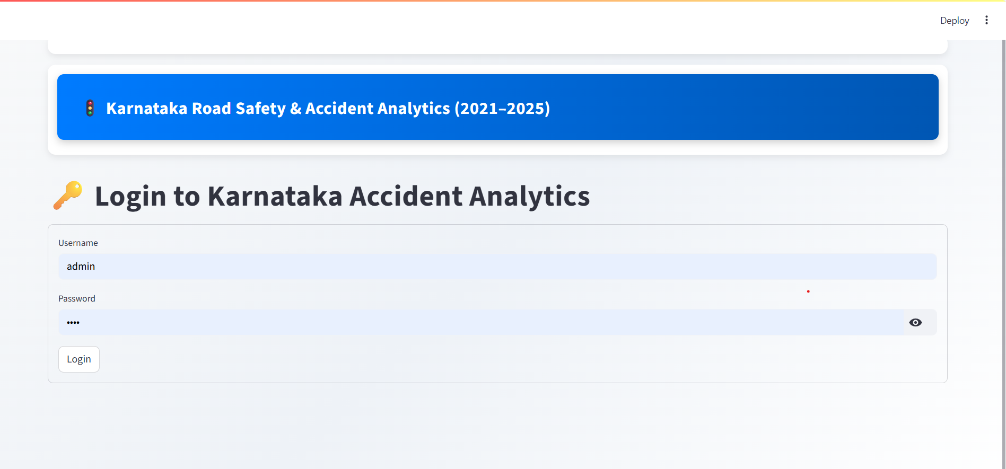
Figure 6.4.1
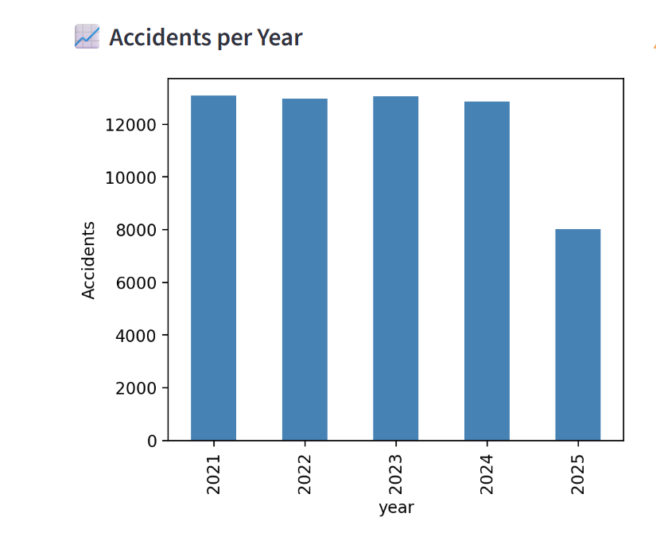
Figure 6.4.2
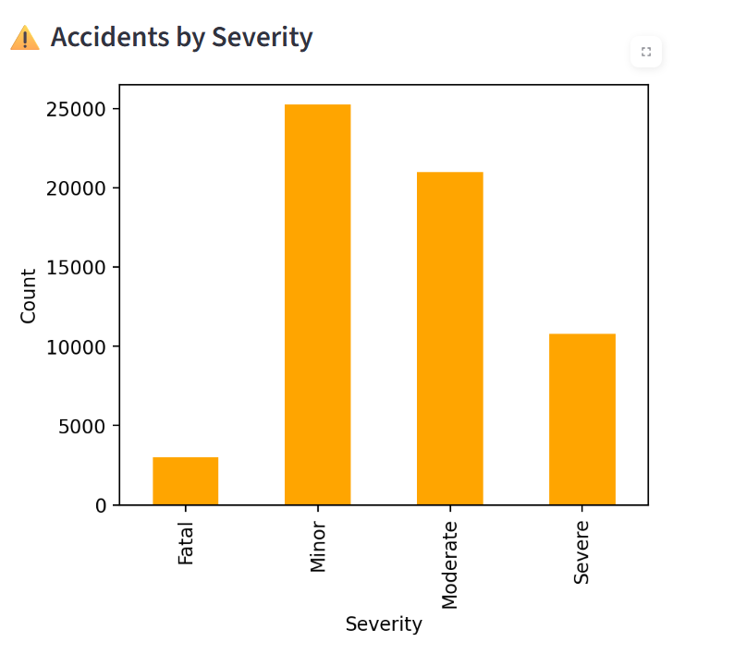
Figure 6.4.2
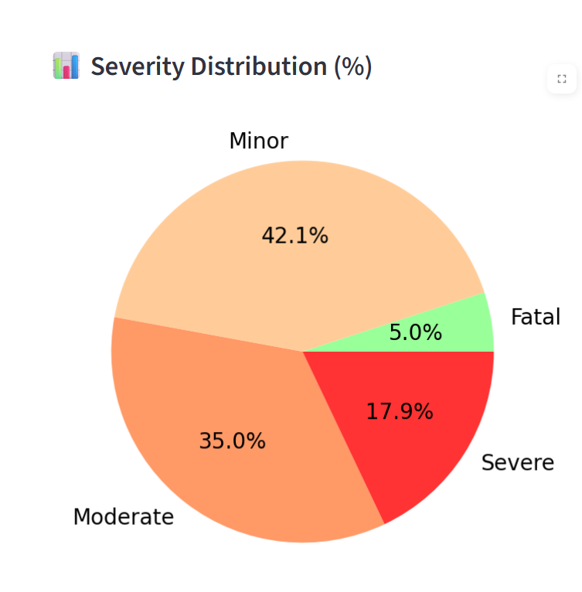
Figure 6.4.3

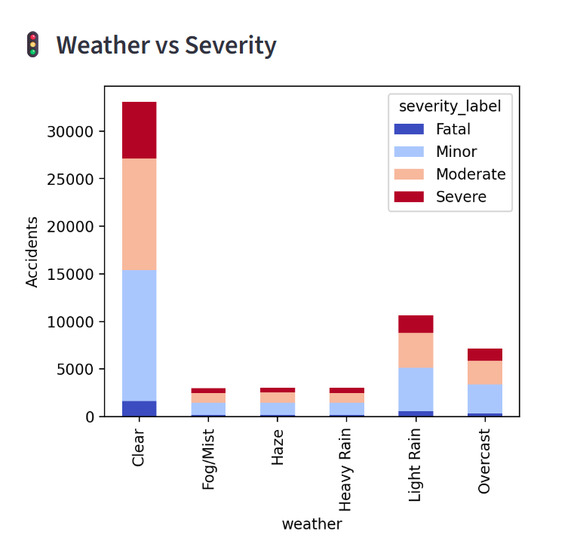
Figure 6.4.4
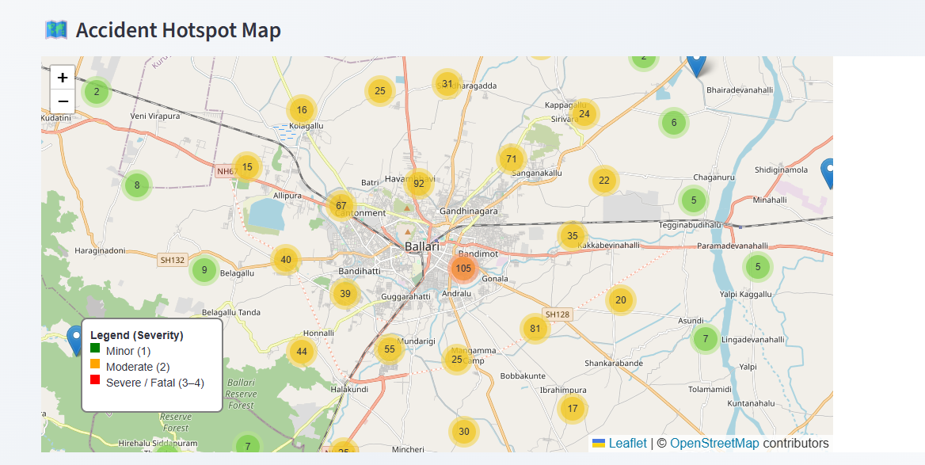
Figure 6.4.5
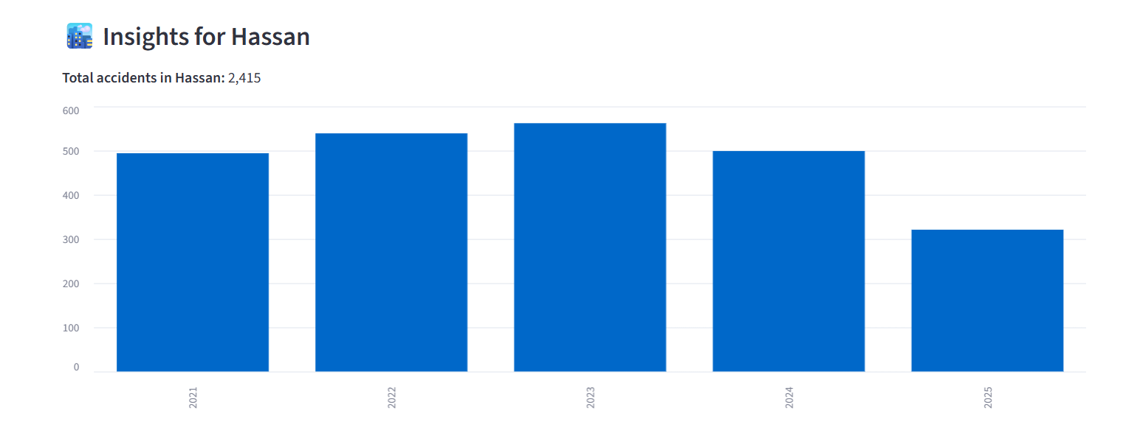
Figure 6.4.6
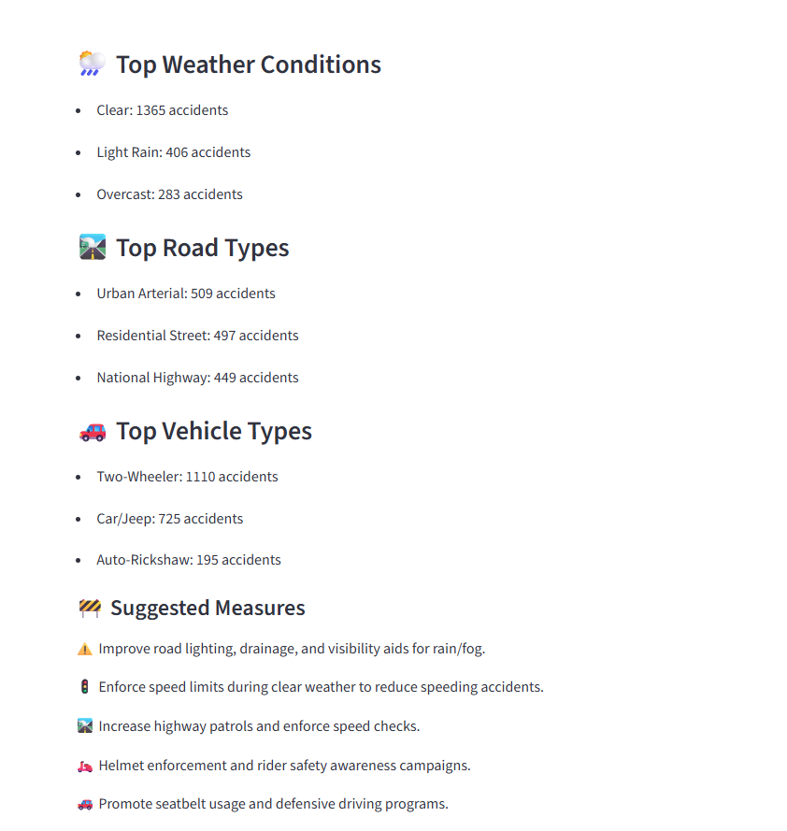
Figure 6.4.7

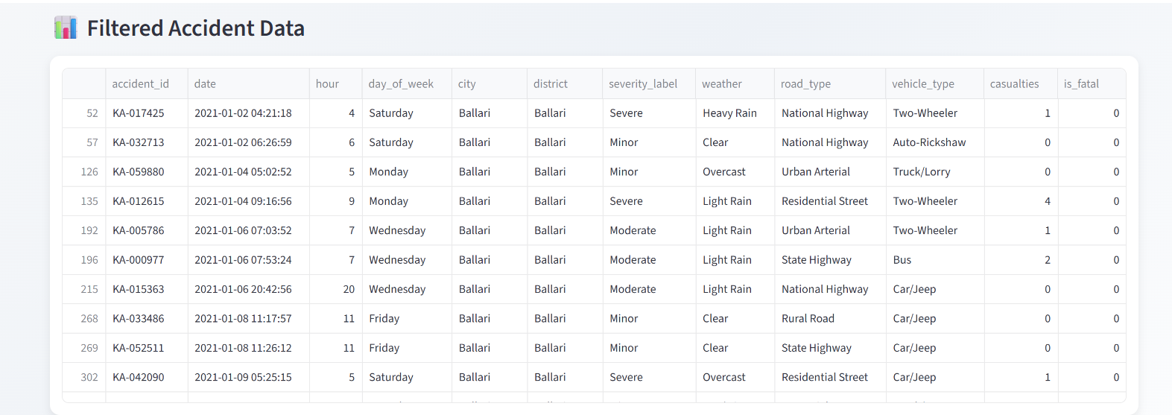
Figure 6.4.8

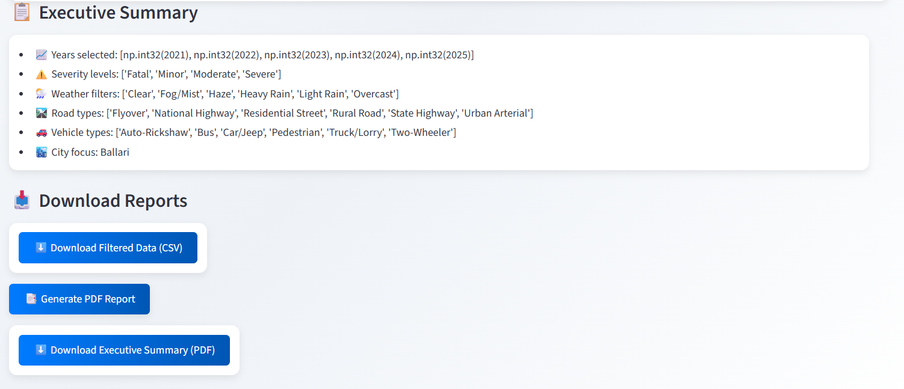
Figure 6.4.9
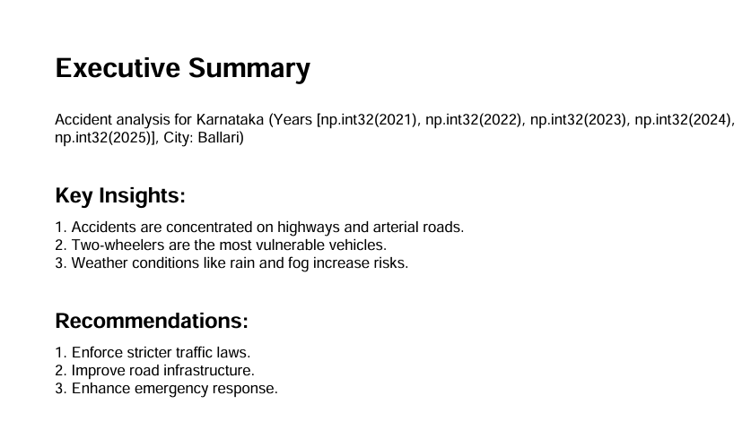

Figure 6.4.10
CHAPTER-7
RESULTS AND DISCUSSION

A comprehensive evaluation of the models' performance was carried out after training and testing. This step aimed to assess how well the models learned from past accident data and whether they could generate practical forecasts and insights for the future.

7.1 Model Performance

- The models are being trained on very huge amount of the dataset consisting of thousands od data (60,000) and then tested on unknown records to ensure dependability.
- Accident hotspots were successfully categorized using K-Means and DBSCAN clustering methods. K-Means performed well when clusters were well-defined, but DBSCAN proved more effective in locating unpredictable or scattered hotspots.
- The strengths of various classification models varied:
- Logistic regression results were straightforward and easy to interpret, which made them perfect for giving a straightforward explanation of severity classifications.
- Decision trees demonstrated which factors, including vehicle type, weather, and road type, had the most impact on severity.
- Overall, Random Forests outperformed the other models in terms of accuracy and robustness, with less overfitting and more balanced predictions.

7.2 Graphical Representation of Results

To make the outcomes easier to understand, multiple graphs and plots were generated:
- Confusion Matrix – Showed how many accidents were correctly classified into severity categories (e.g., minor, moderate, severe). It also revealed the common misclassifications, helping us see where the model struggled.
- ROC Curve & AUC – Illustrated how well the models difference between serious and non-serious cases among the accidents that have happened between those 5 years (2021-2025). A higher AUC value indicated stronger predictive ability.
- Learning Curves – Displayed the training and validation performance over iterations, helping detect overfitting (when a model memorizes instead of generalizing).

7.3 Comparison with Baseline Methods
To understand the value of the advanced models, a baseline was created using very simple statistical methods. For instance, one version always predicted the most small and non serious accidents(minor accidents), while another predicted much serious accidents (major accidents)based on the most frequent weather condition, and road types. These baseline methods acted as a reference point, showing what kind of results could be achieved without using any advanced techniques.
While the baseline worked reasonably well for predicting the majority of cases, it quickly became clear that it failed in situations where accurate insights matter the most—such as identifying severe or fatal accidents. In other words, the baseline gave safe but shallow answers and could not capture the complexity hidden in the data.
The machine learning models, on the other hand, went much deeper. By analyzing multiple factors—like road type, vehicle category, time of day, and weather—they were able to spot less obvious relationships and predict rare but critical events with far better accuracy. This demonstrated that the advanced models were not only more precise but also more practical and useful for real-world decision-making.
In simple terms, the baseline gave a basic guess, while the machine learning models provided actionable intelligence that could genuinely help authorities plan safety measures and prevent accidents.

7.4 Strengths of the Results
- Accuracy & Robustness: Models like Random Forests delivered high accuracy and correct prediction without or while avoiding overfitting.
- Interpretability: Decision Trees and Logistic Regression allowed easy and flexible explanation of results for better understanding , which is important for policymakers.
- Practical Value: Hotspot identification through clustering provided actionable insights that can guide road safety measures.
- Scalability: The system can be applied to larger or more recent datasets without major
- modifications.

Limitations of the Results
- Data Quality Issues: Some accident records had missing or incomplete values, which might have influenced some bad or inaccurate data or wrong prediction.
- Imbalanced Data: Minor accidents were far more common than fatal ones, making it harder for models to predict rare but serious cases.
- Geographical Generalization: The models were trained on Karnataka data, so results may not directly apply to other regions without retraining.
- Model Complexity: Advanced models like Random Forests gave strong results but required more computing resources compared to simpler models.

CHAPTER-8
CONCLUSION AND FUTURE WORK

8.1 Summary of Project Achievements
This project successfully developed a data-driven accident analysis system for Karnataka, transforming raw traffic records into meaningful insights. Starting with data preprocessing and cleaning, the project carried out extensive exploratory data analysis (EDA), used clustering models to detect accident hotspots, and applied classification models to predict accident severity. The integration of these methods into an interactive Streamlit dashboard allowed users to filter, visualize, and explore accident patterns across districts, road types, and weather conditions. Automated PDF reporting and CSV export features made the system practical for both researchers and policymakers.
In short, the project proved that machine learning and data visualization can go beyond static reports by providing interactive, actionable intelligence for road safety planning.

8.2 Applications and Real-World Usage
- Traffic Authorities: By using the interactive dashboard, authorities can quickly spot accident-prone zones and direct patrol units, signage, or safety measures to those areas. Instead of relying on static annual reports, they get live, visual insights for better planning and enforcement.
- Policymakers and Government Agencies: Insights from the system can guide data-driven decisions, such as where to build flyovers, widen roads, or improve lighting. They can also design targeted awareness campaigns—for example, enforcing helmet rules more strictly in districts with high two-wheeler accident rates.
- Researchers and Analysts: The platform provides a rich dataset for conducting academic studies or policy research. Researchers can analyze the effects of weather, vehicle type, or time of day on accident severity and publish findings that contribute to the field of road safety and urban planning.
- Public Awareness Campaigns: NGOs, schools, and safety organizations can use the findings to create awareness drives. For instance, campaigns can highlight why driving in rainy weather or at night is riskier, or why two-wheeler riders need to be extra cautious.
- Urban Planners and Infrastructure Developers: The data can highlight whether poor road conditions or bad design (like blind turns or unmarked crossings) are contributing to accidents. This can lead to better infrastructure planning in the future.
- Insurance Companies: Accident insights could also be valuable for risk assessment, helping insurers design fairer premium structures based on accident-prone regions or vehicle categories.
- Emergency Response Units: By knowing which areas experience frequent severe accidents, emergency services (ambulance, fire, police) can optimize their station locations and response times, potentially saving more lives.

8.3 Suggestions for Improvement and Future Enhancements
This project forms a strong foundation but leaves room for growth:
- Integration of Real-Time Data from IoT devices, GPS trackers, or live traffic feeds to make the system dynamic.
- For future Advanced Machine Learning Models such as Gradient Boosting or Neural Networks can be used for better improve of many predictions such as perfect severity prediction and accident analysis to decrease the accident rate for future.
- Predictive Accident Alerts that can warn drivers or authorities about high-risk areas in real time.
- For flexibility Mobile-fitted version of the dashboard can be made for easy access by traffic police, field officers and the general public.
- Inclusion of Additional Features such as driver demographics, vehicle condition, and road lighting to make analysis richer.
- Scalability Across States by retraining models on regional datasets, turning this into a nationwide accident-monitoring platform.
- Integration with GIS Systems for more advanced geospatial insights.
- Policy Simulation Tools to test “what-if” scenarios, like how stricter enforcement or road upgrades might affect accident rates.

CHAPTER-9
RESEARCH PAPERS

- K. Katoch and R. G. Tiwari, "Machine Learning-Based Classification of Road Accident Severity in India: A Comparative Analysis of Algorithms," 2023 14th International Conference on Computing Communication and Networking Technologies (ICCCNT), Delhi, India, 2023, pp. 1-5, doi: 10.1109/ICCCNT56998.2023.10308335.
- J. Xi, S. Wang, Chen Xiaodong and Zhurongtao, "Accident cause analysis method based on traffic accident information system," 2010 International Conference on Computer Application and System Modeling (ICCASM 2010), Taiyuan, 2010, pp. V13-230-V13-233, doi: 10.1109/ICCASM.2010.5622735.
- M. F. Labib, A. S. Rifat, M. M. Hossain, A. K. Das and F. Nawrine, "Road Accident Analysis and Prediction of Accident Severity by Using Machine Learning in Bangladesh," 2019 7th International Conference on Smart Computing & Communications (ICSCC), Sarawak, Malaysia, 2019, pp. 1-5, doi: 10.1109/ICSCC.2019.8843640.
- S. Subhashini and R. Maruthi, "A Predictive Model for Road Traffic Data Analysis and Visualization to Detect Accident Zones," 2023 9th International Conference on Advanced Computing and Communication Systems (ICACCS), Coimbatore, India, 2023, pp. 1227-1231, doi: 10.1109/ICACCS57279.2023.10112862.
- C. Wenxue, W. Hengpeng, S. Shangjiang and A. Lilu, "An improved hazardous material road transportation accident rate analysis model," 2010 International Conference on Logistics Systems and Intelligent Management (ICLSIM), Harbin, China, 2010, pp. 1081-1085, doi: 10.1109/ICLSIM.2010.5461123.
- N. LAARAJ and F. JAWAB, "Road accident modeling approaches: literature review," 2018 International Colloquium on Logistics and Supply Chain Management (LOGISTIQUA), Tangier, Morocco, 2018, pp. 188-193, doi: 10.1109/LOGISTIQUA.2018.8428276.

CHAPTER-10
APPENDICES
10.1 Code Snippet

10.1.1 1 Importing Required Libraries
# Import core libraries
import pandas as pd
import numpy as np
import matplotlib.pyplot as plt
import seaborn as sns
# Geospatial & dashboard tools
import folium
from folium.plugins import HeatMap
import streamlit as st
# Machine Learning
from sklearn.model_selection import train_test_split
from sklearn.ensemble import RandomForestClassifier
from sklearn.metrics import classification_report, confusion_matrix, roc_curve, auc

10.1.2 Loading & Exploring the Dataset
# Load accident dataset
df = pd.read_csv("karnataka_accidents.csv")
# Show first 5 rows
st.write("Sample Data:", df.head())
# Display basic info
st.write("Data Shape:", df.shape)
st.write("Missing Values:", df.isnull().sum())

10.1.3 Feature Engineering (Creating New Columns)
# Extract day, month, and year from Date column
data['Year'] = data['Date'].dt.year
data['Month'] = data['Date'].dt.month
data['Day'] = data['Date'].dt.day
data['Hour'] = data['Date'].dt.hour
# Categorize into Day/Night
data['Time_Category'] = data['Hour'].apply(lambda x: 'Day' if 6 <= x <= 18 else 'Night')
# Accident density per district
accident_density = data.groupby('District').size().reset_index(name='Accident_Count')
data = data.merge(accident_density, on='District', how='left')

10.1.4 Encoding and Preparing Data for ML Models
from sklearn.preprocessing import LabelEncoder
# Encode categorical features
encoder = LabelEncoder()
data['Vehicle_Type'] = encoder.fit_transform(data['Vehicle_Type'])
data['Weather'] = encoder.fit_transform(data['Weather'])
data['Severity'] = encoder.fit_transform(data['Severity'])
Splitting into features and target
X = data[['Hour', 'Vehicle_Type', 'Weather', 'Accident_Count']]
y = data['Severity']

10.1.5 K-Means Clustering (Hotspot Detection)
from sklearn.cluster import KMeans
import matplotlib.pyplot as plt
# Select location data
location_data = data[['Latitude', 'Longitude']].dropna()
# Apply K-Means
kmeans = KMeans(n_clusters=5, random_state=42)
kmeans.fit(location_data)

# Assign cluster labels
data['Cluster'] = kmeans.labels_

# Visualize clusters
plt.scatter(location_data['Longitude'], location_data['Latitude'], c=data['Cluster'], cmap='viridis', s=10)
plt.title("Accident Hotspot Clusters (K-Means)")
plt.xlabel("Longitude")
plt.ylabel("Latitude")
plt.show()

10.1.6 Data Preprocessing
# Handle missing values
df = df.dropna()
# Convert datetime to useful features
df['Date'] = pd.to_datetime(df['Date'])
df['Year'] = df['Date'].dt.year
df['Month'] = df['Date'].dt.month
df['Day_Night'] = df['Date'].dt.hour.apply(lambda x: 'Day' if 6 <= x <= 18 else 'Night')
# Encode categorical variables
df['Severity'] = df['Severity'].map({'Minor':0, 'Major':1, 'Fatal':2})

10.1.7 Dashboard Layout (Streamlit)
# Sidebar filters
st.sidebar.title("Filters")
year_filter = st.sidebar.selectbox("Select Year", sorted(df['Year'].unique()))
weather_filter = st.sidebar.selectbox("Select Weather", df['Weather'].unique())

# Filter data
filtered_df = df[(df['Year'] == year_filter) & (df['Weather'] == weather_filter)]

# Show filtered results
st.write(f"Filtered Data for Year {year_filter} & Weather {weather_filter}")
st.write(filtered_df.head())

# Plot severity distribution
sns.countplot(x='Severity', data=filtered_df)
st.pyplot(plt.gcf())

10.2 Dataset Sample
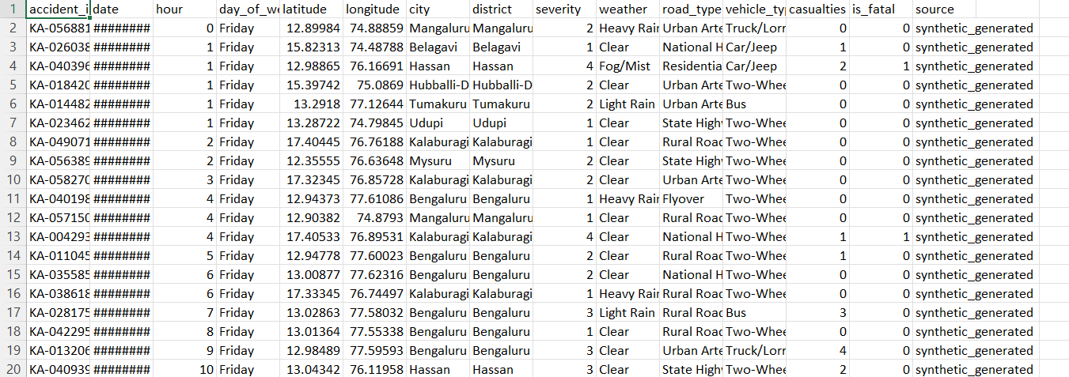
Figure 10.2.1
Figure 10.2.2

10.3 User manual
10.3.1 Launching the Dashboard
To get started with the accident analysis dashboard, follow these steps:Install Dependencies
Make sure Python is installed on your system. Then, install all required libraries by running the command:
1. Install Dependencies:
Before running the dashboard, make sure Python (version 3.8 or above) is installed on your system.
Install all required libraries by running the following command in your terminal:
“pip install streamlit pandas folium matplotlib seaborn scikit-learn reportlab plotly”

2. Run the Application
Navigate to the folder where your app.py file is located and execute the command below:
“streamlit run app.py”
This command will launch the Streamlit application locally on your machine.
3. Access in Browser
Once the application starts, it will automatically open in your default web browser at:
http://localhost:8501
From here, users can begin interacting with the dashboard.
4. First-Time Setup Note
- If the dashboard uses a CSV dataset, ensure that the file is placed in the correct data/ directory path.
- If the dashboard connects to an API or live data source, ensure that your system has an active internet connection.
- For better performance, it is recommended to close unnecessary background applications while running the dashboard.
- You can modify configuration parameters (like default filters or theme) in the settings section of the app.py file.
5. Troubleshooting
- If the dashboard doesn’t load, check whether all dependencies are properly installed.
- In case of data not loading, verify that the dataset filename and path are correct.
- For display issues, clear the Streamlit cache using:
- streamlit cache clear
- Ensure your browser supports JavaScript and is up to date for smooth interactivity.

10.3.2 Features Available
The dashboard provides a comprehensive, interactive, and user-friendly interface that enables data exploration, predictive analysis, and automated reporting. Each feature is designed to help users gain meaningful insights into road accidents effectively.
- Data Filters
• Users can select a specific year (2021–2025) to focus on a desired period.
• Additional filters include severity level, weather condition, city, road type, and vehicle type.
• Multiple filters can be applied simultaneously to refine results for detailed investigation.
• Default filters can be reset easily with a single click, ensuring quick re-analysis.
- Visualizations
• Accident Trends: Line and bar charts show temporal accident variations across months and years.
• Severity Distribution: Pie and bar charts visually display the proportions of minor, major, and fatal accidents.
• Geospatial Maps: Interactive heatmaps and marker clusters created using Folium and Plotly highlight accident hotspots across different regions.
• Correlation Plots: Identify relationships between variables like weather, time, and accident severity.
All graphs are interactive, with tooltips and legends that display additional details when hovered.
- Predictive Analysis
• The predictive module allows users to input features such as weather, road type, time of day, and vehicle type.
• Based on a pre-trained machine learning model (e.g., Logistic Regression or Random Forest), the system predicts accident severity (Minor, Major, or Fatal).
• It enables what-if analysis, allowing users to simulate potential scenarios and understand how
specific conditions may influence accident risks.
• The module also displays confidence scores and a probability distribution for more transparent predictions.
- Export Options
• Users can download filtered datasets in CSV format for offline use or further statistical analysis.
• The dashboard supports automated PDF report generation using the ReportLab library, which includes charts, summaries, and policy recommendations.
• Reports are formatted for academic and research documentation, making them ideal for students, analysts, and government authorities.
• Exports are timestamped and saved automatically in a reports/ folder.
- User-Friendly Navigation
• A clear sidebar menu guides users through filters, data uploads, and analysis options.
• Interactive buttons allow quick resetting or re-running of the analysis without reloading the page.
• Tooltips, legends, and color-coded visuals make the interpretation of results simple and intuitive.
• The design follows a responsive layout, making it compatible with laptops, desktops, and large screens.
- Additional Insights
• Heatmaps depict district-wise accident density and hotspot zones.
• Seasonal comparisons reveal how accident rates vary between summer, monsoon, and winter seasons.
• Day vs. Night analysis highlights the difference in accident frequency based on time.
• Vehicle-wise analysis identifies which categories (two-wheelers, cars, trucks, etc.) contribute most to accidents.
• Weather-based patterns uncover which conditions (rain, fog, clear) are most associated with severe accidents.
• Optionally, users can visualize monthly and weekday patterns for temporal correlation.
7. Interactive Dashboard Summary
The dashboard acts as a complete analytical ecosystem — combining data visualization, predictive modeling, and reporting into a single platform. Its modular design allows for future enhancements such as:
Integration with real-time accident APIs,
- Addition of live map layers, and
- Deployment on cloud platforms like Streamlit Cloud or Heroku.

