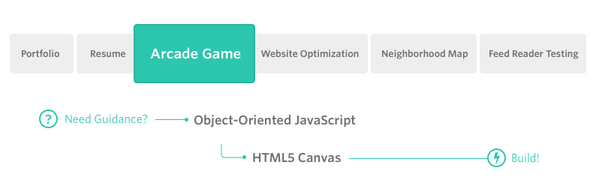

**Project Overview**

You will be provided visual assets and a game loop engine; using these tools you must add a number of entities to the game including the player characters and enemies to recreate the classic arcade game Frogger.

**Note**

If you have successfully completed the project for the Object Oriented JavaScript course in the past (which entails having graduated from the course and having access to your course certificate), simply email us at frontend-project@udacity.com with your passing evaluation and we'll give you credit for this project.

**Why this Project?**

Games have a lot of objects and those object do a lot of different things; but sometimes those object do some very similar things as well. This creates a great opportunity to practice object-oriented programming, an important programming paradigm that influences your application architecture as well as provides performance optimizations.

**What will I Learn?**

You will learn JavaScript’s object oriented programming features to write eloquently designed classes capable of creating countless instances of similarly functioning objects. You will discover a variety of ways inheritance and delegation can be used to create well architected and performant applications.

**How does this Help my Career?**

* JavaScript enables the development of complex applications on the web.
* JavaScript runs on normal web browsers, which makes it one of the most accessible and flexible programming languages.
* Complex applications that must be “broken down” into simpler entities that manage their own properties and functionality