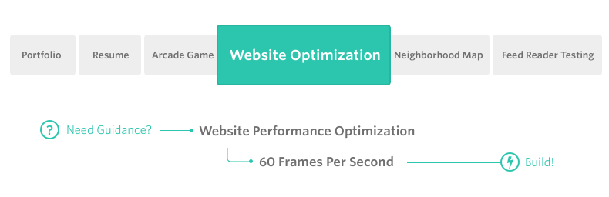

**Project Overview**

You will optimize a provided website with a number of optimization- and performance-related issues so that it achieves a target PageSpeed score and runs at 60 frames per second.

**Note**

If you have successfully completed the project for the Website Performance Optimization course in the past (which entails having graduated from the course and having access to your course certificate), simply email us at frontend-project@udacity.com with your passing evaluation and we'll give you credit for this project.

**Why this project?**

As web applications become increasingly interactive and accessed on a variety of devices there are a variety of opportunities in which performance issues can hinder the user experience. This project presents a number of those performance issues and provides an opportunity to showcase your skills in identifying and optimizing web applications.

**What will I learn?**

You will learn about the critical rendering path, the process by which the browser receives HTML, CSS and JavaScript and the required processing to turn them into rendered pixels. You’ll also start to think of your work as a continuously running web application that requires a consistent framerate to produce the most enjoyable user experience.

**How will this help my Career?**

* As the number of devices users can access an application from continues to grow, ensuring a quality user experience across those devices is important.
* Understanding lower-level concepts regarding how the browser works and interprets your code enables you to produce highly performant applications.