**Evaluation**

Your project will be evaluated by a Udacity reviewer according to the rubric below. Be sure to review it thoroughly before you submit. All criteria must "meet specifications" in order to pass.

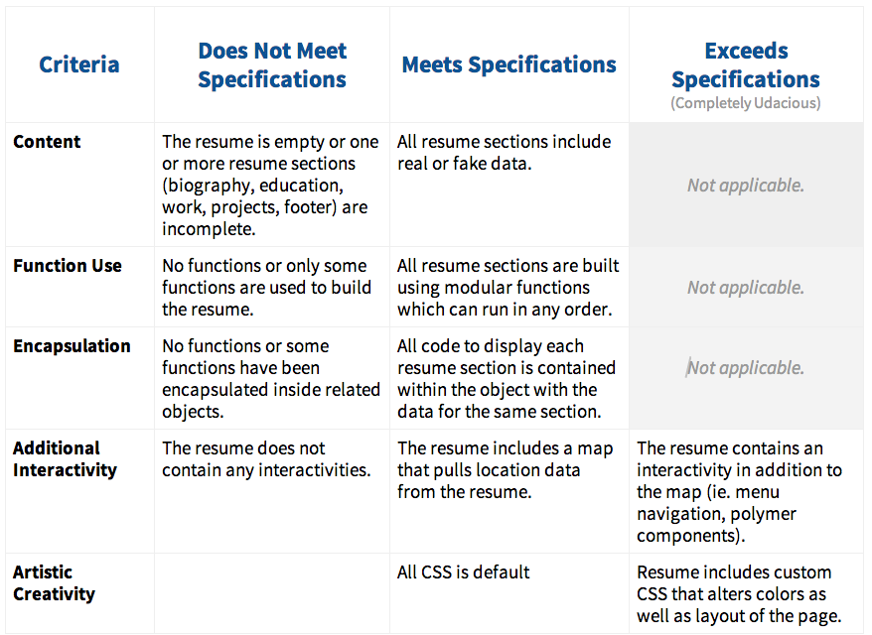

**Submission**

When you're ready to submit your project go back to your [Nanodegree Portal](https://www.udacity.com/course/nd001" \t "_blank), click on Project 2, and we'll walk you through the rest of the submission process.

If you are having any problems submitting your project or wish to check on the status of your submission, please email us at **frontend-project@udacity.com** or visit us in the [discussion forums](http://discussions.udacity.com/).

**What's Next?**

You will get an email as soon as your reviewer has feedback for you. This could take up to two weeks, but in most cases is much faster. In the meantime, review your next project and feel free to get started on it or the courses supporting it!