**ReadMe for Movie Trailer website:**

Using a terminal, navigate to the project directory. For example in the start menu on a Windows machine, type "cmd" and open the command prompt. Then navigate to the project directory as shown in the screenshot below

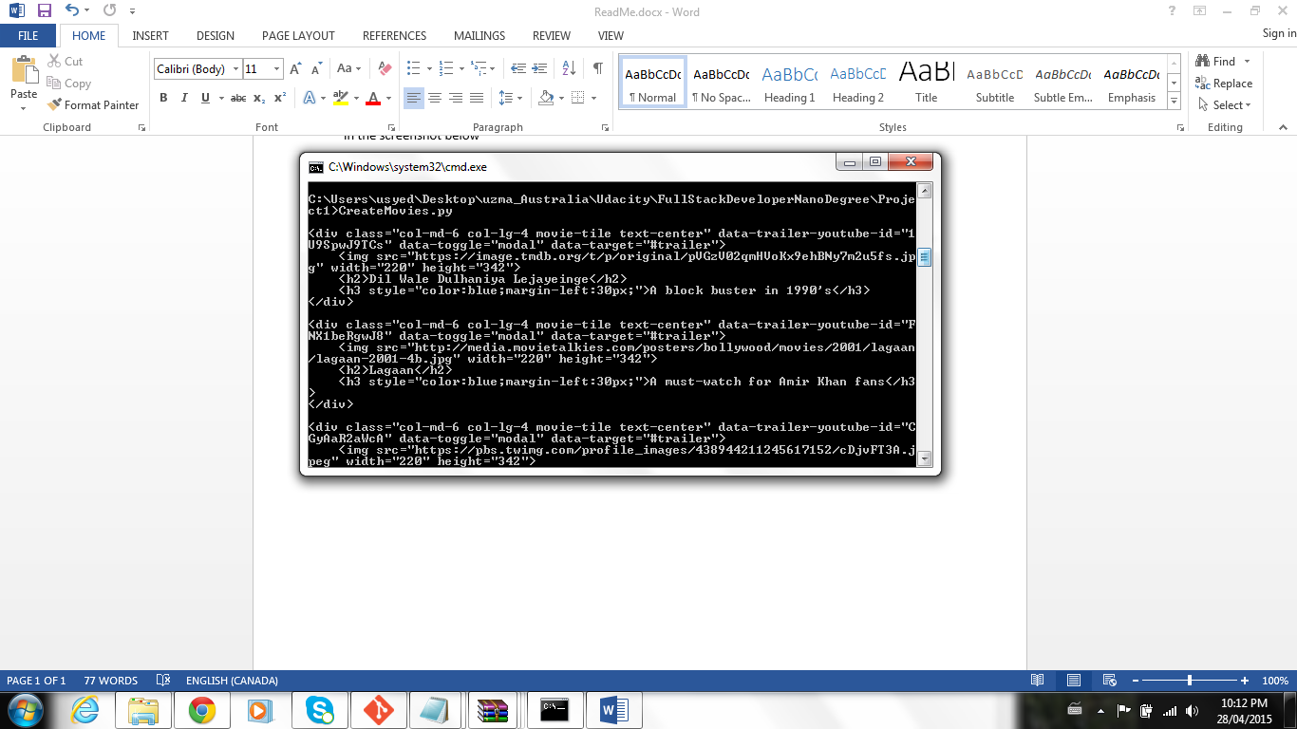

When in the project directory, execute CreateMovies.py as shown in the screenshot above. This will generate fresh_tomatoes.html.

Right click on the generated fresh_tomatoes.html in the project directory and open in a browser of your choice. This will display all the movies created.