### ***PROJECT WORK***

### **Comprehensive Digital Marketing For PTron**

***Shaik uzma suha***

***Vasavi Mahila Kalasala***

***22231014044***

[***Shaikuzma13@gmail.com***](mailto:Shaikuzma13@gmail.com)



PTron, a leading player in the consumer electronics industry, is set to revolutionize its digital marketing strategy to amplify its brand presence and engage with its target audience more effectively. Leveraging a comprehensive approach, PTron aims to harness the power of various digital channels to establish itself as a household name among tech enthusiasts and everyday consumers alike. Through strategic content marketing initiatives, including blog posts, videos, and social media campaigns, PTron will provide valuable insights, tips, and entertainment to its audience, positioning itself as a trusted authority in the electronics space. Additionally, personalized email marketing campaigns will be employed to nurture leads and foster long-term relationships with customers, offering exclusive deals, product updates, and personalized recommendations tailored to individual preferences

. ***Brand study competitors analysis & Buyer’s/Audience’s Persona***

### **1. Brand Study**

.Research the company’s history, mission, and values

. Analyze the brand’s unique selling proposition (USP), positioning, and messaging

### **2. Competitor Analysis**

. Identify direct and indirect competitors

.Research competitors’ strengths, weaknesses, and market

### **3. Buyer’s/Audience’s Persona**

.Identify the target audience’s demographics, needs, goals, and pain points

. Create a detailed persona profile, including:

- Name and bio

- Age, occupation, and education

- Goals, challenges, and motivations

- Preferred communication channels and behaviours

- Buying habits and decision-making processes

### ***SEO & Keyword Research***

**1. SEO Audit**

- Website Crawling: Crawl Ptron's website to identify technical SEO issues, such as broken links, duplicate pages, and redirect chains.

- Site Speed Analysis: Test Ptron's website loading speed and identify areas for improvement, such as image compression and code optimization

**2. Keyword Research for Ptron**

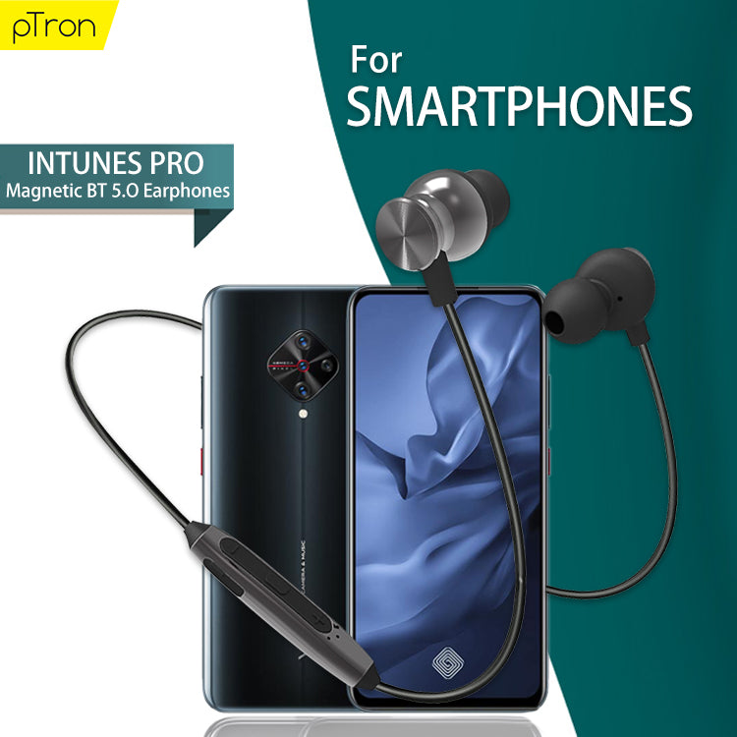- Identify Seed Keywords: Brainstorm a list of relevant keywords related to Ptron's products and services, such as "wireless earbuds," "smartwatches," and "portable chargers."

- Use Keyword Research Tools: Utilize tools like Google Keyword Planner, Ahrefs, or SEMrush to expand the keyword list and gather data on search volume, competition, and cost-per-click (CPC).

**3. On-Page Optimization for Ptron**

- Optimize Meta Tags: Update Ptron's website's meta tags (title, description, keywords) to accurately reflect the website's content and target keywords.

- Header Tags and Content Structure: Organize Ptron's website content using header tags (H1, H2, H3, etc.) and ensure a clear content structure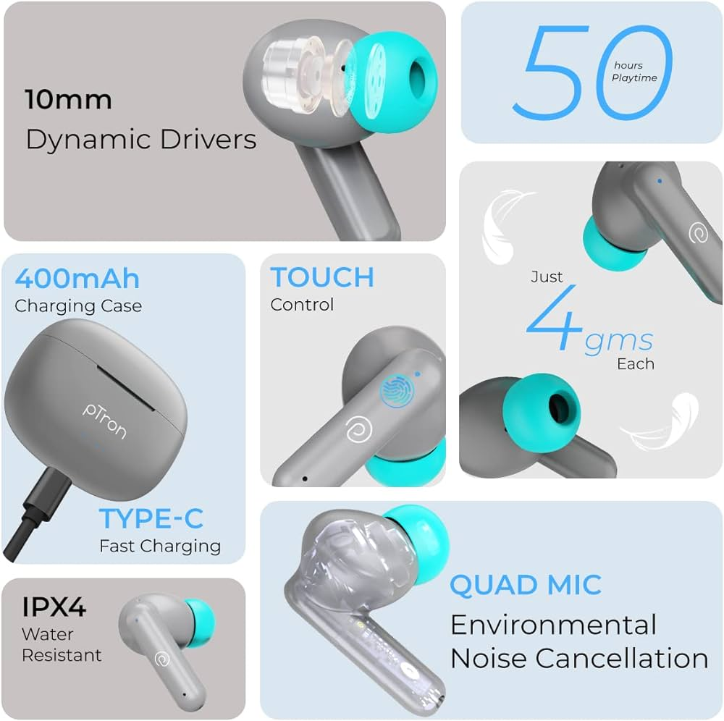

***Content Ideas and Marketing Strategies***

**1. Content Ideas**

**Blog Posts**

1. “10 Ways to Use Your Smartphone More Efficiently”

2. “The Future of Wireless Earbuds: Trends and Innovations”

**Social Media Posts**

1. “Motivation Monday: Stay focused and productive with our wireless earbuds! #Ptron #WirelessEarbuds”

2. “Did you know? Our smartwatches can track your fitness goals and receive notifications! #Ptron #Smartwatches”

**Videos**

1. “Unboxing and Review of Ptron’s Latest Wireless Earbuds”

2. “How to Pair Your Ptron Smartwatch with Your Smartphone”

**Infographics**

1. “The Benefits of Wireless Earbuds: Convenience, Comfort, and Style”

2. “Smartwatch Features: A Comparison of Ptron’s Models”

**2. Marketing Strategies**

***Digital Marketing***

1. Social Media Advertising: Run targeted ads on Facebook, Instagram, and Twitter to reach our target audience.

2. Influencer Marketing: Partner with influencers in the tech and lifestyle niches to promote Ptron’s products.

***Content Marketing***

1.Guest Blogging: Write guest posts for other reputable tech and lifestyle blogs to increase brand visibility and backlinks.

2.Product Reviews: Reach out to review websites and offer free products in exchange for honest reviews.

***Offline Marketing***

1. Trade Shows and Events: Attend trade shows and events in the tech and lifestyle industries to showcase Ptron’s

2.Partnerships: Partner with retailers and distributors to increase Ptron’s product visibility

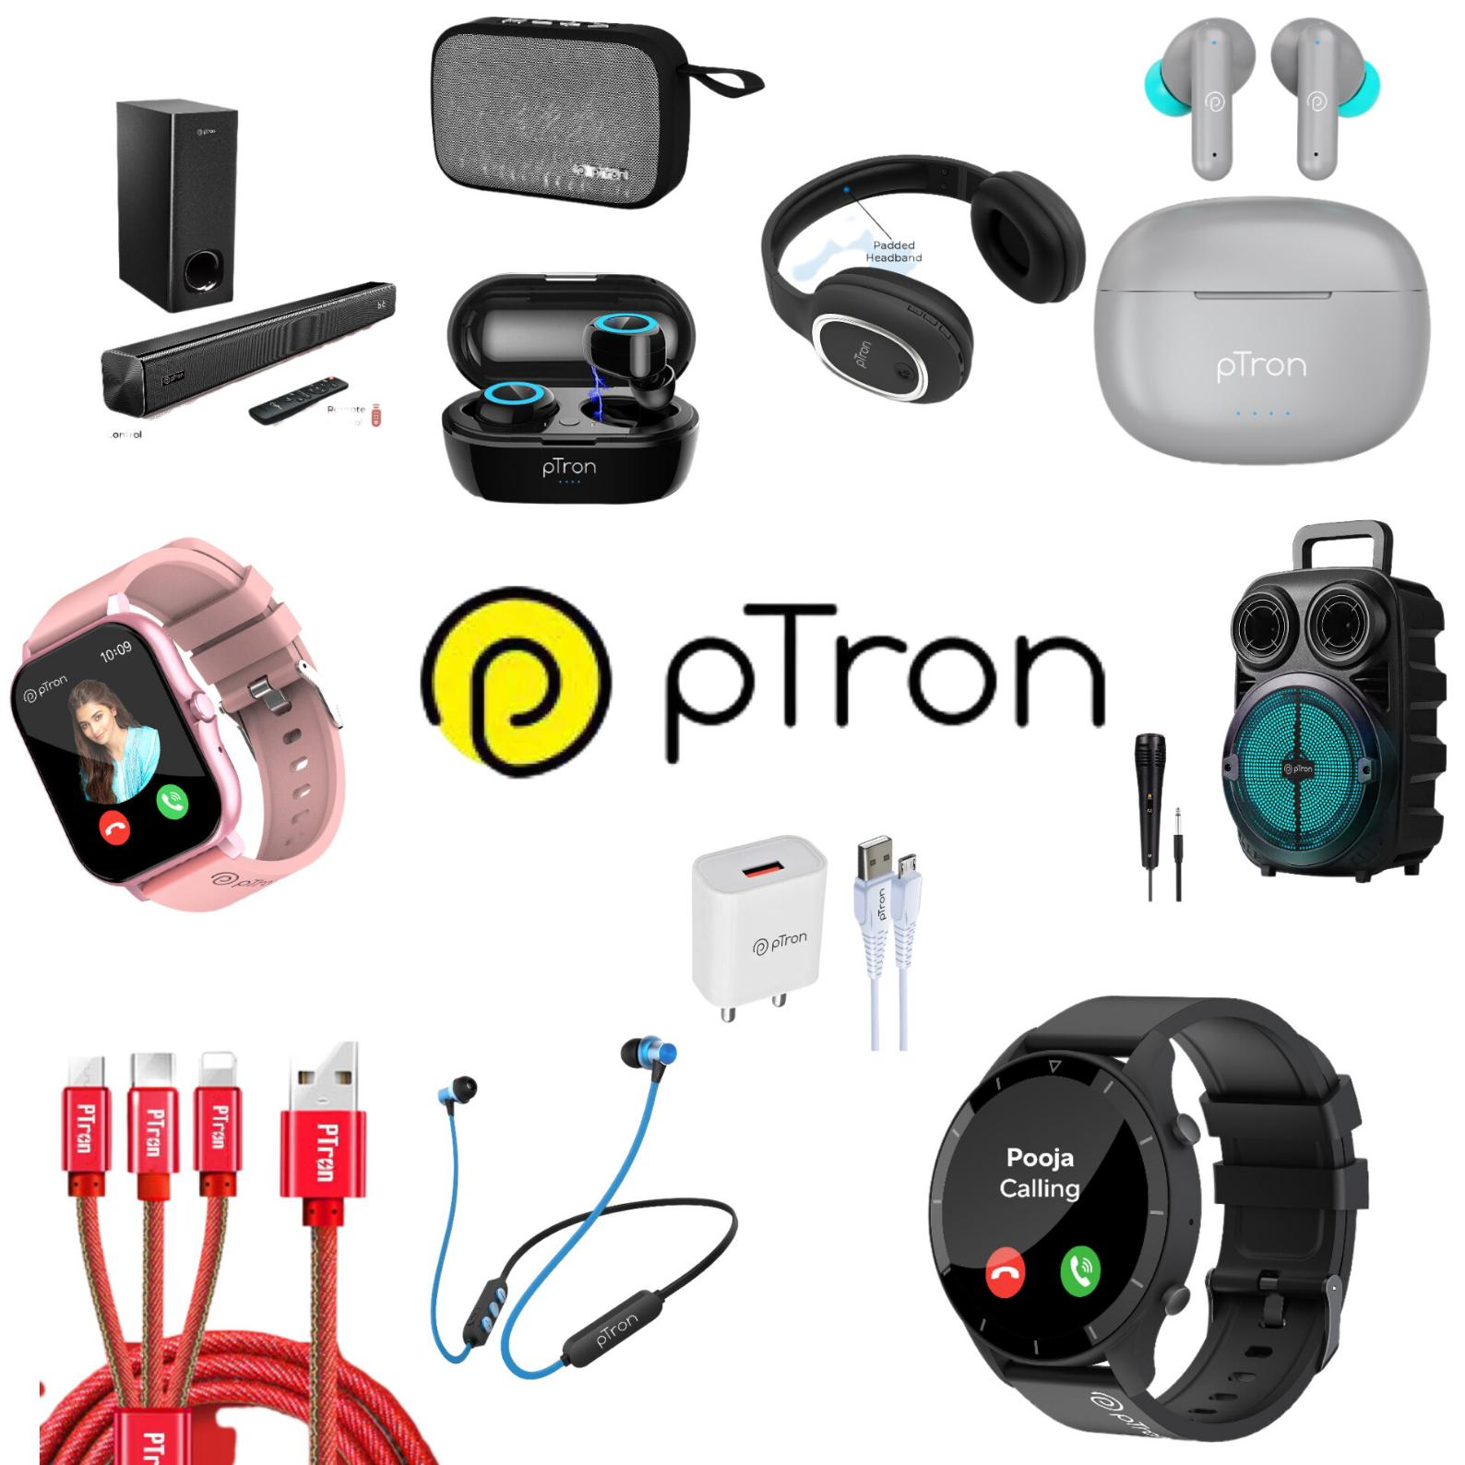

***Content Creation and Curation***

**1. Post Creations**

**- Blog Posts:**

-"5 Ways to Use Ptron's Wireless Earbuds for a More Productive Day"

**- Social Media Posts:**

- Facebook: "Motivation Monday: Stay focused with Ptron's wireless earbuds! #Ptron #WirelessEarbuds"

**- Email Newsletters:**

- "Exclusive Offer: Get 10% off on Ptron's wireless earbuds this week only!"

**2. Designs/Video Editing**

-Visual Identity:

- Logo: Update the logo to make it more modern and sleek.

- Graphic Designs:

- Social media graphics: Create eye-catching graphics for Facebook, Instagram, and Twitter.

- Video Editing:

- Product demo videos: Create short and engaging videos showcasing Ptron's products.

**3. Ad Campaigns over Social Media**

-Facebook Ads:

- Ad format: Image and video ads

- Instagram Ads:

- Target audience: Fashion-conscious and lifestyle-oriented individuals.

- Twitter Ads:

- Target audience: Tech enthusiasts and industry professionals.

**4. Email Ideation and Creation**

- Welcome Email:

- Subject line: "Welcome to Ptron!"

**- Promotional Email:**

- Subject line: "Exclusive Offer: 10% off on Ptron's wireless earbuds!"

- Abandoned Cart Email:

- Subject line: "Don't miss out! Complete your purchase now!"

