**Convolution Formula**

**Flops Benchmark**

**DRAM Memory Bus Bandwidth Benchmark (*WikiChip*)**

* 1. # Flops:
  2. # Memory moves: 2 moves across bottleneck bandwidth,

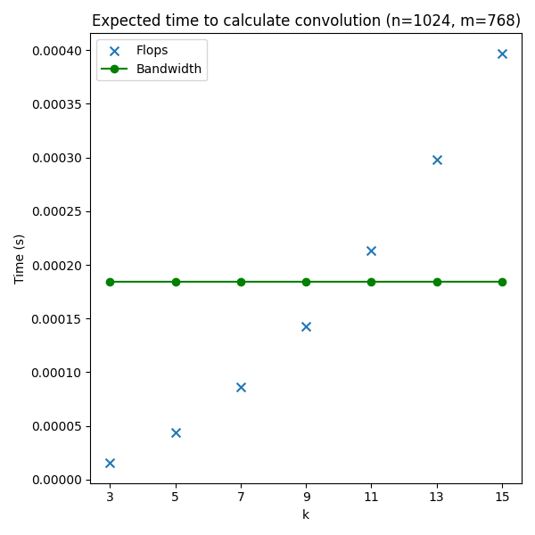

1. The way that the data is cached when loaded from memory is likely heavily affecting the performance of the program. For the original implementation, the data is loaded sequentially, line by line across the entire image, so data that was previously loaded into cache and used for calculations would be evicted and replaced by new data, only for that same data to be reloaded into cache and used again.
2. After improving the code with parallel code, I managed to get within a factor of 20 of the model.