**1**

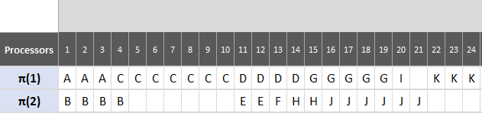

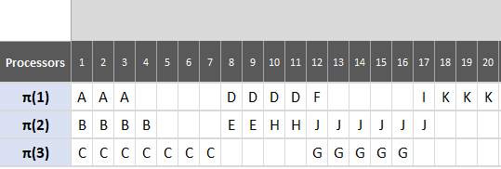

**2**

**3**

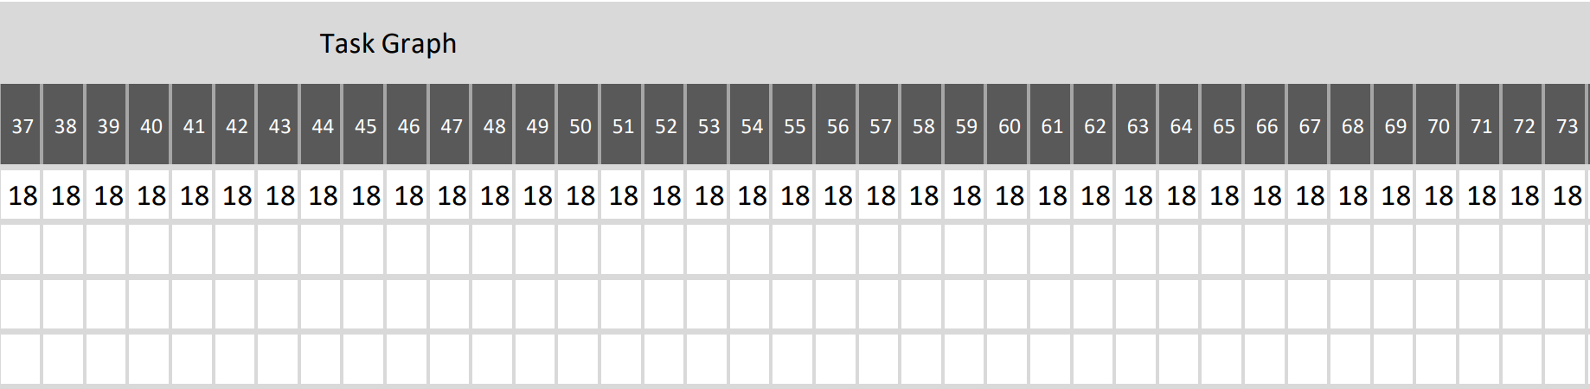

**4**

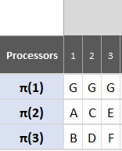

**5**

**0**



