EMPLOYEE ATTRITION ANALYSIS REPORT
Challenge: A company is experiencing employee turnover and wants to understand the patterns associated with employees leaving.
Management wants to understand:
What patterns are associated with employee attrition, and what can the company learn from its employee data to improve retention?
Goal of this analysis: analysis should help the company understand its workforce, identify patterns that may be associated with attrition, and highlight areas that may require further investigation.
Workforce overview
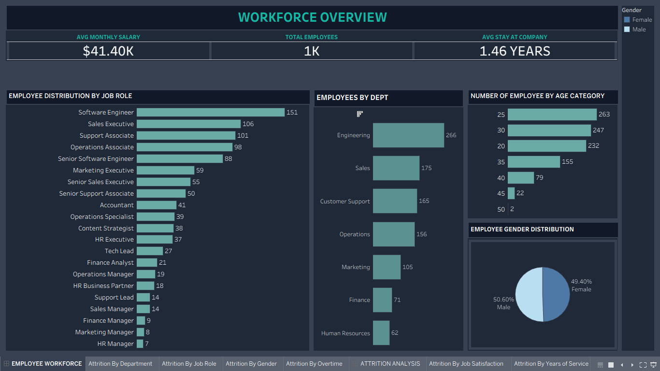
The company currently employs 1,000 staff members across 7 departments and 21 job roles, with an overall average salary of $41.40K and a notably short average tenure of 1.46 years.
- Department & Role Concentration: The workforce is heavily concentrated in four core operational departments: Engineering (266), Sales (175), Customer Support (165), and Operations (156), which together account for 76.2% of total headcount. At the role level, individual contributor positions dominate—led by Software Engineers (151), Sales Executives (106), Support Associates (101), Operations Associates (98), and Senior Software Engineers (88). Managerial and lead roles represent a very small fraction of the organization (7 to 27 employees per role), indicating wide spans of control and limited internal management slots.
- Demographics (Age & Gender): The company has an overwhelmingly young, early-career workforce. 74.2% of all employees are between ages 20 and 30—specifically in the 25 (263), 30 (247), and 20 (232) age categories—while only 10.3% of staff are aged 40 or older. Gender representation across the company is nearly perfectly balanced at 50.60% Male and 49.40% Female.

Attrition analysis
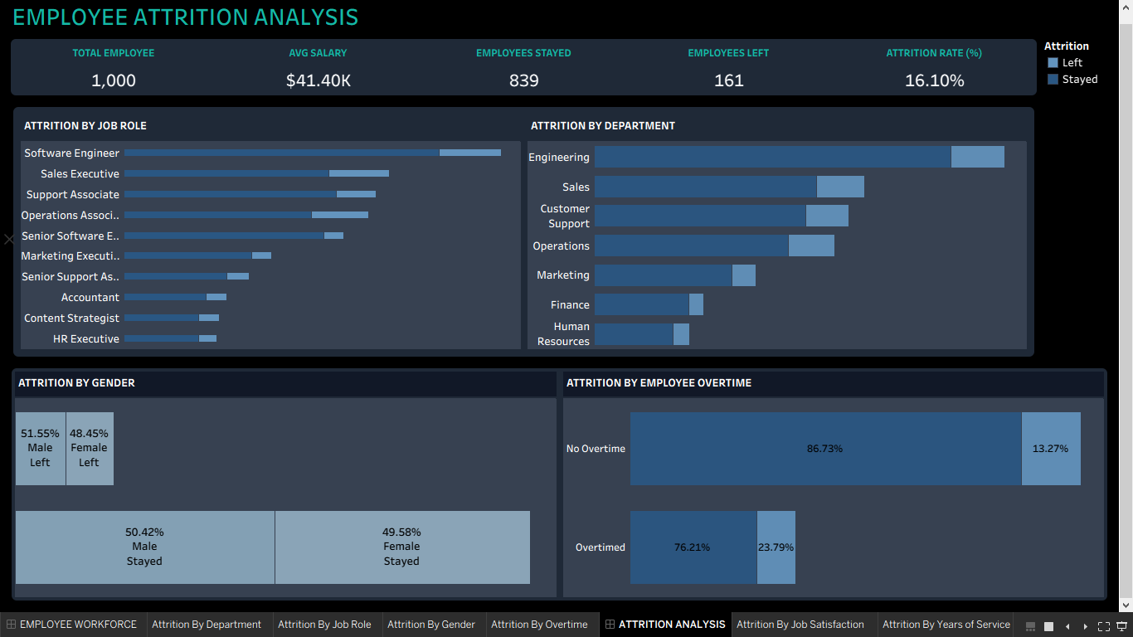

Out of 1,000 employees, 161 have left the company and 839 have stayed, resulting in an overall attrition rate of 16.10%.
- Overtime is a Major Risk Factor: Comparing attrition rates across working conditions reveals a clear burnout signal. Employees who work overtime leave at a rate of 23.79% (compared to 76.21% who stay), whereas employees with no overtime leave at a rate of only 13.27% (86.73% stay). Working overtime makes an employee nearly 1.8 times more likely to leave.
- Department & Job Role Patterns: In absolute terms, turnover volume is highest in Engineering, Sales, Customer Support, and Operations, and among Software Engineers, Sales Executives, Support Associates, and Operations Associates. This aligns closely with the largest frontline and technical cohorts in the company.
- No Gender Disparity in Turnover: Attrition is evenly split across genders. Among employees who left, 51.55% were Male and 48.45% were Female, which closely mirrors the employees who stayed (50.42% Male and 49.58% Female). Gender is not a driver of attrition.

Attrition Drivers/Retention
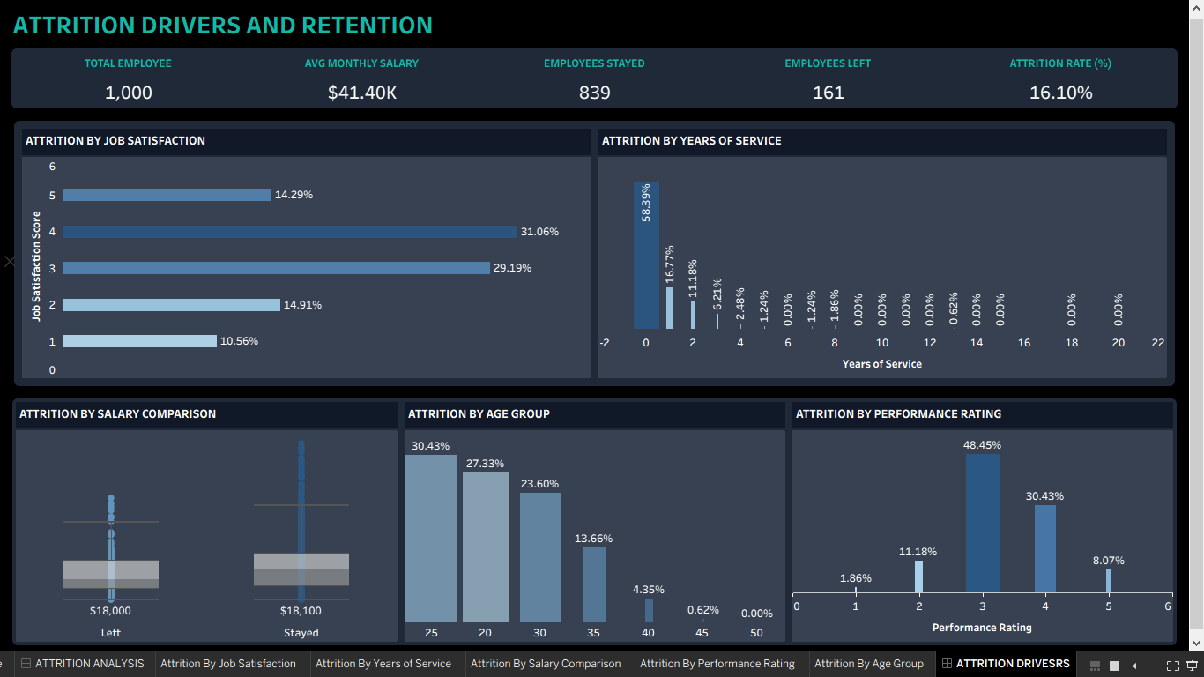

Attrition Drivers / Retention
Analyzing the characteristics of the 161 employees who left highlights clear patterns around tenure, career stage, performance, and satisfaction:
- Severe First-Year & Early-Tenure Drop-Off: Turnover is overwhelmingly front-loaded. 58.39% of all employees who left did so within their first year (0 years of service), followed by 16.77% at Year 1, 11.18% at Year 2, and 6.21% at Year 3. Combined, 86.34% of all attrition occurs within the first two years, and 92.55% occurs within the first three years. Employees who stay past Year 4 rarely leave.
- Early-Career Turnover (Age Group): Consistent with the tenure data, 81.36% of leavers are aged 20 to 30, led by the age 25 group (30.43%), age 20 group (27.33%), and age 30 group (23.60%). Turnover drops sharply to 13.66% at age 35, 4.35% at age 40, and less than 1% at age 45+.
- Regrettable Loss of Solid & High Performers: The company is not losing underperformers; only 1.86% of leavers had the lowest performance rating (1) and 11.18% had a rating of 2. Instead, 86.95% of leavers were solid-to-top performers, including 48.45% with a rating of 3, 30.43% with a rating of 4, and 8.07% with a rating of 5.
- Job Satisfaction Paradox: Most employees who left were not actively dissatisfied. 74.54% of leavers reported moderate-to-high job satisfaction—with 31.06% scoring 4, 29.19% scoring 3, and 14.29% scoring 5—compared to only 25.47% scoring 1 or 2. This indicates that employees are likely leaving due to workload, onboarding friction, or external career progression rather than day-to-day dissatisfaction alone.
- Salary Comparison: The salary distribution between employees who left and those who stayed shows nearly identical median base pay ($18,000 for Left vs. $18,100 for Stayed) and similar interquartile ranges, although the "Stayed" group contains higher upper-end salary outliers. Across-the-board base pay is not the primary differentiator for early exits.
Recommendations to Improve Retention
- Overhaul Onboarding & First-Year Support (Target: Year 0–1 Cohort):
  - Because 75.16% of all exits happen in Years 0 and 1, implement a structured 30-60-90-day onboarding program, pair new hires with peer mentors, and require formal manager check-ins at months 1, 3, 6, and 9 to resolve role ambiguity early.
- Curb Overtime & Rebalance Workloads (Target: Overtime Cohort):
  - Address the 23.79% overtime attrition rate by auditing teams with chronic overtime, setting workload caps, and reallocating headcount or hiring support in high-volume frontline roles (Engineering, Sales, Support, Operations).
- Create Clear Early-Career Progression Ladders (Target: Ages 20–30 & Rating 3–4 Performers):
  - With a flat organizational structure (very few Manager/Lead roles) and a young workforce, capable employees (Ratings 3–5) leave within 1–2 years to advance their careers. Introduce clearer intermediate career tiers (e.g., Associate I →→ II →→ Senior), skill-based milestones, and internal mobility pathways.
- Conduct "Stay Interviews" with High Performers Before the 1-Year Mark:
  - Do not rely solely on job satisfaction surveys, as satisfied employees (Scores 3–4) are still leaving in large numbers. Have managers conduct proactive career and retention conversations with Rating 3–5 employees at the 6-to-12-month mark.

