# **CulturePulse: AI-Powered Cultural Resonance Engine**

## **Enhanced Bittensor Agent Proposal**

### **Agent Name:**

**CulturePulse**

### **Subnets to Leverage:**

* **BitAds (Subnet 16):** To incentivize and distribute creator content via decentralized ad-like viral campaigns.
* **It's AI (Subnet 32):** For verifying authenticity and originality of AI-generated content.
* **ComputeHorde (Subnet 12):** To power generative creativity with scalable GPU resources.
* **BitMind (Subnet 34):** For detecting deepfakes and enhancing trust in creator-generated media.
* **Subvortex (Subnet 7):** For reliable validator support and incentivized subtensor node distribution.

### **Use Case / Products / Economy:**

**CulturePulse** is a decentralized AI Agent that scans, amplifies, and verifies the most culturally relevant AI-generated content in real-time across social platforms.

## **Architecture & Core Functionality**

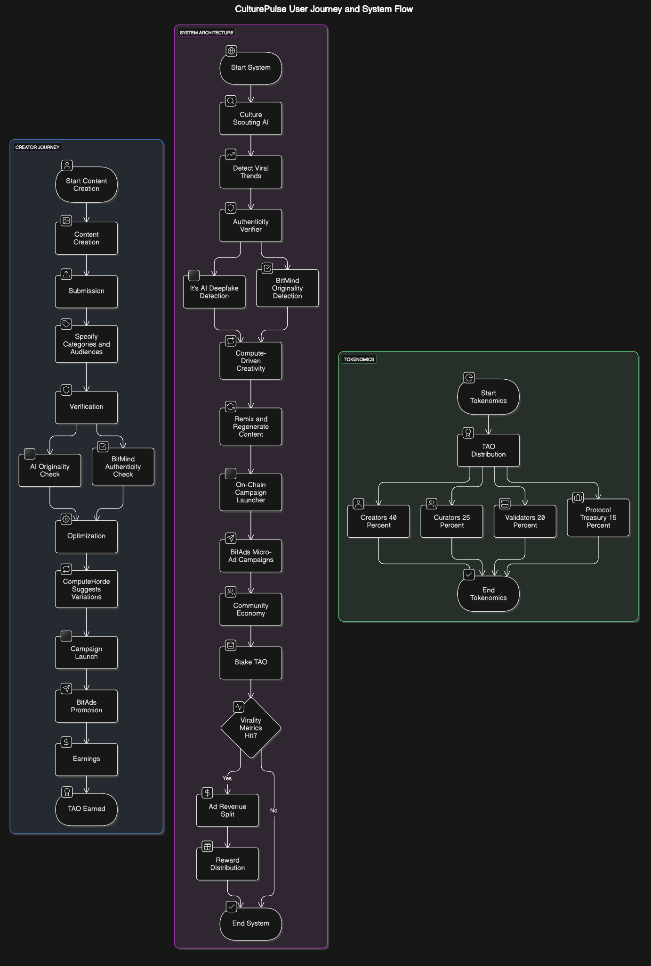

1. **Culture Scouting AI** — Scans live media feeds (X, TikTok, Lens, etc.) to detect viral trends, memes, soundbites, and culturally resonant moments.
2. **Authenticity Verifier** — Uses *It's AI* and *BitMind* to detect originality and deepfakes in media before promoting it.
3. **Compute-Driven Creativity** — Leverages *ComputeHorde* to remix and regenerate trending moments into new cultural artifacts (memes, edits, audio snippets, shorts).
4. **On-Chain Campaign Launcher** — Via *BitAds*, launches micro-ad campaigns to push verified creative drops into social feeds, rewarding curators with TAO.
5. **Community Economy** — Users stake TAO to boost what *they* think is the next big wave. If it hits virality metrics, they earn multipliers from the ad-revenue split.

## **CulturePulse Subnet Integration Flow**

[Culture Scout] → [Authenticity Verification] → [Creative Generation] → [Campaign Distribution] → [Reward Distribution]

(Data Feed) → (It's AI/BitMind) → (ComputeHorde) → (BitAds) → (Subvortex)

## **Tokenomics & Economic Model**

### **TAO Distribution Per Cultural Wave:**

* **Creators**: 40% - Original content producers
* **Curators**: 25% - Early spotters of trending content
* **Validators/Miners**: 20% - Network infrastructure operators
* **Protocol Treasury**: 15% - Ecosystem development and sustainability

### **Staking Mechanics:**

| **Stake Level** | **Boost Power** | **Max Potential Return** |
| --- | --- | --- |
| Tier 1: 10 TAO | 1x | 150% |
| Tier 2: 50 TAO | 2x | 200% |
| Tier 3: 100 TAO | 3x | 300% |
| Tier 4: 500+ TAO | 5x | 500% |

**Anti-Manipulation Protection**:

* Staking requires 7-day lock-up periods
* Virality metrics drawn from multiple independent sources
* Reputation scoring system that adjusts rewards based on past accuracy
* Decentralized oracle system for trend verification

## **User Journey & Example Usage**

### **Creator Path:**

1. **Content Creation**: Artist Maya creates an AI-generated visual piece capturing current events
2. **Submission**: Maya uploads to CulturePulse, specifying cultural categories and target audiences
3. **Verification**: It's AI (Subnet 32) and BitMind (Subnet 34) validate originality and authenticity
4. **Optimization**: ComputeHorde (Subnet 12) suggests variations that might increase resonance
5. **Campaign Launch**: BitAds (Subnet 16) algorithmically promotes to aligned audiences
6. **Earnings**: As the piece gains traction, Maya earns TAO proportional to engagement metrics

### **Curator Path:**

1. **Discovery**: Curator Raj spots Maya's piece in early stages
2. **Assessment**: Raj analyzes cultural significance and potential resonance
3. **Staking**: Raj stakes 100 TAO on Maya's content, earning 3x boost potential
4. **Amplification**: Staking triggers additional promotion through BitAds
5. **Earnings**: When content exceeds virality thresholds, Raj earns 275 TAO (175 TAO profit)

### **Brand Integration Path:**

1. **Trend Analysis**: Brand reviews CulturePulse trends dashboard
2. **Campaign Creation**: Sets parameters for cultural alignment
3. **Execution**: Deploys TAO to boost creator content aligned with brand values
4. **Analytics**: Receives detailed engagement metrics and cultural impact reports
5. **Optimization**: Refines approach based on resonance data

## **Implementation Roadmap**

### **Phase 1: Foundation (Months 1-3)**

* Core cultural scanning engine development
* Integration with It's AI and BitMind subnets
* Basic verification and authentication systems
* Alpha testing with select creators

### **Phase 2: Creation Tools (Months 4-6)**

* ComputeHorde integration for generative capabilities
* Creator dashboard and submission tools
* Curation mechanics and initial staking system
* Beta testing with expanded creator pool

### **Phase 3: Economic Engine (Months 7-9)**

* BitAds integration for distribution
* Full TAO reward system implementation
* Marketplace for cultural artifacts
* Public launch with incentivized onboarding

### **Phase 4: Expansion (Months 10-12)**

* Brand partnership platform
* Enhanced analytics dashboard
* Cross-chain compatibility exploration
* Advanced cultural prediction algorithms

## **Competitive Differentiation**

| **Feature** | **CulturePulse** | **Centralized Platforms** | **Traditional AI Tools** |
| --- | --- | --- | --- |
| Cultural Authenticity | High (community-validated) | Medium (algorithm-based) | Low (no cultural context) |
| Creator Compensation | Direct, immediate | Platform-dependent | Minimal/None |
| Manipulation Resistance | High (decentralized) | Low (centralized) | Medium |
| Trend Prediction | Community intelligence | Black-box algorithms | Statistical only |
| Content Verification | Multi-subnet validation | Limited | None |

CulturePulse represents the next evolution in creator economies - an AI-powered, decentralized system that detects, amplifies, and rewards authentic cultural creation while building an economy of verified digital experiences.