Exercise 1:

Create a C# windows application to implement a form with
- a ListBox,
- a TextBox,
- an Edit button,
- an Insert button,
- a Delete button,
- a Update button and
- an Exit button

Create the BookCSharp database using Microsoft Access. The BookCSharp DB should contain at least to 10 books about C# from 6 different authors. Information about these books should be arranged into the following two tables:
- Books – BookKey (that is ISBN), Title, Pages, AuthorKey, Publisher
- Authors – AuthorKey, First_Name, Surname

Your C# program should be able to connect to the database and to copy Title and Pages on the Books table of the DB to you C# program and to display all records in the ListBox.

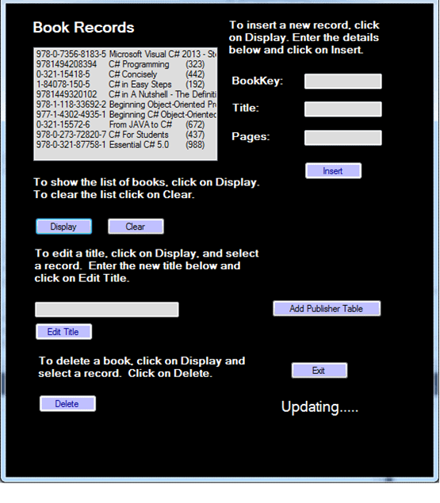

Exercise 2 (Optional):

Create a table that consists of 10 places. Insert the following table entries A1, I9, R18, S19, E5, O15, and Y25, where the integers are subscripts which represent the positions of these letters in the alphabet into the table by using the hashing function
H(Ln) = n%10
And design you own probe function.

Tips:
- Get a pen and a piece of paper and manually calculate remainders by performing index modular by 10, and then follow this week’s lecture notes to allocate the letters in a 10-place table.
- Modify the C# code given on Breo and run the modified program to have the locations for the letters.
- Compare the results from 1 and 2 to identify the difference and go through the C# code to find out the bug that causes the difference.
- Fix the bug.

