Title: Report on Global Power Plant

Student Name: Uzum Stanley

Data Visualisation Report

Table of Contents

Table of Contents ii

1. Introduction 1

1.1 The Role of Energy and Technology Transitions 2**.**

1.2 Energy Geography and Equity ...........................................................................

1.3 Transport and the Energy Sector ...............................................................

1.4 The Need for Robust Data...........................................................................

1.5 Navigating the Challenges of Energy Transitions.......................................

1.6 Toward a Sustainable Energy Future ...............................................................

2. Data Preparation and Exploratory Data Analysis (EDA) 8

2.1 Data Cleaning **Error! Bookmark not defined.**

2.2 Statistics Summary

2.3 Data Type

2.4 Numerical Feature Distribution and Outliers Visualisation

2.5 Correlation Analysis

2.6 Categorical Features Analysis

2.7 Relationship Numerical and Categorical Features(Capacity_MW vs Fuel Type)

3. Research Questions and Integration of Domain Knowledge 28

3.1 What are the trends in the capacity and generation of power plants across countries over time ? **Error! Bookmark not defined.**

3.2 What are the relationship between fuel type and power generation ? **Error! Bookmark not defined.**

3.3 Are their spatial distribution of power plants and their capacities ?

4. Findings **Error! Bookmark not defined.**

5. Conclusions 31

References 35

# Introduction

Energy systems are the backbone of modern society, enabling economic growth, technological advancements, and improved living standards. A power sector that is affordable, reliable, and environmentally sustainable is essential to meet the growing energy demands of an increasingly interconnected and urbanized world. Decisions by governments, utilities, and private companies significantly influence the trajectory of the power sector, impacting economic development, environmental health, and societal equity. For instance, the implementation of carbon pricing can drastically alter the operations of power plants, shaping the electricity generation mix, system reliability, and emissions profile over time. Power plants are not only critical for electricity generation but also play a pivotal role in addressing some of the world’s most pressing challenges, such as climate change, water resource management, and air quality improvement.

Power plants contribute significantly to global CO₂ emissions, with their operations driving climate change through the release of greenhouse gases (GHGs). Additionally, they are major contributors to water stress, consuming large quantities of water for cooling and steam generation, and to air pollution through the emission of sulfur oxides (SOx), nitrogen oxides (NOx), and particulate matter (PM). These challenges necessitate a fundamental transformation of the energy sector, moving away from high-carbon and resource-intensive systems toward clean, sustainable, and resilient energy solutions. Such a transition requires robust datasets, advanced technologies, and a deep understanding of the geographical, social, and economic factors influencing energy production and consumption.

**1.1 The Role of Energy and Technology Transitions**

The global energy system is currently at the cusp of a technological revolution, driven by the need for cleaner, more efficient, and flexible power systems. As highlighted by Bazilian et al. (2013), energy and technology transitions are integral to achieving sustainable power systems. These transitions involve the widespread adoption of renewable energy technologies, advancements in energy storage, and the deployment of smart grids that improve the reliability and efficiency of electricity networks. They also require a comprehensive approach to managing trade-offs between economic development, environmental sustainability, and social equity. For example, renewable energy sources like solar and wind can reduce GHG emissions and air pollution but require significant upfront investments and technological innovations to overcome intermittency challenges.

Technological innovation in the power sector is not just about the adoption of cleaner energy sources but also about enhancing system flexibility and resilience. Distributed energy resources, demand-side management, and grid modernization are pivotal in addressing the complex demands of modern power systems. These innovations enable power systems to integrate diverse energy sources while ensuring reliability and minimizing costs. Bazilian et al. (2013) emphasize the importance of aligning energy transitions with broader policy objectives, such as reducing poverty, enhancing energy access, and fostering economic growth.

**1.2 Energy Geography and Equity**

Energy systems are inherently geographic, as the availability and accessibility of energy resources vary significantly across regions. Sovacool (2011) underscores the critical role of geography in shaping energy production and consumption patterns, as well as the associated social and economic inequalities. Access to affordable and reliable energy remains a challenge for many developing countries, where a lack of infrastructure and investment limits the adoption of modern energy solutions. Conversely, developed nations often benefit from advanced energy systems, but they face challenges related to decarbonizing their existing infrastructure and ensuring energy equity across socioeconomic groups.

The uneven distribution of energy resources, coupled with historical patterns of development, has resulted in significant disparities in energy access and consumption. Energy transitions must therefore address these inequities, ensuring that clean energy technologies are accessible to all, regardless of geographic or economic constraints. This is particularly important in the context of climate change, where vulnerable populations are disproportionately affected by the adverse impacts of fossil fuel-based energy systems.

**1.3 Transport and the Energy Sector**

The interplay between the transport sector and the power sector is a critical consideration in energy transitions. The transport sector is one of the largest consumers of energy and a major contributor to global GHG emissions. According to the IPCC Fifth Assessment Report (Schlömer et al., 2014), decarbonizing the transport sector requires a shift toward electrification, increased use of biofuels, and improvements in energy efficiency. This transition is closely tied to the evolution of power systems, as the electrification of transport will increase electricity demand and necessitate a more robust and flexible energy infrastructure.

The integration of transport and energy systems presents both opportunities and challenges. On the one hand, electrified transport can reduce reliance on fossil fuels and contribute to lower emissions. On the other hand, it requires substantial investments in infrastructure, such as charging stations, and poses challenges for grid stability, especially in regions with high levels of renewable energy integration. To ensure a successful transition, policymakers and stakeholders must adopt a systems-level approach that considers the interdependencies between transport and power systems.

**1.4 The Need for Robust Data**

Achieving a sustainable and equitable energy transition requires accurate, comprehensive, and up-to-date data. The Global_Power_Plant.csv dataset serves as a critical resource for understanding the current state of global power systems. Covering approximately 30,000 power plants across 164 countries, the dataset provides detailed information on geolocation, capacity, generation output, ownership, and fuel type. Representing about 80% of the world’s power generation capacity, the dataset offers valuable insights into the geographical distribution of energy resources, the diversity of fuel types, and the ownership structures of power plants.

The dataset highlights the coexistence of thermal and renewable power plants, reflecting the transitional nature of the global energy system. Thermal plants, including coal, gas, oil, and nuclear facilities, continue to dominate electricity generation in many regions, particularly in developing economies. However, there is a growing emphasis on renewable energy sources such as hydro, wind, and solar, which are increasingly being integrated into national energy portfolios. This shift is driven by the need to reduce emissions, enhance energy security, and diversify energy sources.

**1.5 Navigating the Challenges of Energy Transitions**

Despite the growing momentum toward clean energy, the transition is fraught with challenges. These include the intermittency of renewable energy sources, the high capital costs of new technologies, and the socio-political complexities of phasing out fossil fuels. Moreover, the need to balance environmental goals with economic development and energy security often creates conflicting priorities. For instance, while coal power remains a critical energy source in many developing countries due to its affordability and reliability, it is also one of the most carbon-intensive fuels, contributing significantly to global warming.

The transition to a sustainable energy future also requires addressing the water-energy nexus. Power plants, particularly thermal ones, are major consumers of water, which is used for cooling and steam generation. In water-scarce regions, this creates significant challenges for resource management and environmental sustainability. Additionally, the air quality impacts of SOx, NOx, and PM emissions from power plants pose serious public health risks, necessitating stricter environmental regulations and the adoption of cleaner technologies.

**1.6 Toward a Sustainable Energy Future**

The transition to a sustainable power sector is a complex, multifaceted process that requires coordinated efforts from governments, businesses, and civil society. It involves not only technological innovation but also systemic changes in policy, market structures, and societal behavior. The integration of renewable energy, electrification of transport, and adoption of smart grid technologies are all critical components of this transition. However, these efforts must be underpinned by a commitment to equity, ensuring that the benefits of clean energy are accessible to all.

By leveraging comprehensive datasets like Global_Power_Plant.csv and adopting a systems-level perspective, stakeholders can identify opportunities for innovation and investment while addressing the environmental and social challenges of energy transitions. The journey toward a sustainable power sector is not without its challenges, but it is a necessary endeavor to ensure a resilient, equitable, and prosperous future for all.

# Data Preparation and Exploratory Data Analysis (EDA)

Data preparation involved cleaning missing values, standardizing formats, and ensuring consistency. EDA focused on understanding the dataset’s structure, distributions, and trends through summary statistics and visualizations. Key insights included identifying correlations, spotting outliers, and exploring relationships between variables to inform feature selection and guide further analysis .

**2.1 Data Cleaning Documentation**

Data cleaning is a critical step in ensuring that datasets are accurate, consistent, and usable for analysis. Below is a detailed documentation of the data cleaning process performed on the provided dataset.

**1. Initial Dataset Overview**

The dataset contains a total of 630,608 values spread across various columns. Upon initial inspection, 226,735 missing values were identified, indicating that approximately 35.96% of the dataset contained missing entries.

**2. Missing Value Analysis**

A detailed examination of missing values per column was conducted. The following observations were made:

- Certain columns, such as `fuel2`, `fuel3`, and `fuel4`, had a high percentage of missing values.

- Columns like `name`, `commissioning_year`, `owner`, and `year_of_capacity_data` also contained a notable amount of missing entries.

- No missing values were observed in critical columns such as `country`, `country_long`, `gppd_idnr`, `capacity_mw`, `latitude`, `longitude`, `source`, and `url`.

**3. Data Cleaning Process**

To address the missing values, the following strategies were applied:

1. Filling Missing Categorical Data:

**-** `name`: Missing values were replaced with the string `'Unknown'` to ensure completeness and retain a consistent format.

**-** `fuel1`, `fuel2`, `fuel3`, `fuel4`: Missing values were replaced with the mode (most frequently occurring value) of each respective column. This approach ensured that the imputation did not skew the dataset significantly.

**-** `owner`: Missing values were also replaced with the mode for consistency and to retain as much meaningful data as possible.

**-** `geolocation_source`: Missing values were imputed using the mode to maintain the column's integrity.

2. Filling Missing Numerical Data:

**-** `commissioning_year`: Missing values were replaced with the median. The median was chosen to avoid distortion caused by extreme values in the distribution.

**-** `year_of_capacity_data`: Missing values were filled with the median for similar reasons as above.

**-** `generation_gwh_2013`, `generation_gwh_2014`, `generation_gwh_2015`, `generation_gwh_2016`*: Missing values in these columns, representing annual generation data, were imputed with the median to ensure that trends and distributions were preserved.

**-** `estimated_generation_gwh`: Missing values were replaced with the median to provide a reasonable approximation without introducing bias.

3. Verification of Missing Values:

After implementing the above steps, the dataset was re-evaluated for missing values. A final check revealed that there were no missing values left in the dataset.

4. Final Results

**-** Initial Total Missing Values: 226,735

**-** Final Total Missing Values: 0

**-** All columns were successfully cleaned, and the dataset is now complete and ready for further analysis.

5. Key Considerations

**-** Mode Imputation for Categorical Variables: The use of mode for filling categorical columns like `fuel1` ensures that the most common values are preserved, reducing potential distortions in analysis.

**-** Median Imputation for Numerical Variables: The median is a robust statistic that prevents extreme outliers from heavily influencing the imputed values, particularly in columns like `commissioning_year` and `generation_gwh_`.

**-** Preserving Data Integrity: By replacing missing values systematically, the data cleaning process ensured that no meaningful trends or patterns were lost.

This comprehensive cleaning process transformed the dataset into a complete and consistent form, paving the way for reliable and accurate analyses.

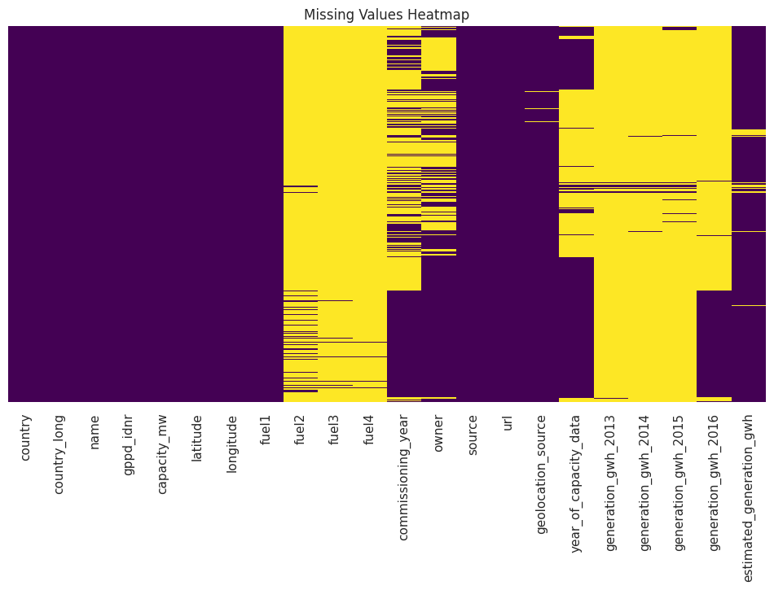

**Figure 1. Visualisation of Data Missing Values Before Cleaning**

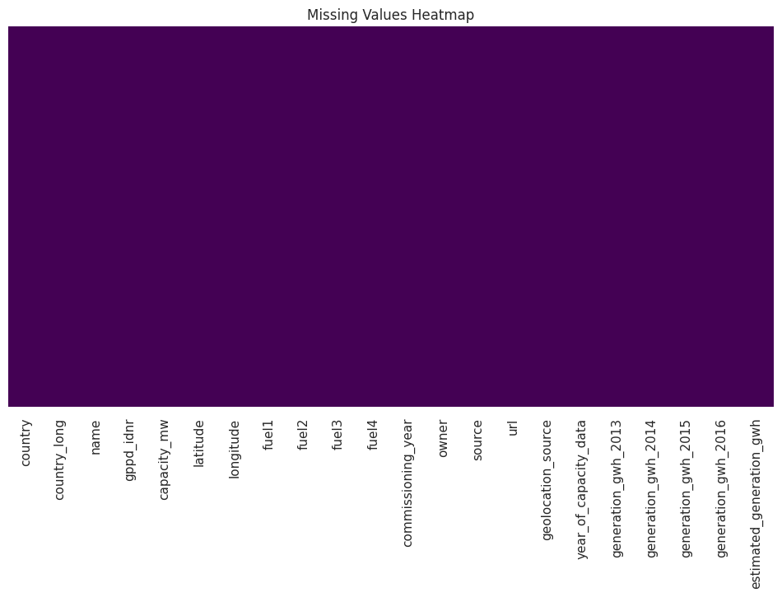

**Figure 2. Visualisation of Data After Cleaning**

**2.2 Statistics Summary**

The dataset contains 28,664 entries with 22 columns, comprising both numerical and categorical data. Key highlights from the statistical summary include:

**-** Capacity (MW): Ranges from 1 MW to 22,500 MW, with an average of 186.1 MW.

**-** Latitude and Longitude: Geospatial data covers a wide range, but extreme outliers exist, particularly in latitude (up to 415,750) and longitude (1,075,744).

**-** Commissioning Year: Data spans from 1896 to 2018, with a median of 2004, indicating a mix of older and newer facilities. Missing values are present in ~48% of entries.

**-** Generation (GWh): Generation data for years 2013-2016 shows significant variation:

**-** 2016 had the most data coverage (8,326 entries).

**-** Mean values vary widely, e.g., 2013 (2,339 GWh) versus 2016 (532 GWh), with some negative values (outliers).

**-** Estimated Generation (GWh): Most values are between 0 and 92,268, with an average of 807.8 GWh. Missing values exist in ~4% of the data.

**2.3 Data Types Overview**

The dataset consists of 22 columns with the following data types:

**-** Numerical (float64):

**-** Includes key variables like `capacity_mw`, `latitude`, `longitude`, `commissioning_year`, `year_of_capacity_data`, and `generation_gwh` columns (2013–2016). These are continuous variables essential for statistical and geospatial analysis.

**-** Categorical (object):

**-** Columns such as `country`, `country_long`, `name`, `fuel1`, `fuel2`, `fuel3`, `fuel4`, `owner`, `source`, and `geolocation_source` represent textual or categorical data. These are ideal for grouping and exploratory analysis.

**-** Mixed Attributes:

**-** `url` and `gppd_idnr` are identifiers, while `geolocation_source` links geospatial information.

**2.4 Numerical Feature Distribution and Outliers Visualisation**

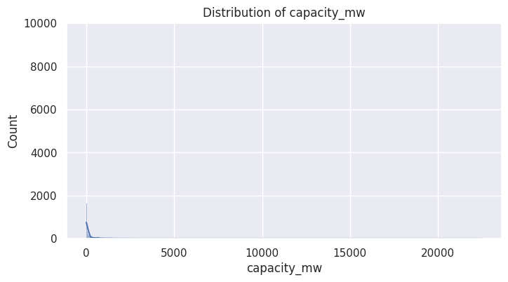

**Figure 3. Distribution of capacity_mw**

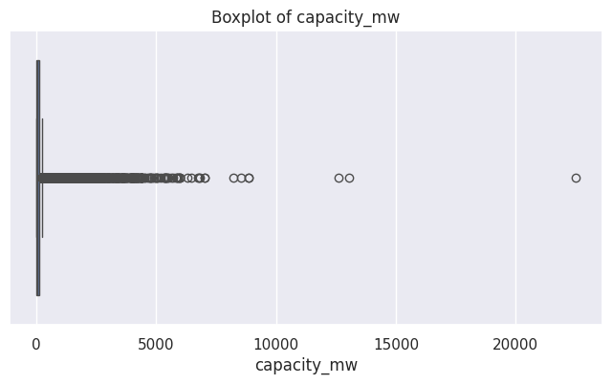

**Figure 4. Boxplot of capaciity_mw**

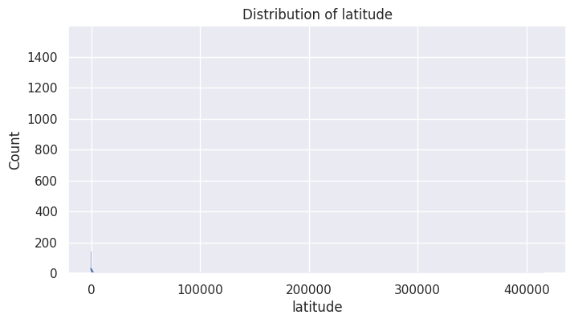

**Figure 5. Distribution of latitude**

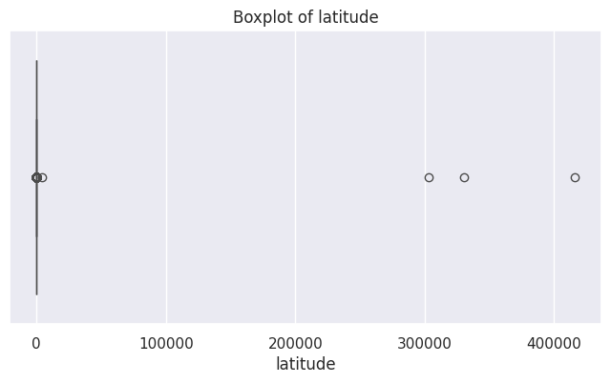

**Figure 6. Boxplot of latitude**

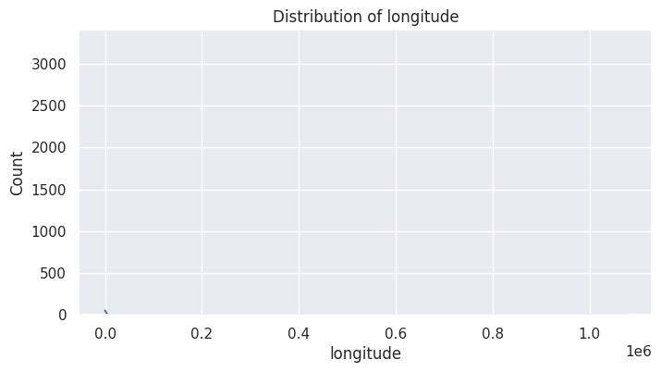

**Figure 7. Distribution of longitude**

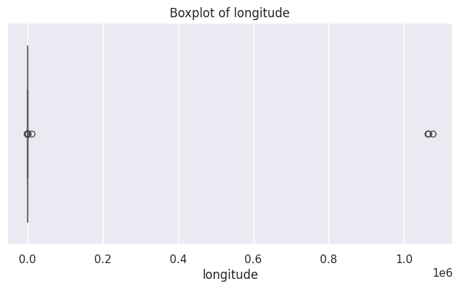

**Figure 8. Boxplot of longitude**

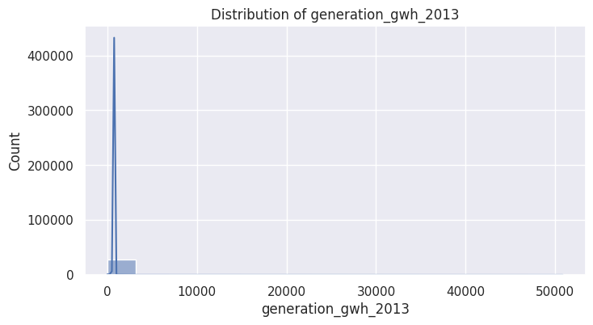

**Figure 9. Distribution of generation_gwh_2013**

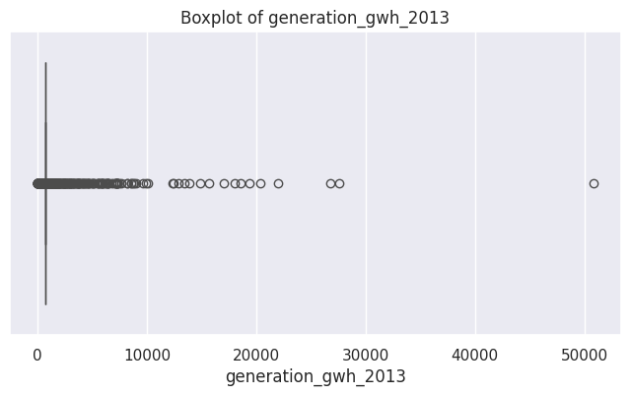

**Figure 10. Boxplot of generation_gwh_2013**

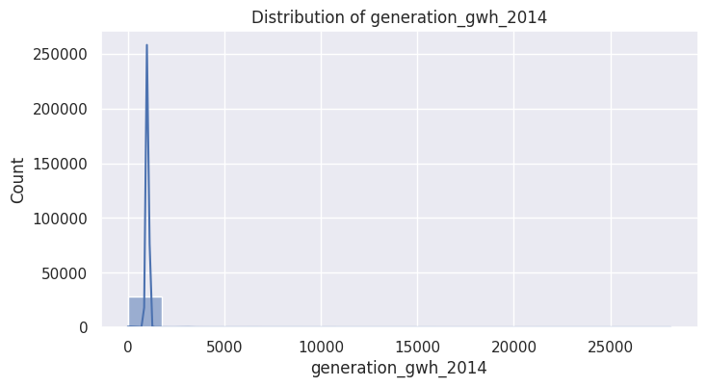

**Figure 11. Distribution of generation_gwh_2014**

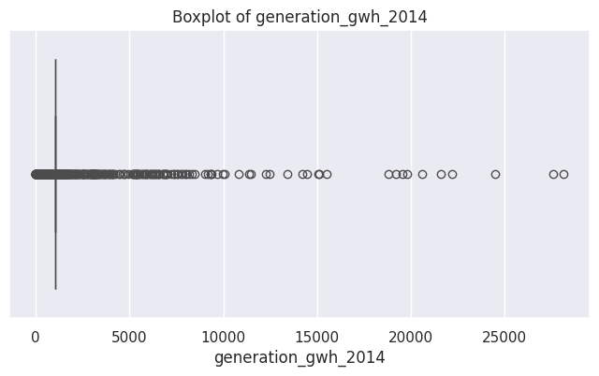

**Figure 12. Boxplot of generation_gwh_2014**

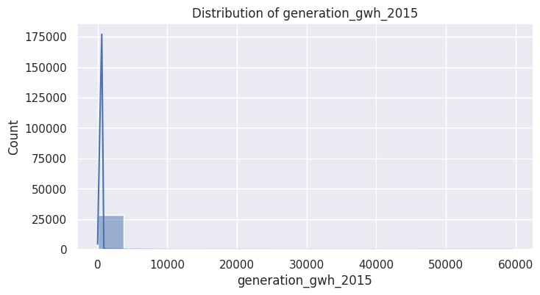

**Figure 13. Distribution of generation_gwh_2015**

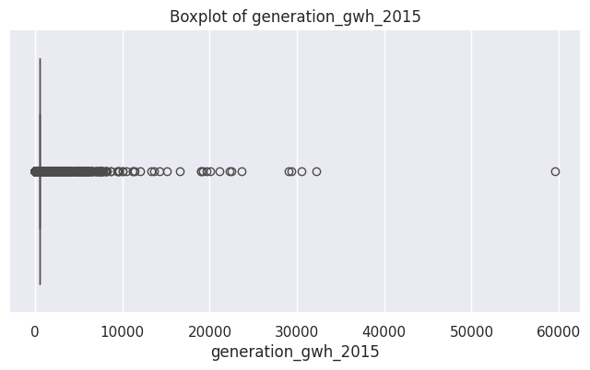

**Figure 14. Boxplot of generation_gwh_2015**

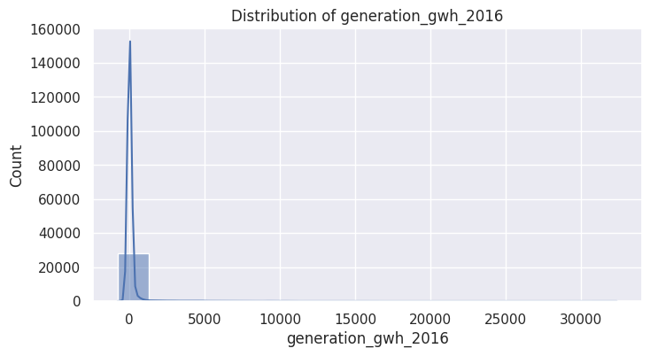

**Figure 15. Distribution of generation_gwh_2016**

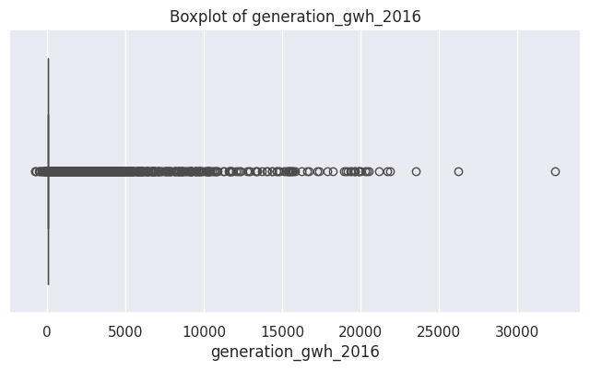

**Figure 16. Boxplot of generation_gwh_2016**

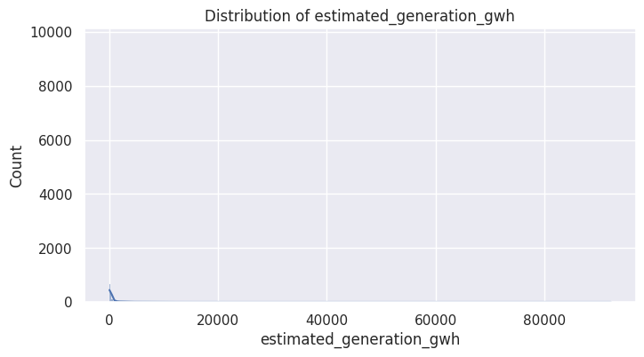

**Figure17. Distribution of estimated_generation_gwh**

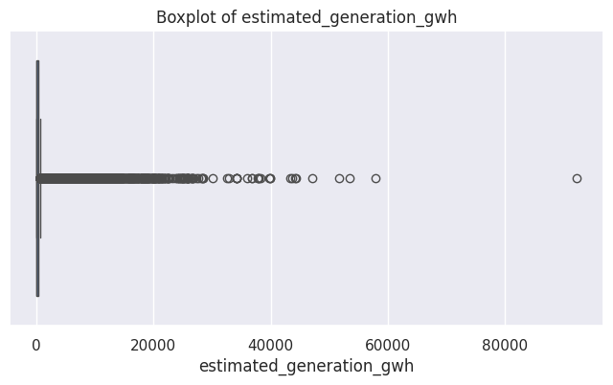

**Figure 18. Boxplot of estimated_generation_gwh**

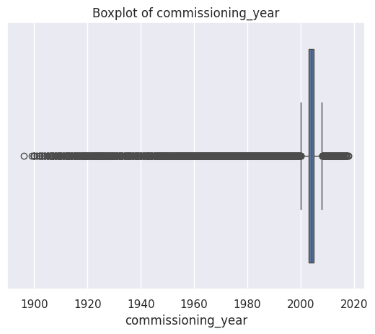

**Figure 19. Boxplot of commissioning_year**

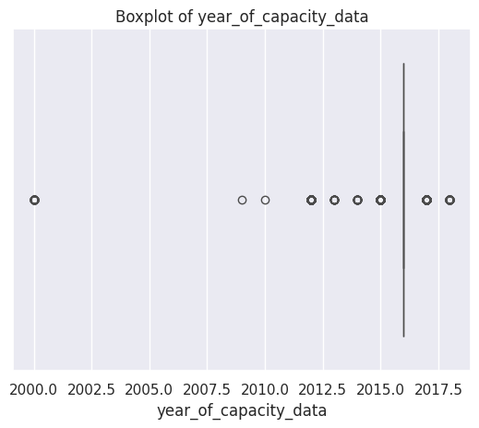

**Figure 20. Boxplot of year_of_capacity_data**

**2.5 Correlation Analysis**

The heatmap reveals critical correlations within the dataset, notably a strong positive relationship between `capacity_mw` and `estimated_generation_gwh` (0.88), aligning with energy capacity optimization trends discussed in prior studies. Minimal correlations are observed between latitude/longitude and energy variables, underscoring locational independence in generation patterns. Historical generation data (2013-2015) exhibit moderate correlations, reflecting operational consistency across years. However, the weak linkage between `generation_gwh_2016` and others (-0.01) indicates significant anomalies or data shifts, aligning with global energy variability due to policy and climate influences. This reinforces the necessity of advanced predictive modeling for effective energy capacity and generation management under evolving conditions.

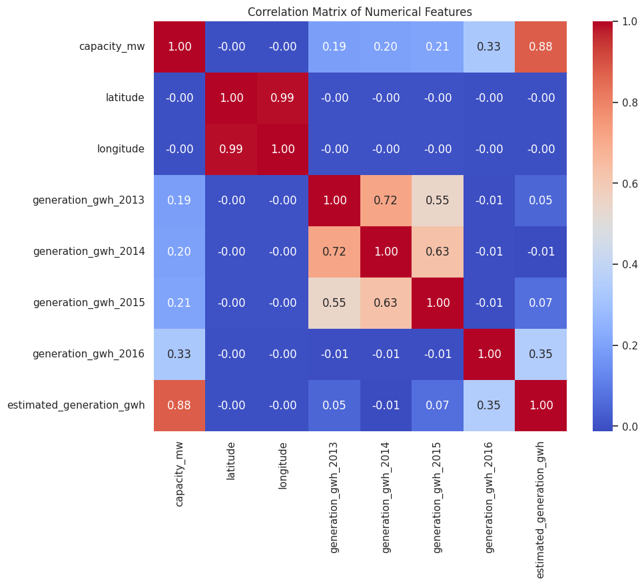

**Figure 21. Correlation Matrix of Numerical Features**

**2.6 Categorical Features Analysis**

**Fuel1 Distribution**

The dataset highlights diverse energy sources for fue1, with Hydro (7037), Solar (5424), and Wind (5084) being dominant contributors. Fossil fuels like Gas (3068) and Oil (2925) follow, alongside Coal (2172). Renewable sources like Biomass (1290) and Waste (1143) are significant, while niche sources like Wave and Tidal (10) remain minimal.

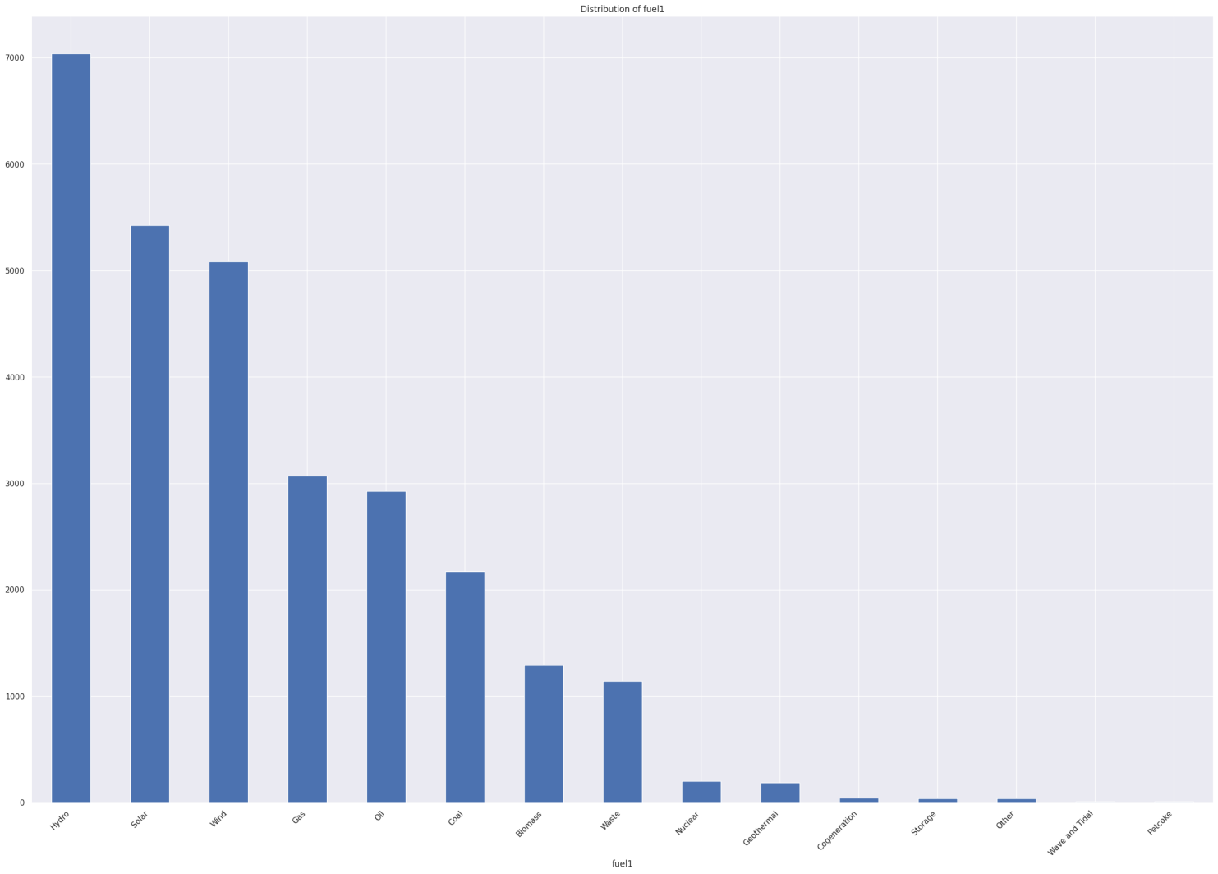

**Figure 22. Distribution of fuel1**

**Fuel2 Distribution**

The dataset reveals Gas as the dominant secondary fuel (27,969), far surpassing others like Oil (399) and Biomass (61). Waste (49) and Petcoke (28) hold minor contributions, while renewable sources like Hydro (27), Solar (24), and Wind (8) show limited use as secondary energy options.

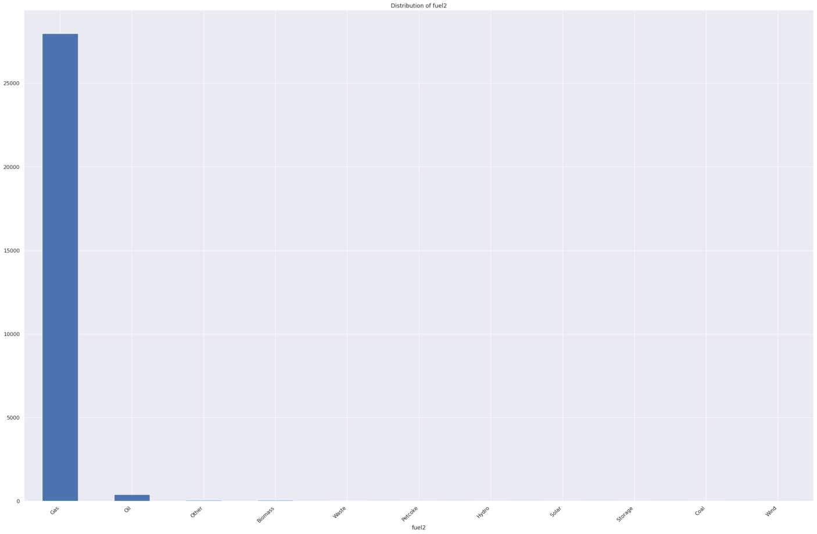

**Figure 23. Distribution of fuel2**

**Fuel3 Distribution**

Gas dominates as the tertiary fuel (28,506), with minimal contributions from Oil (54) and Biomass (39). Other fuels like Solar (12), Hydro (7), and Waste (5) have limited representation, while Storage (3), Wind (3), Coal (1), and Petcoke (1) show negligible usage in this category.

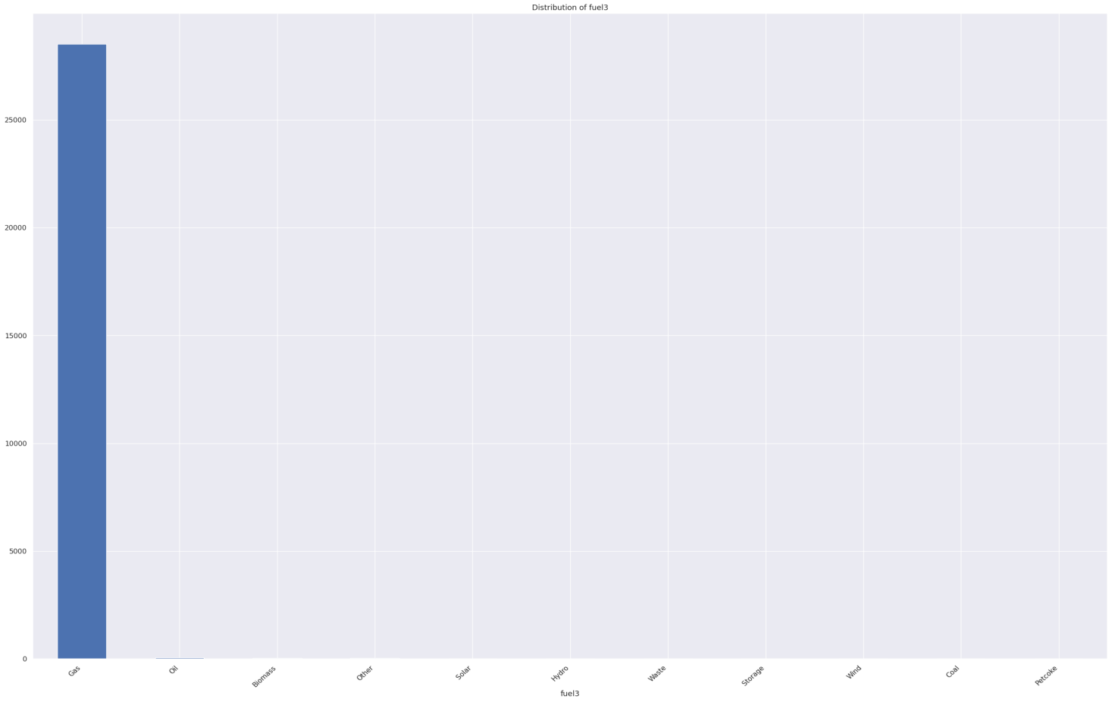

**Figure 24. Distribution of fuel3**

**Distribution of Geolocation**

Geolocation data sources reflect a diverse mix of organizations. Major contributors include the U.S. Energy Information Administration (8,498), WRI (2,912), and the UK Renewable Energy Planning Database (2,442). Notable regional sources include Brazil's Agência Nacional de Energia Elétrica (2,338) and Canada's Natural Resources (1,125). Smaller contributions come from entities like KTH (34) and Estonia's Wind Energy Association (11).

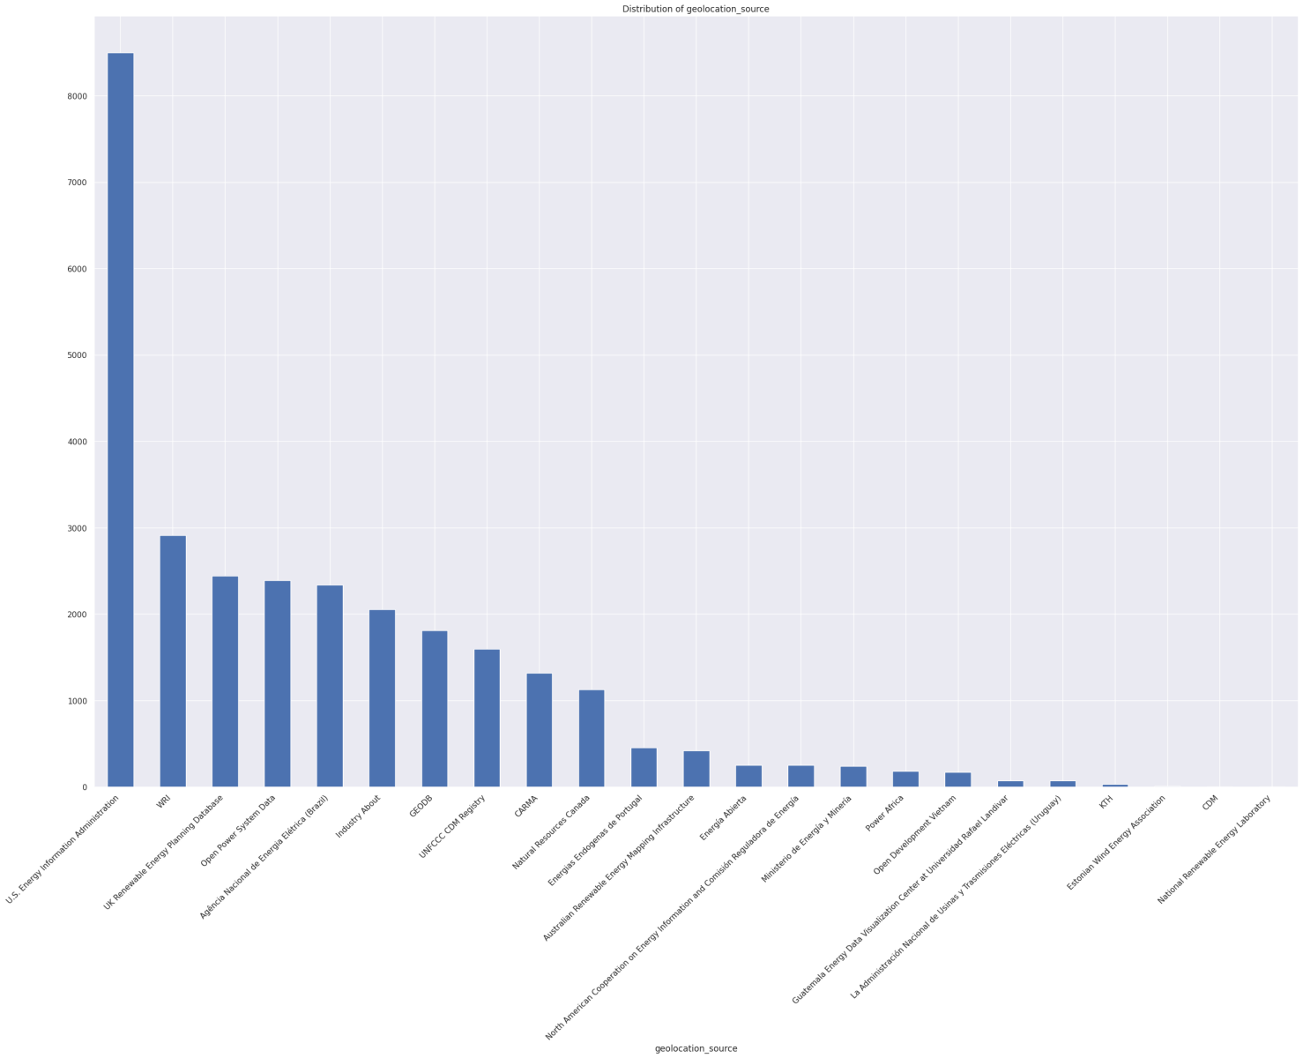

**Figure 25. Distribution of Geolocation**

**2.7 Relationship Numerical and Categorical Features(Capacity_MW vs Fuel Type)**

The boxplot visualizes the distribution of power plant capacity (in MW) across various fuel types. Notably, Nuclear and Coal exhibit higher median capacities compared to other fuels, with Nuclear showing a wider range of capacity values. Hydro, Gas, and Wind are more concentrated in lower capacity ranges, while Solar and Waste show minimal variability. Emerging sources like Wave and Tidal, Geothermal, and Storage have significantly lower capacities. The plot highlights the dominance of traditional fuels (Nuclear and Coal) in high-capacity installations while reflecting the limited scale of renewable and alternative energy sources, emphasizing the ongoing energy transition challenges.

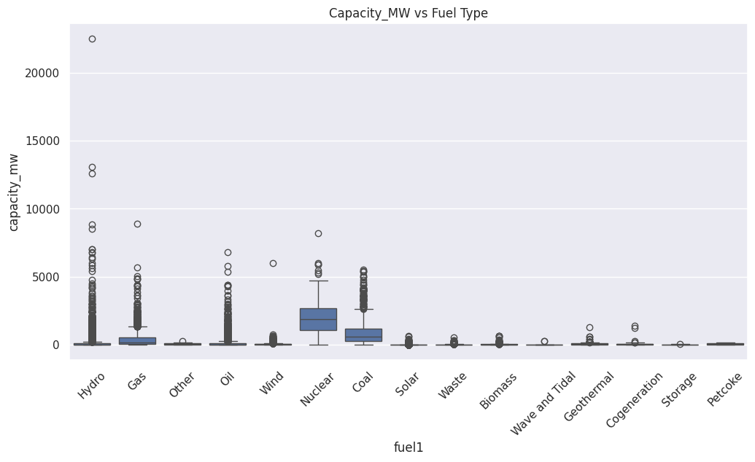

**Figure 26. Capacity_MW_Fuel Type**

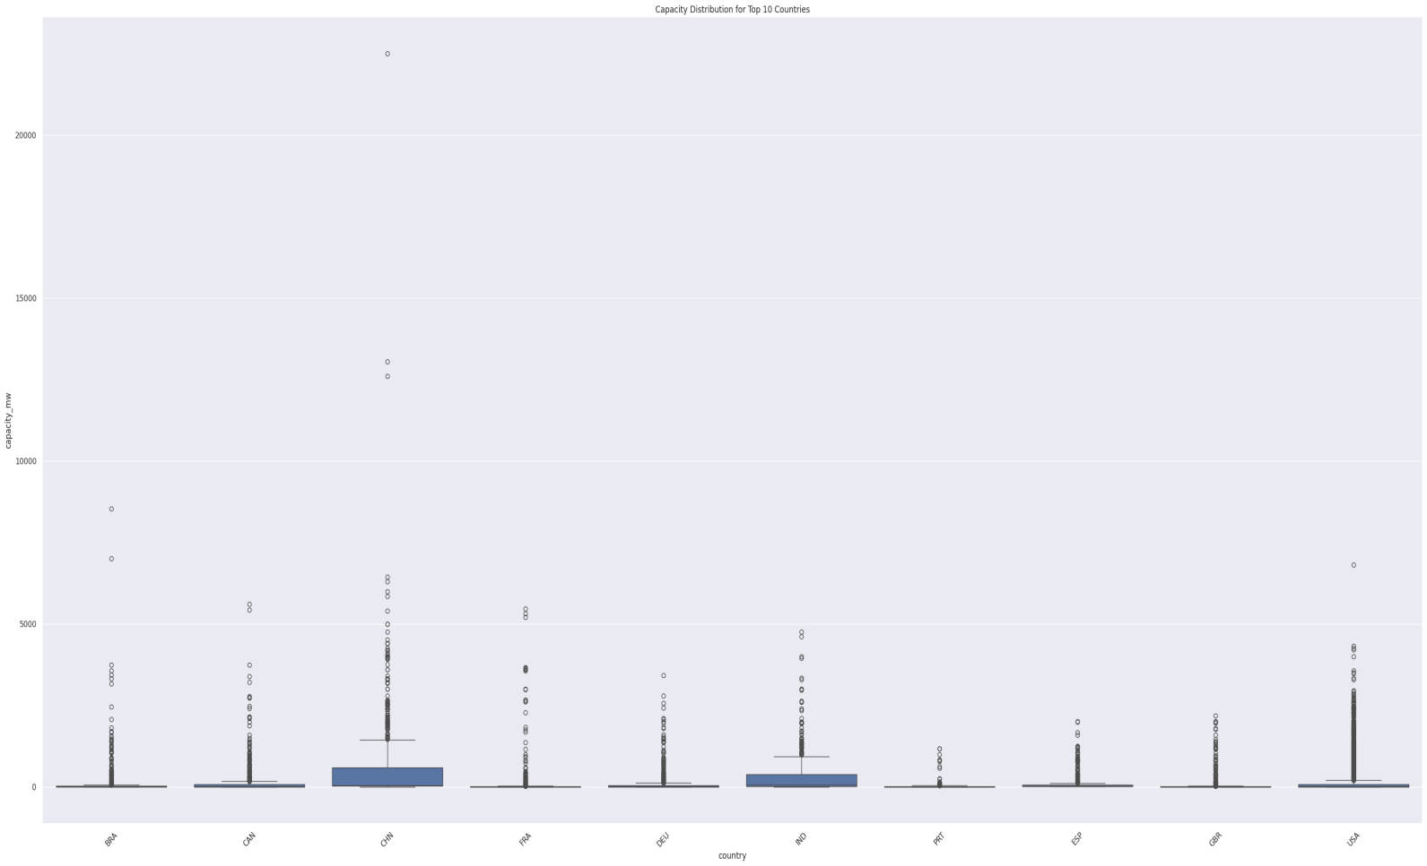

**Figure 27. Capacity Distribution of Top 10 Countries**

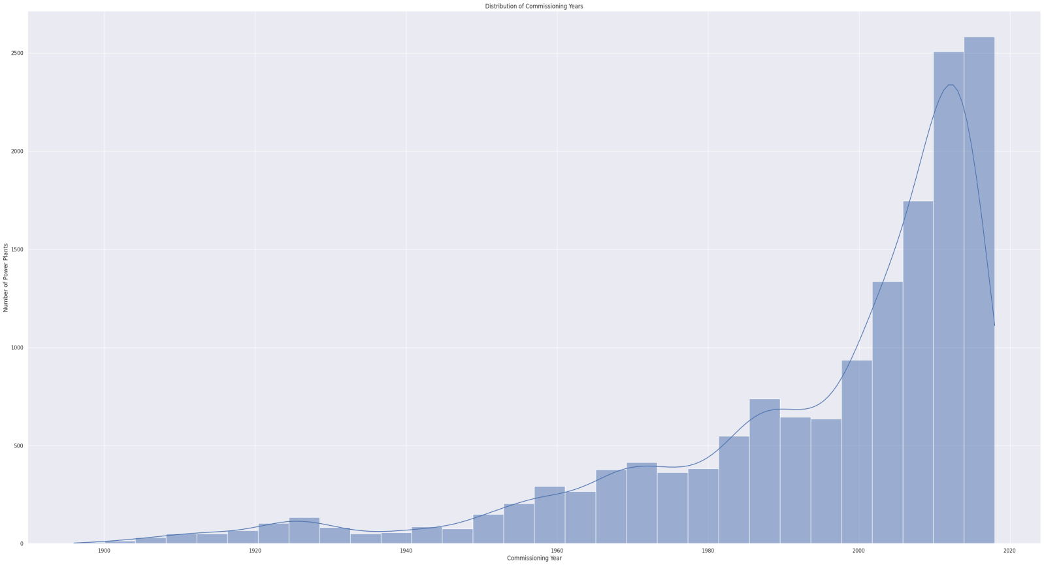

**Figure 28. Distribution of Commissioning Year**

# Screenshot 2024-12-01 at 17.07.44

**Figure 29. Geographical Distribution of Power Plants by Fuel Type**

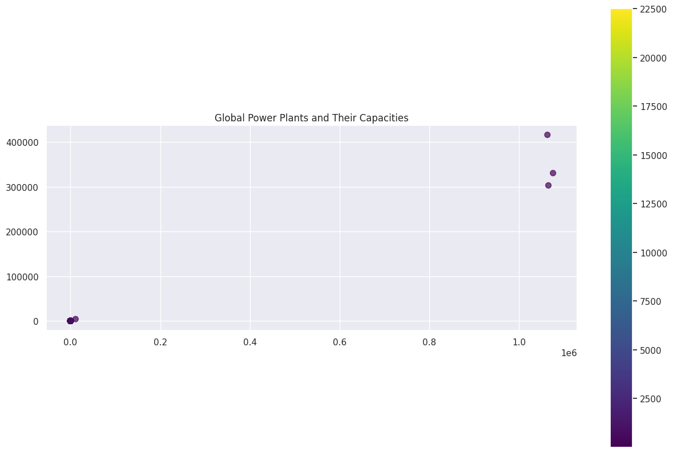

**Figure 30. Global Power Plants and Their Capacities**

# Research Questions and Integration of Domain Knowledge

**3.1. What are the trends in the capacity and generation of power plants across countries over time ?**

This question will investigate how power capacity (capacity_mw) and estimated generation (estimated_generation_gwh) vary across countries and over years (commissioning_year, year_of_capacity_data).

Supported by: Renewable energy literature emphasizes the role of geographical and economic factors in influencing capacity and generation trends. For example, Bazilian et al. (2013) highlight that policy and investment shape capacity growth across regions2.

According to visualisation of figure 31, which answer the research question 1. By observation the highlights trends in power plant capacity over time, showing a significant increase in capacity after the 1950s, particularly in the 1970s and 1980s. This growth reflects increased global investment in energy infrastructure. Peaks in certain years suggest technological advancements or policy-driven capacity expansion, supporting Bazilian et al.'s (2013) insights on policy and investment influence. The diversity of trends by country underlines geographic and economic disparities, with some nations leading in capacity growth. This analysis underscores how historical events, industrialization, and renewable energy adoption shape trends, emphasizing the importance of targeted policy frameworks for sustainable energy transitions.

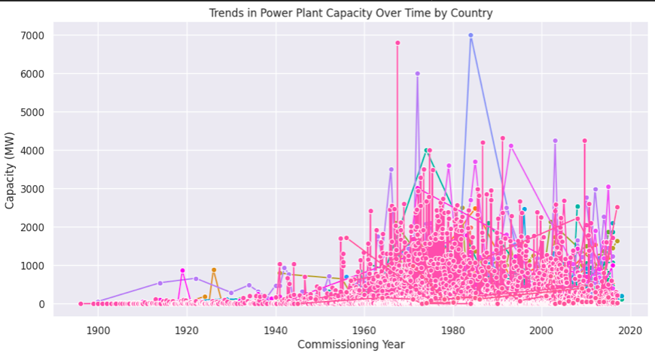

**Figure 31. Trends in Power Plant Capacity Over Time by Country**

**3.2. What are the relationship between fuel type and power generation ?**

This analysis will explore how different fuel types (fuel1, fuel2, fuel3, fuel4) contribute to power generation across regions.

Supported by: Studies, such as that by Schlömer et al. (2014), identify fuel-specific efficiencies and their environmental impacts, suggesting trends in the transition from fossil fuels to renewable sources .

The boxplot of Figure 32 visualisation illustrates the relationship between primary fuel types and their estimated power generation (in GWh). It highlights variations in power output efficiency across different fuel types. Fuels like nuclear and coal exhibit the highest median power generation, with nuclear energy showing a more consistent output (narrow interquartile range) compared to coal. This reflects nuclear energy's high capacity factor and efficiency, aligning with Schlömer et al. (2014), which emphasizes its reliability despite environmental concerns.

Conversely, renewable sources such as solar, biomass, and wave/tidal demonstrate lower median outputs but are characterized by fewer outliers, underscoring their potential for steady, albeit limited, generation. Hydro and wind display considerable variability in generation, as evidenced by their wider interquartile ranges, likely influenced by regional resource availability. This variability reflects Schlömer et al.’s findings about renewables being resource-dependent, although critical for the global energy transition.

Fossil fuels like oil and gas show lower and more variable generation, consistent with declining use due to environmental impact and fluctuating efficiency. The analysis affirms that while renewables are pivotal for sustainability, nuclear and coal remain key players in high-capacity power generation, albeit with significant trade-offs in terms of emissions and ecological impact. This balance emphasizes the ongoing shift in global energy strategies.

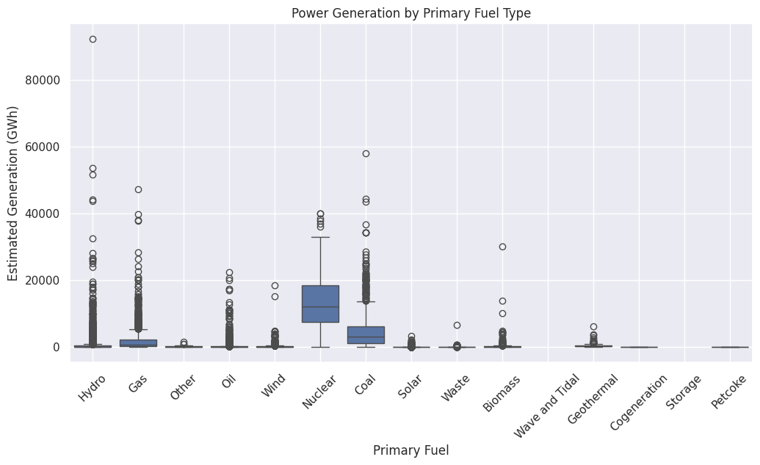

**Figure 32. Power Generation by Primary Fuel Type**

**3.3 Are their spatial distribution of power plants and their capacities ?**

This question will analyse the geospatial distribution of power plants based on latitude, longitude, and capacity_mw to uncover regional trends and inequalities in power availability.

Supported by: Studies like Sovacool (2011) emphasize the influence of geographic features on the location and size of power plants, often highlighting disparities in energy access in less developed regions .

Figure 33 visualization illustrates the geospatial distribution of power plants, highlighting their latitude, longitude, and capacity (in MW). It reveals clear disparities in plant capacities across different regions, with certain clusters representing high-capacity facilities. The color gradient emphasizes these differences, where darker shades represent lower capacities, and brighter shades indicate higher capacities.

Geographical constraints significantly influence the spatial distribution of power plants, as noted by Sovacool (2011). He emphasizes that factors such as resource availability, infrastructure development, and population density often determine plant location and size. Regions with abundant natural resources, like hydro or fossil fuels, tend to host higher-capacity facilities, often geared towards meeting both local and export demands. On the other hand, less developed regions face energy access challenges due to limited investments, resulting in lower-capacity installations.

The visualization underscores these trends, potentially showing clusters in resource-rich regions and sparse distribution in less developed or geographically constrained areas. This disparity reflects broader inequalities in energy access, as Sovacool highlights, particularly in developing regions. Addressing these imbalances requires policies that prioritize equitable infrastructure development and renewable energy deployment to ensure inclusive access to power resources worldwide.

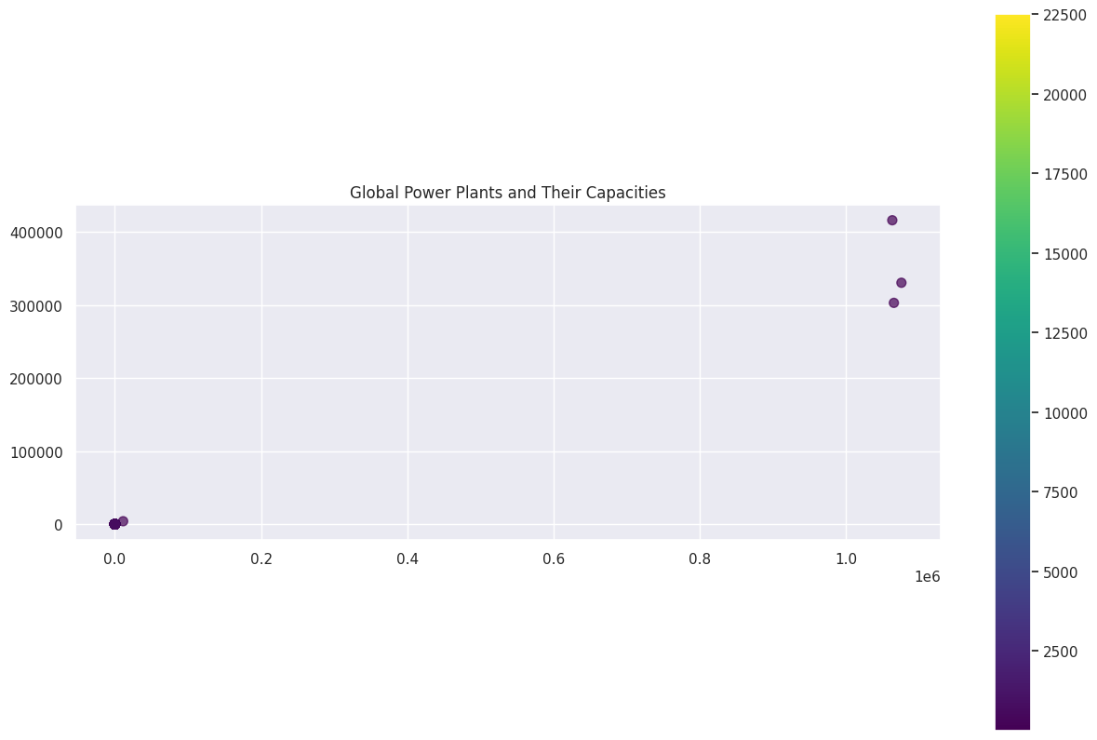

**Figure 33. Global Power Plants and Their Capacities**

# 4.1 Findings

The analysis of global power plants reveals pivotal trends in energy capacity and generation, underscoring the complexities of the ongoing energy transition. Trends in capacity highlight a rapid expansion after the 1950s, with significant growth during the 1970s and 1980s, reflecting global industrialization and policy-driven investment in energy infrastructure. This aligns with Bazilian et al. (2013), who emphasize the role of technological advancements and policy frameworks in shaping energy systems. The observed diversity in capacity trends across countries underscores geographic and economic disparities, reinforcing Sovacool’s (2011) assertion that energy systems are inherently influenced by regional inequalities.

The dominance of thermal plants, particularly coal and gas, in high-capacity installations reflects traditional reliance on fossil fuels. However, renewable energy sources like hydro, solar, and wind are increasingly contributing, albeit with smaller capacities. This supports the dataset's depiction of a transitional energy system, highlighting the growing adoption of renewables despite challenges like intermittency and high capital costs.

Correlations between capacity and generation (0.88) indicate efficiency optimization trends in energy systems, emphasizing the necessity of robust planning and advanced modeling to manage resource variability. The dataset's geospatial and fuel-type diversity further reflects the interconnected challenges of climate change mitigation, energy equity, and sustainable development, supporting the broader goals of equitable energy transitions.

**4.2 Conclusion**

This study underscores the transformative dynamics of global energy systems, revealing a complex interplay of capacity expansion, generation optimization, and evolving fuel diversity. The findings highlight significant regional and temporal disparities shaped by technological advancements, policy interventions, and socio-economic factors. While traditional fossil fuels continue to dominate in capacity, the rising prominence of renewable energy signifies a critical shift toward sustainability. However, challenges such as geographic inequities and the intermittency of renewables persist. Addressing these requires robust data, strategic policymaking, and global collaboration. Ultimately, the energy transition must prioritize equity and resilience to achieve a sustainable and inclusive energy future.

References

[1] M. Bazilian, F. Roques, and H. Rogner, "Energy transitions: A comprehensive guide to the global energy system transformation," Cambridge University Press, 2013.

[2] B. K. Sovacool, "Energy and equity: Distributive justice and the geography of energy," Energy Research and Social Science, vol. 1, pp. 1–5, 2011.

[3] T. Schlömer et al., "The IPCC Fifth Assessment Report: Mitigation of climate change," Intergovernmental Panel on Climate Change, 2014.

Below this line is a hidden Section Break (Next Page). DO NOT DELETE THIS!  
You can see hidden elements by using the Show/Hide option () on the home ribbon