**2.1. A Weighted Undirected Graph**

A graph G = (V, E) consists of:

- A set of vertices

- A set of edges $E=\{e_{0},e_{1},....\}.$

Each edge e connects a pair of vertices {u,v}, where u and v may be the same or different. The vertices u and v are called the endpoints of edge e. If u and v are the same, e is called a self loop. Edges connecting the same pair of vertices are called parallel.

In a finite graph, both V and E are finite sets. In an undirected graph, the order of the vertices in an edge does not matter.

**Paths**

A path is a sequence of edges $e_{0},e_{1},.....e_{n}$ such that:

1. Each pair of consecutive edges $e_{i}$ and $e_{i+1}$ share a common endpoint, for 0 ≤ i <n.

2. If is not a self loop, it shares one endpoint with $e_{i−1}$ and another endpoint with $e_{i+1}$ (except for the first edge $e_{0}$ and the last edge $e_{n}$.

**Weighted Graphs**

In a weighted graph, each edge e is assigned a length l(e) . The length of a path P= $e_{0},e_{1},.....e_{n}$ is the sum of the lengths of its edges:

$$l(P)=\sum_{i=0}^{n}{l(e_{i})}$$

**Additional Definitions**

- A path is simple if no vertex appears more than once.

- A graph is connected if, for every pair of vertices u and v in V, there exists a path that starts at u and ends at v.

- A circuit is a path where the start and end vertices are the same.

- A connected graph which has no circuits is called a tree.

For an example of a weighted graph, consider Figure 2.1, which includes:

- The set of vertices: {A,B,C,D,E,F}

- The set of edges: {$e_{0},e_{1},....,e_{8}$}

In this graph:

- Edges $e_{4}$ and $e_{8}$ are parallel.

- Edge $e_{8}$ is a self loop.

The length of the simple path $e_{0},e_{3},e_{7}$ is 2 + 9 + 6 = 17 .

The path $e_{0},e_{1},e_{2},e_{7},e_{6},e_{4}$ forms a simple circuit.

Additionally, the graph depicted in Figure 2.2 is a tree.

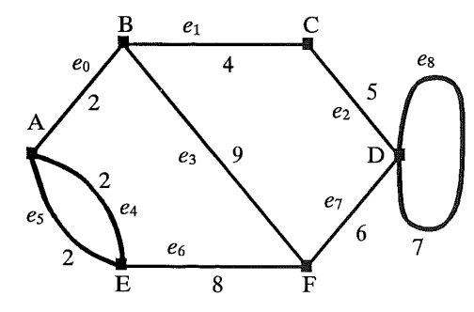

**Fig. 2.1. A weighted non-directed graph**

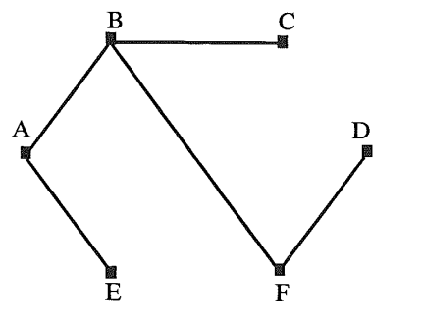

**Fig. 2.2. A tree**

**2.2. A Weighted Directed Graph**

In a directed graph, the endpoints of an edge have a specific order. The first endpoint is called the start vertex and the second endpoint is called the end vertex. An edge is considered directed from its start vertex to its end vertex.

- Parallel edges: Edges with the same start and end vertices.

- Antiparallel edges: If u $≠$ v and $e_{1}$ is directed from u to v while $e_{2}$ is directed from v to u, then $e_{1}$ and $e_{2}$ are antiparallel.

A directed path is a sequence of edges $e_{0}$, $e_{1}$,...., $e_{n}$ such that the end vertex of $e_{i}$ is the start vertex of $e_{i+1 }$ for 0 ≤ i < n. The length of a directed path and a simple directed path are defined similarly to those in an undirected case.

A directed graph (V, E) is called strongly connected if for every pair of vertices u and v in V, there exists a directed path from u to v and a directed path from v to u. A weighted, directed, strongly connected graph is known as a network.

**2.3. Representing a Road Network by a Graph**

A (physical) road network can be represented using a weighted, non-directed, finite graph.

- Vertices V: Represent the road structures.

- Edges E: Represent the connecting roads.

An edge e connects two vertices u and v if and only if there is a road connecting the road strucrures represented by u and v.

The length of an edge e, denoted l(e), is defined as the distance (in kilometers, for instance) separating the road structures connected by e. The length of a path in the road network is the total distance covered by traveling along that path.

To illustrate this, consider a graph representing a small part of the London Road network, which has been simplified and modified for clarity; see Figure 2.3. This example demonstrates how the distances between road structures can be represented as edge lengths in a graph, and how the total distance of a path can be calculated by summing the lengths of the edges that comprise it.

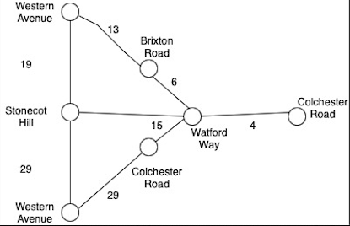

**Fig. 2.3.**

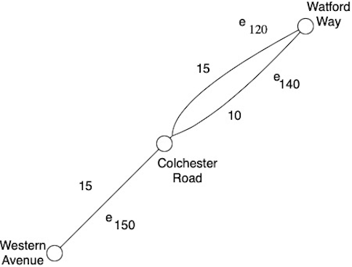

**Fig. 2.4.**

**Representing a London Road Network by a Graph**

**London Road Network**

The vertices of the graph represent different road structures in the London Road Network. The edges represent the connecting roads, and the lengths of these edges are the distances used for tariff calculations.

For instance, consider the path:

- Western Avenue > Stonecot Hill > Watford Way > Colchester Road > Western Avenue

The total length of this path is 78 km.

**Example Representation in a Graph**

A network of road services can be represented by a **weighted directed graph**. Here, the road structures are represented by the vertices of the graph. An edge \( e \) directed from a start vertex \( u \) to an end vertex \( v \) represents a traveler moving from the starting point represented by \( u \) (e.g., Road A) to the endpoint represented by \( v \) (e.g., Road B). The length of an edge is the time it takes to travel from Road A to Road B.

#### Specific Example with Three Road Structures

Consider three road structures: Watford Way, Colchester Road, and Western Avenue, with the following travel scenarios:

- **Two cars** traveling from Watford Way to Colchester Road:

- Represented by edges \( e_{120} \) and \( e_{140} \)

- **One car** traveling from Colchester Road to Colchester Road:

- Represented by edge \( e_{150} \)

In this example:

- The vertices are the road structures (Watford Way, Colchester Road, and Western Avenue).

- The directed edges (e.g., \( e_{120} \), \( e_{140} \), \( e_{150} \)) represent the travel paths between these road structures.

- The weight of each edge is the travel time between the corresponding roads.