**What is the HTML**

HTML stands for HyperText Markup Language.

* A markup language defines the structure and presentation of raw text.
* A HyperText is text displayed on a computer or device that provides access to other text through links (hyperlinks).

HTML is a markup language used to create documents on the web. It describes the structure and layout of a web page.

* HTML was originally developed by Tim Berners-Lee while at CERN.(1991) HTML5(2014)

HTML Page Structure

* The **<head>** element contains metadata about the page. HTML metadata is data about the HTML document and metadata is not displayed. Metadata typically defines the document title, character set, styles, scripts, and other meta information.
* The **<body>** element indicates what should appear in the main browser window.

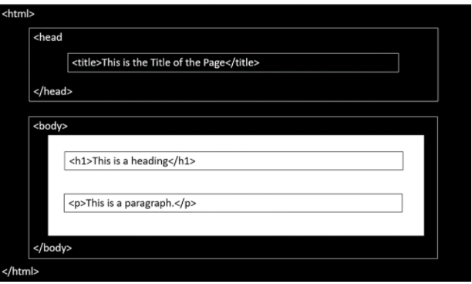

**A Simple HTML Document**

<!DOCTYPE html>

<html>

<head>

<title>Page Title</title>

</head>

<body>

<h1>This is a Heading</h1>

<p>This is a paragraph.</p>

</body>

</html>

* The **<!DOCTYPE html>** declaration defines this document to be HTML5.
* The **<html>** element is the root element of an HTML page.
* The **<head>** element contains meta information about the document.
* The **<title>** element specifies a title for the document.
* The **<body>** element contains the visible page content.
* The **<h1>** element defines a large heading.
* The **<p>** element defines a paragraph.

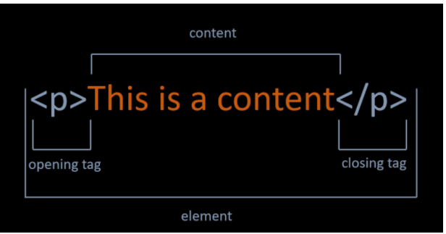

***https://www.w3schools.com/tags/default.asp**** All elements in HTML.

**HTML Div Tag**

The <div> tag defines a division or a section in an HTML document.

The <div> tag is used as a container for HTML elements - which is then styled with CSS or manipulated with JavaScript.

Note: By default, browsers always place a line break before and after the <div> element.

**HTML Attributes**

Attributes provide additional information about the contents of an element. Attributes are always specified in the opening tag and are made up of two parts: a name and a value, separated by an equals sign.

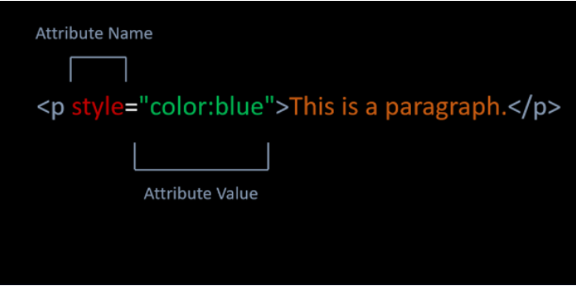

**HTML Headings**

Headings are used to describe content, like the title of an article. HTML has six "levels" of headings, which are graded according to importance. Headings are defined with **the <h1> to <h6>** tags. **<h1>** defines the most important heading. **<h6>** defines the least important heading.

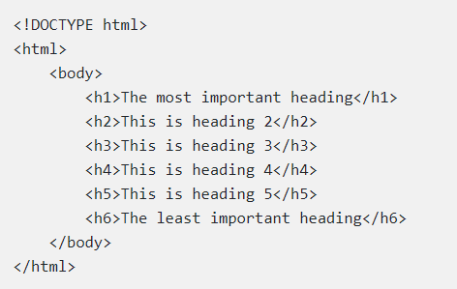

**HTML Paragraphs**

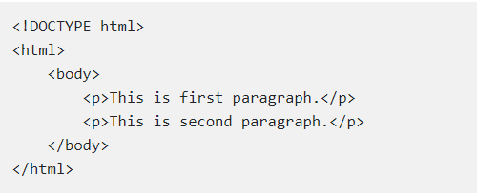

**Horizontal Lines**

The **<hr>** tag creates a horizontal line.

The **<hr>** tag is displayed as a horizontal rule.

The **<hr>** tag is used to separate content on a HTML page.

**HTML Line Breaks**

The HTML **<br>** tag stands for a line break.

The **<br>** tag is used to add a single line break.

The **<br>** tag has no end tag.

**HTML Comments**

Comments can add the text between these characters.

**<!-- This is a comment-->**

**HTML Formatting Elements**

**HTML < b > Element**

The **<b>** element is used to define bold text.



**HTML < strong > Element**

The **<strong>** element is used to define strong text.

The **<strong>** element uses for the semantic important texts.



**HTML < i > Element**

The **<i>** element is used to define italic text.



**HTML < em > Element**

The **<em>** element is used to define emphasized text.

**<em>** means that the text is "important".



**HTML < small> Element**

The **<small>** element is used to define smaller text.



**HTML < sup > Element**

The **<sup>** element is used to define superscript characters such as the suffixes of dates.



**HTML < sub > Element**

The **<sub>** element is used to define subscripted text.



**HTML < mark > Element**

The **<mark>** element is used to define marked text.



**HTML < ins > Element**

The **<ins>** element is used to define inserted text.



**HTML < del > Element**

The **<del>** element is used to define deleted text.



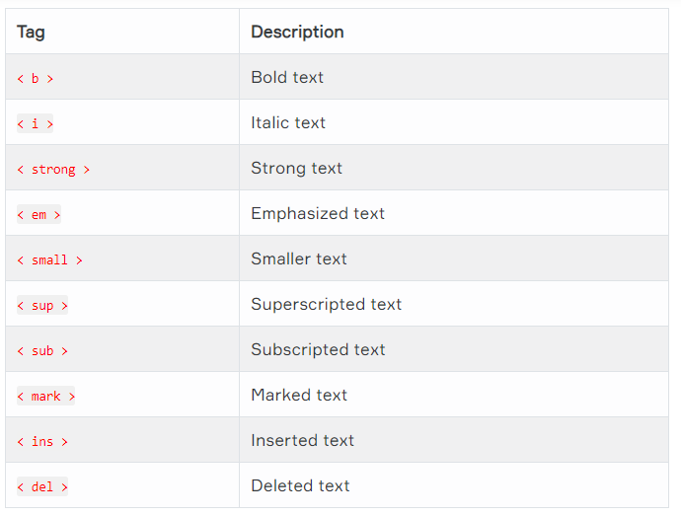

**Ordered List Elements**

The **<ol>** element is used to create ordered lists with a sequential order.

Each list item is defined by the **<li>** tag.

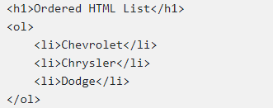

**Unordered List Elements**

The **<ul>**element is used to create unordered lists with no particular order.

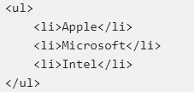

**Basics of Table**

In order to create a table in HTML, we use **<table>** tag.

The **<tr>** tag is used to define each table row.

The **<th>** tag defines a table header.

A table cell is defined with the **<td>** tag.

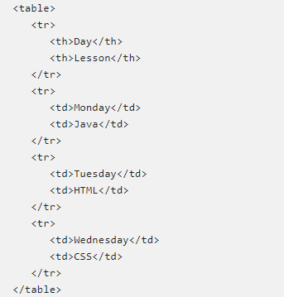

**Table Border**

We can add border to table with border attribute in table tag like example below.

**<table border="number">**

**Colspan Attribute**

We can span two or more columns by using the colspan attribute like example below.

**< td colspan="2" >Java< /td >**

**Rowspan Attribute**

We can span two or more rows by using the rowspan attribute like example below.

**< td rowspan="2" >Java< /td >**

**Align Attribute**

To change table or cell position, we can use the align attribute inside <table> tag or <td> tag.

**<td align="center">java</td >**

**HTML Images**

**The < img > Tag**

The **<img>** tag is used to define an image.

The **<img>** tag is empty. It means that it does not have a closing tag.

The src attribute allows us to specify the web address (URL) of the image and it is mandatory.

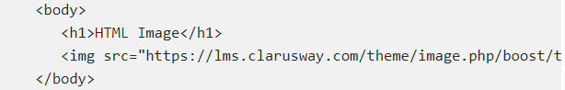

**The alt attribute**

The alt attribute is used to provide an alternate text for an image in case the image fails to load on a web page or it is not supported by the browser, etc.

<img src=”https:……..” alt=”Resim altına gelecek yazı”

**The < a > Tag**

One of the advantages of HTML , is the ability to link to other web pages.

The **<a>** element and including text is used to define a link.

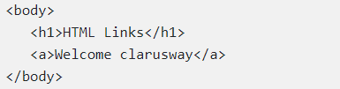

**The href Attribute**

The href attribute defines the address of the link.

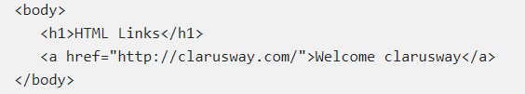

**The target Attribute**

The target attribute is used to specify how a link should open.

In order to open link in a new page, the target attribute requires a value of _blank.

<a href="http://clarusway.com/" target="_blank">Welcome clarusway</a>

**Image as a Link**

For this, it is enough to put an <img> tag between opening and closing <a> tag.

<a href="http://clarusway.com/" target="_blank"><img src="https://drive.google.com/open?id=1u4ycHASa7sVNknCxXeca2dwD7l9Va0PK" alt="A lighthouse" width="50%" height="auto"></a>