**Microservice of biling**

import json

import random

import sqlite3

def create_database():

conn = sqlite3.connect('billing.db')

cursor = conn.cursor()

# Create a table to store billing information

cursor.execute('''CREATE TABLE IF NOT EXISTS bills (

id INTEGER PRIMARY KEY AUTOINCREMENT,

customer_name TEXT NOT NULL,

amount REAL NOT NULL,

paid BOOLEAN NOT NULL DEFAULT 0

)''')

# Commit the changes and close the database connection

conn.commit()

conn.close()

def add_bill(customer_name, amount):

conn = sqlite3.connect('billing.db')

cursor = conn.cursor()

cursor.execute('INSERT INTO bills (customer_name, amount) VALUES (?, ?)', (customer_name, amount))

conn.commit()

conn.close()

def pay_bill(bill_id):

conn = sqlite3.connect('billing.db')

cursor = conn.cursor()

cursor.execute('UPDATE bills SET paid=1 WHERE id=?', (bill_id,))

conn.commit()

conn.close()

def get_unpaid_bills():

conn = sqlite3.connect('billing.db')

cursor = conn.cursor()

cursor.execute('SELECT * FROM bills WHERE paid=0')

unpaid_bills = cursor.fetchall()

conn.close()

return unpaid_bills

if _name_ == '_main_':

# Create the database (if not already created)

create_database()

# Add some sample bills

add_bill('Uzwa Safdar', 100.0)

add_bill('Esha Afzal ', 50.0)

# Get unpaid bills

unpaid_bills = get_unpaid_bills()

print("Unpaid Bills:")

for bill in unpaid_bills:

print(f"Bill ID: {bill[0]}, Customer: {bill[1]}, Amount: {bill[2]}, Paid: {bill[3]}")

# Mark a bill as paid

bill_id_to_pay = 1

pay_bill(bill_id_to_pay)

# Get updated unpaid bills

updated_unpaid_bills = get_unpaid_bills()

print("\nUpdated Unpaid Bills:")

for bill in updated_unpaid_bills:

print(f"Bill ID: {bill[0]}, Customer: {bill[1]}, Amount: {bill[2]}, Paid: {bill[3]}"

Code screenshot

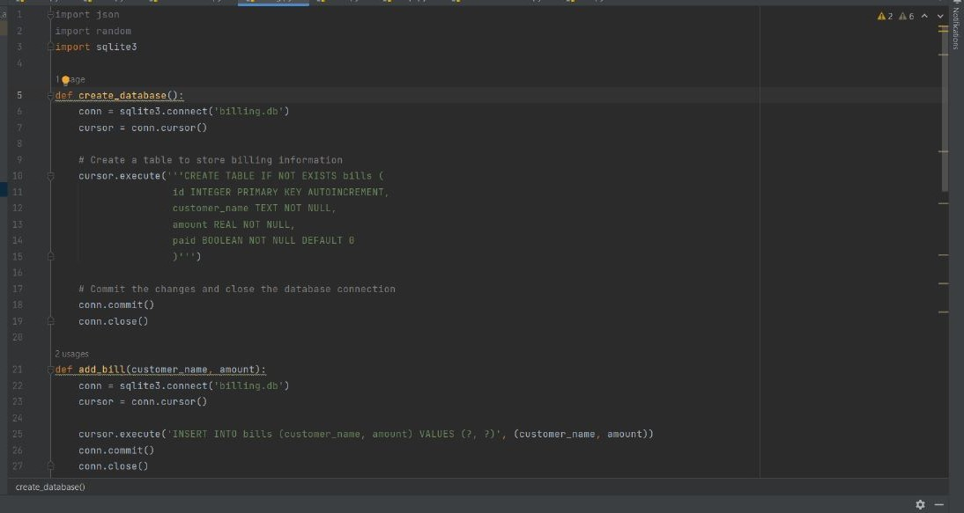

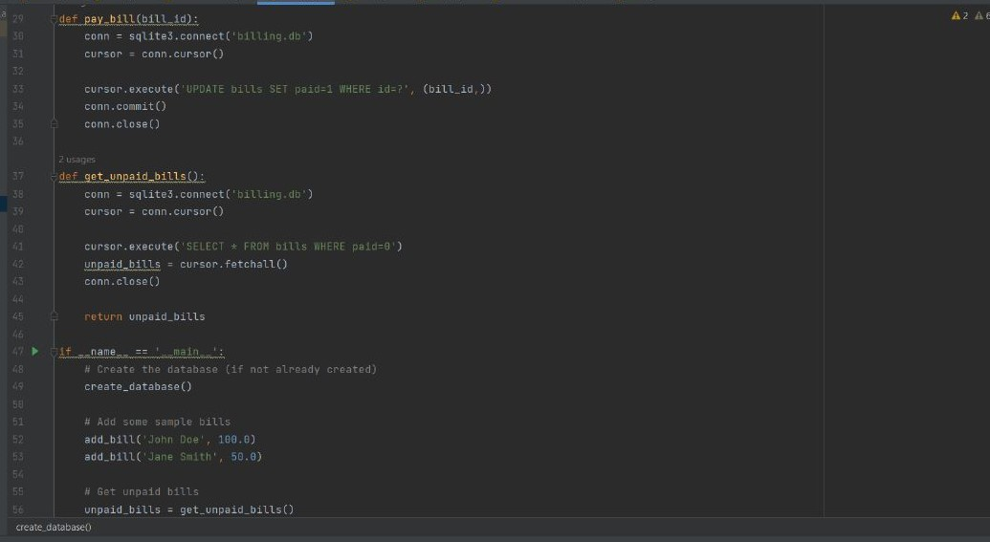

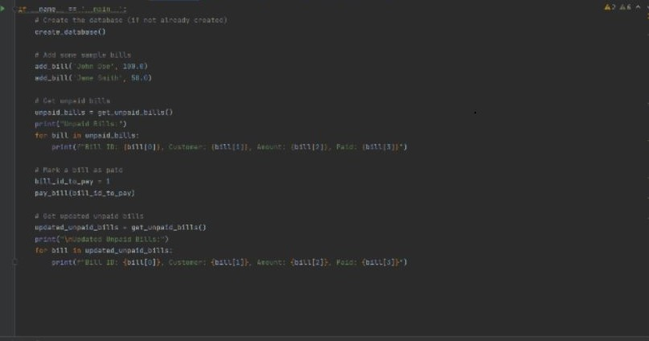

**output**

