# Zombie Apocalypse

We seek to understand the rapid spread of the infectious disease, Zombiism in a large number of people in a given population within a short period of time.

You must design simulation in NetLogo that contains humans and zombies, both humans and zombies are autonomous agents.

Humans turn into zombies if they are bitten by zombies. Humans will attempt to avoid zombies but if they do get into a conflict with a zombie they will kill the zombie according to a particular percentage of the time determined by the global variable convert_probability

### Setup Requirements

1. The world must be 101 patches wide by 101 patches high
2. The origin of the world must be at the centre (center)
3. The world must wrap both horizontally and vertically
4. The patch size must be set to 5
5. The framerate must be set to 30 frames per second

### Overall Model Requirements

1. The following code must be placed the beginning of your model:

breed [humans person]

breed [zombies zombie]

globals [convert_probability]

1. A breed called humans must be used to represent the humans in the model
2. A breed called zombies must be used to represent the zombies in the model
3. The global variable convert_probability must be used to set the probability of a human being converted to a zombie when a zombie is encountered

### World Setup

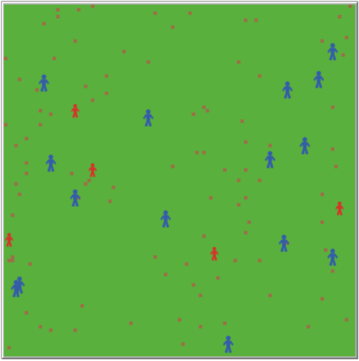The model must have a function called setup_world that sets up the world with the following parameters:

1. Creates 5 randomly placed zombies that are set to size 4, are person shaped and are red in color
2. Creates 15 randomly placed humans that are set to size 5, are person shaped and are blue in color
3. Sets the background color of your world to green using the patches
4. Creates 100 randomly placed patches that are brown in color. These patches should represent solid blocks in your world that the agent cannot pass through
5. No humans or zombies should be placed on a brown patch as this would make it impossible for the agent to move
6. Humans and zombies should not be initialised within 5 patches of each other.
7. The model must clear any previous activities when the setup_world procedure is called
8. Your simulation must run in full when a function called run_model is called, must add a tick to the counter as it runs

### Human Behaviours

The human agents in your model must behave according to the following parameters:

1. Humans must be able to move and wander in any direction
2. Humans must not be able to pass though brown patches as these are meant to represent solid structures
3. The speed at which humans move must be set at a randomly selected float value between 1 and 2 to represent variability in the agents
4. The orientation (heading) of the human must be set randomly when wandering but must be limited to a range of 90 degrees (45 to the left and 45 to the right) per step taken
5. Humans must try to avoid zombies if they are within their sight in a radius of between 10 and 20 patches
6. When humans are unable to avoid zombies they must attempt to fight and kill the zombie. The probability of a human winning a fight with a zombie must be determined by the global variable convert_probability. i.e. if convert_probability is set to 8 the human would have an 80% chance of winning the fight and killing the zombie and the zombie would have a 20% chance of converting the human to a zombie
7. When a human is converted to a zombie it must change breeds and have the same parameters as a zombie (color, size, speed, etc…).
8. When a human kills a zombie the zombie must die and be removed from the population

### Zombie Behaviours

1. Zombies must be able to move and wander in any direction
2. Zombies must not be able to pass though brown patches as these are meant to represent solid structures
3. Zombies must move forward at a speed of 0.5 (slower than humans)
4. Zombies must be attracted to humans by smell and must have a smell radius of 10
5. Zombies must attempt to convert humans to zombies
6. When zombies get killed they must die and be removed from the population