(1) Write a program to demonstrate Tightly Coupled code.
Code:
Ques1Manager.java

package com.bootcamp.springAssignment.SpringAssignment.TightlyCoupled;
public class Ques1Manager {
private Ques1Lazy ques1Lazy;
private Ques1Excellent ques1Excellent;
public Ques1Manager(Ques1Lazy ques1Lazy, Ques1Excellent ques1Excellent) {
this.ques1Lazy = ques1Lazy;
this.ques1Excellent = ques1Excellent;
}
public void mycall()
{
ques1Excellent.work();
ques1Lazy.work();
}
}

Ques1Excellent.java
package com.bootcamp.springAssignment.SpringAssignment.TightlyCoupled;
public class Ques1Excellent {
public void work()
{
System.out.println("\nExcellent is workings");
}
}

Ques1Lazy.java
package com.bootcamp.springAssignment.SpringAssignment.TightlyCoupled;
public class Ques1Lazy {
public void work()
{
System.out.println("\nLazy is working");
}
}

Ques1MainApp.java
package com.bootcamp.springAssignment.SpringAssignment.TightlyCoupled;
public class Ques1MainApp {
public static void main(String[] args) {
//Now in this we are demonstrating Tightly Coupled Exampmle
Ques1Manager ques1Manager=new Ques1Manager(new Ques1Lazy(),new Ques1Excellent());
System.out.println("-----------------");
ques1Manager.mycall();
}
}

Output
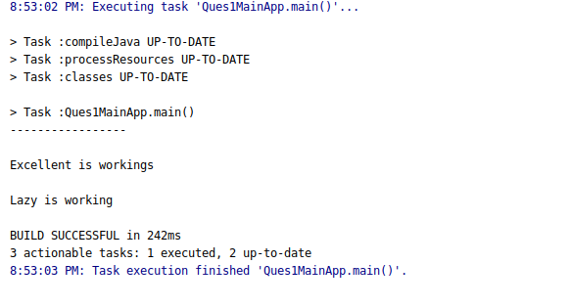

(2) Write a program to demonstrate Loosely Coupled code.
Code:

Ques2Worker.java

package com.bootcamp.springAssignment.SpringAssignment.LooselyCoupled;
public interface Ques2Worker {
void dowork();
}

Ques2Manager.java
package com.bootcamp.springAssignment.SpringAssignment.LooselyCoupled;
public class Ques2Manager {
private Ques2Worker ques2Worker;
public Ques2Manager(Ques2Worker ques2Worker) {
this.ques2Worker = ques2Worker;
}
public void myCall()
{
ques2Worker.dowork();
}
}

Ques2Excellent.java
package com.bootcamp.springAssignment.SpringAssignment.LooselyCoupled;
public class Ques2Excellent implements Ques2Worker {
@Override
public void dowork() {
System.out.println("Excellent is working");
}
}
Ques2Lazy.java
package com.bootcamp.springAssignment.SpringAssignment.LooselyCoupled;
public class Ques2Lazy implements Ques2Worker{
@Override
public void dowork() {
System.out.println("Lazy is working");
}
}
Ques2Main.java
package com.bootcamp.springAssignment.SpringAssignment.LooselyCoupled;
public class Ques2Main {
public static void main(String[] args) {
//Lossely Coupled Example
//We are using the interface concept
Ques2Manager ques2Manager=new Ques2Manager(new Ques2Excellent());
//If we want to call Lazy
// Ques2Manager ques2Manager=new Ques2Manager(new Ques2Lazy());
ques2Manager.myCall();
}
}
Output
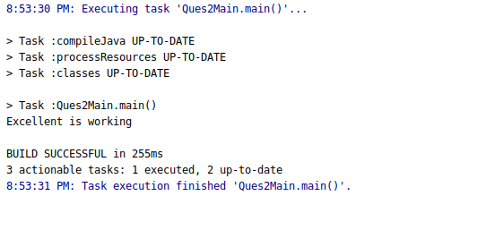

(3) Use @Compenent and @Autowired annotations to in Loosely Coupled code for dependency management
(4) Get a Spring Bean from application context and display its properties.
(5) Demonstrate how you will resolve ambiguity while autowiring bean (Hint : @Primary)
(6) Perform Constructor Injection in a Spring Bean

Solution: The answers of above 3 to 6 question is given below in code:
Code:
Ques3Excellent.java

Use @Primary annotation

package com.bootcamp.springAssignment.SpringAssignment;
import org.springframework.context.annotation.Primary;
import org.springframework.stereotype.Component;
@Component //Use of component
@Primary
public class Ques3Excellent implements Ques3Worker {
@Override
public void dowork() {
System.out.println("\nExcellent is working");
}
}

Ques3Lazy.java
package com.bootcamp.springAssignment.SpringAssignment;
import org.springframework.stereotype.Component;
@Component
public class Ques3Lazy implements Ques3Worker {
@Override
public void dowork() {
System.out.println("\nLazy is working");
}
}

Ques3Manager.java
package com.bootcamp.springAssignment.SpringAssignment;
import org.springframework.beans.factory.annotation.Autowired;
import org.springframework.stereotype.Component;
@Component
public class Ques3Manager {
private Ques3Worker ques3Worker;
@Autowired //Use of Autowired
public Ques3Manager(Ques3Worker ques3Worker) { //This is constructor injection
this.ques3Worker = ques3Worker;
}
public void myCall()
{
ques3Worker.dowork();
}
}

Ques3Worker.java
package com.bootcamp.springAssignment.SpringAssignment;
public interface Ques3Worker {
void dowork();
}

SpringAssignmentApplication.java
package com.bootcamp.springAssignment.SpringAssignment;
import org.springframework.boot.SpringApplication;
import org.springframework.boot.autoconfigure.SpringBootApplication;
import org.springframework.context.ApplicationContext;
@SpringBootApplication
public class SpringAssignmentApplication {
public static void main(String[] args) {
// Ques3 : Use @Compenent and @Autowired annotations to in Loosely Coupled code for dependency management
//@Component for make the Bean
// Ques4 : Get a Spring Bean from application context and display its properties.
ApplicationContext applicationContext=SpringApplication.run(SpringAssignmentApplication.class, args);
Ques3Manager ques3Manager=applicationContext.getBean(Ques3Manager.class);
//Ques 5 : Demonstrate how you will resolve ambiguity while autowiring bean (Hint : @Primary)
// Solution : We use the @Primary annotation on bean
//Ques6 : Perform Constructor Injection in a Spring Bean
//Solution : We @AutoWired on constructor
ques3Manager.myCall();
}
}

Output
