- Write Java code to define List . Insert 5 floating point numbers in List, and using an iterator, find the sum of the numbers in List.

Code:
package mycollection;
import java.util.*;
public class Ques1List {
public static void main(String[] args) {
Scanner sc=new Scanner(System.in);
//Define List
List<Float> li=new ArrayList<>();
int i=1;
System.out.println("Enter the 5 floating numbers.");
float fnum;
while (i<=5)
{
fnum=sc.nextFloat();
li.add(fnum);
i++;
}
float sum=0.0f;
ListIterator it =li.listIterator();
while (it.hasNext())
{
sum+=(Float) it.next();
}
System.out.println("The sum of all floating element in the list is :"+sum);
}
}

Output
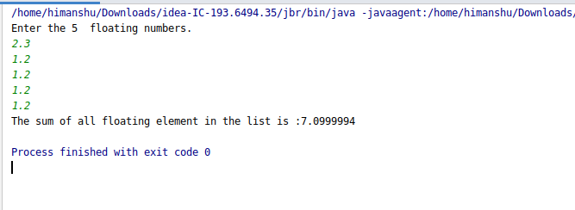

- Write a method that takes a string and returns the number of unique characters in the string.

Code:
package mycollection;
import java.util.*;
public class Ques2unique {
public static void main(String[] args) {
Scanner sc=new Scanner(System.in);
Map<Character,Integer> m=new HashMap<>();
System.out.println("Enter the string..");
String str=sc.nextLine();
String str1=str.replace(" ","");
System.out.println(str1);
char []ch=str1.toCharArray();
int kval;
for (int i=0;i<ch.length;i++)
{
if(m.containsKey(ch[i]))
{
kval=m.get(ch[i]);
m.put(ch[i],kval+1);
}
else
{
m.put(ch[i],1);
}
}
System.out.println("Unique Character");
for(Map.Entry<Character,Integer> entry :m.entrySet())
{
if(entry.getValue()<2) {
System.out.println(entry.getKey());
}
}
}
}

Output
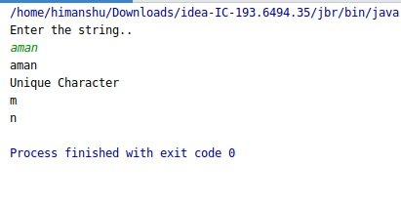

- Write a method that takes a string and print the number of occurrence of each character characters in the string.

Code:
package mycollection;
import java.util.HashMap;
import java.util.Map;
import java.util.Scanner;
public class Ques3occurence {
public static void main(String[] args) {
Scanner sc=new Scanner(System.in);
Map<Character,Integer> m=new HashMap<>();
System.out.println("Enter the string..");
String str=sc.nextLine();
String str1=str.replace(" ","");
System.out.println(str1);
char []ch=str1.toCharArray();
int kval;
for (int i=0;i<ch.length;i++)
{
if(m.containsKey(ch[i]))
{
kval=m.get(ch[i]);
m.put(ch[i],kval+1);
}
else
{
m.put(ch[i],1);
}
}
System.out.println("Key--Occurence");
for(Map.Entry<Character,Integer> entry :m.entrySet())
{
System.out.println(entry.getKey()+"----"+entry.getValue());
}
}
}
Output
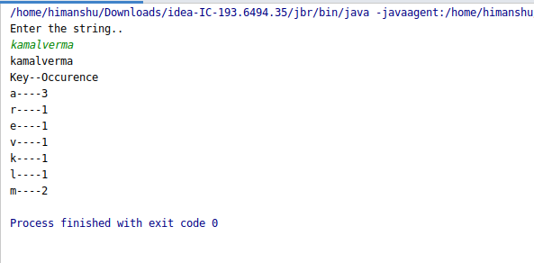

- Write a program to sort HashMap by value.
package mycollection;
import java.util.Comparator;
import java.util.*;
import java.util.List;
import java.util.Map.Entry;
public class Ques4Hashmap {
static void printMap(HashMap <Integer, String >m) {
for (Entry<Integer, String> entry : m.entrySet()) {
System.out.println(entry.getKey() + "\t" + entry.getValue());
}
}
static void sortMapByValue(HashMap<Integer, String >m){
List<Entry<Integer, String >> ll=new LinkedList(m.entrySet());
Collections.sort(ll, new Comparator<Entry<Integer, String >>() {
@Override
public int compare(Entry<Integer, String > o1, Entry<Integer, String > o2) {
return o1.getValue().compareTo(o2.getValue());
}
});
System.out.println("After Sort by Value");
System.out.println("key Value");
HashMap<Integer, String> sortedMap = new LinkedHashMap();
for (Entry<Integer, String> entry : ll)
{
sortedMap.put(entry.getKey(), entry.getValue());
}
printMap(sortedMap);
}
public static void main(String[] args) {
HashMap<Integer, String > hm=new HashMap();
Scanner sc=new Scanner(System.in);
System.out.println("Enter number of students:");
int n=sc.nextInt();
int r=0;
String s=null;
System.out.println("enter student roll and name for "+n+" students:");
for(int i=0;i<n;i++){
r=sc.nextInt();
sc.nextLine();
s=sc.nextLine();
hm.put(r,s);
}
System.out.println("Before sort");
System.out.println("key Value");
printMap(hm);
sortMapByValue(hm);
}
}

Output

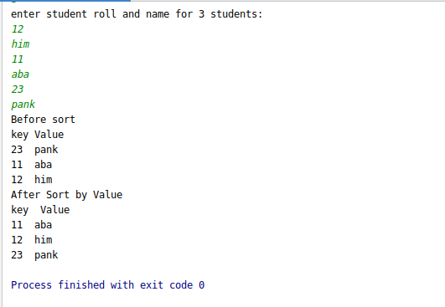

- Write a program to sort Employee objects based on highest salary using Comparator. Employee class{ Double Age; Double Salary; String Name
Code:
package mycollection;
import java.util.*;
class Employee
{
String name;
Double age,salary;
public Employee() {
}
public Employee(String name, Double age, Double salary) {
this.name = name;
this.age = age;
this.salary = salary;
}
public String getName() {
return name;
}
public void setName(String name) {
this.name = name;
}
public Double getAge() {
return age;
}
public void setAge(Double age) {
this.age = age;
}
public Double getSalary() {
return salary;
}
public void setSalary(Double salary) {
this.salary = salary;
}
}
class Sortbysalary implements Comparator
{
@Override
public int compare(Object o, Object o1) {
Employee emp1=(Employee)o;
Employee emp2=(Employee)o1;
if(emp1.salary==emp2.salary)
{
return 0;
}
else if(emp1.salary<emp2.salary)
{
return 1;
}
else
{
return -1;
}
}
//sort employee object based on highest salary
}
public class Ques5Emp {
public static void main(String[] args) {
//First store some Emp object in Array List
Employee e1=new Employee("kamal",12.0,45000.50);
Employee e2=new Employee("rahul",22.0,55000.50);
Employee e3=new Employee("mike",42.0,450000.50);
Employee e4=new Employee("murphy",40.0,65000.50);
List<Employee> li=new ArrayList<>();
li.add(e1);li.add(e2);li.add(e3);li.add(e4);
System.out.println("All data is :");
System.out.println("Age name salary");
System.out.println("----------------------------------");
Iterator it =li.iterator();
while (it.hasNext())
{
Employee temp=(Employee) it.next();
System.out.println(temp.getAge()+" "+temp.getName()+" "+temp.getSalary());
}
System.out.println("---------------------------------------------------------------");
Collections.sort(li,new Sortbysalary());
System.out.println("\nSo here the result of Employee objects based on highest salary......");
Iterator it2 =li.iterator();
while (it2.hasNext())
{
Employee temp=(Employee) it2.next();
System.out.println(temp.getAge()+" "+temp.getName()+" "+temp.getSalary());
}
}
}
Output

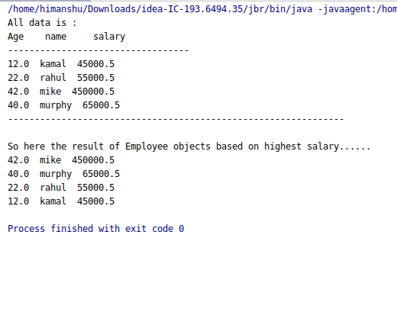

- Write a program to sort the Student objects based on Score , if the score are same then sort on First Name . Class Student{ String Name; Double Score; Double Age Code:
Code:
package mycollection;
import java.util.ArrayList;
import java.util.Collections;
import java.util.Comparator;
class Student{
String name;
Double Age;
Double Score;
Student(String n, Double s, Double a){
this.name=n;
this.Score=s;
this.Age=a;
}
public String toString(){
return name+" "+Score+" "+Age;
}
}
class CompareByScore implements Comparator<Student> {
public int compare(Student e1, Student e2){
if(e1.Score>e2.Score)
return -1;
else if(e1.Score<e2.Score)
return 1;
else
return new NameComparator().compare(e1, e2);
}
}
class NameComparator implements Comparator<Student> {
public int compare(Student e2, Student e1){
return e2.name.compareTo(e1.name);
}
}
public class Ques6Student {
public static void main(String[] args) {
ArrayList<Student> ar=new ArrayList<Student>();
ar.add(new Student("mike",20.0, 24.0));
ar.add(new Student("pagar",25.0, 22.0));
ar.add(new Student("munna",34.0, 25.0));
ar.add(new Student("amisha",34.0, 21.0));
ar.add(new Student("Aishika",32.0, 11.0));
ar.add(new Student("lohit",21.0, 18.0));
ar.add(new Student("neha", 33.0, 20.0));
Collections.sort(ar, new CompareByScore());
for(int i=0;i<ar.size();i++){
System.out.println(ar.get(i));
}
}
}

Output

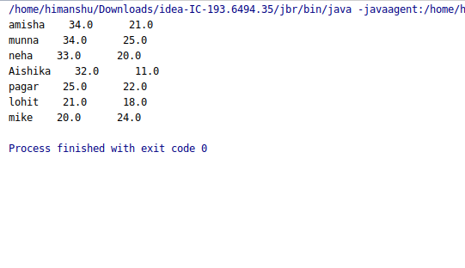

- Print the elements of an array in the decreasing frequency if 2 numbers have same frequency then print the one which came first.
Code:
package mycollection;
import java.util.*;
import java.util.Map.Entry;
//Print the elements of an array in the decreasing frequency if 2 numbers have same frequency
// then print the one which came first.
public class Ques7frequency {
static void sortMapByValue(TreeMap<Integer, Integer >m) {
//LinkedList used Insertion order preserved
List<Entry<Integer, Integer>> ll = new LinkedList<>(m.entrySet());
Collections.sort(ll, new Comparator<Entry<Integer, Integer>>() {
@Override
public int compare(Entry<Integer, Integer> o1, Entry<Integer, Integer> o2) {
if (o1.getValue() > o2.getValue())
return -1;
else if (o1.getValue() < o2.getValue())
return 1;
else
return 0;
}
});
// System.out.println("safsafsdf"+ll);
System.out.println("After Sorting: ");
for (Entry entry : ll) {
System.out.println(entry.getKey() + "\t" + entry.getValue());
}
}
public static void main(String[] args) {
Scanner sc=new Scanner(System.in);
System.out.println("enter size:");
int n=sc.nextInt();
int arr[]=new int[n];
for(int i=0;i<n;i++){
arr[i]=sc.nextInt();
}
//Insert element in TreeMap
TreeMap<Integer, Integer> tm=new TreeMap<Integer, Integer>();
for(int a: arr) {
if (tm.containsKey(a)) {
tm.put(a, tm.get(a) + 1);
} else
tm.put(a, 1);
}
System.out.println("Before Sorting: ");
for (Entry entry : tm.entrySet()) {
System.out.println(entry.getKey() + "\t" + entry.getValue());
}
sortMapByValue(tm);
}
}

Output
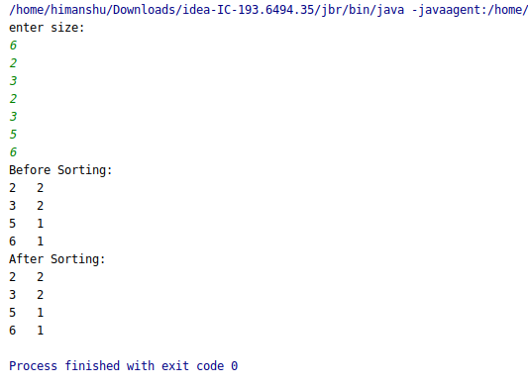

- Design a Data Structure SpecialStack that supports all the stack operations like push(), pop(), isEmpty(), isFull() and an additional operation getMin() which should return minimum element from the SpecialStack. (Expected complexity O(1))
Code:
package mycollection;
import java.util.Scanner;
class SpecialStack
{
private int []mystack;
private int top,size;
public SpecialStack(int size)
{
mystack=new int[size];
top=-1;
this.size=size;
}
public int getTop()
{
return top;
}
//Get value of top[index]
public int getTopVal()
{
return mystack[top];
}
public boolean isEmpty()
{
if(top==-1)
{
return true;
}
else {
return false;
}
}
public boolean isFull() {
if (top == size - 1) {
return true;
} else {
return false;
}
}
//Print all element
public void printAllElement()
{
System.out.println("Stack element is :");
for(int i=top;i>=0;i--)
{
System.out.println(mystack[i]);
}
}
//push element
public void push(int ele)
{
if(isEmpty())
{
top=top+1;
mystack[top]=ele;
}
else if(isFull())
{
System.out.println("Not inserted ! Already full");
}
else {
top=top+1;
mystack[top]=ele;
}
}
//pop element
public int pop()
{
int temp=0;
if(isEmpty())
{
System.out.println("Stack empty");
}
else
{
temp=mystack[top];
--top;
}
return temp;
}
}
public class Ques8Stack {
public static void main(String[] args) {
Scanner sc=new Scanner(System.in);
int len=0,val,choice=0;
int minimum=10000;
SpecialStack sstack=null;
do {
System.out.println("************* Stack Operation ************");
System.out.println("Select your Choice");
System.out.println("\n1:Push Element");
System.out.println("\n2:Pop Element");
System.out.println("\n3:Get top index");
System.out.println("\n4:Get top element");
System.out.println("\n5:Check stack is empty or not.");
System.out.println("\n6:Check stack is full or not.");
System.out.println("\n7:Print all stack element");
System.out.println("\n8:GET MINIMUM ELEMENT IN O(1)");
System.out.println("\n9:Exit");
choice=sc.nextInt();
if (choice == 9) {
System.exit(1);
}
switch (choice) {
case 1: {
System.out.println("Enter the size of stack");
len = sc.nextInt();
sstack = new SpecialStack(len);
System.out.println("Enter the elements for stack..");
for (int i = 0; i < len; i++)
{
val = sc.nextInt();
if(val<minimum)
{
minimum=val;
}
sstack.push(val);
}
}
break;
case 2:
int gio=sstack.pop();
System.out.println("Poped element is :"+gio);
break;
case 3:
int mytop=sstack.getTop();
System.out.println("Top is at index :"+mytop);
break;
case 4:
int mytopval=sstack.getTopVal();
System.out.println("Top value is : "+mytopval);
break;
case 5:
boolean mycheck=sstack.isEmpty();
if(mycheck==true)
{
System.out.println("Stack is empty..");
}
else
{
System.out.println("Stack is not empty");
}
break;
case 6:
boolean mychek=sstack.isFull();
if(mychek==true)
{
System.out.println("Stack is full..");
}
else
{
System.out.println("Stcak is not full");
}
break;
case 7:
sstack.printAllElement();
break;
case 8:
System.out.println("Minimum element is:"+minimum);
break;
default:
System.out.println("wrong selection....");
}
}while (choice>0);
}
}

Output
