Questions:
- Add a gradle dependency and its related repository url.

Solution

File: build.gradle

apply plugin: 'java'
sourceSets {
main {
java.srcDirs = ['src']
}

}
dependencies{

compile group:'commons-io',name:'commons-io',version:'2.6'

}
repositories{
//this is the repositry where all the dependencies exists
mavenCentral()
}

- Using java plugin, make changes in the manifest to make the jar executable. Using java -jar JAR_NAME, the output should be printed as "Hello World"

Solution

File: build.gradle

apply plugin: 'java'

sourceSets {
main {
java.srcDirs = ['src’]
}
}

dependencies{
compile group:'commons-io',name:'commons-io',version:'2.6'
}
repositories{
mavenCentral()
}

// Question 2
// Change in manifest file and make the jar executable
// Command : java -jar FirstGradle.jar

jar {
manifest {
attributes 'Main-Class': 'Question2'
}
}

--------------------------------------------------------------------------

File: Question2.java
Code:

public class Myfirst {
public static void main(String[] args) {
System.out.print("hello world");
}
}
----------------------------------------------------------------------------------
* Now we are execute the FirstGradle.jar file

- Differentiate between the different dependency scopes: compile, runtime, testCompile, testRuntime using different dependencies being defined in your build.gradle.

Solution
Dependency configuration is nothing but defines a set of dependencies. We can use this feature to declare external dependencies, which you want to download from the web. This defines the following different standard configurations.

- Compile − The dependencies required to compile the production source of the project.
- Runtime − The dependencies required by the production classes at runtime. By default, also includes the compile time dependencies.
- Test Compile − The dependencies required to compile the test source of the project. By default, it includes compiled production classes and the compile time dependencies.
- Test Runtime − The dependencies required to run the tests. By default, it includes runtime and test compile dependencies.

build.gradle

apply plugin: 'java'

sourceSets {
main {
java.srcDirs = ['src/main/javaCode1','src/main/javaCode2']
}
}
dependencies{

//compile
compile group:'commons-io',name:'commons-io',version:'2.6'
//runtime
runtime group:org.apache.httpcomponents,name:'httpclient',version: '4.5.1'
//testCompile
testCompile group: 'junit', name: 'junit', version: '4.8'

}

repositories{
mavenCentral()
}

- Create a custom plugin which contains a custom task which prints the current date-time. Using that plugin in your project, execute that task after the jar task executes.

Solution

File: build.gradle

apply plugin: 'java'
sourceSets {
main {
java.srcDirs = ['src']
}
}

dependencies{
compile group:'commons-io',name:'commons-io',version:'2.6'
}

repositories{
mavenCentral()
}

//-----------------------------------------------------------------------------
// Question 4
// Create a custom plugin which contains a custom task which prints the current date-time.

class DatePlugin implements Plugin<Project>
{
@Override
void apply(Project project) {
project.task('DateTask'){
dependsOn('build')
doLast {
println("My date is : "+new Date());
}
}
}
}
apply plugin:DatePlugin;

-------------------------------------------------------------------------------------------------------------------

Command:

gradle DateTask

(DateTask is the name of the task which is used to display the current Date).
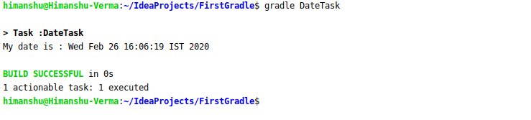

- Instead of using default source set, use src/main/javaCode1, src/main/javaCode2 to be taken as code source. Make sure that the JAR created contains files from both the directories and not from src/main/java.

Solution

File: build.gradle

apply plugin: 'java'
sourceSets {
main {
java.srcDirs = ['src/main/javaCode1','src/main/javaCode2']
}
}

dependencies{
compile group:'commons-io',name:'commons-io',version:'2.6'
}

repositories{
mavenCentral()
}

Aim: JAR created contains files from both the directories and not from src/main/java.

Now we have created the two packages javaCode1 and javaCode2 and in this we have two Javacode1.java and Javacode2.java.

Command:
build gradle

After successfully build gradle.
Showing the content of FirstGradle.jar
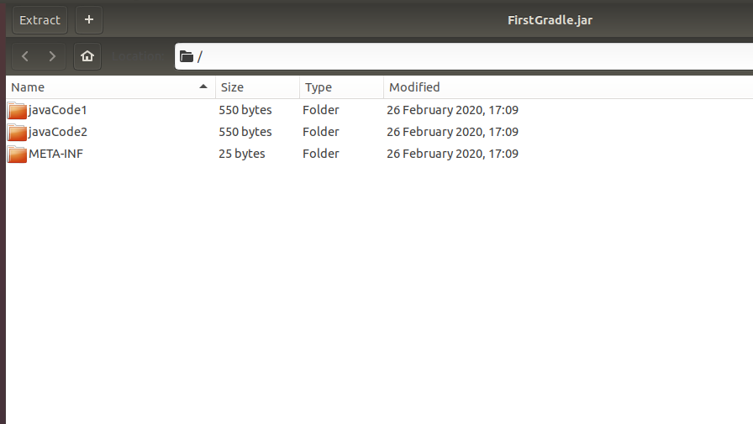

- Override the Gradle Wrapper task to install a different version of gradle. Make sure that the task written in Q4 also executes with it.

Solution

For checking the version of gradle wrapper
./gradlew -version

For install the gradle wrapper
gradle wrapper --gradle-version 4.5

For executing task
./gradlew DateTask

First GradleWrapper Version in my project is 4.5 and executing the task in Q4.

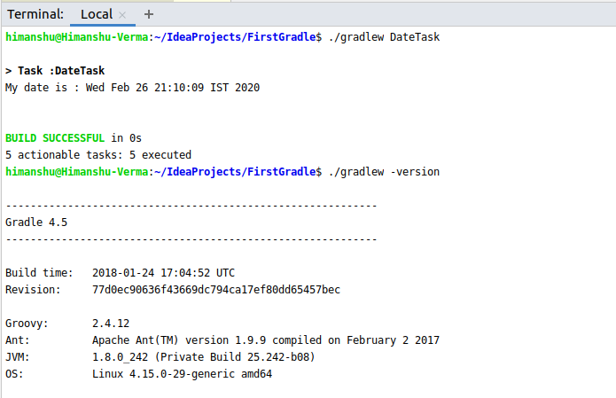

Now I am installing GradleWrapper Version 6.0.1 and executing the same task in Q4.

