2. WAP to sorting string without using string Methods?.
Code:
package javapart2;
import java.util.Scanner;
public class Ques2sort {
static void sort(char mystr[])
{
int n = mystr.length;
for (int i = 1; i < n; ++i) {
char key = mystr[i];

while (j >= 0 && mystr[j] > key) {
mystr[j + 1] = mystr[j];
j = j - 1;
}
mystr[j + 1] = key;
}
System.out.println("Sorted string..");
for(int i=0;i<mystr.length;i++)
{
System.out.print(mystr[i]);
}
}
public static void main(String[] args) {
Scanner sc=new Scanner(System.in);
System.out.println("Enter the string..");
String str=sc.next();
char mystr[]=str.toCharArray();
sort(mystr);
}
}

Output
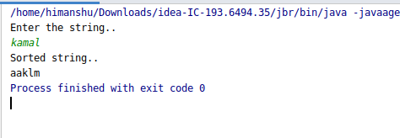

3. WAP to produce NoClassDefFoundError and ClassNotFoundException exception.
Code:
NoClassDefFoundError
package javapart2;
public class Ques3b {
public static void main(String[] args) {
//NoclassDefFoundError example
try
{
B b=new B();
}
catch (NoClassDefFoundError ex)
{
ex.printStackTrace();
}
}
}
class B
{
int a=10;
}
Output
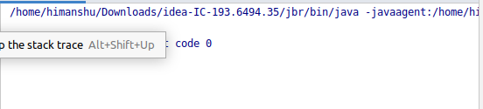

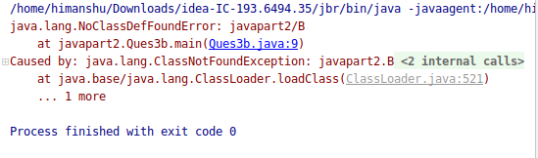

ClassNotFoundException
package javapart2;
public class Ques3a {
public static void main(String[] args) {
//This is example of class not found Exception
try
{
Class.forName("kamal");
}
catch (ClassNotFoundException ex)
{
ex.printStackTrace();
}
}
}
Output
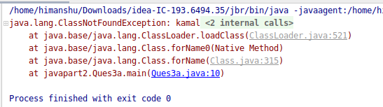

4. WAP to create singleton class.
Code:
package javapart2;
class Hello
{
private static Hello h;
private Hello()
{
}
public static Hello getobject()
{
//Here I am using Lazy Intantiation
//At demand the object will created.
if(h==null) {
new Hello();
}
return h;
}
}
public class Ques4Singleton {
public static void main(String[] args) {
Hello h=Hello.getobject();
}
}
Output
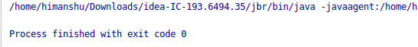

5. WAP to show object cloning in java using cloneable and copy constructor both.
package javapart2;
class MyClone implements Cloneable
{
public String name;
public int age;
MyClone(String n,int val)
{
name=n;
age=val;
}
@Override
public String toString() {
return "MyClone{" +
"name='" + name + '\'' +
", age=" + age +
'}';
}
@Override
protected Object clone() throws CloneNotSupportedException {
return super.clone();
}
}
public class Ques5Clone {
public static void main(String[] args) throws CloneNotSupportedException{
MyClone ob1=new MyClone("kamal",12);
System.out.println("The ob1 value is :"+ob1);
//calling clone method
MyClone ob2=(MyClone) ob1.clone();
System.out.println("The ob2 value is :"+ob2);
}
}
Output
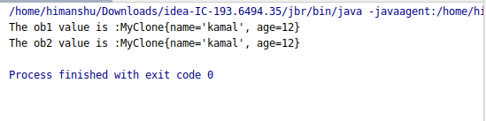

package javapart2;
class Demo
{
public String name;
public int age;
Demo(String n,int val)
{
name=n;
age=val;
}
//Copy constructor
Demo (Demo demo1)
{
name=demo1.name;
age=demo1.age;
}
@Override
public String toString() {
return "Demo{" +
"name='" + name + '\'' +
", age=" + age +
'}';
}
}
public class Ques5Contructor {
//Copy Constructor
public static void main(String[] args) {
//First create object
Demo demo1=new Demo("kamal",12);
System.out.println("The value of demo1 object is:"+demo1);
//Now copy-construtor
Demo demo2=new Demo(demo1);
System.out.println("The value of demo2 object is :"+demo2);
}
}

Output
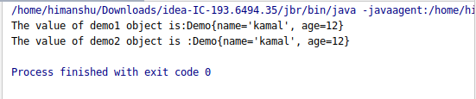

6. WAP showing try, multi-catch and finally blocks.
Code:
package javapart2;
import java.util.InputMismatchException;
import java.util.Scanner;
public class Ques6Block {
public static void main(String[] args) {
//example of try, multiple catch and finally block
//Here I am considering a example of array
Scanner sc=new Scanner(System.in);
int size;
System.out.println("Enter the size of array");
size=sc.nextInt();
int []myarray=new int[size];
try
{
for(int i=0;i<size;i++)
{
myarray[i]=sc.nextInt();
}
//myarray[0]=21;
int temp=myarray[0]/0;
System.out.println(myarray[5]);
}
catch (InputMismatchException e3)
{
e3.printStackTrace();
}
catch (ArrayIndexOutOfBoundsException e)
{
e.printStackTrace();
}
catch (ArithmeticException e1)
{
System.out.println(e1);
}
catch (Exception e2)
{
e2.printStackTrace();
}
}
}

Output
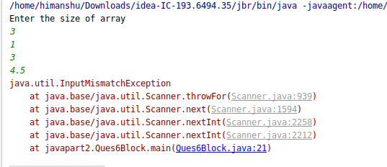

7. WAP to convert seconds into days, hours, minutes and seconds.
Code:
package javapart2;
import java.util.Scanner;
public class Ques7Second {
public static void main(String[] args) {
//user input is in second
// find hour, minute and days
Scanner sc=new Scanner(System.in);
System.out.println("Enter the seconds");
int sec=sc.nextInt();
int hour=sec/(60*60);
System.out.println("The total hour is :"+hour);
float days=(float) hour/24;
System.out.println("The days is:"+days);
int min=sec/60;
System.out.println("The total min is :"+min);
}
}

Output
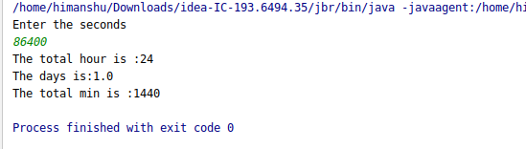

8. WAP to read words from the keyboard until the word done is entered. For each word except done, report whether its first character is equal to its last character. For the required loop, use a
a)while statement
Code:
package javapart2;
import java.util.Scanner;
public class Ques8Input {
public static void main(String[] args) {
System.out.println("Reading word from user untill it typed 'done ..'");
Scanner sc=new Scanner(System.in);
String str;
int c=0;
while (true)
{
str=sc.next();
if(str.equals("done"))
{
break;
}
else
{
if(str.charAt(c)==str.charAt(str.length()-1))
{
System.out.println("Yes first and last character is same..");
}
else
{
System.out.println("Not same first and last character..");
}
}
}
}
}

Output
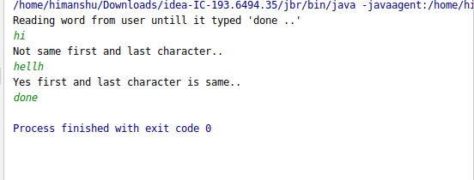

b)do-while statement
Code:
package javapart2;
import java.util.Scanner;
public class Ques8InputB {
//With do-while loop
public static void main(String[] args) {
System.out.println("Reading word from user untill it typed 'done ..'");
Scanner sc=new Scanner(System.in);
String str;
int c=0;
do
{
str=sc.next();
if(str.equals("done"))
{
break;
}
else
{
if(str.charAt(c)==str.charAt(str.length()-1))
{
System.out.println("Yes first and last character is same..");
}
else
{
System.out.println("Not same first and last character..");
}
}
}while (true);
}
}

Output

9. Design classes having attributes for furniture where there are wooden chairs and tables, metal chairs and tables. There are stress and fire tests for each products.
package javapart2;
abstract class Furniture
{
abstract public void stress_Test();
abstract public void fire_Test();
}
abstract class Wooden extends Furniture
{
}
abstract class Metal extends Furniture
{
}
class Chair extends Wooden
{
@Override
public void stress_Test() {
System.out.println("Wooden chair passed in stress");
}
@Override
public void fire_Test() {
System.out.println("Wooden chair passed in fire");
}
}
class Table extends Wooden
{
@Override
public void stress_Test() {
System.out.println("Wooden table passed in stress");
}
@Override
public void fire_Test() {
System.out.println("Wooden table passed in fire");
}
}
class Chair1 extends Metal
{
@Override
public void stress_Test() {
System.out.println("Metal chair1 passed in stress");
}
@Override
public void fire_Test() {
System.out.println("Metal chair1 passed in fire");
}
}
class Table1 extends Metal
{
@Override
public void stress_Test() {
System.out.println("Metal table1 passed in stress");
}
@Override
public void fire_Test() {
System.out.println("Metal table1 passed in fire");
}
}
public class Ques9Furniture {
public static void main(String[] args) {
Furniture f=new Chair() ;
f.stress_Test();
f.fire_Test();
f=new Table();
f.stress_Test();
f.fire_Test();
//End of wooden
System.out.println("------------------------------");
//Start for metal
f=new Chair1();
f.stress_Test();
f.fire_Test();
f=new Table1();
f.stress_Test();
f.fire_Test();
}
}

Output
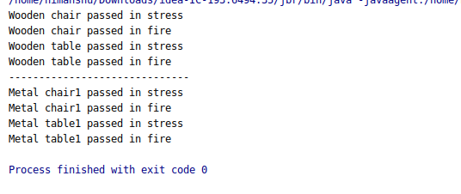

10. Design classes having attributes and method(only skeleton) for a coffee shop. There are three different actors in our scenario and i have listed the different actions they do also below
* Customer
- Pays the cash to the cashier and places his order, get a token number back
- Waits for the intimation that order for his token is ready
- Upon intimation/notification he collects the coffee and enjoys his drink
( Assumption: Customer waits till the coffee is done, he wont timeout and cancel the order. Customer always likes the drink served. Exceptions like he not liking his coffee, he getting wrong coffee are not considered to keep the design simple.)
* Cashier
- Takes an order and payment from the customer
- Upon payment, creates an order and places it into the order queue
- Intimates the customer that he has to wait for his token and gives him his token
( Assumption: Token returned to the customer is the order id. Order queue is unlimited. With a simple modification, we can design for a limited queue size)
* Barista
- Gets the next order from the queue
- Prepares the coffee
- Places the coffee in the completed order queue
- Places a notification that order for token is ready

Code:
Barista Class
package barista;
public class Barista {
int size=100;
int []orderqueue=new int[size];
public void retrieveOrderQueue()
{
//get whole queue
//it return the whole orderqueue to check how many order is completed and how many is pending.
}
public void updateOrderQueue()
{
//call the setOrderQueue(int tokenId)
}
public void notificationMsg()
{
//It notifies the customer that order is ready
}
}

Cashier Class
package barista;
public class Cashier {
int size=100;
int []orderqueue=new int[size];
public void retrieveOrderQueue()
{
//get whole queue
//it return the whole orderqueue to check how many order is completed and how many is pending.
}
public int tokenGenerate(Customer c)
{
//generate token based on customer requirement
}
public void statusforOrder()
{
//print the status of order wheather is is ready or not
}
}

Communication Class
package barista;
public class Communication {
public void gettokenfromcashier()
{
//call the function tokenGenerate(Customer c) and get the token
//set it to customer attribute(tokenId)
}
public void getInitialStatus()
{
//call the statusforOrder() function in Cashier to get the status of order
}
public void getOrderStatus()
{
//call the statusforOrder() function in Barista to get the status of order
}
public void lastNotification()
{
//call the Barista public void notificationMsg()
}
}

Customer Class
package barista;
public class Customer {
private String customerName,orderName,statusforOrder;
private int tokenId,waitingTimeforToken,waitingTimeforOrder;
private double paidAmount;
public Customer() {
}
public Customer(String customerName, String orderName, double paidAmount) {
this.customerName = customerName;
this.orderName = orderName;
this.paidAmount = paidAmount;
}
public String getCustomerName() {
return customerName;
}
public void setCustomerName(String customerName) {
this.customerName = customerName;
}
public String getOrderName() {
return orderName;
}
public void setOrderName(String orderName) {
this.orderName = orderName;
}
public String getStatusforOrder() {
return statusforOrder;
}
public void setStatusforOrder(String statusforOrder) {
this.statusforOrder = statusforOrder;
}
public int getTokenId() {
return tokenId;
}
public void setTokenId(int tokenId) {
this.tokenId = tokenId;
}
public int getWaitingTimeforToken() {
return waitingTimeforToken;
}
public void setWaitingTimeforToken(int waitingTimeforToken) {
this.waitingTimeforToken = waitingTimeforToken;
}
public int getWaitingTimeforOrder() {
return waitingTimeforOrder;
}
public void setWaitingTimeforOrder(int waitingTimeforOrder) {
this.waitingTimeforOrder = waitingTimeforOrder;
}
public double getPaidAmount() {
return paidAmount;
}
public void setPaidAmount(double paidAmount) {
this.paidAmount = paidAmount;
}
//The total time taken for getting the token
public void timeForToken()
{
}
//The total time taken for getting order ready
public void timeForOrder()
{
}
}

OrderQueue Class
package barista;
public class OrderQueue {
//Order queue can be implement using array datastructure, 1 flag means order is placed and set value 1 and inserted
// every time whenever the order is recevied.
//After ready the order the flag 1 (means order plced) is set to 0 by index.
// index indicate the sequence of order.
//For better we can use the ArrayList (Collection) for maintaining the order queue.
//I am assuming that 100 times will placed
int size=100;
int []orderqueue=new int[size];
public int[] getOrderQueue()
{
//it return the whole orderqueue to check how many order is completed and how many is pending.
return orderqueue;
}
public void setOrderQueue(int tokenId)
{
//this method is called every time when order is placed and Cashier placed order in order Queue.
//On each access to this method the value is set 1 in new index.
}
}

Maininterface Class
package barista;
public class Maininterface {
public static void main(String[] args) {
//Take the customer information like customer name ,ordername which is coffee and amount
System.out.println("Enter the customer");
System.out.println("Enter order name");
System.out.println("Pay amount for coffee");
//So here first create the object of customer and stores this information in customer object.
//We can enclosed in loop this for multiple customer.
Customer c1=new Customer();
//Now the Customer and Cashier is interact via Communication class
//and pass the information to the cashier and cashier set the information in customer object.
//Now get the token
c1.getTokenId();
//Waiting time for token
c1.getWaitingTimeforToken();

//creating object of communication class
Communication comm=new Communication();
//check the status of order
comm.getOrderStatus();
//Get the ready notification for order
comm.lastNotification();
}
}

11. Convert the following code so that it uses nested while statements instead of for statements:
int s = 0;
int t = 1;
for (int i = 0; i < 10; i++)
{
s = s + i;
for (int j = i; j > 0; j−−)
{
t = t * (j - i);
}
s = s * t;
System.out.println("T is " + t);
}
System.out.println("S is " + s);
Code:
package javapart2;
public class Ques11Convertcode {
public static void main(String[] args) {
//Here i am converting the code and using while loop instead of for loop.
int s = 0;
int t = 1;
int i=0,j;
while (i < 10)
{s = s + i;
j=i;
while(j>0)
{
t = t * (j - i);
j--;
}
s = s * t;
System.out.println("T is " + t);
i++;
}
System.out.println("S is " + s);
}
}
Output
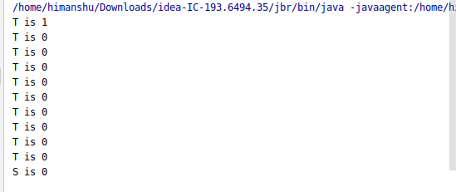

12.What will be the output on new Child(); ?
class Parent extends Grandparent {
{
System.out.println("instance – parent");
}
public Parent() {
System.out.println("
}
static {
System.out.println("static - parent");
}
class Grandparent {
static {
System.out.println("static - grandparent");
}
{
System.out.println("instance – grandparent");
}
public Grandparent() {
System.out.println("
}
}
class Child extends Parent {
public Child() {
System.out.println("
}
static {
System.out.println("static - child");
}
{
System.out.println("instance - child");
}
}

Output
So here the static block is always executed first and the anonymous block is executed before the constructor.
static - grandparent
static - parent
static - child
instance - grandparent
constructor - grandparent
instance - parent
constructor - parent
instance - child
constructor – child

Q13. Create a custom exception that do not have any stack trace.
Code:
package javapart2;
import java.util.Scanner;
class CheckAge extends RuntimeException
{
private boolean myflag=false;
CheckAge(String msg,boolean myflag)
{
super(msg,null,myflag,!myflag);
}
}
public class Ques13Exception {
public static void main(String[] args) {
Scanner sc=new Scanner(System.in);
System.out.println("Enter the age for check..");
int age=sc.nextInt();
try {
if (age < 18) {
throw new CheckAge("Sorry your age is less than 18",true);
}
}
catch (CheckAge c)
{
// System.out.println(c);
c.printStackTrace();
}
}
}

Output
